CPE301 – SPRING 2019

Design Assignment 2BT1

Student Name: Billy Maddex

Student #: 2000928390

Student Email: [maddex@unlv.nevada.edu](mailto:maddex@unlv.nevada.edu)

Primary Github address: <https://github.com/billymaddex/fluffy-chainsaw>

Directory: DA2B/T1

Submit the following for all Labs:

1. In the document, for each task submit the modified or included code (only) with highlights and justifications of the modifications. Also, include the comments.
2. Use the previously create a Github repository with a random name (no CPE/301, Lastname, Firstname). Place all labs under the root folder ESD301/DA, sub-folder named LABXX, with one document and one video link file for each lab, place modified asm/c files named as LabXX-TYY.asm/c.
3. If multiple asm/c files or other libraries are used, create a folder LabXX-TYY and place these files inside the folder.
4. The folder should have a) Word document (see template), b) source code file(s) and other include files, c) text file with youtube video links (see template).

1. **COMPONENTS LIST AND CONNECTION BLOCK DIAGRAM w/ PINS**

Atmega328PB-XMINI

Multi-Function Arduino Module

1. **INITIAL/MODIFIED/DEVELOPED CODE OF TASK 1/A**

;

; DA2AT1.asm

;

; Created: 9/29/2019 3:15:15 PM

; Author : Billy

;

;; Set GPIO ports

;; Set DDR B,C,D to known initial value

LDI R25, 0x00

OUT DDRB, R25

OUT DDRC, R25

OUT DDRD, R25

;; set PORT B,C,D to know initial value

LDI R25, 0xFF

OUT PORTB, R25

OUT PORTC, R25

OUT PORTD, R25

;; set PORTB 2 and 3 to output

SBI DDRB, 3

SBI DDRB, 2

;; set PINC 3 to input

CBI DDRC, 3

MAIN_LOOP:

;; LED pulse

;; turn the light on

CBI PORTB, 3

;; call delay at 250ms

LDI R17, HIGH(250)

LDI R16, LOW(250)

CALL DELAY

;; turn the light off

SBI PORTB, 3

;; call delay at 375ms

LDI R17, HIGH(375)

LDI R16, LOW(375)

CALL DELAY

;; if switch is not pressed, repeat the loop

SBIC PINC, 3

RJMP MAIN_LOOP

;; otherwise, flash the other light

;; turn the light on

CBI PORTB, 2

;; call delay at 1333ms

LDI R17, HIGH(1333)

LDI R16, LOW(1333)

CALL DELAY

;; turn the light off

SBI PORTB, 2

;; repeat the loop

RJMP MAIN_LOOP

;; simple delay function

;; takes input as 16-bit int in R17:R16

;; delay is supposed to be in ms

DELAY:

LDI R20, 0

MOV R22, R17

MOV R21, R16

L3:

LDI R23, 0X2F

L2:

LDI R24, 0X70

NOP

L1:

DEC R24

BRNE L1

DEC R23

BRNE L2

SUBI R21, 1

SBCI R22, 0

BRNE L3

CP R21, R20

BRNE L3

RET

1. **DEVELOPED MODIFIED CODE OF TASK 2/A from TASK 1/A**

;

; DA2BT1.asm

;

; Created: 10/05/2019 1:15:15 PM

; Author : Billy

;

.INCLUDE <M328PBDEF.INC>

.ORG 0

JMP MAIN

.ORG 0X02

JMP EX0_ISR

.ORG 0x08

JMP PCINT11_ISR

MAIN:

;; Set GPIO ports

;; Set DDR B,C,D to known initial value

LDI R25, 0x00

OUT DDRB, R25

OUT DDRC, R25

OUT DDRD, R25

;; set PORT B,C,D to know initial value

LDI R25, 0xFF

OUT PORTB, R25

OUT PORTC, R25

OUT PORTD, R25

;; set PORTB 2 and 3 to output

SBI DDRB, 3

SBI DDRB, 2

;; set PINC 3 to input

CBI DDRC, 3

;; configure interupt handling

;; enable INT0

LDI R20, 1 << INT0

OUT EIMSK, R20

;; set to falling edge trigger

LDI R20, 0X02

STS EICRA, R20

;; enable PCINT11 (PINC.3)

LDI R20, 0x08

STS PCMSK1, R20

LDI R20, 1 << PCIE1

STS PCICR, R20

;; enable global interupt

SEI

MAIN_LOOP:

;; LED pulse

;; turn the light on

CBI PORTB, 3

;; call delay at 250ms

LDI R17, HIGH(250)

LDI R16, LOW(250)

CALL DELAY

;; turn the light off

SBI PORTB, 3

;; call delay at 375ms

LDI R17, HIGH(375)

LDI R16, LOW(375)

CALL DELAY

;; repeat the loop

RJMP MAIN_LOOP

;; pin change interupt handler function

PCINT11_ISR:

;; if switch is not pressed, exit the function

SBIC PINC, 3

RETI

;; switch is pressed, flash light 2

CALL LIGHT2

RETI

;; external interupt handler function

EX0_ISR:

;; if switch is not pressed, exit the function

SBIC PIND, 2

RETI

;; switch is pressed, flash light 2

CALL LIGHT2

RETI

;; long flash on secondary LED

LIGHT2:

;; save all delay function registers

PUSH R16

PUSH R17

PUSH R20

PUSH R21

PUSH R22

PUSH R23

PUSH R24

;; turn the light on

CBI PORTB, 2

;; call delay at 1333ms

LDI R17, HIGH(1333)

LDI R16, LOW(1333)

CALL DELAY

;; turn the light off

SBI PORTB, 2

;; restore all delay function registers

POP R24

POP R23

POP R22

POP R21

POP R20

POP R17

POP R16

RET

;; simple delay function

;; takes input as 16-bit int in R17:R16

;; delay is supposed to be in ms

DELAY:

;;RET ;; FOR DEBUG ONLY

LDI R20, 0

MOV R22, R17

MOV R21, R16

L3:

LDI R23, 0X2F

L2:

LDI R24, 0X70

NOP

L1:

DEC R24

BRNE L1

DEC R23

BRNE L2

SUBI R21, 1

SBCI R22, 0

BRNE L3

CP R21, R20

BRNE L3

RET

1. **SCHEMATICS**

Use fritzing.org

1. **SCREENSHOTS OF EACH TASK OUTPUT (ATMEL STUDIO OUTPUT)**

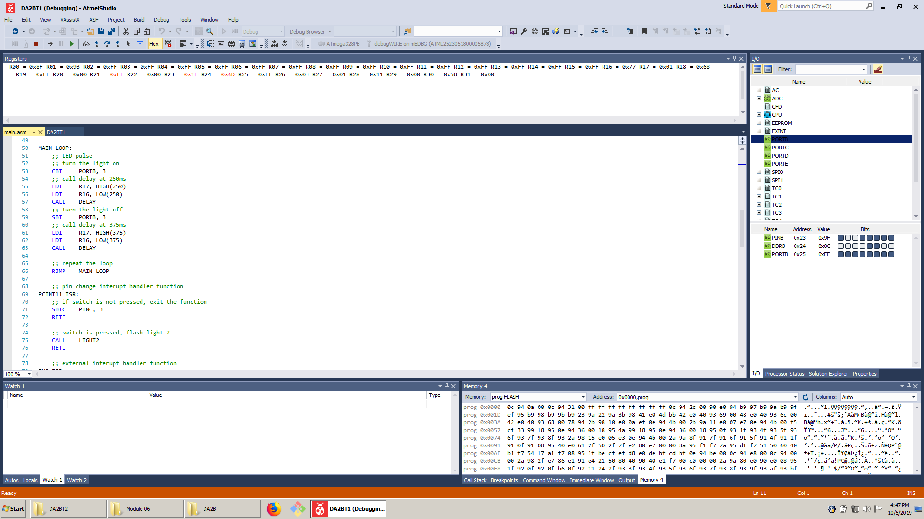

1. **SCREENSHOT OF EACH DEMO (BOARD SETUP)**

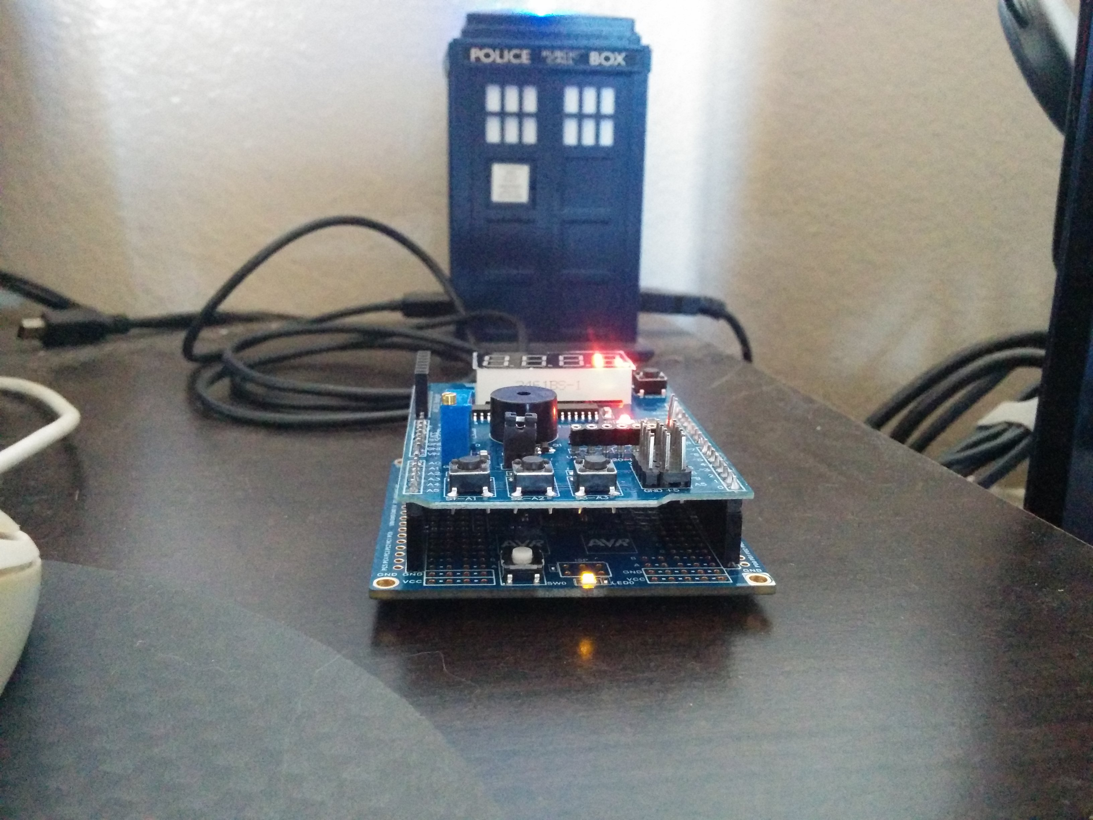

1. **VIDEO LINKS OF EACH DEMO**

https://youtu.be/UKjEhzYyDC0

1. **GITHUB LINK OF THIS DA**

<https://github.com/billymaddex/fluffy-chainsaw/tree/master/DesignAssignments/DA2B/T1>

**Student Academic Misconduct Policy**

<http://studentconduct.unlv.edu/misconduct/policy.html>

“This assignment submission is my own, original work”.

Billy Maddex