CPE301 – SPRING 2019

Design Assignment 2CT3

Student Name: Billy Maddex

Student #: 2000928390

Student Email: [maddex@unlv.nevada.edu](mailto:maddex@unlv.nevada.edu)

Primary Github address: <https://github.com/billymaddex/fluffy-chainsaw>

Directory: DA2C/DA2CT3

Submit the following for all Labs:

1. In the document, for each task submit the modified or included code (only) with highlights and justifications of the modifications. Also, include the comments.
2. Use the previously create a Github repository with a random name (no CPE/301, Lastname, Firstname). Place all labs under the root folder ESD301/DA, sub-folder named LABXX, with one document and one video link file for each lab, place modified asm/c files named as LabXX-TYY.asm/c.
3. If multiple asm/c files or other libraries are used, create a folder LabXX-TYY and place these files inside the folder.
4. The folder should have a) Word document (see template), b) source code file(s) and other include files, c) text file with youtube video links (see template).

1. **COMPONENTS LIST AND CONNECTION BLOCK DIAGRAM w/ PINS**

Atmega328PB-XMINI

Multi-Function Arduino Module

1. **INITIAL/MODIFIED/DEVELOPED CODE OF TASK 2/B**

/*

* DA2BT2.c

*

* Created: 10/5/2019 2:28:51 PM

* Author : Billy

*/

#define F_CPU 1600000UL

#include <avr/io.h>

#include <avr/interrupt.h>

#include <util/delay.h>

// long flash on secondary LED

int light2 (void)

{

// turn the light on

PORTB &= ~(1 << 2);

// call delay

_delay_ms(13330);

// turn the light off

PORTB |= (1 << 2);

return 0;

}

// external interrupt handler

ISR (INT0_vect)

{

if (~PIND & (1 << 2))

{

light2();

}

}

// pin change interrupt handler

ISR (PCINT1_vect)

{

if (~PINC & (1 << 3))

{

light2();

}

}

int main(void)

{

// Set DDR B,C,D to known initial value

DDRB = 0x00;

DDRC = 0x00;

DDRD = 0x00;

// set PORT B,C,D to know initial value

PORTB = 0xFF;

PORTC = 0xFF;

PORTD = 0xFF;

// set PORTB 2 and 3 to output

DDRB |= (1 << 3);

DDRB |= (1 << 2);

// set PINC 3 to input

DDRC &= ~(1 << 3);

// configure interrupt handling

// enable INT0, falling edge trigger

EIMSK = (1 << INT0);

EICRA = 0x02;

// enable PCINT11 (PINC.3)

PCMSK1 = 0x08;

PCICR = (1 << PCIE1);

// enable global interrupt

sei();

// LED pulse

while (1)

{

// turn the light on

PORTB &= ~(1 << 3);

// call delay

_delay_ms(2500);

// turn the light off

PORTB |= (1 << 3);

// call delay

_delay_ms(3750);

// if switch is pressed, flash the other light

/*if (~PINC & (1 << 3))

{

light2();

}*/

}

}

1. **DEVELOPED MODIFIED CODE OF TASK 3/C from TASK 2/B**

/*

* DA2CT3.c

*

* Created: 10/12/2019 1:35:55 PM

* Author : Billy

*/

#define F_CPU 16000000UL

#include <avr/io.h>

#include <avr/interrupt.h>

// global constants and variables

const int COMP = 249;

const int ON1 = 250;

const int OFF1 = 375;

const int ON2 = 1333;

int clock1, clock2, led3;

// long flash on secondary LED

int light2 (void)

{

// turn the light on

PORTB &= ~(1 << 2);

// set clock 2 to CTC operation

TCCR2A = (1 << WGM21);

// COMPA = 249

OCR2A = COMP;

// set the clock value

clock2 = ON2;

// start clock 2 with prescalar = 64

TCCR2B |= (1 << CS22);

return 0;

}

// external interrupt handler

ISR (INT0_vect)

{

if (~PIND & (1 << 2)) light2();

}

// pin change interrupt handler

ISR (PCINT1_vect)

{

if (~PINC & (1 << 3)) light2();

}

// timer0 OVF interrupt handler

ISR (TIMER0_COMPA_vect)

{

// decrement the clock counter and reset the timer

clock1--;

TIFR0 |= (1 << OCF0A);

if (clock1 == 0)

{

// if LED3 is on

if (led3)

{

// turn LED3 off

PORTB |= (1 << 3);

led3 = 0;

// set the off clock1 value

clock1 = OFF1;

}

// if LED3 in off

else

{

// turn LED3 on

PORTB &= ~(1 << 3);

led3 = 1;

// set the on clock1 value

clock1 = ON1;

}

}

}

// timer2 OVF interrupt handler

ISR (TIMER2_COMPA_vect)

{

// decrement the clock counter and reset the timer

clock2--;

TIFR2 |= (1 << OCF2A);

if (clock2 == 0)

{

// turn LED off

PORTB |= (1 << 2);

// stop timer 2

TCCR2B &= ~(1 << CS22);

}

}

int main(void)

{

// Set DDR B,C,D to known initial value

DDRB = 0x00;

DDRC = 0x00;

DDRD = 0x00;

// set PORT B,C,D to know initial value

PORTB = 0xFF;

PORTC = 0xFF;

PORTD = 0xFF;

// set PORTB 2 and 3 to output

DDRB |= (1 << 3);

DDRB |= (1 << 2);

// set PINC 3 to input

DDRC &= ~(1 << 3);

// configure interrupt handling

// enable INT0, falling edge trigger

EIMSK = (1 << INT0);

EICRA = 0x02;

// enable PCINT11 (PINC.3)

PCMSK1 = 0x08;

PCICR = (1 << PCIE1);

// enable TIMER0 COMPA interrupt

TIMSK0 |= (1 << OCIE0A);

// enable TIMER2 COMPA interrupt

TIMSK2 |= (1 << OCIE2A);

// LED pulse

// set clock 1 to CTC operation

TCCR0A |= (1 << WGM01);

// COMPA = 249

OCR0A = COMP;

// turn the light on

PORTB &= ~(1 << 3);

led3 = 1;

// set the on clock1 value

clock1 = ON1;

// start clock 1 with prescalar = 64

TCCR0B |= (1 << CS01) | (1 << CS00);

// enable global interrupt

sei();

// loop forever

while (1);

}

1. **SCHEMATICS**

Use fritzing.org

1. **SCREENSHOTS OF EACH TASK OUTPUT (ATMEL STUDIO OUTPUT)**

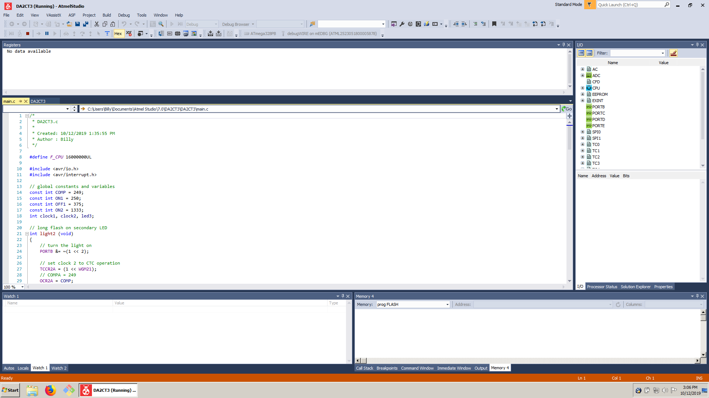

1. **SCREENSHOT OF EACH DEMO (BOARD SETUP)**

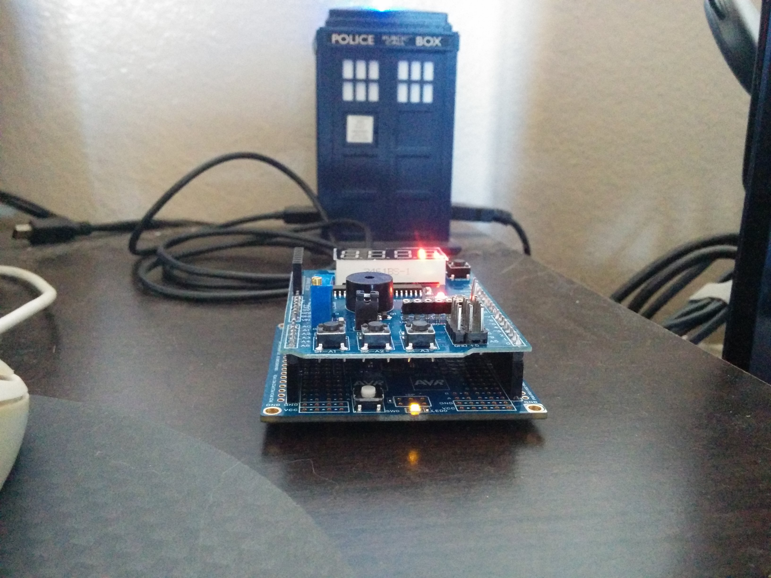

1. **VIDEO LINKS OF EACH DEMO**

https://youtu.be/JV2nWGm-CmA

1. **GITHUB LINK OF THIS DA**

<https://github.com/billymaddex/fluffy-chainsaw/tree/master/DesignAssignments/DA2C/DA2CT3>

**Student Academic Misconduct Policy**

<http://studentconduct.unlv.edu/misconduct/policy.html>

“This assignment submission is my own, original work”.

Billy Maddex