CPE301 – SPRING 2019

Design Assignment 4A

Student Name: Billy Maddex

Student #: 2000928390

Student Email: [maddex@unlv.nevada.edu](mailto:maddex@unlv.nevada.edu)

Primary Github address: <https://github.com/billymaddex/fluffy-chainsaw>

Directory: DA4A

Submit the following for all Labs:

1. In the document, for each task submit the modified or included code (only) with highlights and justifications of the modifications. Also, include the comments.
2. Use the previously create a Github repository with a random name (no CPE/301, Lastname, Firstname). Place all labs under the root folder ESD301/DA, sub-folder named LABXX, with one document and one video link file for each lab, place modified asm/c files named as LabXX-TYY.asm/c.
3. If multiple asm/c files or other libraries are used, create a folder LabXX-TYY and place these files inside the folder.
4. The folder should have a) Word document (see template), b) source code file(s) and other include files, c) text file with youtube video links (see template).

1. **COMPONENTS LIST AND CONNECTION BLOCK DIAGRAM w/ PINS**

Atmega328PB-XMINI

Breadboard Arduino Module

1K Ohm Potentiometer

LED (to show PWM duty cycle output)

1. **INITIAL/MODIFIED/DEVELOPED CODE OF TASK 3A**

/*

* DA4A.c

*

* Created: 11/11/2019 8:45:32 AM

* Author : Billy

*/

#define F_CPU 16000000UL

#include <avr/io.h>

#include <avr/interrupt.h>

// pin change vector

// toggle PWM output signal on each button press

ISR(PCINT0_vect)

{

if(~PINB & (1 << 7))

{

DDRD ^= (1 << DDRB3);

}

}

// ADC conversion complete vector

// update PWM duty cycle on each conversion

ISR(ADC_vect)

{

unsigned int voltage = ADCH;

OCR2B = (voltage * 242) / 255;

}

// configure pin change interrupt for PINB7

void button_init()

{

PCMSK0 = (1 << PCINT7);

PCICR = (1 << PCIE0);

}

// configure TIMER2 for non-inverting fast PWM, OCR2B/PIND3 output,prescalar 64

void PWM_init()

{

TCCR2B |= (0 << WGM22) | (1 << CS22) | (0 << CS21) | (0 << CS20);

TCCR2A |= (1 << COM2B1) | (0 << COM2B0) | (1 << WGM21) | (1 << WGM20);

}

// enable ADC on PINC5, free running, interrupt enable

void ADC_init()

{

ADMUX =

// Reference Selection Bits

// AVcc with external capacitor at AREF

(0 << REFS1) |

(1 << REFS0) |

// ADC Left Adjust Result

(1 << ADLAR) |

// Analog Channel Selection Bits

// ADC5 (PC5 PIN28)

(0 << MUX3) |

(1 << MUX2) |

(0 << MUX1) |

(1 << MUX0);

ADCSRA =

// ADC ENable

(1 << ADEN) |

// ADC Start Conversion

(1 << ADSC) |

// ADC Auto Trigger Enable

(1 << ADATE) |

// ADC Interrupt Flag

(0 << ADIF) |

// ADC Interrupt Enable

(1 << ADIE) |

// ADC Prescaler Select Bits

// prescalar = 128

(1 << ADPS2) |

(1 << ADPS1) |

(1 << ADPS0);

ADCSRB =

// disable analog comparator

(0 << ACME) |

// enable free running mode

(0 << ADTS2) |

(0 << ADTS1) |

(0 << ADTS0);

}

int main(void)

{

// initialize input buttons

button_init();

// initialize PWM

PWM_init();

// initialize ADC

ADC_init();

// enable those interrupts

sei();

// the usual infinite loop

while (1);

}

1. **DEVELOPED MODIFIED CODE OF TASK B from TASK A**
2. **SCHEMATICS**

Use fritzing.org

1. **SCREENSHOTS OF EACH TASK OUTPUT (ATMEL STUDIO OUTPUT)**

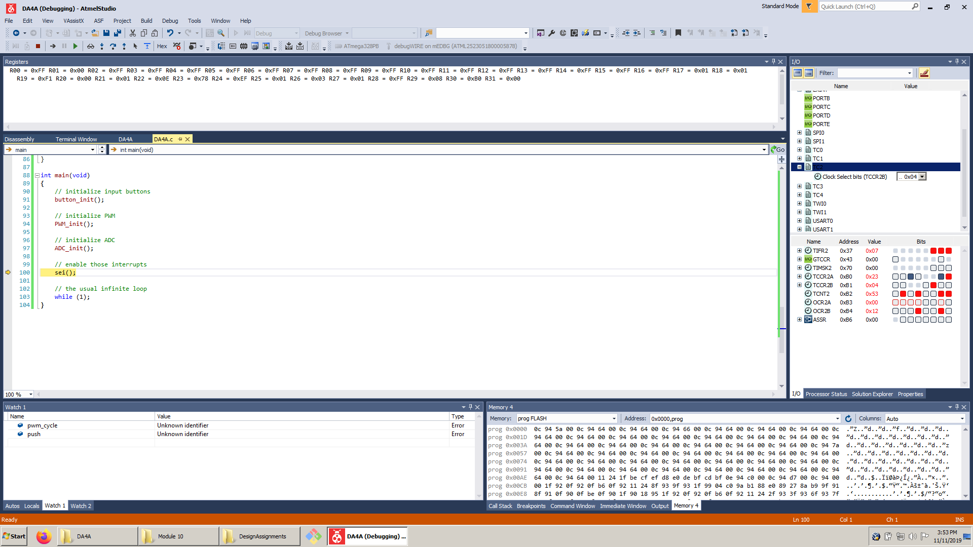

1. **SCREENSHOT OF EACH DEMO (BOARD SETUP)**

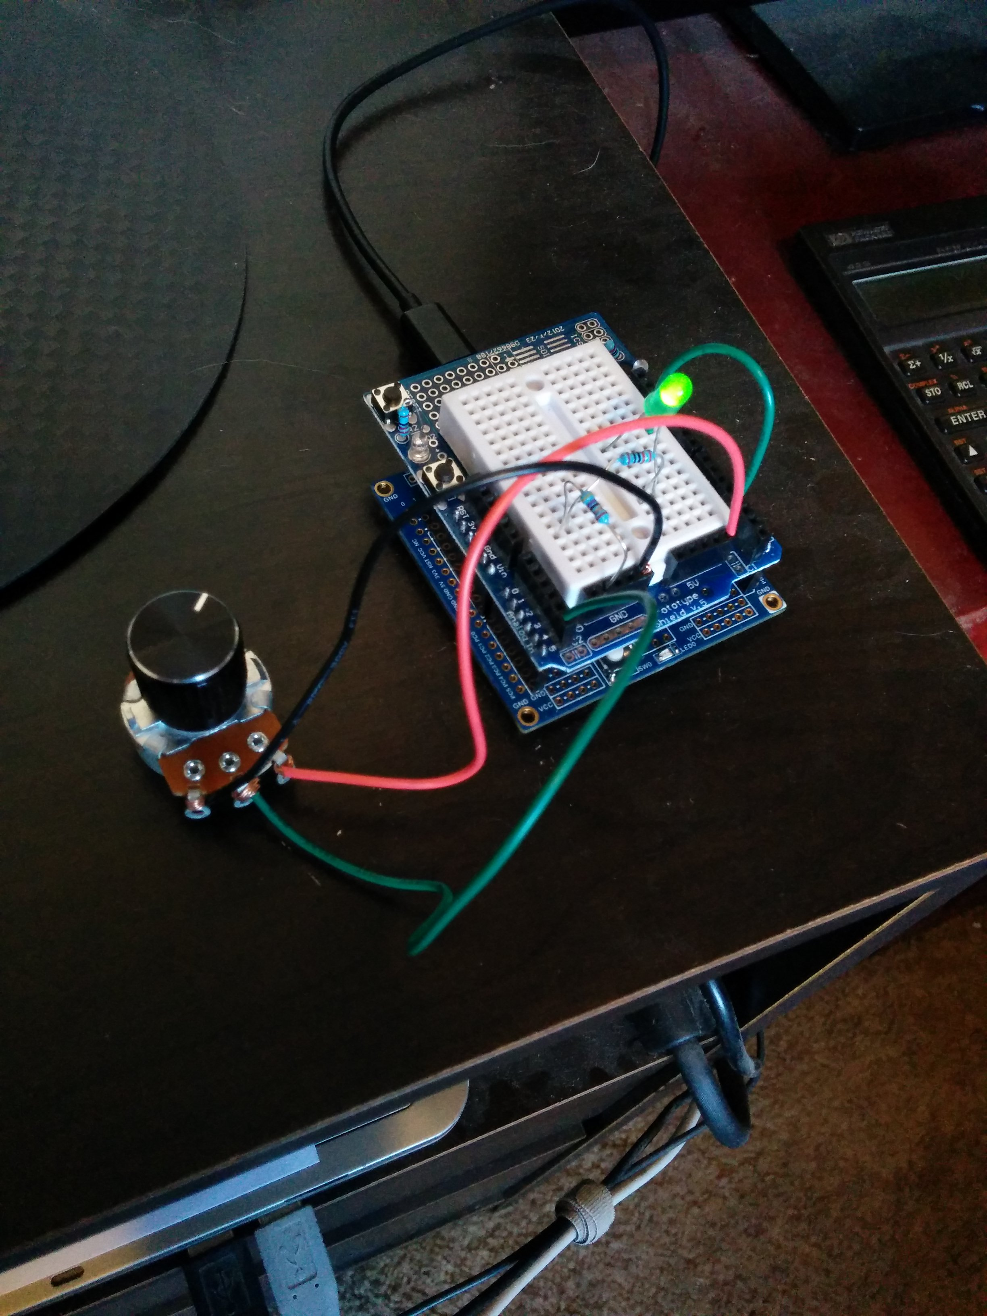

1. **VIDEO LINKS OF EACH DEMO**

https://youtu.be/kstyw8gMm5U

1. **GITHUB LINK OF THIS DA**

<https://github.com/billymaddex/fluffy-chainsaw/tree/master/DesignAssignments/DA4A>

**Student Academic Misconduct Policy**

<http://studentconduct.unlv.edu/misconduct/policy.html>

“This assignment submission is my own, original work”.

Billy Maddex