Candidate 1114l
1.
(a)
(i)
Figure 1 shows a driver tree for AlphaDrugs profit, which is a function of its revenue and cost. Figure 2 shows the same driver tree after inputting the information given in the question.
The total unit cost is calculated by: £5 + £0.4 + £0.3 = £5.7
No fixed costs are mentioned, so I assume fixed costs = 0
Revenue per unit is given at £8
Taking z to be the production volume, total revenue is 8z and total costs are 5.7z
Profit is calculated by revenue – costs
Therefore profit is equal to 8z – 5.7z
Profit = 2.3z, where z is the quantity produced and sold.
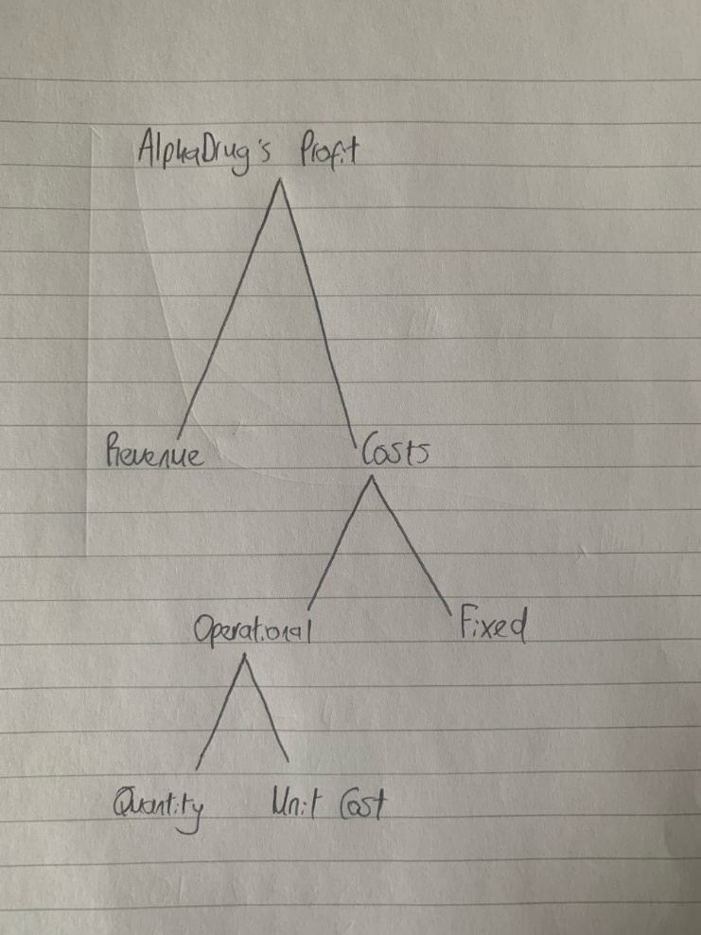
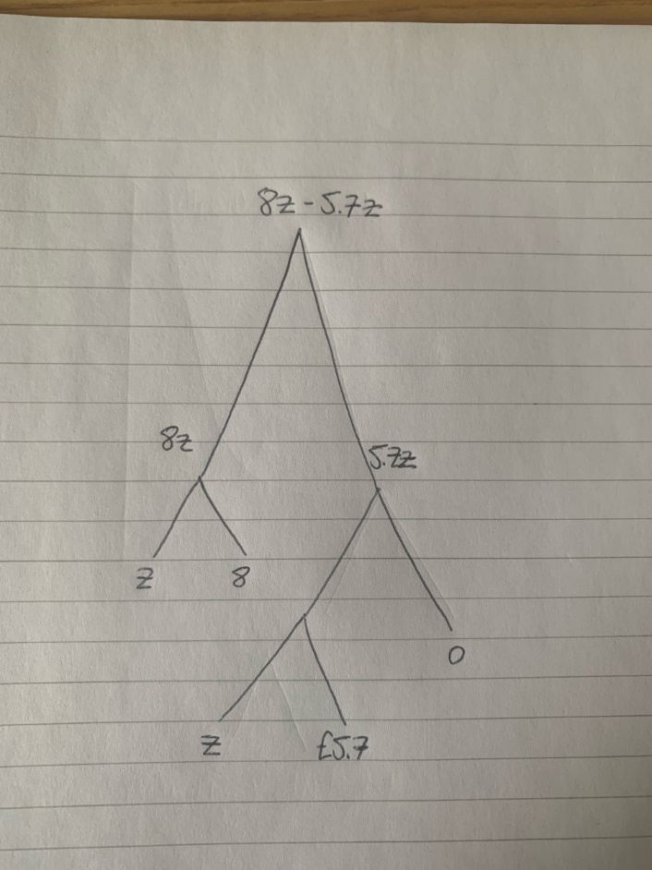

(ii)
The risk of making a loss is lower when choosing a capacity level of 48,000. For this capacity level, the risk of making a loss is 1.5%, whereas for the 52,000 capacity level the risk is 3.1%. This might lead a risk-averse manager to choose a capacity level of 48,000.
The maximum possible profit is higher when choosing a capacity level of 52,000. At this capacity level, the maximum profit is £239,200, compared to £220,800 at a capacity level of 48,000. Therefore a manager with a high risk tolerance might choose a capacity level of 52,000 because the potential reward is higher.
However, the median profit is higher when choosing a capacity level of 48,000, £193,655.46 compared to £174,300.59. In each capacity choice, there is an equal chance of the profit being higher or lower than this amount.

2.
(a)
(i)
The 3NN algorithm classifies the new observation based on the classification of its 3 nearest “neighbours” or data points. This graph shows that of the 3 data points nearest to the observation located at (?,?), 2 are Class B and 1 is Class A. Thus based on the majority rule, the predicted label for the new observation with features (?,?) is Class B.
The 7NN algorithm classifies the new observation based on the classification of its 7 nearest “neighbours” or data points. This graph shows that of the 7 data points nearest to the observation located at (?,?), 4 are Class A and 3 are Class B. Thus based on the majority rule, the predicted label for the new observation with features (?,?) is Class A.
A higher value for k increases how tightly groups are clustered, which is desirable. However in an extreme case this results in too many clusters, for example where k = n, each data point becomes its own cluster. This is not useful in the world of business where we are seeking to create groups of data points from which we can draw conclusions.
The best value for k is often close to:
$\frac{√n}{2}$ or $√n$
However, k should never be a multiple the number of classes or labels in the data set.
(ii)
The k-means algorithm aims to divide a number of observations in multiple and similar clusters. The process involves choosing k number of centres, before assigning each data point to a cluster based on its nearest centre.
In this example, the centres (shown in black) do not appear to match well with the data. For example, both the blue and yellow clusters are very close to one another, whilst the green cluster appears concentrated around two different points.
It would that doing more iterations could improve these clustering results, for example by having centres at (0,0), (5,-1) and (5,6). This model would have the same number of centres, but would reduce the average distance between each data point and the centre of its cluster.
(b)
The concept of a decision tree could be useful for many businesses. For example, when deciding whether or not to acquire a patent for a new product, there are many factors the company must weigh up.
First, they must consider the cost of applying for a patent, as well as the probability of being granted the patent. The must also consider the probability of the product being a commercial success. The business can calculate the expected market value of the product’s sales by using the “rolling-back technique, which accounts for the probabilities of various outcomes. This EMV can then be compared to the cost of acquiring the patent, to inform the decision.
A sketch of the decision tree this business could use is shown below.

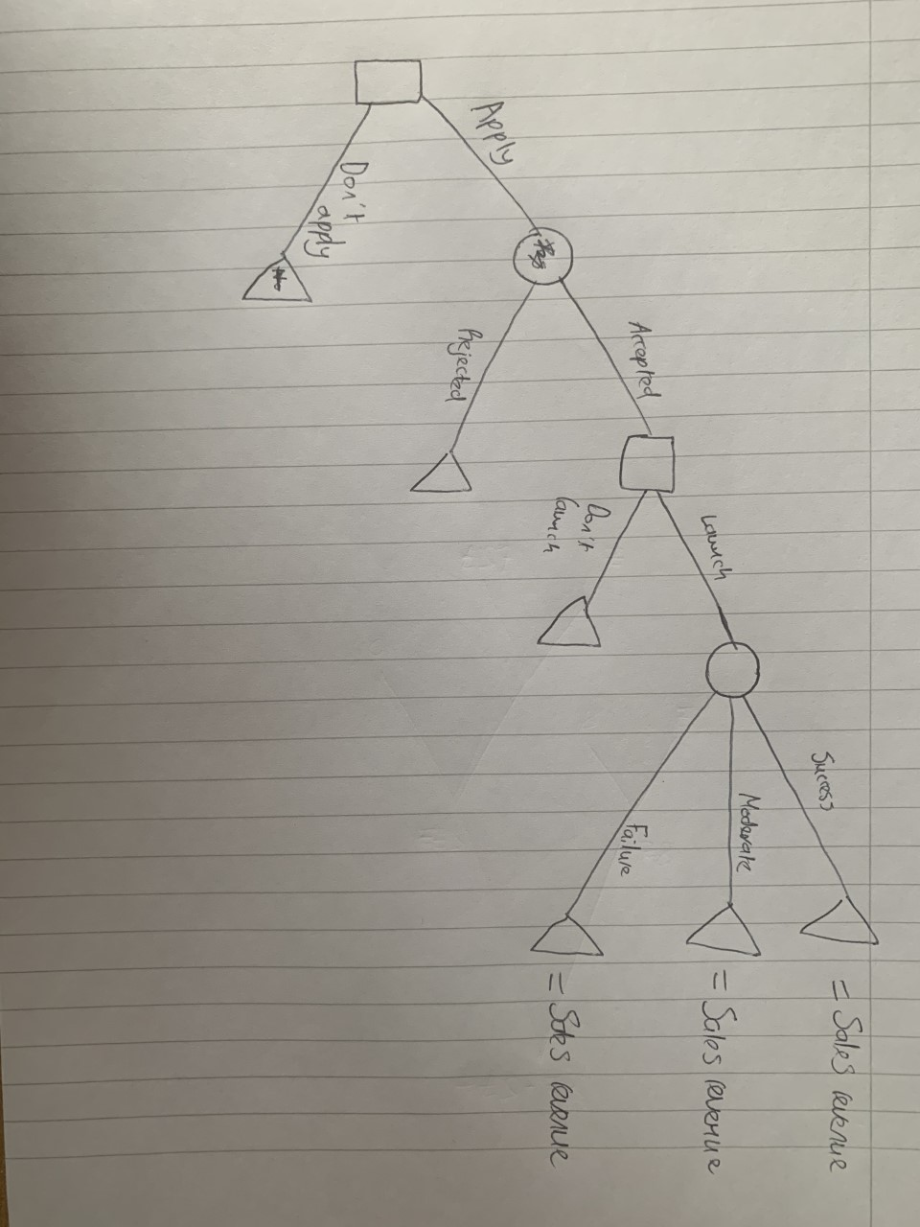

3.
(a)
(i)
Let litres of raw material = x₁ and production hours = x₂
Per kg of A
5kg of A requires 1 litre of raw materials, 20 hours of production time and £20 production costs
1kg of A requires 0.2x₁, 4x₂ and £4 production costs
Price per kg of A is £200
Profit per kg of B
8kg of B requires 1 litre of raw materials, 30 hours of production time and £400 production costs
1kg of B requires 0.125x₁, 3.75x₂ and £50 production costs
Price per kilogram of B is £300
Profit maximisation equation
Taking the previous analysis into account, OrganicPrime’s problem can be formulated as
Max: 200(0.2x₁ + 4x₂ – 4) + 300(0.125x₁ + 3.75x₂ – 50)
Constraints
X₁ $≤$ 5,000,000
X₂ $≤$ 10,000,000
(b)
(i)

4
(a)
(i)
The correlation coefficient is 0.606. The correlation coefficient is a measure of the strength of the linear relationship between the independent variable (overall service) and the dependent variable (volume). -1 < R < 1, where a positive R means the variables are positively correlated, and a negative R means they are negatively correlated. Further, the closer R is to -1 or 1, the stronger the relationship between the variables. In this case, the variables are positively correlated with moderate strength. This means as the level of overall service increases, we would also expect the level of business to increase. This is intuitive because we would expect a higher quality service to attract more customers.
(ii)
The slope of the independent variable is currently a point estimate. We can construct a confidence interval to estimate the true slope with a greater degree of certainty. At the 85% confidence level, 85% of constructed confidence intervals will contain the true value of the slope.
At the 85% confidence level, the corresponding z value is 1.44. The coefficient given is 8.569. The standard error of the coefficient is 2.649. The confidence interval is calculated by:
[b₁ - zSE, b₁ + Zse]
[8.569 – 1.44(2.649), 8.569 + 1.44(2.649]
[4.7544, 12.38356]
This means that at the 85% confidence level, we are sure that increasing overall service by one unit will increase volume will increase by a unit between 4.75 and 12.38.
(iii)
The R-squared statistic for the multiple regression model is 0.370. R-squared shows us the proportion of variation in the dependant variable that can be explained by the regression equation. In other words, it shows how well our model fits the data. The closer this value is to 1, the greater proportion of Y’s variance is explained by the regression equation. An R-squared value of 0.37 is low, and indicates this model does not fit the data well.
The adjusted R-squared statistic accounts for the number of the data points in the regression sample and the number of independent variables in the regression line. This is useful because adding new variables to the model should always increase R-squared, but adjusted R-squared show whether these variables are significant or not. The adjusted R-squared again shows the model does not fit the data well, as it has a low value of 0.296.
(iv)
Could not complete this as delivery speed variable not present in the model?
However I would use these variables to find the output variable predicted by the model. Then would construct a 95% confidence interval using z = 1.96 and the model’s standard error.

(v)
This question also cannot be completed as there is a variable missing from the multiple regression model.
To perform this hypothesis test, I would construct a confidence interval based on the significance level given, taking a critical z value of 1.64. I would then use the standard error for the slope of overall service, which is 1.291, to construct the confidence interval.

