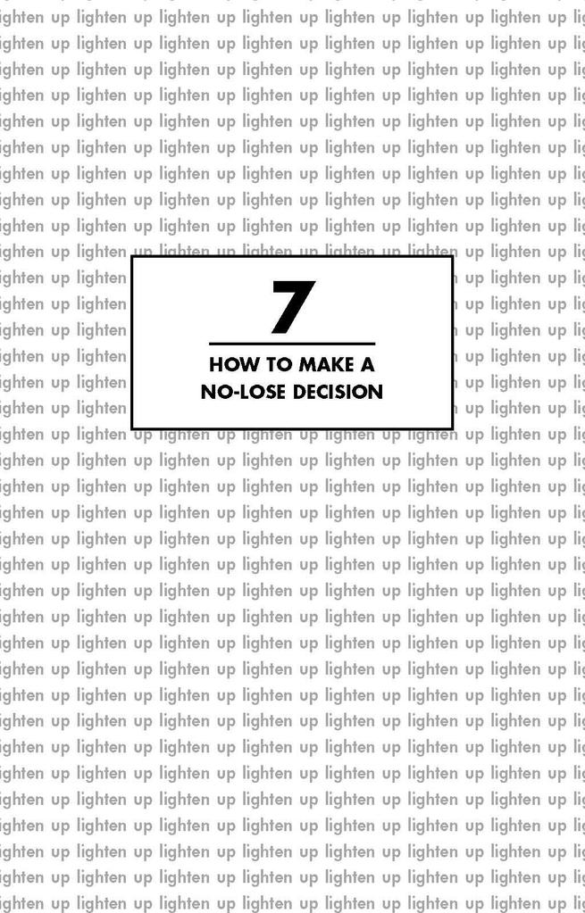

One of the biggest fears that keeps us from moving ahead with our lives is our difficulty in making decisions. As one of my students lamented, “Sometimes I feel like the proverbial donkey between two bales of hay— unable to decide which one I want, and, in the meantime, starving to death.” The irony, of course, is that by not choosing, we *are* choosing—to starve. We are choosing to deprive ourselves of what makes life a delicious feast.

The problem is that we have been taught “Be careful! You might make the wrong decision!” A *wrong* decision! Just the sound of that can bring terror to our hearts. We are afraid that the wrong decision will deprive us of something—money, friends, lovers, status, or whatever the *right* decision is supposed to bring us.

Closely tied to this is our panic over making mistakes. For some reason we feel we should be perfect, and forget that we *learn* through our mistakes. Our need to be perfect and our need to control the outcome of events work together to keep us petrified when we think about making a change or attempting a new challenge.

If the above describes you, I am going to demonstrate that you are worrying needlessly. There really is nothing to lose, only something to gain, whatever the choices you make or actions you take in life. As I stated earlier, *all you have to do to change your world is change the way you think about it.* This concept works beautifully here. You can actually shift your thinking in such a way as to make a wrong decision or mistake an *impossibility.* Let’s begin with decision making.

Suppose you are at a Choice Point in life. If you are like most of us, you have been taught to use the No-Win Model as you think about the decision to be made. The model looks like this:

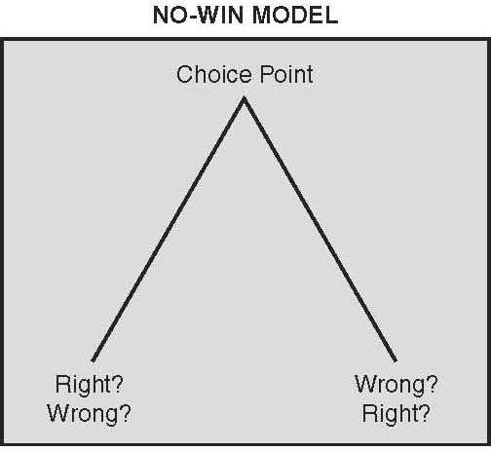

Your heart feels heavy about the choice you have to make. You feel somewhat paralyzed as you think about the consequences in life-and-death terms. You stand at the threshold of the decision, lamenting and obsessing: “Should I do this or should I do that? What if I go this way and that happens? What if it doesn’t work out the way I plan? What if . . . ”

The “what if”s are out in full force. The internal Chatterbox is at it again. You look at the unknown and try to predict the future; you try to take control of outside forces. Both are impossible. At this point you might notice that you are driving yourself crazy.

After the decision is made, the No-Win Model makes you constantly reassess the situation, hoping you didn’t make a mistake. You keep looking back and berating yourself with “If only I had . . . ” You waste valuable energy, and you also make yourself miserable.

You gain relief if the outcome is as you hoped it would be— but only temporarily. As you breathe a sigh of relief, you are already worrying that the situation might reverse itself and that it might *ultimately* prove to be the wrong decision. Furthermore, you are already fearful about the next decision you have to make, because you will have to go through the whole agonizing process once again. Look familiar? Crazy, isn’t it! Clearly, this is a no-win situation. But there is another way—the No-Lose Model.

Go back and stand at the Choice Point again. This time, the situation looks like this:

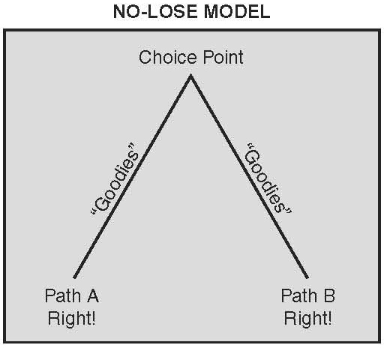

Notice that what lies ahead are simply two paths—A and B*—both of which are right*! Each path has nothing but “goodies” along the way. You are clearly facing a no-lose situation. And what are these goodies? They are opportunities to experience life in a new way, to learn and grow, to find out who you are and who you would really like to be and what you would like to do in this life.

Each path is strewn with opportunities*— despite the outcome.* “What? *Despite the outcome?*” Up to this point you may have been willing to go along with me, but those three words are making you a little dubious, if not downright resistant. “What if . . . ” comes up again in your thinking. Let me answer your “what if”s with an example.

Imagine you are faced with the choice of staying with your present job or taking a new one that has opened up for you. If you stand at the No-Win Choice Point, your Chatterbox takes over and craziness begins:

“If I stay here I might be missing a very good chance to move ahead. But if I go, maybe I won’t be able to handle my new responsibilities. What if I get fired on the new job, and then I have nothing? I really like it here. I’ll have more opportunity to move ahead on the new job. Maybe they’ll promote me and I’ll be making more money. But what if I regret leaving? What if . . .? Oh, I don’t know what to do! I could ruin my whole life if I make the wrong decision!”

If you stand at the No-Lose Choice Point, your “fearless” self takes over:

“Isn’t it fantastic! I’ve been offered a new job. If I take it, I’ll have an opportunity to meet new people, to learn new ways of doing things, to experience an entirely different work atmosphere and to broaden my base of experience.

If something happens and it doesn’t work out, I know I’ll handle it. Even though the job market is difficult right now, I know somehow I’ll find another job if I need one. Even that will be an interesting experience, since I’ll learn to deal with the loss of a job and learn to solve the problems that might come up if I am unemployed.

If I stay, I have an opportunity to deepen the contacts I have made here. I really feel better about myself having been offered the other job, so if I stay, perhaps I’ll ask for a promotion. If for some reason it doesn’t work out here, there will be other opportunities to pursue. It’s all an adventure, no matter which way I turn.”

I really do know people who think this way—and their approach to life is a joy to be around. They truly live in a no-lose world.

Alex is a perfect example. Now a practicing psychologist in Los Angeles, he originally intended to follow in his father’s footsteps and become a lawyer. His college grades were excellent, and he had no trouble getting into what was considered a fine law school. He studied hard and did very well the first two years. But the time spent away from home began making a difference in his personal priorities. He came to realize that he didn’t want to spend the rest of his life in the “combat zone,” as he called it, that being a lawyer required.

He wanted to help people in a different way, and he decided that clinical psychology was much more in line with his personality. He also realized that part of his decision to be a lawyer was his desire to please his father. But now he was much more in touch with the person inside himself, and he made the decision to leave law school and pursue a career in psychology. His father gave him his blessing but refused to pay any more of his college expenses, thus increasing the difficulty of the decision. But Alex trusted his gut and withdrew from a situation that did not suit his needs.

Some, including his father, saw those two years at law school as a waste of time, but Alex never saw it that way. By trying it out, he discovered that being a lawyer was not for him. Finding out what you *don’t* like is, paradoxically, as valuable as finding out what you do like. Also, while at law school he made a number of good friends, who remain his friends today. And the information he gathered from those first two years has helped him in many personal and professional situations since.

For Alex, the goodies didn’t end there. Since his father had stopped paying his expenses, he had to work for two years to obtain enough money to get started on his degree in psychology. Were those two years wasted? Not at all. His job with a construction company was doubly enriching: he was exposed to a different way of life, and, through one of his co-workers, he met the woman who became his wife. Finally, with a fellowship and his two part- time jobs, Alex was able to complete his doctorate.

This set of events was invaluable in terms of teaching Alex to take responsibility for his own life. Perhaps neither he nor his father realized it at the time, but his father really did him a favor by making him stand on his own two feet. Alex learned that if you want something badly enough, there is a way to get it. And if there was a way, he would find it. He knew that if he hadn’t been able to obtain a fellowship, he would have found another way. As a result, he approached future decisions with a feeling of power, energy, and excitement.

Remember that underlying all our fears is *a lack of trust in ourselves.* Each step that Alex took, *despite the outcome*, even when it meant loss of financial support and delay in his education, was an opportunity for him to learn to trust himself to provide for his own needs.

It’s interesting to me that when I present the No-Lose Model to my students, the resistance is initially very high. “Oh, come on, you’re not being realistic.”

As I said earlier, we have been taught to believe that negative equals realistic and positive equals unrealistic. When I challenge my students, they can’t find more credence in the No-Win Model than in the No- Lose Model, yet the latter can move us from a position of pain to one of power, which is ultimately our goal as we learn to deal with fear.

Another point to consider is that *it feels better to come from a no-lose position.* Why continue to resist coming from a no-lose position? Why continue to feel pain, paralysis, and depression? Yet we continue to do it until we incorporate into our being another way of seeing the world. Then we can slowly begin to change the no-win thinking that has kept us victimized.

A critical factor in your accepting the No-Lose Model is the way you think about outcomes and opportunities. It might be hard for you to accept the fact that losing a job is a no-lose situation. Traditionally, opportunities in life are thought of as relating to money, status, and the visible signs of “success.”

I’m asking you to think of opportunity in an entirely different light. The purpose of this book is to help you handle fear in a way that allows you to fulfill your goals in life. Every time you encounter something that forces you to “handle it,” your self-esteem is raised considerably. You learn to trust that you will survive, no matter what happens. And in this way your fears are diminished immeasurably.

**THE KNOWLEDGE THAT YOU CAN HANDLE ANYTHING THAT COMES YOUR WAY**

**IS THE KEY TO ALLOWING YOURSELF TO TAKE HEALTHY, LIFE-AFFIRMING RISKS.**

Getting back to my earlier example, if the outcome of your choosing to move to a new job is for you to lose that job within a few months, you now see how you will have the opportunity to strengthen your self-esteem by facing the storm, regrouping your inner forces, reaching out once again to find a new, perhaps more satisfying, position. In the meantime, you will be meeting new people and enlarging your world. Seen in this light, losing your job becomes a no-lose situation.

I have often said to my students that perhaps the “lucky” ones in life are those who have been forced to face things in their lives that we all hope we will never have to face—things such as losing a job, the death of a loved one, divorce, bankruptcy, illness. Once you have handled any of those things, you emerge a much stronger person.

I know of few people who have experienced loss and haven’t felt a large measure of pride in themselves at finding a way to make their lives work despite their adversity. They have discovered that *security is not having things; it’s handling things.* Thus, when you can answer all your “what if”s with “I can handle it,” you can approach all things with a no-lose guarantee, and the fear disappears.