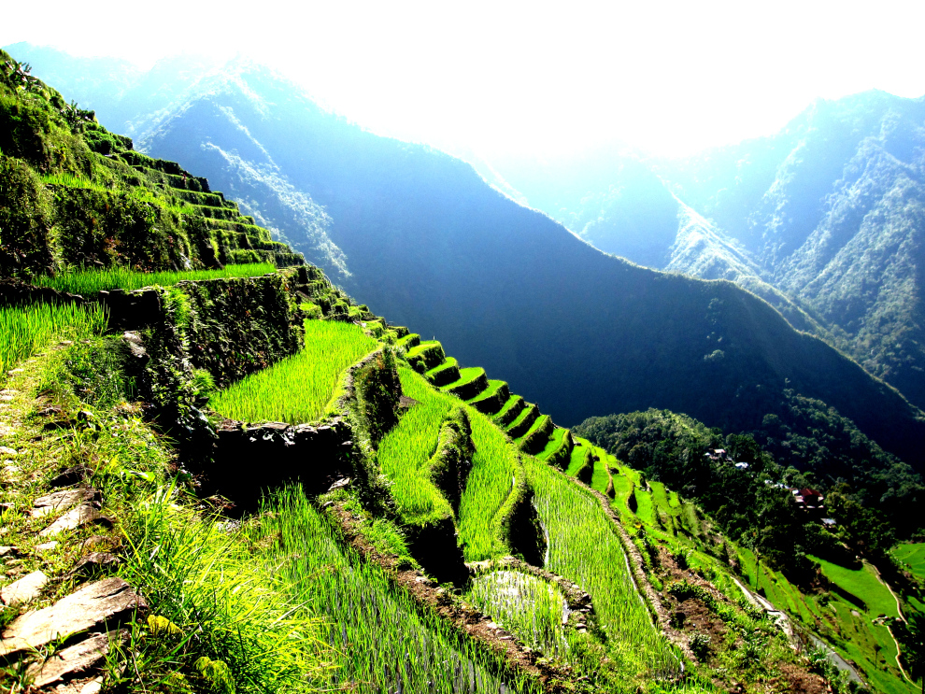

**BANAUE RICE TERRACES**

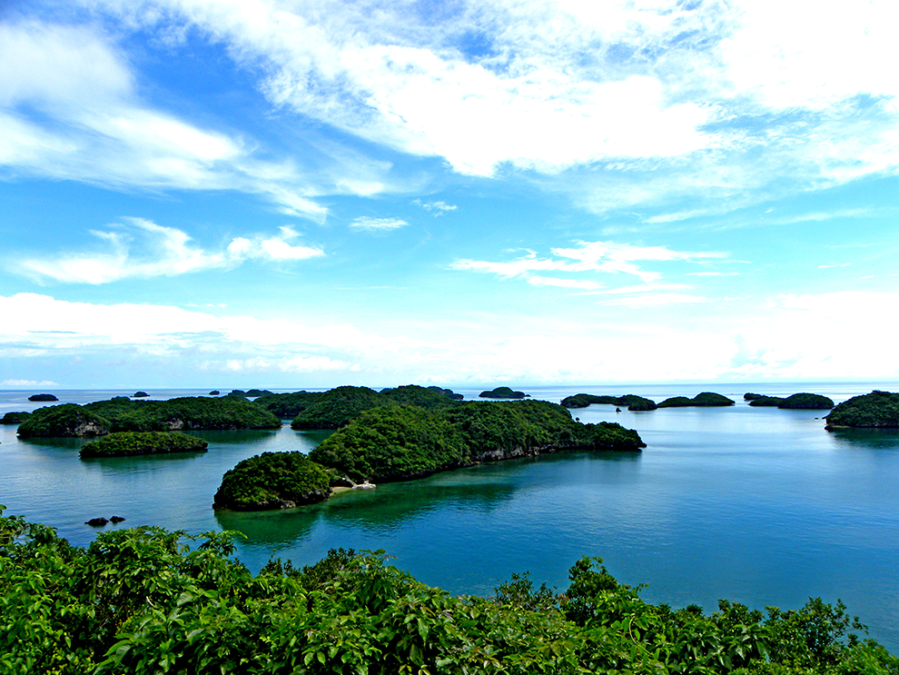

**HUNDRED ISLANDS**

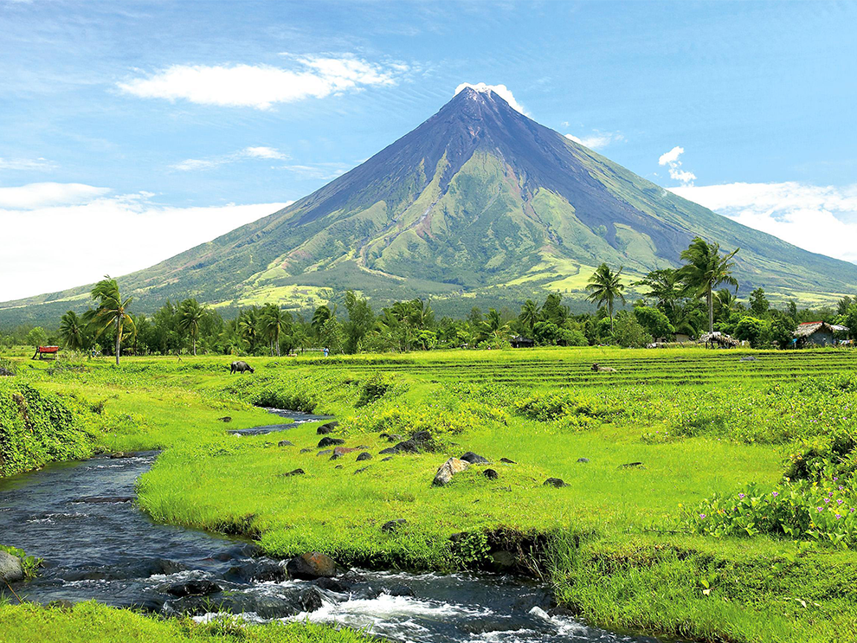

**MAYON VOLCANO**

**PHILIP IVAN L. DAGUM**

**GRADE II – ACACIA**

**S.Y. 2016 - 2017**