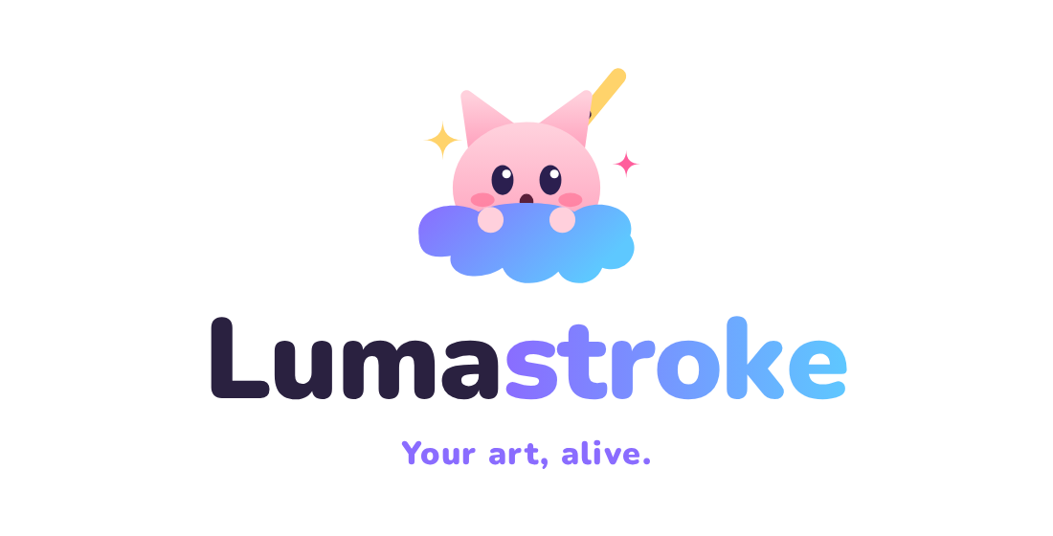
BUILD PLAN
Vision, design, features and roadmap for Lumastroke — a 2D art & animation studio
Version 1.0 · September 2026
148 planned features · 6 workspaces · 9 UI mockups · 6 logo concepts

Contents

Tip: if page numbers look out of date, right-click the table of contents in Word and choose "Update Field".

1. The Vision
Lumastroke in one sentence
A beautifully designed, feature-rich 2D art and animation program that feels as simple as Procreate, paints as realistically as Rebelle, runs as deep as SAI and Clip Studio Paint EX, and animates like Moho Pro, made for young artists who love anime-style drawing.

1.1 What Lumastroke is
Lumastroke is one studio for still art and animation. An artist can sketch a character, ink it, paint it with realistic watercolor or oils, lay it out as a manga page, and bring it to life, either frame by frame or with a bone rig, without ever leaving the app or exporting between programs.

1.2 Who it is for
- Primary: young artists (teens to early twenties) who draw anime and manga-style characters, fan art, OCs (original characters), comics, webtoons and short animations.
- Secondary: hobbyist and semi-pro illustrators, indie animators and VTuber-style creators who want painting and animation in one place.
- Mindset: they want art to look amazing fast, are willing to learn deeper tools over time, and care a lot about how the app looks and feels.

1.3 The promise
Inspiration | What Lumastroke takes from it
Procreate | Simplicity: a canvas-first layout, a handful of obvious tools, gestures, and nothing confusing on screen.
Rebelle | Realistic paint: wet watercolor that bleeds and blooms, thick oils, pigment mixing, paper texture, tilt, blow and dry.
PaintTool SAI | A precise, lightweight brush engine: stabilizer, Blending / Dilution / Persistence, linework layers, perspective rulers.
Clip Studio Paint EX | Comics and manga: pages, panels, balloons, tones, vector ink, 3D poses, and a pro frame-by-frame timeline.
Moho Pro | Rigged animation: bones, Smart Bones, switch layers, lip-sync, physics, meshes and a graph editor.

1.4 Design pillars
- Easy first, powerful always — Normal mode is calm and obvious. Advanced mode holds every tool. One toggle switches between them, and the artwork never changes.
- Beautiful by default — It is an art program, so it has to look like one: dark "studio glass" panels, a luminous accent gradient, and the artwork as the brightest thing on screen.
- Real media, real fast — Physical paint behavior with a GPU brush engine that keeps up with a fast pen.
- Made for anime artists — Line art, flats, cel shading, manga tones, speed lines, chibi rigs and lip-sync are first-class tools, not afterthoughts.
- Every device is a creative tool — Drawing pads of all kinds, microphones and cameras plug straight into the creative flow.
- Opens anything, exports anywhere — Wide import and export support so artists are never locked in.
- Playful and bright — Mochi the mascot, sparkles and a friendly tone, while staying out of the way when an artist is focused.

2. Brand Identity

2.1 Name, logo and slogan
 | Lumastroke  "Luma" (light) + "stroke" (a brush stroke): art that glows and moves.  Slogan: Your art, alive.  Logo: Mochi Splash. Mochi, a kawaii cat-eared mascot, pops out of a paint splash holding a stylus. Playful, bright and instantly "anime".

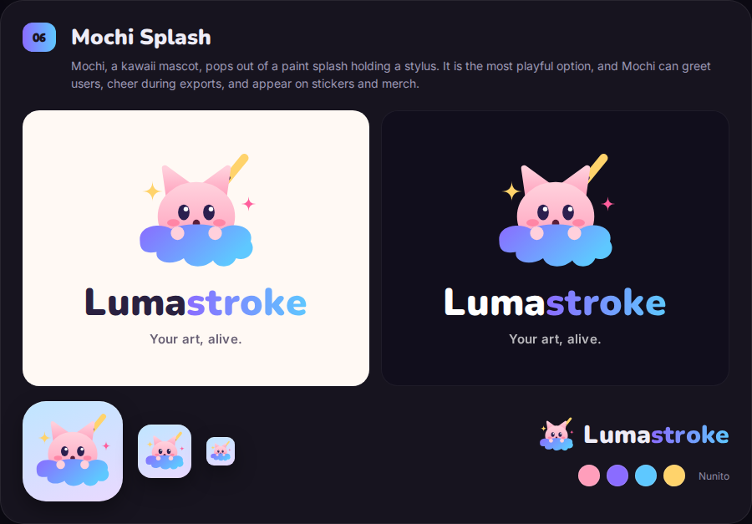
The chosen logo on light and dark backgrounds, as an app icon at three sizes, and as a horizontal lockup.

2.2 Alternate slogans
Keep these for campaigns, splash screens and merch:
- Draw it. Paint it. Make it move.
- Every frame, a spark.
- Sketch it. Color it. Animate it.
- Your story, frame by frame.
- Make your characters breathe.
- From first line to final frame.

2.3 Color palette
Swatch | Name | Hex | Used for
 | Mochi Pink | #FF9EBB | Mascot, warm highlights, merch
 | Luma Violet | #8A6CFF | Primary brand color, Advanced mode, links
 | Sky Splash | #5EC8FF | Wet paint indicators, capture, secondary accent
 | Sparkle Gold | #FFD36B | Sparkles, stars, celebration moments
 | Active Rose | #FF5E8A | The active tool, selections, playhead
 | Studio Ink | #16122B | Dark UI background
 | Paper | #FFF9F4 | Light "Paper" theme background

2.4 Typography
- Logo & playful headings — Nunito Black (rounded and friendly).
- Interface — Inter: clean, highly legible at small sizes, with tabular numbers for sliders.
- Numbers & code — JetBrains Mono, for timecodes and values.
- Comic lettering samples — Fredoka and Mochiy Pop One for SFX and balloon demos (final lettering fonts to be licensed).

2.5 Mochi the mascot
- Appears on the splash screen, in empty states ("No artworks yet, let's make one!"), in first-use tips in Normal mode, and when exports finish.
- Never blocks the canvas, and can be turned off with one tap.
- Future: stickers, merch, a sample rig included with the app so users can learn rigging on Mochi.

2.6 Logo exploration
Six directions were explored before choosing Mochi Splash. They are kept here for reference and possible secondary use, for example Kira Eye as an achievement badge.
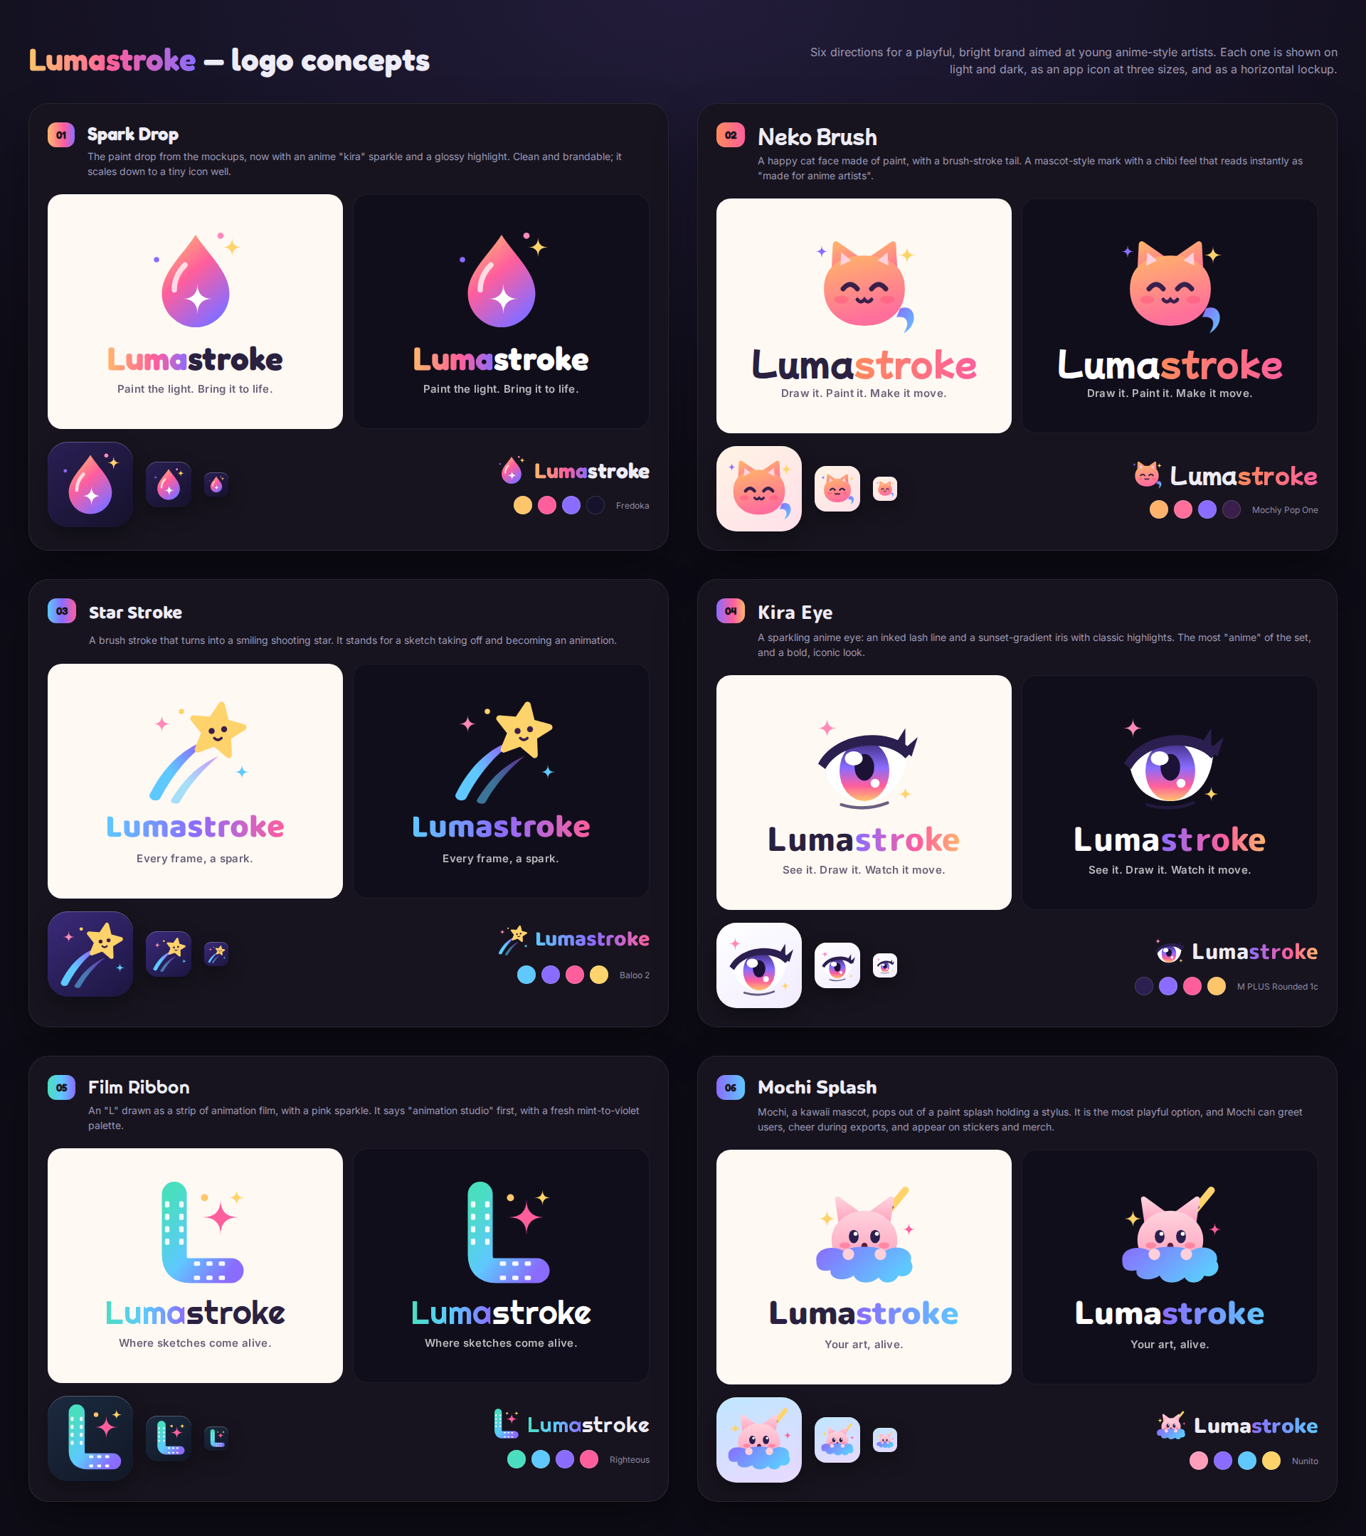
Logo concepts 01–06. Concept 06, Mochi Splash, was selected.

3. How Lumastroke Is Organized

3.1 Two modes, one document
Normal mode — the studio | Advanced mode — the workshop
A full-screen canvas. Across the top: Gallery, Actions, Adjust, Select and Transform on the left; Brush, Smudge, Eraser, Layers and Color on the right. Size and Opacity sliders on the left edge. The Quick Dock along the bottom.  Every feature marked "Normal" in this plan appears here as a simple, one-tap version. | A menu bar, the workspace tabs, a contextual options bar, docked panels (SAI / Clip Studio style), a tool grid, and a status bar showing the connected pen, microphone and camera.  Every setting and every tool. Panels can be moved, saved as workspaces and shared.

The placement rule
If a beginner has to understand a feature before using it, it lives in Advanced mode, and Normal mode gets a friendly preset of it. Example: SAI's three mixing settings become a single "Blend" slider in Normal mode.

3.2 The six workspaces
Workspaces are saved layouts of panels for a job. They are tabs in the top bar in Advanced mode, and they all share the same .LUMA file.
Icon | Workspace | Built for | Main panels
 | Paint | Illustration and realistic media | Brush, Color + Mixer, Layers, Paint Physics, Navigator
 | Ink & Comic | Line art, manga, webtoon | Pages, Story, Panels & Balloons, Tones, Vector, 3D Pose, Rulers
 | Animate | Frame-by-frame animation | Timeline / X-sheet, Onion skin, Light table, Camera, Audio
 | Rig & Motion | Bone-rigged animation | Bones, Smart Bones, Switch, Actions, Graph editor, Physics
 | Capture | Reference and recording | Camera, Voice, Scan, Face tracking, Devices
 | Share | Export and print | Formats, Print prep, Time-lapse, Render queue

3.3 Advanced mode menu bar
File · Edit · Canvas · Layer · Select · Paint · Filter · Comic · Animate · Rig · Capture · View · Window · Help

3.4 Feature map
The poster below shows every feature sorted by workspace, tagged with the program that inspired it, and marked ● Normal or ○ Advanced.
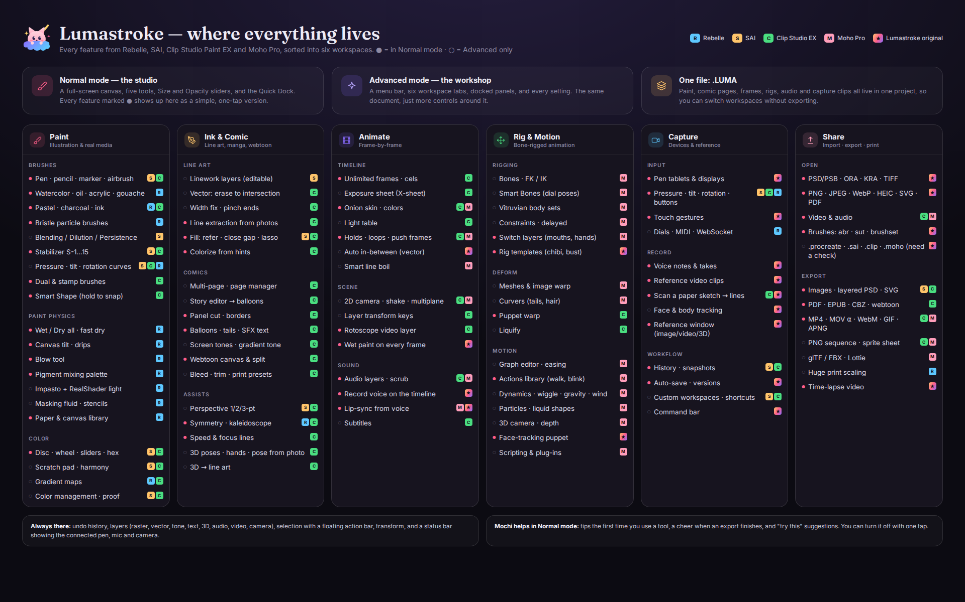
Feature map: where everything lives.

4. UI Mockups
These concept screens set the look and layout for Lumastroke. Each image is 1920 × 1200, and the full-size files are listed in Appendix A.

4.1 Normal mode — the studio (dark)
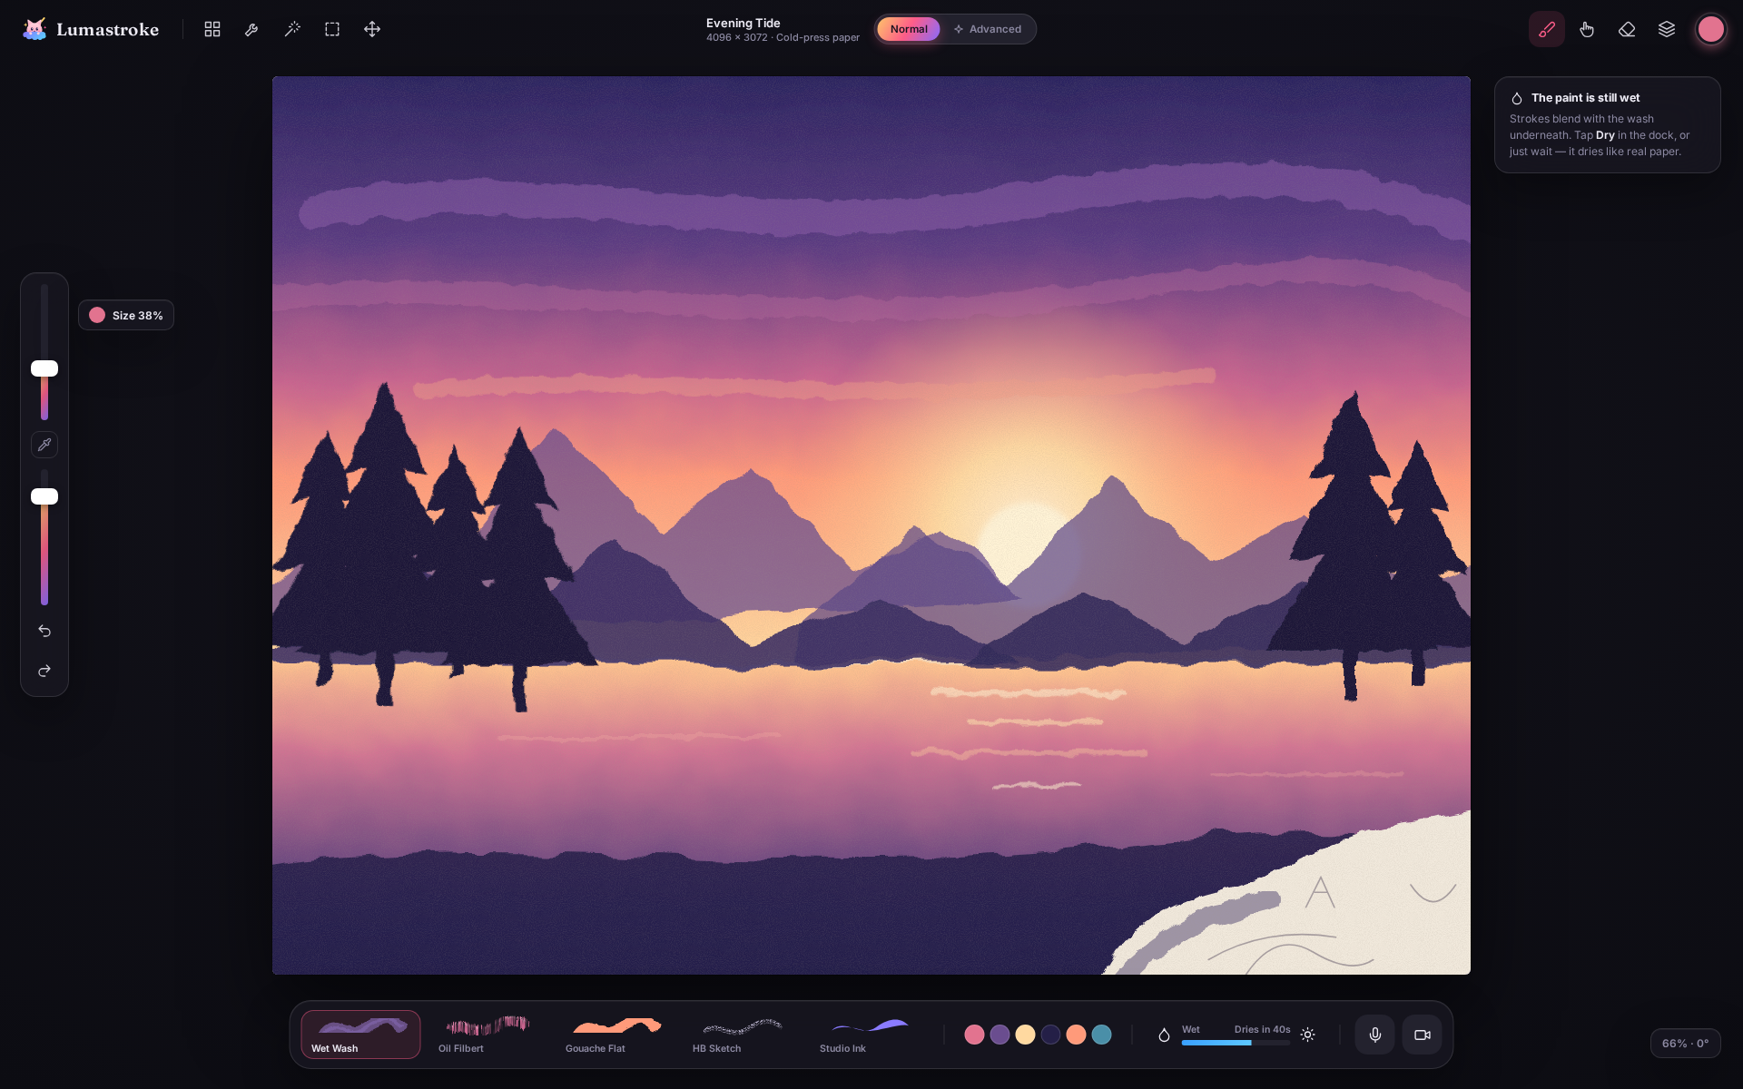
Mockup 01 — Normal mode — the studio (dark)
- The canvas fills the screen: the Procreate-style layout.
- Left edge: Size and Opacity sliders with an eyedropper button, plus undo and redo.
- Quick Dock: recent brushes shown as real strokes, color history, the Wet ↔ Dry meter, and mic and camera buttons.
- A friendly hint explains that the paint is still wet.

4.2 Normal mode — brush library & color
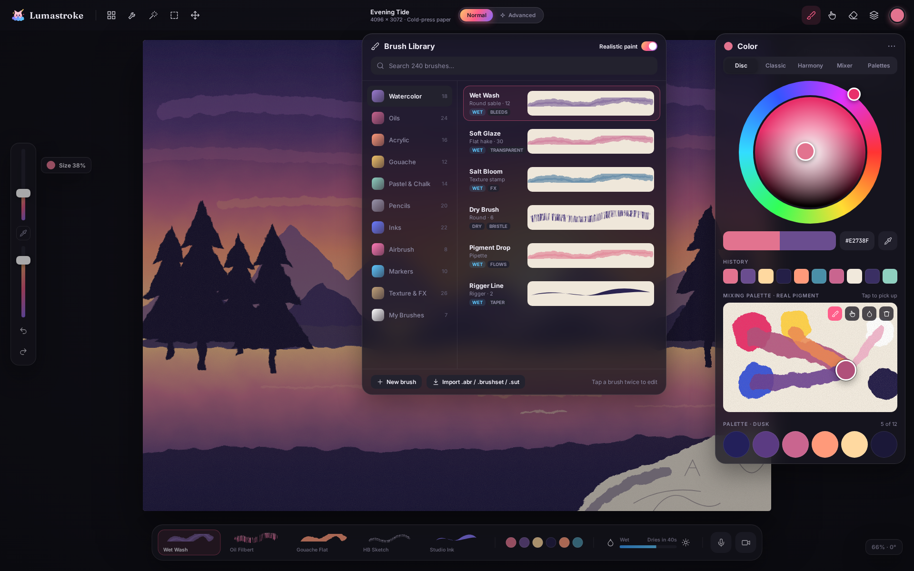
Mockup 02 — Normal mode — brush library & color
- Brush library with realistic stroke previews on paper, and tags such as WET, BLEEDS and BRISTLE.
- Color popover: a Procreate-style disc, history, and a Rebelle-style pigment mixing palette.
- A "Realistic paint" switch and brush import (.abr, .brushset, .sut).

4.3 Advanced — Paint workspace
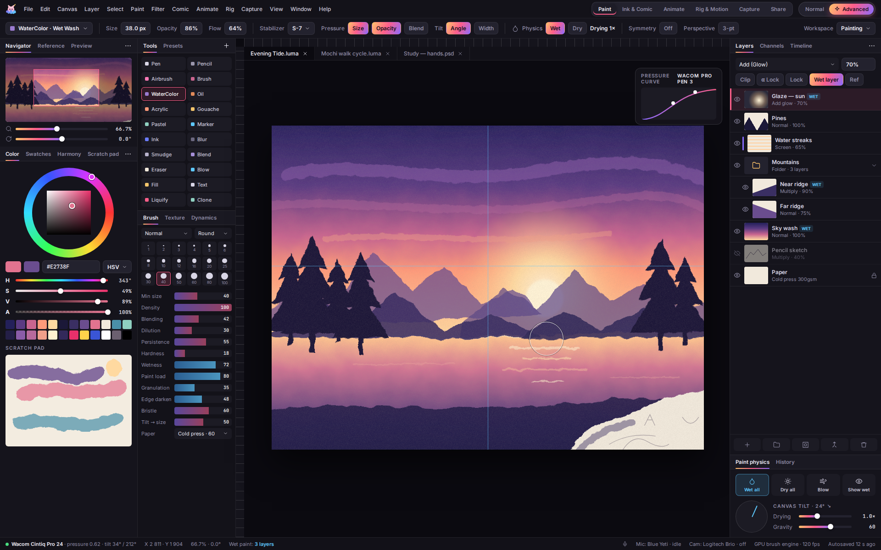
Mockup 03 — Advanced — Paint workspace
- SAI-style docks: Navigator, HSV wheel and sliders, swatches and scratch pad.
- Tool grid and brush-size dots; Blending, Dilution and Persistence plus Wetness, Paint load, Granulation and Edge darken.
- Layers with WET badges, clipping and folders; a Paint Physics panel (Wet all, Dry all, Blow, tilt dial).
- Workspace tabs and the Normal / Advanced toggle in the top bar.

4.4 Animate — frame-by-frame with voice & video
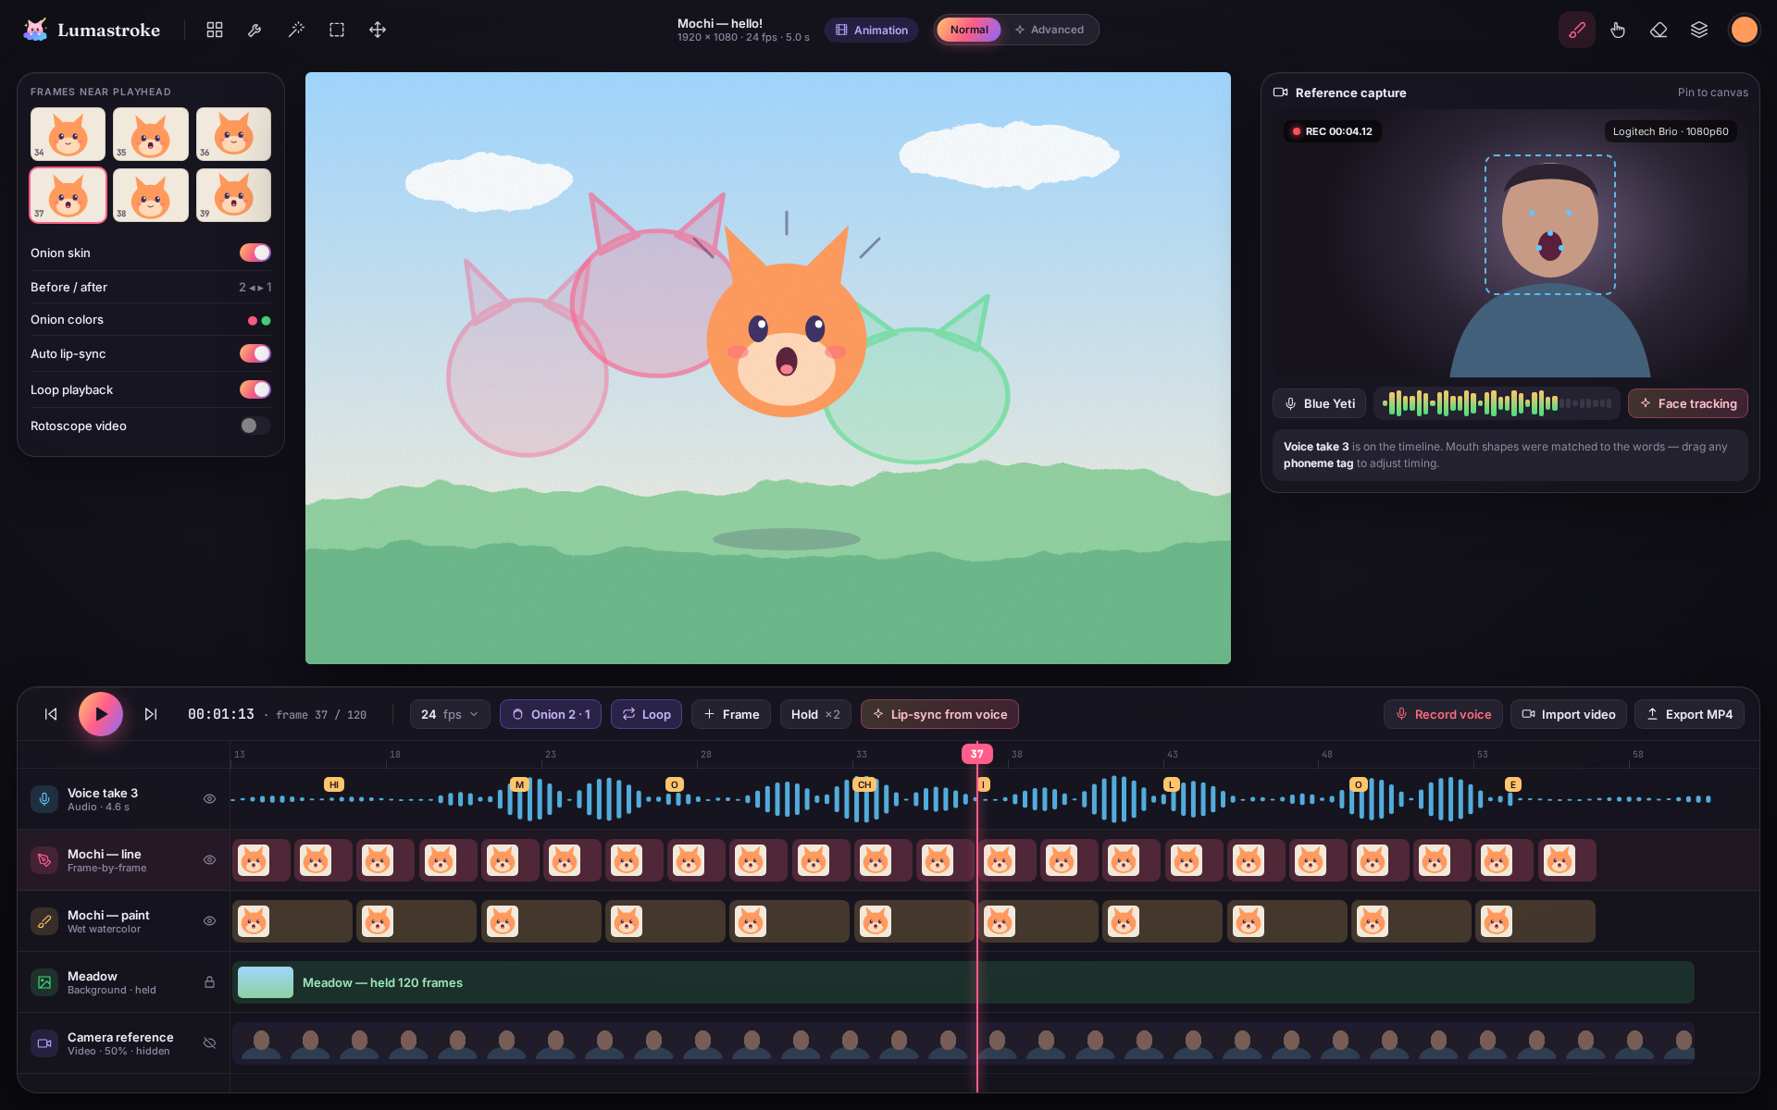
Mockup 04 — Animate — frame-by-frame with voice & video
- Onion skins in pink (before) and green (after).
- Timeline tracks: voice take with phoneme tags, line, paint, background and camera reference.
- Reference capture window with face tracking and a live mic meter.

4.5 Gallery, import & export
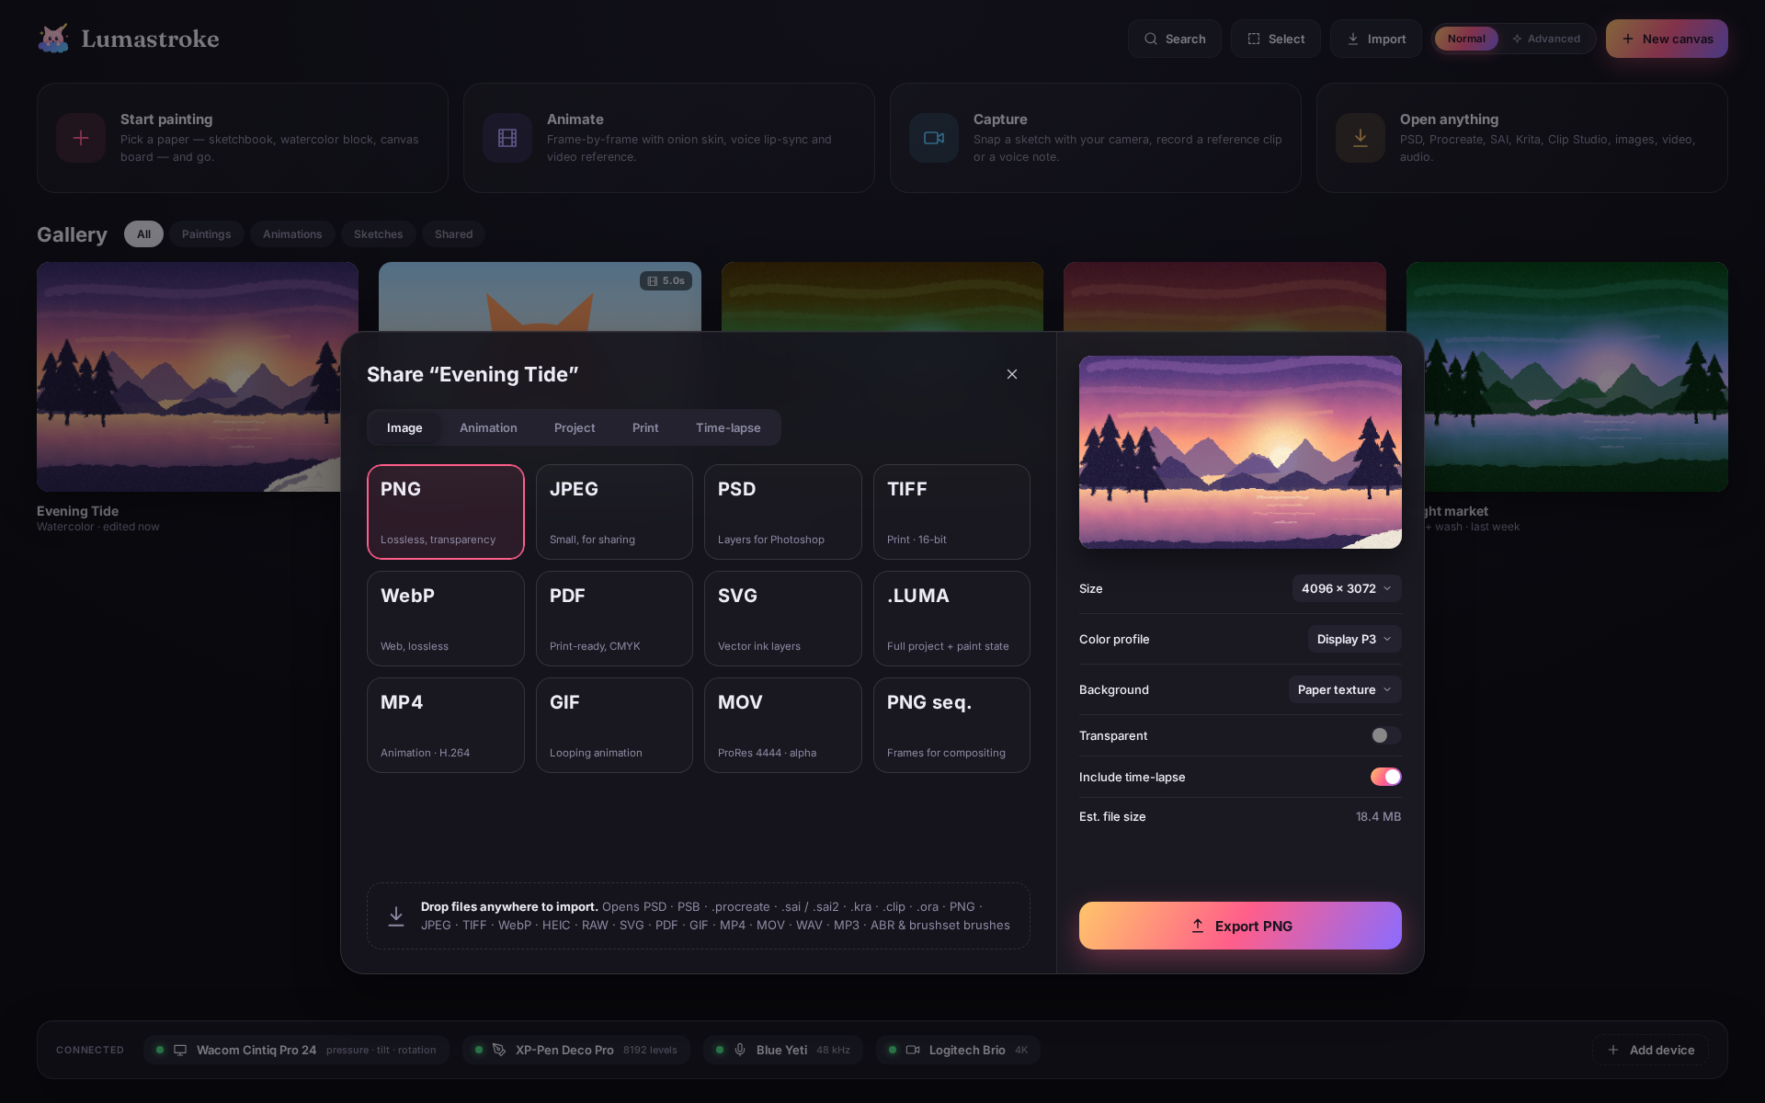
Mockup 05 — Gallery, import & export
- Home screen with Start painting, Animate, Capture and Open anything cards.
- Connected devices strip (tablets, microphone, camera).
- Share sheet with image, animation, project, print and time-lapse formats.

4.6 Normal mode — Paper (light) theme
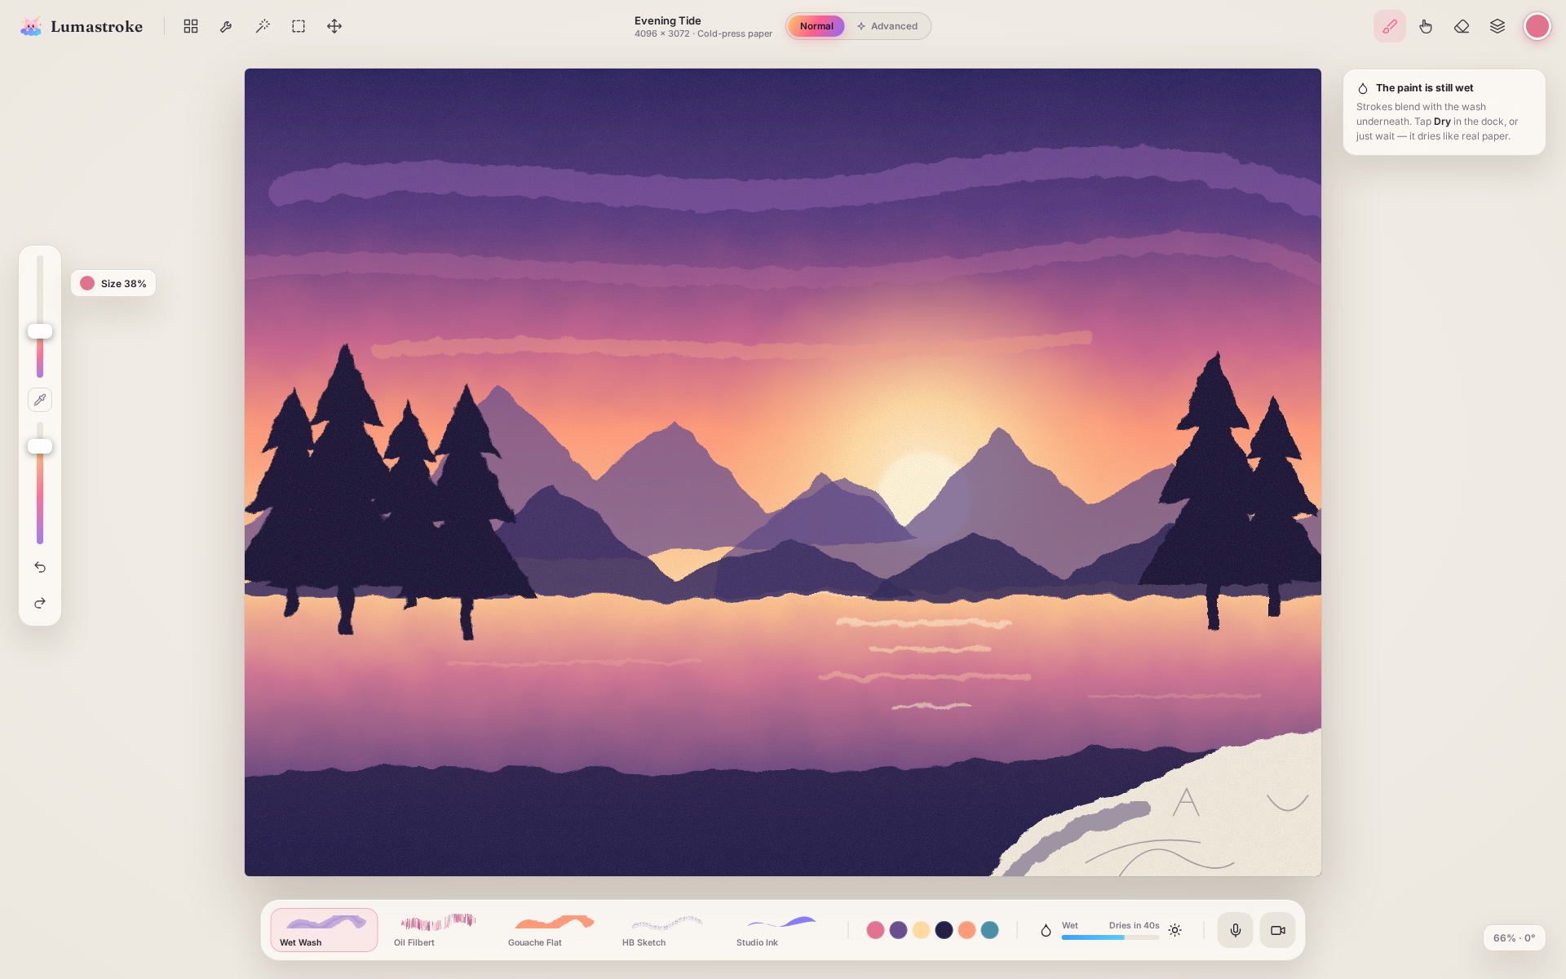
Mockup 06 — Normal mode — Paper (light) theme
- The same studio in a warm, light theme for daytime work.

4.7 Advanced — Ink & Comic workspace
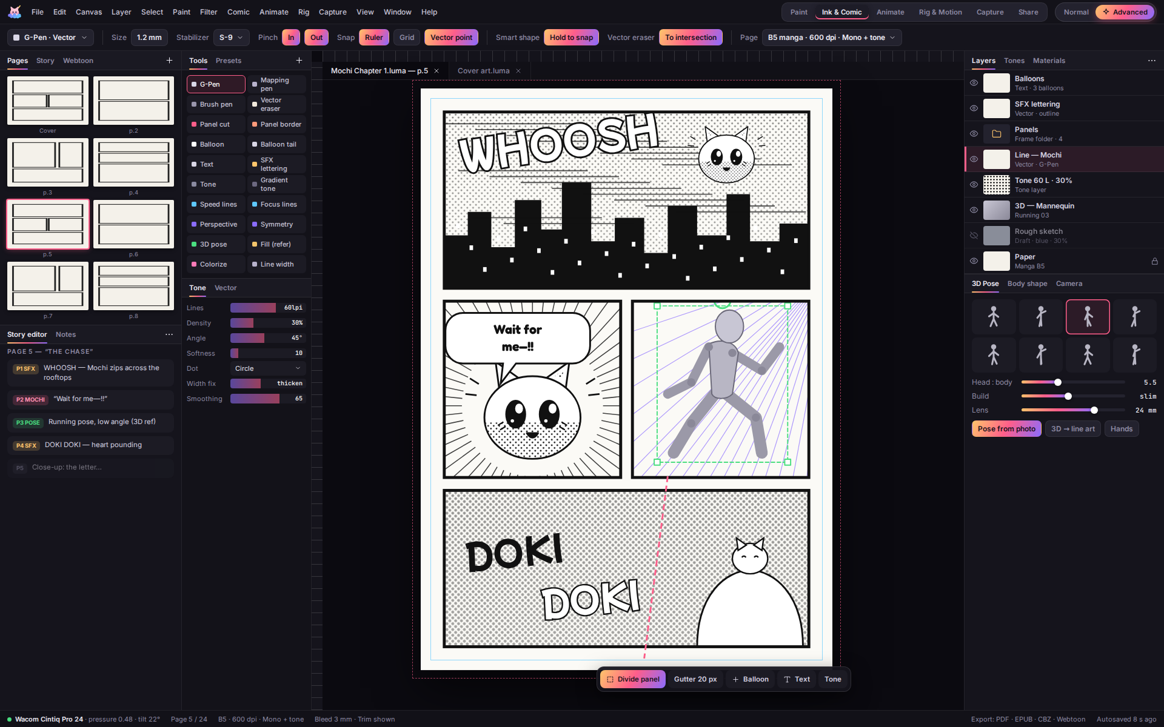
Mockup 07 — Advanced — Ink & Comic workspace
- Page manager and story editor on the left.
- Manga page with a vector G-pen, speed lines, speech balloons, SFX lettering and screen tones.
- 3D pose mannequin with perspective rulers; bleed and trim guides; a floating selection action bar.

4.8 Advanced — Rig & Motion workspace
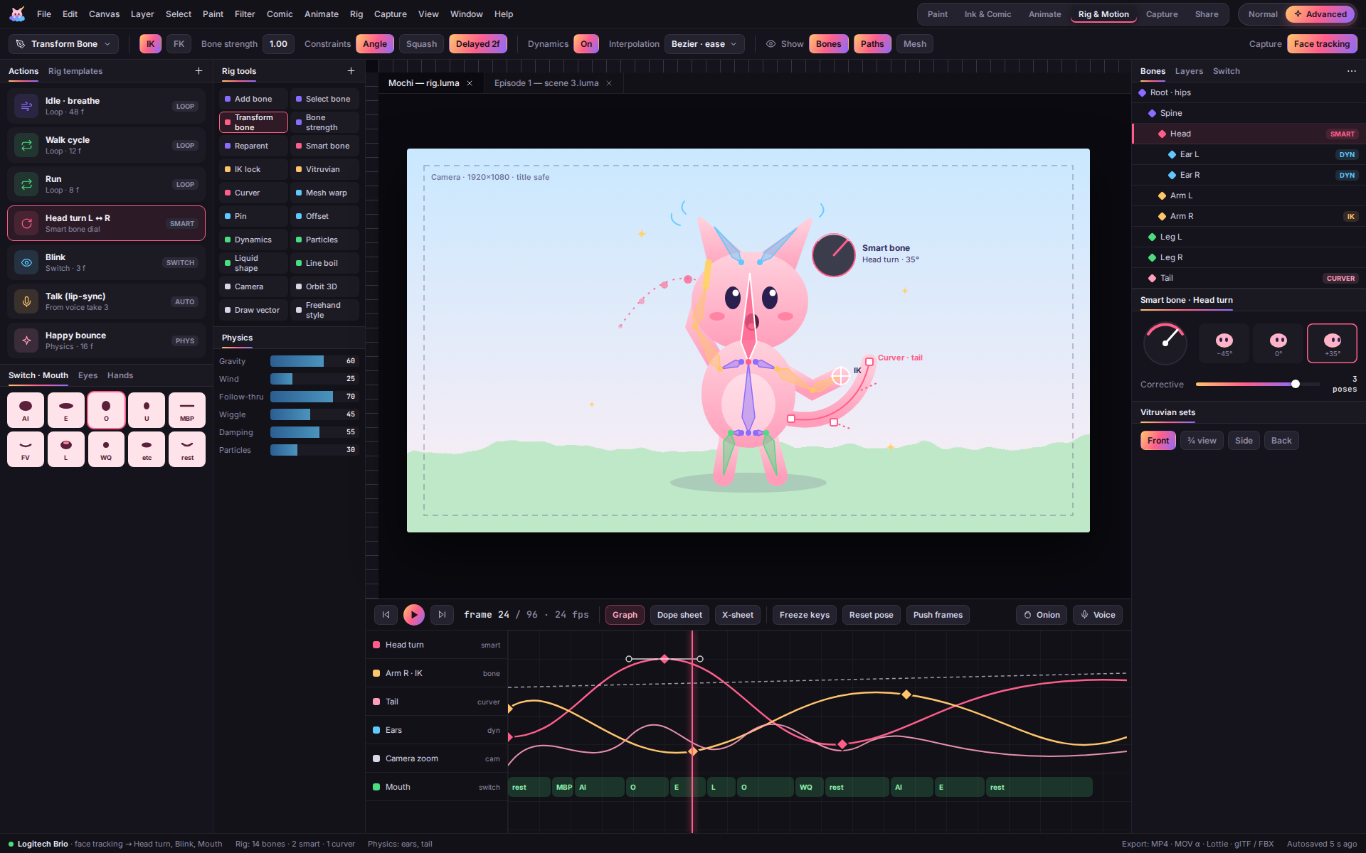
Mockup 08 — Advanced — Rig & Motion workspace
- Mochi rigged with FK/IK bones, a Smart Bone dial for head turns, a curver on the tail and dynamics on the ears.
- Actions library and switch-layer mouth shapes on the left.
- Graph editor with easing curves and an automatic lip-sync track.

5. Feature Catalog
All 148 planned features and abilities, grouped the way they appear in the app. Every feature has a proposed icon.
How to read the feature tables
Icon — the proposed toolbar / menu icon for that feature. Icons are tinted with their workspace color.
Inspired by — Rebelle · SAI · Clip Studio EX · Moho Pro · Lumastroke original.
Where it shows — Normal (in the simple studio), Normal (simple) (a one-tap version in Normal mode, full controls in Advanced), Advanced (Advanced mode only).

5.1 The Studio — modes & workspaces
How Lumastroke is organized: one calm Normal mode, one complete Advanced mode, and six workspaces that all share a single project file.

Modes
Icon | Feature | What it does | Inspired by | Where
 | Normal / Advanced toggle | One switch, always in the top center. It changes how much UI you see but never changes your artwork. | Lumastroke original | Normal
 | Normal mode studio | A full-screen canvas, five tools, Size and Opacity sliders, and the Quick Dock. Easy to learn in minutes. | Lumastroke original | Normal
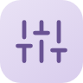 | Advanced mode workshop | Menu bar, docked panels, tool grid and every setting. Powerful, and allowed to feel busy. | Lumastroke original | Advanced
 | Quick Dock | Recent brushes, color history, the wet-paint meter, and one-tap mic and camera. | Lumastroke original | Normal
 | Mochi the guide | The mascot gives tips on first use, cheers when exports finish, and can be switched off. | Lumastroke original | Normal

Workspaces (Advanced tab strip)
Icon | Feature | What it does | Inspired by | Where
 | Paint workspace | Illustration and realistic media: brushes, color, mixer, layers and paint physics. | Lumastroke original | Advanced
 | Ink & Comic workspace | Line art, manga and webtoon: pages, panels, balloons, tones, rulers and 3D poses. | Lumastroke original | Advanced
 | Animate workspace | Frame-by-frame animation: timeline, X-sheet, onion skin, light table, camera and audio. | Lumastroke original | Advanced
 | Rig & Motion workspace | Bone-rigged animation: bones, Smart Bones, switch layers, graph editor and physics. | Lumastroke original | Advanced
 | Capture workspace | Camera, voice, scanning and face tracking for reference and performance. | Lumastroke original | Advanced
 | Share workspace | Export, print preparation, time-lapse and the render queue. | Lumastroke original | Advanced
 | One .LUMA project file | Paint, pages, frames, rigs, audio and clips all live in one file, so switching workspaces never needs an export. | Lumastroke original | Normal

5.2 Brushes & the brush engine
SAI-level precision with Rebelle-level realism and Clip Studio-level variety.

Brush families
Icon | Feature | What it does | Inspired by | Where
 | Pen, pencil, marker, airbrush | Clean, fast, anti-aliased basics for sketching and line art. | SAI, Clip Studio EX | Normal
 | Watercolor, oil, acrylic, gouache | Wet media that behave like real paint on real paper. | Rebelle | Normal
 | Ink, pastel, charcoal, crayon | Dry and ink media with texture that reacts to the paper grain. | Rebelle, Clip Studio EX | Normal
 | Bristle brushes | Every hair of the brush is simulated for lifelike oil and acrylic strokes. | Rebelle | Normal
 | Blur, smudge, blend | Soften and push color around, SAI style. | SAI, Clip Studio EX | Normal
 | Stamp & dual brushes | Sparkles, flowers, hair, lace, foliage and other decoration brushes. | Clip Studio EX | Normal

Control & feel
Icon | Feature | What it does | Inspired by | Where
 | Blending / Dilution / Persistence | SAI's color pickup model. Normal mode shows one "Blend" slider. | SAI | Normal (simple)
 | Stabilizer S-1 … S-15 | Smooths shaky lines, with speed-based and post-correction modes. | SAI, Clip Studio EX | Normal (simple)
 | Pressure / tilt / rotation curves | A curve editor for any brush setting, set per pen device. | SAI, Clip Studio EX, Rebelle | Advanced
 | Brush tips | Round, flat, filbert, fan, rigger or a custom image tip. | Rebelle, Clip Studio EX | Advanced
 | Brush texture | Paper grain per brush, with strength and scale. | SAI, Rebelle, Clip Studio EX | Advanced
 | Smart Shape | Hold at the end of a stroke to snap it into a clean line, curve or ellipse. | Clip Studio EX | Normal
 | Huge brushes | Brushes up to 3,000 px, with a fast preview mode. | Rebelle, Clip Studio EX | Advanced
 | Recent & favorite brushes | Your go-to brushes, always one tap away in the Quick Dock. | Rebelle | Normal
 | Brush Studio | Build and tune brushes on a test pad, with side-by-side A/B comparison. | Lumastroke original | Normal (simple)
 | Brush import | Bring in .abr, .sut, .brushset and .kpp brushes (each format needs a check first). | Lumastroke original | Normal

5.3 Real paint & physics
Rebelle-style wet-media simulation. This is the "wow" feature that makes Lumastroke paintings feel real.

Wet media
Icon | Feature | What it does | Inspired by | Where
 | Watercolor simulation | Diffusion, bleeding, backruns, blooms, granulation and edge darkening. | Rebelle | Normal
 | Wet-on-wet / wet-on-dry | Soft blends on wet paper and crisp edges on dry paper, automatically. | Rebelle | Normal
 | Dry / Wet all | Dry the whole canvas instantly, or re-wet it to keep blending. | Rebelle | Normal
 | Drying speed | Choose how long paint stays wet, from instant to never. | Rebelle | Normal (simple)
 | Canvas tilt | Tilt the paper so drips and runs follow gravity. | Rebelle | Normal (simple)
 | Blow tool | Blow wet paint across the canvas like a straw. | Rebelle | Normal
 | Show wet areas | Overlay that highlights paint that is still wet. | Rebelle | Advanced

Pigment, paper & light
Icon | Feature | What it does | Inspired by | Where
 | Pigment mixing | Real paint mixing: blue and yellow make green, not gray. | Rebelle | Normal
 | Mixing palette | A paint palette where you mix colors, then pick up the mixed result. | Rebelle | Normal
 | Impasto / thickness | Thick oil and acrylic that builds up physical relief. | Rebelle | Normal (simple)
 | Paint lighting (RealShader-style) | Light direction and soft shadows over thick paint. | Rebelle | Advanced
 | Paper & canvas library | Cold press, hot press, rough, canvas, kraft and toned papers, or import your own. | Rebelle | Normal
 | Masking fluid | A layer that resists paint and peels off later. | Rebelle | Normal (simple)
 | Stencils & tape | Moveable hold-down masks for clean edges. | Rebelle | Advanced
 | Wet paint on every frame | Real paint physics that works inside animation frames. | Lumastroke original | Normal

5.4 Color
Friendly color picking in Normal mode, and professional color control in Advanced mode.

Pick & manage
Icon | Feature | What it does | Inspired by | Where
 | Color disc & wheel | Procreate-style disc, HSV wheel, and RGB/HSL/CMYK sliders with hex input. | SAI, Clip Studio EX | Normal
 | Scratch pad | A doodle area for testing colors and strokes. | SAI | Advanced
 | Swatches & palettes | Build palettes, import from an image, and use .ase/.aco files. | Clip Studio EX, Lumastroke original | Normal
 | Color harmony | Complementary, triad and analogous suggestions. | Clip Studio EX | Normal (simple)
 | Eyedropper | Hold on the canvas to pick a color, including the mixed color. | SAI, Clip Studio EX | Normal
 | Color history | Recently used colors in the panel and the Quick Dock. | SAI, Clip Studio EX | Normal
 | Values check | Greyscale toggle for checking light and dark values. | SAI | Normal
 | Gradients & gradient maps | Editable gradient sets, available as a filter or a layer. | Rebelle, Clip Studio EX | Normal (simple)
 | Color management | sRGB, Display P3 and CMYK soft-proofing for print. | SAI, Clip Studio EX | Advanced

5.5 Layers, selection & transform
Layer and editing tools shared by every workspace.

Layers
Icon | Feature | What it does | Inspired by | Where
 | Layer types | Raster, vector, linework, paper, masking, tone, text, balloon, panel, 3D, audio, video and camera layers. | SAI, Clip Studio EX, Rebelle, Moho Pro | Normal (simple)
 | Folders | Group layers, and nest groups inside groups. | SAI, Clip Studio EX | Normal
 | Clipping & alpha lock | Paint only inside the layer below, or lock transparent pixels. | SAI, Clip Studio EX | Normal
 | Layer masks | Hide and show parts of a layer without erasing. | Clip Studio EX | Normal (simple)
 | Blend modes | 28 modes plus Add (Glow), Luminosity and Binary. | SAI, Clip Studio EX | Normal (simple)
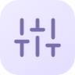 | Correction layers | Non-destructive Levels, Curves, HSL, Gradient Map and more. | Clip Studio EX, Rebelle | Advanced
 | Layer effects | Border outline, watercolor edge and tone effects. | Clip Studio EX | Advanced
 | Layer color & labels | Color-code layers, which helps with animation clean-up. | Clip Studio EX | Advanced

Select & transform
Icon | Feature | What it does | Inspired by | Where
 | Selection tools | Lasso, rectangle, ellipse, magic wand, selection pen and quick mask. | SAI, Clip Studio EX | Normal
 | Selection action bar | A floating bar of actions that appears under your selection. | Clip Studio EX | Normal
 | Transform | Move, scale, rotate, flip, distort and perspective. | SAI, Clip Studio EX | Normal
 | Mesh transform | Bend an image with a grid of points. | Clip Studio EX | Normal (simple)
 | Puppet warp | Pin points and bend limbs and poses like a marionette. | Clip Studio EX | Normal (simple)
 | Liquify | Push, twirl, pinch and bloat pixels. | Clip Studio EX | Normal (simple)
 | Smooth scaling | High-quality resizing without blurry edges. | Rebelle | Advanced
 | History & snapshots | Unlimited undo, a history panel and named snapshots. | SAI, Clip Studio EX | Normal

5.6 Ink & Comic
Clip Studio EX-class tools for manga, comics and webtoons.

Line art
Icon | Feature | What it does | Inspired by | Where
 | Linework layers | Strokes stay editable: move points and change line weight after drawing. | SAI | Normal (simple)
 | Vector eraser | Erase a line back to where it crosses another line. | Clip Studio EX | Advanced
 | Line width fix & pinch ends | Thicken, thin and taper lines after you draw them. | Clip Studio EX | Advanced
 | Line extraction | Turn a photo or scanned sketch into clean line art. | Clip Studio EX | Normal (simple)
 | Smart fill | Fill using other layers as a guide, close gaps, and lasso fill. | SAI, Clip Studio EX | Normal
 | Colorize from hints | Scribble hint colors and flats fill in automatically. | Clip Studio EX | Normal (simple)

Comics & manga
Icon | Feature | What it does | Inspired by | Where
 | Multi-page projects | A page manager with spreads and page reordering. | Clip Studio EX | Normal (simple)
 | Story editor | Write the script once and it flows into the speech balloons. | Clip Studio EX | Advanced
 | Panel cutting | Cut and divide panels with gutters, or start from a template. | Clip Studio EX | Normal (simple)
 | Speech balloons & tails | Round, spiky, thought and flash balloons. | Clip Studio EX | Normal
 | SFX lettering | Big, bold sound-effect text such as WHOOSH and DOKI DOKI. | Clip Studio EX | Normal
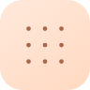 | Screen tones | Dot, line and noise tones, plus gradient tones. | Clip Studio EX | Normal (simple)
 | Webtoon canvas | Tall scrolling canvas with automatic splitting for upload. | Clip Studio EX | Normal
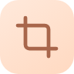 | Bleed & trim | Print-safe guides and presets for manga, US comic and A4. | Clip Studio EX | Advanced
 | Team pages | Assign pages to people and leave review notes. | Clip Studio EX, Lumastroke original | Advanced

Drawing assists
Icon | Feature | What it does | Inspired by | Where
 | Perspective rulers | One-, two- and three-point perspective grids that lines snap to. | SAI, Clip Studio EX | Normal (simple)
 | Symmetry | Mirror, radial and kaleidoscope drawing. | Rebelle, Clip Studio EX | Normal
 | Speed & focus lines | Instant manga action and focus lines. | Clip Studio EX | Normal
 | Special rulers | Concentric, parallel and curve rulers. | Clip Studio EX | Advanced
 | Grids & guides | Snap to a grid or to guide lines. | Clip Studio EX | Normal (simple)
 | 3D pose models | Posable figures and hands with body-shape sliders, including pose from a photo. | Clip Studio EX | Normal (simple)
 | 3D objects & line conversion | Place 3D props and backgrounds, then convert them to line art. | Clip Studio EX | Advanced
 | Reference window | Pin an image, video or 3D model beside the canvas. | Lumastroke original | Normal

5.7 Animate (frame-by-frame)
Traditional hand-drawn animation, with voice and video built in.

Timeline
Icon | Feature | What it does | Inspired by | Where
 | Timeline & cels | Unlimited frames, organized into animation folders. | Clip Studio EX | Normal
 | Exposure sheet (X-sheet) | Pro studio timing sheet view. | Clip Studio EX | Advanced
 | Onion skin | See the frames before and after, with custom colors and counts. | Clip Studio EX, Moho Pro | Normal
 | Light table | Trace from any frame or drawing. | Clip Studio EX | Normal (simple)
 | Holds, loops, ping-pong | Timing tools including hold ×2 and push frames. | Clip Studio EX, Moho Pro | Normal
 | Auto in-between | Generates in-between drawings for vector lines. | Lumastroke original | Advanced
 | Smart line boil | A hand-drawn "wobble" effect on still frames. | Moho Pro | Normal (simple)

Scene, sound & video
Icon | Feature | What it does | Inspired by | Where
 | 2D camera | Pan, zoom, rotate, shake and multiplane depth. | Clip Studio EX, Moho Pro | Normal (simple)
 | Transform keyframes | Animate position, scale, rotation and opacity. | Clip Studio EX | Normal (simple)
 | Rotoscoping | Import video and draw over it frame by frame. | Clip Studio EX | Normal (simple)
 | Audio layers | Import music and sound effects, and scrub audio as you drag. | Clip Studio EX, Moho Pro | Normal
 | Record voice | Record voice takes straight onto the timeline. | Lumastroke original | Normal
 | Lip-sync from voice | Mouth shapes are matched to the words automatically. | Moho Pro, Lumastroke original | Normal
 | Subtitles | Add captions to animations and videos. | Clip Studio EX | Normal (simple)

5.8 Rig & Motion
Moho Pro-class rigged animation, so a character can move without redrawing every frame.

Rigging
Icon | Feature | What it does | Inspired by | Where
 | Bones (FK / IK) | A skeleton for a character, with inverse kinematics for arms and legs. | Moho Pro | Advanced
 | Smart Bones | A dial bone that drives corrective poses, such as head turns and hand shapes. | Moho Pro | Advanced
 | Vitruvian Bones | Swap whole body setups (front, ¾ and side) on the fly. | Moho Pro | Advanced
 | Constraints | Angle, squash and delayed constraints for natural follow-through. | Moho Pro | Advanced
 | Switch layers | Swap drawings for mouths, eyes and hands. | Moho Pro | Normal (simple)
 | Rig templates | Ready-made rigs for chibi, bust and full-body anime characters. | Lumastroke original | Normal

Deform & motion
Icon | Feature | What it does | Inspired by | Where
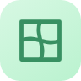 | Meshes & image warp | Bend painted artwork smoothly. | Moho Pro | Advanced
 | Curvers | Bend tails, hair, snakes and tentacles along a curve. | Moho Pro | Advanced
 | Graph editor | Bezier, ease, bounce and elastic motion curves. | Moho Pro | Advanced
 | Actions library | Reusable walk, run, blink, talk and idle cycles. | Moho Pro | Normal (simple)
 | Dynamics & physics | Follow-through, wiggle, gravity, wind and collisions. | Moho Pro | Normal (simple)
 | Particles | Sparkles, petals, rain and snow emitters. | Moho Pro | Advanced
 | Liquid shapes | Organic fire, smoke and water effects. | Moho Pro | Advanced
 | 3D camera & depth | Layer depth, orbit and parallax. | Moho Pro | Advanced
 | Face-tracking puppet | Drive a rigged character's face from your webcam. | Lumastroke original | Normal
 | Scripting & plug-ins | Automate tasks and extend Lumastroke. | Moho Pro | Advanced

5.9 Capture & devices
Every drawing pad, microphone and camera works as a first-class creative tool.

Input devices
Icon | Feature | What it does | Inspired by | Where
 | Pen tablets & displays | Wacom, XP-Pen, Huion, Apple Pencil (via Sidecar) and Surface Pen, with per-device curves. | Lumastroke original | Normal
 | Pressure, tilt, rotation, buttons | Full pen data mapped to any brush setting. | SAI, Clip Studio EX, Rebelle | Normal
 | Touch gestures | Two-finger undo, pinch to zoom and rotate, and hold for the eyedropper. | Lumastroke original | Normal
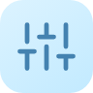 | Dials & MIDI controllers | TourBox-style dials and MIDI knobs mapped to tools. | Lumastroke original | Advanced
 | Remote control input | WebSocket control for live performance and installations. | Rebelle | Advanced

Recording & reference
Icon | Feature | What it does | Inspired by | Where
 | Voice notes & takes | Record ideas, dialogue and sound effects. | Lumastroke original | Normal
 | Reference video | Record reference clips (poses, motion) from any camera. | Lumastroke original | Normal
 | Scan a paper sketch | Photograph a sketch and get clean line art. | Clip Studio EX, Lumastroke original | Normal
 | Face & body tracking | Tracks face and body for rigs and pose reference. | Lumastroke original | Normal (simple)

5.10 Files, export & sharing
Opens almost anything and exports to wherever the art needs to go.

Import
Icon | Feature | What it does | Inspired by | Where
 | Native .LUMA | The full project: layers, wet paint state, pages, frames, rigs and audio. | Lumastroke original | Normal
 | Images | PSD/PSB, ORA, KRA, TIFF, PNG, JPEG, WebP, HEIC, BMP, GIF, SVG and PDF. | Lumastroke original | Normal
 | Video & audio | MP4, MOV, WebM, WAV, MP3 and AAC. | Clip Studio EX, Moho Pro | Normal
 | Other apps' files | .procreate, .sai/.sai2, .clip and .moho are goals; each needs a legal and technical check first. | Lumastroke original | Advanced

Export
Icon | Feature | What it does | Inspired by | Where
 | Image export | PNG, JPEG, WebP, 16-bit/CMYK TIFF, layered PSD and SVG. | SAI, Clip Studio EX | Normal
 | Comic export | Multi-page PDF, EPUB, CBZ and webtoon strips. | Clip Studio EX | Normal
 | Animation export | MP4, MOV with alpha, WebM, GIF, APNG, PNG sequence and sprite sheets. | Clip Studio EX, Moho Pro | Normal
 | Game & web export | glTF/FBX for game engines and Lottie for the web. | Moho Pro | Advanced
 | Print scaling | Upscale up to 20× for large prints, plus print presets. | Rebelle | Advanced
 | Time-lapse | Every painting records its own process video. | Lumastroke original | Normal

5.11 Everyday comfort
The details that make an app pleasant to use every day.

Workflow & care
Icon | Feature | What it does | Inspired by | Where
 | Auto-save & versions | Never lose work, and roll back to any earlier version. | Lumastroke original | Normal
 | Shortcuts & workspaces | Custom keyboard shortcuts and saved panel layouts. | SAI, Clip Studio EX | Advanced
 | Command bar | Type to find any tool or action. | Lumastroke original | Advanced
 | Themes | Dark studio and warm "Paper" light theme, with adjustable UI scale. | Lumastroke original | Normal
 | Performance | GPU brush engine and canvases up to 100,000 px. | SAI | Normal
 | Lessons | Interactive tutorials and "What's this?" hover cards. | Lumastroke original | Normal
 | Accessibility | Screen reader labels, high-contrast theme, color-blind-safe UI and a left-hand layout. | Lumastroke original | Normal
 | Community | Share brushes, palettes and workspaces with other artists. | Lumastroke original | Normal (simple)

6. Devices & File Formats

6.1 Supported hardware
Device | Support
Pen tablets & pen displays | Wacom, XP-Pen, Huion and Gaomon via Windows Ink / WinTab and macOS tablet events; Apple Pencil via Sidecar; Surface Pen. Pressure, tilt, rotation, barrel buttons and eraser end, with per-device pressure curves.
Touch | Pinch zoom and rotate, two-finger undo, three-finger redo, hold for eyedropper, palm rejection.
Controllers | TourBox-style dials, MIDI controllers and a WebSocket remote-control API.
Microphones | Any system mic; 48 kHz recording for voice takes, sound effects and voice notes.
Cameras | Webcams and phone cameras for reference clips, sketch scanning, and face and body tracking.

6.2 Import & export
Direction | Formats
Open / import | .LUMA (native), PSD/PSB, ORA, KRA, TIFF, PNG, JPEG, WebP, HEIC, BMP, GIF, SVG, PDF, MP4/MOV/WebM, WAV/MP3/AAC, brushes (.abr, .sut, .brushset). Goals, each needing a check first: .procreate, .sai/.sai2, .clip, .moho.
Export — image | PNG, JPEG, WebP, TIFF (16-bit / CMYK), layered PSD, PDF, SVG (vector layers)
Export — animation | MP4 (H.264/H.265), MOV (ProRes 4444 with alpha), WebM, GIF, APNG, PNG/TGA sequence, sprite sheet
Export — comics | Multi-page PDF, EPUB, CBZ, webtoon strips
Export — rigs | glTF / FBX for game engines, Lottie for the web
Time-lapse | An automatic process recording, exported as MP4

7. Technology Plan
A proposed architecture, built for speed with a pen, realistic paint on the GPU, and long-term growth into animation and rigging. The engineering team should confirm these choices during Phase 0.
Layer | Proposed technology | Why
Core engine | C++20, a tile-based canvas (256 px tiles), tile-delta undo | Performance and memory control for huge canvases (up to 100,000 px).
GPU rendering | Vulkan / Metal / Direct3D 12 through one abstraction (e.g. Qt RHI or wgpu-native); compute shaders | Brush dabs, blending and paint physics run on the graphics card.
UI & pen input | Qt 6 (QML) with custom-styled components | Mature, cross-platform pen tablet support (pressure, tilt, rotation) and a fully custom look.
Paint physics | GPU fluid simulation for watercolor (shallow-water / lattice methods); Kubelka–Munk pigment mixing; height-map impasto with lighting | Proven research approaches for realistic wet media and color mixing.
Vector & text | Skia; HarfBuzz + FreeType | High-quality vector lines, balloons and lettering.
Animation & rigs | In-house timeline, bone and mesh-deform system; Lua scripting | Frame-by-frame and rigged animation in one data model.
Audio & lip-sync | miniaudio for audio; Rhubarb Lip Sync (MIT license) for phoneme detection | Record, scrub and auto-lip-sync voice takes.
Video | FFmpeg (LGPL build) | Import reference video, and export MP4/MOV/WebM/GIF.
Tracking | MediaPipe face and pose models (Apache 2.0) run on the device | Face-tracking puppet and pose-from-photo, with no uploads.
Color | LittleCMS | ICC color management and CMYK soft-proofing.
3D poses | glTF models, a lightweight 3D viewport | Posable mannequins, hands and props.
File format | .LUMA = a ZIP container with a JSON manifest, compressed tiles, vector data, timeline, rig and audio | Robust, versioned, easy to inspect and recover.

7.1 Platforms
- Launch: Windows 10/11 and macOS (Apple silicon and Intel), where drawing-tablet users are.
- Next: iPad (Apple Pencil) and Android tablets, reusing the same core engine.
- Later: Linux.

8. Build Roadmap
Lumastroke combines what four professional apps do, so it has to be built in phases. Each phase ships something artists can use. The timeline assumes a core team of about 6–10 people; a smaller team stretches it.
# | Phase | When | What gets built | Milestone
0 | Foundations | Months 0–3 | Engine prototype: tiled canvas, GPU brush dabs, pen input (pressure/tilt), layers, undo, .LUMA v0. UI design system in code. | Internal tech demo
1 | Core Studio | Months 3–9 | Normal mode + Advanced Paint workspace; SAI-style brush engine and stabilizer; color disc, wheel and palettes; selection and transform; PSD/PNG/JPEG I/O; Quick Dock; Mochi tips; gallery. | Private alpha (drawing and painting)
2 | Real Paint | Months 9–14 | Watercolor simulation, wet/dry, drying, tilt, blow; pigment mixing palette; paper library; impasto and lighting; masking fluid. | Closed beta
3 | Animate & Capture | Months 12–18 | Timeline, onion skin, light table, 2D camera; audio layers and voice recording; lip-sync; reference camera and sketch scan; MP4/GIF export; time-lapse. | Lumastroke 1.0 public launch
4 | Ink & Comic | Months 18–24 | Vector and linework layers, smart fill, colorize; pages, story editor, panels, balloons, SFX; tones; perspective and special rulers; 3D pose models; webtoon; PDF/EPUB/CBZ. | Lumastroke 1.5
5 | Rig & Motion | Months 24–32 | Bones (FK/IK), Smart Bones, Vitruvian sets, switch layers; meshes and curvers; graph editor; dynamics and particles; face-tracking puppet; rig templates; glTF/Lottie export. | Lumastroke 2.0
6 | Everywhere | Month 30+ | iPad and Android apps, community sharing (brushes, palettes, rigs), plug-ins and scripting API, localization (Japanese, Korean, Spanish, Portuguese and more). | Ongoing

Why launch 1.0 after Phase 3?
Painting, realistic media and simple animation with voice lip-sync already make a complete, exciting product for young anime artists. Comics (1.5) and rigging (2.0) then become big free or paid upgrades that bring people back.

8.1 Suggested team
Role | When | Focus
Tech lead / graphics engineer | Phase 0 | Engine architecture, GPU pipeline, performance
Engine engineers (×2) | Phase 0 | Canvas, layers, file formats, undo, brush engine
UI engineer | Phase 0 | Qt/QML interface, Normal/Advanced modes, workspaces
Product / UI designer | Phase 0 | Design system, icons, mockups to final UI, usability tests
Simulation engineer | Phase 1 | Watercolor, pigment mixing, impasto (GPU compute)
Brush & content artist (anime style) | Phase 1 | Default brushes, papers, palettes, templates, tutorials, Mochi art
QA engineer | Phase 1 | Tablet and device lab, regression testing, performance budgets
Animation & rig engineer | Phase 3 | Timeline, audio, lip-sync, bones, meshes, physics
Community manager | Phase 2 | Beta program, Discord, feedback loop with young artists

8.2 Quality targets
- Pen latency under 10 ms from stylus to pixels on recommended hardware.
- A steady 120 fps canvas while painting on 4K canvases; physics running at 60 fps or more.
- Canvases up to 100,000 px, with a cold start in under 3 seconds.
- Crash-safe: auto-save every 30 seconds, with version history.
- Normal mode usability goal: a new user paints and exports a first picture in under 5 minutes, without a tutorial.

9. Risks, Legal & Privacy
Risk | How we handle it
Scope is huge | Phased roadmap; each phase ships on its own; Advanced-only features can slip without blocking launch.
Paint-physics performance | GPU-first design from Phase 0, a fast preview mode for big brushes, and hardware tiers with automatic quality settings.
Copying other apps | Lumastroke implements capabilities, not copies: its own code, UI, icons, brushes, names and art. No competitor brush files or assets ship with the app.
Proprietary file formats | .procreate, .sai, .clip, .moho and .rebelle import each need a legal review and a technical feasibility check before being promised.
Patents & licenses | Freedom-to-operate review for paint-simulation techniques; only permissively licensed libraries (MIT, BSD, Apache, LGPL-dynamic); avoid non-commercial licenses.
Young users & privacy | Voice, camera and face tracking are processed on the device and never uploaded by default. Clear permission prompts, and a COPPA/GDPR-K-aware sign-up if accounts or sharing are added.
Hardware variety | A dedicated tablet and device test lab (Wacom, XP-Pen, Huion, Apple Pencil, Surface) plus public beta feedback.

10. Next Steps
☐ Confirm the name "Lumastroke": check trademark availability and register domains and social handles.
☐ Finalize the Mochi logo with a professional illustrator (vector master, app icon set, mascot poses).
☐ Validate the vision with 10–20 young anime artists: show the mockups and gather feedback.
☐ Hire or contract the Phase 0 team (tech lead, 2 engine engineers, UI engineer, designer).
☐ Build the Phase 0 engine prototype: pen latency, GPU brush dabs, tiled canvas.
☐ Commission legal review of file-format import and paint-simulation IP.
☐ Turn the icon proposals in Section 5 into a final, consistent icon set.

Appendix A — Asset Inventory
Everything created for Lumastroke so far. The paths are relative to the lumastroke/ folder in the Star-Writer repository (branch claude/beautiful-goldberg-3fatam).
Asset | File(s) | Notes
Mockups | mockups/01-normal-studio-dark.png … 09-feature-map.png | 9 UI screens at 1920 × 1200
Mockup sources | mockups/src/*.mjs | HTML/SVG generators that re-render every screen
Logos | branding/00-logo-concepts-overview.png, 01–06-logo-*.png | Six logo concepts; 06 Mochi Splash chosen
Logo sources | branding/src/build.mjs | Vector (SVG) logo marks and the concept sheet generator
Feature spec | FEATURES.md | Markdown version of the feature list
Feature icons | docs/build-plan/assets/icons/*.png | 148 proposed feature icons (plus workspace variants)
Cover art | docs/build-plan/assets/cover-logo.png, mochi-mark.png | Mochi logo lockup and standalone mark
This document | docs/Lumastroke-Build-Plan.docx | The build plan, generated by docs/build-plan/build-doc.mjs

A.1 Workspace icon set
The six workspace icons, shown in their workspace colors:
Paint | Ink & Comic | Animate | Rig & Motion | Capture | Share

Appendix B — Research Sources
The feature research drew on public product pages, manuals, release notes and news coverage:
- Escape Motions — Rebelle 8: What's New; Rebelle 8 release notes; Rebelle manuals (v7–8.1); CG Channel, "Escape Motions releases Rebelle 8.3" (2026); Digital Production, "Rebelle 8" (2025).
- SYSTEMAX — PaintTool SAI product pages; Paint Tool SAI 2 documentation; Wikipedia, "PaintTool SAI".
- Celsys — Clip Studio Paint Ver. 4.0 and 5.0 announcements; "New features up to Ver. 5.0"; EX vs PRO feature differences; Clip Studio Tips, "Page manager and story editor".
- Lost Marble — Moho Pro 14 product page and features; Moho 14.2 and 14.4 updates; Cartoon Brew, "Moho 14 is out now"; Vitruvian Bones tutorial.

