Piper Cub 40: XFLR5 Modelling and Aerodynamic Analysis
Independent project by Billal Noor
Prepared for public release on GitHub

Project summary
This report documents the reconstruction of a Piper Cub 40 (oz13332) model in XFLR5, the assignment of mass and inertia properties, aerodynamic polar studies, and an assessment of elevator, aileron, and rudder effectiveness. A companion MATLAB script estimates the mass of representative ribs, spars, stabilising surfaces, and fuselage frames from the preserved XFLR5 airfoil coordinate file.

1. Project overview

1.1 Aircraft selection
The Piper Cub 40 (oz13332) was selected because its conventional high-wing layout, accessible plan drawings, and straightforward balsa/plywood construction make it suitable for a transparent modelling study. The aircraft is an approximately 18% scale radio-controlled interpretation of the Piper J-3 Cub.

1.2 Principal characteristics
Parameter | Value used in the model
Configuration | High-wing monoplane
Wingspan | 1,902.6 mm
Wing area | 0.515 m²
Wing type | Flat-bottom section with slight dihedral
Fuselage | Conventional balsa/plywood box structure
Controls | Ailerons, elevator and rudder
Nominal total mass | 4.0 kg

1.3 Materials and propulsion assumptions
The model is represented as a lightweight wooden structure using balsa, plywood and pine members, with local reinforcement where required. The original configuration references a four-channel radio installation, an OS FS-48 Surpass four-stroke engine and a Pitts-style muffler. These component references are contextual; the aerodynamic model depends primarily on geometry, mass placement and operating conditions.

2. Geometry reconstruction in XFLR5
Dimensions were taken from the Piper Cub 40 plan and transferred into XFLR5. The plan was scaled using known dimensions and a 100 mm reference grid. The wing, horizontal tail, vertical tail and fuselage representation were then checked in plan, front, side and perspective views before analysis.
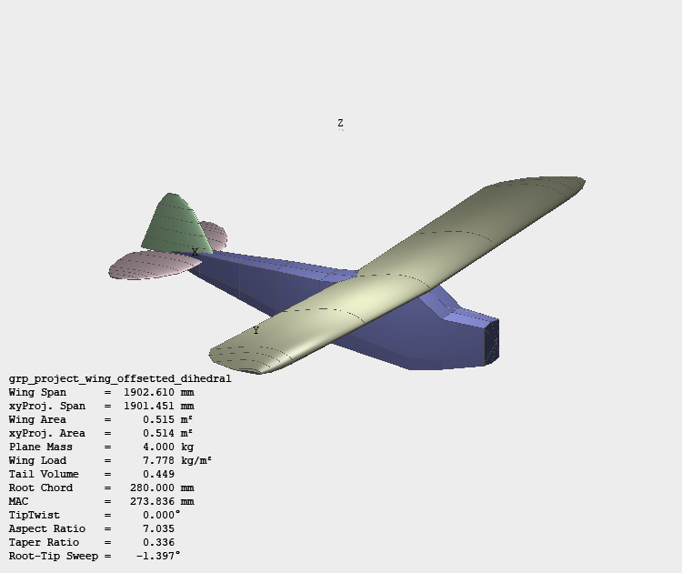
Figure 1. Reconstructed aircraft model in XFLR5.
The resulting model captures the principal lifting surfaces and their relative positions. It is intended for comparative aerodynamic analysis rather than detailed structural certification.

3. Airfoil data
The repository preserves the XFLR5 airfoil coordinate file under its original filename, `R3_GRP_PROJECT(1).dat`. The companion MATLAB script reads this file directly and ignores its first-line airfoil name before processing the coordinate pairs.
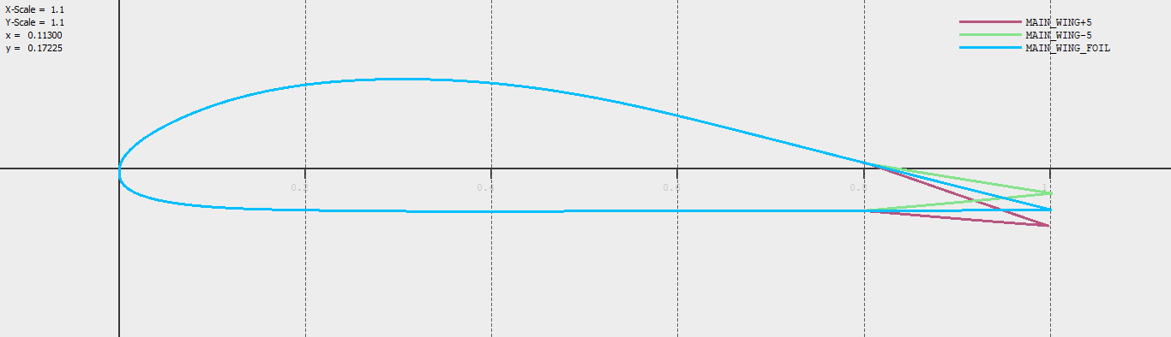
Figure 2. Airfoil geometry displayed in XFLR5.

4. Mass and inertia model

4.1 Mass breakdown
Component | Assigned mass
Radio equipment | 0.60 kg
Fuselage | 1.20 kg
Horizontal tail | 0.20 kg
Vertical tail | 0.10 kg
Propeller | 0.10 kg
Engine | 0.50 kg
Landing gear | 0.30 kg
Main wing | 1.00 kg
Total | 4.00 kg
The component masses were entered as distributed or point masses at representative physical locations. This produced a total mass of 4.0 kg and a centre of gravity approximately 183 mm aft of the selected model origin, with the vertical coordinate approximately 40 mm below the origin. The values are model inputs and should be replaced with measured masses for a built aircraft.
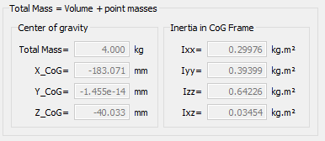
Figure 3. XFLR5 mass, centre-of-gravity and inertia summary.
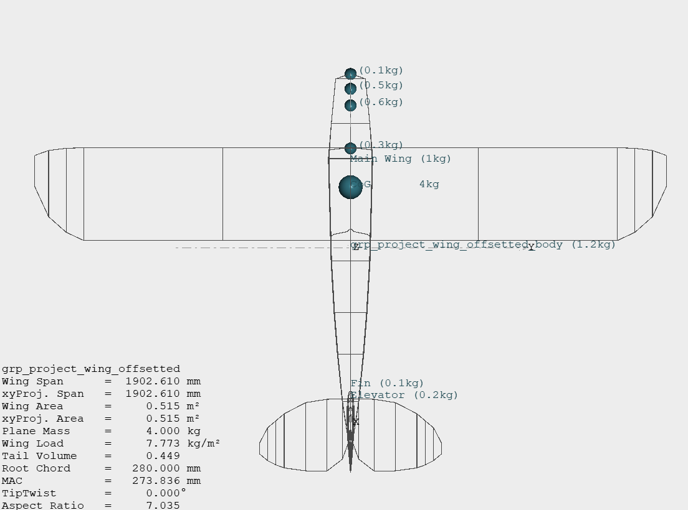
Figure 4. Assigned mass distribution in the XFLR5 model.

5. Airfoil batch analysis
A batch analysis was used to compare the main-wing section with a NACA 0009 section across a range of Reynolds numbers and angles of attack. The plot set includes lift, drag, pitching-moment and efficiency trends.
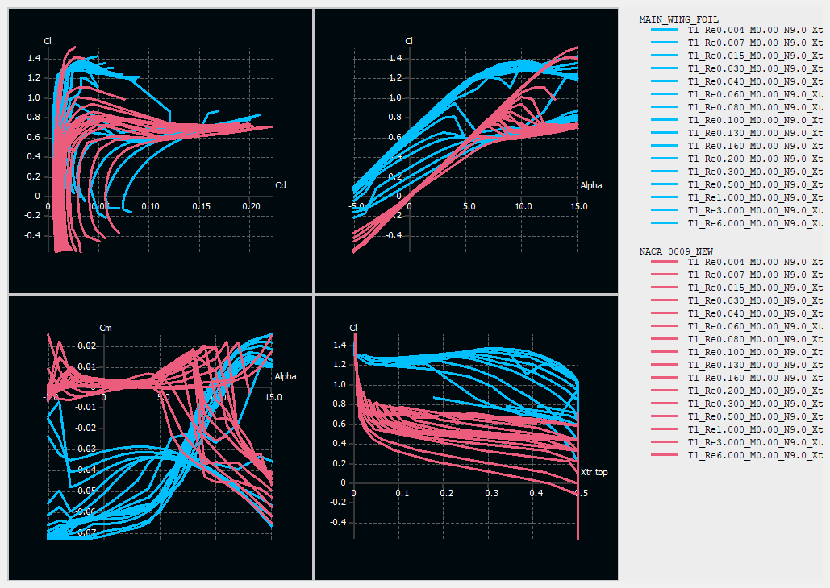
Figure 5. XFLR5 batch-analysis polar plots.
- The NACA 0009 result set develops greater lift at the upper end of the analysed angle-of-attack range and appears to retain attached flow for longer in this simulation.
- The main-wing section shows stronger lift-to-drag performance in part of the lower-drag operating range, which is relevant to cruise efficiency.
- Increasing Reynolds number generally improves the predicted polar by increasing lift capability and reducing the relative influence of viscous drag.
These observations are limited by the selected solver, transition assumptions, panel density and convergence quality. The curves should be treated as comparative simulation outputs rather than direct flight-test results.

6. Whole-aircraft aerodynamic analysis

6.1 Derived wing characteristics
Quantity | Value
Span | 1,902.6 mm
Area | 0.515 m²
Mass loading | 7.77 kg/m²
Aspect ratio | 7.035
Mean aerodynamic chord | 273.836 mm

6.2 Dihedral comparison
The analysed configurations with and without dihedral show broadly similar longitudinal trends. Around the modelled trim region, the zero pitching-moment condition occurs near an angle of attack of approximately 1 degree and corresponds to a lift coefficient of roughly 0.4. The no-dihedral case shows a small performance advantage in portions of the plotted polar, while the dihedral case is expected to offer a lateral-stability benefit that is not fully represented by a simple longitudinal comparison.
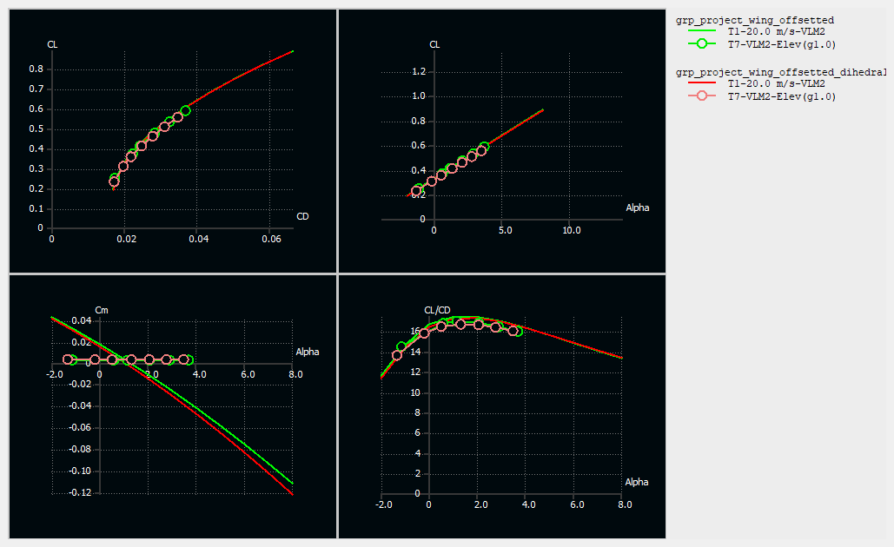
Figure 6. Aerodynamic comparison of the dihedral configurations.
The original graph interpretation included values labelled as lift-to-drag ratio that appear inconsistent with the plotted scale. For publication, the figure is retained but those values are not presented as validated numerical conclusions. Any quoted optimum should be re-read directly from the exported XFLR5 data.

7. Control-surface effectiveness

7.1 Elevator
The elevator-deflected case shifts the pitching-moment curve relative to the clean configuration. This demonstrates that elevator input provides the expected pitch-control authority and changes the trim condition. A shallower or shifted moment curve should not be interpreted on its own as improved static stability; static stability is determined primarily by the derivative of pitching moment with respect to angle of attack around the operating point.
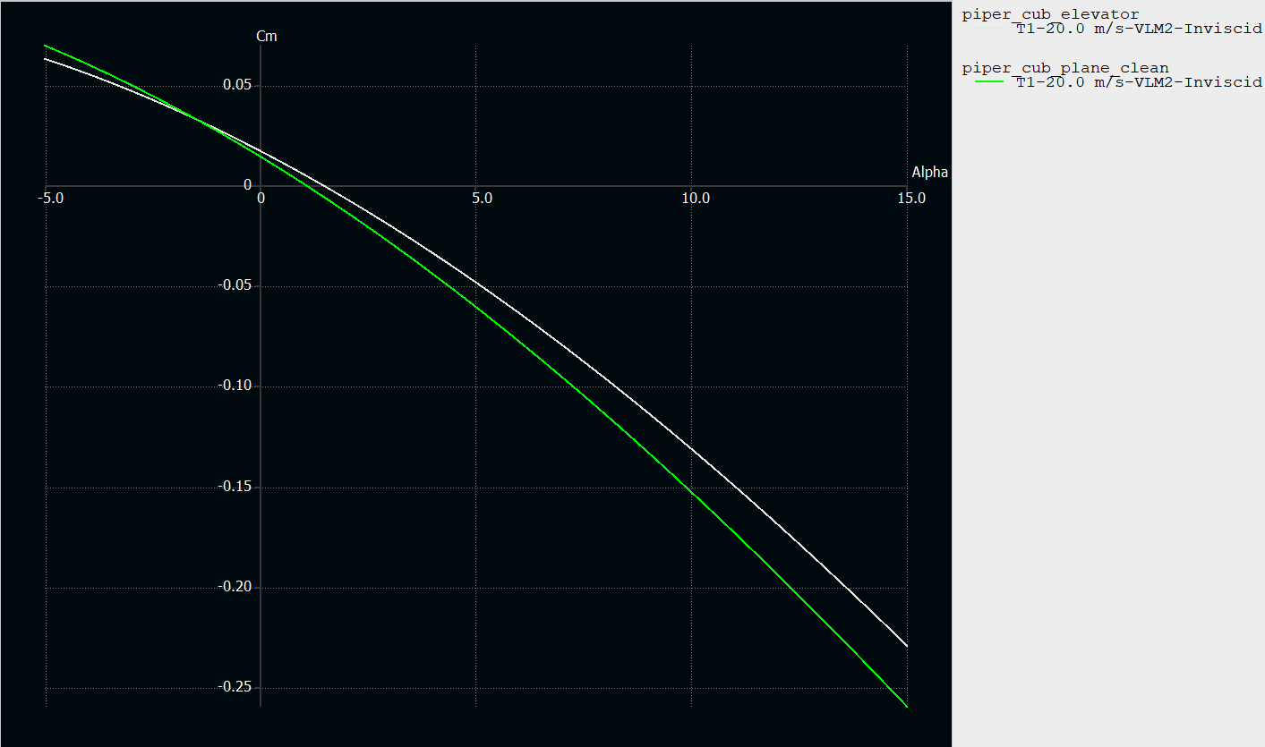
Figure 7. Clean and elevator-deflected pitching-moment results.

7.2 Ailerons
The aileron-deflected case changes the aerodynamic loading and produces a measurable difference in the plotted lift response. The primary design purpose of the ailerons is rolling-moment generation; therefore, a complete assessment should also examine the rolling-moment coefficient and adverse-yaw response at equal and opposite deflections.
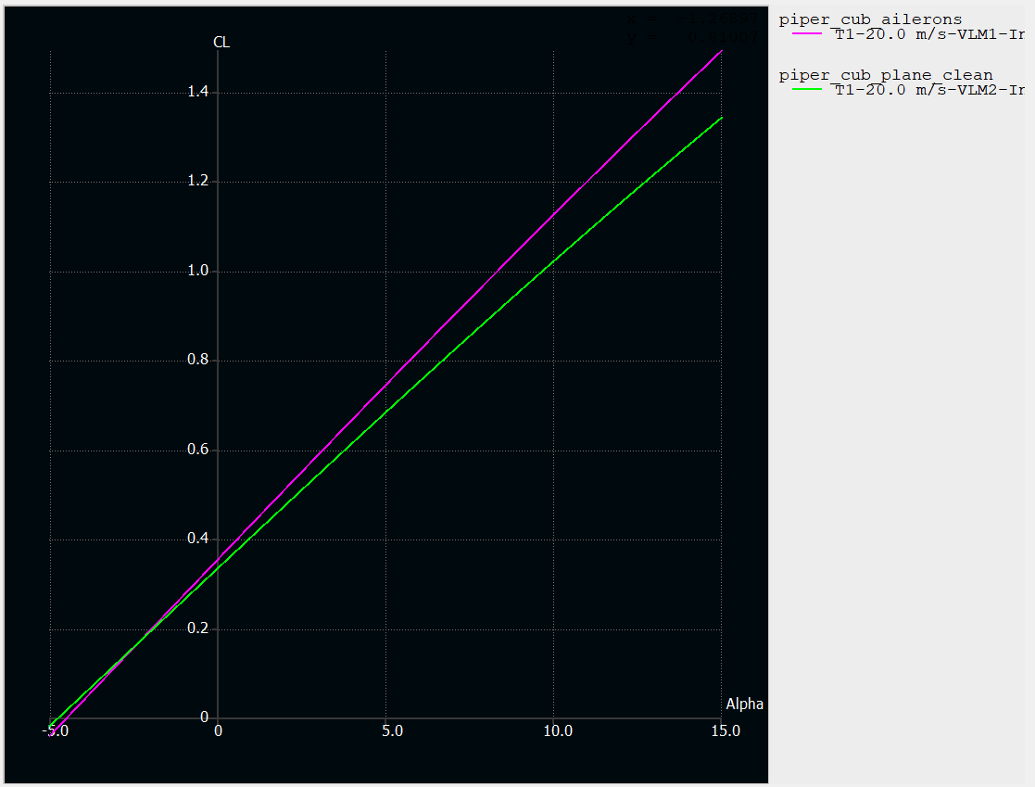
Figure 8. Clean and aileron-deflected results.

7.3 Rudder
A positive rudder deflection shifts the yawing-moment coefficient in the negative direction in the adopted sign convention. This confirms directional-control authority. The sign indicates the direction of the generated moment; it does not by itself indicate a loss of directional stability, which requires examination of the yawing-moment derivative with sideslip.
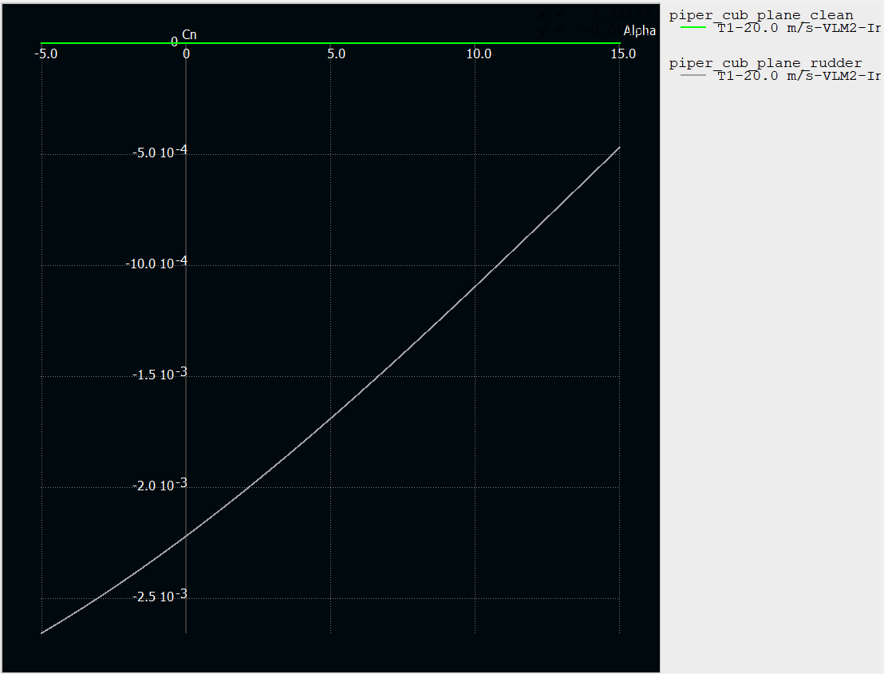
Figure 9. Clean and rudder-deflected yawing-moment results.

8. MATLAB mass-estimation method
The MATLAB script was rewritten for a reproducible repository layout while retaining the original script filename. It now loads the preserved XFLR5 coordinate file by a path relative to the script, validates the data, handles the text header correctly and uses numerical integration to calculate the normalised airfoil area and chordwise centroid.
- Rib masses scale with the square of chord because the cross-sectional area scales with chord squared at constant sheet thickness and density.
- Spar masses are estimated from rectangular cross-sections, material density and span.
- Wing and stabiliser rib-system centres of gravity are calculated with mass-weighted moments.
- The fuselage estimate uses elliptical frame areas plus four longitudinal members.
The calculation remains a preliminary structural estimate. Glue, covering, hardware, cut-outs, joints and local reinforcement are not explicitly modelled.

9. Conclusions
The project produced a coherent XFLR5 representation of the Piper Cub 40 and a documented set of aerodynamic and mass-property studies. The simulations show conventional high-wing behaviour, usable pitch, roll and yaw control authority, and modest differences between the analysed dihedral configurations. The most reliable use of the results is comparative: assessing how geometry, control deflection and Reynolds number change the predicted trends.
For a future validation stage, the component masses should be measured, the centre of gravity should be confirmed by balancing the completed airframe, and selected XFLR5 predictions should be compared with flight-test observations. The GitHub version preserves the original XFLR5 filename to maintain compatibility with the MATLAB workflow.

10. References and source material
- Outerzone, Piper Cub 40 plan (oz13332): https://outerzone.co.uk/plan_details.asp?ID=13332
- XFLR5 project website: http://www.xflr5.tech
- Great Planes J-3 Piper Cub 76-inch model product references.
- Piper Cub J3 CAD reference models available through GrabCAD.
- Great Planes 40 Cub wing-build tutorial references.
- OS FS-48 Surpass engine and compatible engine-mount product references.
- Commercial Piper Cub model listings used only as mass-approximation checks.

