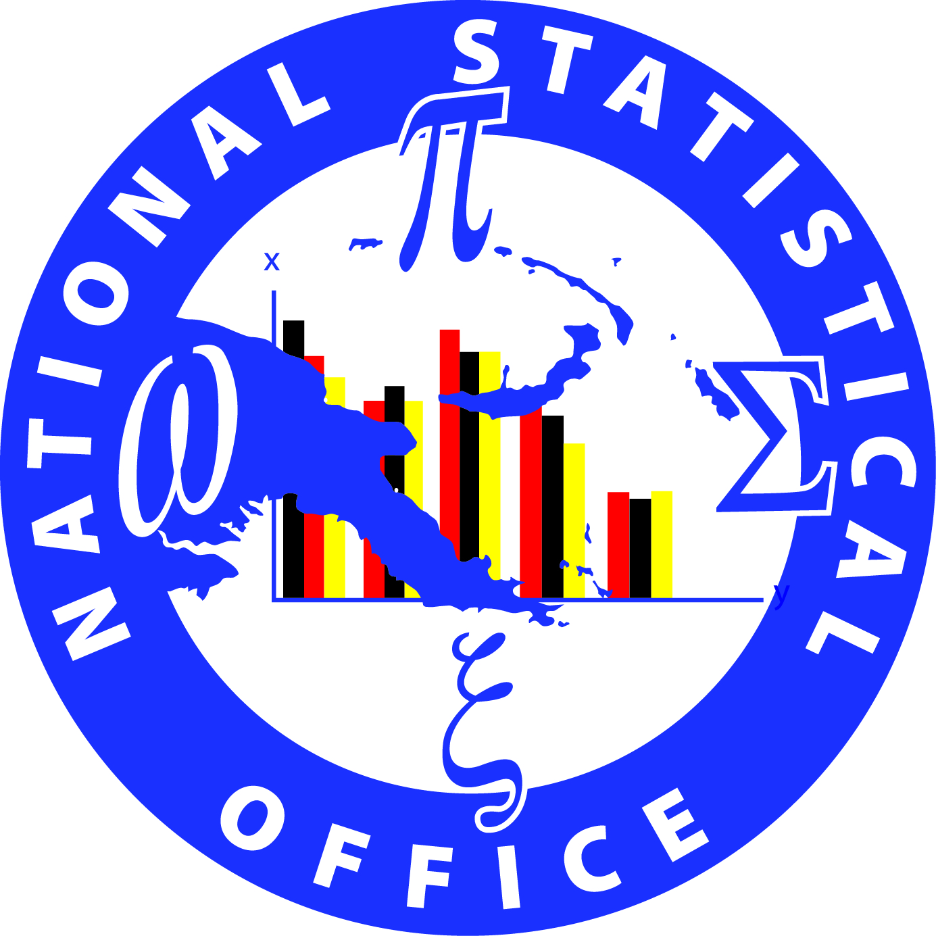

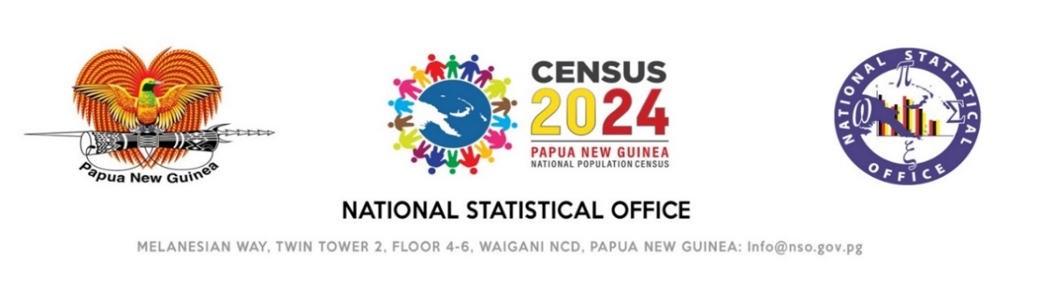

Melanesian Way, Level 6, Twin Tower #2| P.O. Box 337, WAIGANI| National Capital District

Telephone: 323 1200 Email: [john.igitoi@nso.gov.pg](mailto:jigitoi@nso.gov.pg) or [johnigitoi334@gmail.com](mailto:johnigitoi334@gmail.com) |

Website: [www.nso.gov.pg](http://www.nso.gov.pg) Email: [info@nso.gov.pg](mailto:info@nso.gov.pg)

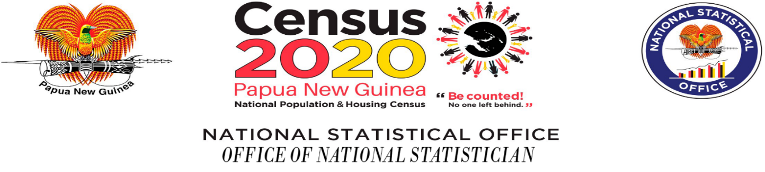

NATIONAL STATISTICAL OFFICE

**Office of the National Statistician**

**PNG Economy Bounces back from COVID.**

The National Statistical Office (NSO) recently released 2021 and 2022 Gross Domestic Product (GDP). The NSO notes that Constant Price GDP fell during the COVID years, with 2020 falling 3.2% and 2021 falling 0.8%. However, post COVID the PNG economy showed strong growth with 2022 recording a 5.2% increase. Changes in Constant Price GDP are only due to changes in production volumes as prices are held constant.

The NSO has also reported that the size of Current Price GDP has reached K111.2 billion in 2022, breaking the K100 billion barrier for the first time. Current price GDP measures PNG economic production valued at the prices for the particular year, an increase in Current Price GDP reflects changes in both production volumes and prices.

**Changes in Current Price GDP**

**In 2021,** key industries that contributed to the economy were Mining and Quarrying (up by K3.2 billion, +15.8%), Agriculture, Forestry and Fishing (up by K1.9 billion,+12.4%), Wholesale and Retail (up by K0.9 billion,+10.7%).

**For 2022**, key Industries that contributed to the economy were Mining and Quarrying (up by K12.2 billion, +53.2%), Agriculture, Forestry and Fishing (up by K1.4 billion,+8.3%) and Wholesale and Retail (up by K1.1 billion, +12.6%)

For more information, please visit [**www.nso.gov.pg**](http://www.nso.gov.pg)**.**

***Authorised by***

***Mr. John Aseavu Igitoi***

***National Statistician***