Project Title: Mood Booster Chatbot - AI-Powered Chatbot API Server

Team Number: m14prj

Team Members:

Billy Wei
Brief explanation: With experience using Ruby on Rails, MVCs, and frontend development using React.js, I ended doing everything on my own.

Project Idea:

This project implements an AI-powered RESTful API server that provides a mood-boosting chatbot service. The system allows users to register and interact with an AI chatbot powered by GPT-2 model from HuggingFace. Users receive 20 free API calls, after which the service continues to work but displays a warning. The application follows a microservice architecture with three main components:

1. Backend API Server (Node.js/Express): Handles user authentication, API endpoints, database operations, and communicates with the LLM service
2. LLM Service (Python/Flask): Hosts the GPT-2 model from HuggingFace and generates conversational responses
3. Frontend Client (React): Provides the user interface for login, registration, chat interaction, and admin dashboard

The chatbot is designed to provide humorous, engaging, and mood-boosting responses to user messages, helping to improve users' emotional well-being through interactive conversations.

Microservice Architecture Diagram (Rough Sketch):

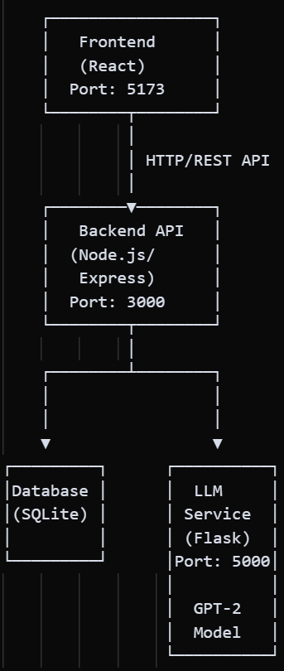

Description:
- Frontend and Backend are on separate origins (different domains when hosted)
- Backend communicates with LLM Service via HTTP REST API
- Backend manages all database operations
- LLM Service hosts the pre-trained GPT-2 model from HuggingFace
- All services can be hosted separately or together depending on hosting provider capabilities

