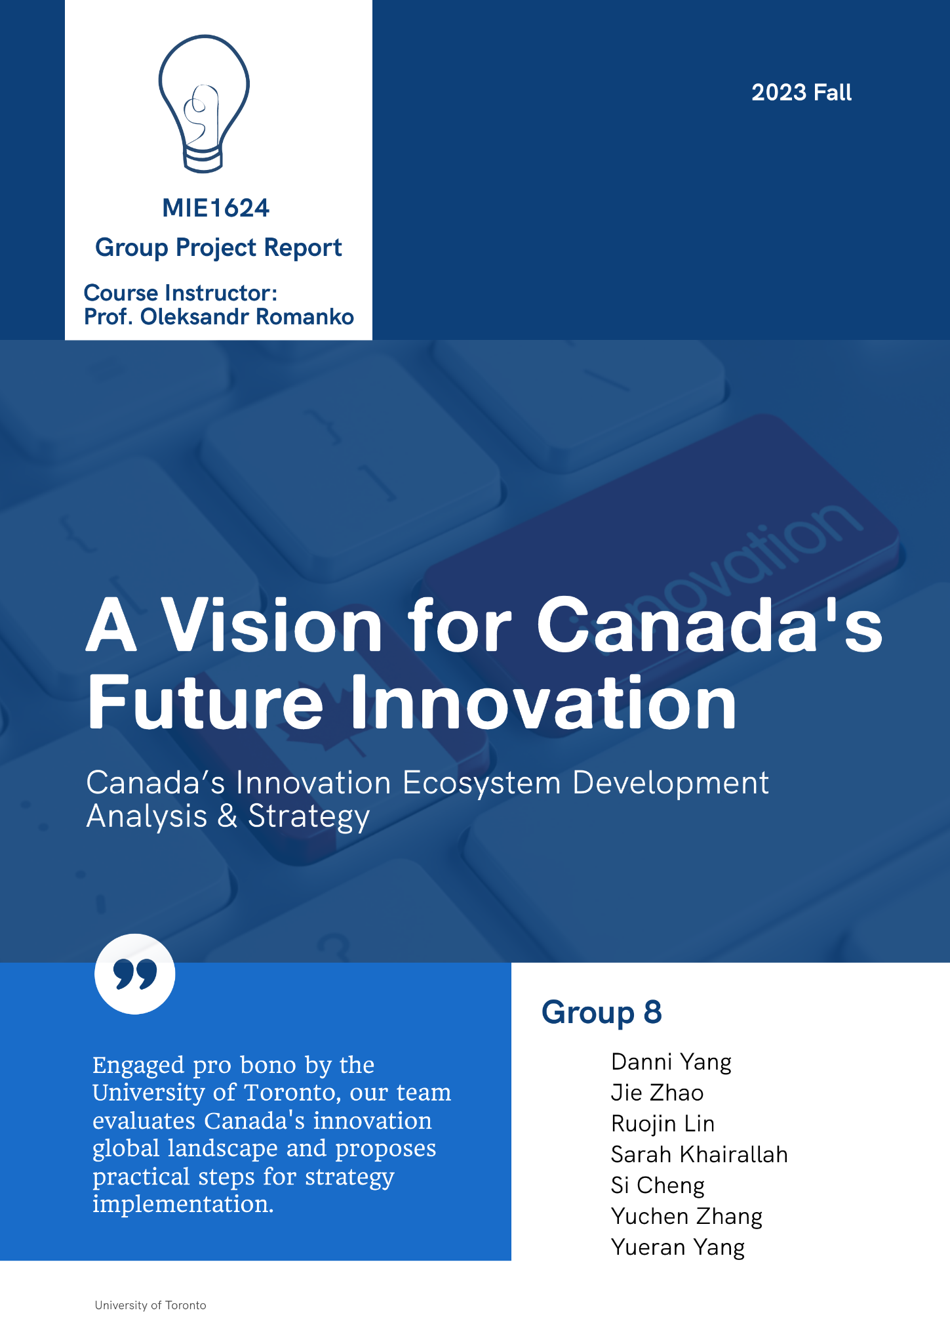

Global Innovation Index Analysis: Unveiling Key Features and Insights Across Countries
Our research integrated the “Global Innovation Index: Panel Data (2011-2022)” dataset from Mendeley Data with the Global Innovation Index 2023 dataset from the World Intellectual Property Organization (WIPO). This comprehensive dataset comprises 1,720 rows and 10 columns, encapsulating a wide array of innovation metrics from 160 countries, spanning the years 2011 to 2023. The Global Innovation Index (GII) is central to the dataset, a pivotal indicator of a country’s innovative capacity and outcomes. The dataset incorporates seven critical features influencing the GII rankings of each country, namely Institutions, Human Capital and Research, Infrastructure, Market Sophistication, Business Sophistication, Knowledge and Technology Outputs, and Creative Outputs. Correlation analysis showed strong positive relationships between ‘Creative Outputs’ and ‘Infrastructure’ with the Global Innovation Index (GII), each having a correlation coefficient of 0.91. This implies that improvements in these areas may lead to higher innovation rankings (refer to Appendix Figure 1.1). However, as correlation primarily detects linear relationships, it might overlook non-linear ones. To tackle this challenge, we utilized the Random Forest Regressor (refer to Appendix Figure 1.2), renowned for its proficiency in managing non-linear relationships and intricate variable interactions. Additionally, its resilience against overfitting makes it a robust choice for our analysis. The chart shows ‘Creative Outputs’ as the most impactful feature on the GII with a score of around 0.60, followed by ‘Infrastructure’ and ‘Knowledge and Technology Outputs’ with scores of 0.13 and 0.1, respectively. The prominence of these features underscores their key roles in determining a country’s innovation capacity as measured by the GII. For a focused comparison of Canada’s GII with top innovators, we selected countries in the top 20, including the UK, Singapore, the US, Switzerland, and Japan. The rationale behind this selection lies in their sustained high GII rankings, providing a benchmark for Canada. Their diverse innovation ecosystems also enable a broad analysis of the factors driving high innovation indices. Data from these six advanced economies were extracted and analyzed to ascertain feature importance. ‘Knowledge and Technology Outputs’ was identified as the most influential feature with an importance score of 0.53, followed by ‘Human Capital and Research’ at 0.22 (see Appendix Figure 1.3). We assessed the average rankings for each country across various features in the GII over 13 years. A radar chart illustrating innovation factors for the six countries revealed distinct strengths (see Appendix Figure 1.4). Switzerland stood out, consistently ranking first with a pronounced lead in ‘Knowledge and Technology Outputs’. Canada’s ‘Institutions’ and ‘Market Sophistication’ have commendably maintained average rankings around the 6th and 4th positions respectively. However, areas such as ‘Human Capital and Research’ and ‘Knowledge and Technology Outputs’ lagged, with average rankings of approximately 19th and 21st, respectively. These findings pinpoint these two features as focal points for our subsequent research. Compared to Canada, the other five countries had higher average rankings in these two features. Notably, Singapore ranked around 4th in ‘Human Capital and Research’, and the United States ranked about 5th in ‘Knowledge and Technology Outputs’. This suggests that these countries’ innovation strategies could provide valuable lessons for enhancing Canada’s performance in these critical sectors.

Strategic Insights from OpenAI API: Summarizing National Innovation Strategies
Based on the important features we identified, we employed keyword searches to gather policy insights from other countries as references for drafting Canada's 2023 innovation strategy. Taking the United States as an example, innovation strategies often vary across industries, regions, and sectors. Central to these strategies are novel discoveries, technical insights, and refinements, especially in critical and emerging technologies (CET). The National Defense Science & Technology Strategy 2023 underscores the significance of Research and Development (R&D), defined as systematic activities aimed at acquiring new knowledge or improving existing knowledge to develop new products, processes, or services. This strategy notes that standards frequently incorporate patented technologies, with licensing revenues from these patents enabling the industry to recoup R&D expenses and reinvest in future innovations. It also highlights actions by the Department of Justice's Antitrust Division, the U.S. Patent and Trademark Office, and NIST to enhance innovation and competitiveness in the marketplace, including withdrawing their policy statement on Standards Essential Patents (SEPs), which often encompass breakthroughs at the heart of new technologies.
On the other hand, the UK Innovation Strategy also mentions the IP education program for research education to help researchers leverage their intellectual property for commercialization. The UK Intellectual Property Office (IPO) recognizes the need to support Small and Medium-sized Enterprises (SMEs) in commercializing their IP and will provide support for research and development, securing and managing new IP rights, and helping with cutting down the costs which businesses face when leveraging their IP assets. For instance, the Patent Box tax incentive is another measure that supports the retention of IP in the UK by allowing businesses to pay a reduced rate of tax on profits arising from exploiting patents and other qualifying products.

In conclusion, shaping Canada’s 2023 innovation strategy should involve leveraging global insights, particularly drawing from the experiences of the U.S. and the UK. The U.S. model emphasizes sector-specific nuances and the integral role of R&D, linking patented technologies to innovation cycles. The UK’s emphasis on intellectual property (IP) education programs and support for SMEs offers valuable lessons for Canada. As Canada moves forward, integrating these insights - sector specificity, a robust R&D focus, and a strong patent policy support - will be instrumental in elevating the country to a forefront position in the worldwide innovation arena.

Executive Proposal for Canada’s Innovation Strategy
Our objective is to elevate Canada's role in global innovation, focusing on enhancing ‘Knowledge and Technology Outputs’ and ‘Human Capital and Research’. Despite its commendable innovation capabilities, Canada encounters challenges that necessitate policy refinements to narrow the innovation gap with leading countries and achieve superior innovation performances. The dynamic nature of the innovation field calls for concerted efforts among academia, industry, and government.

Feature Analysis
Knowledge and Technology Outputs
The ‘Knowledge and Technology Output’ dimension serves as a cornerstone of a nation’s innovation ecosystem, representing the confluence of intellectual acumen and technological mastery. This feature encompasses a spectrum of groundbreaking discoveries, advanced patented technologies, and dynamic creative outputs, all of which are pivotal in driving economic advancement and elevating a nation's standing in the global competitive arena. It underscores the importance of harnessing intellectual capital to foster the development of innovative products, processes, and services, thereby catalyzing Canada’s transformative journey in the realm of global innovation.

Human Capital and Research
The feature ‘Human Capital and Research’ underscores the crucial role of human resources in advancing a nation’s innovation landscape. It involves assessing the active engagement of a skilled workforce in research initiatives, evaluating the quality and quantity of research activities, and ensuring alignment with the goals of the innovation ecosystem. By promoting incentives, support mechanisms, and interdisciplinary collaboration, this feature aims to cultivate impactful research that not only meets high standards but also contributes significantly to economic growth and technological advancement. Continuous measurement of the impact of research activities allows for strategic improvements and ensures that the nation’s human capital remains a driving force in innovation.

Discussion of Alternatives
In considering alternatives to fortify Canada’s innovation landscape, two distinct options emerge. A key alternative involves the implementation of Regulatory Innovation Frameworks [1]. This strategy centers on the modernization of regulatory processes to create a more agile and innovation-friendly environment. By streamlining regulations and fostering adaptive frameworks, Canada can position itself as a global leader in facilitating the rapid integration of cutting-edge technologies. This approach emphasizes efficiency and responsiveness in regulatory procedures, ensuring that innovative solutions encounter minimal barriers and promoting a dynamic and supportive ecosystem for businesses and researchers alike. The second alternative proposes a National Research Collaboration Initiative [2], fostering collaboration among diverse research institutions nationwide. By encouraging knowledge-sharing and optimizing resources, this initiative accelerates the translation of research findings into practical applications. Combining these alternatives can create a comprehensive framework, ensuring Canada’s innovation ecosystem remains resilient and diversified.

Policy Recommendations
Policy 1: Holistic Engagement for Advanced Innovation Programs (HEAIP)
The Higher Education Achievement Incentive Program (HEAIP) strategically addresses financial, legal, and partnership challenges in scientific research, offering tailored support from idea inception to patent realization [3]. By promoting collaboration between research institutions and industry, the program enhances Canada’s research capabilities, fostering global competitiveness. With four distinct modes, including financial assistance, commercialization support, international collaboration, and intellectual property protection, HEAIP provides solutions to diverse participant needs. The program's detailed approach ensures participants receive targeted assistance across specific innovation pathways, contributing to a vibrant and impactful research landscape in Canada [4].

Policy 2: Intellectual Property Strategy
This policy advocates aligning Canada’s innovation trajectory with a robust intellectual property strategy, drawing inspiration from the U.S. post-1980 model [5]. It emphasizes guiding businesses, creators, entrepreneurs, and innovators through the intricacies of comprehending, safeguarding, and leveraging their intellectual property rights. The implications of this policy are extensive, ensuring comprehensive support throughout the innovation journey, and instilling confidence in innovators to pursue and achieve their research goals. Additionally, the policy capitalizes on international trade agreements, such as the Comprehensive Economic and Trade Agreement (CETA) with the European Union and its member states, and the United States-Mexico-Canada Agreement (USMCA), to shape and enhance Canada's approach towards patents and intellectual property management on a global scale.

Policy 3: InnoHarbor Canada Program (IHCP)
The InnoHarbor Canada Program (IHCP) serves as a bridge between private enterprise objectives and national R&D targets by providing exclusive access to government-funded incubators and networking platforms [6]. This initiative fosters a collaborative environment between private businesses and the government, offering incentives for impactful innovation through research projects. The policy implications are two-fold. Firstly, it encourages collaboration between private enterprises and government-funded incubators, establishing a platform for joint research and development efforts. Secondly, it advocates setting ambitious targets to increase Canada’s R&D spending, thereby motivating businesses to conduct more research and elevate Canada’s standing in the global innovation landscape [7].

Policy 4: Innovation Hub Model
The Innovation Hub Model focuses on establishing hubs concentrating on ‘Knowledge and Technology Outputs’ to facilitate collaborative research and technology transfer [7]. These hubs act as catalysts for interdisciplinary collaboration and innovation, connecting academia with industry in specialized environments. The policy implications are twofold: firstly, it drives collaborative research initiatives by bringing together experts from diverse fields to collectively address complex challenges. Secondly, it accelerates the transfer of knowledge and technologies from academic research to practical applications in industries, ensuring a seamless flow of innovation [8].

Policy 5: STEM Education Enhancement
The STEM Education Enhancement policy aims to fortify STEM education, aligning it with industry needs to enhance ‘Human Capital and Research’. Its primary objective is to nurture a skilled workforce capable of meeting the demands of innovative sectors [9]. The policy implications are twofold: firstly, it fosters skilled workforce development by aligning educational programs with industry requirements, directly addressing the talent demand in innovative sectors. Secondly, it emphasizes the long-term benefits of investing in education, envisioning sustained innovation and economic growth as a result [9].

Implementation
The implementation involves engaging stakeholders through consultations and partnerships, collaborating with government bodies for funding and regulatory support, and garnering public support through awareness campaigns and showcasing success stories. Potential opposition can be addressed through transparent communication and flexibility in adjusting the policy based on feedback. The fiscal impact can be managed by proposing diversified funding sources, including public-private partnerships. The core of our evaluation plan is the continuous monitoring of innovation metrics, periodic reviews with stakeholders to assess impact, and an adaptive approach to policy adjustments based on evolving needs and feedback.

In short, our proposal envisions a resilient innovation landscape for Canada, strategically aligning policies with global best practices. These policies symbolize Canada’s commitment to pioneering advancements and ensuring a sustainable, competitive future. We will focus on elaborating Policies 1 and 3 in the Implementation Strategies section, providing a detailed analysis of their significance and application.

Implementation Strategies: Practical Steps and Approaches

Time Series Analysis of Knowledge and Technology Outputs Data
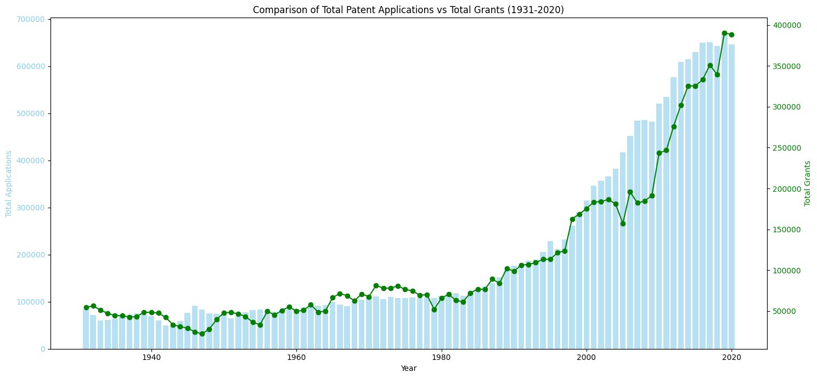
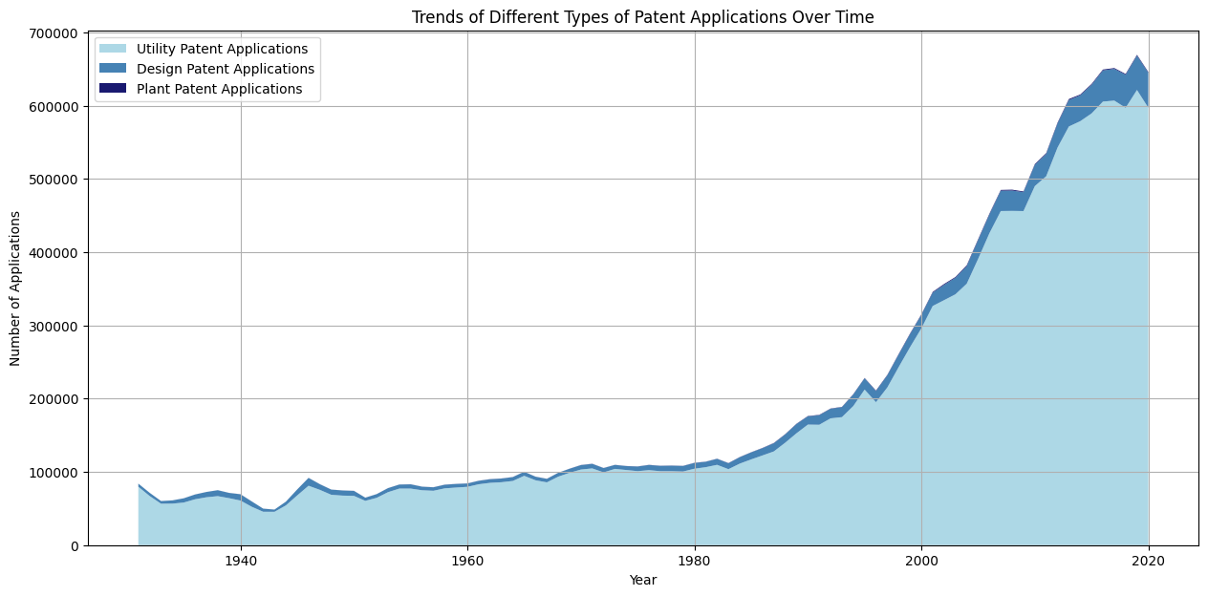
Patents represent a key indicator of knowledge and technology output, which led us to analyze U.S. patent data spanning from 1931 to 2020.

Figure 1: Comparison of Total Patent Applications vs Total Grants (1931-2020)
Figure 2: Stacked Area Plot of Different Types of Patent Applications

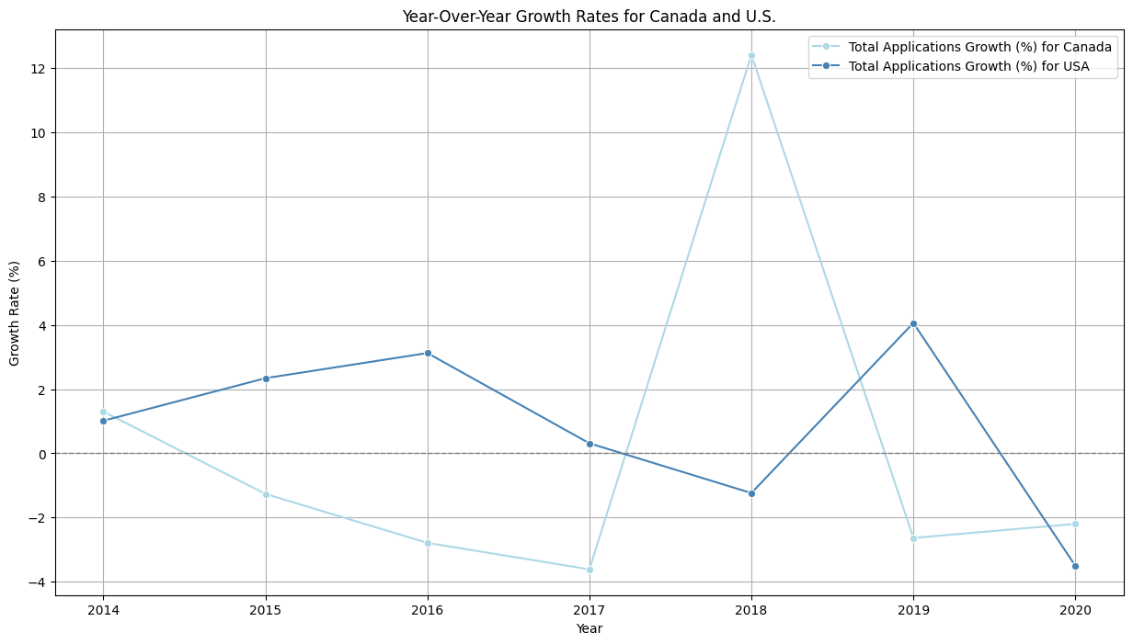
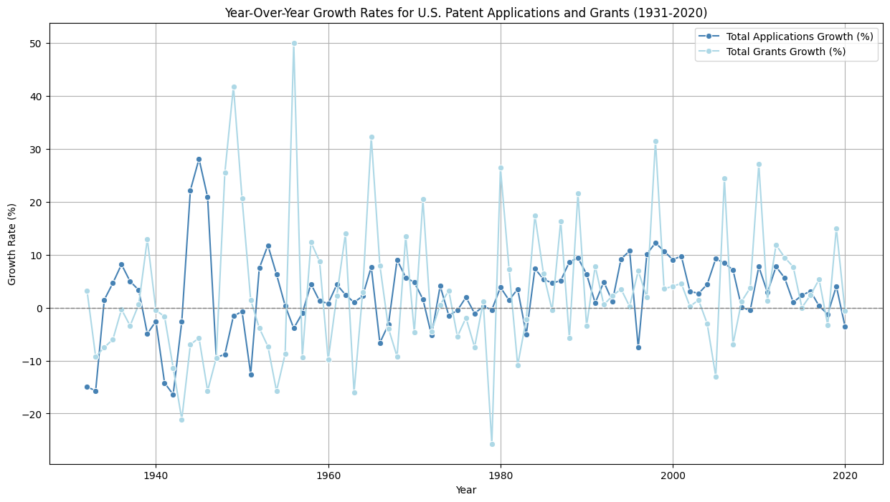
The graph in Figure 1 presents a comparative view of the yearly trends in total patent applications (represented by bars) and total grants (shown as a line plot). A notable increase in both applications and grants is observed post-1980, correlating with the implementation of a significant policy in the United States during that year. Figure 2, on the other hand, illustrates the trends in different types of patents – Utility, Design, and Plant – over time. This graph provides a stacked visual representation, clearly showing the proportion of each patent type within the total count. We proceeded to calculate the annual growth rates for both patent applications and grants in the United States, as illustrated in Figure 3. Furthermore, we analyzed the annual growth rate of total patent applications in Canada from 2014 to 2020, detailed in Figure 4.

Figure 3: Growth Rates for U.S. Patent Applications and Grants (1931-2020)
Figure 4: Growth Rates for Canada and U.S. (2014-2020)
A significant uptick was observed in 2018, attributable to the following potential factors:
- Intellectual Property Strategy: Canada unveiled this strategy in 2018 aimed at assisting businesses, creators, entrepreneurs, and innovators in comprehending, safeguarding, and leveraging their intellectual property (IP) rights.
- Canada-European Union Comprehensive Economic and Trade Agreement (CETA): Implemented in September 2017, CETA significantly influenced IP rights in Canada, particularly in the realm of patents, marking a pivotal change in the IP landscape.
- United States-Mexico-Canada Agreement (USMCA): This agreement, encompassing various IP provisions, has played a potential role in shaping Canada’s approach towards patents and IP management.

In analyzing the U.S. patent growth rate, we employed various time series models, including ARIMA(1,1,1), Simple Exponential Smoothing, Double Exponential Smoothing, and Additive Holt-Winters. The ARIMA model indicated the data’s non-stationary nature, as evidenced by an ADF statistic of -1.401477 and a p-value of 0.581568, prompting the necessity for data differencing. Autocorrelation Function (ACF) and Partial Autocorrelation Function (PACF) plots were instrumental in determining the optimal P and Q values. The comparative analysis of Mean Squared Errors (MSE) across these models - 0.0019, 0.0014, 0.0217, and 0.0039, respectively - led to the selection of the Simple Exponential Smoothing model, attributed to its minimal MSE. This model, when applied to Canada's growth rate data, yielded an MSE of 0.0033, affirming its effectiveness and applicability to the Canadian context. Our predictive modeling forecasts a growth rate of 2.68% for the next decade in Canada, influenced by analogous U.S. policies that are expected to stimulate patent growth.

Strategies Centered on the Knowledge and Technological Outputs

Program Name: Higher Education Achievement Incentive Program (HEAIP)
HEAIP is designed to alleviate concerns related to financial support, legal protection of research, partnership formation, and guidance from national or academic authorities. By ensuring comprehensive assistance from idea inception to patent realization, the program aims to instill confidence in students to achieve their research goals.

Program Information: Our program aims to promote scientific and technological innovation and facilitate knowledge transformation by strengthening cooperation between scientific research institutions and industry. We provide financial support to schools and scientific research institutions to help them realize their scientific research outcomes and assist with patent applications to protect these results. These efforts will enhance Canada’s research capabilities and contribute to scientific and technological innovation. Furthermore, this process is designed to stimulate economic growth and enhance Canada's competitiveness in global innovation. The program offers four tailored modes, designed to cater to diverse participant needs, with the flexibility to engage in one or several tracks concurrently. Mode 1 is aimed at individuals seeking financial support for scientific research projects at universities or research institutions. Mode 2 targets representatives from business or investment entities, offering avenues to invest in R&D projects or innovation funds. Mode 3 serves those in need of expert assistance from global research institutions and universities for their research projects. Lastly, Mode 4 is for individuals or teams poised to take their scientific research outcomes to the next level, either by commercializing these results or securing patents for innovations developed during their research.

Program Details
For Mode 1:
- The program will offer financial support ranging from 2,000 to 100,000 Canadian dollars to the applicant’s team, depending on the analysis report of the program reviewer.
- If the applicant achieves the scientific research results confirmed by the reviewer upon project completion, a research bonus ranging from 500 to 50,000 Canadian dollars will be provided.
- This funding originates from a collaboration platform with the government and includes contributions from businesses or investment entities, innovation funds, and program start-up capital.
- A strict evaluation mechanism is in place to ensure that the funds are used for the most promising innovative projects.
- More funding is allocated to projects that are expected to achieve specific, concrete results.
- Program applicants are required to submit a final report to the dedicated supervisor, summarizing the project’s completion status and the use of funds.
For Mode 2:
- The program will match applicant organizations or companies with the most commercially viable scientific research projects, focusing primarily on those anticipated to yield significant research results.
- Analysts dedicated to these projects will furnish applicants with a comprehensive analysis report, encompassing complete details about the projects.
- The program employs a professional fund management team to oversee the innovation funds invested by the applicants.
For Mode 3:
- The program will establish a collaborative platform between universities and international academic research institutions. Each institution or university will designate an academic support contact, with whom applicants can communicate their specific needs for assistance.
- An innovation accelerator program has been set up for applicants with a clearly defined research plan or direction. Professional team members from these academic institutions and universities will be assigned to support the applicant’s research project.
- The program includes research consultants who have specific professional backgrounds. These consultants can provide project planning for the applicants’ ideas and plans, as well as facilitate connections with professional researchers.
For Mode 4:
- The program provides enhanced support for intellectual property legal frameworks through legal advisors, thereby protecting the results of inventors and innovative enterprises.
- By coordinating with government patent departments, the program not only facilitates but also financially supports the patent application and technology licensing processes for applicants.
- The program organizes regular technology exhibitions and exchange events to showcase the scientific research achievements of the applicants. This initiative fosters attention and collaboration from both domestic and international investors and companies, thereby aiding in the commercialization of research outcomes.
- a digital media and online platform has been established to widely publicize the technological achievements and innovative projects of both the applicants and the overall program, thus expanding their recognition and influence.

Application Process
Application Submission
- Prospective applicants should first register for an applicant account on the official program website, and then decide which mode of the program they wish to pursue. Those unclear about their situation can use a questionnaire survey available on the site, which will help generate modes based on their responses.
- Fill out the application form on the website, select the application mode, and submit relevant documents for your project, information about your institution, or your resume. Sign and submit the application form.
Application Review (About 4 Weeks)
- The initial reviewer of the program receives the application form and the applicant's information. They conduct a preliminary check of the applicant’s eligibility and the completeness of the information. If everything is in order, the application is then moved to the program team responsible for the applicant’s chosen mode.
- The team responsible for the chosen program mode conducts a further review of the application.
- If the application passes this stage, it is forwarded to an interviewer for an interview. If the application does not pass, the applicant will be asked to provide any missing information or receive an audit report informing them of the application’s rejection.
Application Approval (About 2 Weeks)
- Once the applicant passes the interview, the interviewer issues a program approval letter to the applicant.
- The applicant and their project are then transferred to the team responsible for the chosen program mode, where both parties will plan and arrange the subsequent program proceedings. For applicants of Mode 1 who pass, the finance department will immediately distribute the requested funds.
Program Start to Completion (Depending on the Specific Project)
- The dedicated program manager for the applicant’s project will contact the applicant using the provided contact details.
- The program analyst or program supervisor and other employees will get in touch with the applicant to fulfill their responsibilities.
- The person in charge will regularly complete and submit progress reports on the program.
Program Ends and Results Analysis
- Once the applicant completes the program, the manager confirms its completion and submits a termination request to the responsible department.
- After the termination request is approved, the manager submits a final report on the program outcomes. The supervisor or analyst then presents this report to both the program team and the applicant.
- The analysis team evaluates and reports on the scientific outcomes and the efficiency of the project.

Expected Results
- To encourage the practical application of research findings and promote collaboration between commercial and academic entities
- To enhance the competitiveness of Canada’s innovative products in both domestic and foreign markets, and to bolster Canada’s scientific and technological innovation and international competitiveness.
- To foster collaboration among government, industry, and academia in developing innovative solutions in key technology areas.

Strategy based on Human Capital and Research

As a main factor, Research and Development (R&D) serves as a foundational element of Human Capital and Research. Based on data obtained (OECD, 2023), Figure 5 illustrates that Canada’s gross spending on R&D (% GDP) consistently lags behind among the seven countries of interest. Notably, over the last two decades (2000-2021), Canada’s R&D to GDP ratio has been on a declining trend, while other nations have significantly increased their R&D investments, shedding light on a potential cause for Canada’s lower ranking in the Human Capital and Research Index.
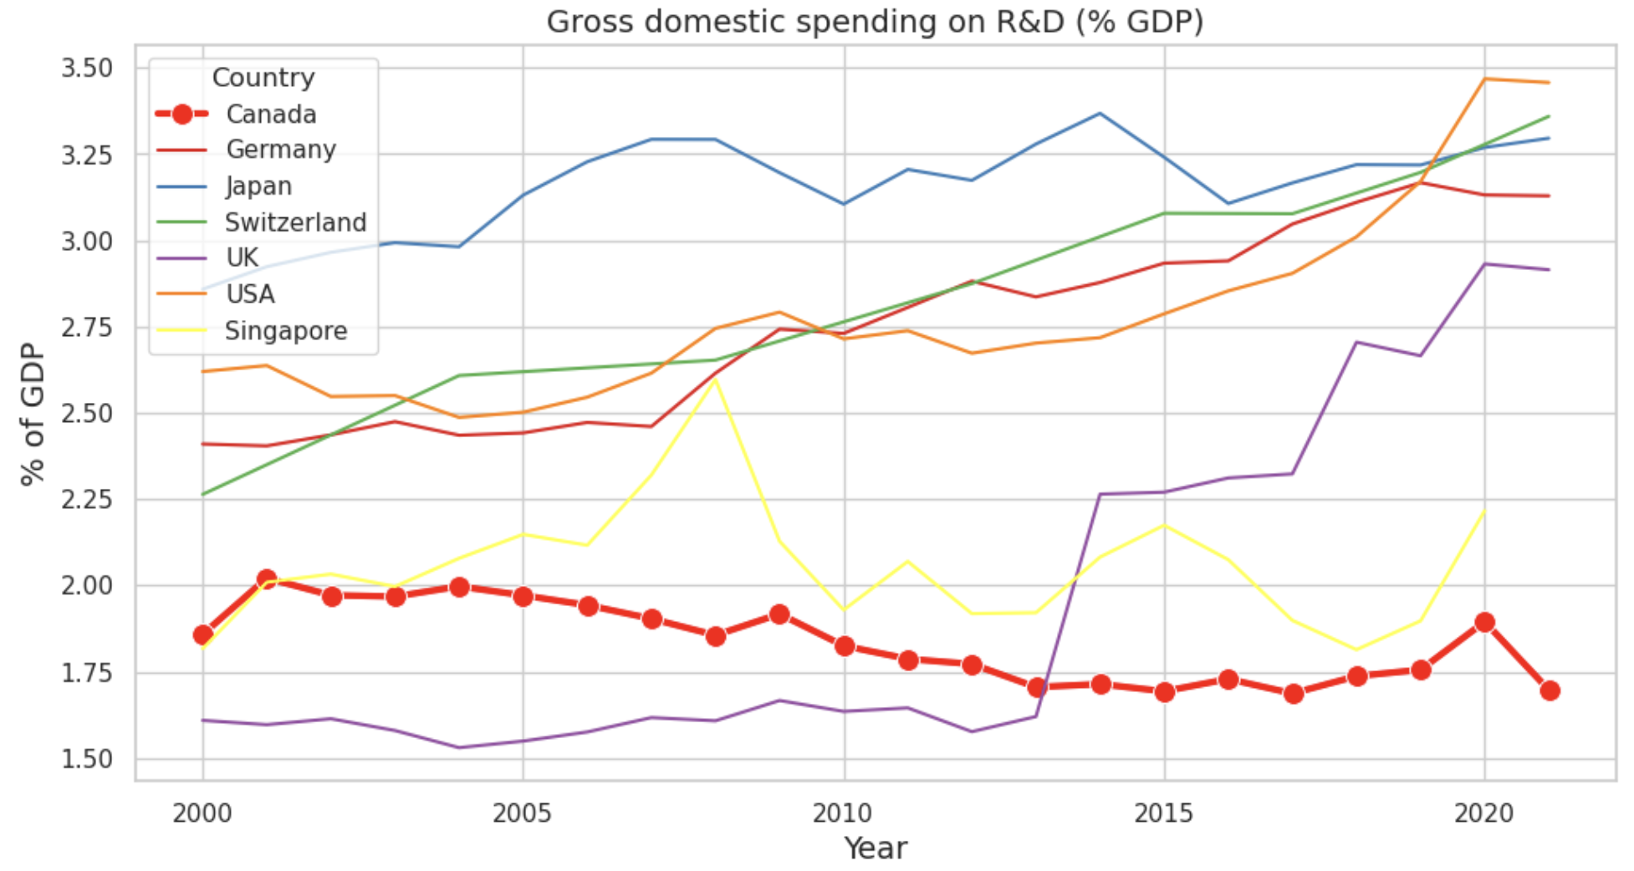
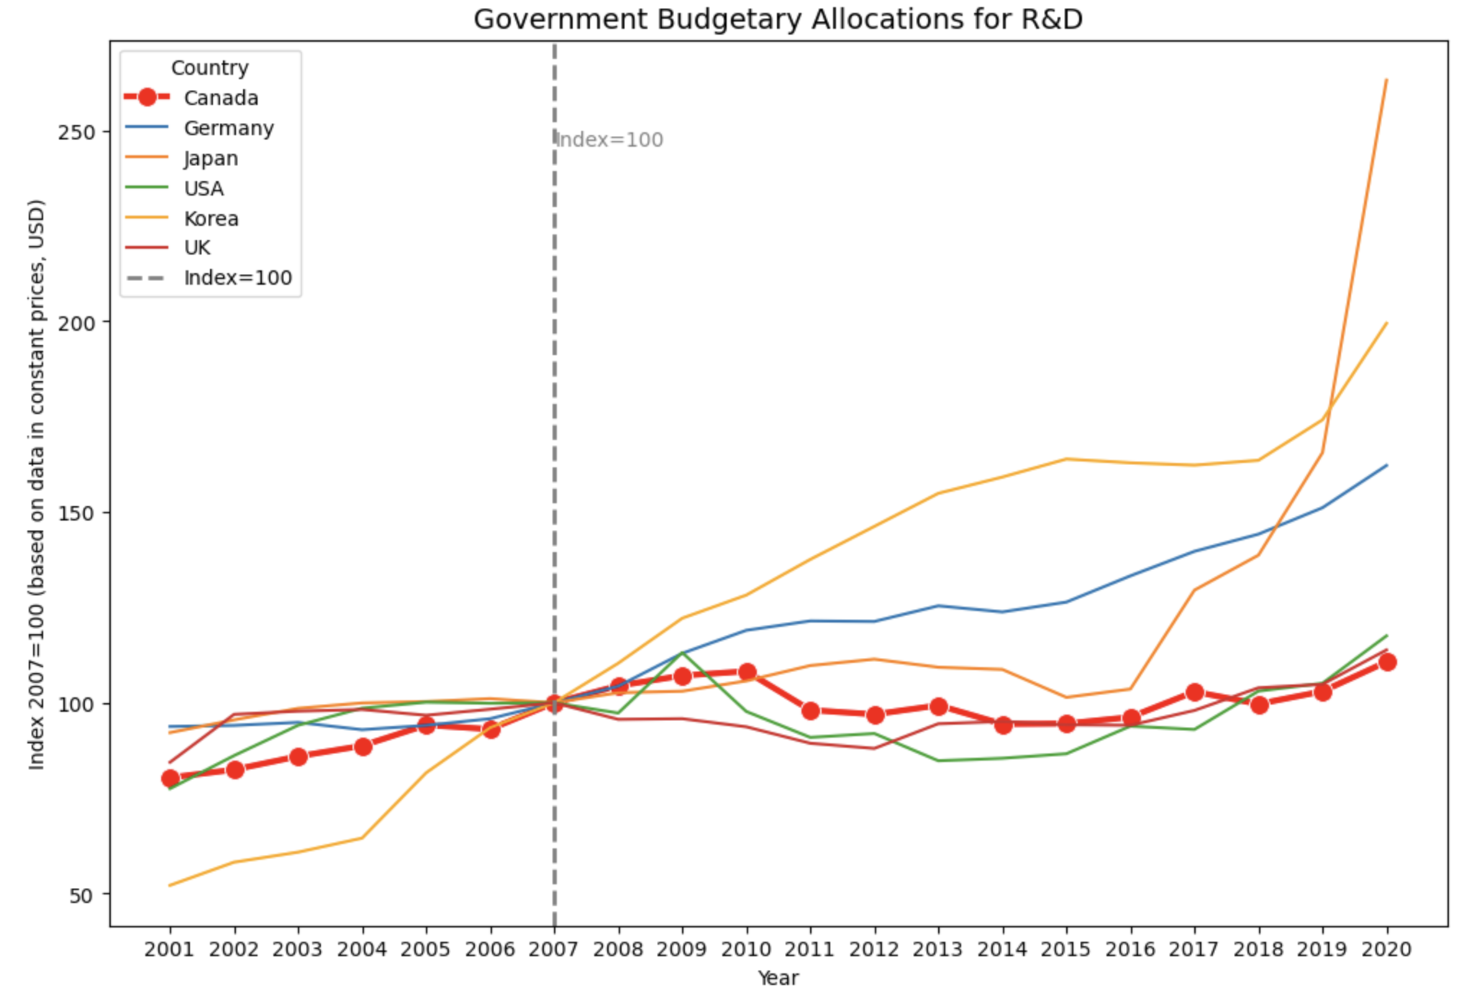

Figure 6: Government Budgetary Allocations on R&D
Figure 5: National Gross Domestic Spending on R&D (% GDP)
Additional statistics (OECD, 2023), Figure 6, have shown that the Canadian government’s R&D budget allocation (with reference index 2007 = 100 at constant USD prices) has remained relatively low, with no significant growth over the past 20 years. In contrast, the USA, with a similar percentage of the government budget for R&D throughout the same period, has experienced a substantial increase in its gross domestic spending on R&D and ranked first among the seven countries by 2021. This suggests that factors beyond government spending are at play.
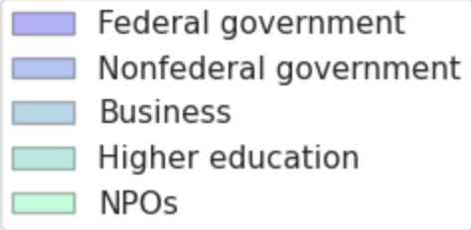
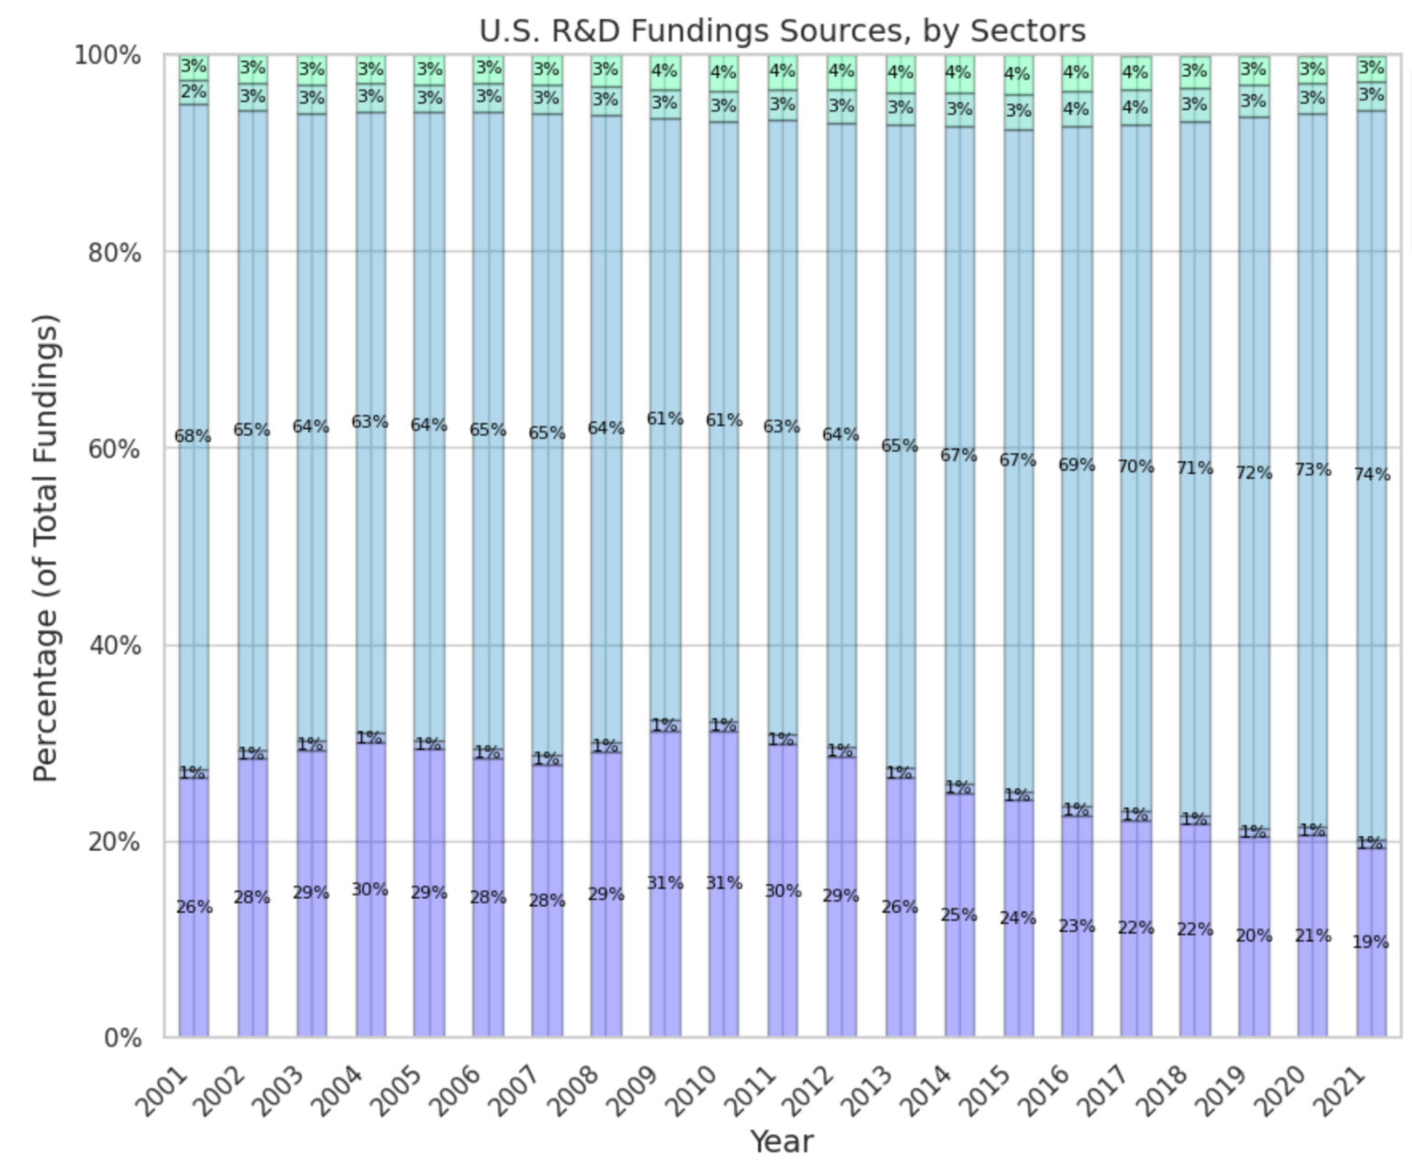
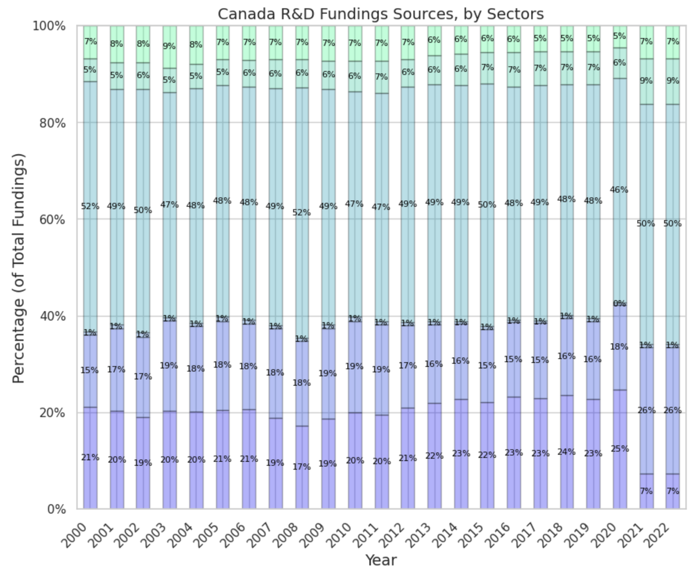
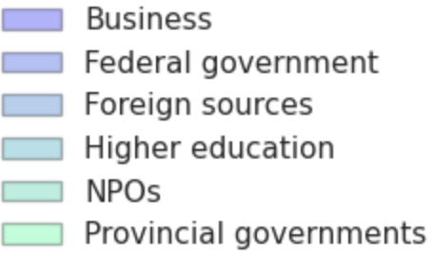

Figure 7: USA R&D Funding Sources by Sectors
Figure 8: Canadian R&D Funding Sources by Sectors

A detailed comparison of funding source allocations between Canada and the USA (Figure 7 and Figure 8) illustrates that a significant gap in R&D funding lies in the business sector. In Canada, only around 20% of R&D funding comes from the business sector, and the number dropped further to 7% in both 2021 and 2022 after the COVID-19 pandemic. On the contrary, the business sector has been a major contributor to R&D funding in the USA, consisting of 60% to 70%, with an increasing trend even after the pandemic. These findings suggest a potential approach for Canada to improve its Human Capital and Research index by increasing R&D funding from the business sector. Canada needs to address the prolonged decline in gross domestic spending on R&D (% GDP) over the past 15 years. To align with other countries’ average increasing rate of 1.26% over the same period, Canada needs not only to recover to the average value of the past 15 years, 1.75% by 2025, but also to strive for further growth, reaching 1.95% by 2029 from the current 1.55% in 2022. In response to this, we propose a strategy centered around this objective and introduce the following program.

Program Name: InnoHarbor Canada Program (IHCP)
InnoHarbor Canada is a program that connects the objectives of private enterprise with Canada’s national R&D targets. With a duration of 5 years, the program is designed to stimulate the business sector to conduct research by providing exclusive access to government-funded incubators and networking platforms, thereby increasing investment in Research and Development (R&D) activities. Enterprises across various industries, regardless of their size, are invited to actively participate in conducting all STEM-related open projects (products, services, etc) that will be beneficial in enhancing Canada's innovation development. The program aims to foster a collaborative environment for the business and the government, to incentivize impactful innovation. Successful enterprises that meet self-set R&D goals by the end of the program will be eligible for additional incentives provided by the government.

Objectives
- Increase Canada’s R&D spending to 1.75% of the total GDP by 2025, and to 1.95% by the end of the program, i.e. 2029.
- Encourage the business sector to conduct more STEM research/projects to potentially improve Canada’s innovation ranking.
- Create a nationwide collaborative environment between private businesses and the government by providing a platform that allows different stakeholders to work together.
Program Details
Application Process
- To enroll, prospective enterprises need to first register on the official portal by providing information including the enterprise’s name, industry sector, and contact information, etc.
- Registered enterprises are required to submit comprehensive project proposals electronically, including a thorough description of the objectives, methodologies, timelines, milestones and anticipated R&D results following the guidelines and templates provided. Documentation supporting the proposed R&D project should also be submitted.
- Submitted proposals are assessed based on predefined criteria such as innovation potential, feasibility, and possible impact on Canada’s R&D, by the panel of experts.
During the Program
- For transparency and effective monitoring, participating enterprises are mandated to submit detailed progress reports every six months through the InnoHarbor portal. These reports must highlight recent achievements, encountered challenges, and a summarized plan for the upcoming period. Non-compliance, such as failing to submit reports or demonstrating minimal progress, may lead to disqualification from the program.
- The program’s management team is committed to providing support, including flexibility in adjusting project timelines or objectives to meet the specific needs of the participating enterprises.
What Support Can Enterprises Expect?
- Access to private, government-funded incubators that offer workspace, resources, and advisory services according to each project’s need.
- Participation in numerous networking events held throughout the program, where enterprises have the opportunity to connect with potential clients, partners, and investors.
How is the Output Evaluated?
Projects are evaluated dynamically and ongoingly by panels comprising government staff and industry leaders in various sectors. The evaluation process is based on the following metrics:

Key Evaluation Metrics | Descriptions | Benchmarks
Industry Advancement  (R&D) | Measures project impact on industry advancement through innovation, competitiveness, and sustainability. | - Number of Patents Filed  - Sustainability Index  - R&D Expenditure Ratio
Societal Benefit | Assesses project effects on society, employment creation, environmental sustainability, and overall societal well-being. | - Employment Creation Rate  - Resource Conservation Ratio  - Carbon Footprint Factor
Market (Industry)  Impact | Evaluates project impacts on industrial markets, including penetration, expansion, or disruption. | - Market Share Growth  - Competitive Displacement  - Brand Equity Growth
Economic Growth | Quantifies project contributions to economic growth, emphasizing GDP impact, increased productivity, and long-term revenue generation. | - GDP Contribution Ratio*  - Gross Output Value  - Tax Revenue Growth  * National scale, if possible

How does the Program Benefit Enterprises Post-Completion?
Upon successfully achieving their self-defined R&D objectives, enterprises are rewarded with additional incentives such as
- Global Market Access Support
- Expedited Permitting and Regulatory Processes
- Access to Government Research Facilities for Future Research
- Corporate Social Responsibility (CSR) Recognition
- Government Procurement Opportunity

Conclusion

To conclude, our extensive examination of the Global Innovation Index, coupled with strategic insights from diverse national models, has illuminated the primary catalysts of innovation. It becomes unmistakably clear that knowledge and Technology Outputs along with Human Capital and Research are pivotal in shaping a nation’s capacity for innovation. The strategies employed by the U.S. and the UK, with their focused investments in sector-specific R&D and comprehensive STEM education initiatives, offer valuable blueprints for Canada’s innovation journey. By assimilating these insights, Canada’s innovation strategy for 2023 should prioritize bespoke R&D initiatives, a solid foundation in education, and strategies tailored to specific industry sectors. We anticipate that adopting such a multifaceted approach will not only boost patent filings and R&D activities but also significantly close the innovation gap between Canada and its global counterparts in critical areas. Furthermore, by fostering more research and innovative projects in our strategic plan, we aim to introduce novel and dynamic approaches to Canada's development, thereby substantially elevating its position in the global innovation index.

Appendix

Figure 1.1 Correlation Heatmap for Global Innovation Index
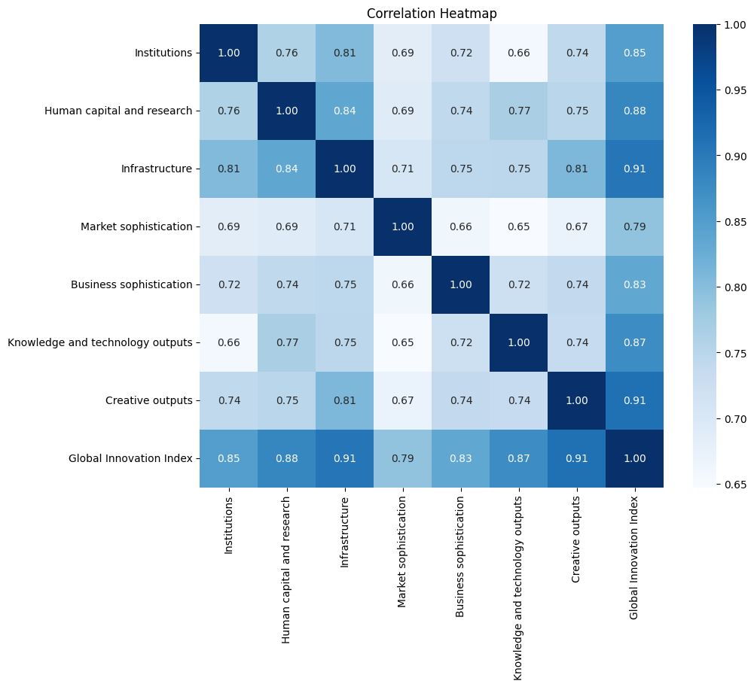

Figure 1.2: Feature Importance in the Global Innovation Index Across 160 Countries
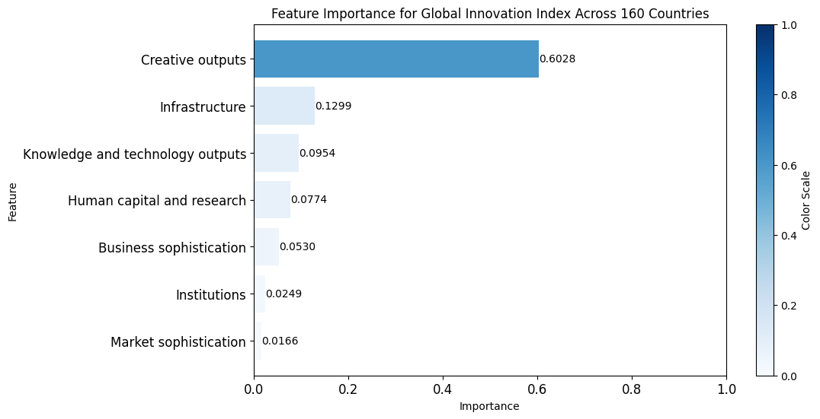

Figure 1.3: Feature Importance in the Global Innovation Index Across Six Countries
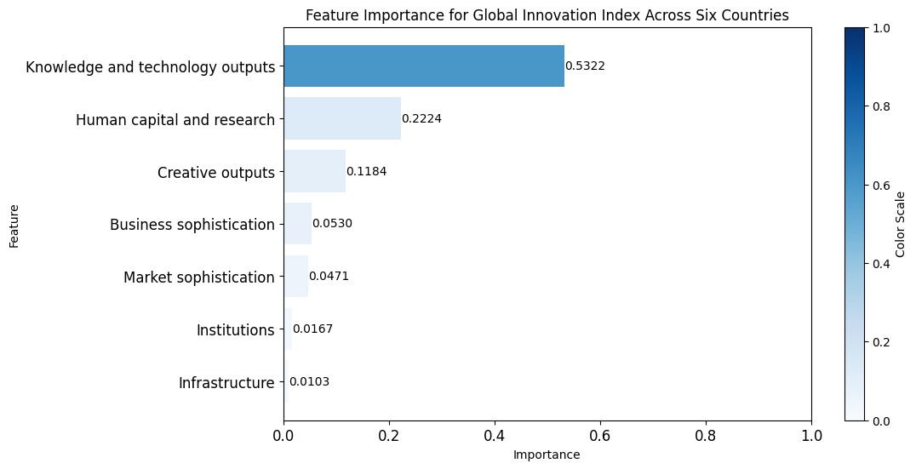

Figure 1.4: Radar Chart for Innovation Factors by Six Countries
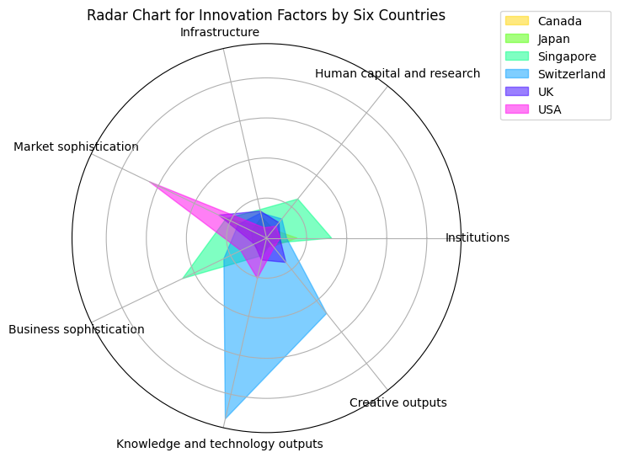

Figure 4.1 Line Plot of Total U.S. Patent Grants From 1931 to 2020

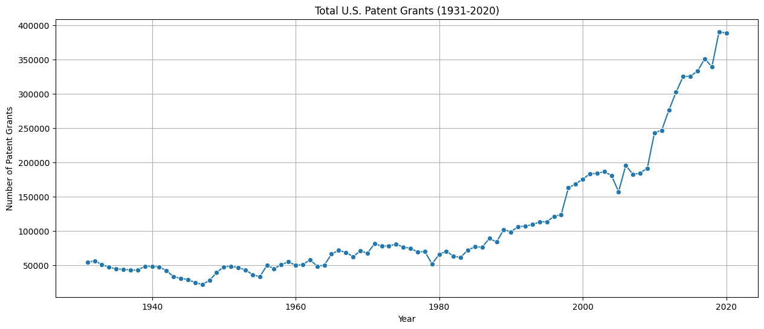

Figure 4.2 Stacked Area Plot of Three Types of U.S. Patent Grants (Utility, Design, and Plant) From 1931 to 2020

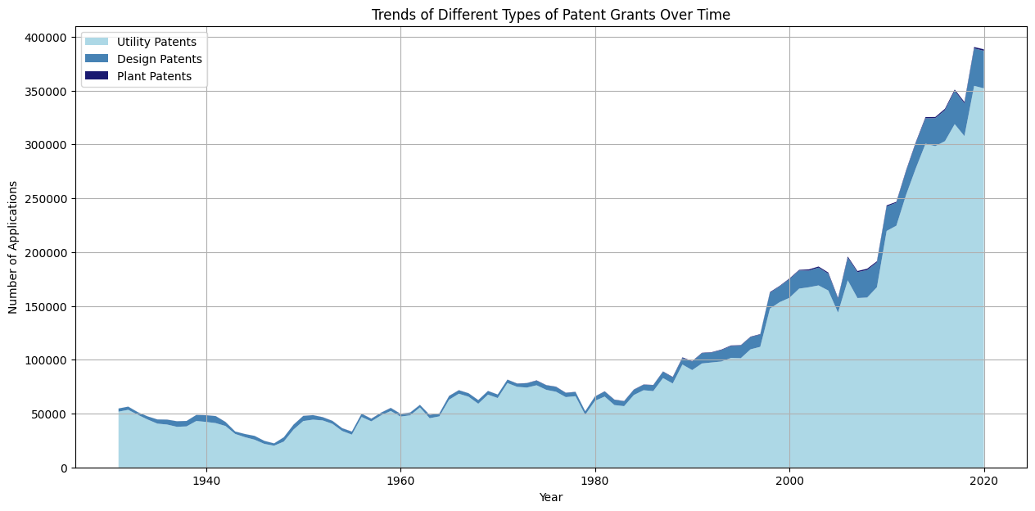

Figure 4.3 Line Plot of total Canada patent applications from 2013 to 2020
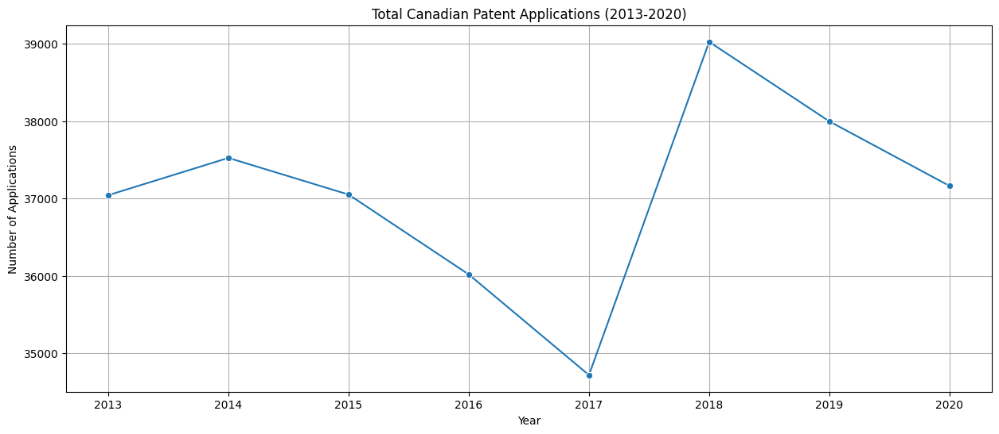

Figure 4.4 ACF and PACF of Differenced U.S. Total Applications Growth Rate

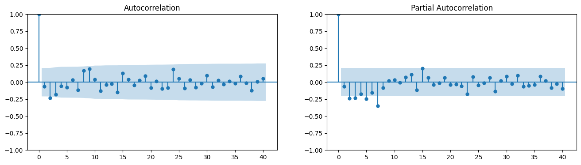

Figure 4.5 Seasonal Decomposition of U.S. Total Applications Growth Rate

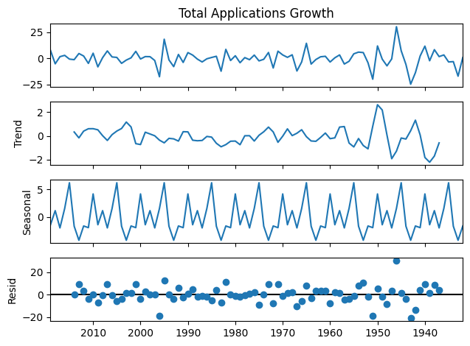

Reference
Anderson, J., & Davis, R. (2019). “Shaping Innovation through Intellectual Property: Lessons from the U.S. Post-1980 Model”. Journal of Intellectual Property Studies, 12(4), 321-340.

Baker, C., & Taylor, R. (2018). “The Role of Innovation Hubs in Knowledge Transfer: A Case Study of Canadian Initiatives”. Journal of Innovation Management, 14(2), 89-104.

Brás, Gonçalo (2022), “Global Innovation Index: panel data (2011-2022)”, Mendeley Data, V4, doi: 10.17632/cvkdzr8tv3.4

Bury, P. (2016). “Innovation in Regulatory Policy: A Fresh Look”. Regulatory Policy Institute.

Canadian Intellectual Property Office. (2020). Patent Statistics 2019-2020. Innovation, Science and Economic Development Canada. Retrieved from https://ised-isde.canada.ca/site/canadian-intellectual-property-office/en/patent-statistics-2019-2020
Department for Science, I. and T. (2023, November 14). UK innovation strategy: Leading the future by creating it. GOV.UK. https://www.gov.uk/government/publications/uk-innovation-strategy-leading-the-future-by-creating-it
Harris, D., & Nelson, S. (2021). “Motivating R&D Spending: Insights from the InnoHarbor Canada Program”. Science and Innovation Policies, 25(3), 201-220.

Johnson, M., & White, L. (2020). “Collaborative Models in Scientific Research: Lessons from HEAIP Implementation in Canada”. Research Policy, 45(2), 112-128.

Lock Search Group. (2018, June 18). Canada’s Expertise in Innovation [Image]. Retrieved from https://www.locksearchgroup.com/canadas-expertise-in-innovation/

OECD. (2023a). OECD Main Science and Technology Indicators - OECD. https://www.oecd.org/sti/msti.htm

OECD. (2023b). Research and development (R&D) - gross domestic spending on R&D - OECD data. https://data.oecd.org/rd/gross-domestic-spending-on-r-d.htm

Reed, G., & Foster, A. (2019). “Facilitating Interdisciplinary Collaboration through Innovation Hubs: Lessons from the Canadian Experience”. Journal of Interdisciplinary Studies in Innovation, 6(1), 45-62.

Sector, S. and I. P. (2022a, July 7). Government of Canada. Government of Canada, Innovation, Science and Economic Development Canada, Office of the Deputy Minister, Strategy and Innovation Policy Sector. https://ised-isde.canada.ca/site/canada-fundamental-science-review/en

Smith, A. (2019). “Incentivizing Scientific Research: A Comparative Analysis of Global Programs”. Journal of Innovation and Research Policies, 10(3), 215-230.

United States Patent and Trademark Office. (n.d.). U.S. Patent Statistics Chart [Data set]. Retrieved from https://www.uspto.gov/web/offices/ac/ido/oeip/taf/us_stat.htm

WIPO (2023), “Global Innovation Index 2023, 16th Edition Innovation in the face of uncertainty” Dataset retrieve from: https://www.wipo.int/publications/en/details.jsp?id=4679

Young, E., & Turner, L. (2020). “Aligning STEM Education with Industry Needs: A Case Study of Policy Impacts in Canada”. Journal of STEM Education, 15(3), 167-185.

