* **John wanted to go the movie with Sally.**

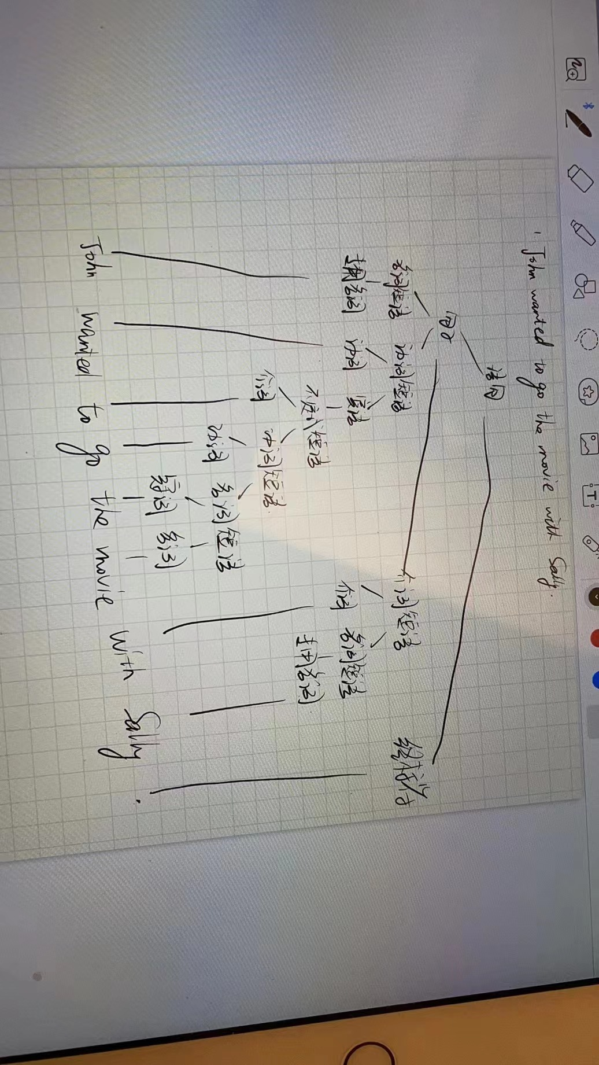

* **John wanted to go to the movie with Robert Redford.**

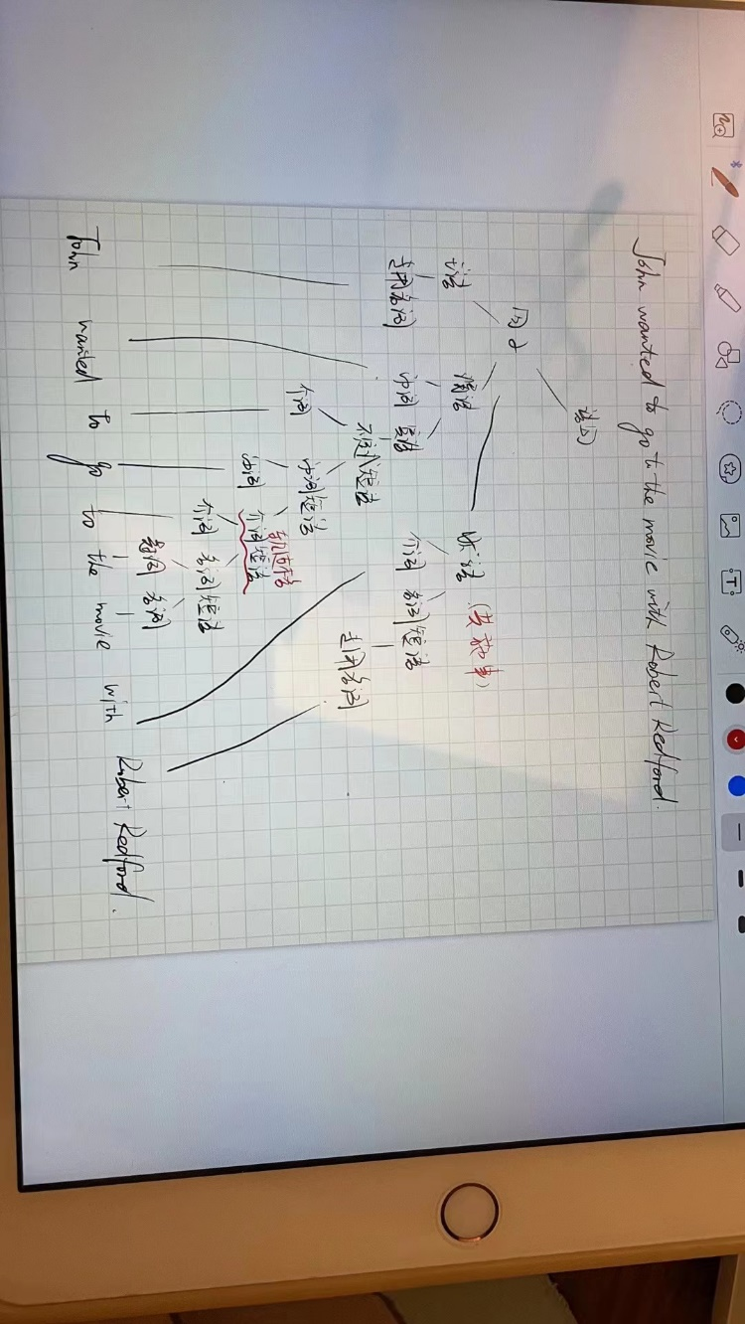

* **I heard the story listening to the radio.**

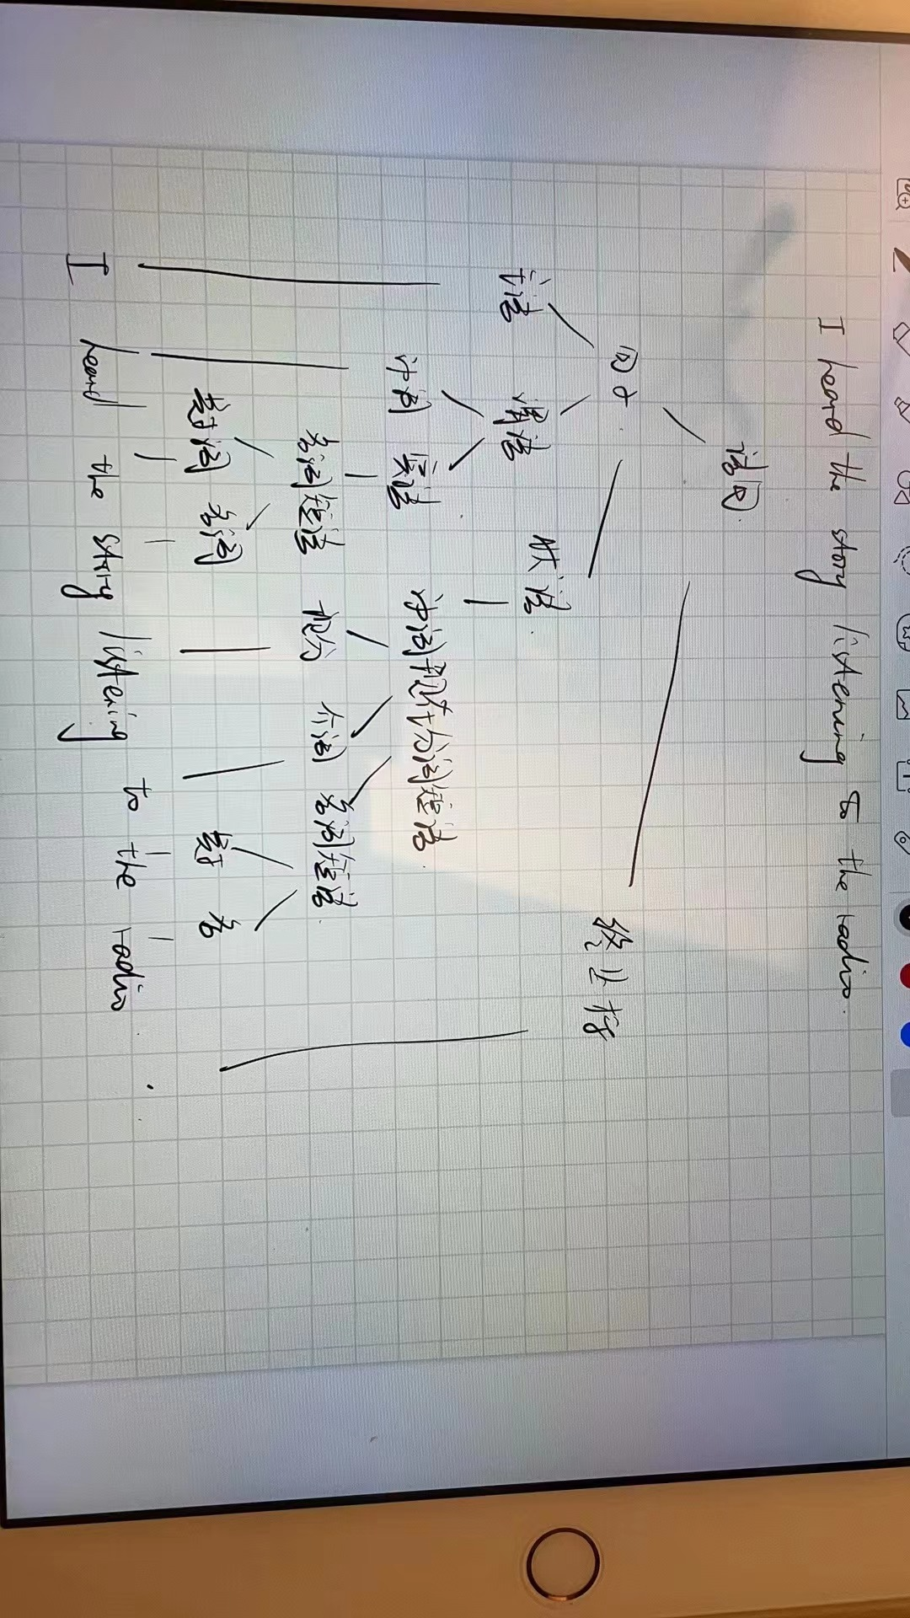

* **I heard the kids listening to the radio.**

