BIM-Intellect v2
Deep Learning and Graph Anomaly Detection
Technical Evaluation Note
Prepared for client and academic/professor review
Scope: model architecture, verified training evidence, requested AUC/Recall/True-False metrics, and inference-time evaluation plan
Key interpretation
The current deep-learning component is an unsupervised graph anomaly detector used for review prioritization. It is not the authoritative clash detector. The deterministic clash engine remains responsible for CLASH and CLEARANCE_VIOLATION decisions.

1. Executive Summary
BIM-Intellect v2 contains an optional deep-learning subsystem for graph anomaly detection. The subsystem is implemented as a two-layer sparse Graph Convolutional Network (GCN) autoencoder. It learns patterns in the IFC/Neo4j building graph and assigns an anomaly score to BIM elements that are difficult to reconstruct from their geometric, topological, and categorical context.
The model is deliberately separated from the deterministic clash-detection engine. It does not create, remove, or reclassify clashes. Instead, its anomaly scores are written to elements and can be attached to clash relationships as an additional triage signal for engineering review.
Current verified result
The supplied 100-epoch training history shows stable convergence: total loss decreased from 0.3562 to 0.1915 (46.2% reduction), feature reconstruction loss decreased 52.9%, and structural reconstruction loss decreased 40.8%. The calibrated anomaly threshold is 0.7904, selected at the 99th percentile of training scores.

However, the current repository and supplied artifacts do not contain expert-reviewed anomaly ground-truth labels. Therefore ROC-AUC, Recall, Precision, F1, TP, TN, FP, and FN cannot yet be reported as scientifically valid performance measures. These metrics require a labelled validation set. Inference time is also not recorded in the supplied artifacts and must be measured with a controlled benchmark.

2. Position of Deep Learning in the BIM-Intellect Architecture
The system has two distinct analysis paths that must not be conflated:
Path | Method | Authoritative output | Role
Clash / clearance analysis | Deterministic AABB geometry + sweep-and-prune rules | CLASH or CLEARANCE_VIOLATION | Engineering issue detection
Graph anomaly analysis | Unsupervised sparse GCN autoencoder | Continuous anomaly score + isAnomaly flag | Review prioritization / triage signal

Conceptual flow:
IFC models -> Neo4j graph -> node features and graph edges -> GCN encoder -> latent representation -> feature/link reconstruction -> reconstruction errors -> anomaly score -> thresholded triage flag
Only the pre-clash graph relationships are used as model inputs. CLASHES_WITH edges are explicitly excluded so the neural network cannot learn the output of the deterministic clash detector. This is an important anti-leakage design decision.

3. Deep-Learning Inputs and Model Architecture

3.1 Node features
The documented anomaly feature set includes:
- Geometry: bounding-box availability, center coordinates, extents, and log-scaled approximate volume.
- Topology: total/in/out degree, mean neighbor degree, isolation, and relationship-specific degree counts.
- Spatial context: storey presence and storey category.
- Semantic context: one-hot IFC type and one-hot storey, with explicit unknown buckets.
- Source graph edges: AGGREGATES, CONTAINS, BOUNDS, and PORT_OF. CLASHES_WITH is excluded.

3.2 Neural-network structure
The model uses two sparse GCN encoder layers. The encoder produces a compact latent representation of each graph node. Two decoders are then used: an MLP feature decoder reconstructs node attributes, while a dot-product link decoder reconstructs graph connectivity.
Parameter | Current configured value
Encoder | Two sparse GCN layers
Hidden dimension | 64
Latent dimension | 16
Dropout | 0.1
Epochs | 100
Learning rate | 0.001
Weight decay | 1e-05
Negative sampling ratio | 1.0
Device in supplied run | CPU
Seed | 42

3.3 Training objective
The documented training objective is a weighted reconstruction loss:
Loss = alpha x Feature Reconstruction Loss + beta x Structural Reconstruction Loss
For the supplied run, alpha = 0.7 and beta = 0.3. Feature reconstruction therefore has the larger weight. Structural reconstruction uses positive graph links together with sampled negative links.

4. Verified Training Evidence
The following values are directly supported by the supplied training_history.json artifact. They demonstrate optimization/convergence of the autoencoder, not supervised classification accuracy.
Metric | Epoch 1 | Epoch 100 | Relative reduction
Total loss | 0.3562 | 0.1915 | 46.2%
Feature reconstruction loss | 0.2302 | 0.1085 | 52.9%
Structural reconstruction loss | 0.6501 | 0.3850 | 40.8%

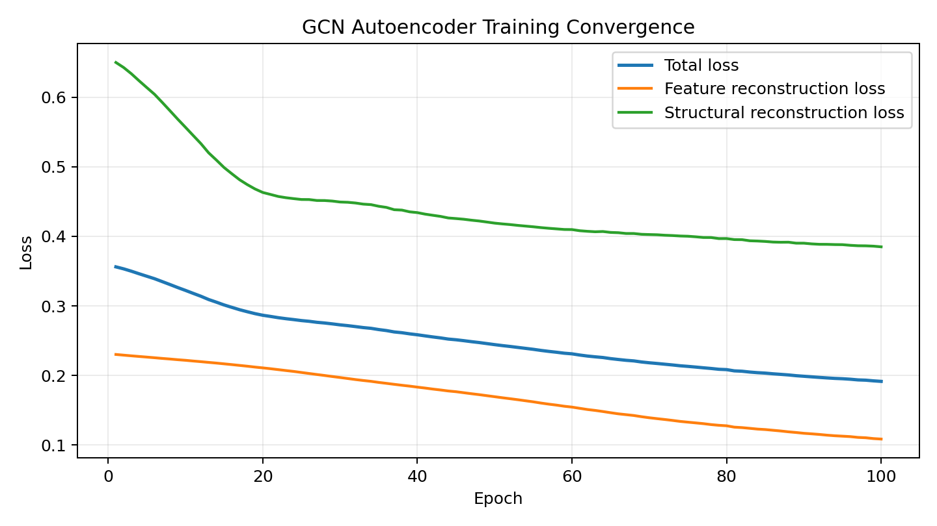
Figure 1. Training convergence across 100 epochs. The three reconstruction objectives decline steadily.
Calibration statistic | Verified value
Mean anomaly score | 0.215824
Score standard deviation | 0.621703
Threshold percentile | 99.0th percentile
Anomaly threshold | 0.790425
Mean feature error | 0.107058
Mean structural error | 0.469612

Critical clarification
A 99th-percentile anomaly threshold does NOT mean 99% accuracy. It means that a high reconstruction-error tail of the training-score distribution is used as the triage cutoff. Accuracy/AUC/Recall require ground-truth labels.

5. Client-Requested Metrics: What Can and Cannot Be Reported Today
The client has requested AUC, Recall, False/True metrics, and inference time. The correct current status is summarized below.
Requested metric | Current status | Reason / evidence needed
ROC-AUC | Not currently measurable | Requires labelled normal/anomalous ground truth and continuous anomaly scores.
PR-AUC | Not currently measurable | Also requires labelled ground truth; useful when anomalies are rare.
Recall / Sensitivity | Not currently measurable | Requires TP and FN from labelled validation data.
Precision | Not currently measurable | Requires TP and FP from labelled validation data.
F1 score | Not currently measurable | Requires labelled Precision and Recall.
True Positives (TP) | Not currently measurable | Needs expert labels defining actual anomalies.
True Negatives (TN) | Not currently measurable | Needs expert labels defining actual normal elements.
False Positives (FP) | Not currently measurable | Needs comparison between model flags and expert labels.
False Negatives (FN) | Not currently measurable | Needs comparison between model flags and expert labels.
Reconstruction losses | Available and verified | Contained in the supplied 100-epoch training artifact.
Anomaly threshold | Available: 0.7904 | 99th-percentile calibration from training scores.
Inference time | Not yet benchmarked | Must be measured on a specified graph, CPU/GPU, checkpoint, and timing scope.

It would be scientifically incorrect to insert arbitrary zero values for unavailable classification metrics. A value of 0 would mean the metric was actually evaluated and the model obtained zero performance. The correct notation is N/A or “not yet measurable without labelled validation data.”

6. How AUC, Recall, and True/False Metrics Should Be Evaluated

6.1 Required ground truth
A reviewed validation set must assign each evaluated BIM element a reference label such as NORMAL or ANOMALOUS. These labels should ideally be produced or approved by a BIM/domain expert using explicit anomaly criteria. The existing reconstruction score can then be compared with these labels.
 | Ground truth: Anomaly | Ground truth: Normal
Predicted anomaly | True Positive (TP) | False Positive (FP)
Predicted normal | False Negative (FN) | True Negative (TN)

6.2 Core formulas
Metric | Formula | Interpretation
Recall / Sensitivity | TP / (TP + FN) | Of all real anomalies, how many were detected?
Precision | TP / (TP + FP) | Of all flagged anomalies, how many were truly anomalous?
Specificity / TNR | TN / (TN + FP) | Of all normal elements, how many were correctly left unflagged?
False Positive Rate | FP / (FP + TN) | What fraction of normal elements were incorrectly flagged?
F1 score | 2 x Precision x Recall / (Precision + Recall) | Balances Precision and Recall.

6.3 ROC-AUC and PR-AUC
ROC-AUC should be computed from the continuous anomaly score, not only from the fixed 0.7904 threshold. The threshold is swept across the score range and the True Positive Rate is plotted against the False Positive Rate. AUC summarizes ranking/separation across all thresholds.
Because anomaly datasets are often highly imbalanced (many normal elements and relatively few anomalies), Precision-Recall AUC (PR-AUC) should be reported alongside ROC-AUC. PR-AUC is usually more informative about performance on the minority anomalous class.

7. Recommended Validation Protocol
To produce professor/client-ready supervised metrics, use the following protocol:
- Freeze the current trained checkpoint, feature encoder, normalization rules, and 99th-percentile threshold before evaluation.
- Create a validation set that is not used for training or threshold calibration.
- Obtain expert-reviewed labels for normal/anomalous BIM elements, with written criteria for what counts as an anomaly.
- Run the model once on the labelled validation set and retain each continuous anomaly score.
- Compute ROC-AUC and PR-AUC using the continuous scores.
- At the production threshold (0.7904), compute TP, TN, FP, FN, Recall, Precision, Specificity, FPR, and F1.
- Report the number of evaluated elements and class prevalence (number/percentage anomalous).
- Where feasible, use bootstrap confidence intervals or repeated validation to quantify uncertainty.
- Keep the anomaly evaluation separate from clash-detection accuracy because the two subsystems answer different questions.
Recommended minimum reporting table
Dataset/split size; anomaly prevalence; threshold; TP/TN/FP/FN; Recall; Precision; Specificity; F1; ROC-AUC; PR-AUC; confidence intervals where possible; and exact model/checkpoint identifier.

8. Inference-Time Evaluation
The supplied documents and training history do not record a validated inference-time measurement. Therefore no latency value should be claimed yet. Inference should be benchmarked under a fixed hardware/software configuration and should distinguish neural-network time from surrounding graph/database work.
Timing level | What it measures
Feature preparation | Reading/constructing graph tensors and encoded node features.
Model forward pass | GCN encoder + feature/link reconstruction for the prepared graph.
Score calculation | Feature/structural errors, anomaly-score computation, thresholding.
Persistence | Writing anomalyScore / error / isAnomaly fields back to Neo4j.
End-to-end | Complete anomaly operation as experienced by the application/API.

8.1 Recommended benchmark method
- Use the same checkpoint and preprocessing pipeline used for production.
- Record hardware (CPU/GPU model), RAM, PyTorch version, thread settings, and graph size.
- Perform 5-10 warm-up runs before timing.
- Perform at least 30 measured runs under the same conditions.
- Report mean, median, standard deviation, P95 latency, and throughput (nodes/second or ms per 1,000 nodes).
- Report model-only time separately from end-to-end API/Neo4j time.
Benchmark field | Value to report after measurement
Graph/model scope | e.g., labelled validation graph or 210_King_Merged.ifc project scope
Number of nodes / edges | Measured value
Device | CPU or GPU + exact model
Model forward pass | xx ms
Feature + model inference | xx ms
End-to-end incl. Neo4j | xx ms
Median / P95 | xx ms / xx ms
Throughput | xx nodes/s

9. Interpretation Relative to Clash Detection
The deterministic clash engine remains the authoritative issue detector. It classifies AABB overlap as CLASH and sub-threshold envelope separation as CLEARANCE_VIOLATION. The anomaly model is a separate unsupervised signal. It can make a clash easier to prioritize for review if one or both involved elements are anomalous, but it cannot change the deterministic issue label or metric.
Question | Answered by
Do these two elements geometrically clash under the implemented AABB rule? | Deterministic clash engine
Is this element unusual relative to learned graph/feature patterns? | GCN anomaly model
Which detected issue may deserve earlier human review? | Deterministic issue + optional anomaly scores

When anomaly inference is enabled, the system can persist anomalyScore, anomalyFeatureError, anomalyStructuralError, and isAnomaly on nodes. Issue relationships may additionally receive anomaly scores for both endpoints and a combined anomaly score. By design, the rule-based issue and metric remain unchanged.

10. What the Current Results Do Prove - and What They Do Not
Supported by current evidence | Not supported yet
The GCN autoencoder trained for 100 epochs with steadily decreasing reconstruction losses. | A claim that the model has a specific anomaly-detection accuracy.
The model produces continuous reconstruction-based anomaly scores. | ROC-AUC/PR-AUC without labelled validation data.
The current triage cutoff is the 99th-percentile threshold (0.7904). | A claim that the 99th percentile equals 99% accuracy.
The architecture separates deterministic engineering rules from ML prioritization. | Precision, Recall, F1, TP/TN/FP/FN without expert ground truth.
The supplied run was configured on CPU. | A specific production inference-time number without a benchmark.

11. Suggested Wording for Client / Professor
“BIM-Intellect uses a sparse Graph Convolutional Network autoencoder as an unsupervised anomaly-detection layer over the IFC/Neo4j building graph. The model learns geometric, semantic, and graph-relational patterns and assigns higher scores to elements that are harder to reconstruct. The current model uses two GCN encoder layers, a 64-dimensional hidden representation and a 16-dimensional latent representation. Across 100 epochs, total reconstruction loss decreased by approximately 46.2%, feature reconstruction loss by 52.9%, and structural reconstruction loss by 40.8%. Anomaly triage currently uses a 99th-percentile threshold of 0.7904. The anomaly subsystem is intentionally separated from the deterministic clash engine and does not alter clash classifications.”
“At this stage, the repository does not contain expert-reviewed anomaly ground-truth labels. Consequently, supervised performance measures such as ROC-AUC, Recall, Precision, F1, TP, FP, TN, and FN cannot yet be reported scientifically. The correct next step is to construct an independent labelled validation set, evaluate the continuous anomaly scores using ROC-AUC and PR-AUC, compute the confusion matrix and threshold-based metrics at the deployed cutoff, and separately benchmark model-only and end-to-end inference latency under a documented hardware configuration.”

12. Recommended Next Deliverables
- A labelled anomaly-validation CSV containing element identifier, project/source model, expert label, anomaly score, and review notes.
- A confusion-matrix report at the current 0.7904 threshold.
- ROC and Precision-Recall curves with AUC values.
- Recall, Precision, Specificity, FPR, F1, and class-prevalence table.
- CPU inference benchmark with model-only and end-to-end timing.
- A versioned evaluation report tying every result to the exact checkpoint, feature schema, dataset split, and software/hardware environment.

13. Source Basis
This note is grounded in the supplied BIM-Intellect project documentation and training artifact. No unsupported AUC/Recall/inference values have been invented.
Ref. | Source | Used for
S1 | BIM-Intellect v2 - Integrated Project Report (report date 2026-09-05). | System architecture, graph anomaly role, documented two-building 12,311-node artifact, limitations, and separation from deterministic clash detection.
S2 | BIM-Intellect v2 - README. | High-level architecture, optional sparse-GCN anomaly scoring, technology stack, verification summary.
S3 | BIM-Intellect v2 - System Documentation, version 2.4 (updated 2026-09-05). | Detailed graph anomaly features, model/training defaults, leakage prevention, inference integration, and evaluation limitation.
S4 | training_history.json. | Exact 100-epoch loss history, configuration, calibration distribution, and threshold 0.7904250622.

Final academic interpretation
The current evidence is strong enough to document the implemented neural architecture and its reconstruction convergence. It is not yet sufficient to claim supervised anomaly-detection effectiveness. A labelled validation stage is therefore not a cosmetic addition; it is the necessary experimental step that converts an unsupervised engineering prototype into a quantitatively evaluated anomaly detector.

