## **Part 1 – Configure application**

**Create a service connection in a Azure DevOps project to your subscription**

New service connection

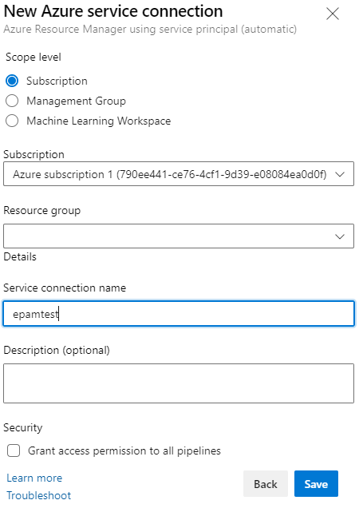 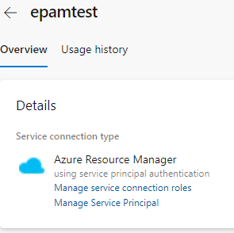

add app role

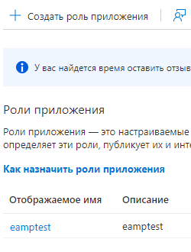

1. **Find a .net pet project for the experiments**

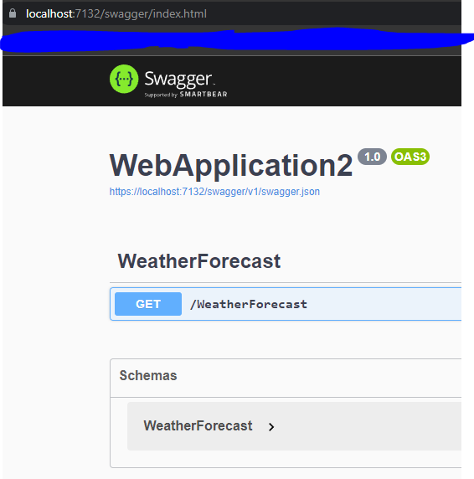

1. **Build your app locally .net project via dotnet tool. dotnet restore/build/run**



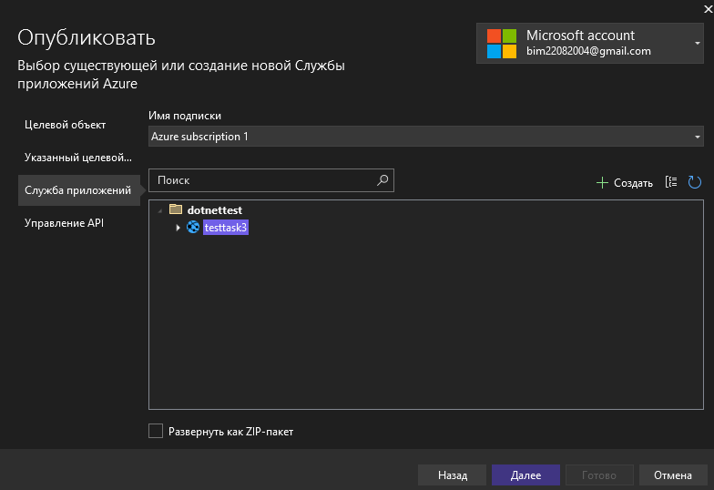

1. **Create an Azure DevOps repo**

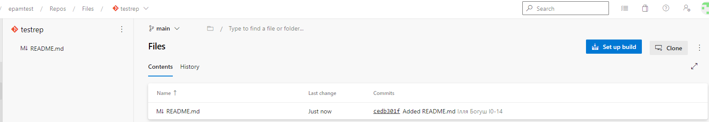

1. **Create a branching policy for your application**

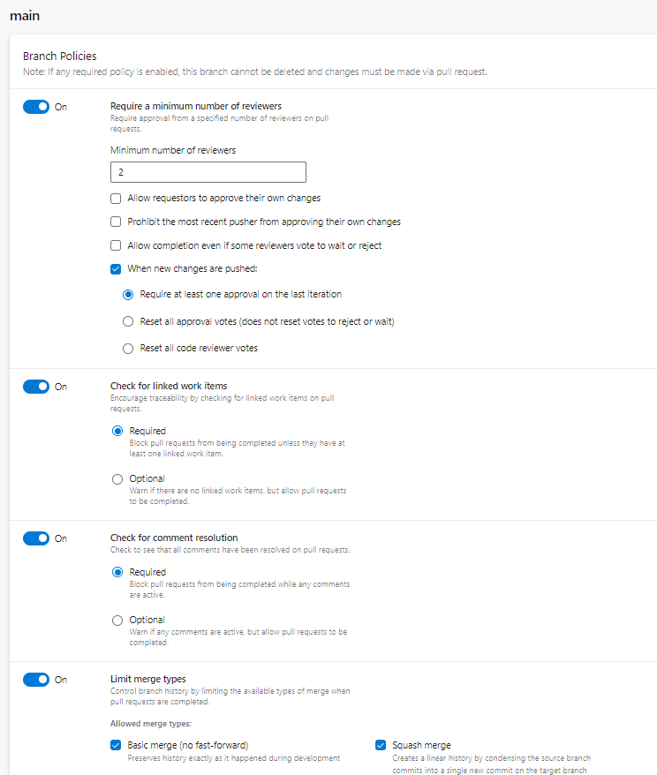

## **Part 2 – Configure a pipeline to deploy infrastructure**

**Below is describing on how to do it via terraform. If you want to use terraform you need to create service connection in manual way. Otherwise you won’t be able to deploy your iac – Navigate to the last section**

### **Terraform storage account**

**Create a separate resource group and deploy azure storage account**

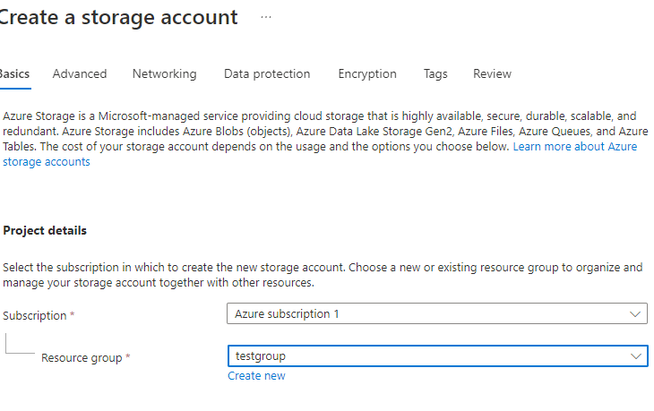

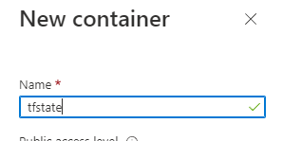

### **Terraform preparation**

1. **Create another repo to store devops code**

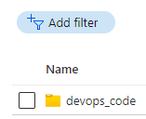

1. **Create a folder terraform**

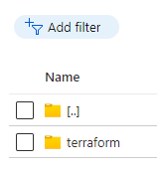

1. **Add app service implementation**

