Linux administration with bash. Home task

**A. script_1.sh**

without arguments



incorrect parameter



key --all

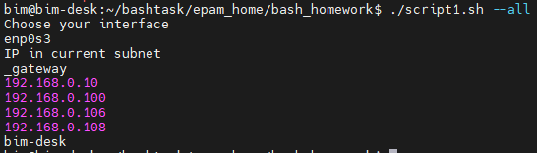

key --target

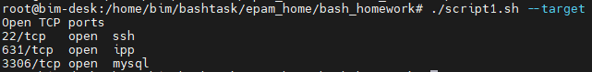

**B. script_2.sh**

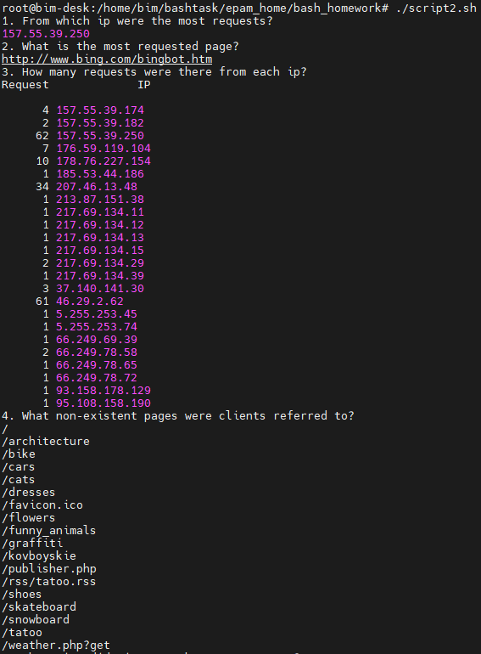

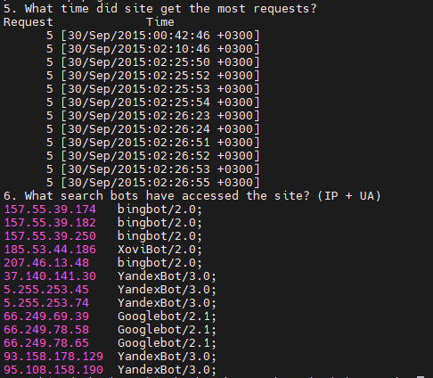

**C. script_3.sh**

before running **script_3.sh**



running **script_3.sh**

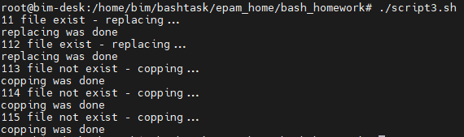

after running **script_3.sh**

