**Operating Systems.**

**CSE2005 LAB**

**LAB1**

**Bimal Parajuli (20BDS0405)**

**Task:**

* Make a file and write numbers from 1 to 100 in it.
* Read the contents of that file.
* Create a oddnumbers file and store the odd numbers of the 1st file into it.
* Create a evennumbers file and store the even numbers of the 2nd file into it.

***Codes.:***

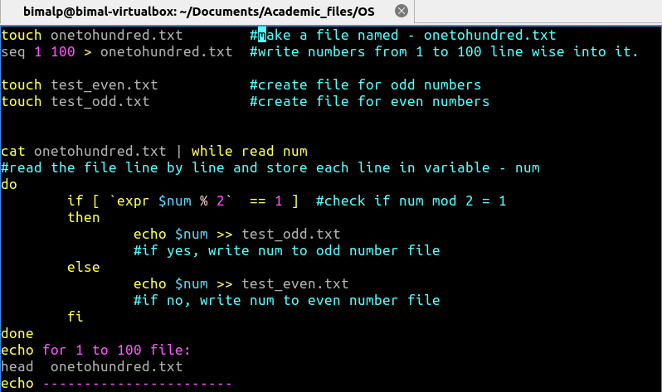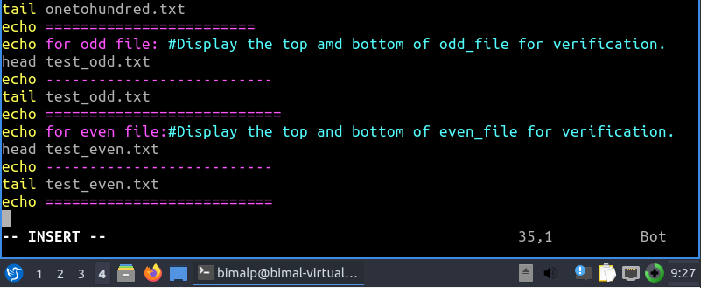

**Output After execution.:**

