# DIGITAL LOGIC CIRCUIT DESIGN

**SIMPLIFICATION OF BOOLEAN FUNCTIONS USING K-MAP TECHNIQUES**

**OBJECTIVE:**

* To develop the truth table for a combinational logic problem
* To use Karnaugh map to simplify Boolean expressions.
* To draw and simplify sum of products expressions.
* To draw logic diagrams using NAND gates.

# APPARATUS:

− PB-503

* + 7400 Quadruple 2 input NAND gates.
  + 7404 Hex inverters
  + 7410 Triple 3-input NAND gates
  + 7420 Dual 4-input NAND gates
  + 7432 Dual 2-input OR gates
  + 7408 Dual 2-input AND gates

***Part 1: BCD invalid code detector***

BCD is a 4-bit binary code representing the decimal numbers 0 through 9. The binary numbers 1010 through 1111 are not used in BCD.

1. Construct a truth table containing all possible inputs and desired output. Assume that the desired output for a valid code is a 1, and for an invalid code is 0. Complete the truth table as shown in Table 1. A is the most significant bit, and D is the least significant bit.

|  |  |  |  |  |
| --- | --- | --- | --- | --- |
| A | B | C | D | X |
| 0 | 0 | 0 | 0 | 1 |
| 0 | 0 | 0 | 1 | 1 |
| 0 | 0 | 1 | 0 | 1 |
| 0 | 0 | 1 | 1 | 1 |
| 0 | 1 | 0 | 0 | 1 |
| 0 | 1 | 0 | 1 | 1 |
| 0 | 1 | 1 | 0 | 1 |
| 0 | 1 | 1 | 1 | 1 |
| 1 | 0 | 0 | 0 | 1 |
| 1 | 0 | 0 | 1 | 1 |
| 1 | 0 | 1 | 0 | 0 |
| 1 | 0 | 1 | 1 | 0 |
| 1 | 1 | 0 | 0 | 0 |
| 1 | 1 | 0 | 1 | 0 |
| 1 | 1 | 1 | 0 | 0 |
| 1 | 1 | 1 | 1 | 0 |

Table: Truth Table of validity of BCD.

1. Draw the Karnaugh map, and write the simplified Boolean expression for

the valid codes as sum of products.

|  |  |  |  |  |
| --- | --- | --- | --- | --- |
| AB \ CD | 00 | 01 | 11 | 10 |
| 00 | 1 | 1 | 1 | 1 |
| 01 | 1 | 1 | 1 | 1 |
| 11 | 0 | 0 | 0 | 0 |
| 10 | 1 | 1 | 0 | 0 |

F = A’ + B’ C’

1. Draw the circuit for the above simplified Boolean expression.

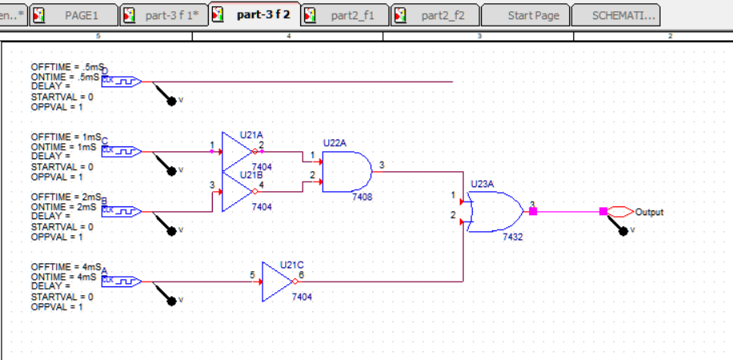

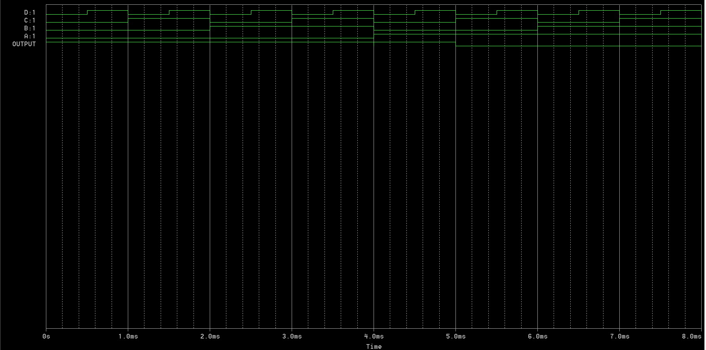

1. Using the universal property of the NAND gate

connect an equivalent circuit for these codes that uses only NAND gates.

**Using NAND gates only:**

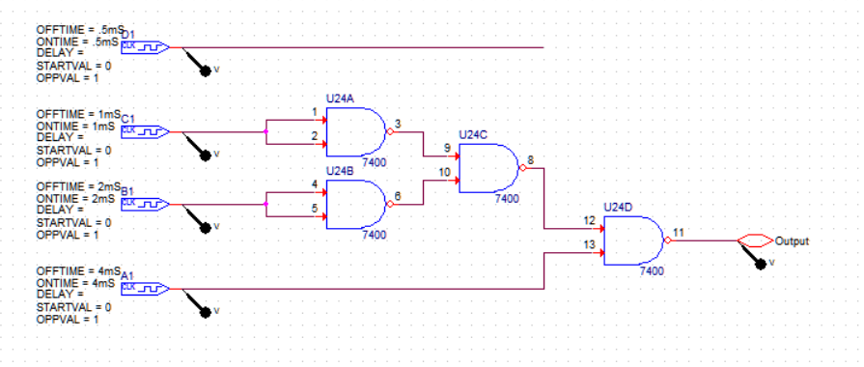

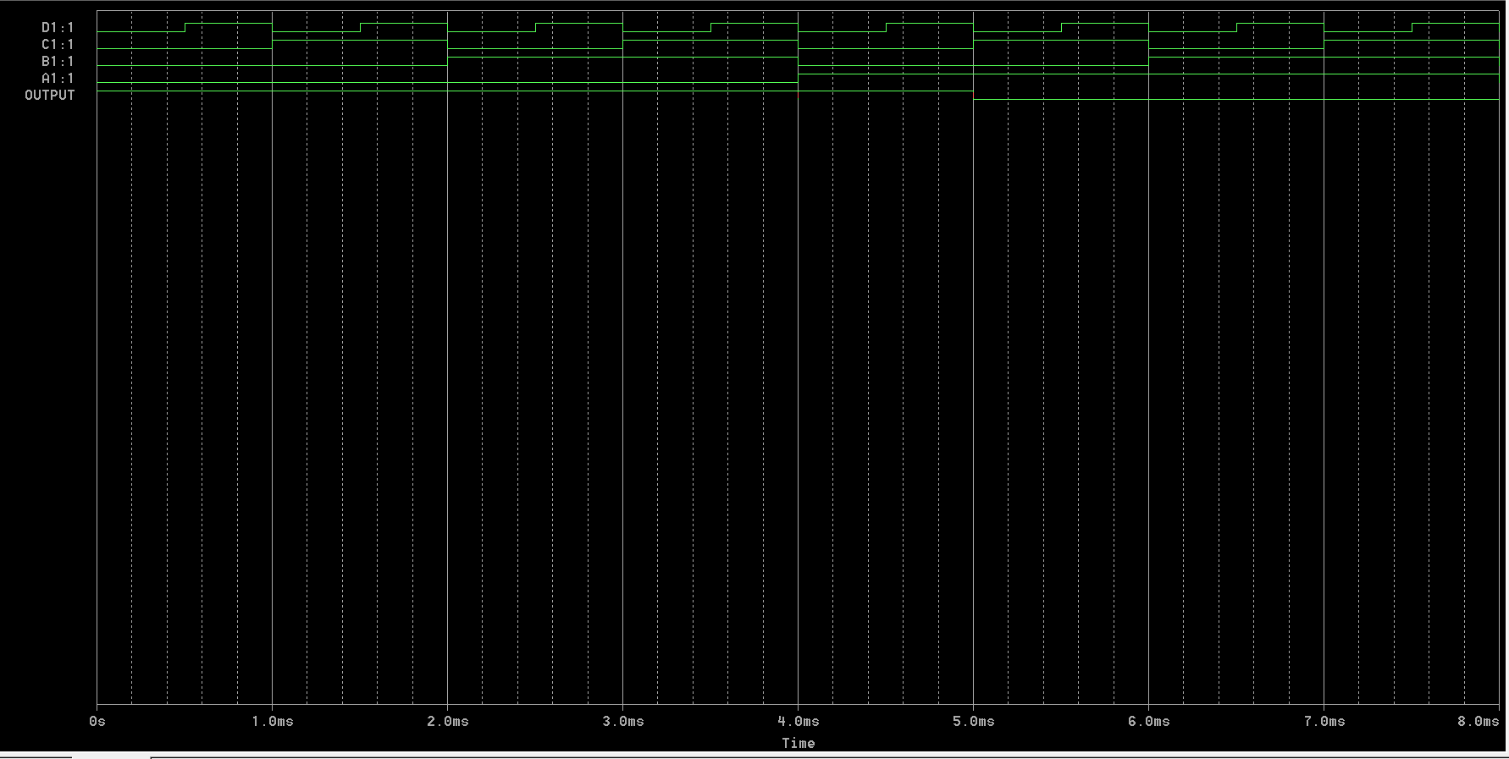

***Part 2: Boolean Functions (1)***

* 1. Simplify the following two Boolean functions by means of Karnaugh maps.
  2. Draw the logic diagrams for outputs F1 and F2 in terms of the inputs A, B, C, and D.
  3. Implement and draw the two functions F1 and F2 together by using minimum number of NAND gates.
  4. Connect the circuit and verify it’s operation by preparing a truth table for F1 and F2 similar to Table 1.

For Boolean Function F1:

F1 (A, B, C, D) = Σm (0,1,4,5,8,9,10,12,13)

K- Map of F1:

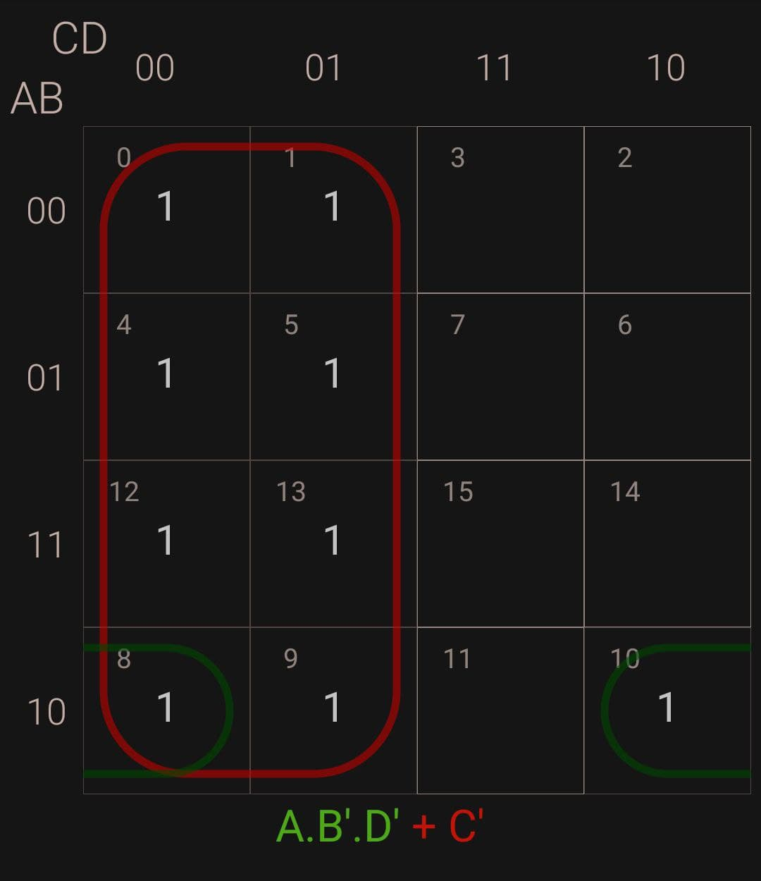

Logic Circuit of F1:

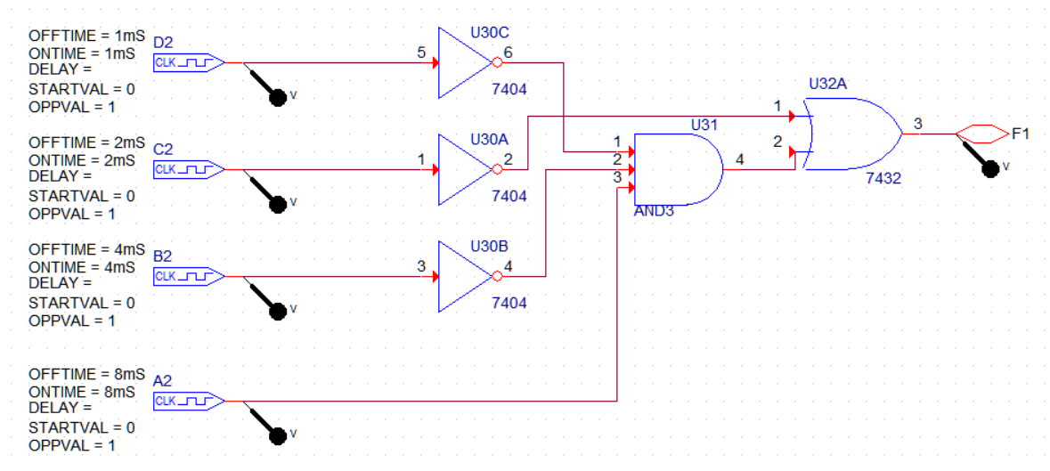

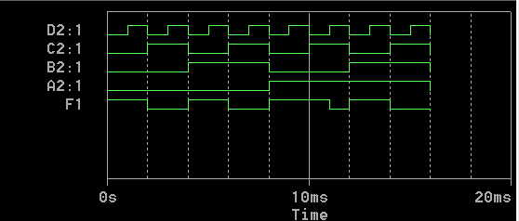

Logic Circuit of F1 using Only NAND gates:

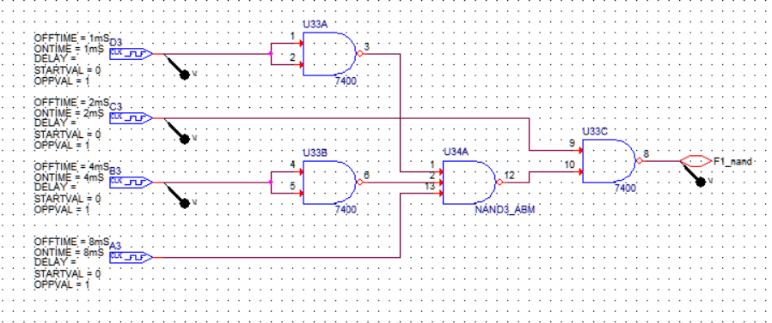

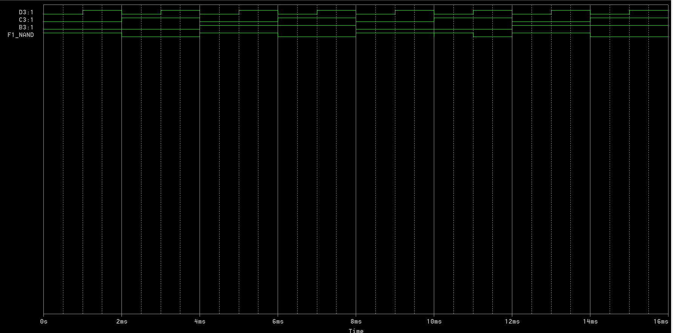

F2 (A,B,C,D)= Σm (3,5,7,8,10,11,13,15)

**K- Map of F2:**

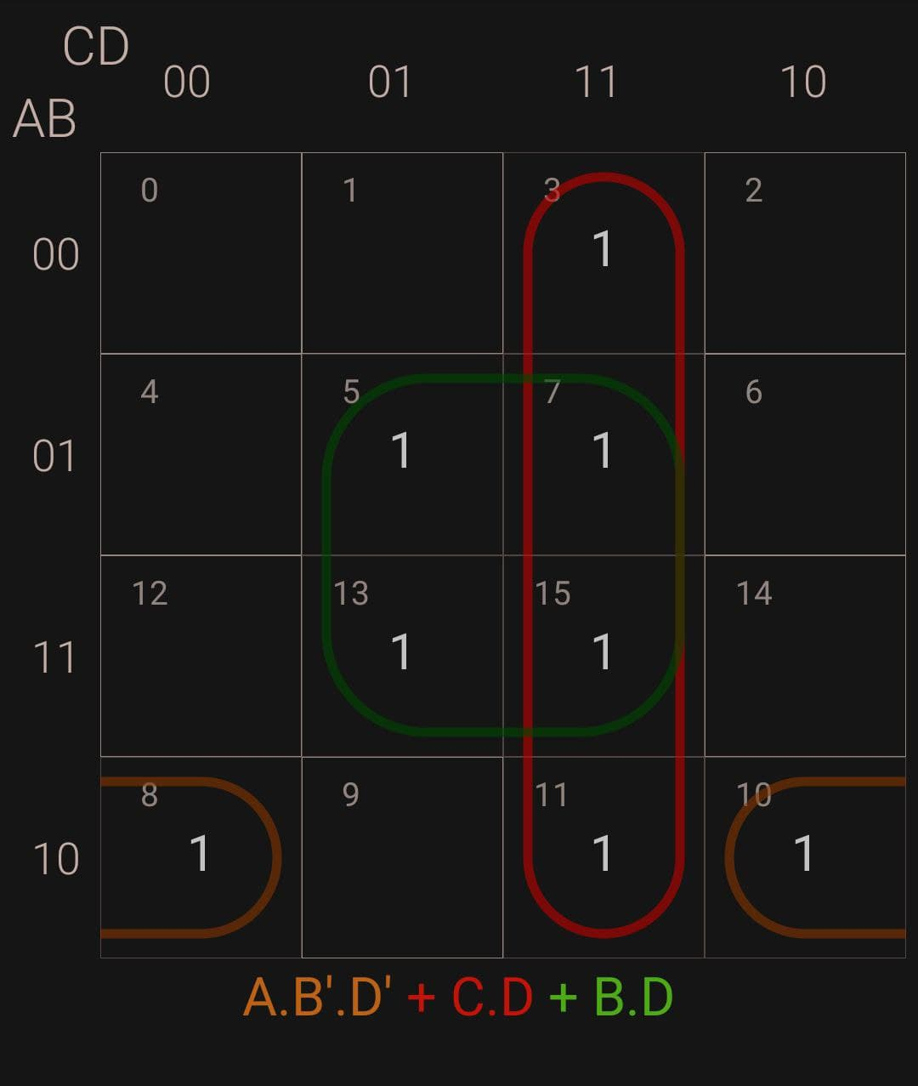

Logic Circuit of F2:

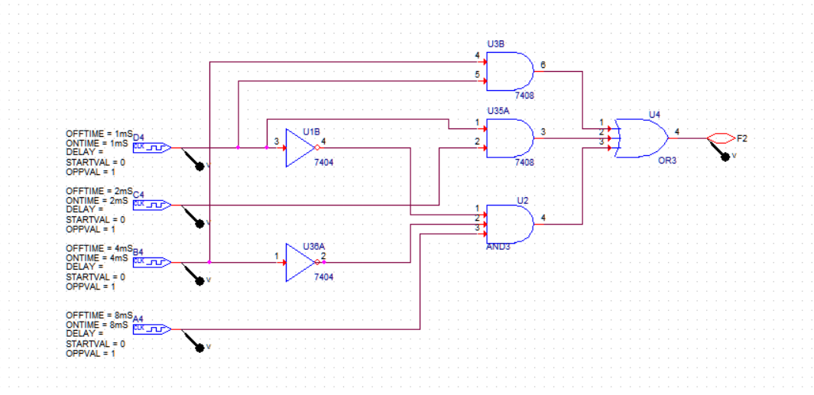

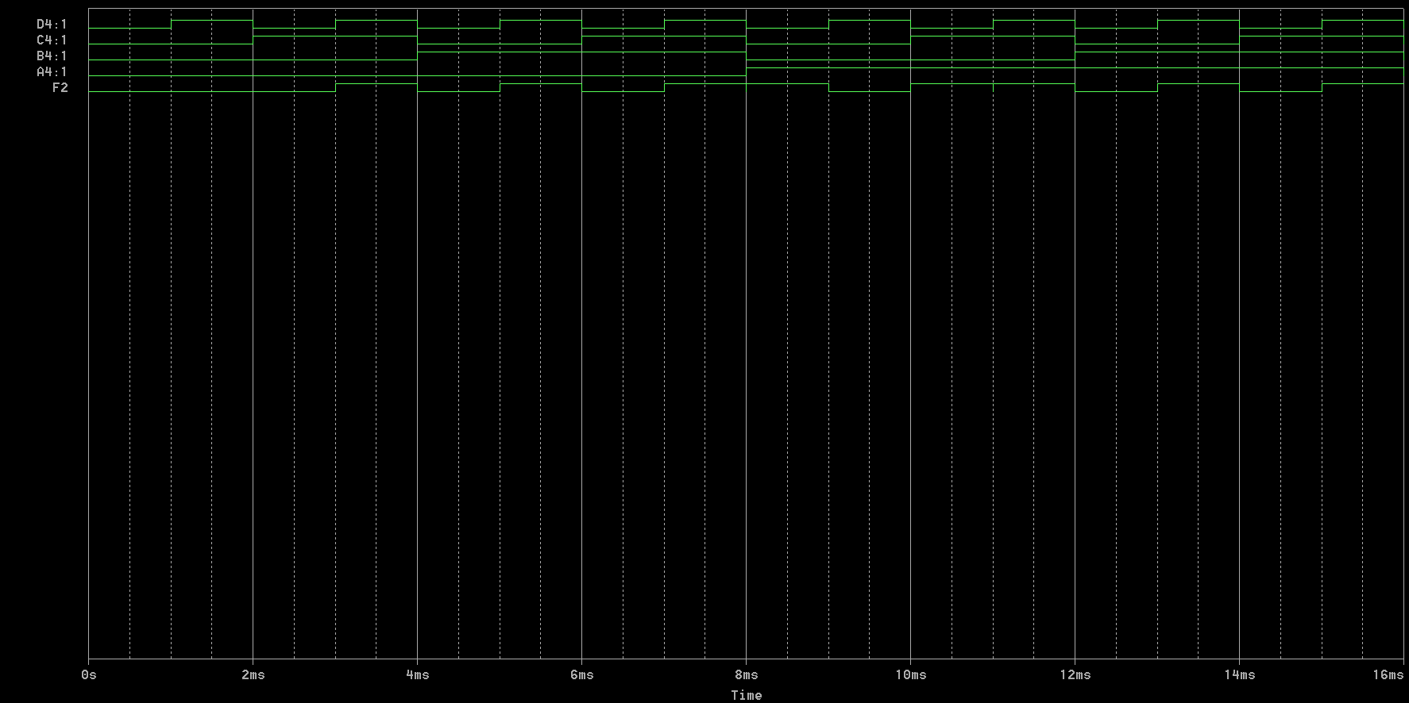

Logic Circuit of F2 using Only NAND gates:

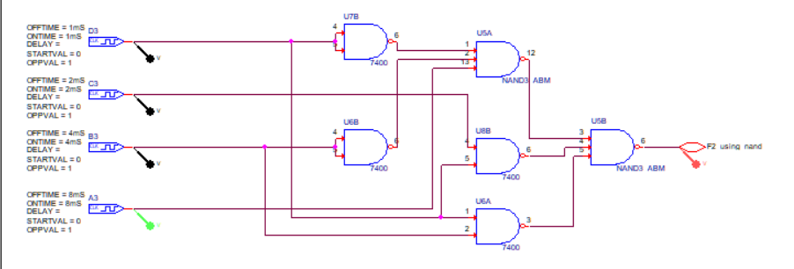

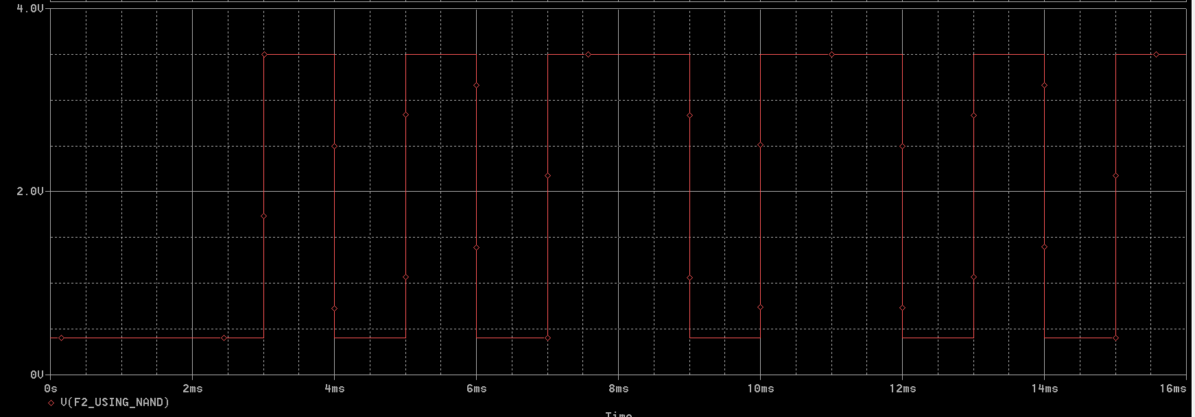

***Part 3: Boolean Functions (2)***

1. Derive a truth table for the following Boolean Functions.

*F=A’D+B’D+BC+AB’D*

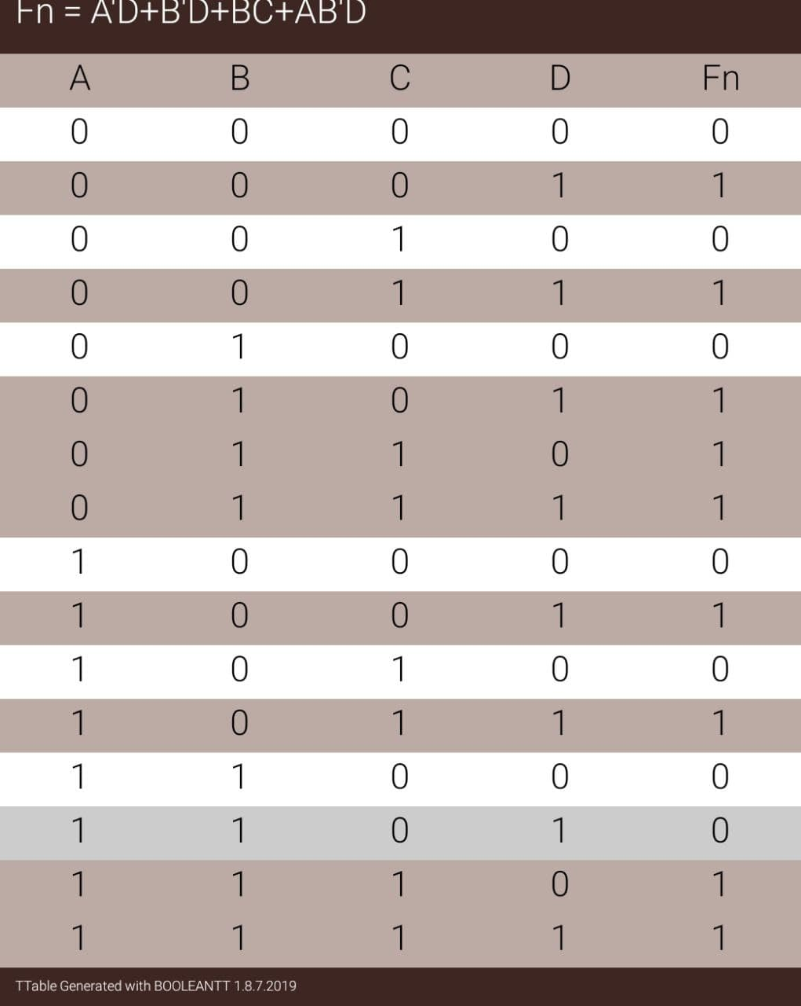

1. Draw a Karnaugh map.

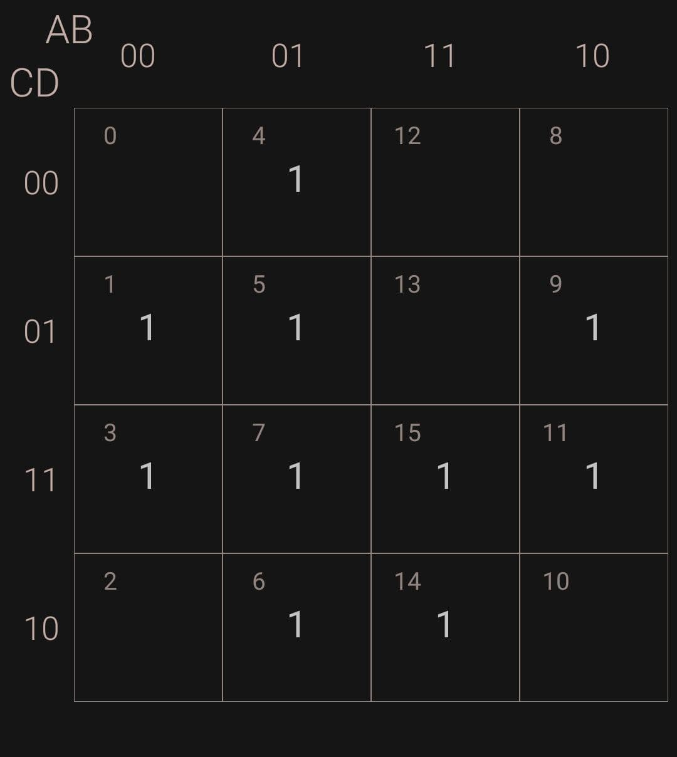

1. Combine all the 1’s to obtain the simplified function for *F*.

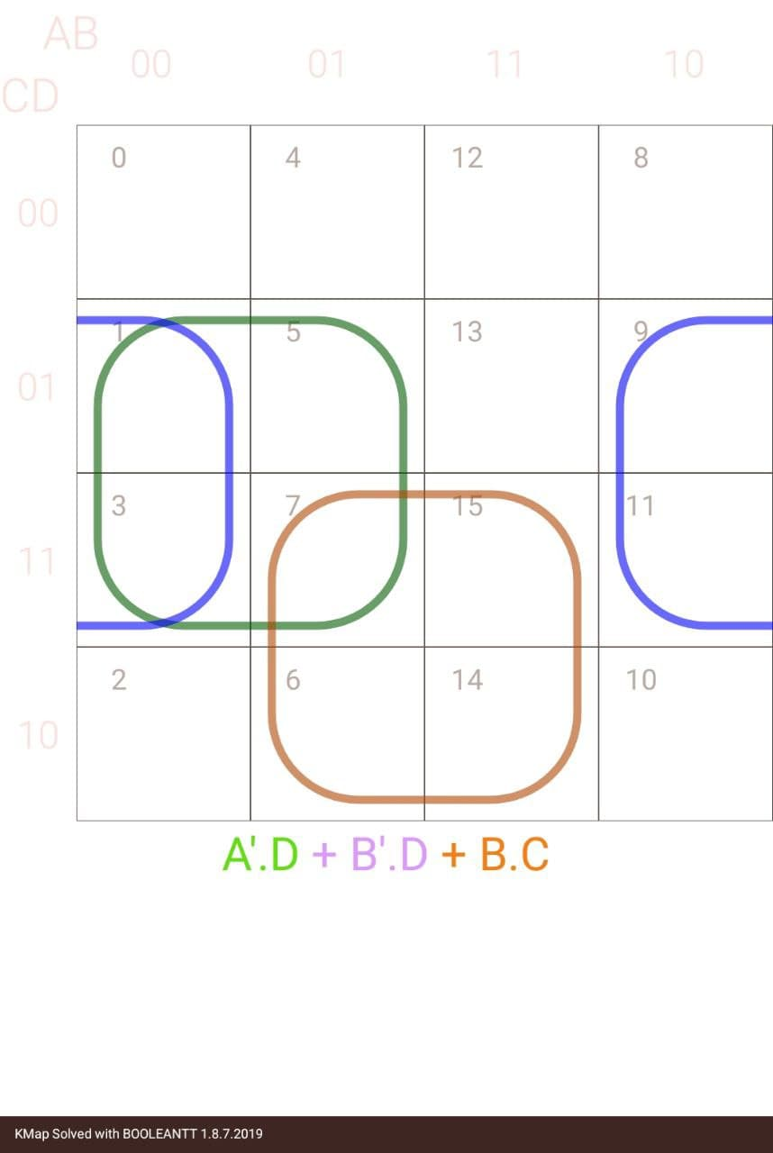

1. Combine all the 0’s to obtain the simplified function for *F’*.

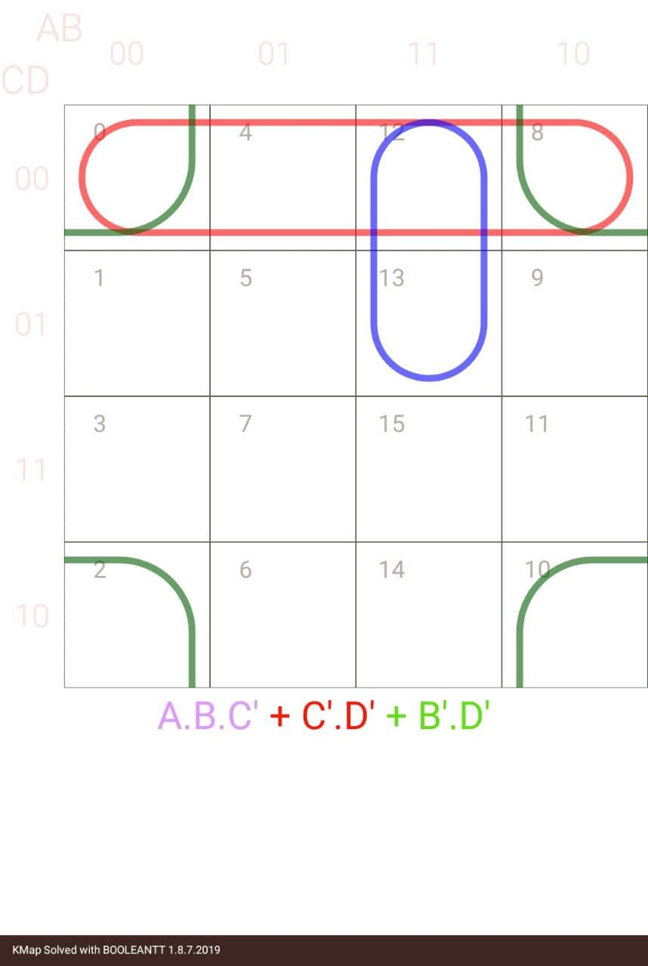

1. Draw both circuits.

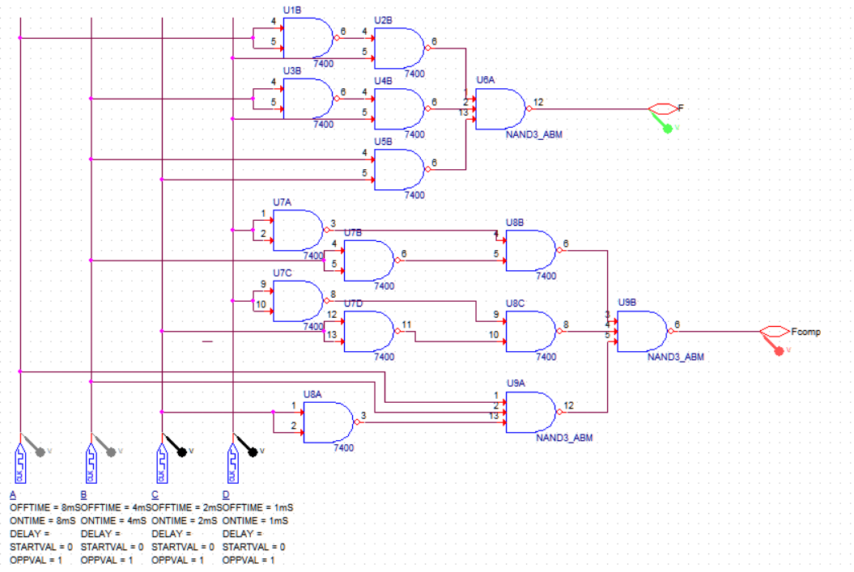

1. Using OrCAD, implement both F and F’ using NAND gates and connect two circuits to the same input switches but to separate output LED’s. Prove that both circuits are complement of each other. In the lab implement and verify the operations of the circuit.

Logical Circuit and Output of Both above circuits are:

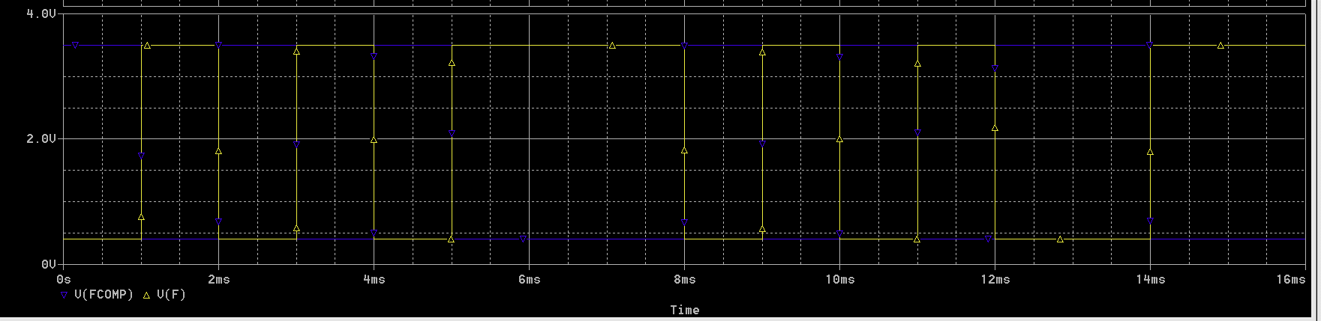

***Part 4: A Majority***

A nine member legislative committee requires a 2/3 vote to spend a billion dollars. The vote is tabulated and converted to BCD code. If 2/3 of the committee is in favor, the vote will be the BCD representation of 6, 7, 8, or 9.

* 1. Derive a truth table for the problem, Table 2.

|  |  |  |  |  |
| --- | --- | --- | --- | --- |
| **A** | **B** | **C** | **D** | **X** |
| 0 | 0 | 0 | 0 | 0 |
| 0 | 0 | 0 | 1 | 0 |
| 0 | 0 | 1 | 0 | 0 |
| 0 | 0 | 1 | 1 | 0 |
| 0 | 1 | 0 | 0 | 0 |
| 0 | 1 | 0 | 1 | 0 |
| 0 | 1 | 1 | 0 | 1 |
| 0 | 1 | 1 | 1 | 1 |
| 1 | 0 | 0 | 0 | 1 |
| 1 | 0 | 0 | 1 | 1 |
| 1 | 0 | 1 | 0 | X |
| 1 | 0 | 1 | 1 | X |
| 1 | 1 | 0 | 0 | X |
| 1 | 1 | 0 | 1 | X |
| 1 | 1 | 1 | 0 | X |
| 1 | 1 | 1 | 1 | X |

* 1. Derive a minimum sum of products expression from the map. {Enter the invalid BCD codes on the map as don’t cares (x)}.

|  |  |  |  |  |
| --- | --- | --- | --- | --- |
| AB\CD | 00 | 01 | 11 | 10 |
| 00 | 0 | 0 | 0 | 0 |
| 01 | 0 | 0 | 1 | 1 |
| 11 | x | x | x | x |
| 10 | 1 | 1 | x | X |

Hence, from the above Kmap, the minimal SOP form is:

**F= A + BC**

* 1. Using LogicWorks, design a circuit that lights an LED if a majority has voted in favor of spending the billion dollars. Implement this circuit and verify its operation in the lab using hardware.

