# EE 200 DIGITAL LOGIC CIRCUIT DESIGN EXPERIMENT #4

**BOOLEAN ALGEBRA**

# OBJECTIVE:

* To verify the rules and regulations of Boolean Algebra
* To simplify and modify Boolean logic functions by means of Demorgan’s theorem.
* To design and implement a logic circuit.

# APPARATUS:

    PB-503

* 7400 Quadruple 2 input NAND gates.
* 7402 Quadruple 2 input NOR gates
* 7408 Quadruple 2 input AND gates
* 7432 Quadruple 2 input OR gates
* 7404 Hex inverters
* 7411 Triple 3-input AND gate

**THEORY:**

1. A+0 = A

2. A+1 = 1

3. A .0 = 0

4. A .1 = A

5. A+A = A

6. A+A’ = 1

7. A.A = A

8. A.A’ = 0

9. (A’)’ = A

1. A+AB = A
2. A+A’B = A+B

12. (A+B). (A+C) = A+BC

13. A’. B’ = (A+B)’

14. A’+B’ = (A.B)’

# Procedure 1:

* 1. Prove rule 1 using OrCAD.

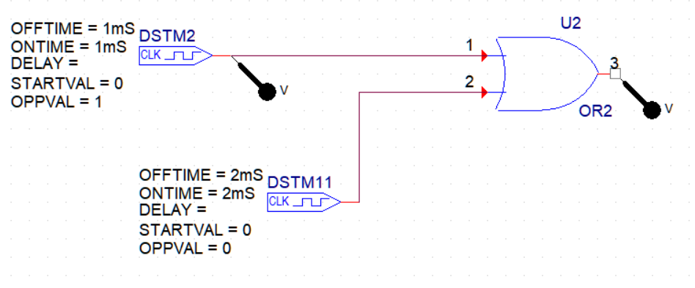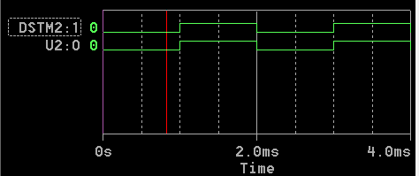

Fig.1 Verifying Rule 1

* 1. Connect the circuit of Fig.2 Using OrCAD. Which rule does this circuit illustrate?

1

0

1

0

3

Vo

2

Fig.2

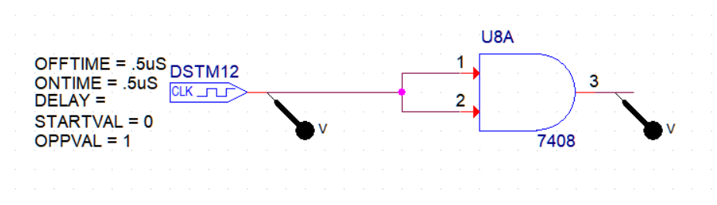

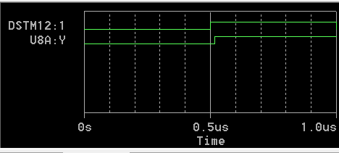

The above circuit illustrates **Idempotent Law** i.e. **A . A = A**

* 1. Design a circuit that illustrates rule 10. Copy the circuit from OrCAD and paste it in your lab report.

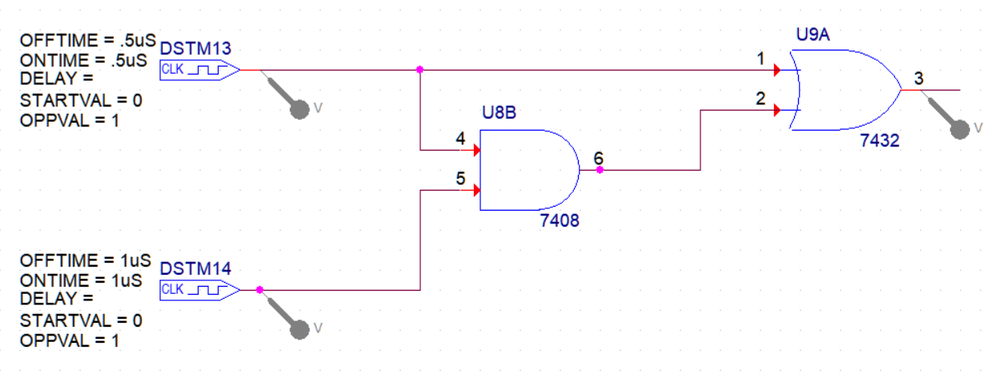

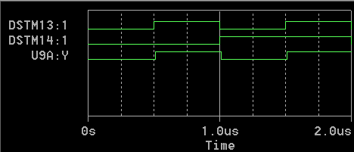

* 1. Rule 6 illustrates that A+A’ could be replaced with a wire to Vcc. What does rule 8 illustrate?

Ans:

Rule 8 illustrates that **A.A’** can be represented with a break in the line or with a wire directly connected to the ground voltage (**GND**) because the output of **A.A’** is **Always Low.**

* 1. Rule 11 states that A+A’B = A+B. Using OrCAD design a circuit that illustrates each of these expressions.

**A+A’B**

**A+B**

Prove that these two circuits perform equivalent logic. (Connect two circuits and show that their outputs are the same).

For the first circuit, **A + A’B** :

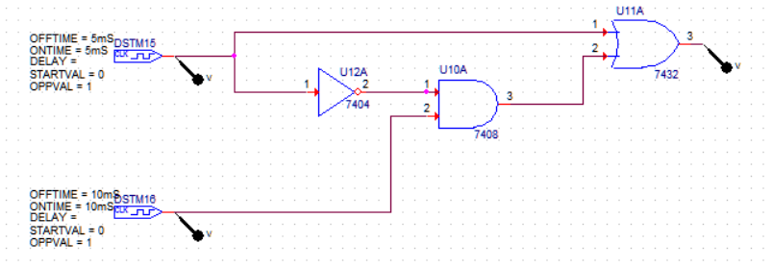 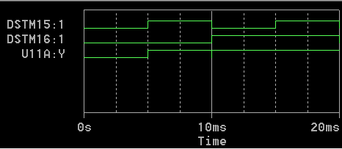

For the second circuit, **A + B**:

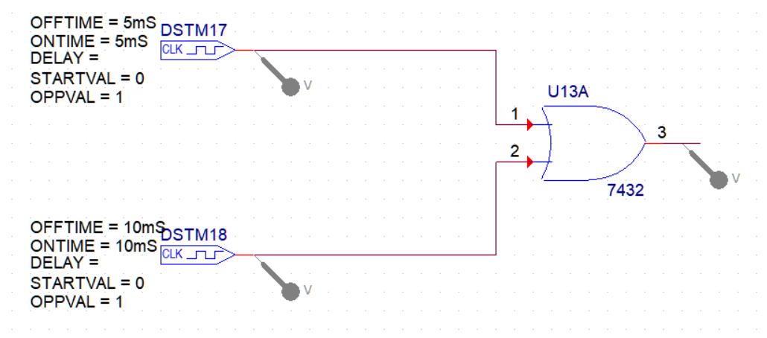 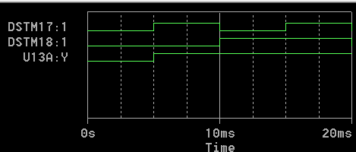

From the simulation, we can observe that the above circuits are logically equivalent as both of them give identical logical plots as output of simulation.

Hence, **A + A’B = A + B.**

Thus, Rule 11 is proved

# Procedure 2: Demorgan’s Theorem

**Proof of equation (1)**

Using OrCAD Cadence Capture construct the two circuits given in Figs.3 and 4 corresponding to the functions A’. B’ and (A+B)’ respectively.

Show that for all combinations of A and B, the two circuits give identical results.

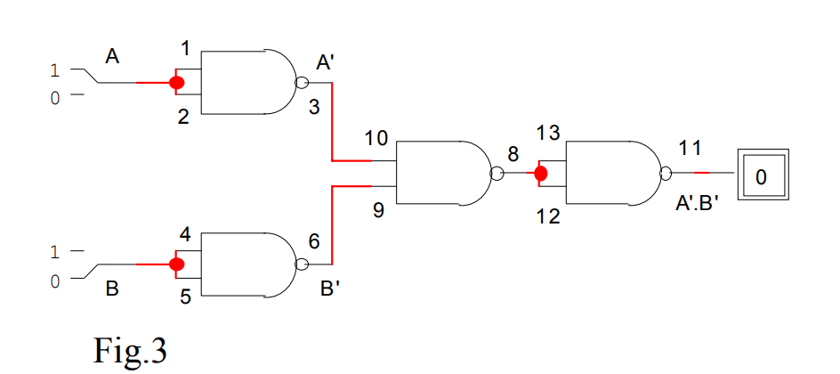

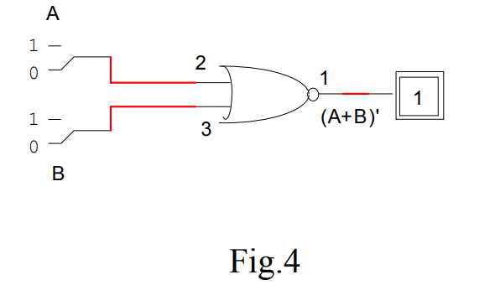

Circuit Analysis for fig 3:

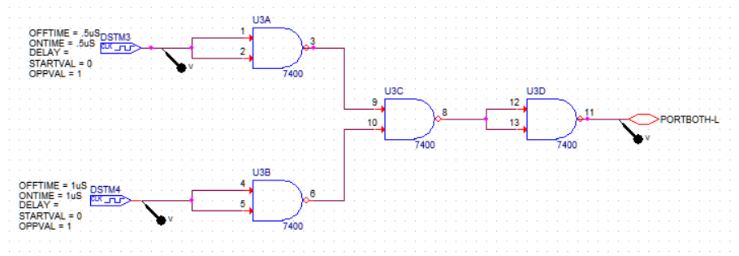

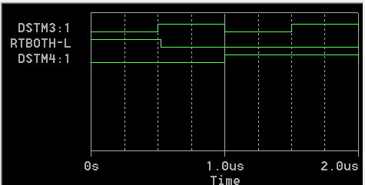

Circuit Analysis for Fig 4: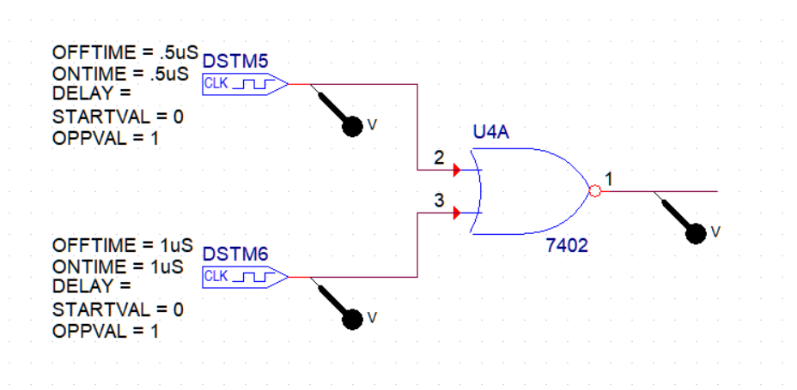

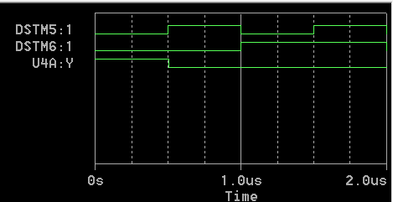

Here, from the result obtained by simulation, it is clearly visible that both the gates are logically equivalent.

Thus, Demorgan’s first law is verified.

**Proof of equation (2)**

Using OrCAD, construct two circuits given in Figs. 5 and 6, corresponding to the functions A’+B’ and (A.B)’ A.B, respectively.

Show that, for all combinations of A and B, the two circuits give identical results. In the lab connect these circuits and verify their operations.

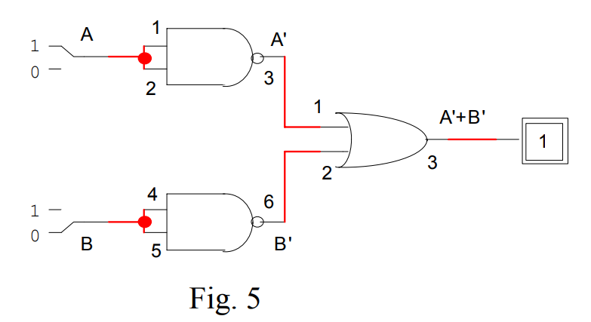

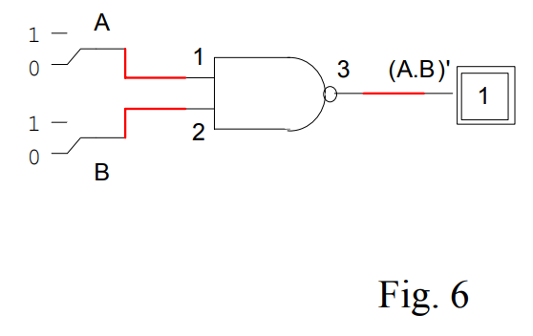

Circuit Analysis For Fig 5:

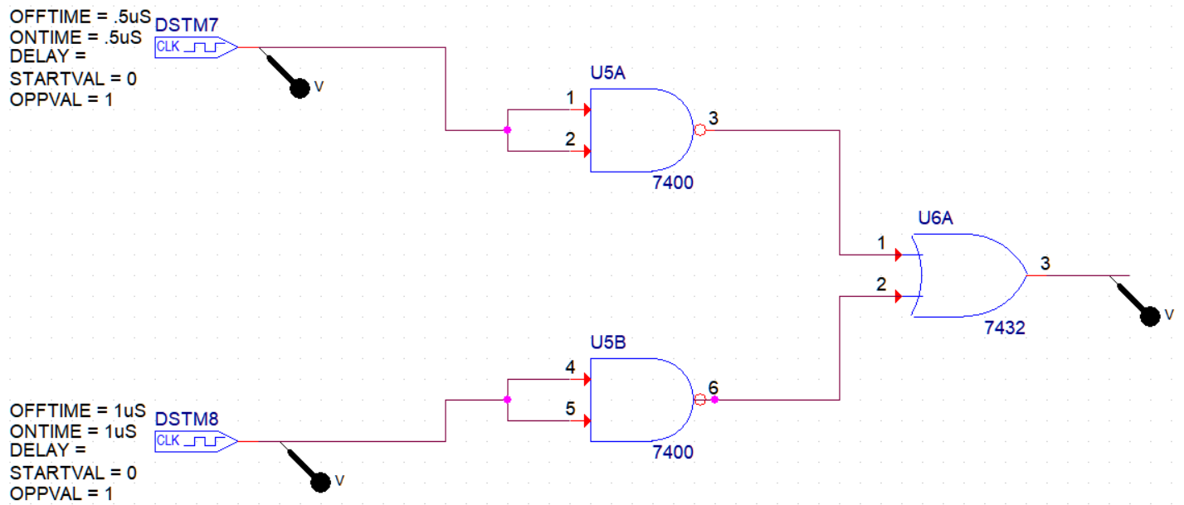

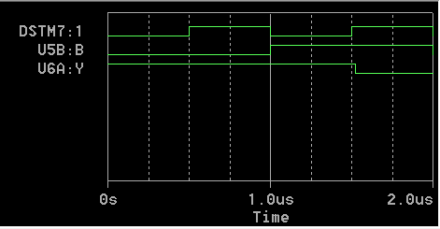

Circuit Analysis For Fig 6:

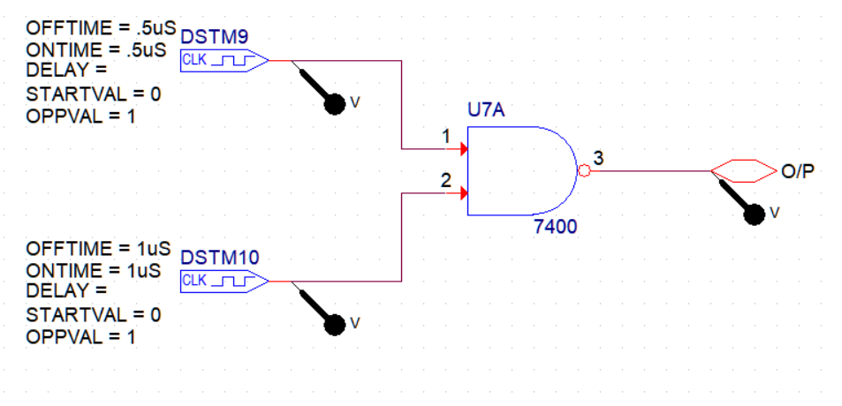

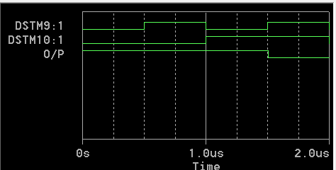

Here, from the result obtained by simulation, it is clearly visible that both the gates are logically equivalent.

Thus, Demorgan’s second law is verified.

# Design of a Digital Circuit

Consider the following problem:

Four chairs A, B, C, and D are placed in a row. Each chair may be occupied (“l”) or empty (“0”). A Boolean function F is “l” if and only if there are two or more adjacent chairs that are empty.

* 1. Give the truth table defining the Boolean function F

Ans:

The required truth table for this problem is:

|  |  |  |  |  |
| --- | --- | --- | --- | --- |
| **A** | **B** | **C** | **D** | **F** |
| 0 | 0 | 0 | 0 | 1 |
| 0 | 0 | 0 | 1 | 1 |
| 0 | 0 | 1 | 0 | 1 |
| 0 | 0 | 1 | 1 | 1 |
| 0 | 1 | 0 | 0 | 1 |
| 0 | 1 | 0 | 1 | 1 |
| 0 | 1 | 1 | 0 | 1 |
| 0 | 1 | 1 | 1 | 0 |
| 1 | 0 | 0 | 0 | 1 |
| 1 | 0 | 0 | 1 | 1 |
| 1 | 0 | 1 | 0 | 1 |
| 1 | 0 | 1 | 1 | 0 |
| 1 | 1 | 0 | 0 | 1 |
| 1 | 1 | 0 | 1 | 0 |
| 1 | 1 | 1 | 0 | 0 |
| 1 | 1 | 1 | 1 | 0 |

`

* 1. Express F as a minterm expansion (standard sum of product)

Ans:

The minterm expansion of above Boolean function is:

**F** = A’.B’.C’.D’ + A’.B’.C’.D + A’.B’.C.D’ + A’.B’C.D + A’.B.C’.D’ + A’.B.C’.D + A’.B.C.D’ + A.B’.C’.D’ + A.B’.C’.D + A.B’.C.D’ + A.B.C’.D’

* 1. Express F as a maxterm expansion (standard product of sum).

Ans:

The maxterm expansion of above Boolean function is:

**F** = (A+B’+C’+D’) . (A’+B+C’+D’) . (A’+B’+C+D’) . (A’+B’+C’+D) . (A’+B’+C’+D’)

* 1. Using postulates and theorems Of Boolean algebra, simplify the minterm expansion of F to a form with as few occurrences of each as possible.

The above Boolean function can be reduced to the following form using the **Laws of Boolean Algebra:**

**F = A’.B’ + B’.C’ + C’.D’ + A’.C’ + B’.D’ + A’.D’**

* 1. Implement on LogicWorks for the pre-lab and then on PB-503, the simplified Boolean function with logic gates and check the operation of the circuit.

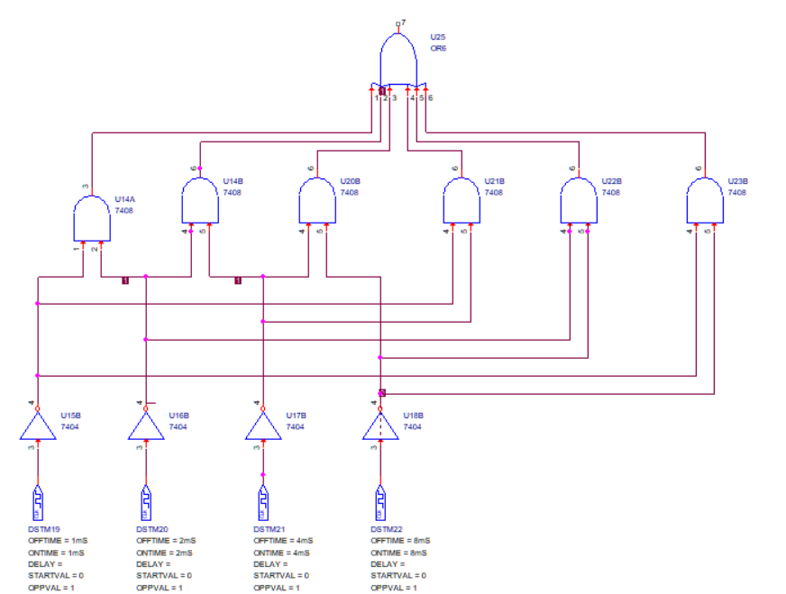

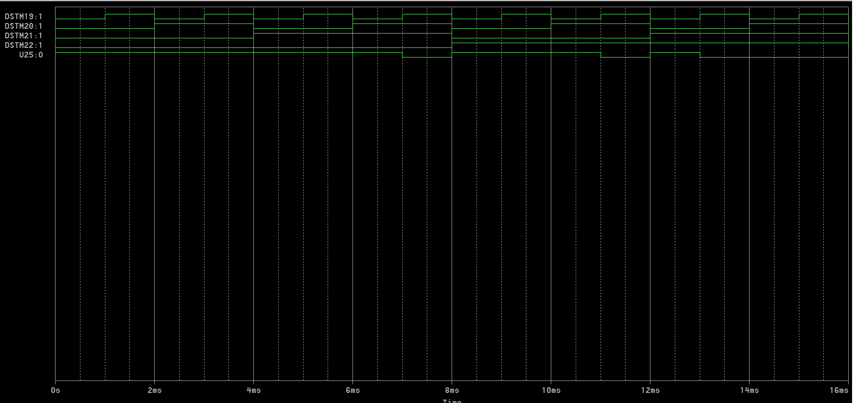

# Result:

All truth tables, circuits (using OrCAD), etc. used in completing this experiment has been shown above.

In this way, the laws of Boolean algebra can be observed, verified and studied practically using circuits and simulations