What is JNDI ?
The Java Naming and Directory InterfaceTM (JNDI) is an application programming interface (API) that provides naming and directory functionality to applications written using the JavaTM programming language. It is defined to be independent of any specific directory service implementation. Thus a variety of directories(new, emerging, and already deployed) can be accessed in a common way.

What is its basic use?
Most of it is covered in the above answer but I would like to provide architecture here so that above will make more sense.

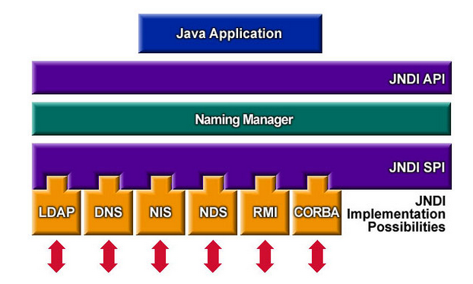

To use the JNDI, you must have the JNDI classes and one or more service providers. The Java 2 SDK, v1.3 includes three service providers for the following naming/directory services:
- Lightweight Directory Access Protocol (LDAP)
- Common Object Request Broker Architecture (CORBA) Common Object Services (COS) name service
- Java Remote Method Invocation (RMI) Registry
So basically you create objects and register them on the directory services which you can later do lookup and execute operation on.

