MyOB Test Documentation

System Architecture

This test system built using .NET Core 2.1 framework and Used WebApi with Angular 5 for presentation layer and WebApi Interaction with Angular. And Payslip processing is based on
GRPC (Google Remote Procedure Call https://grpc.io/) based Micro service Architecture with Protobuf used
To transmit the data as binary Stream.

1. I decided to use this technology as GRPC gives huge benefits with performance of huge data
Processing and data pipeline can be setup as bidirectional. I used same in this test transmit data
To and from micro service.

2. For presentation layer I used angular 5 as this framework really mature and it makes building
Presentation layer much easier. Angular 4 onwards providing you component based
Development enabling developer to handle ui related task very easily.

3. For Unit test case implementation it is XUnit being used and it is really sophisticated framework
For unit testing and if it is integration testing with all business related process with XUnit we
Can use EF.Effort to mock Database completely.

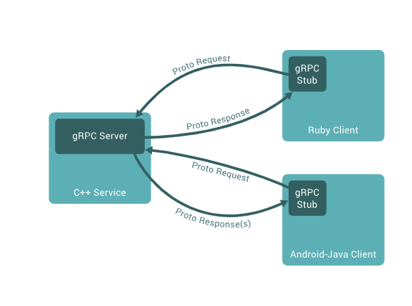

Use Case Diagram for Payslip Processing

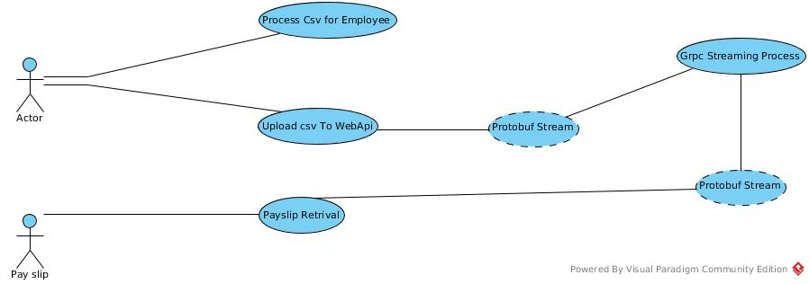

Sequence Diagram for Payslip Processing

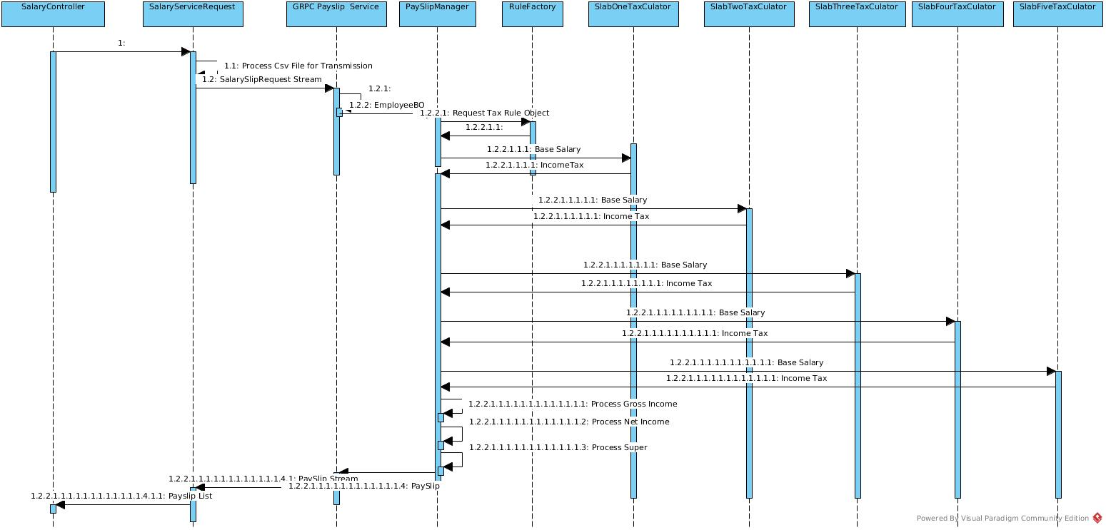

Class Diagram For the Business Process

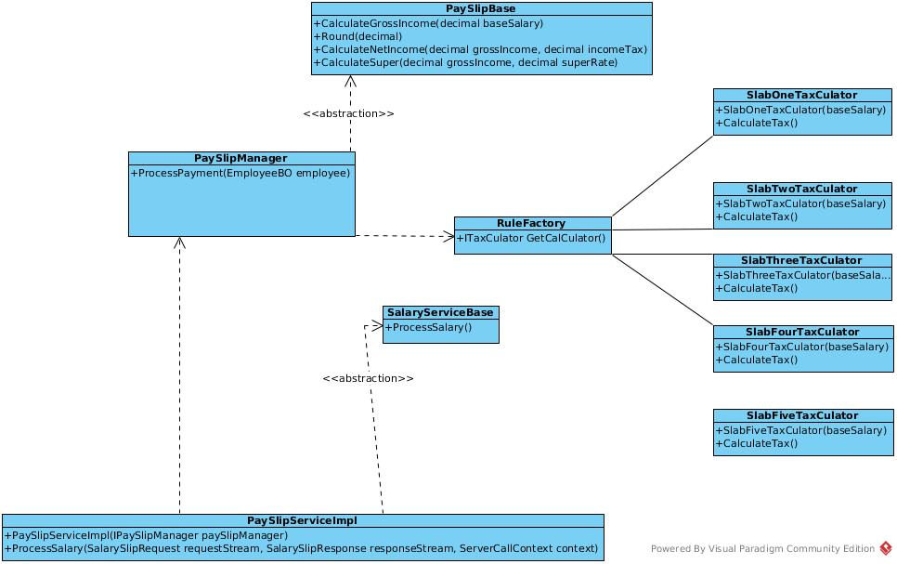

Execution Instructions

- To load this project first it is required to install .NET Core 2.1 SDK
- First Run ProtoService Micro service
- Second Execute WebApp UI Service
- Upload File already in /home/bimal/RiderProjects/OBDalaries/employees.csv
- In seconds you can view the results.

I take this opportunity to thank you all giving me room to implement this test.

Cheers

Bimal Kaluarachchi

