**Project Proposal**

**On**

**Online Movie Tickets Booking**



**Module: STW300CEM Android Application Development**

Softwarica College of IT and E-Commerce

Mahakavi Marg, Kathmandu 44600, Nepal

**Submitted by: Submitted to:**

**Bimal Paudel Kiran Rana**

**ID: 160170**

**Batch: Jan19 C**

Contents

Contents 2

1. Introduction 3

a. Project Introduction 3

b. Justification of the project 3

i. Background of the project 3

ii. Problem statement 3

c. Description of the project 3

i. Features of the project 3

2. Aim and Objectives 4

a. Aim 4

b. Objectives 4

3. Development Methodology 5

a. Description of the methodology 5

b. Design Pattern 6

i. MVC (Model - View – Controller) 6

c. System Architecture 7

i. Three tier architecture 7

4. Configuration Management 8

5. Prototype 9

6. Conclusion 12

References 13

# 1. Introduction

## a. Project Introduction

This is a project on development of android application on E-movie ticket booking. It will provide a platform for customers to book and buy tickets.

## b. Justification of the project

### i. Background of the project

Movies have been a source of entertainment in people’s life for generations. Online streaming services such as Netflix, Hulu and Amazon prime means people have plenty to watch from their home but it hasn’t decreased the popularity and trend of going to Cinema halls to watch a new release with your loved ones.

### ii. Problem statement

Time people can afford to go to the theatres, stay in line and buy tickets to watch the movie of their liking has decreased. Therefore, people have been looking for to find an easy and efficient way to book movies. That’s where online ticket booking will be helpful where users can get what they want from their preferred time and place.

## c. Description of the project

As the title “Online Movie Tickets Booking” suggests, this project focuses on providing an application for customers to buy tickets for movies. Customers can buy or reserve seats for movies anytime and from anywhere.

### i. Features of the project

The application will show currently showing movies in “NOW SHOWING” section. Upcoming movies will be in the “COMING SOON” section. Users will be able to login using their Gmail account. Logged in users can choose the movie of their liking and either reserve or buy tickets for it. Tickets for the reserved tickets should be bought before two hours of scheduled movie or will be available once again for all users.

Tickets can be bought using multiple online payment methods. Tickets generated can be downloaded in PDF format.

# 2. Aim and Objectives

## a. Aim

The aim of the project is to create an Android based mobile application through which users can buy and reserve movie tickets from their desired place and time.

## b. Objectives

There are multiple objectives I need to complete in order to achieve the aim of the project. Below listed are the objectives.

1. Research on users’ requirements and their preferences need to be done properly.
2. Designing an attractive interface along with easily maintainable backend is also an important objective.
3. Design needs to be implemented properly.
4. The created software need to be tested in order to make it error free and make sure that it is secure before launching it into the real world.
5. Provide users with an android application that will save time on booking ticket for movies efficiently.
6. Develop a secure Android application that won’t jeopardize users personal and bank details.

# 3. Development Methodology

## a. Description of the methodology

I have decided to use Waterfall methodology for this project. It is a very simple model to use in development where one phase must be completed in order to move into the next phase. I chose to use this model instead of other commonly used model such as Agile because of its effectiveness when the requirements are clear and fixed.

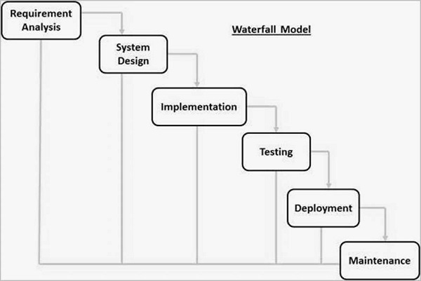

## b. Design Pattern

### i. MVC (Model - View – Controller)

I have decided to use MVC design pattern for this project. This pattern has three interconnected parts, Model, View and Controller. Each parts handle their own specific tasks and interact with each other to make the application work. This multipart pattern means the application will be easier to manage. For example, if any changes should be made to appearance of the application, whole code won’t need to be exposed, as it can be handled in View.

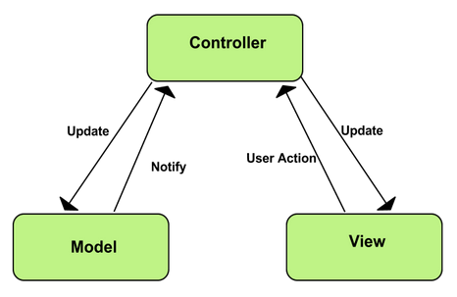

## c. System Architecture

### i. Three tier architecture

A three tier architecture is a client-server architecture in which the functional process logic, data access, computer data storage and user interface are developed and maintained as independent modules on separate platforms. In three tier architecture, communication happens linearly that is user interface only communicates with data storage via the middle tier. ([techopedia](https://www.techopedia.com/definition/24649/three-tier-architecture))

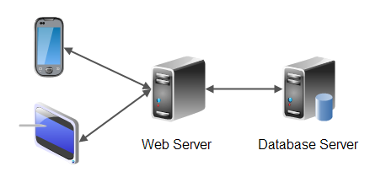

# 4. Configuration Management

A configuration is the set of characteristics that define a final product or variable. (Cite). The process of managing these characteristics and assets is called configuration management. For this project I will use Github to manage the configuration. Github is a web-based hosting service that offers version control and source code management functionality.

Github link: <https://github.com/bimalpaudels/Online-Movie-Ticket-Booking.git>

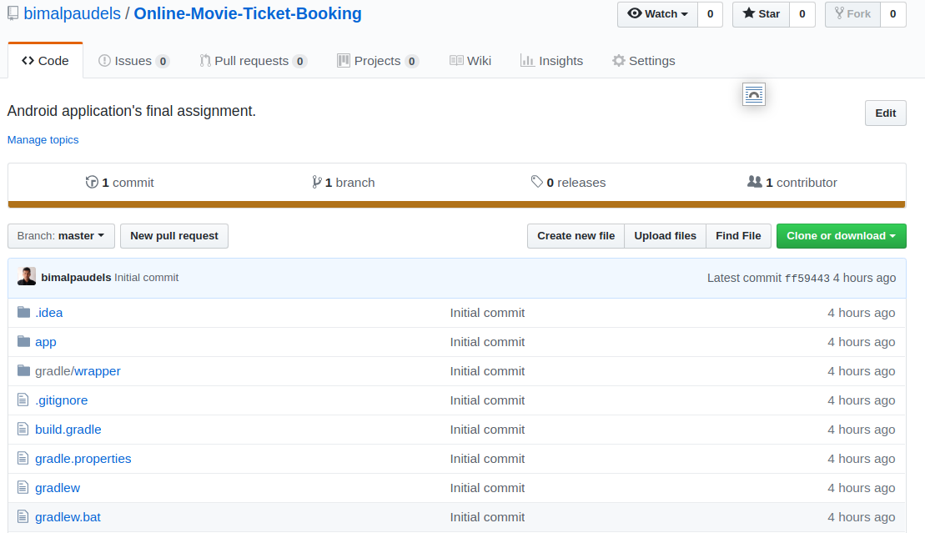

# 5. Prototype

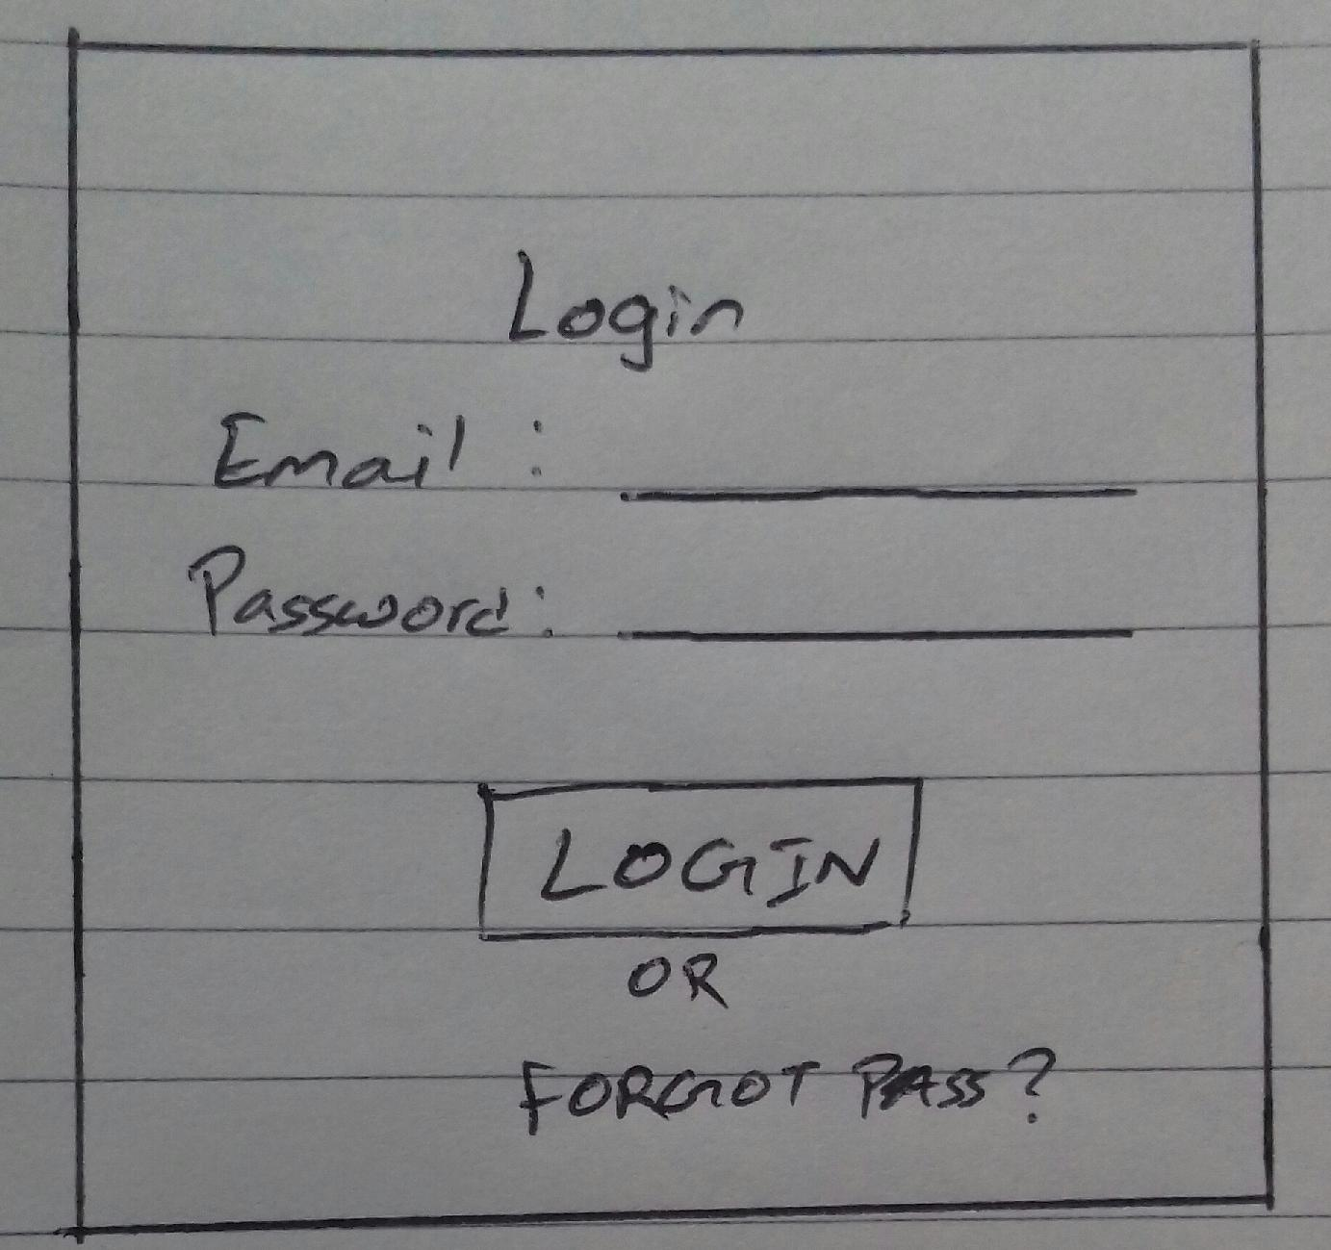Following are some of the hand-drawn prototypes of the activities that will be in the application.

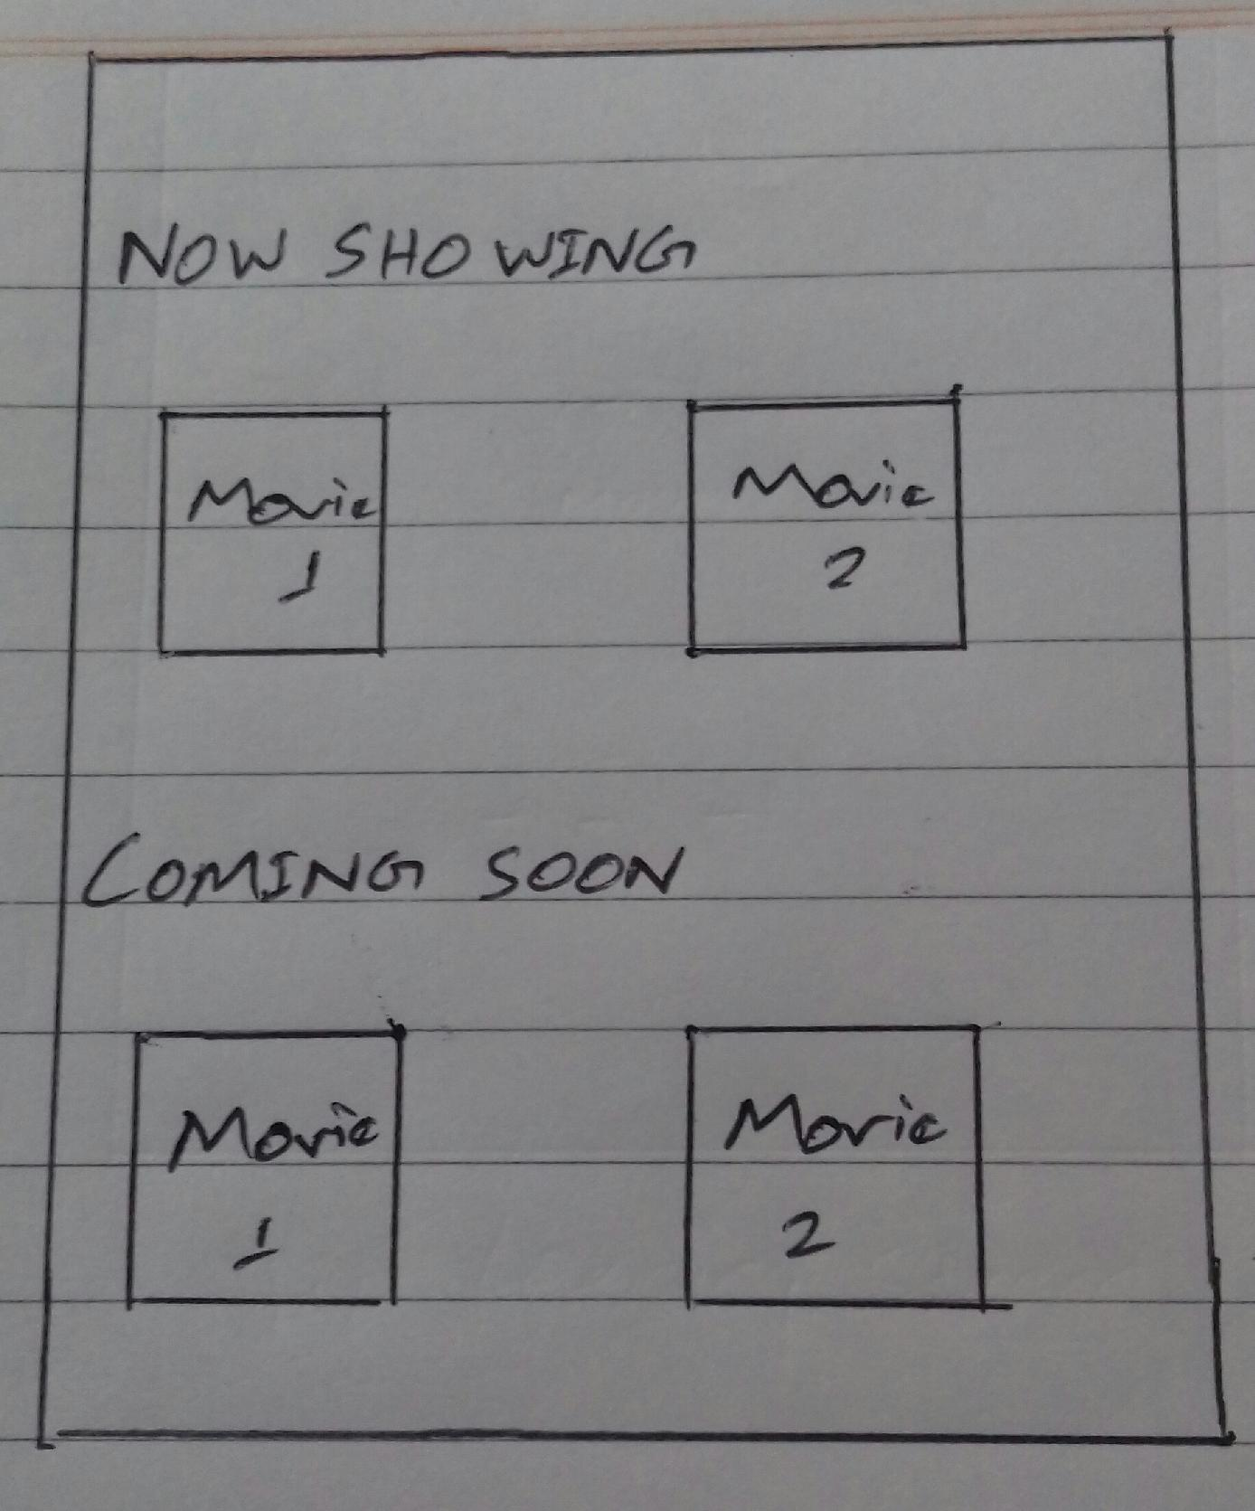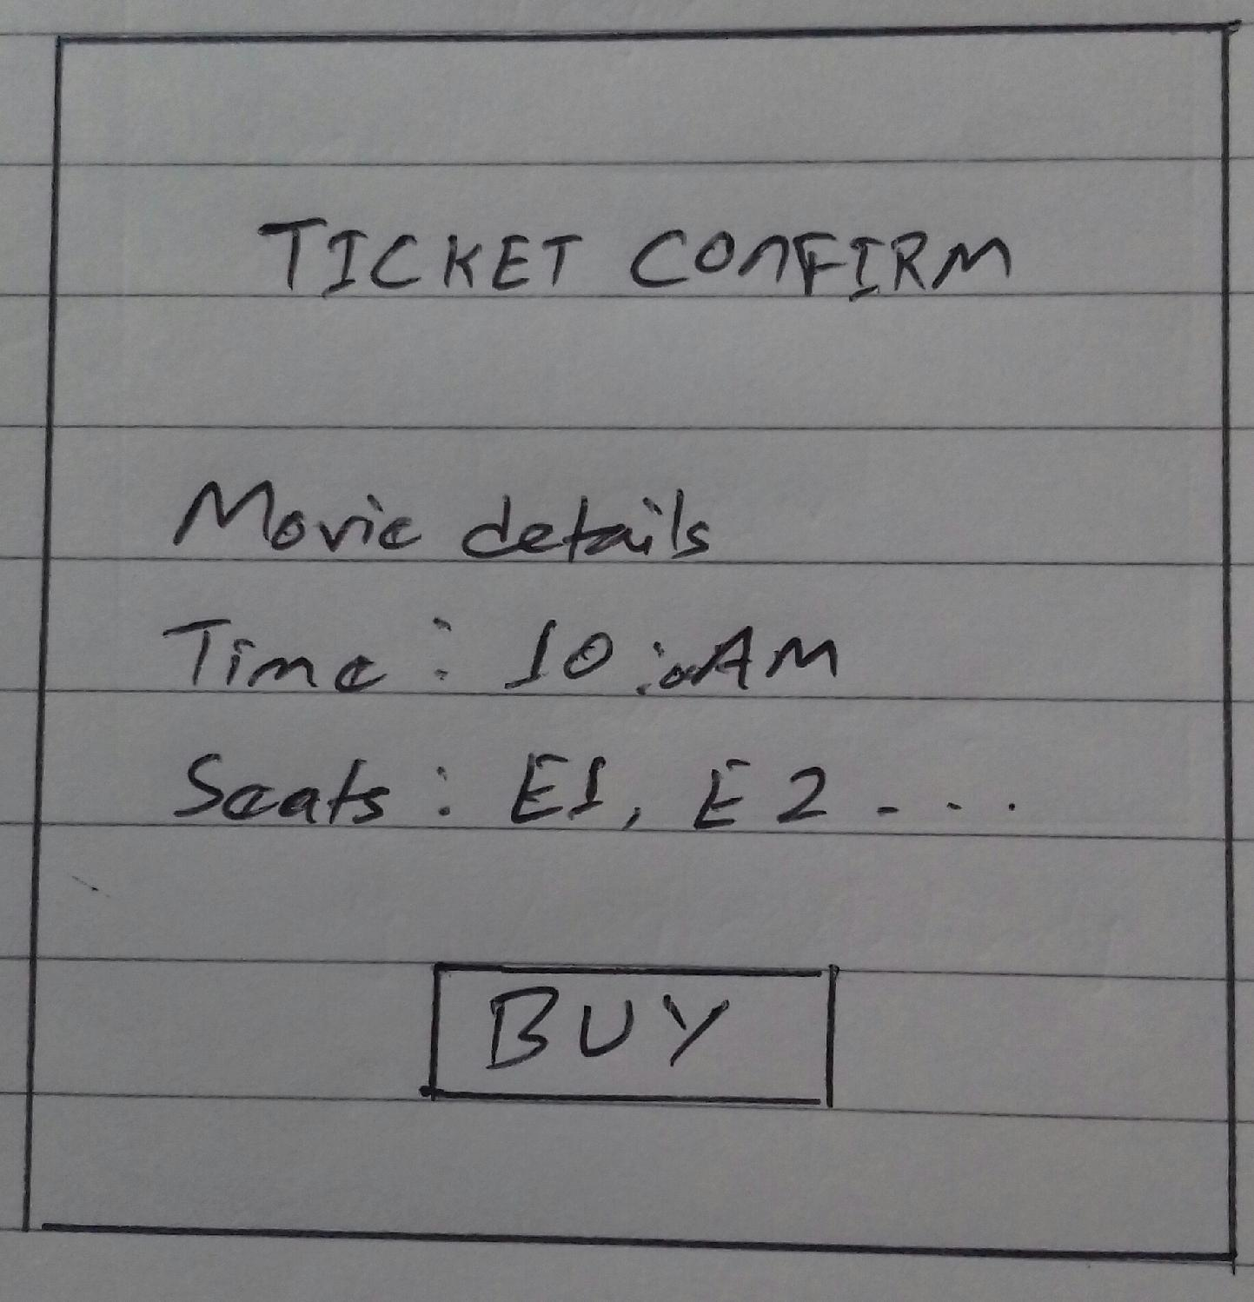

# 6. Conclusion

An Android based online movie ticket booking application will be created using the Waterfall Development Model. For the development, MVC pattern will be used along with three tier system architecture. The configuration of the project will be managed in GitHub where the code will be pushed regularly. Thus the project will be created.

# References

*Benefits of using MVC Model for Effective Web Application Development*. (2019, April 10). Retrieved from Brainvire: https://www.brainvire.com/six-benefits-of-using-mvc-model-for-effective-web-application-development/?fbclid=IwAR2L9Agodq1ViCveySTTNDBf4QAaa7KWFnQEs5MiSpCoUZ_6KiHcNE8XZNI

QA, T. (2019, April 10). *What is Waterfall Model?* Retrieved from http://tryqa.com/what-is-waterfall-model-advantages-disadvantages-and-when-to-use-it/?fbclid=IwAR0D8W1UdheHes3fj6K47Wfn2GsS8YA2X-yBnQwQ5LXSlD5qgYTdUXdcS4c

Wrike. (2019, April 9). *What is Configuration Management?* Retrieved from https://www.wrike.com/project-management-guide/faq/what-is-configuration-management-in-project-management/