Launch Plan: Droptimize for Mac
A one-page summary for the team, with an appendix. Drop this file on the bubble to turn it into a PDF.

Why it matters
Shrinking a file is a solved problem. The detour around it is not: find a website, upload, wait, download, unzip, find the file again. Droptimize removes the detour. You drop the file where you already are, and the result is saved next to the original and copied to the clipboard.

What ships first
- Images: WebP, AVIF, JPG, PNG and HEIC, compression to a size, half size and background removal.
- Videos: WebM by default, AV1, MP4, HEVC and GIF, compression to a size, resizing and muting.
- Documents: compress PDFs, turn pages into images, put images into a PDF, and turn Word files into PDFs.

Launch steps
- Finish hands-on testing on a real Mac.
- Open the store and set the Pro price ($9.99, once).
- Publish the launch film and the website.

Results so far
File | Before | After | Smaller by
IMG_2041.heic | 12.4 MB | 486 KB | 96%
screenshot.png | 3.1 MB | 412 KB | 87%
launch.mov | 840 MB | 24.1 MB | 97%
report.pdf | 8.4 MB | 912 KB | 89%
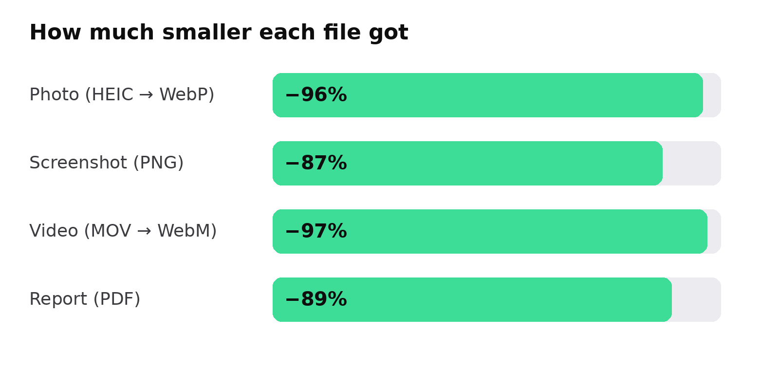
Figure 1. Savings on the files above.
Drop it. Done.

Appendix: how the PDF is made
When Microsoft Word is installed, Droptimize asks Word to save the document as a PDF, out of sight. The PDF then looks exactly like the document, including this page’s header and the page numbers at the bottom.
Without Word, Pages does the same. Without either, Droptimize reads the document itself: the text, styles, lists, table, picture, header and page numbers come through, but fonts that come with Office are swapped for the closest ones a Mac has, so the card says the layout may differ.

What to check
- Two pages, with this appendix starting on page 2.
- The header at the top right of each page.
- “Page 1 of 2” and “Page 2 of 2” at the bottom.
- The table and the chart where they are on page 1.

