Customer API
Implementation, Kubernetes, CI/CD and New Relic Observability Report
Final local implementation record

1. Executive Summary
This report documents the completed implementation of the Customer API project. The work covered the application and database foundation, automated CI, Docker packaging, GHCR publishing, local Kubernetes deployment, RollingUpdate behavior, health probes, resource controls, New Relic Kubernetes monitoring, New Relic Java APM, and a single-pane observability dashboard.
The resulting local architecture is production-oriented in design, but the Kubernetes cluster is still local to the developer workstation. A cloud deployment such as AWS EKS was not completed because an AWS account was not available.

2. End-to-End Architecture
Developer -> Git push -> GitHub Actions -> Tests -> Maven build -> Docker build -> GHCR
GHCR -> local Docker Desktop kind Kubernetes -> Customer API Deployment -> Service -> PostgreSQL
Kubernetes -> New Relic OTel Collector -> New Relic Cloud
Spring Boot -> New Relic Java Agent -> New Relic APM

3. Delivery Milestones
Area | Status | Evidence / outcome
Application | Complete | Spring Boot Customer API running on Java 21
Database | Complete | PostgreSQL + Flyway migrations verified
CI | Complete | GitHub Actions tests/build green
Docker | Complete | Image built and runs
GHCR | Complete | Customer API image published
Kubernetes | Complete | 2-replica Deployment + Service
RollingUpdate | Complete | Explicit strategy with maxUnavailable=0/maxSurge=1
Health | Complete | startup/readiness/liveness probes
New Relic infra | Complete | OTel collector reports Kubernetes metrics
New Relic APM | Complete | Customer API registered with transaction telemetry
Dashboard | Complete | Combined Kubernetes + APM dashboard
Cloud CD | Pending | Needs remotely reachable cluster/AWS account

4. Application and Database
PostgreSQL is used as the application database. From Kubernetes the application connects using jdbc:postgresql://host.docker.internal:5432/customer_db. Flyway migrations were maintained as versioned SQL scripts, including customer status and customer type changes.
The API was repeatedly exercised through Postman after deployment, confirming that requests reached the Spring Boot application and database.

5. CI/CD Pipeline
GitHub Actions performs source checkout, Java 21 setup, Maven tests, application build, GHCR authentication, Docker image build, and image publishing. Images are tagged with both latest and the Git commit SHA.
The project also contains deployment logic that can use GITHUB_SHA to update a Kubernetes Deployment with the exact image produced by a commit.

6. Docker
The final Docker image uses Eclipse Temurin 21 JRE, copies the Spring Boot artifact, copies the New Relic Java agent and configuration, and starts Java with -javaagent:/app/newrelic/newrelic.jar.
ENTRYPOINT ["java", "-javaagent:/app/newrelic/newrelic.jar", "-jar", "/app/app.jar"]

7. Kubernetes
The Deployment runs two replicas and uses an explicit RollingUpdate strategy. A Service exposes the application, a ConfigMap provides non-secret configuration, and Kubernetes Secrets hold credentials.
Final rollout model:
- 2 replicas
- maxUnavailable: 0
- maxSurge: 1
- startupProbe for slow Spring Boot initialization
- readinessProbe for traffic eligibility
- livenessProbe for automatic restart
- CPU request 250m / limit 500m
- memory request 256Mi / limit 512Mi

8. RollingUpdate Troubleshooting
The first rollout stalled because the application took about 55 seconds to start while the liveness check began too early. Kubernetes repeatedly observed connection refused and restarted the new Pod.
Adding a startup probe with a 120-second allowance separated application startup from normal liveness/readiness evaluation. After the change, the Deployment reached 2/2 Ready and 2/2 Available.

9. New Relic Kubernetes Observability
Helm was installed and the New Relic Kubernetes OpenTelemetry collector was deployed into the newrelic namespace.
An initial HTTP 403 occurred because the collector was using the US OTLP endpoint while the New Relic account was in the EU region. After changing to the EU endpoint, Kubernetes metrics flowed successfully.
Observed Kubernetes metrics included:
- k8s.pod.cpu_limit_utilization
- k8s.pod.cpu_request_utilization
- k8s.node.cpu.usage
- container.cpu.usage
- k8s.pod.memory_request_utilization
- container.memory.usage
- node.memory.usage.percentage
- kube_pod_status_phase

10. New Relic Java APM
The New Relic Java agent was added to the Docker image and loaded by the JVM using -javaagent. The agent was initially rejected because the supplied license key was invalid. After the Kubernetes Secret was corrected and the EU collector configuration was applied, the agent connected successfully.
The final agent log confirmed New Relic Agent v9.4.0 started, connected to collector.eu01.nr-data.net, and reported the Customer API application to the EU New Relic account.
APM then exposed actual application telemetry including:
- Throughput
- Response time
- Error rate
- Transactions
- JVM and database views
Captured transaction examples included api/customers (GET) at about 309 ms average and api/customers (POST) at about 773 ms average in the observed window, with 0% error rate.

11. New Relic Dashboard
A custom dashboard named Customer API - Kubernetes & Application Health was created and saved in New Relic. It combines Kubernetes infrastructure health with application APM.
- Pod count and Kubernetes metric volume
- Pod CPU and CPU request utilization
- Node CPU
- Container/pod memory
- Pod status
- CPU and memory request/limit ratios
- Deployment telemetry
- Kubernetes events
- API throughput
- Average response time
- P95 response time
- API error rate
- Transactions by endpoint
- Errors by endpoint
- Slow transactions

12. Security Practices
PostgreSQL and New Relic credentials are stored as Kubernetes Secrets. The New Relic license key is not placed in newrelic.yml, the dashboard JSON, or the application source. The dashboard JSON should be treated as a private operational artifact.

13. What Remains for Full Cloud CD
The local implementation is complete. The remaining cloud phase would move Kubernetes to a remotely reachable service such as AWS EKS and configure GitHub Actions OIDC -> AWS IAM -> EKS.
In that model, the pipeline can automatically deploy the exact image tagged with GITHUB_SHA, execute kubectl rollout status, and fail the release if the rollout does not become healthy.

14. Useful Commands
kubectl get nodes
kubectl get pods
kubectl get deployment customer-api
kubectl rollout status deployment/customer-api
kubectl rollout history deployment/customer-api
kubectl rollout undo deployment/customer-api
kubectl get rs -l app=customer-api
kubectl get service customer-api-service
kubectl port-forward service/customer-api-service 8082:8080
helm list -n newrelic
kubectl get pods -n newrelic
kubectl logs <pod-name>
kubectl logs <pod-name> --previous
kubectl exec <pod-name> -- ls -lh /app/newrelic
kubectl exec <pod-name> -- sh -c "tr '\0' ' ' < /proc/1/cmdline"

15. Screenshots and Evidence
The screenshots below were supplied during the implementation and are included to document the major checkpoints.
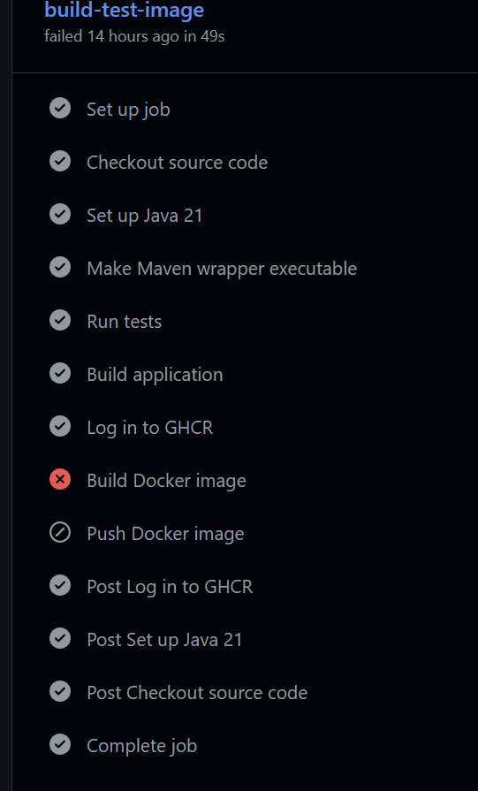
GitHub Actions: Docker build failure during the New Relic agent integration.
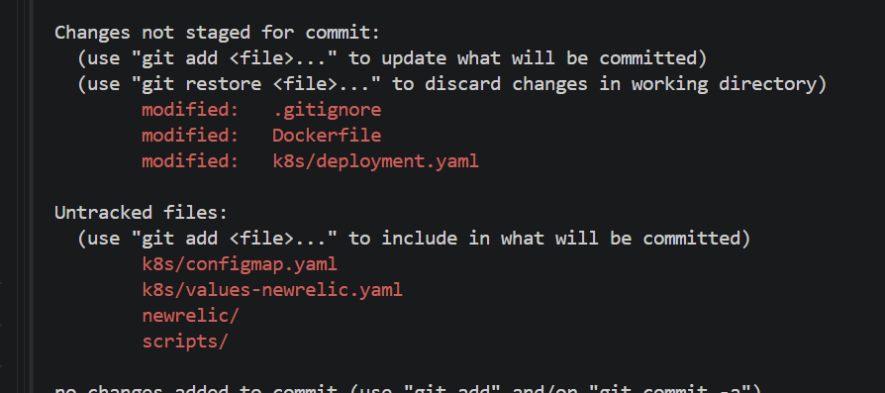
Git status before committing the New Relic and Kubernetes changes.
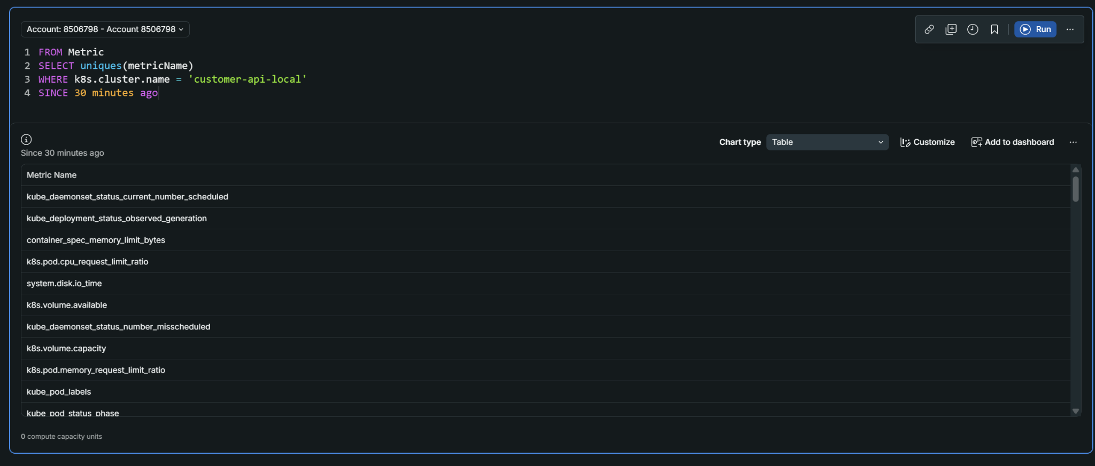
New Relic metric discovery for Kubernetes telemetry.
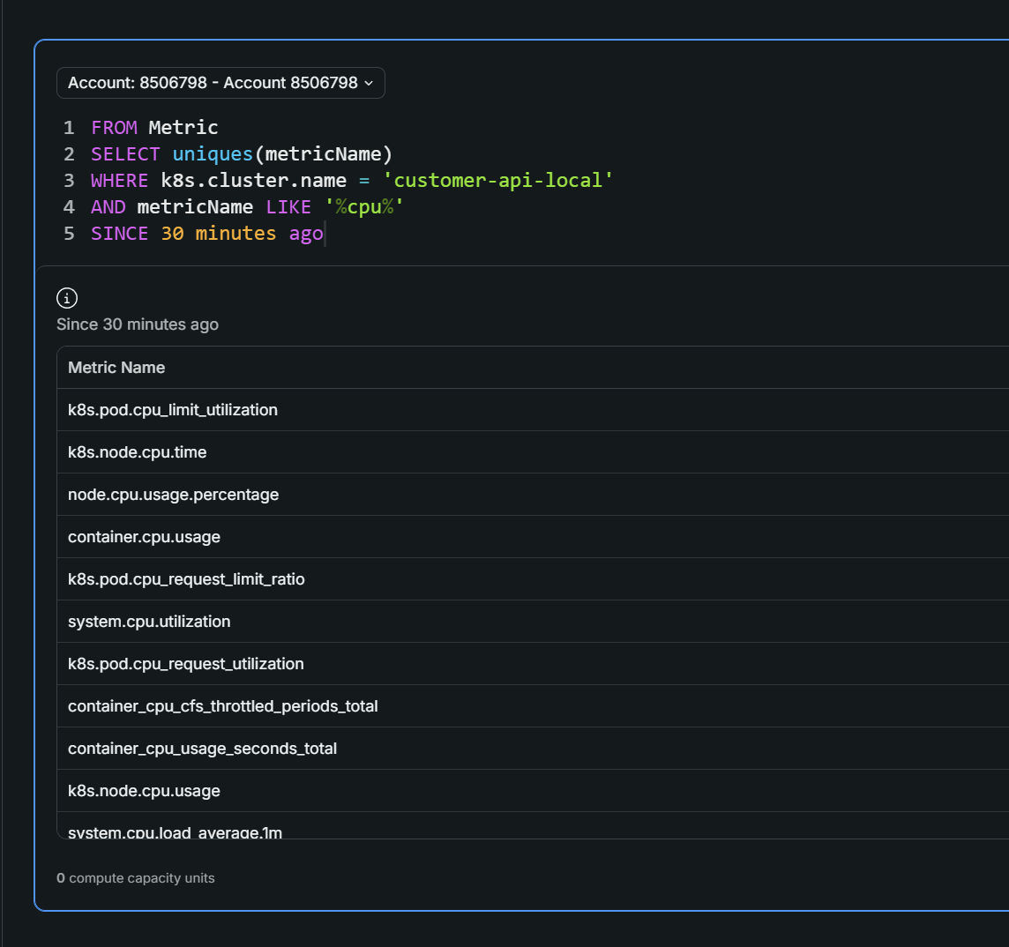
CPU metrics discovered in New Relic.
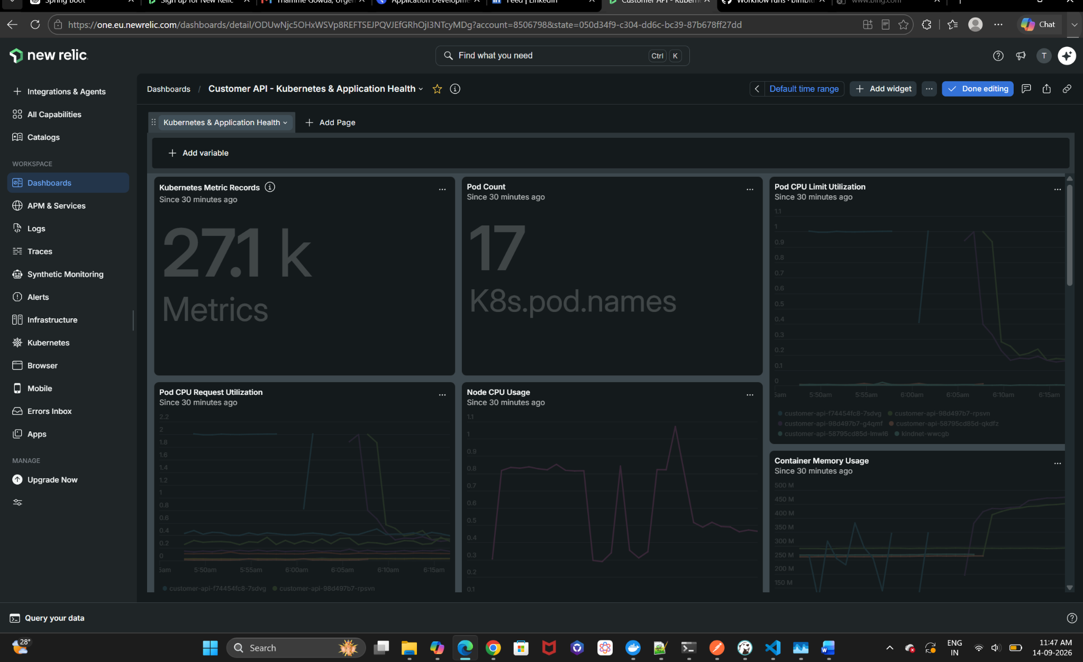
Custom Customer API Kubernetes and Application Health dashboard.
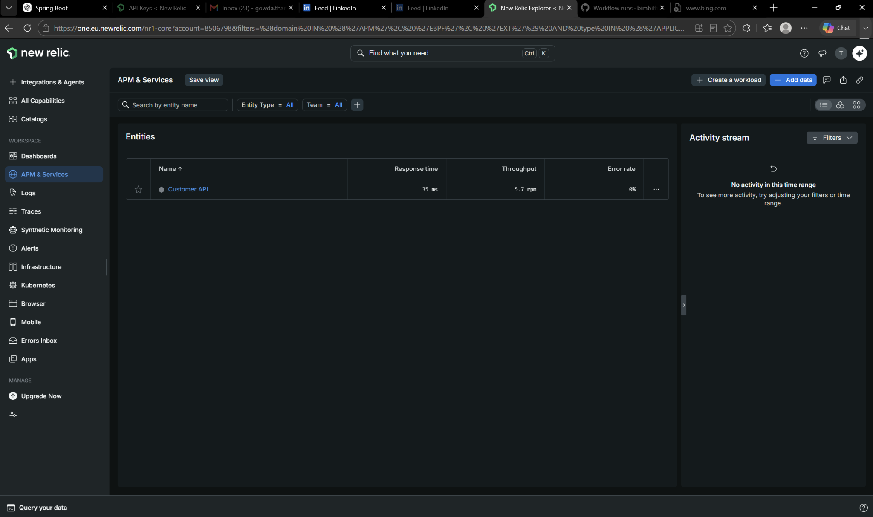
New Relic APM entity showing Customer API response time, throughput, and error rate.
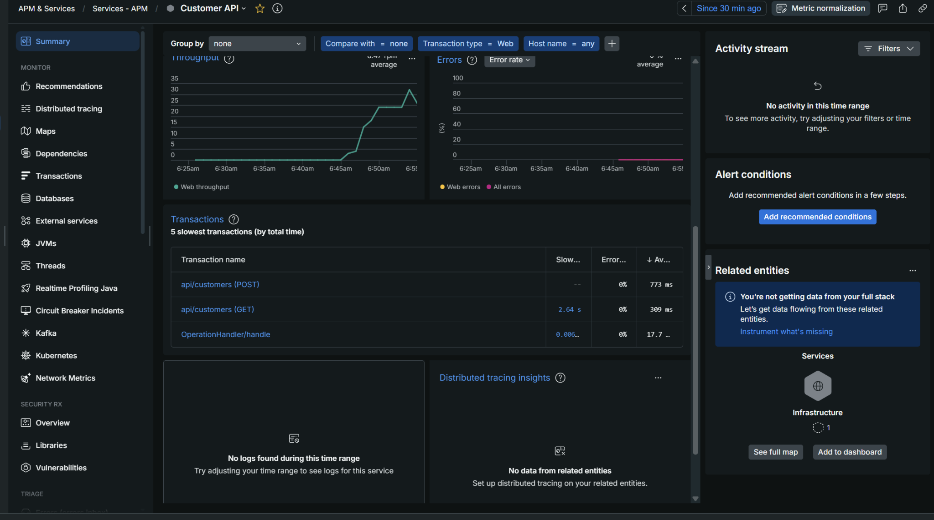
Customer API APM Transactions view showing endpoint-level performance.

16. Final Verification Checklist
- Application runs on Java 21
- PostgreSQL connectivity verified
- Flyway migrations versioned
- CI pipeline green
- Docker image builds
- GHCR image published
- Kubernetes node Ready
- 2/2 Deployment replicas Ready and Available
- Explicit RollingUpdate configured
- Startup, readiness and liveness probes configured
- CPU/memory requests and limits configured
- Customer API reachable through Kubernetes Service
- New Relic Kubernetes collector healthy
- Kubernetes metrics visible in New Relic
- New Relic Java agent loaded in the Pod
- Customer API visible in APM
- API response time, throughput and error rate visible
- Custom observability dashboard saved

17. Closing the Work in Git
After adding this report and README to the repository:
git status
git add README.md Customer_API_Implementation_Report.docx
git commit -m "Document Customer API CI Kubernetes and New Relic observability"
git push origin master

18. Conclusion
The Customer API implementation now demonstrates a complete local engineering lifecycle: source control, automated CI, container packaging, GHCR, Kubernetes orchestration, controlled rolling deployment, startup/readiness/liveness health management, and centralized New Relic infrastructure and application observability. The remaining architectural enhancement is to move Kubernetes to a remotely reachable cloud cluster so GitHub Actions can perform the final automated CD stage.

