Performance Analysis

Each trial tested all three of the classes by creating instances of the classes and calling their methods. For each design 10 million instances of the class were created and each get method was called. For design 5, half of the instances were of the subclass PointCP2 and the other half were of the subclass PointCP3. The time was recorder before and after the instances were created and used, allowing for a difference to be calculated. After the maximum, minimum, and mean were calculated, they were outputted to the console. Below is a sample of this output and tables of all the data collected.

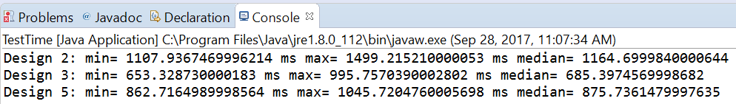

Design 2:

|  |  |  |  |
| --- | --- | --- | --- |
| Trial # | Median Time (ms) | Maximum Time (ms) | Minimum Time (ms) |
| 1 | 1074 | 1165 | 1069 |
| 2 | 1145 | 1484 | 1094 |
| 3 | 1123 | 1606 | 1056 |
| 4 | 1108 | 1499 | 1165 |
| 5 | 1232 | 1771 | 1110 |

Design 3:

|  |  |  |  |
| --- | --- | --- | --- |
| Trial # | Median Time (ms) | Maximum Time (ms) | Minimum Time (ms) |
| 1 | 655 | 665 | 653 |
| 2 | 693 | 1480 | 665 |
| 3 | 885 | 1460 | 869 |
| 4 | 685 | 996 | 653 |
| 5 | 739 | 999 | 684 |

Design 5:

|  |  |  |  |
| --- | --- | --- | --- |
| Trial # | Median Time (ms) | Maximum Time (ms) | Minimum Time (ms) |
| 1 | 843 | 852 | 826 |
| 2 | 880 | 1002 | 864 |
| 3 | 884 | 1460 | 869 |
| 4 | 863 | 1046 | 876 |
| 5 | 927 | 1199 | 876 |

As is evident from the table, design 3 is the fastest, followed by design 5 and then design 2. The reason for this is most likely that the conversion from polar to cartesian is more time consuming than the conversion from cartesian to polar. That is the main difference between the classes, so it is likely the reason. Also, it follows that design 5 would be in the middle of the two implementations because it was tested half as cartesian and half as polar.