Sample Outputs

PointCPTest2:

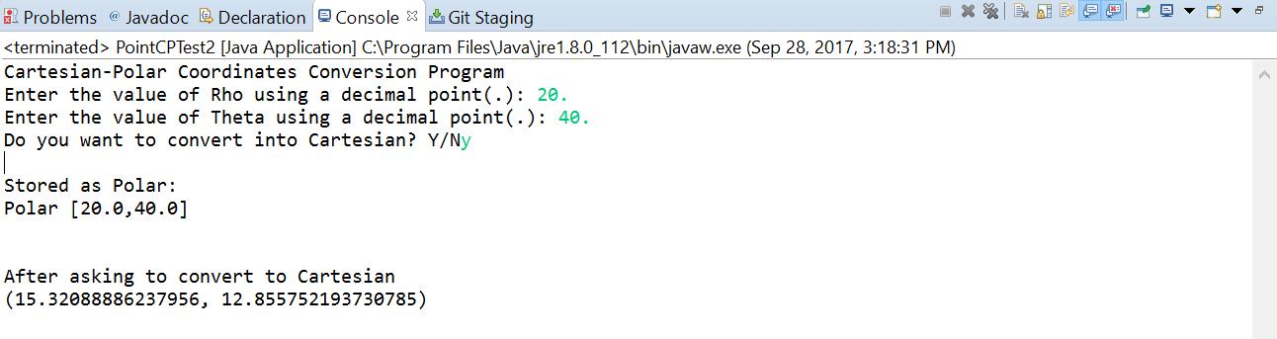

PointCPTest3:

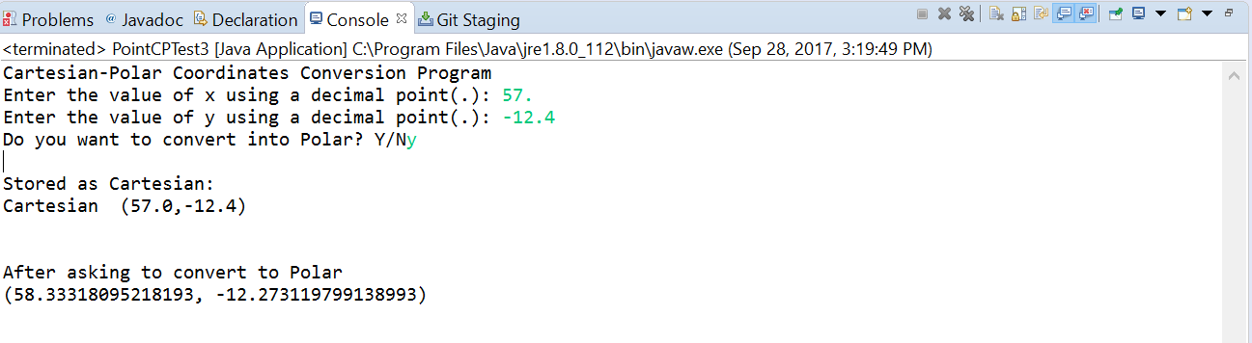

PointCPTest5:

