Assignment 3 - Keshav Bimbraw and Antoine De Meeûs

**Question 1** - (magnitude spectrum from scratch at end)

a) Histogram for ‘rect’

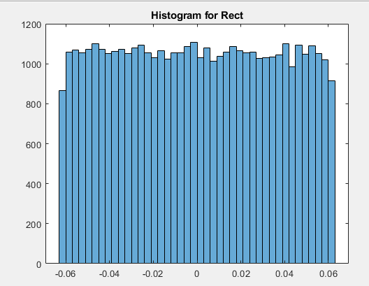

b) Pwelch for Rect

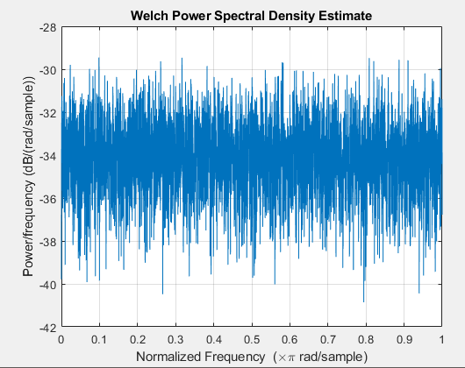

c) Histogram for tri

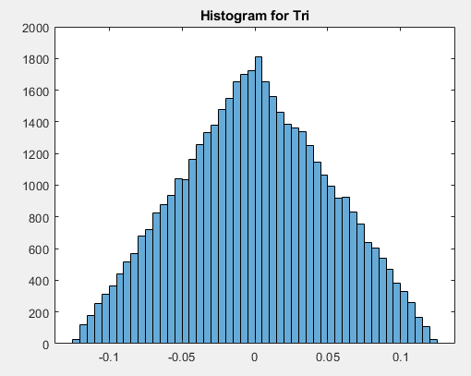

d) Pwelch for tri

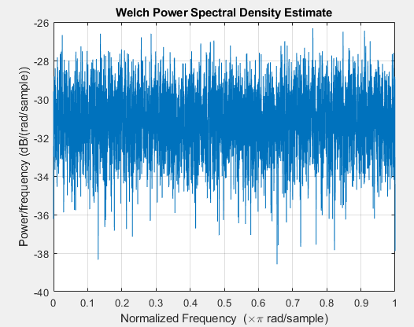

e) Histogram for hp

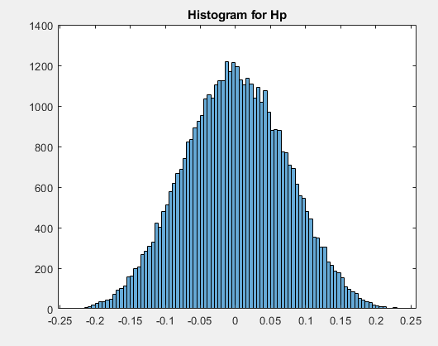

f) Pwelch for hp

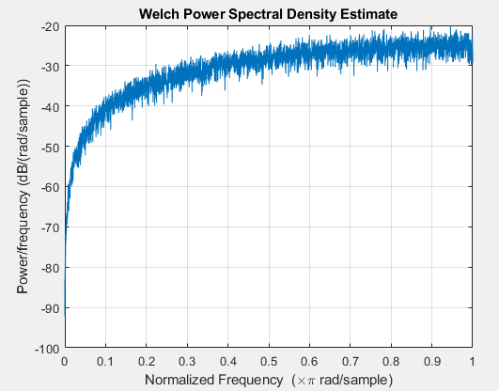

End - magnitude Spectrum

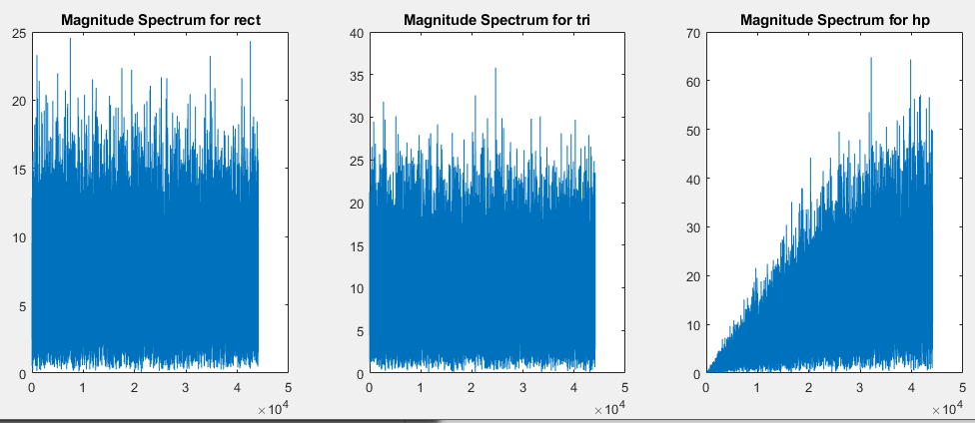

**Question 2** - details in the code implemented

**Question 3 - (First Pwelch and then M. S.)**

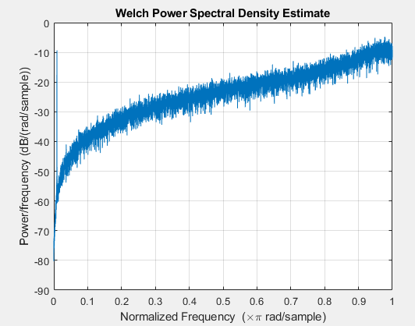

Magnitude Spectrum -

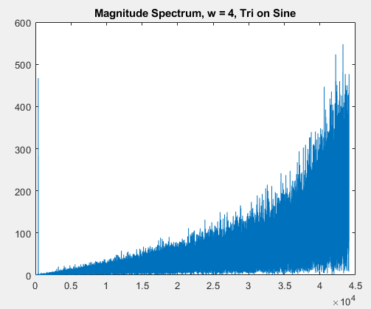

**Question 4 - (first pwelchs and then M. S. at end)**

a) myQuantize for w = 4

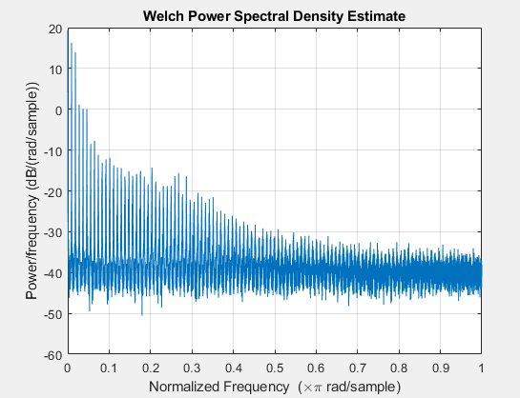

b) myQuantize for w = 8

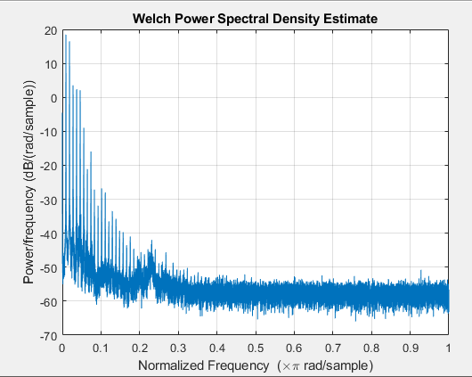

c) myDither for w = 4

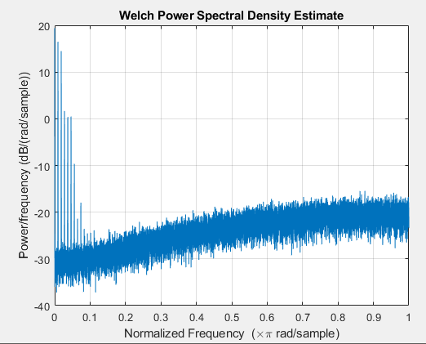

d) myDither for w = 8

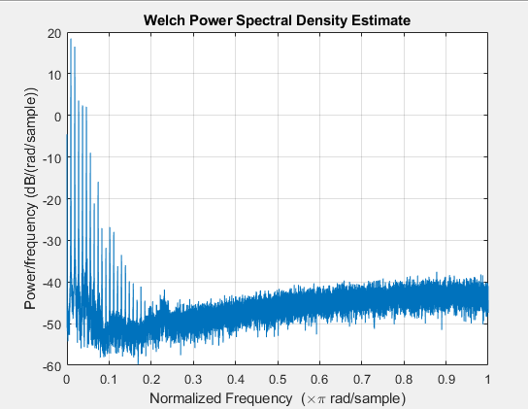

e) myNoiseShape for w = 4

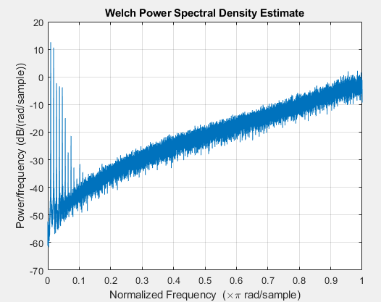

f) myNoiseShape for w = 8

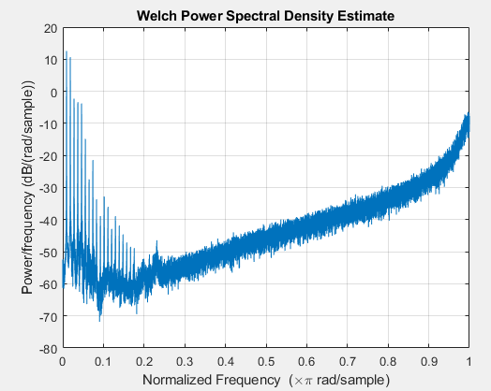

End -

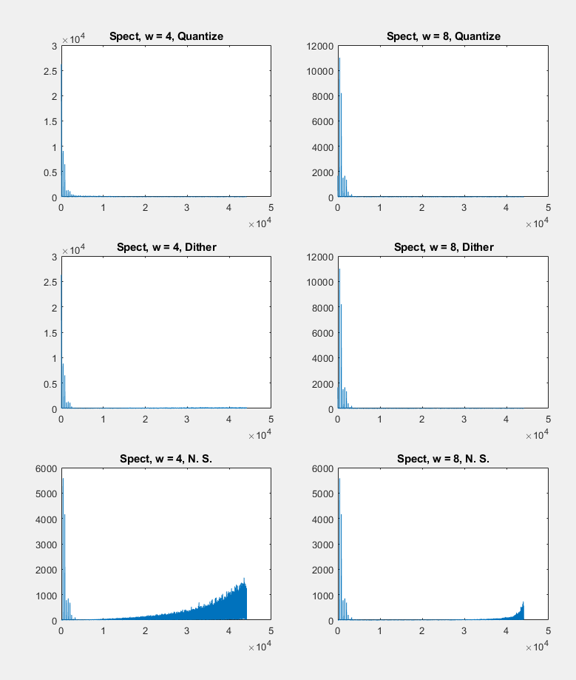

Discussion -

* Using the myQuantize function - when the word length is 4 - there is considerably more noise than when word length is 8. The sound is definitely more ‘shrill’ as compared to myDither function. Since it’s quantized - distinct states can be perceived while listening carefully.
* Using the myDither function - when the word length is 4 - there is considerably more noise than when word length is 8. Using myDither - the sound files are considerably ‘softer’ as compared to myQuantize for both the word lengths, with the sound being much clearer and the noise being much less for higher word length for both myQuantize and myDither.
* Using the N. S. function - when the word length is 4 - the noise is more than when the word length is 8. But - the noise is way too much for both the cases - so much so that sonic characteristics for the sound file were not as easily perceptible as they were for myDither and myQuantize functions.