Assignment:- Weekely Lab Activity 1

Name:- Bimlendra yadav

Lev:- 3 Semester:-2nd

Sec:- A Std Id:- 6102

Week-3

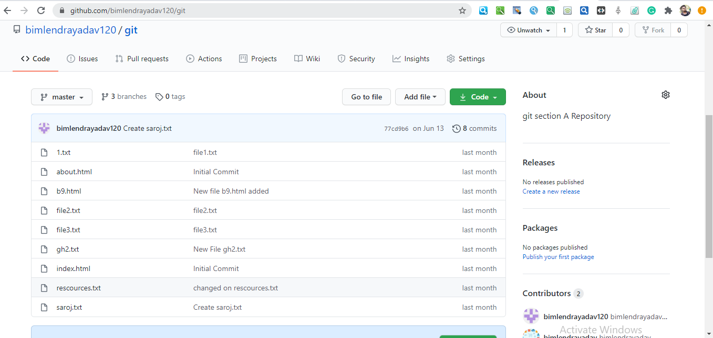

Github Repository link:- <https://github.com/bimlendrayadav120>