Assignment:- Weekely Lab Activity 1

Name:- Bimlendra yadav

Lev:- 3 Semester:-2nd

Sec:- A Std Id:- 6102

Week-4

Task-1:-

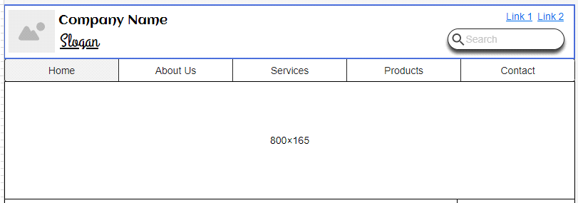

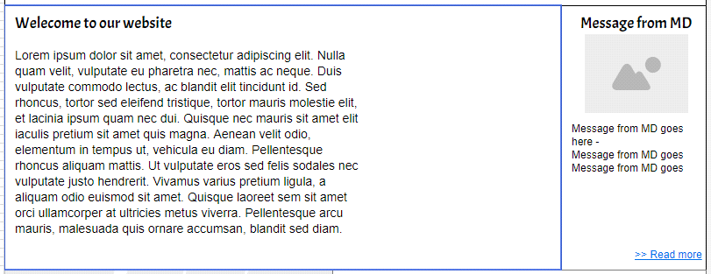

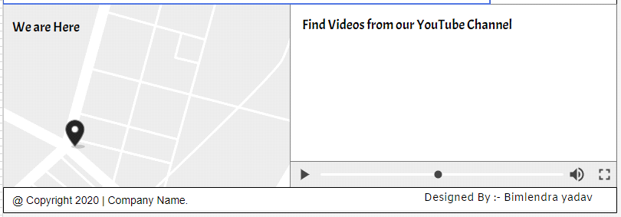

Final screenshot of Task-1

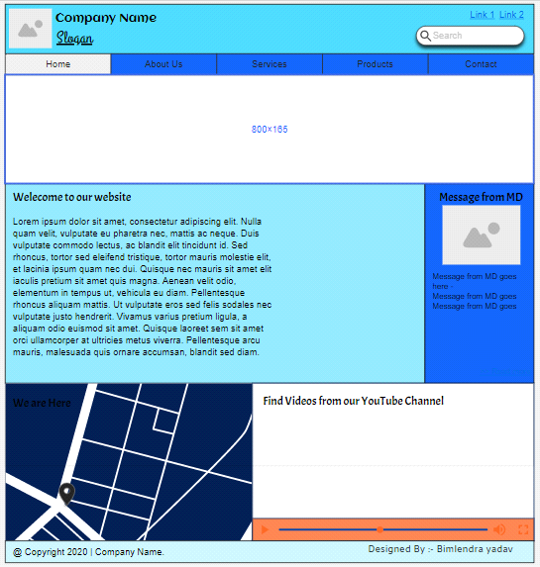

Task-2:-

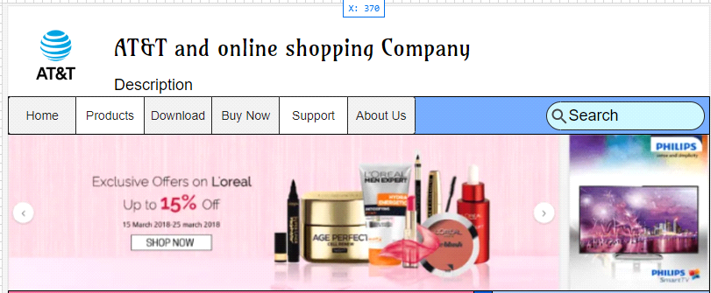

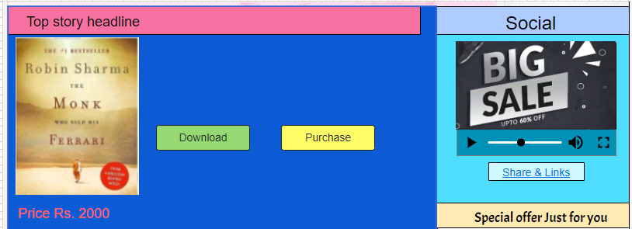

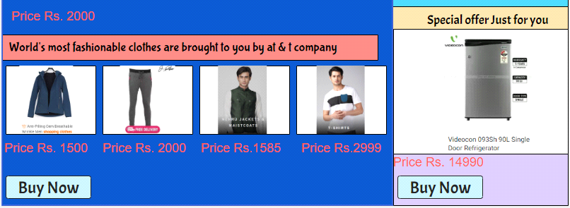

Final Screenshot of Task-2

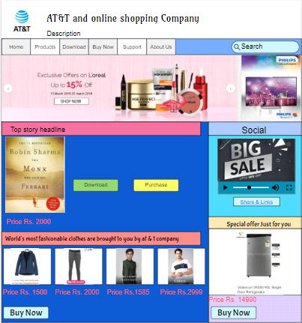

Task-3:-

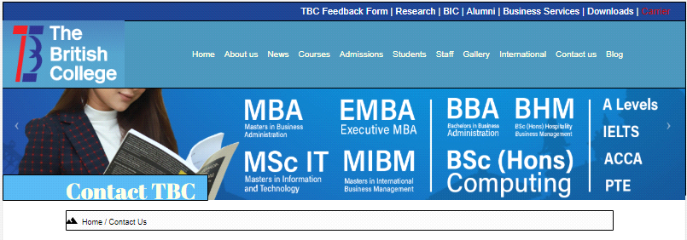

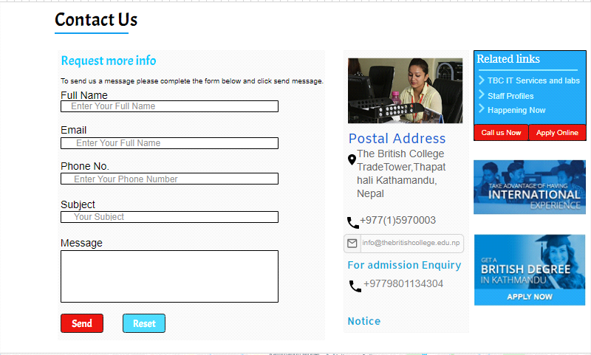

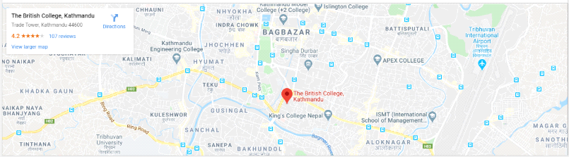

Final screenshot of task-3

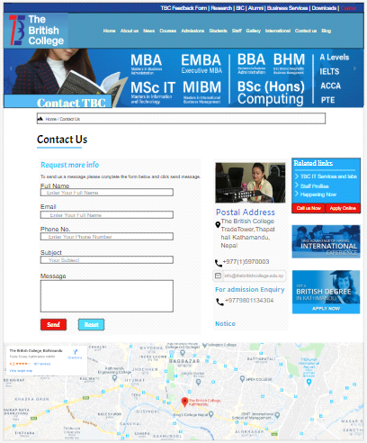

Wireframe And Mockup Link of week-4:- <https://app.moqups.com/unsaved/b7d79094/edit/page/ad64222d5>