Assignment(Week-10)

Task-1

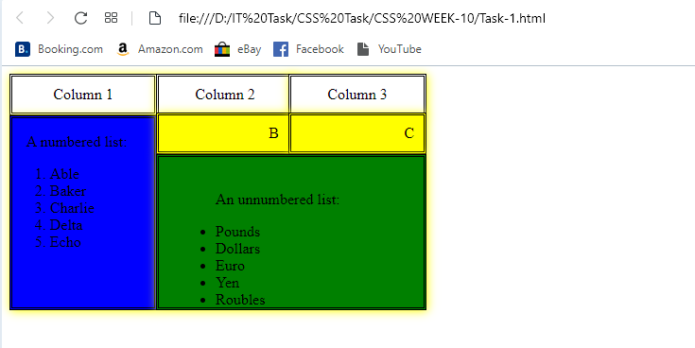

Link of Task-1 :- <file:///D:/IT%20Task/CSS%20Task/CSS%20WEEK-10/Task-1.html>

Task-2

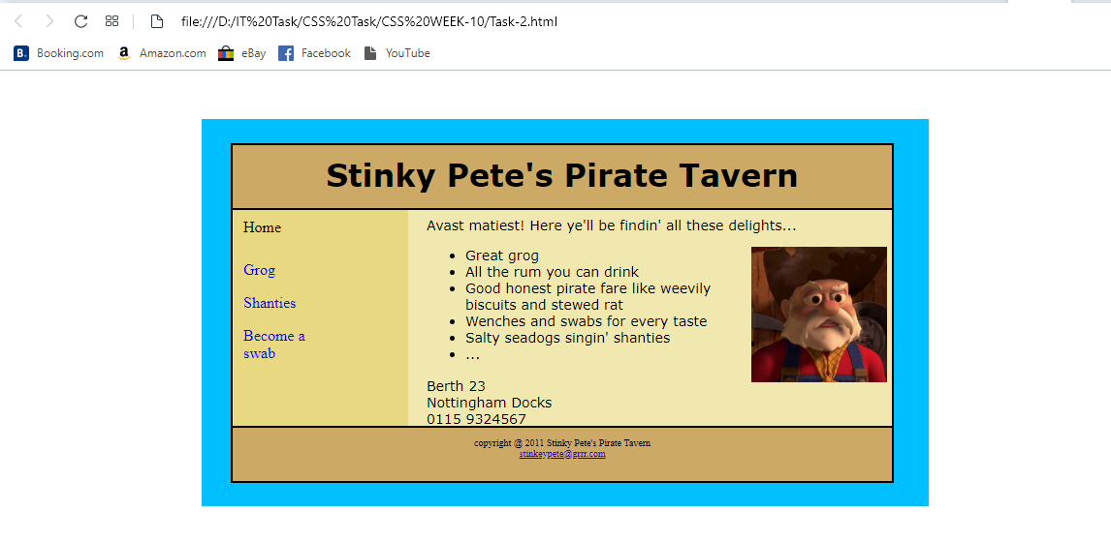

Link of Task-2 :- <file:///D:/IT%20Task/CSS%20Task/CSS%20WEEK-10/Task-2.html>

Task-3

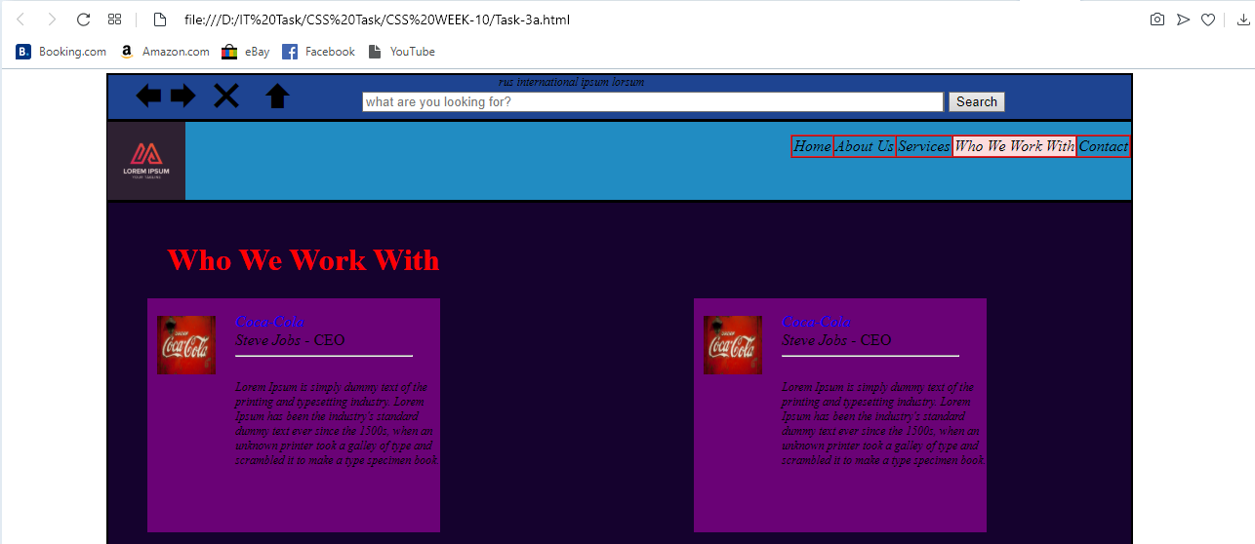

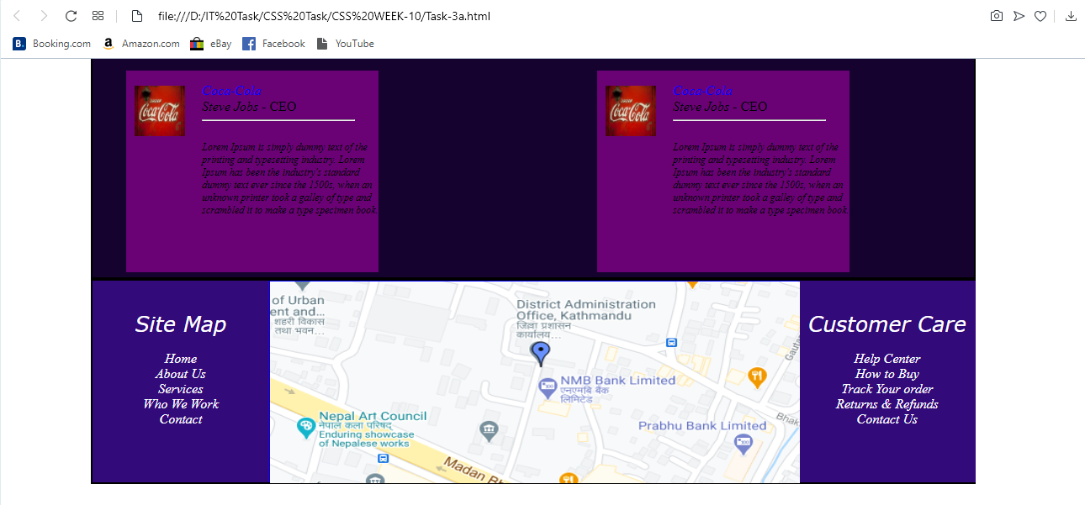

Link of Task-3 :- <file:///D:/IT%20Task/CSS%20Task/CSS%20WEEK-10/Task-3a.html>