Assignment:- Weekely Lab Activity 1

Name:- Bimlendra yadav

Lev:- 3 Semester:-2nd

Sec:- A Std Id:- 6102

Week-6

Exercise-1

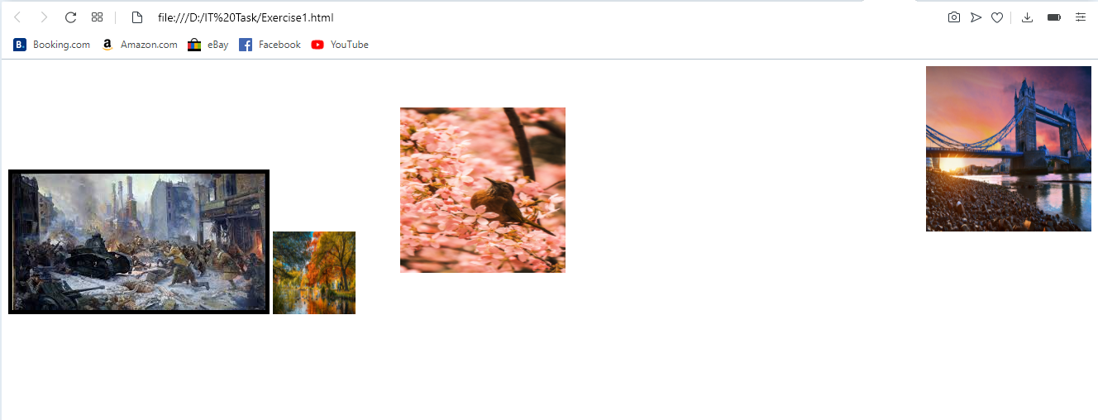

Exercise-2



Exercise-3

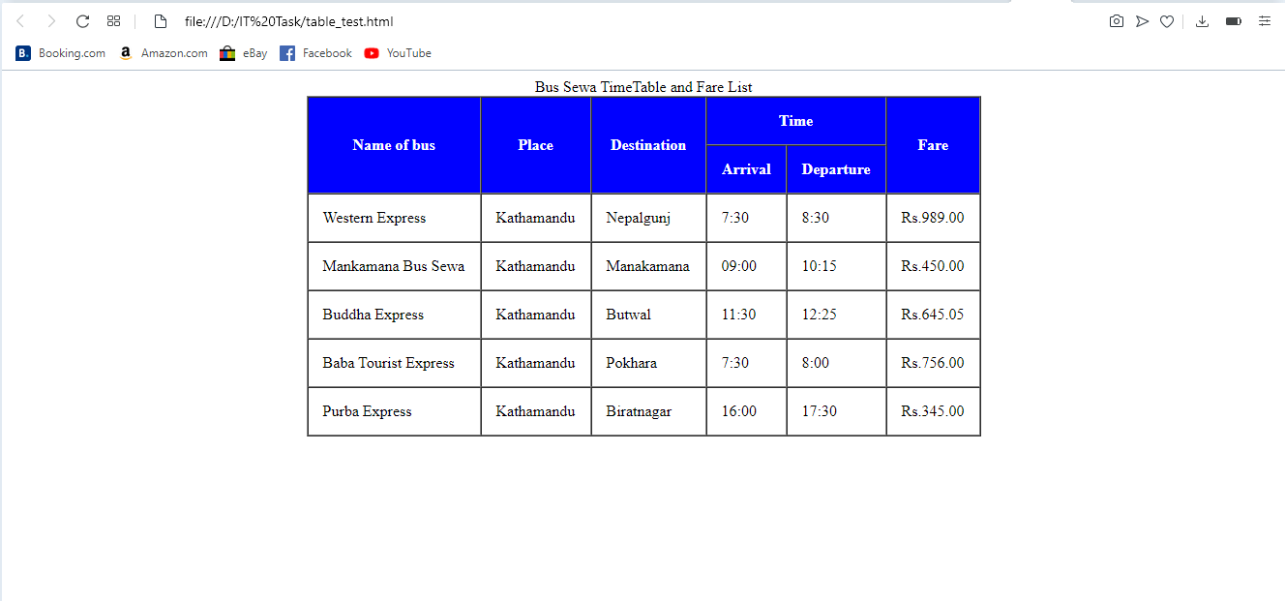

Link of week-6:-

Exercise-1

<file:///D:/IT%20Task/Exercise1.html>

Exercise-2

<file:///D:/IT%20Task/Exercise-2%20(2).html>

Exercise-3

<file:///D:/IT%20Task/table_test.html>