Assignment:- Weekely Lab Activity 1

Name:- Bimlendra yadav

Lev:- 3 Semester:-2nd

Sec:- A Std Id:- 6102

Week-5

Exercise-1

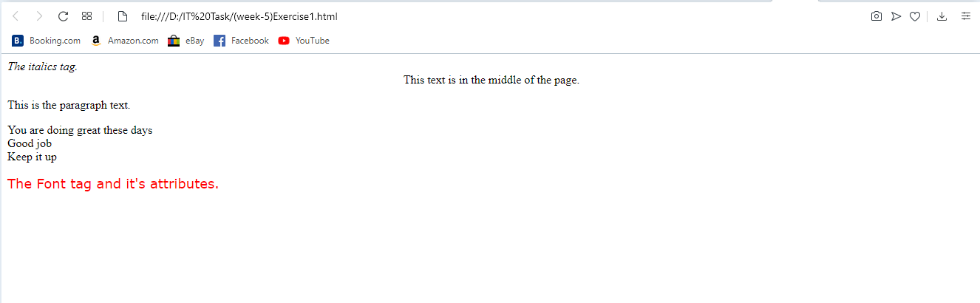

Exercise-2

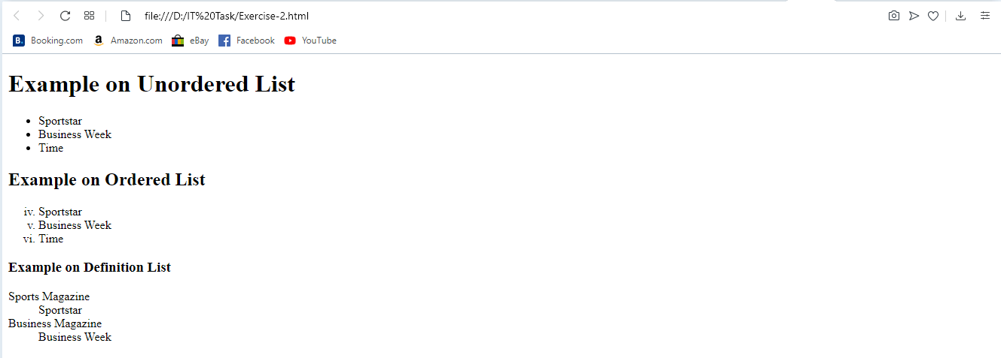

Exercise-3

a)

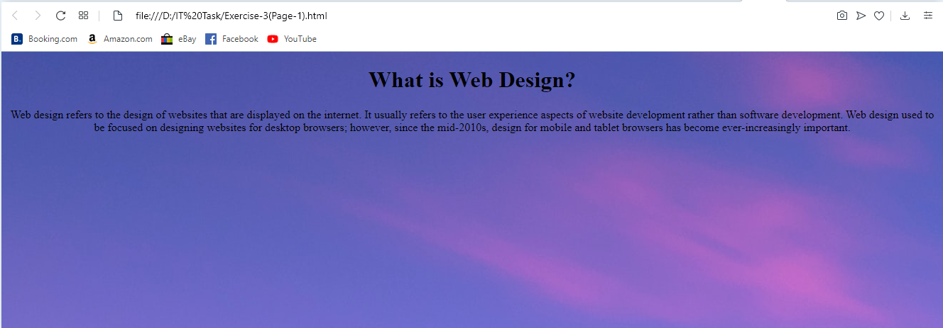

b)

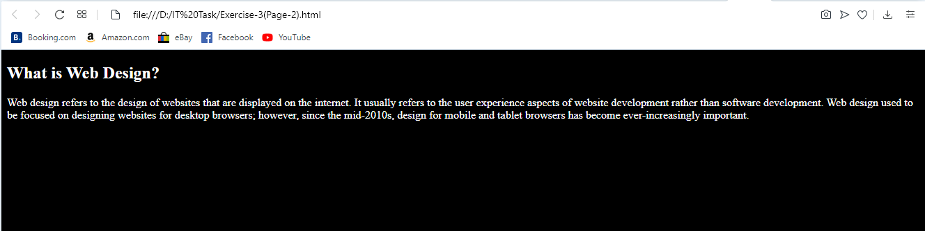

Link of week-5:-

Exercise-1

<file:///D:/IT%20Task/(week-5)Exercise1.html>

Exercise-2

<file:///D:/IT%20Task/Exercise-2.html>

Exercise-3

a)

<file:///D:/IT%20Task/Exercise-3(Page-1).html>

b)

<file:///D:/IT%20Task/Exercise-3(Page-2).html>