Assignment:- Weekely Lab Activity 1

Name:- Bimlendra yadav

Lev:- 3 Semester:-2nd

Sec:- A Std Id:- 6102

Week-7

Exercise-1

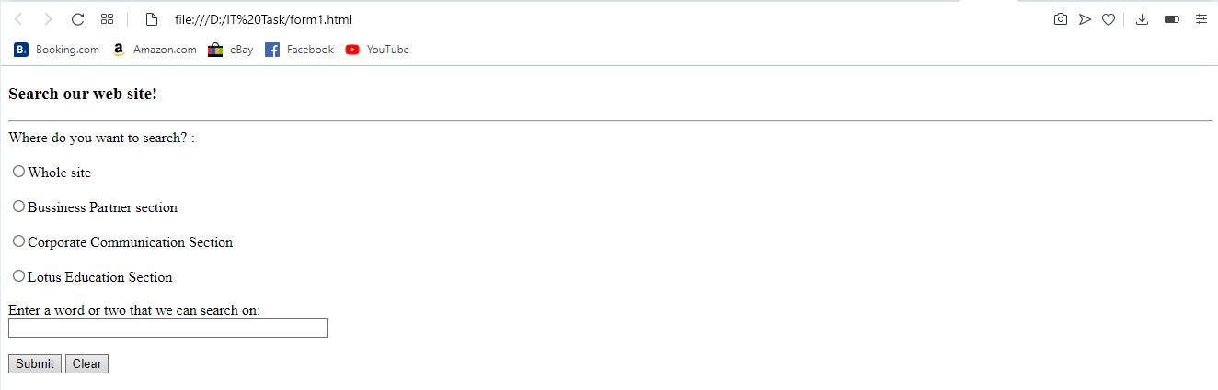

Exercise-2

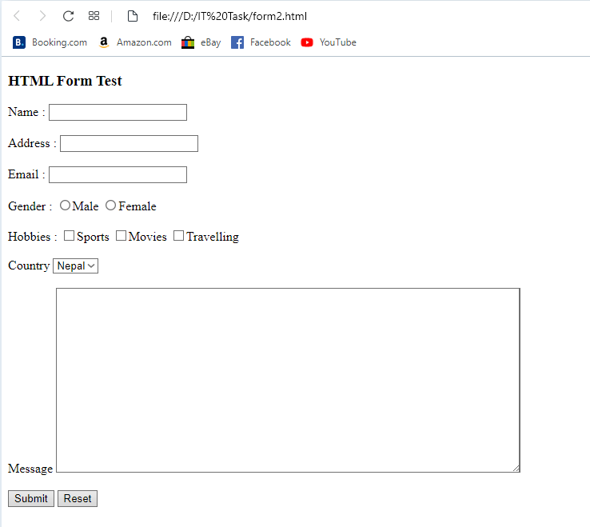

Link of week-7:-

Exercise-1

<file:///D:/IT%20Task/form1.html>

Exercise-2

<file:///D:/IT%20Task/form2.html>