|  |
| --- |
| ***Lab Report***  ***IA 3203 – Digital Signal Processing***  *Department of Instrumentation and Automation Technology*  *University of Colombo* |
| **DSP 303 – Linear Time Invariant Systems** |

|  |  |
| --- | --- |
| **Registration No: 2021t01108** |  |
| **Students Name: G.G.B.S Gunawardana** |  |
| **Date (dd/mm/yy): 19/07/2024** |  |

**Exercise:**

Question 01:

**Answer:**

***Octave code:***

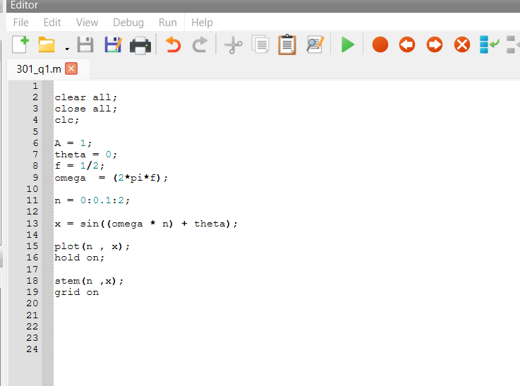

***Figures:***

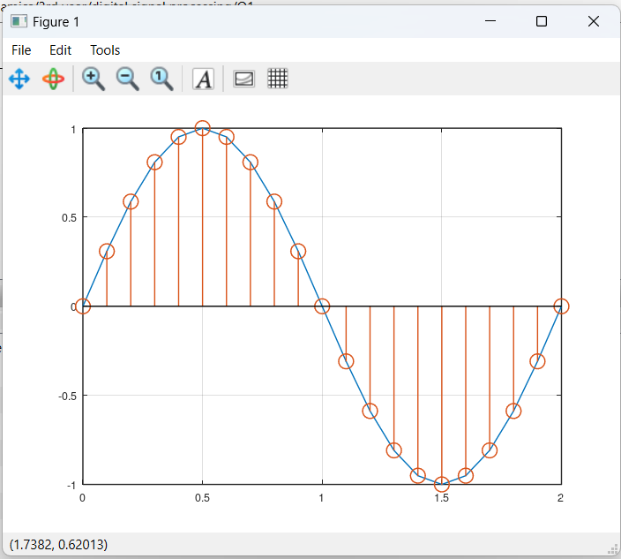

***Results/Answers in Command Window:***

**No results in command window**

Question 02:

**Answer:**

i. ***Octave code:***

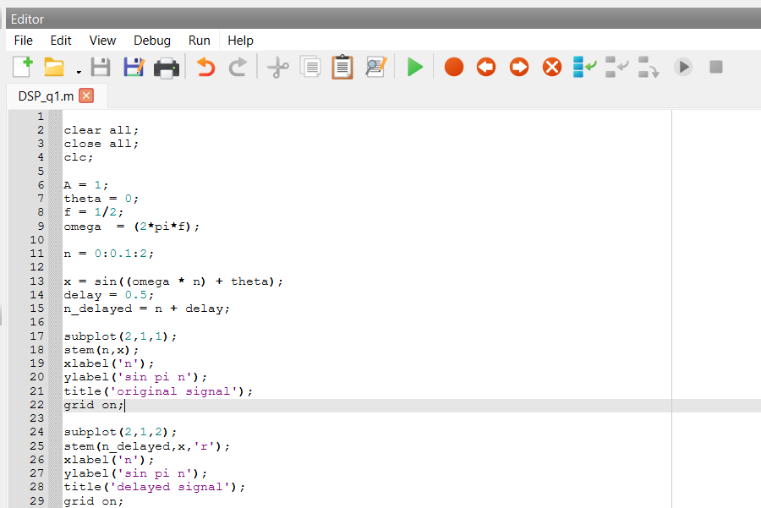

***Figures:***

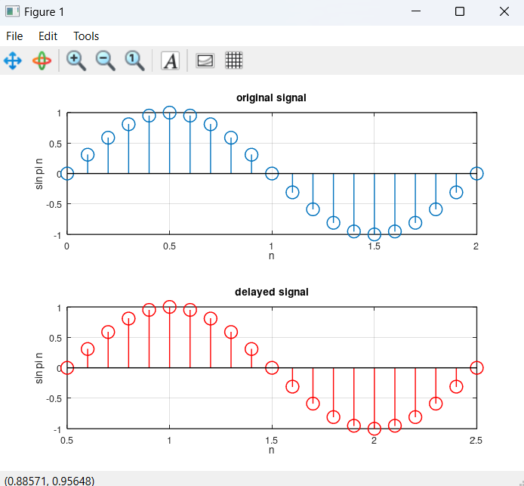

ii. ***Octave code:***

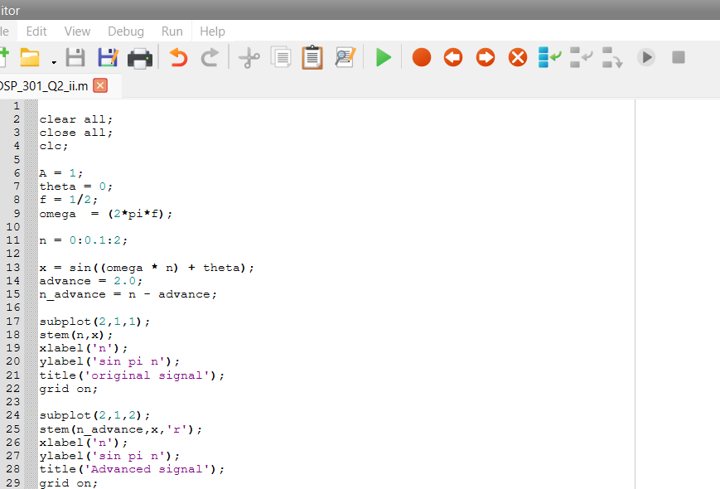

***Figures:***

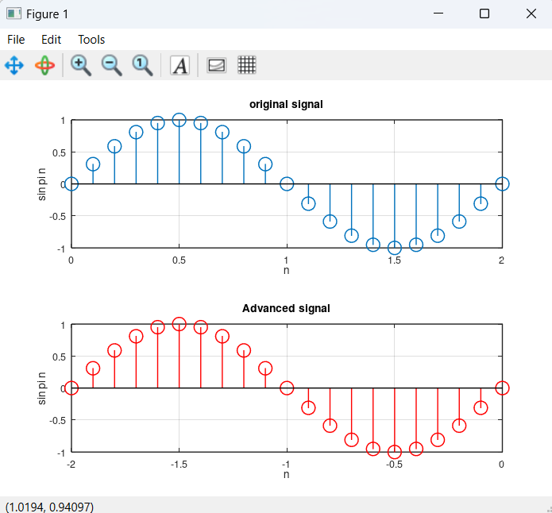

iii. ***Octave code:***

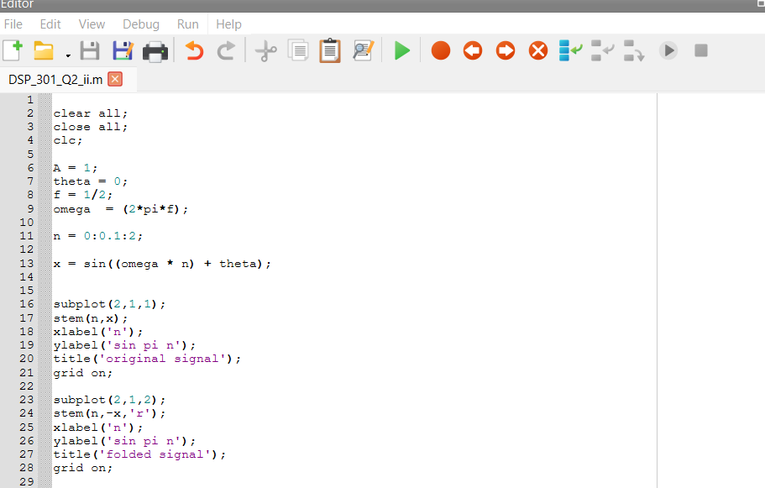

***Figures:***

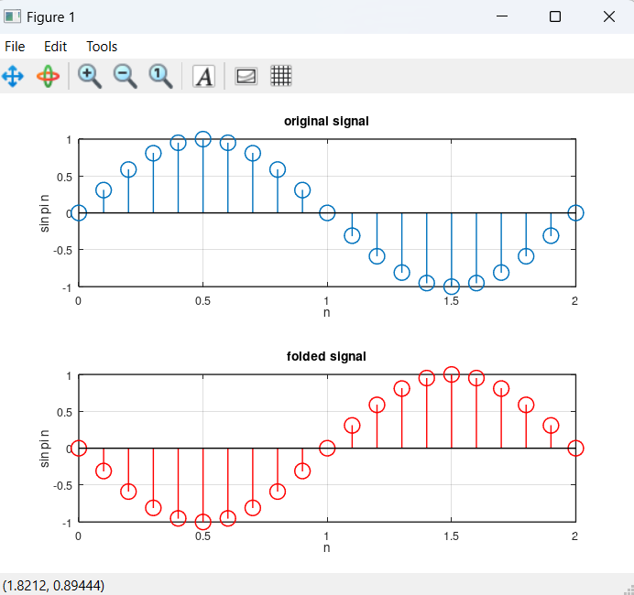

iv. ***Octave code:***

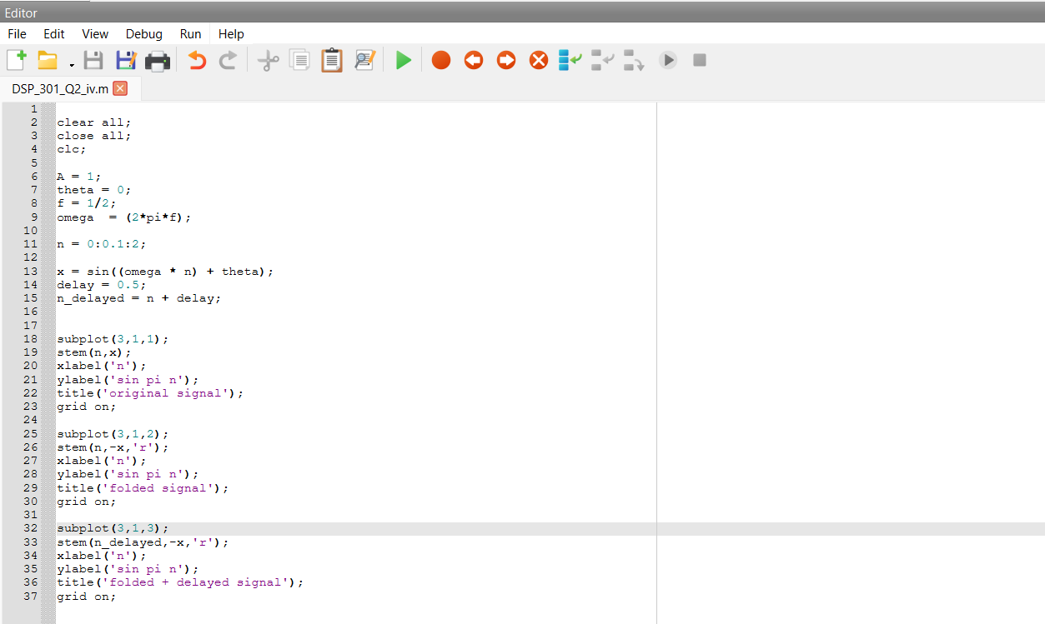

***Figures:***

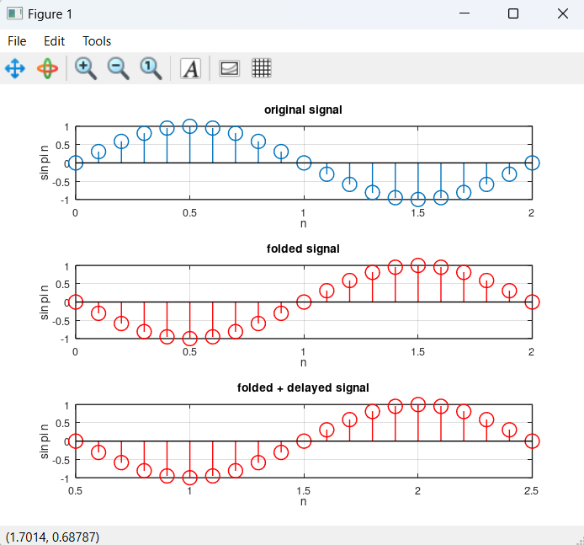

v. ***Octave code:***

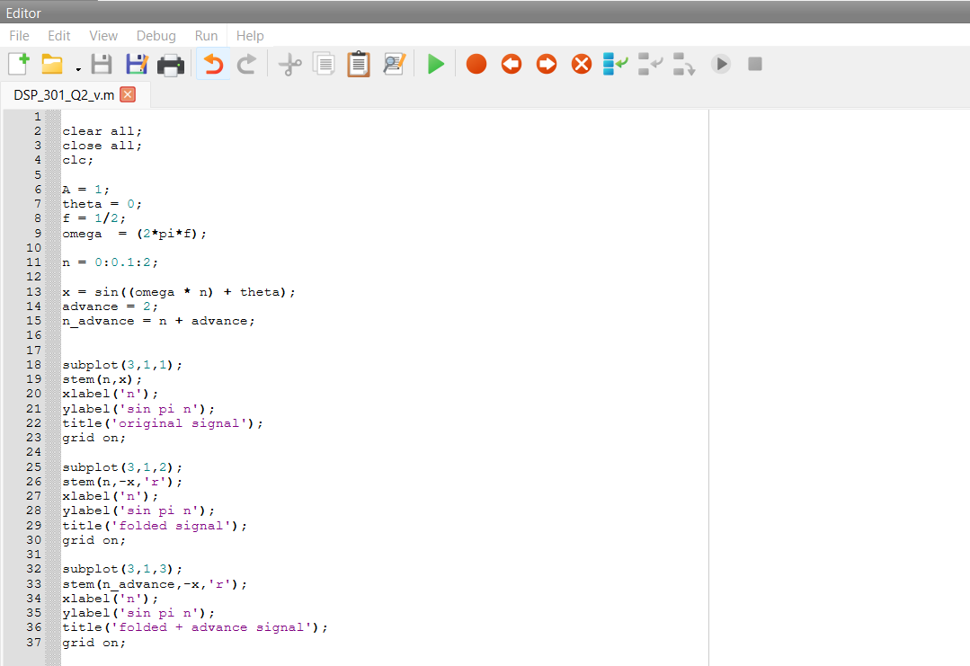

***Figures:***

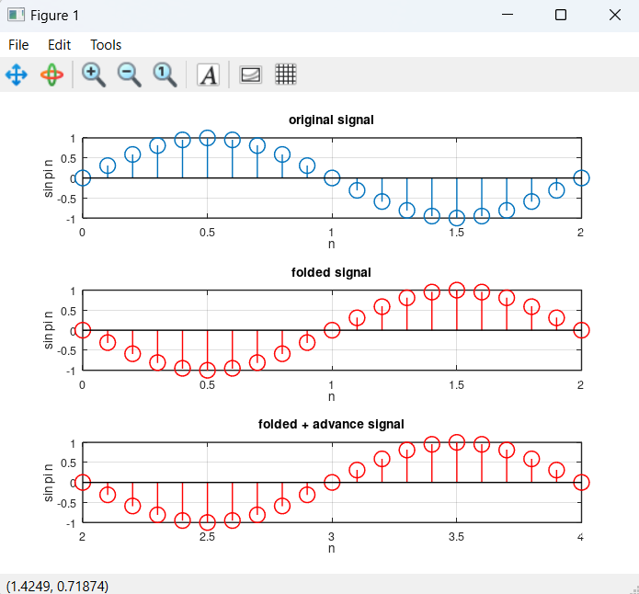

***vi. Octave code:***

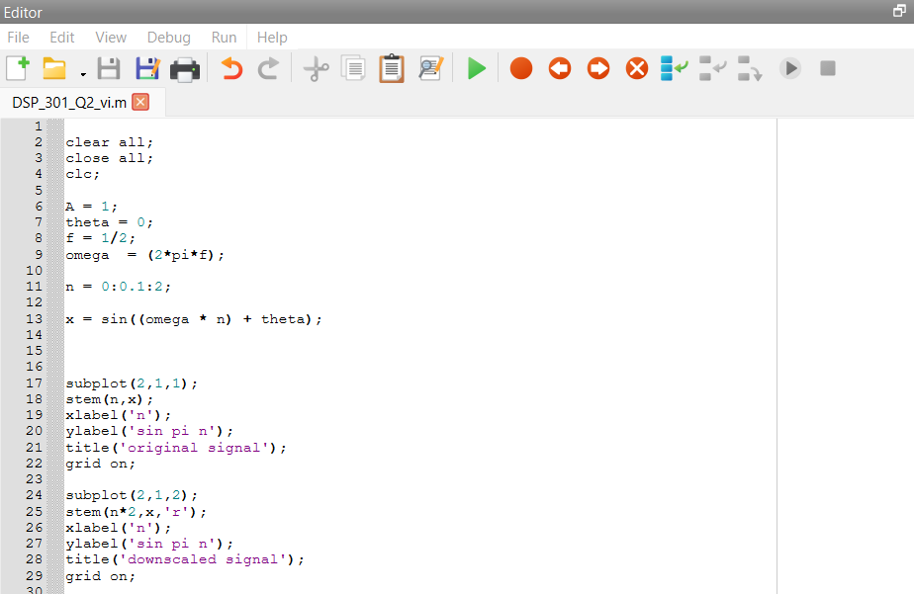

***Figures:***

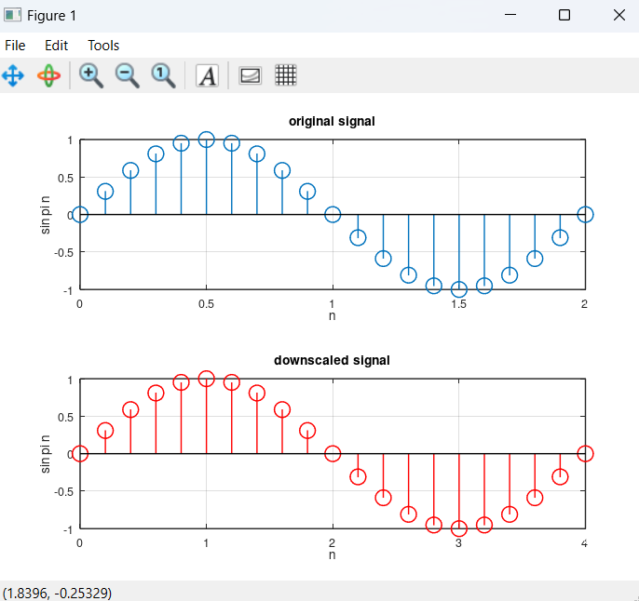

vii. ***Octave code:***

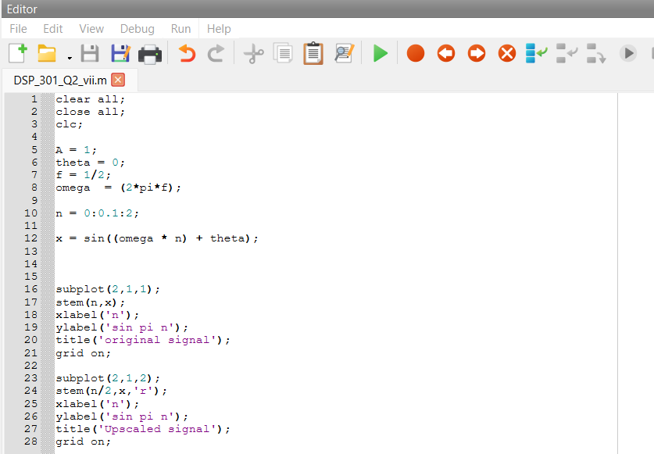

***Figures:***

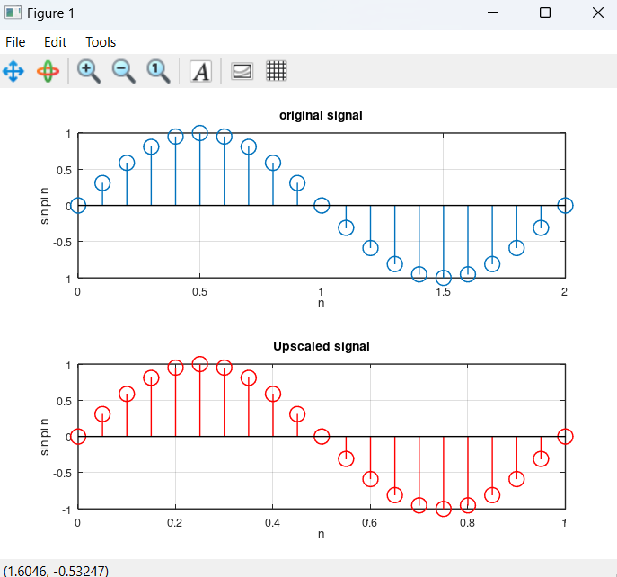

viii. ***Octave code:***

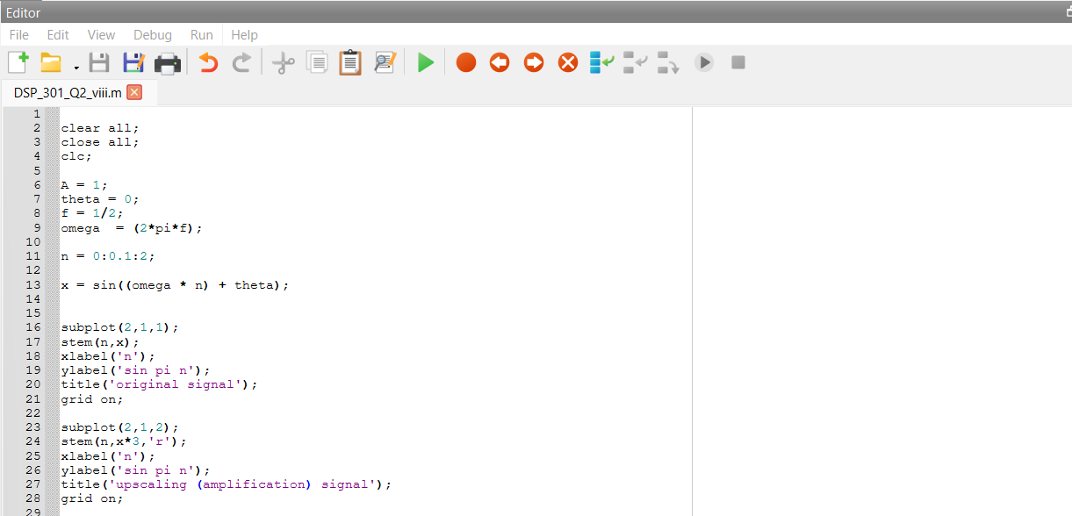

***Figures:***

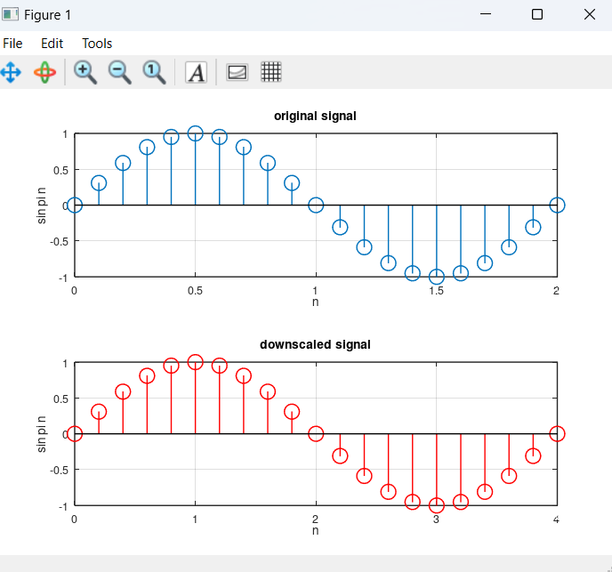

***ix. Octave code:***

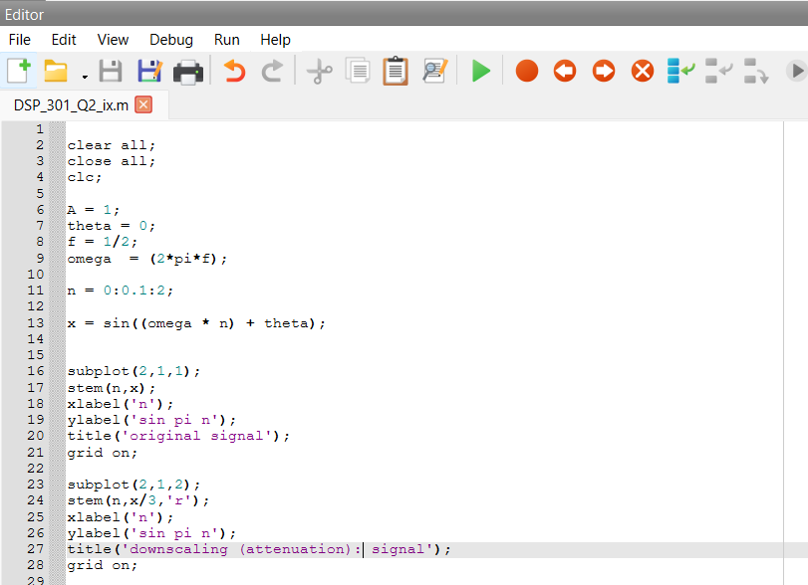

***Figures:***

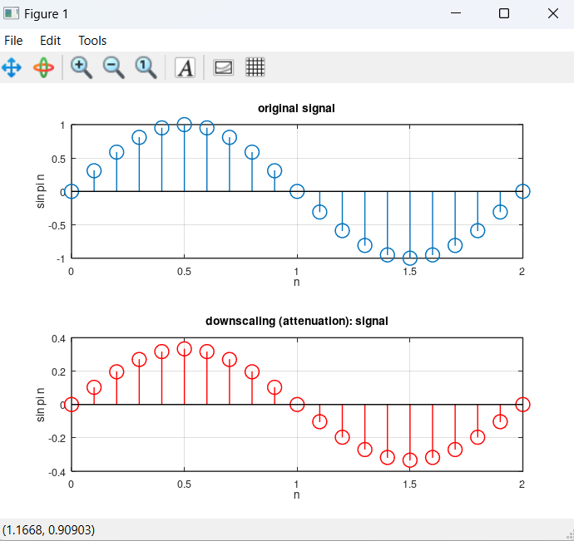

Question 03:

**Answer:**

***Octave code:***

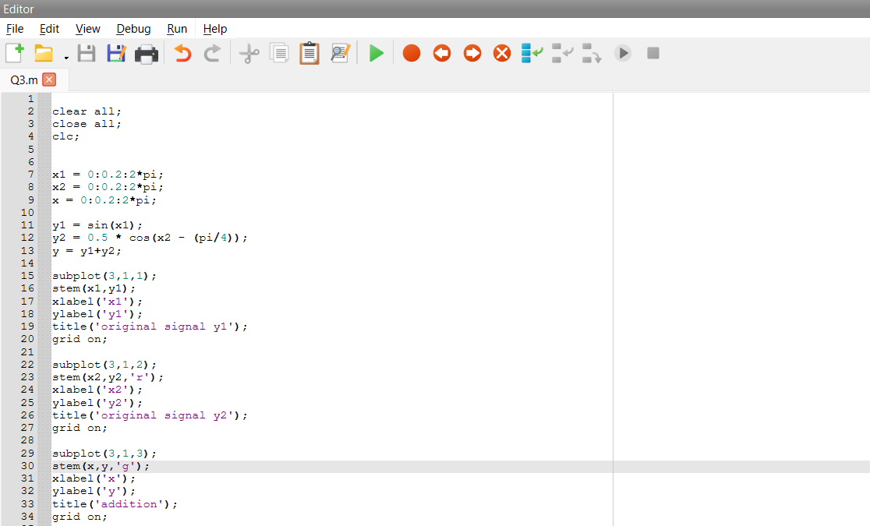

***Figures:***

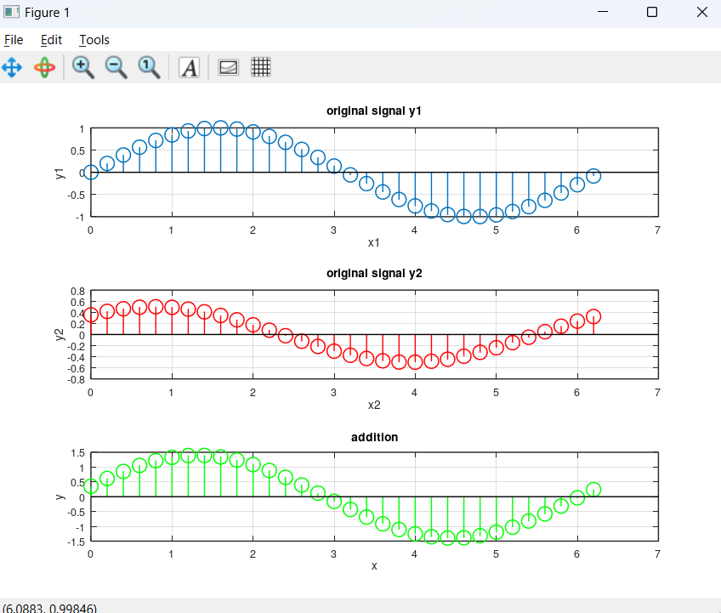

Question 04:

**Answer:**

***Octave code:***

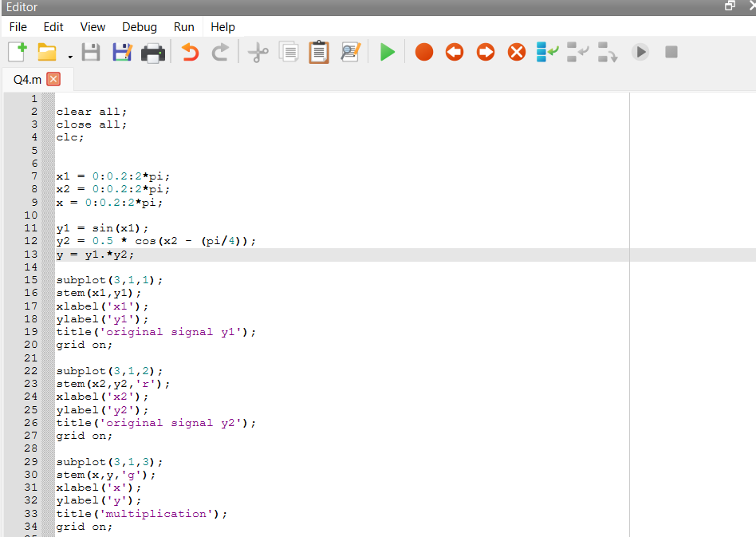

***Figures:***

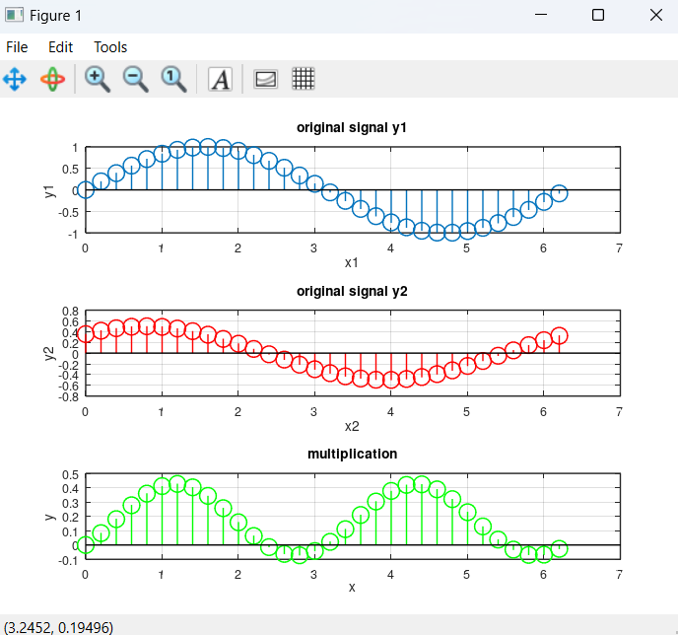

Question 05:

**Answer:**

**Time delay:**

* Signal reconstruction with digital filters
* Signal synchronization in communication systems
* Target direction in radar systems

**Amplification**

* In Audio systems
* With Sensors
* In power supply units