|  |
| --- |
| ***Lab Report***  ***IA 3203 – Digital Signal Processing***  *Department of Instrumentation and Automation Technology*  *University of Colombo* |
| **DSP 304 – – Analog to Digital Conversion** |

|  |  |
| --- | --- |
| **Registration No: 2021t01108** |  |
| **Students Name: bimsara gunawardana** |  |
| **Date (dd/mm/yy): 1/11/2024** |  |

**Exercise:**

Question 01.a:

**Answer:**

***Octave code:***

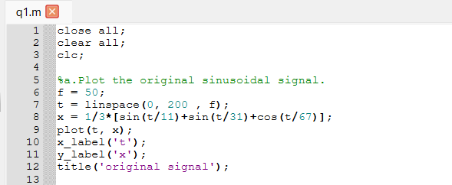

***Figures:***

Question 01.b:

**Answer:**

***Octave code:***

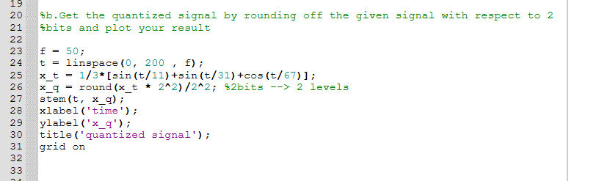

***Figures:***

Question 01.c:

**Answer:**

***Octave code:***

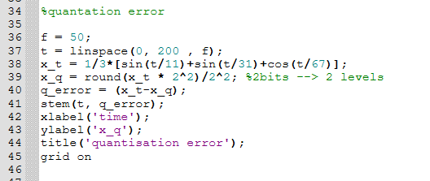

***

Question 01.d:

**Answer:**

***Octave code:***

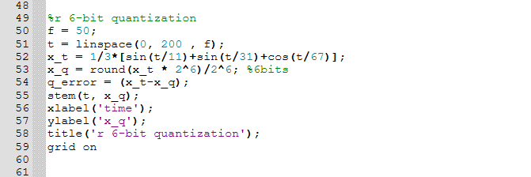

***Figures***

Question 01.e:

**Answer:**

***Octave code:***

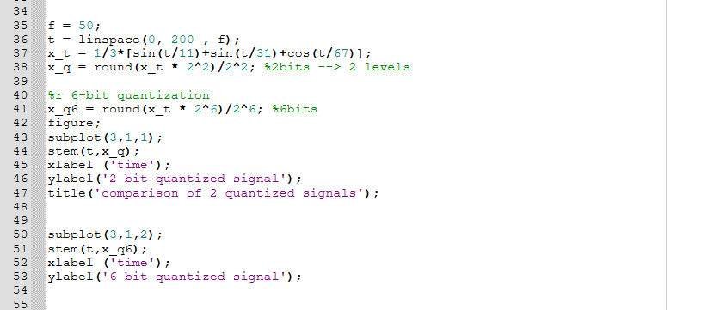

***Figures***

