**\*\*Note:**

**This file is parsed from README.md on the GitHub, it is recommended to read the documentation from there.**

**Apache Admin V 1.0.0**



╔═══╗────────╔╗─────╔═══╗─╔╗ ║╔═╗║────────║║─────║╔═╗║─║║  
║║─║╠══╦══╦══╣╚═╦══╗║║─║╠═╝╠╗╔╦╦═╗ ║╚═╝║╔╗║╔╗║╔═╣╔╗║║═╣║╚═╝║╔╗║╚╝╠╣╔╗╗ ║╔═╗║╚╝║╔╗║╚═╣║║║║═╣║╔═╗║╚╝║║║║║║║║ ╚╝─╚╣╔═╩╝╚╩══╩╝╚╩══╝╚╝─╚╩══╩╩╩╩╩╝╚╝ ────║║ ────╚╝ ─────╔╗─╔═══╗╔═══╗  
────╔╝║─║╔═╗║║╔═╗║ ╔╗╔╗╚╗║─║║║║║║║║║║ ║╚╝║─║║─║║║║║║║║║║  
╚╗╔╝╔╝╚╦╣╚═╝╠╣╚═╝║ ─╚╝─╚══╩╩═══╩╩═══╝ ╔══╗───────╔╗──╔╗─────╔═══╗  
║╔╗║───────║║──║║─────║╔═╗║ ║╚╝╚╦╗─╔╗──║╠══╣╚═╦═╗─║║─╚╬══╦══╦═╦══╦══╗  
║╔═╗║║─║║╔╗║║╔╗║╔╗║╔╗╗║║╔═╣║═╣╔╗║╔╣╔╗║║═╣ ║╚═╝║╚═╝║║╚╝║╚╝║║║║║║║║╚╩═║║═╣╚╝║║║╚╝║║═╣ ╚═══╩═╗╔╝╚══╩══╩╝╚╩╝╚╝╚═══╩══╩══╩╝╚═╗╠══╝ ────╔═╝║──────────────────────────╔═╝║ ────╚══╝──────────────────────────╚══╝

**What is Apache Admin**

Apache admin is an opensource bash script to control your Apache Web-Server fully, installing/uninstalling Apache web-  
server, edit your Apache configurations with just small number of tabs for choosing and much more as shown in  
documentation.

**Installing Apache Admin**

• First you have to clone the Apache from the GitHub repository git clone

https://github.com/bin0mial/apache-admin.git

• Next start using Apache make the file executable by using the following command chmod +x apache-  
 admin/main.shthen run it as follows: sudo ./apache-admin/main.sh Or You can run it directly using the  
 following code: sudo bash ./apache-admin/main.sh

• In case you don't run as a root

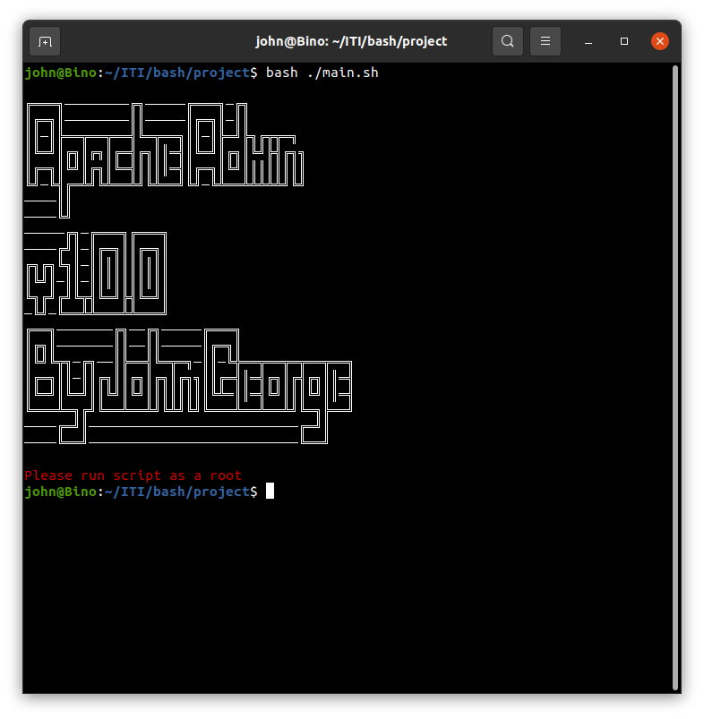

• After Successful running the following screen show

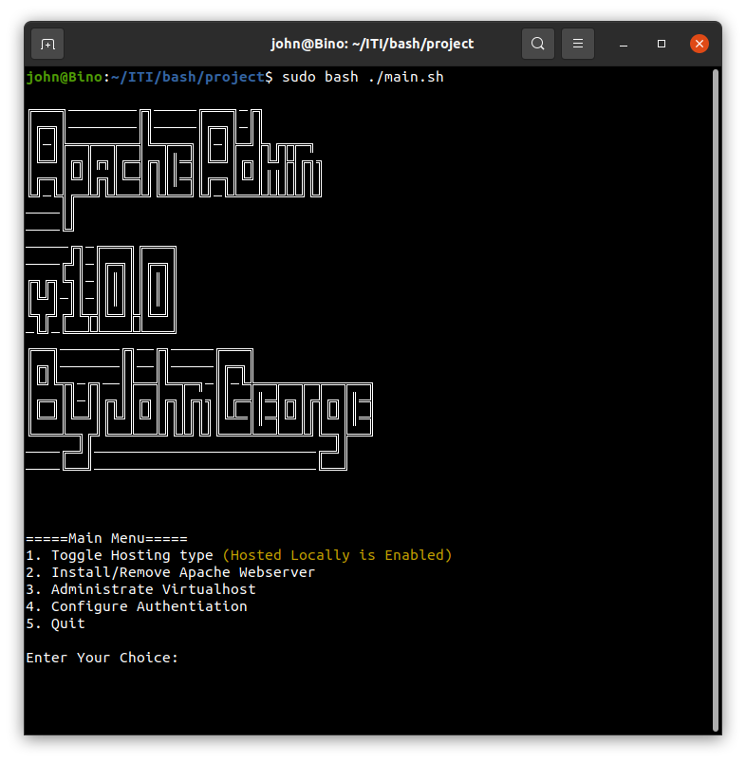

**Go farther with Apache Admin**

As shown after successful installation page you will get the following choices:

1. Toggle Hosting type (Default Enabled)

2. Install/Remove Apache Web Server

3. Administrate Virtual-host

4. Configure Authentication

5. Quit

**Toggle Hosting type**

This choice only to toggle whether it will be hosted locally or on a server its default value is enabled. In case of hosting  
locally enabled virtual hosts will be directly added to /etc/hostsfile as follows:

127.0.0.1 john.com 127.0.0.1 [www.john.com](http://www.john.com/)

**Install/Remove Apache Web Server**

This option is very **dangerous** because it can delete your Web Server if it is installed, but don't worry we will take your confirmation in case of installation or removal

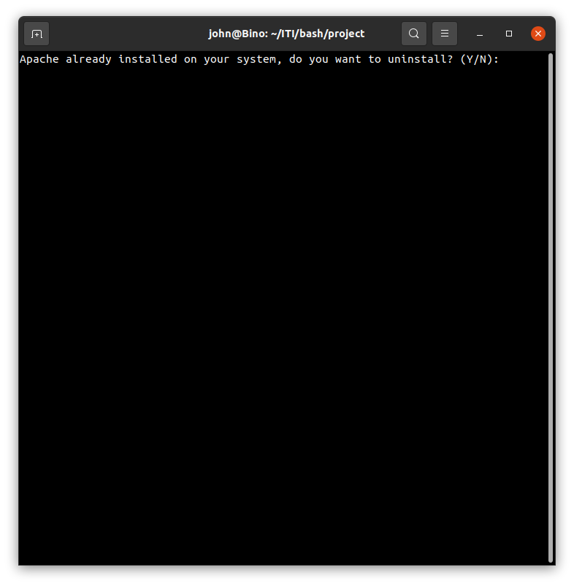

**Administrate Virtual-host**



It's one of our most cool feature, this feature can

1. List Virtual-Hosts

◦ We care about your view to Apache virtual hosts available so we ignored apache2ctl -S and created our

special view for you.

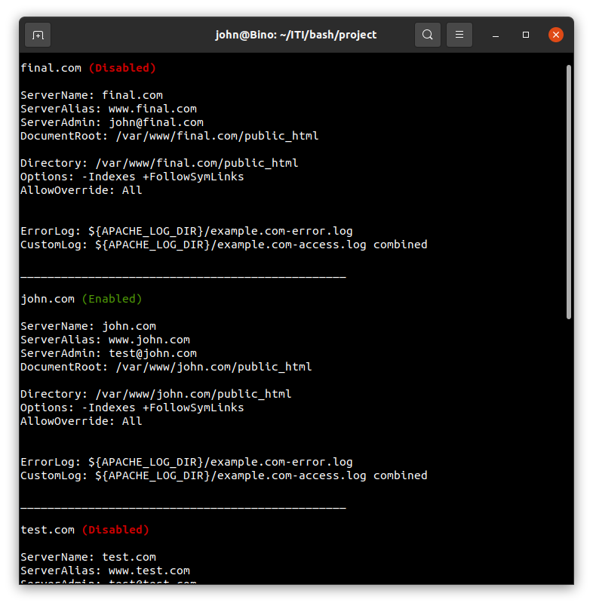

2. Add Virtual-Host

◦ You can add new Virtual host by as simple as possible by just entering your Server Name and your Email

< Optional >>.

◦ Try to make sure that your Server Name is unique or you will get an error.

◦ If it is created successfully you will get the following response:

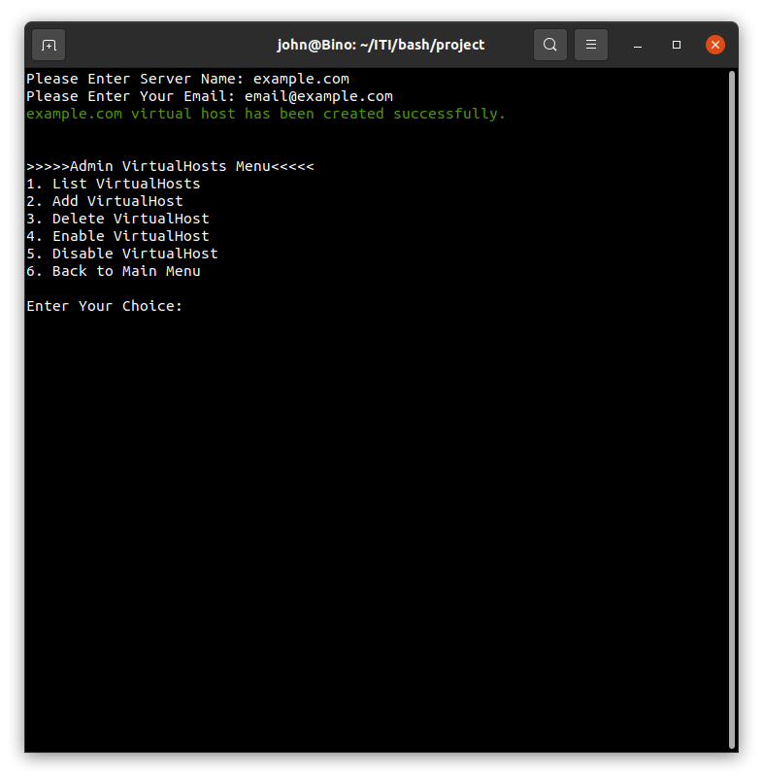

3. Delete Virtual-Host

◦ It is very simple here to delete a virtual host all you have to do is typing the Server Name and vola it is

deleted if it is exists.

◦ The response if it is successful will be as follows:

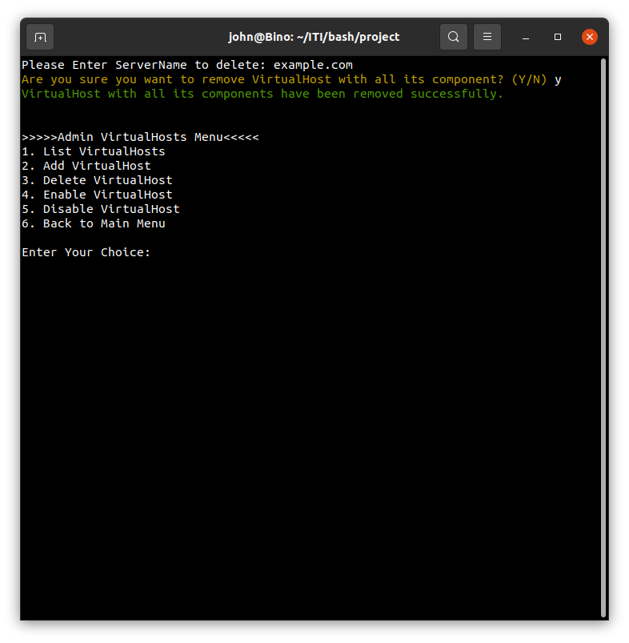

4. Enable Virtual-Host

◦ Unfortunately web server can't run on its own after installation, you must enable the virtual host by using  
 this option and type the virtual host Server Name and leave the script prepare everything for you.  
◦ If everything goes alright you should receive the following response: enter image description here

---Note  
 don't forget about the toggle host, because hosts file will be affected in this part.

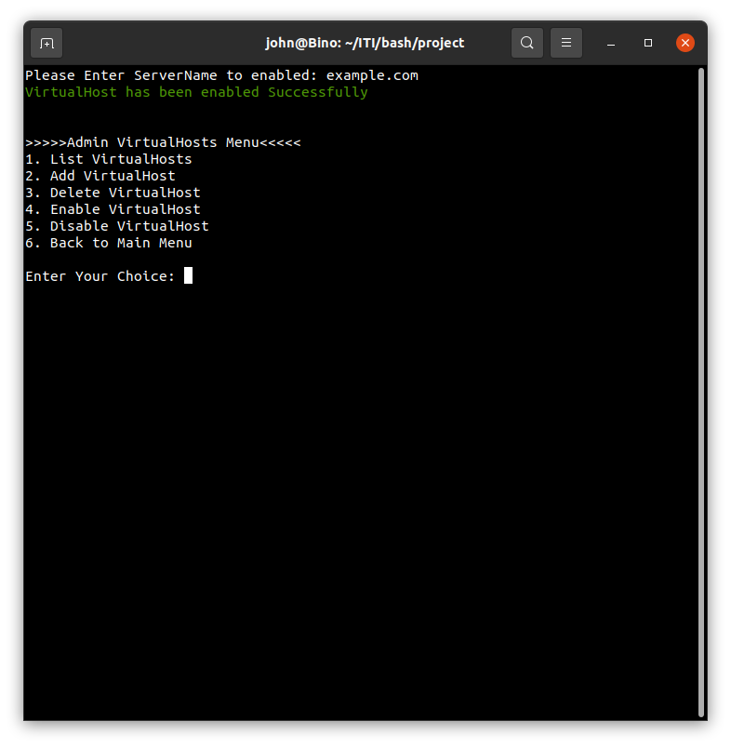

5. Disable Virtual-Host

◦ It is that simple as Enabling Virtual-Host, all you have to do is to type Server Name and vola, you  
 deactivated the targeted virtual host with out losing any data, also you can enable it anytime.  
◦ If it is successfully exists and disabled you will see this output: enter image description here

---Note don't  
 forget about the toggle host, because hosts file will be affected in this part.

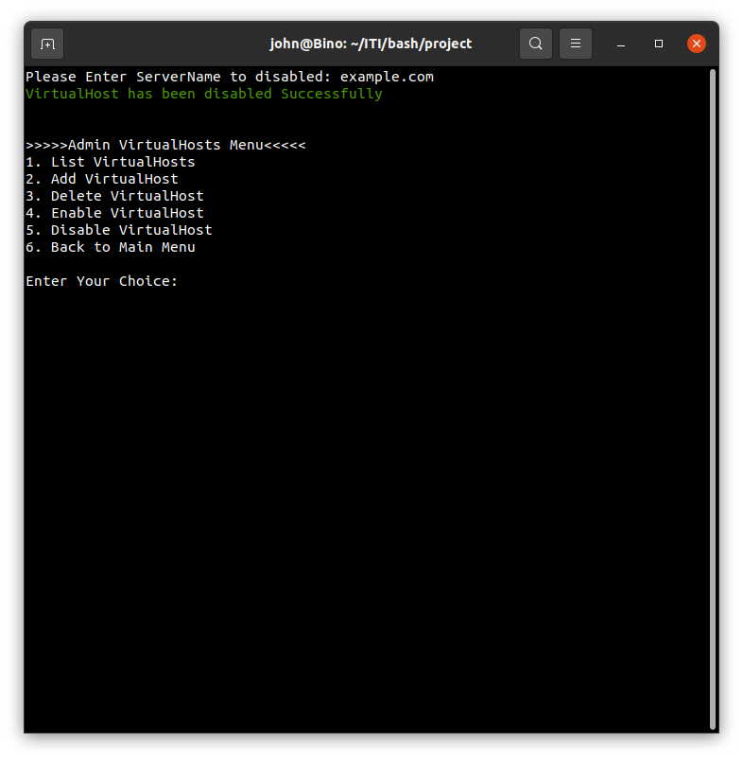

6. Back to Main Menu

**Configure Authentication**

Now its security time, Apache Admin deals with security you can authorize who can access your virtual host and who  
can't simply Apache Admin provide you is various options to do that:

1. Enable Authentication

◦ By default authentication is not enabled in virtual host, you can enable it by just send the Server Name and  
 if it is the first time, you should send us Admin username and password, if all data is provided correctly  
 you should get this screen:

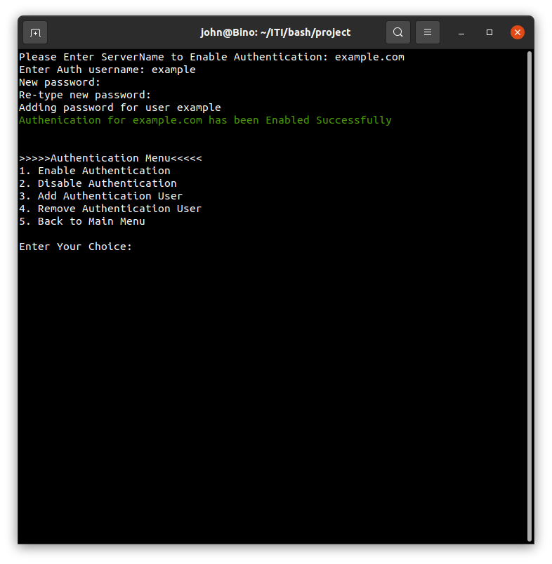

2. Disable Authentication

◦ No longer need authentication simply you can disable it by just providing us with Server Name and keep

the rest from validation and so on on us

◦ Successful response will be provided to you as follows:

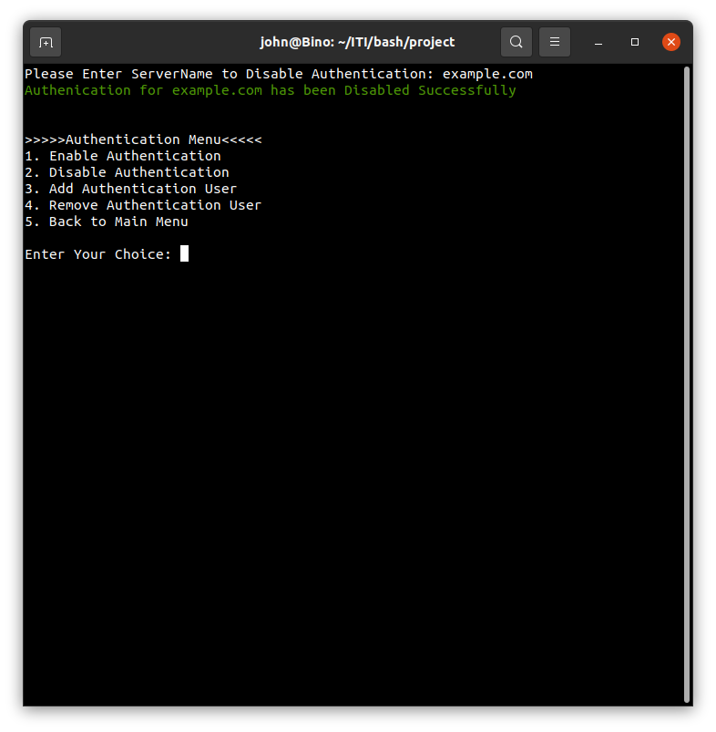

3. List Authenticated Users

◦ In this part you can list users who have authentication in the virtual host and can access it, simply send  
 Server Name and it will be listed as follows if file and people exists:

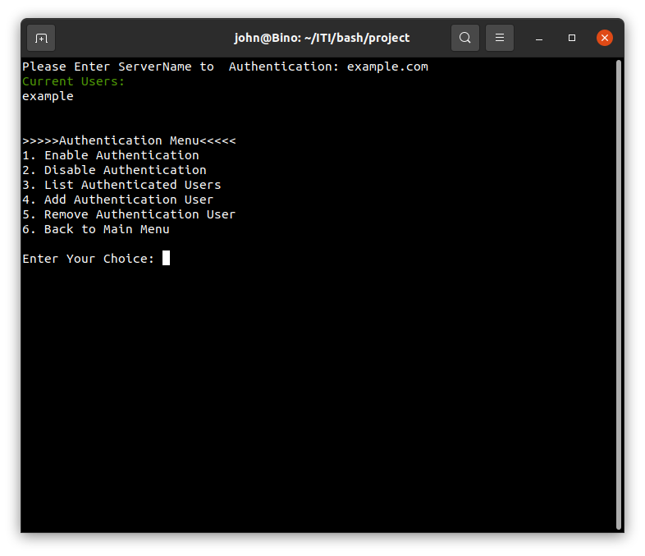

4. Add Authentication User

◦ Now after enabling authentication, of course you need some users to login on your system, you can choose  
 this option and provide us with Server Name, username and password to be added immediately.  
 ◦ Successful response will reach to you as follows:

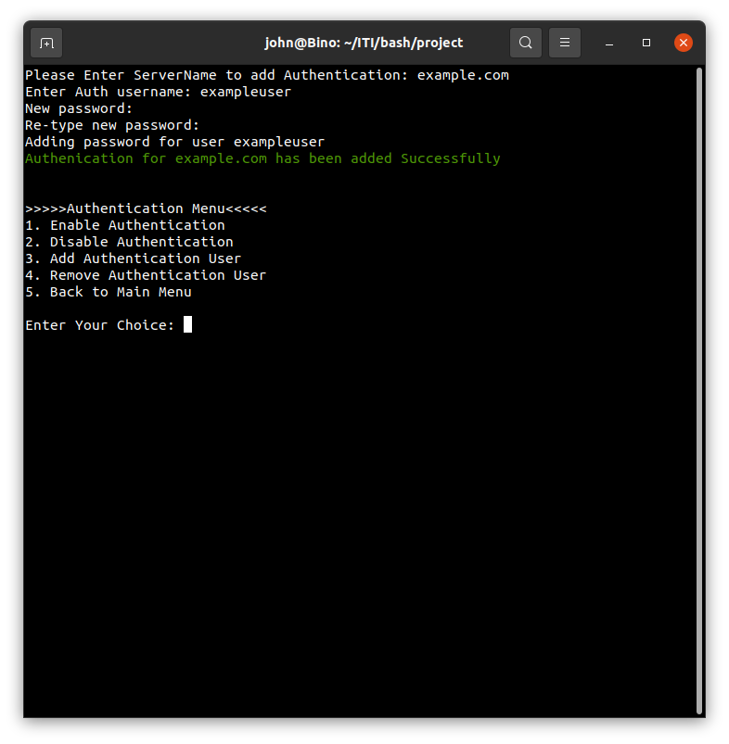

5. Remove Authentication User

◦ Now if you no longer need user, just remove him from the server, and it is that simple, just provide us with  
 Server Name, and username only, and leave the deleting on us.



◦ If removed successfully you will receive the following response:

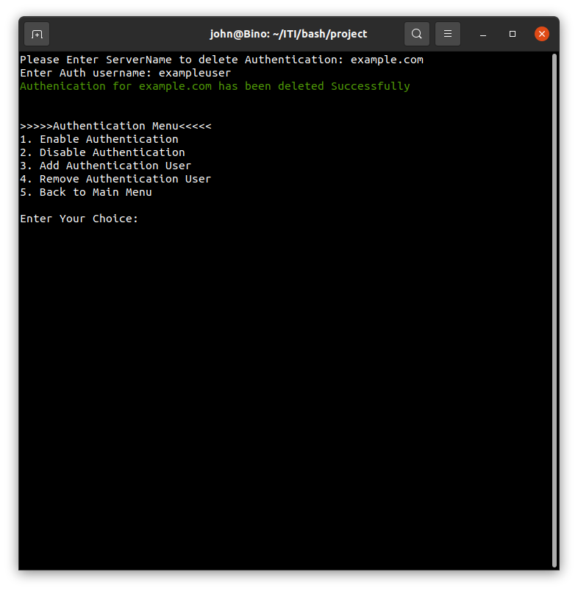

6. Back to Main Menu

**That's all for Apache Admin**

╔══╦╗──────╔╗─╔═╦╗────╔══╗───╔╦╦═╦╗ ╚╗╔╣╚╦═╗╔═╦╣╠╗╚╗║╠═╦╦╗║═╦╩╦╦╗║║║═╬╬═╦╦═╗ ─║║║║║╬╚╣║║║═╣╔╩╗║╬║║║║╔╣╬║╔╝║║╠═║║║║║╬║ ─╚╝╚╩╩══╩╩═╩╩╝╚══╩═╩═╝╚╝╚═╩╝─╚═╩═╩╩╩═╬╗║ ─────────────────────────────────────╚═╝ ╔══╗──────╔╗───╔══╗╔╗──╔╗  
║╔╗╠═╦═╗╔═╣╚╦═╗║╔╗╠╝╠══╬╬═╦╗ ║╠╣║╬║╬╚╣═╣║║╩╣║╠╣║╬║║║║║║║║  
╚╝╚╣╔╩══╩═╩╩╩═╝╚╝╚╩═╩╩╩╩╩╩═╝ ───╚╝ ╔══╗───╔╗─╔╗────╔══╗  
║╔╗╠╦╗─║╠═╣╚╦═╦╗║╔═╬═╦═╦╦╦═╦═╗ ║╔╗║║║╔╣║╬║║║║║║║╚╗║╩╣╬║╔╣╬║╩╣  
╚══╬╗║╚═╩═╩╩╩╩═╝╚══╩═╩═╩╝╠╗╠═╝ ───╚═╝───────────────────╚═╝

---By John George (*Binomial*) --- All rights reserved.