Phần cứng sử dụng
- Board: Lichee Pi Nano
- SoC: Allwinner F1C100s
- RAM: 32MB
- Flash: SPI NOR 16MB
- Wi-Fi: ESP8089 SDIO
- Giao tiếp debug: UART qua CP2102, baudrate 115200
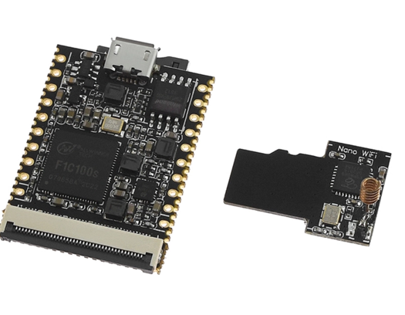

Bố cục SPI NOR
mtd0: 00070000 "uboot" 448 KiB
mtd1: 00010000 "dtb" 64 KiB
mtd2: 00480000 "kernel" 4.5 MiB
mtd3: 00b00000 "rootfs" 11 MiB
Tổng: 0x01000000 = 16 MiB
Kết quả boot
Kernel đã mount rootfs trực tiếp từ SPI NOR:
VFS: Mounted root (squashfs filesystem) readonly on device 31:3.
Run /linuxrc as init process
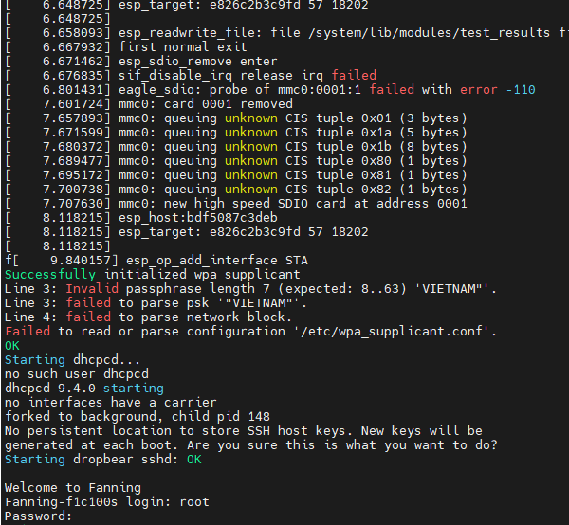

Kết quả bộ nhớ RAM
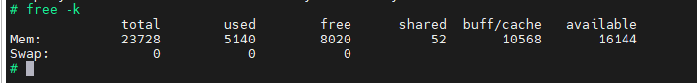
Mem: total 23728 KB, used 5140 KB, available 16144 KB
Swap: 0
Driver chip esp8089
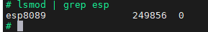
WLAN
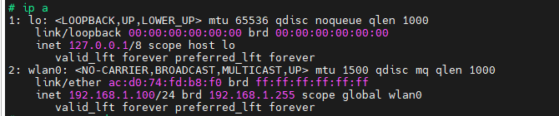
SCAN Wifi
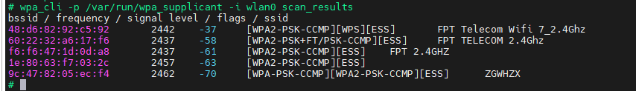

Connect wifi:
killall wpa_supplicant
rm -rf /var/run/wpa_supplicant
mkdir -p /var/run/wpa_supplicant
cat > /tmp/wpa.conf <<'EOF'
ctrl_interface=/var/run/wpa_supplicant
network={
ssid="FPT Telecom Wifi 7_2.4Ghz"
psk="12345678"
}
EOF
wpa_supplicant -B -Dnl80211,wext -iwlan0 -c/tmp/wpa.conf
sleep 8
wpa_cli -p /var/run/wpa_supplicant -i wlan0 status
