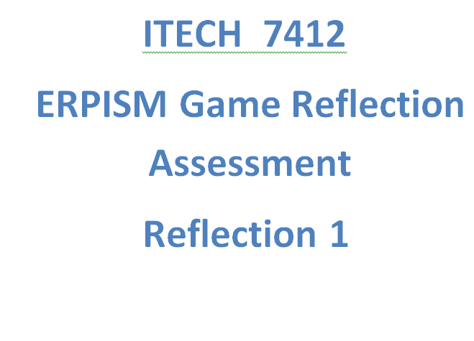

**Submitted by :** Binay Maharjan

**StudentID :** 30372506

**ERPsim:**

ERPsim business simulation game is designed to experience the real-time business strategies for a company. ERPsim simulation game has lead to learning by doing and face the problem based approaches. This game was developed at HEC Montreal as a participants one can feel the real life within ERP system. During the period of game I found this workshop is based on distribution company where participants have to operate the full business cycle such as: plan, procure, and sells and reporting.

**Game Details and Business related process:**

During this game we had altogether 4 team members named as group ‘U’ where we had a numbers of round in game to be played according to divided roles to members. We were introduced with overall steps based on hypothetical game related to Dairy products where Items were listed from T01 to T06 .Initially we planned for roles and planned for our business strategy in order to make positive net profit. The roles included were divided according to task that was needed to be performed such as stock transfer, pricing, Financial statement, Sales and Marketing Data.

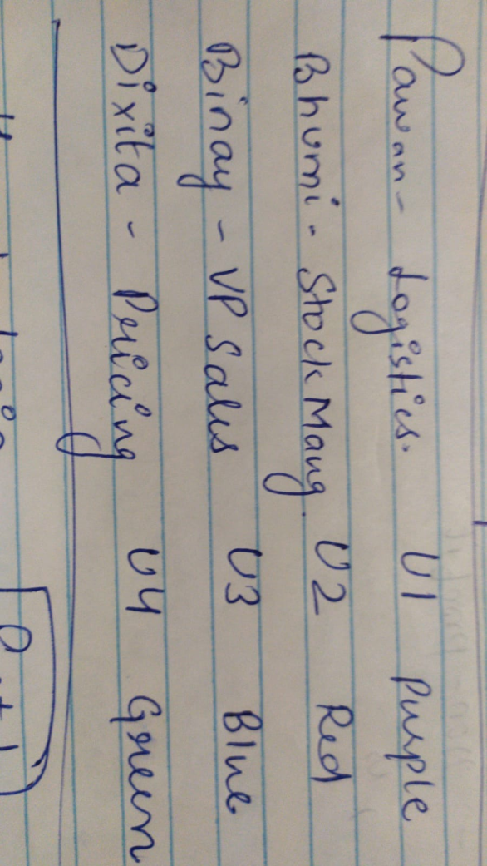

Figure 1: Role Division

In this game, we had three regions where related products were in demand. Here, the demand in preferences were generated at the beginning of every new game, but did not change over period. North, West, South were the three regional customers from German where we had to implement either push or pull methods for making purchase order.

As we know, push method is used to purchase the material by the certain interval of time whereas; the pull method is way to purchase material only when product is in demand (Mariam Houti, 2017). We initially implemented the push technique then later on due to increased quantity in stock we had to move to pull technique.

On the other hand, we had other general information provided regarding the German market such as transportation charges and warehousing costs.

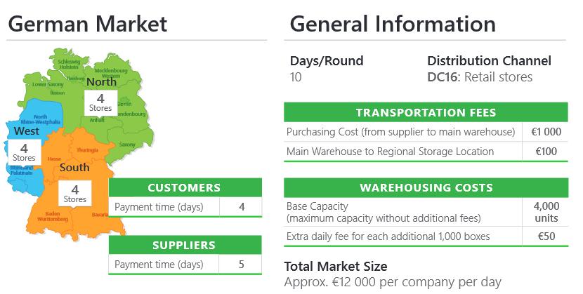

Figure 2 General Information

We had overall 10 round which was equivalent to 10 days. In each round Our team were communicating through application named ‘Whats App’ beside the adobe connect.

I choose to do the sales and Market Data under the sales process, where I was tracking profit or loss by checking the value of the quantity so we can amend the mistakes. Meantime, I had other responsible too like making summary sales report and Detailed Sales Report. In this category I was locating the stocks and keeping the team up to date if any case they need to change the price or quantity to be increased if decreasing in the stock. During this position I had to frequently update the team member for about increasing stock item and decreased ones as well.

However, because of the few reasons even after notifying the team members about increase of stock from Inventory Report we were barely able to control the quantity as we changed our strategy it declined for a while but increased by several thousand numbers (meaning items were selling out less than previously).

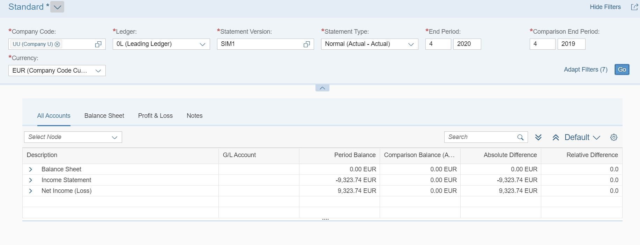

Figure 3 Financial Statement

The above picture figure 3 represents the financial statement of last round where we can see the net income is in loss about 9323.74EUR but on overall as a team ‘U’ had profit of 139,856.10 which can be depicted from figure 4.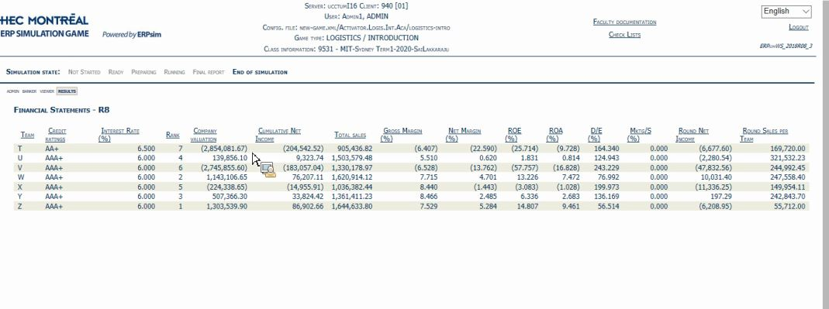

Figure 4 Summary of Game

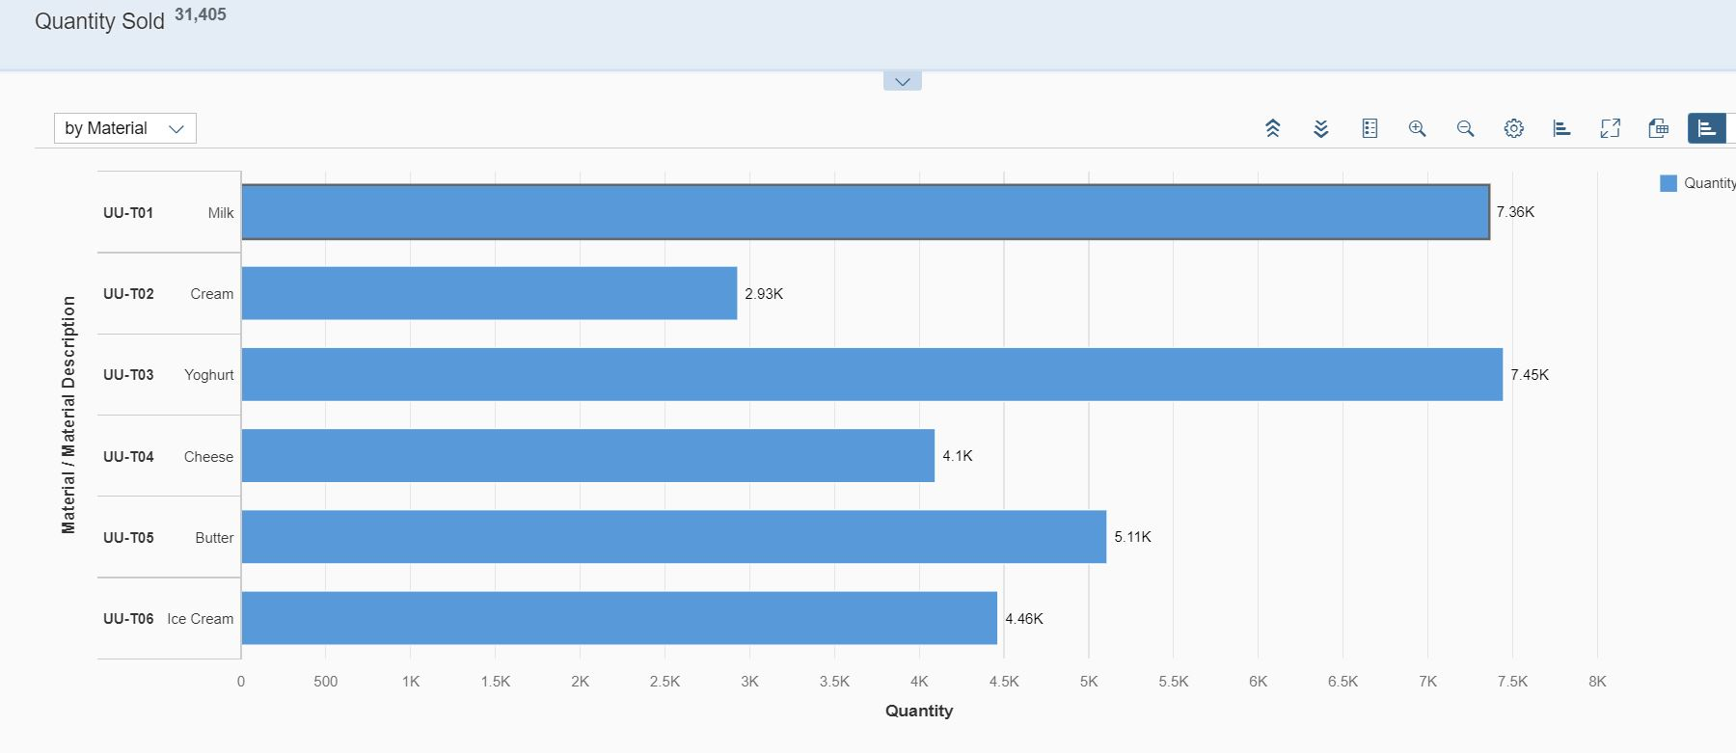

Figure 5 Total Quantity Sold

In the figure5: we can see the highest sold item is Yoghurt that is about 7.45k transaction; On the contrary the least sold item is cream about 2.93k.

In overall, the team U sold about 31,405 quantities.

**Team Experience:**

This game has lead me value of upstream and downstream information flows and the value of process integration across platform, plus the impact of poor decision-making and timing by one player on team performance (Pierre-Majorique Léger, March 2010).

**Game experience:**

Very user friendly interface, where one can easily get used to it with few trainings. I felt real competitive in every round along with others team member presence and also made me to push the team if there were anything lacking behind. I realised the importance of team members to complete the process and importance of collaboration. Basically, in my team if someone lacks clarity and one who is aware of the next step would lead to another, later on I soon realized it was better to switch on the role that he/she has understood.

Most importantly, this game also made sense of time management is very crucial. Sometimes making only right decision doesn’t value much until it is made within at right time.

Some Facts During the game

One of least interested during this game experience is the medium of communication where every moment as a team leader I had to check out the completion of task by asking each of the team while lot of time were consumed. The stimulation still lacks the features to track any incompletion of task to other team members so communication was essential for every strategy to be implemented. For example: one of my team members couldn’t notify his complete role while he stood stand by without checking the status of Inventory stock task. He wasn’t sure about completion of task as he was unaware of once the process is performed next step was to save the task which eventually lead him to do same task again and again.

The additional knowledge skills that I prefer to make this game more interesting would be to get more connected with team. Firstly, the game is mainly based on the communication of team rather than skills because there are multiple tasks to be done in collaborative way. From my perspective, I see managing the things by teamwork is much more important rather than doing the business process in specific skills possessed by individual. So at last I really considered to get the team full understanding of the game and communicate before following the steps blindly since, most likely the process is periodically repetitive and need to trigger frequently which only possible through team communication.

# References:-

Mariam Houti, L. E. (2017). Lean ERP: a hybrid approach Push / Pull . *Research Gate*, (p. 7).

Pierre-Majorique Léger, J. R. (March 2010). ERP Simulation Game . *ERP Simulation Game: A distribution game to teach the value of integrated systems* , 14.