Analytical Report on Municipal Waste

Binay Maharjan

30372506

Contents

Executive Summary 2

Introduction 2

Why do we use BI? 2

Why this BI solution is chosen? 3

Municipal Waste 4

Food waste 7

QR (Quick Response) 10

Reference 11

# Executive Summary

In this article I have mentioned about how the use of Business Intelligence tool will help any organisation to make decision, This report includes examples of usage of BI in any findings and shows how we can predict the trend with the help of various charts.

The main object of this report is to show how the use of data warehousing and business intelligence will improve the business organisation.In this article I have mainly content descriptive and predictive analysis of data taken from the source.

This article describes about the condition of waste that has been produced since 2000-2017. Where different countries from all around the world is collected then compared, analysed the maximum and minimum waste product that had been collected from the municipal.

We have used zoho analysis to generate the information for this article.

We have included data from various given source from NGO and INGO website and database.

The dashboard produced from zoho analytics gives an easy interpretation of data which helps to know about the patterns.

In this article we have found out how the use of BI will help the organisation to know about the current status and how they can predict the future outcomes.

# Introduction

Data warehousing also known as enterprise data is warehousing is a process of storing huge amount of data. It is a system that is used for reporting data and analysing it. Data warehouse is considered one of the core component o for business intelligence. Data warehouse is the central repository for data which are collected from many separate sources. These data are further used to create analytic reports.

Data from warehouse is used by business intelligence tool to analyse the data. It is a technology driven process.

There are various tool in Business intelligence. There are various methods and applications which enables the organisation to collect data. The organisation can collect data from external and internal environment. The organisation can prepare the data for analysis. Then the BI will create a dashboard, report and data visualisation to make analytical results.(Abai, Yahaya, & Deraman, 2015)

# Why do we use BI?

Businesses use various application, tools, practices and technologies that are used to gather, integrate, analyse and produce any kind of data used by the organization to create useful information for the business. These applications are mainly used by the businesses to help the executives, manager and other operational staff to make better informed decisions for the business. These applications are also used by the companies to look into other business opportunities, reorganize inefficient business process as well as expensive business processes. These applications are mostly data driven Decision Support System (DSS). BI applications are used along with query and report tools, briefing books and executive information systems which helps the users to analyse data for themselves. These analysis helps in making informed decision that are supported by numbers rather than just assumptions. With the data that has been collected in the data warehouse and the data mart from operations of business the business intelligence software systems help to create a history of current and future prediction of the business operation. It is very important for business owners and managers to make correct decisions for the business, however, these decisions are not solely depended upon their intellectual power, most of these decisions are a result of information that they have. It reduces the stress of micromanaging, For example employees are able to more clarification through more transparent environment.Plus,if decision makers are making critical decision then it’s vital to have data that supprots their argument.

BI helps manager to focus on realistic not just the perspective of executives.Since, Growth of the company doesn’t rely on gut instinct any longer BI software helps to reduce leaps of faith.As the organisation grows the data need to store more and more decision is need to be taken as there is adage that with power comes great responsibility, and with data comes reliability.In every busines there is stakeholders by use of BI they can rely for long-term planning.On the other hand,Business has high disruption which is unpredictable here we can select and displayed the organiztion’s strengths,highlighting possible opportunities for revenue.

The major need of BI application is to take all the data available in the business and analyse it in the structured manner so as to provide strategic decision. When we look into the area of sales, if we give proper tools to the sales staff to record data about the variability within a certain time frame then they can utilize this data to come up with strategic planning to exploit maximum benefit. Moreover it helps in data accuracy, expose transparency and also it refines current processes to establish a much efficient process.(Sun, Sun, & Strang, 2018)

# Why this BI solution is chosen?

Among various BI tool I used Zoho analytics. Zoho is a completely new and free computing process that has heightened level of cognitive computing. It is known to create predictive models for hiring process that will help in better hiring patterns and decisions. For example, the application collects hired staff’s work history and other information which with the help of the analytic software will be converted into correlations and prediction on how many, to hire and create a hiring pattern and also to increase retention. Many workers are exposed to injury during their work, the application finds out relations between the causes of injuries so that the senior team can look into the conditions and provide a safer environment. It allows us to look into data that relates a slack in generation of revenue from certain clients when there is a slowdown in certain industry sector. Hence, it will help to identify whether a certain industry can be effectively profitable for the company to focus on and hence help the companies to reach more rewarding clients. Zoho analytics integrates and analyse client revenue data from generally available sources of data about the customers and insights about the behaviour of the market which enable them to meet daily budgets and expectations. We can easily generate report by interative visualization where we can explore data through the manipulation of chart images,with the color,size,brightness,shape and motion of visual objects representing dataset.Moreover, it is also able to handle customer queries and has increased the response time. Zoho is being used in many insurance companies such that it helps to calculate payouts by referring to thousands of medical certificate with every minute detail. It has self-learning capacity such that it is able to study about the customer and provide proper care to them by filtering and forecasting. It uses natural language to process data such that the questions can be answered and easily understood. However, such a powerful tool as this is not only limited to desktop and laptops but it also can be used in iPads. (Olsen & Dupin-Bryant, 2012)

There are various kinds of BI reporting tools for us to make judgements. It is differentiated on the types of data that we need to view. There are 3 basic types of data analysis which are namely:

1. Descriptive Analysis: It is the primary analysis in the given 3 kinds of analysis. In descriptive analysis we provide all the current data to the system and gain information about the current status. For example the amount of sugar sold in a supermarket in a given time or the amount of petrol sold in a region at a given amount can be considered as descriptive analysis.(Bogdan, 2014)
2. Predictive Analysis: In this model, data is fed to the system. Different kinds of data is compared from different perspective, then with the help of those data, we can make the predictions. Predictions are made by comparing the current data and the past data. For example comparing the usage of waste in 2000 and 2017. (Bogdan, 2014)
3. Prescriptive Analysis: This is the final phase of analysis. In this type of analysis, the past data is compared with the present data. Then the software compares and checks for the reason of change in data. Then it generates the solution to solve those problem by analyzing the data. For example Business Intelligence software finding the cause of increasing waste and finding the solution can be considered as prescriptive analysis.(Bogdan, 2014)

I have explained in the article below on how we can use the three kinds of analysis

## Municipal Waste

Municipal waste collected on behalf of municipal authorities which includes source like households, commerce, offices, public institutions and municipal services. However, excluded waste from municipal sewage networks and municipal construction and demolition waste. Data on municipal are collected annually and voluntarily. The list of country inlcude is shown by figure1.

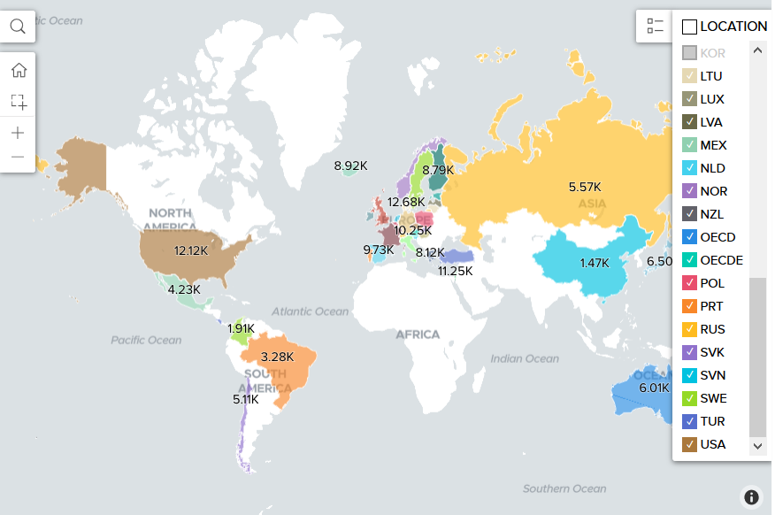

Figure what are the values by location

The data collected from the municipal waste from different top 10 countries like Denmark, Switzerland, United State Of America, Luxembourg, Israel, Germany, Netherland, Austria, Ireland, and Spain.

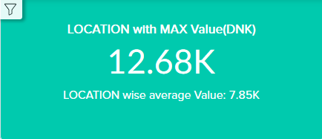

Figure 3 max valued

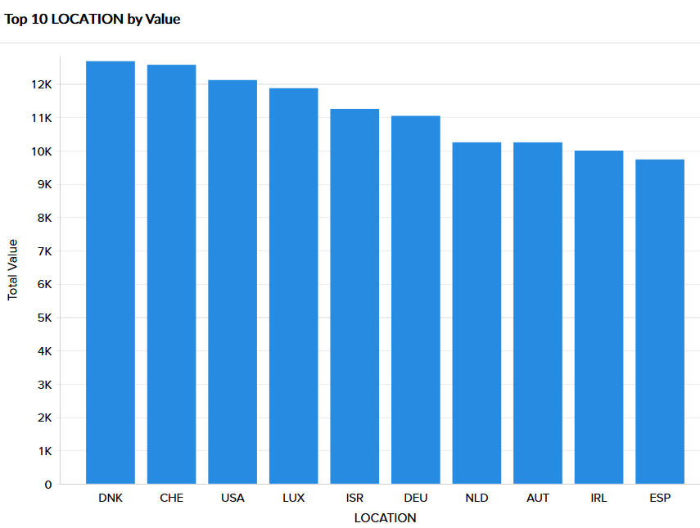

Figure Top 10 locations by Value

From the figure 3 and figure 2, we can see that maximum waste material generated 12.68K from 2000-2017 was Denmark. On the other hand, among this top countries the least waste material that was generated in the same period of time was Spain.

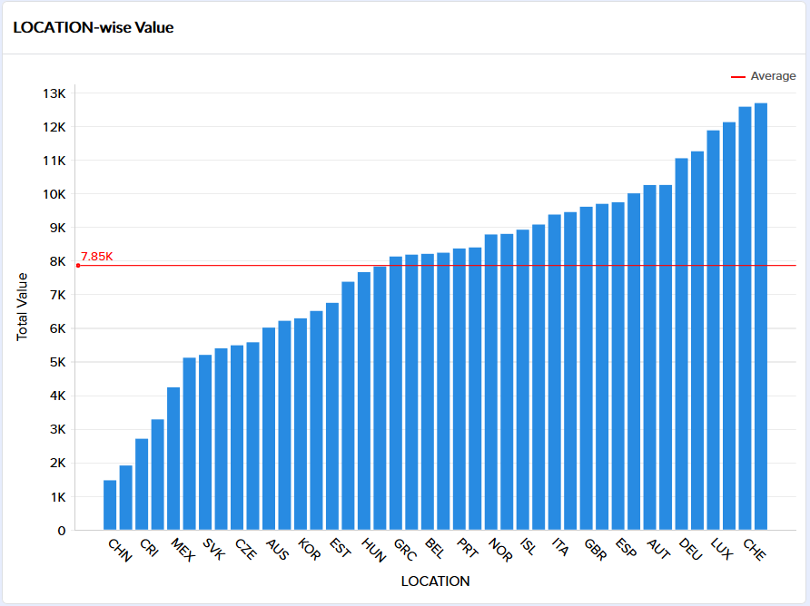Comparatively, there are lots of other countries in this data that were accounted of wastage being generated from where we can derive average value of 7.85k from all of other nations such as given in the diagram.

Figure 4value by location

Only, countries like China, Costa Rica, Mexico, Slovakia, Czech Republic, Australia, Korea and Hungary are below the average value of wastage. Whereas, the rest of the top countries seems to beyond the average which we can see from the red line in the graphical representation.

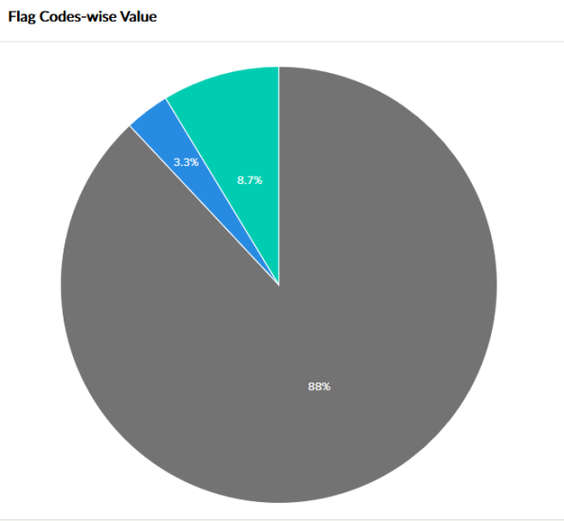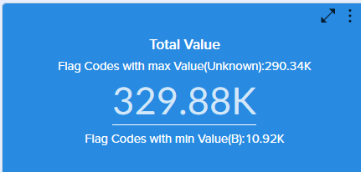

Figure 5 total value generated

Figure 6 flag codes-wise value

In overall, from all around the world the known waste from figure 5 municipal collected was 329.88k where from figure 6 290.34k was unknown that is 88% of waste value is unknown.Both figure tells us about the flags where categorised value as B which if less than 10.92k and only 3.3% of collected value were less.

There are different sort of waste being collected which is not clarified in this data however, there might be other reasons that we can investiage like there are different types of waste such as water waste, emiision of harmul gas waste,food waste and many more so, for more comparisons

I have chosen the food waste In order to control the increase of waste and proper management of this wastage.

## Food waste

Now, Analysing another data regarding food waste we are about to discuss the impact on monetary and economic impact and others caused by the given time such as.

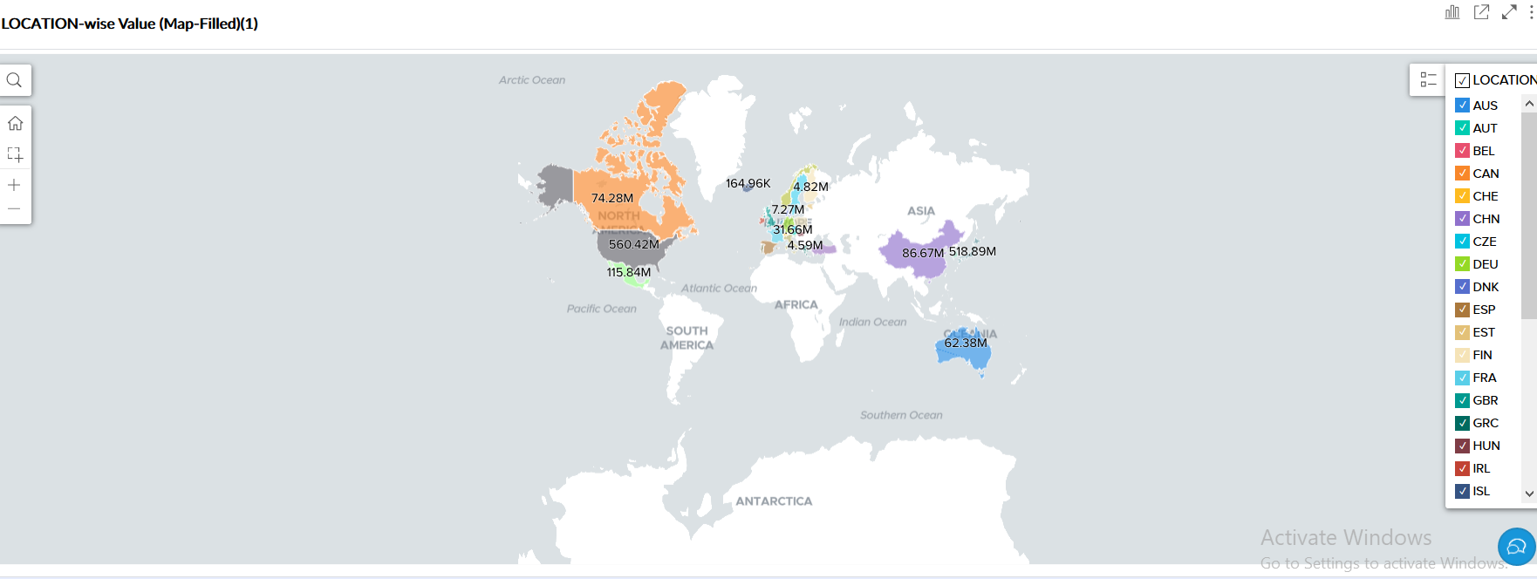

Figure 7

Figure 7 shows the graph of total food loss by location.

As we dig more inside the data we have following graphical representation.

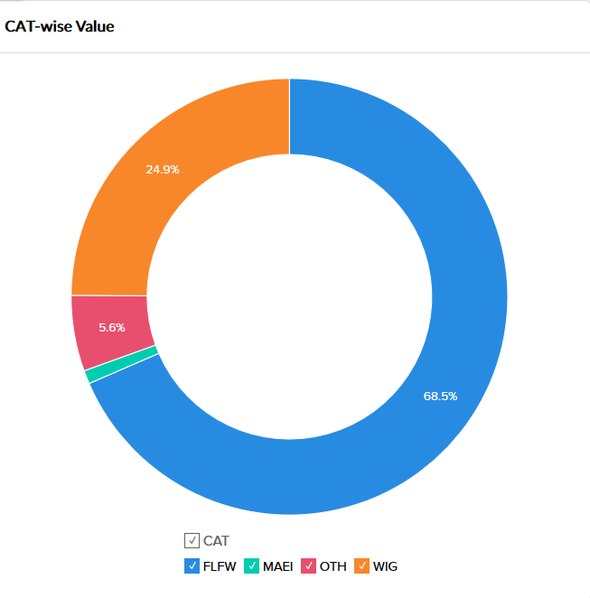

Figure 8

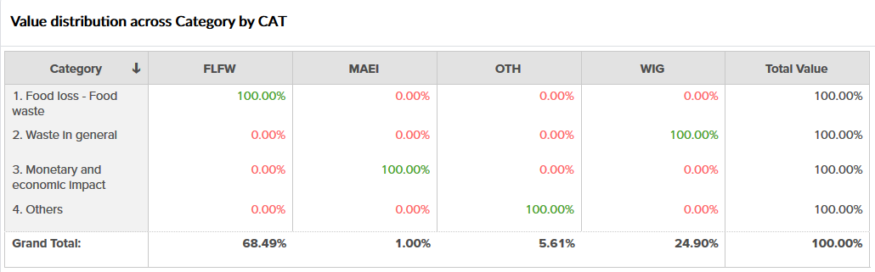

Figure 9

From the figure 8 the given chart shows that total waste of food is 68.5% which is represented by FLFW(Food loss-Food waste) which is the highest among other categories. The second highest value is 24.9% which is Waste In General. Next, is 5.6% of other value meanwhile, 1% of monetary and economic impact was accounted due to food waste.

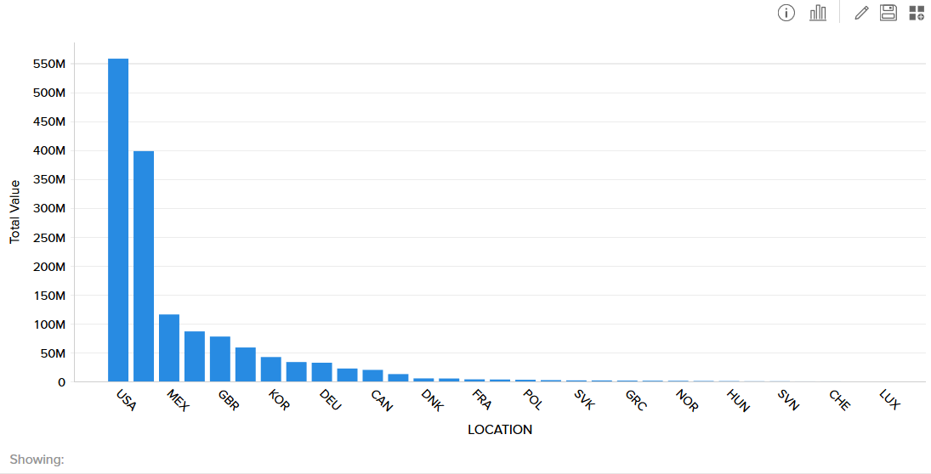

Figure 10

Here we can analyze from fig 10 , value of USA is in maximum while DNK had maximum municipal waste from figure 3 which means , what we assumption I have concluded is that though the USA had less than average municipal waste comparatively, it seems they had huge food waste. Likewise, in this context DNK country seems in safe side. Thus, in order to decrease waste generation a simple effective awareness could be enough for the public

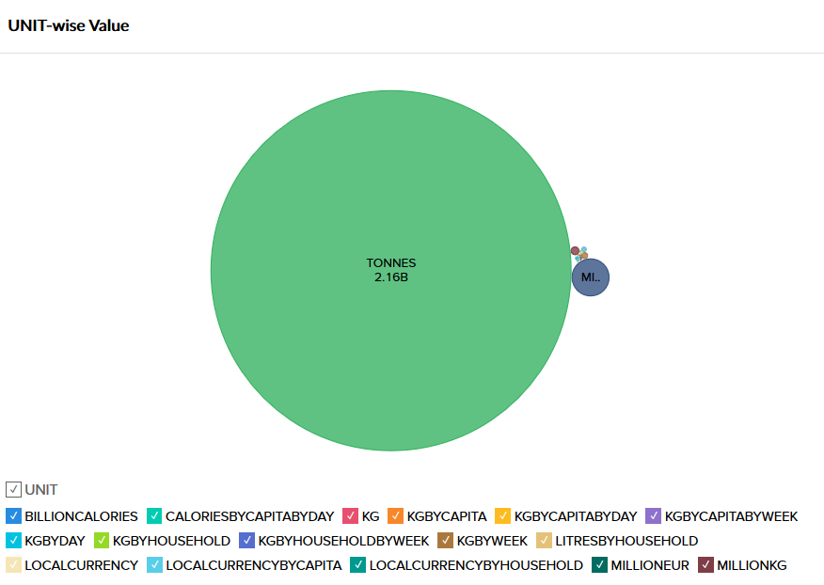

Figure 10

The given figure 10 shows that 2.16Billions tones of calories were wasted.

My assumption is that ,as we research thoroughly from the whole world about the data collected what we can see here is that, we can take some serious measure through USA in other to minimize the increase of the waste by simply giving effectiveness awareness about the food waste and it’s impact in finance and monetary.

Logical Recommendation to CEO

CEO’s are required to make numerous decisions on a daily basis, and these decisions are responsible for the proper functioning, growth and the profit of the business. BI software is able to collect numerous data from a day to day basis and analyse them to create patterns and information which are used by the CEO’s to make informative decisions. Apart from the day to day decisions, the BI software is responsible for doing the task of many employees in much efficient ways, and CEO’s are able to exploit such benefit as it brings lesser liability to the company. It helps in customer profiling and a report about sales pattern which helps them to come up with strategic plans for up-sales and loyalty. However, even if such applications are much sophisticated and provide complex data they do not necessarily have to be complicated to use such that the CEO’s need to constantly run after the IT specialists. CEO’s are able to identify what products, services or processes are not efficient and have proven to be unprofitable for the company so they can alter the ways of such processes to make it more profitable. These BI applications help CEO’s monitor KPI and help them answer important questions such as:

Is the municpal financial status in good condition?

Are the users being satisfied?

Are our opportunities being well exploited?

Are our services and awareness of the top quality?

When these questions are answered with the help of BI software, CEO’s are able to make decisions such that these requirements are met. The software also provides a well of information looking at which the CEO is able to make decisions that are good for the company. (Catalina Monica, Cristina Petronela, & Catalin George, 2014)

# QR (Quick Response)

QR code is a two-dimensional barcode which means it is scanned in two directions that is vertical as well as horizontal. It requires a more sophisticated reader. QR code can be generated for individuals use and enterprises without cost.QR code offers an opportuniy to Interact with costumers.For thir report as well while analysing the data the dashboard that I created for this report can be navigated by scanning the following QR code with mobile.



Conclusion

By using Business Intelligence tool what I experience is that with big data is a very powerful tool that can be used by any organization to analyze the data faster, accurately and predict the future outcome from the present data.

BI helps the organization to take serious measure that should be taken before the failure of the system where it helps to manage the situation easily.Besides, this point it has eliminated the waste and guesswork.BI has powerful workspace combination with different sort of feature like filtering ,sorting,and efficient inventory management.Along with that I see no limitation where when properly used it can make huge difference in decision making for contemporary competative world.

Finally, I would like to conclude that there are only few BI tool which provides all the facility required to perform a good and reliable analysis. There are many BI vendors like SAP, IBM, Microsoft, Oracle etc. I found zoho as easiest tool which helps us to describe the results in a visualized form.

# Reference

Abai, N. H. Z., Yahaya, J. H., & Deraman, A. (2015). An integrated framework of business intelligence and analytic with performance management system: A conceptual framework (pp. 452-456).

Bogdan, N. (2014). Business Intelligence Systems. *Database Systems Journal*(4), 12-20.

Cătălina Monica, A., Cristina Petronela, S., & Cătălin George, A. (2014). BUSINESS INTELLIGENCE – PAST, PRESENT AND FUTURE. *Network Intelligence Studies*(1), 7-14.

Nikitopoulos, C. S., Squires, M., Thorp, S., & Yeung, D. (2017). Determinants of the crude oil futures curve: Inventory, consumption and volatility. *Journal of Banking and Finance, 84*, 53-67. doi:10.1016/j.jbankfin.2017.07.006

Olsen, D. H., & Dupin-Bryant, P. A. (2012). Combining Business Intelligence And Stock Market Data: A Primer For Data Analytics And Business Intelligence. *Journal of Applied Business Research (JABR), 29*(1), 139. doi:10.19030/jabr.v29i1.7562

Sun, Z., Sun, L., & Strang, K. (2018). Big Data Analytics Services for Enhancing Business Intelligence. *Journal of Computer Information Systems, 58*(2), 162-169. doi:10.1080/08874417.2016.1220239