1. Currently running 2560 @ 3.3V, but all but sub systems need 5v logic except the Bluetooth needs 3.3v (HC-05). Will be changing to 5v (16MHz) for the 2560
2. Bluetooth Sheet:
   1. Logic level shifter needs to be implemented on the RXD pin of the Bluetooth chip (when we go to 5v 2560 Vcc). Logic level shifter will be added once we change to 5v on the 2560
   2. Reset button not actually connected to the circuit. Will be fixed
   3. Ask why we need the p-fet/n-fet config again instead of just using straight 3.3v(we can already set to AT command mode using the key digital pin and the reset button). This will be removed because of now using a LDO
   4. Suggest to remove the state LED (unless chase knows something we don’t)… “PwrOn” LED is actually the “blinky status” LED that is on the module board. Going to add Solder bridge to this. 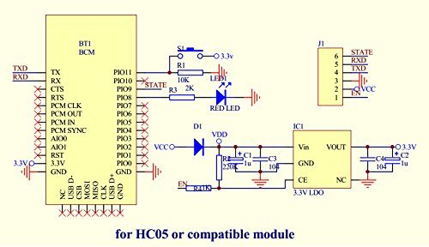
3. Barrel Jack: Do we need to finish this? (Last capacitor not connected). Will add through hole pin for bigger capacitor. Which will finish this up
4. Loadcell:
   1. Consider changing the VDD/VCC to the 5V regulator bus. Will change this to 5v
   2. Add a solder pad for the inductor just in case its wonky
5. Smraza LCD Pinouts: Are these pin outs correct? Could you walk us through how these work chase? These are the pinouts right?
6. Motion Sense: Axeing this whole thing, just going to use the module, so add pinouts for this
   1. Make sure this is going to an analog pin on the MCU
   2. Consider axeing this whole thing and just use the module we bought
7. RGB LEDs
   1. LEDS_Din must be 5v logic will be resolved by changing 2560 to 5v
   2. Add a separate set of pinouts in case we want a second strip of LEDS
8. RGB LED Separate Dev LED Indicator: Consider Axeing Going to keep cuz its easy
9. Linear Regulator (Between MCU_VCC_5V and the MCU_3.3V): What does this do? Will be deleted by chase
10. Buzzer: Axe the buzzer? Going to keep, no biggie
11. What is this: missing the library to make look like a 6 pin pinout

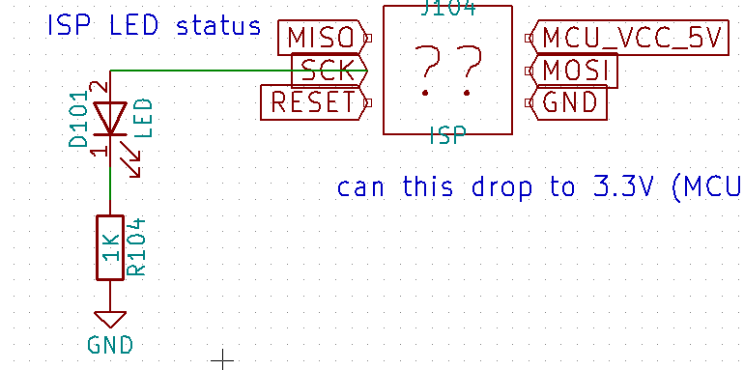

1. Need to come to resolutions on the push buttons. (Capacitive touch adequate?) Further investigation going on, will be breakout digital pins in case we use a pushbuttons

Add separate pinouts for another stip of leds