Ruoyi-AI平台（后端服务、管理端界面前端、用户端界面前端）生产环境Linux Server容器化部署手册
- 准备AlmaLinux / RockyLinux 9.x 操作系统基础环境
- 禁用SELinux及防火墙
setenforce 0
firewall-cmd --set-default-zone=trusted
sed --follow-symlinks -i "s/SELINUX=enforcing/SELINUX=disabled/g" /etc/selinux/config

- 安装docker服务软件及docker-compose命令
dnf config-manager --add-repo=https://download.docker.com/linux/centos/docker-ce.repo
国内网络可以：
dnf config-manager --add-repo=http://mirrors.aliyun.com/docker-ce/linux/centos/docker-ce.repo
然后：
dnf install docker-ce docker-ce-cli
systemctl enable --now docker
最后安装docker-compose命令：
curl -L -o /usr/local/bin/docker-compose https://github.com/docker/compose/releases/download/v2.36.0/docker-compose-linux-x86_64
chmod +x /usr/local/bin/docker-compose

- 安装git命令
dnf install git

- 下载源码
- 创建工作目录
mkdir /root/ruoyi-ai-docker
mkdir /root/ruoyi-ai-docker/source-code
mkdir /root/ruoyi-ai-docker/build-docker-images
mkdir /root/ruoyi-ai-docker/deploy
cd /root/ruoyi-ai-docker/source-code
- 下载源码
git clone https://github.com/ageerle/ruoyi-ai
git clone https://github.com/ageerle/ruoyi-admin
git clone https://github.com/ageerle/ruoyi-web
- 修改源码目录名
mv ruoyi-ai ruoyi-ai-backend
mv ruoyi-admin ruoyi-ai-admin
mv ruoyi-web ruoyi-ai-web
- 切换后端服务源码分支
cd ruoyi-ai-backend
git checkout v2.0.4
cd ..

- 应用构建编译打包
- Java后端服务ruoyi-ai.jar包文件构建
- 修改 /root/ruoyi-ai-docker/source-code/ruoyi-ai-backend/ruoyi-admin/src/main/resources/application-prod.yml 内容：
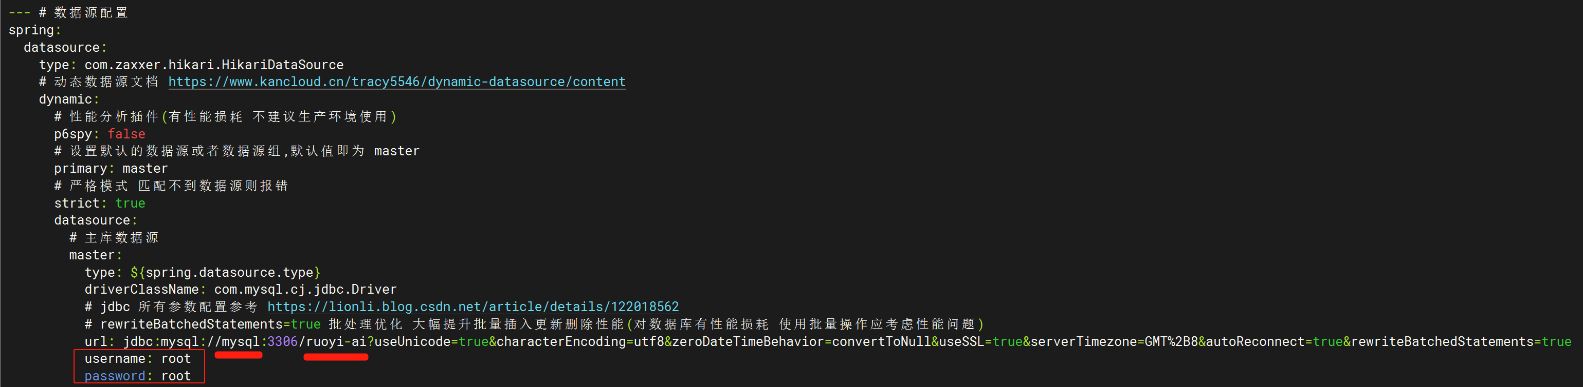
需要修改MySQL数据库服务器地址（这里改为名称mysql）、数据库名（这里改为ruoyi-ai），用户名root密码root，可根据实际需求改为复杂值。
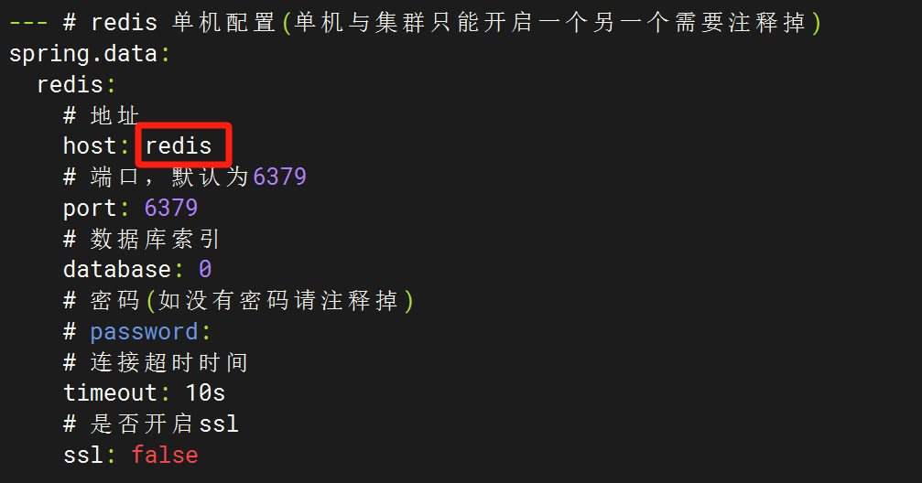
需要修改Redis服务器地址（这里改为名称redis）
- 用maven容器构建应用jar包：
docker run --rm --name build-ruoyi-ai -v /root/ruoyi-ai-docker/source-code/ruoyi-ai-backend:/app -w /app maven:3.9.9-eclipse-temurin-17-alpine bash -c "mvn clean package -Pprod"

- 如果网络正常，代码没有错误，耐心等待编译构建过程直至结束，得到生成的jar包文件：
/root/ruoyi-ai-docker/source-code/ruoyi-ai-backend/ruoyi-admin/target/ruoyi-admin.jar

- 管理端界面前端程序JS目录编译打包（.env.*文件内容可选择性修改，也可保持不变，按实际安全要求决定）
rm -f /root/ruoyi-ai-docker/source-code/ruoyi-ai-admin/apps/web-antd/.env.analyze
rm -f /root/ruoyi-ai-docker/source-code/ruoyi-ai-admin/apps/web-antd/.env.development
rm -f /root/ruoyi-ai-docker/source-code/ruoyi-ai-admin/apps/web-antd/.env.production
rm -f /root/ruoyi-ai-docker/source-code/ruoyi-ai-admin/apps/web-antd/.env.test
rm -f /root/ruoyi-ai-docker/source-code/ruoyi-ai-admin/apps/web-antd/vite.config.mts
按需对上述文件进行修改后覆盖到源码目录位置：
cp /root/ruoyi-ai-docker/build-docker-images/modify-source-code/ruoyi-ai-admin/.env.analyze /root/ruoyi-ai-docker/source-code/ruoyi-ai-admin/apps/web-antd/
cp /root/ruoyi-ai-docker/build-docker-images/modify-source-code/ruoyi-ai-admin/.env.development /root/ruoyi-ai-docker/source-code/ruoyi-ai-admin/apps/web-antd/
cp /root/ruoyi-ai-docker/build-docker-images/modify-source-code/ruoyi-ai-admin/.env.production /root/ruoyi-ai-docker/source-code/ruoyi-ai-admin/apps/web-antd/
cp /root/ruoyi-ai-docker/build-docker-images/modify-source-code/ruoyi-ai-admin/.env.test /root/ruoyi-ai-docker/source-code/ruoyi-ai-admin/apps/web-antd/
cp /root/ruoyi-ai-docker/build-docker-images/modify-source-code/ruoyi-ai-admin/vite.config.mts /root/ruoyi-ai-docker/source-code/ruoyi-ai-admin/apps/web-antd/
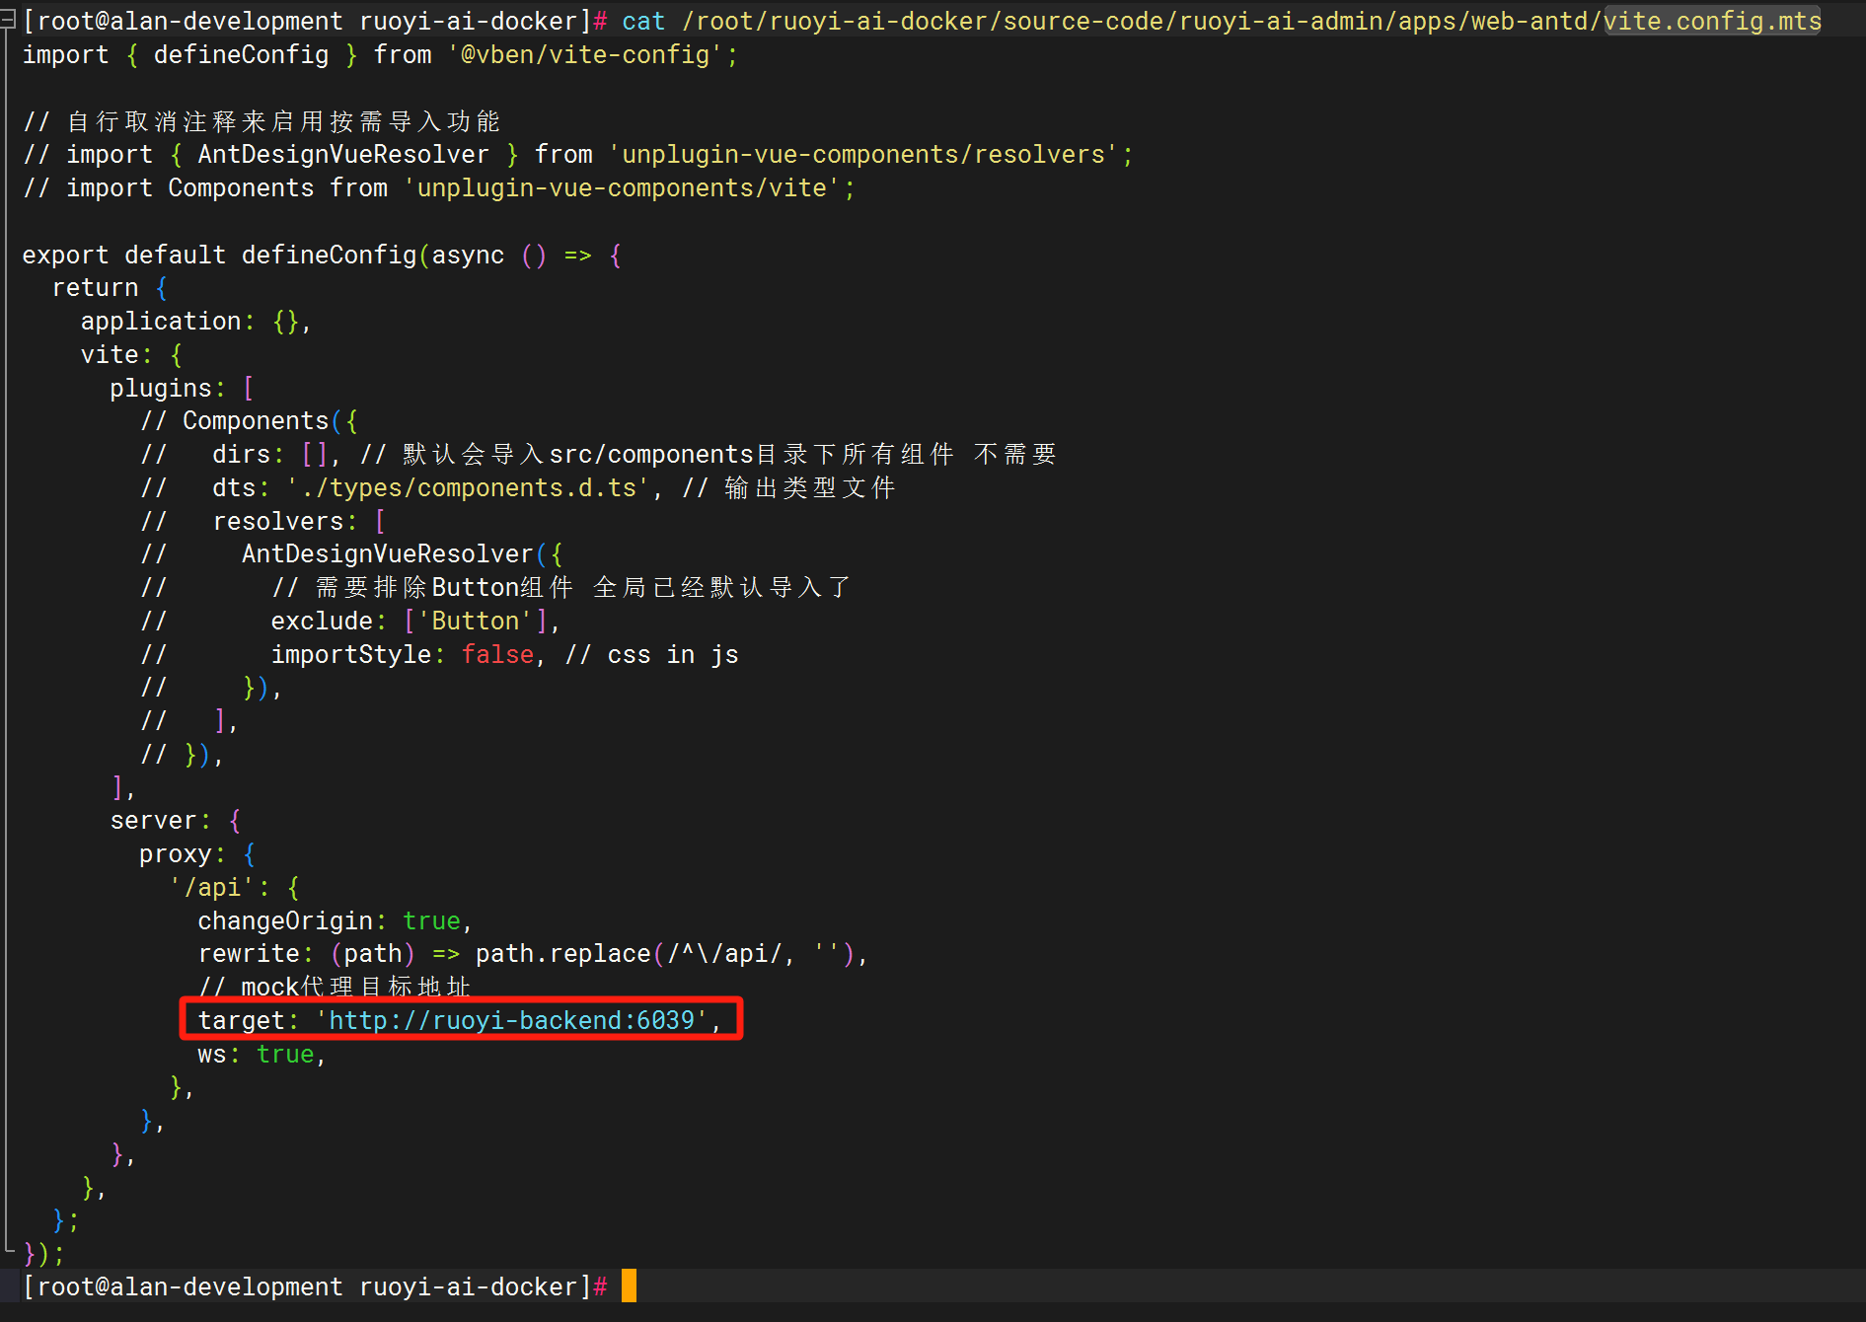
将vite.config.mts 文件里将target的地址修改为：'http://ruoyi-backend:6039', 然后进行编译打包：
docker run --rm --name build-ruoyi-ai-admin -v /root/ruoyi-ai-docker/source-code/ruoyi-ai-admin:/app -w /app node:20 bash -c "npm install -g pnpm && pnpm install && pnpm build"
如果网络正常，代码没有错误，耐心等待编译构建过程直至结束，得到生成的dist.zip文件：
/root/ruoyi-ai-docker/source-code/ruoyi-ai-admin/apps/web-antd/dist.zip

- 用户端界面前端程序JS目录编译打包
docker run --rm --name build-ruoyi-ai-web -v /root/ruoyi-ai-docker/source-code/ruoyi-ai-web:/app -w /app node:20 bash -c "npm install -g pnpm && pnpm install && pnpm build"
如果网络正常，代码没有错误，耐心等待编译构建过程直至结束，得到生成的dist文件夹：
/root/ruoyi-ai-docker/source-code/ruoyi-ai-web/dist

- 构建容器镜像
- 构建Java后端服务容器镜像
cd /root/ruoyi-ai-docker/build-docker-images/Dockerfile-Resources/ruoyi-ai-backend/
在当前目录创建Dockerfile文件内容如下：
FROM openjdk:17-jdk
WORKDIR /app
COPY ruoyi-admin.jar /app/ruoyi-admin.jar
EXPOSE 8080
ENTRYPOINT ["java","-jar","ruoyi-admin.jar"]
拷贝前阶段得到的ruoyi-admin.jar文件到当前目录，即可开始构建容器镜像：
cp /root/ruoyi-ai-docker/source-code/ruoyi-ai-backend/ruoyi-admin/target/ruoyi-admin.jar ./
docker build -t ruoyi-ai-backend:v2.0.4 .

- 构建管理端界面前端服务容器镜像
cd /root/ruoyi-ai-docker/build-docker-images/Dockerfile-Resources/ruoyi-ai-admin/

在当前目录创建Dockerfile内容如下：
FROM nginx:1.25-alpine
COPY dist/ /usr/share/nginx/html/
COPY nginx.conf /etc/nginx/conf.d/default.conf
EXPOSE 80
CMD ["nginx", "-g", "daemon off;"]

在当前目录创建nginx软件的配置文件default.conf如下：
server {
listen 80;
server_name localhost;

location / {
root /usr/share/nginx/html;
index index.html index.htm;
try_files $uri $uri/ /index.html;
}

location /prod-api/ {
proxy_pass http://ruoyi-backend:6039/;
proxy_set_header Host $host;
proxy_set_header X-Real-IP $remote_addr;
proxy_set_header X-Forwarded-For $proxy_add_x_forwarded_for;
}

error_page 500 502 503 504 /50x.html;
location = /50x.html {
root /usr/share/nginx/html;
}
}

拷贝前阶段得到的dist.zip文件夹到当前目录，即可开始构建容器镜像：
cp /root/ruoyi-ai-docker/source-code/ruoyi-ai-admin/apps/web-antd/dist.zip ./
unzip dist.zip -d dist
rm -f dist.zip
docker build -t ruoyi-ai-admin:v2.0.4 .

- 构建用户端界面前端服务容器镜像
cd /root/ruoyi-ai-docker/build-docker-images/Dockerfile-Resources/ruoyi-ai-web/

在当前目录创建Dockerfile内容如下：
FROM nginx:1.25-alpine
COPY dist/ /usr/share/nginx/html/
COPY nginx.conf /etc/nginx/conf.d/default.conf
EXPOSE 80
CMD ["nginx", "-g", "daemon off;"]

在当前目录创建nginx软件的配置文件default.conf如下：
server {
listen 80;
server_name localhost;

location / {
root /usr/share/nginx/html;
index index.html index.htm;
try_files $uri $uri/ /index.html;
}

location /api/ {
proxy_pass http://ruoyi-backend:6039/;
proxy_set_header Host $host;
proxy_set_header X-Real-IP $remote_addr;
proxy_set_header X-Forwarded-For $proxy_add_x_forwarded_for;
}

error_page 500 502 503 504 /50x.html;
location = /50x.html {
root /usr/share/nginx/html;
}
}

拷贝前阶段得到的dist.zip文件夹到当前目录，即可开始构建容器镜像：
cp -pr /root/ruoyi-ai-docker/source-code/ruoyi-ai-web/dist ./
docker build -t ruoyi-ai-web:v2.0.4 .
- 编写环境变量文件.env和docker-compose.yaml容器应用栈单机编排文件
- 拷贝数据库初始化文件到MySQL容器需要挂载调用的目录
mkdir -p /root/ruoyi-ai-docker/deploy/mysql-init
cd /root/ruoyi-ai-docker/deploy/mysql-init/
cp /root/ruoyi-ai-docker/source-code/ruoyi-ai-backend/script/sql/ruoyi-ai.sql ./01_ruoyi-ai.sql
cp /root/ruoyi-ai-docker/source-code/ruoyi-ai-backend/script/sql/update/20250407.sql ./02_update_20250407.sql
cp /root/ruoyi-ai-docker/source-code/ruoyi-ai-backend/script/sql/update/20250505.sql ./03_update_20250505.sql
cp /root/ruoyi-ai-docker/source-code/ruoyi-ai-backend/script/sql/update/20250509.sql ./04_update_20250509.sql
cd /root/ruoyi-ai-docker/deploy/

- 在当前目录创建环境变量文件.env
# Timezone
TZ=Asia/Shanghai

# MySQL Configuration
MYSQL_ROOT_PASSWORD=root
MYSQL_DATABASE=ruoyi-ai
MYSQL_PORT=3306

# Redis Configuration
REDIS_PORT=6379
REDIS_PASSWORD=
REDIS_DATABASE=0
REDIS_TIMEOUT=10s

# Backend Configuration
BACKEND_SERVER_PORT=6039
DB_URL=jdbc:mysql://mysql:3306/ruoyi-ai?useUnicode=true&characterEncoding=utf8&zeroDateTimeBehavior=convertToNull&useSSL=true&serverTimezone=GMT%2B8&autoReconnect=true&rewriteBatchedStatements=true
DB_USERNAME=root
DB_PASSWORD=root
REDIS_HOST=redis

# Admin Configuration
ADMIN_SERVER_PORT=8082

# Web Configuration
WEB_SERVER_PORT=8081

- 在当前目录创建docker-compose.yaml文件
version: '3'

services:
mysql:
image: mysql:8.0.33
container_name: ruoyi-ai-mysql
env_file:
- ./.env
environment:
- MYSQL_ROOT_PASSWORD=${MYSQL_ROOT_PASSWORD}
- MYSQL_DATABASE=${MYSQL_DATABASE}
#ports:
# - "${MYSQL_PORT}:3306"
volumes:
- ./mysql-init:/docker-entrypoint-initdb.d
- ./data/mysql:/var/lib/mysql
command:
--default-authentication-plugin=mysql_native_password
--character-set-server=utf8mb4
--collation-server=utf8mb4_general_ci
--explicit_defaults_for_timestamp=true
--lower_case_table_names=1
restart: always
networks:
- ruoyi-net

redis:
image: redis:6.2
container_name: ruoyi-ai-redis
env_file:
- ./.env
#ports:
# - "${REDIS_PORT}:6379"
volumes:
- ./data/redis:/data
command: redis-server --appendonly yes ${REDIS_PASSWORD:+--requirepass ${REDIS_PASSWORD}}
restart: always
networks:
- ruoyi-net

ruoyi-backend:
image: ruoyi-ai-backend:v2.0.4
container_name: ruoyi-ai-backend
env_file:
- ./.env
ports:
- "${BACKEND_SERVER_PORT}:${BACKEND_SERVER_PORT}"
volumes:
- ./data/logs:/ruoyi/server/logs
restart: always
depends_on:
- mysql
- redis
networks:
- ruoyi-net

ruoyi-admin:
image: ruoyi-ai-admin:v2.0.4
container_name: ruoyi-ai-admin
ports:
#- "8082:80"
- "${ADMIN_SERVER_PORT}:80"
restart: always
depends_on:
- ruoyi-backend
networks:
- ruoyi-net

ruoyi-web:
image: ruoyi-ai-web:v2.0.4
container_name: ruoyi-ai-web
ports:
#- "8081:80"
- "${WEB_SERVER_PORT}:80"
restart: always
depends_on:
- ruoyi-backend
networks:
- ruoyi-net

networks:
ruoyi-net:
driver: bridge

- 启动全套服务
cd /root/ruoyi-ai-docker/deploy/
docker-compose up -d
docker-compose logs -f

