Implement BGP Communities

**Topology**

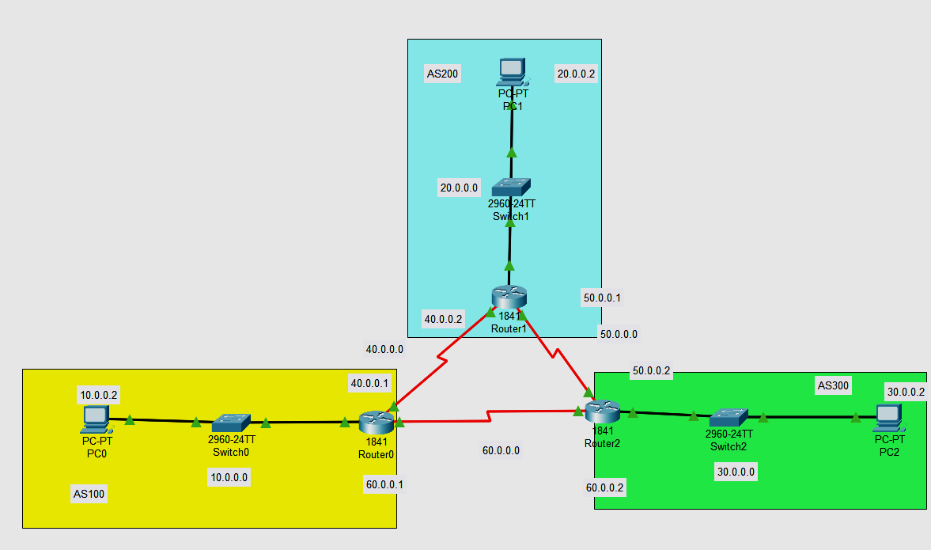

# Addressing Table

| **Device** | **Interface** | **IP Address** | **Subnet Mask** | **Default Gateway** |
| --- | --- | --- | --- | --- |
| R1 | Fa0/0 | 10.0.0.1 | 255.0.0.0 | N/A |
| *R1* | S0/0/0 | 40.0.0.1 | 255.0.0.0 | *N/A* |
| *R1* | S0/0/1 | 60.0.0.1 | 255.0.0.0 | *N/A* |
| R2  R2  R2 | Fa0/0 | 20.0.0.1 | 255.0.0.0 | N/A |
| S0/0/0 | 40.0.0.2 | 255.0.0.0 | N/A |
| S0/0/1 | 50.0.0.1 | 255.0.0.0 | N/A |
| R3  R3  R3 | Fa0/0 | 30.0.0.1 | 255.0.0.0 | N/A |
| S0/0/1 | 50.0.0.2 | 255.0.0.0 | N/A |
| S0/0/0 | 60.0.0.2 | 255.0.0.0 | N/A |
| PC-A | Fa0/0 | 10.0.0.2 | 255.0.0.0 | 10.0.0.1 |
| PC-B | Fa0/0 | 20.0.0.2 | 255.0.0.0 | 20.0.0.1 |
| PC-C | Fa0/0 | 30.0.0.2 | 255.0.0.0 | 30.0.0.1 |

**Part 1: Build the network.**

Step 1: Obtain the devices that are required**.**

Step 2: Name the devices.

Step 3: Connect the devices. According to the connection table

**Part 2: Configure BGP**

Step 1: Configuring Bgp in each router with specific address

Go to each router and configure there neighbour and assign the area

For Router 0 , consider neighbor address 40.0.0.2 and 60.0.0.2

For Router 1 , consider neighbor address 40.0.0.1 and 50.0.0.2

For Router 2 , consider neighbor address 50.0.0.1 and 60.0.0.1

**R1:**

Router(config)#router bgp 100

Router(config-router)#neighbor 40.0.0.2 remote-as 200

Router(config-router)# neighbor 60.0.0.2 remote-as 300

Router(config-router)#network 10.0.0.0 mask 255.0.0.0

Router(config-router)#exit

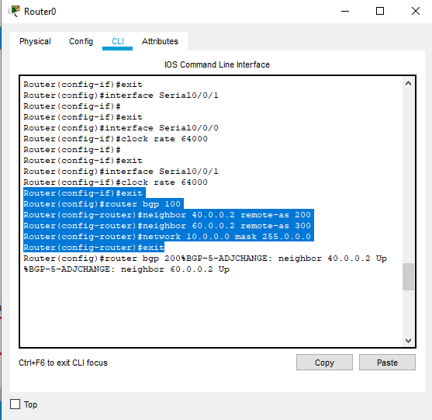

**R2**

Router(config)#router bgp 200

Router(config-router)#neighbor 40.0.0.1 remote-as 100

Router(config-router)# neighbor 50.0.0.2 remote-as 300

Router(config-router)#network 20.0.0.0 mask 255.0.0.0

Router(config-router)#exit

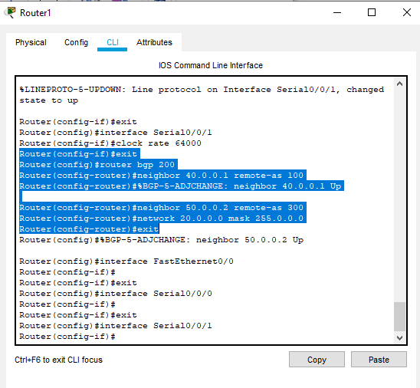

**R3**

Router(config)#router bgp 300

Router(config-router)#neighbor 60.0.0.1 remote-as 100

Router(config-router)# neighbor 50.0.0.1 remote-as 200

Router(config-router)#network 30.0.0.0 mask 255.0.0.0

Router(config-router)#exit

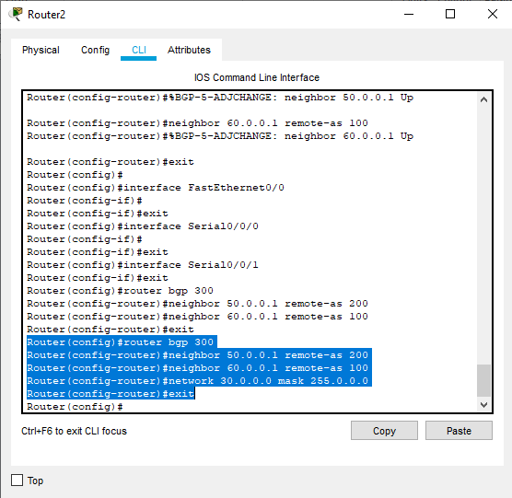

Step 2 Ping from PC to check connection

Ping from PC-C to PC-B

