IMPLEMENT ETHERCHANNEL

**Part 1: Build the network.**

Use the table below to build the switch topology.

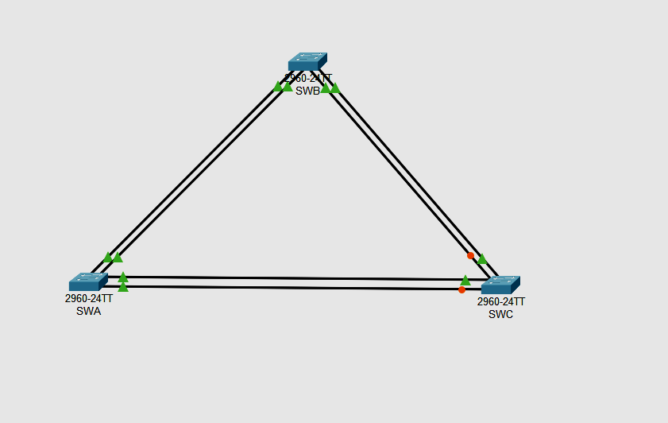

**Step 2: Name the devices.**

**Step 3: Connect the devices.**

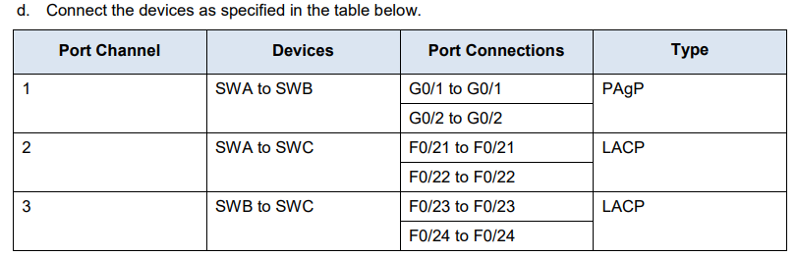

**Part 2: Configure EtherChannel**

Open configuration window On each switch, configure the ports that will be used in the Port Channels as static trunk ports.

**Step 1: Configure a PAgP EtherChannel.**

Follow the procedure that was used in previous activities to configure Port Channel 1 as a PAgP EtherChannel between SWA and SWB.

Both sides should negotiate the EtherChannel.

**In Switch 1(swa):**

Switch>en

Switch#conf t

Enter configuration commands, one per line. End with CNTL/Z.

Switch(config)#int range g0/1-2

Switch(config-if-range)#switchport mode trunk

Switch(config-if-range)#channel-group 1 mode desirable

Switch(config-if-range)#no shut

Switch(config-if-range)#exit

**Switch 2(swb)**

Switch>en

Switch#conf t

Enter configuration commands, one per line. End with CNTL/Z.

Switch(config)#int range g0/1-2

Switch(config-if-range)#switchport mode trunk

Switch(config-if-range)#channel-group 1 mode desirable

Switch(config-if-range)#no shut

Switch(config-if-range)#exit

**Step 2: Configure a LACP EtherChannel.**

**Configure Port Channel 2 as an LACP channel between SWA and SWC.**

**Both sides should negotiate the EtherChannel.**

Switch 1 (swa)

Switch(config)#int range fa0/21-22

Switch(config-if-range)#switchport mode trunk

Switch(config-if-range)#channel-group 2 mode active

Switch(config-if-range)#no shut

Switch(config-if-range)#exit

Switch 3 (swc)

Switch>en

Switch#conf t

Enter configuration commands, one per line. End with CNTL/Z.

Switch(config)#int range fa0/21-22

Switch(config-if-range)#switchport mode trunk

Switch(config-if-range)#channel-group 2 mode active

Switch(config-if-range)#no shut

Switch(config-if-range)#exit

**Step 3: Configure a Backup LACP**

**EtherChannel Configure Port Channel 3 channel as an LACP channel between SWB and SWC. In this case, SWC initiates negotiation with SWB.**

**SWB does not initiate negotiation of the channel**

Switch3(swc)

Switch(config)#int range fa0/23-24

Switch(config-if-range)#switchport mode trunk

Switch(config-if-range)#channel-group 3 mode active

Switch(config-if-range)#no shut

Switch(config-if-range)#exit

Switch2(swb)

Switch>en

Switch#conf t

Enter configuration commands, one per line. End with CNTL/Z.

Switch(config)#int range fa0/23-24

Switch(config-if-range)#switchport mode trunk

Switch(config-if-range)#channel-group 3 mode passive

Switch(config-if-range)#no shut

Switch(config-if-range)#exit

**Output to see all the etherchannel connections**

**Go to any one switch and write the follow command**

**Swc**

Switch#show etherchannel summary

Flags: D - down P - in port-channel

I - stand-alone s - suspended

H - Hot-standby (LACP only)

R - Layer3 S - Layer2

U - in use f - failed to allocate aggregator

u - unsuitable for bundling

w - waiting to be aggregated

d - default port

Number of channel-groups in use: 2

Number of aggregators: 2

Group Port-channel Protocol Ports

------+-------------+-----------+----------------------------------------------

2 Po2(SU) LACP Fa0/21(P) Fa0/22(I)

3 Po3(SU) LACP Fa0/23(D) Fa0/24(P)

**Swa**

Switch#show etherchannel summary

Flags: D - down P - in port-channel

I - stand-alone s - suspended

H - Hot-standby (LACP only)

R - Layer3 S - Layer2

U - in use f - failed to allocate aggregator

u - unsuitable for bundling

w - waiting to be aggregated

d - default port

Number of channel-groups in use: 2

Number of aggregators: 2

Group Port-channel Protocol Ports

------+-------------+-----------+----------------------------------------------

1 Po1(SU) PAgP Gig0/1(P) Gig0/2(P)

2 Po2(SU) LACP Fa0/21(P) Fa0/22(D)

**Swb**

Switch#show etherchannel summary

Flags: D - down P - in port-channel

I - stand-alone s - suspended

H - Hot-standby (LACP only)

R - Layer3 S - Layer2

U - in use f - failed to allocate aggregator

u - unsuitable for bundling

w - waiting to be aggregated

d - default port

Number of channel-groups in use: 2

Number of aggregators: 2

Group Port-channel Protocol Ports

------+-------------+-----------+----------------------------------------------

1 Po1(SU) PAgP Gig0/1(P) Gig0/2(P)

3 Po3(SU) LACP Fa0/23(I) Fa0/24(P)

**Checking trunking**

**Swc**

Switch#show interface trunk

Port Mode Encapsulation Status Native vlan

Po2 on 802.1q trunking 1

Po3 on 802.1q trunking 1

Port Vlans allowed on trunk

Po2 1-1005

Po3 1-1005

Port Vlans allowed and active in management domain

Po2 1

Po3 1

Port Vlans in spanning tree forwarding state and not pruned

Po2 1

Po3 1

**Swb**

Switch#show interface trunk

Port Mode Encapsulation Status Native vlan

Po1 on 802.1q trunking 1

Po3 on 802.1q trunking 1

Port Vlans allowed on trunk

Po1 1-1005

Po3 1-1005

Port Vlans allowed and active in management domain

Po1 1

Po3 1

Port Vlans in spanning tree forwarding state and not pruned

Po1 1

Po3 1

**7B.Tune and optimize Etherchannel Operations**

**TOPOLOGY**

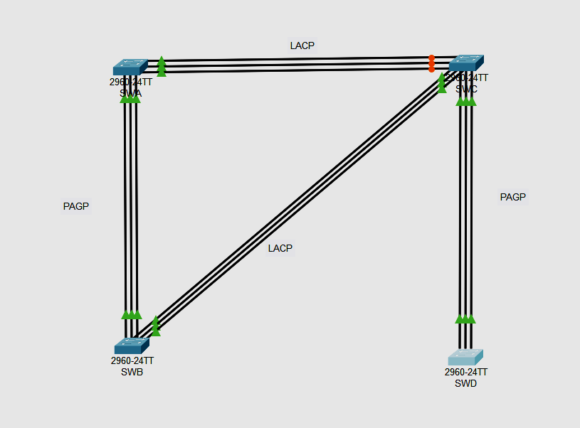

**CONNECTION TABLE**

| **Port Channel** | **Devices** | **Port Connections** | **Type** |
| --- | --- | --- | --- |
| 1 | SWA to SWB | F0/1 to F0/1 | PAgP |
|  |  | F0/2 to F0/2 |  |
| *1* | *SWA to SWB* | F0/3 to F0/3 |  |
| 2  *2* | SWA to SWC  *SWA to SWC* | F0/10 to F0/10 | LACP |
| F0/11 to F0/11 |
| F0/12 to F0/12 |
| 3 | SWB to SWC | F0/15 to F0/15 | LACP |
|  |  | F0/16 to F0/16 |  |
| *3* |  | F0/17 to F0/17 |  |
| 4 | SWC to SWD | F0/22 to F0/22 | PAgP |
|  |  | F0/23 to F0/23 |  |
|  |  | F0/24 to F0/24 |  |
|  |  |  |  |

**Part 1: Build the network.**

Step 1: Obtain the devices that are required**.**

Step 2: Name the devices.

Step 3: Connect the devices. According to the connection table

**Part 2: Configure EtherChannel**

*Open configuration window*

On each switch, configure the ports that will be used in the Port Channels as static trunk ports

**Step 1: Configure a PAgP EtherChannel.**

Configure Port Channel 1 as a PAgP EtherChannel between SWA and SWB. Both sides should negotiate the EtherChannel.

SWA>enable

SWA#configure terminal

Enter configuration commands, one per line. End with CNTL/Z.

SWA(config)#int range f0/1-3

SWA(config-if-range)#switchport mode trunk

SWA(config-if-range)#channel-group 1 mode desirable

SWA(config-if-range)#no shut

SWA(config-if-range)#exit

SWB>en

SWB#conf t

Enter configuration commands, one per line. End with CNTL/Z.

SWB(config)#int range f0/1-3

SWB(config-if-range)#switchport mode trunk

SWB(config-if-range)#channel-group 1 mode desirable

SWB(config-if-range)#no shut

SWB(config-if-range)#exit

**Step 2: Configure a LACP EtherChannel.**

Configure Port Channel 2 as an LACP channel between SWA and SWC. Both sides should negotiate the EtherChannel.

SWA>en

SWA#conf t

Enter configuration commands, one per line. End with CNTL/Z.

SWA(config)#int range fa0/10-12

SWA(config-if-range)#switchport mode trunk

SWA(config-if-range)#channel-group 2 mode active

SWA(config-if-range)#no shut

SWA(config-if-range)#exit

SWC>en

SWC#conf t

Enter configuration commands, one per line. End with CNTL/Z.

SWC(config)#int range fa0/10-12

SWC(config-if-range)#switchport mode trunk

SWC(config-if-range)#channel-group 2 mode active

SWC(config-if-range)#no shut

SWC(config-if-range)#exit

**Step 3: Configure a Backup LACP EtherChannel**

Configure Port Channel 3 channel as an LACP channel between SWB and SWC. In this case, SWB initiates negotiation with SWC. SWC does not initiate negotiation of the channel

SWB>en

SWB#conf t

Enter configuration commands, one per line. End with CNTL/Z.

SWB(config)#int range fa0/15-17

SWB(config-if-range)#switchport mode trunk

SWB(config-if-range)#channel-group 3 mode active

SWB(config-if-range)#no shut

SWB(config-if-range)#exit

SWC(config)#int range fa0/15-17

SWC(config-if-range)#switchport mode trunk

SWC(config-if-range)#channel-group 3 mode passive

SWC(config-if-range)#no shut

SWC(config-if-range)#exit

**Step 4: Configure a Backup PAgP EtherChannel**

Configure Port Channel 4 channel as an LACP channel between SWC and SWD. In this case, SWC initiates negotiation with SWD. SWD does not initiate negotiation of the channel.

SWC(config)#int range fa0/22-24

SWC(config-if-range)#switchport mode trunk

SWC(config-if-range)#channel-group 4 mode desirable

SWC(config-if-range)#no shut

SWC(config-if-range)#exit

SWD>en

SWD#conf t

Enter configuration commands, one per line. End with CNTL/Z.

SWD(config)#int range fa0/22-24

SWD(config-if-range)#switchport mode trunk

SWD(config-if-range)#channel-group 4 mode auto

SWD(config-if-range)#no shut

SWD(config-if-range)#exit

**Part 4: Checking output**

Output to see all the etherchannel connections

Go to any one switch and write the follow command

