1.IMPLEMENT A GRE TUNNEL

Topology: 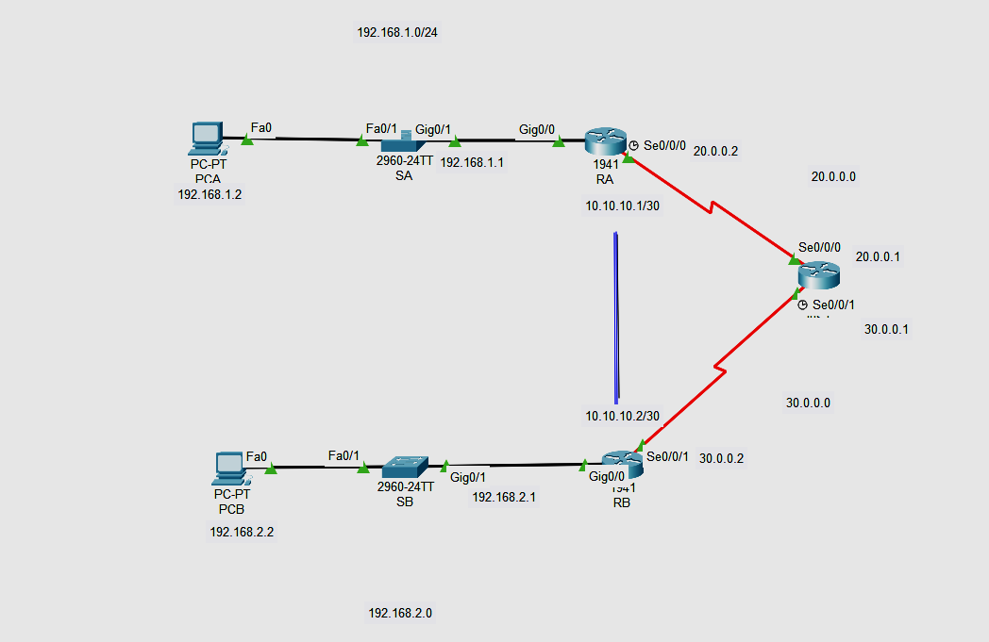

**Addressing** **Table**

| **Device** | **Interface** | **IP** **Address** | **Subnet** **Mask** | **Default** **Gateway** |
| --- | --- | --- | --- | --- |
| RA | G0/0 | 192.168.1.1 | 255.255.255.0 | N/A |
| S0/0/0 | 20.0.0.2 | 255.255.255.252 | N/A |
| Tunnel 0 | 10.10.10.1 | 255.255.255.252 | N/A |
| RB | G0/0 | 192.168.2.1 | 255.255.255.0 | N/A |
| S0/0/0 | 30.0.0.2 | 255.255.255.252 | N/A |
| Tunnel 0 | 10.10.10.2 | 255.255.255.252 | N/A |
| PC-A | NIC | 192.168.1.2 | 255.255.255.0 | 192.168.1.1 |
| PC-C | NIC | 192.168.2.2 | 255.255.255.0 | 192.168.2.1 |

**Part** **1:** **Verify** **Router** **Connectivity**

**Configuring RA**

Router>enable

Router#configure terminal

Enter configuration commands, one per line. End with CNTL/Z.

Router(config)#interface GigabitEthernet0/1

Router(config-if)#ip address 192.168.1.1 255.255.255.0

Router(config-if)#no shutdown

Router(config)#interface Serial0/0/0

Router(config-if)#ip address 20.0.0.2 255.255.255.252

Router(config-if)#clock rate 64000

Router(config-if)#no shutdown

**Configuring RB**

Router>enable

Router#configure terminal

Enter configuration commands, one per line. End with CNTL/Z.

Router(config)#interface GigabitEthernet0/1

Router(config-if)#ip address 192.168.2.1 255.255.255.0

Router(config-if)#no shutdown

Router>enable

Router#configure terminal

Router(config)#interface Serial0/0/1

Router(config-if)#ip address 30.0.0.2 255.255.255.252

Router(config-if)#clock rate 64000

This command applies only to DCE interfaces

Router(config-if)#no shutdown

**Configuring RC**

Router>enable

Router#

Router#configure terminal

Router(config)#interface Serial0/0/0

Router(config-if)#ip address 20.0.0.1 255.255.255.252

Router(config-if)#clock rate 64000

This command applies only to DCE interfaces

Router(config-if)#no shutdown

Router>enable

Router#configure terminal

Router(config)#interface Serial0/0/0

Router(config-if)#ip address 20.0.0.1 255.255.255.252

Router(config-if)#clock rate 64000

This command applies only to DCE interfaces

Router(config-if)#no shutdown

**NOW RIP ALL THE ROUTER**

RA

Router(config)#router rip

Router(config-router)# network 20.0.0.0

RB

Router(config)#router rip

Router(config-router)#network 192.168.2.0

Router(config-router)#network 30.0.0.0

RC

Router(config)#router rip

Router(config-router)#network 20.0.0.0

Router(config-router)#network 30.0.0.0

**Part** **2:** **Configure** **GRE** **Tunnels**

**Step** **1:** **Configure** **the** **Tunnel** **0** **interface** **of** **RA.**

Router>EN

Router#conf t

Router(config)#int tunnel 0

Router(config-if)#ip address 10.10.10.1 255.255.255.252

Router(config-if)#tunnel source s0/0/0

Router(config-if)#tunnel destination 30.0.0.2

Router(config-if)#tunnel mode gre ip

Router(config-if)#no shut

Router(config-if)#exit

Router(config)#ip route 192.168.2.0 255.255.255.0 10.10.10.2

**Step** **2:** **Configure** **the** **Tunnel** **0** **interface** **of** **RB.**

Router>en

Router#conf t

Enter configuration commands, one per line. End with CNTL/Z.

Router(config)#int tunnel 0

Router(config-if)#ip address 10.10.10.2 255.255.255.252

Router(config-if)#tunnel source s0/0/1

Router(config-if)#tunnel destination 20.0.0.2

Router(config-if)#tunnel mode gre ip

Router(config-if)#no shut

Router(config-if)#ip route 192.168.1.0 255.255.255.0 10.10.10.1

Router(config)#

**Step** **3:** **Configure** **a** **route** **for** **private** **IP** **traffic.**

Router(config)#ip route 192.168.2.0 255.255.255.0 10.10.10.2

Router(config-if)#ip route 192.168.1.0 255.255.255.0 10.10.10.1

**Part** **3:** **Verify** **Router** **Connectivity**

**Step** **1:** **Ping** **PCA** **from** **PCB.**

Attempt to ping the IP address of **PCA** from **PCB**. The ping should be successful.

**Step** **2:** **Trace** **the** **path** **from** **PCA** **to** **PCB.**

Attempt to trace the path from **PCA** to **PCB**. Note the lack of public IP addresses in the output.

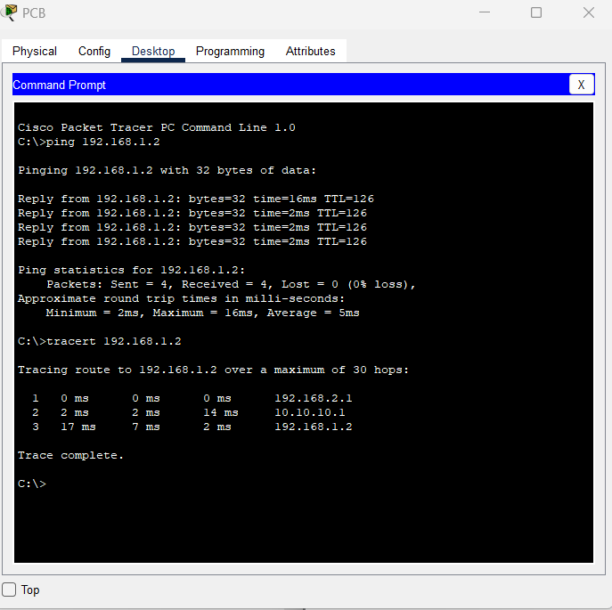

**2.IMPLEMENT VTP**

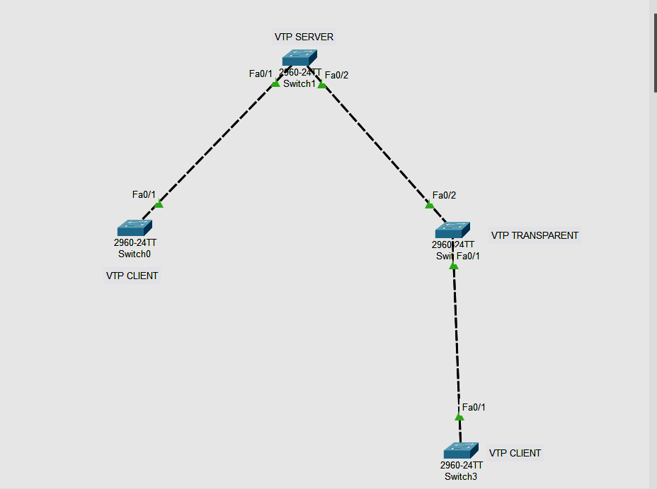

**Part 1 : Configure the Switch and trunking mode**

**Switch 0**

Switch>en

Switch#conf t

Enter configuration commands, one per line. End with CNTL/Z.

Switch(config)#int fa0/1

Switch(config-if)#switchport mode trunk

Switch(config-if)#exit

**Switch 1**

Switch>EN

Switch#conf t

Enter configuration commands, one per line. End with CNTL/Z.

Switch(config)#int fa0/1

Switch(config-if)#switchport mode trunk

Switch(config-if)#int fa0/2

Switch(config-if)#switchport mode trunk

Switch(config-if)#int fa0/2

Switch(config-if)#switchport mode trunk

**Switch 2**

Switch>en

Switch#conf t

Enter configuration commands, one per line. End with CNTL/Z.

Switch(config)#int fa0/1

Switch(config-if)#switchport mode trunk

Switch(config-if)#int fa0/2

Switch(config-if)#switchport mode trunk

Switch(config-if)#exit

**Switch 3**

Switch>en

Switch#conf t

Enter configuration commands, one per line. End with CNTL/Z.

Switch(config)#int fa0/1

Switch(config-if)#switchport mode trunk

Switch(config-if)#exit

**Part 2: Configuring mode of switches**

**Switch 0 to client**

Switch(config)#vtp mode client

Setting device to VTP CLIENT mode.

Switch(config)#

**Switch 2 to transparent**

Switch(config)#vtp mode client

Setting device to VTP CLIENT mode.

Switch(config)#

**Changing Switch 3 to client**

Switch(config)#vtp mode client

Setting device to VTP CLIENT mode.

Switch(config)#

**No need to change the mode of switch 1 since by default mode is server**

**Output to check status of each switch**

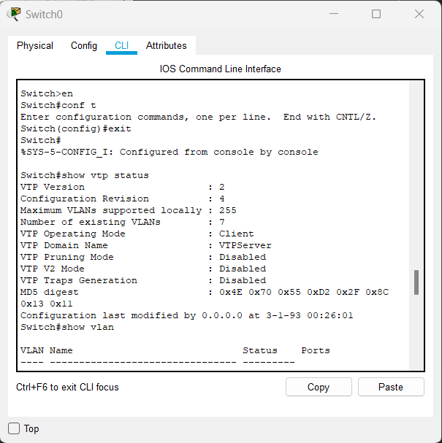

**Check the vtp status**

Switch#Show vtp status

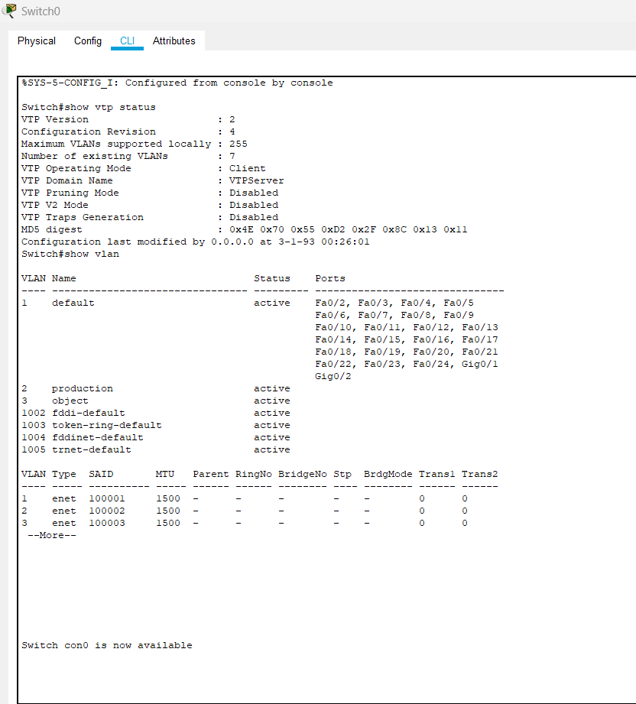

**3.IMPLEMENT NAT**

**Topology:**

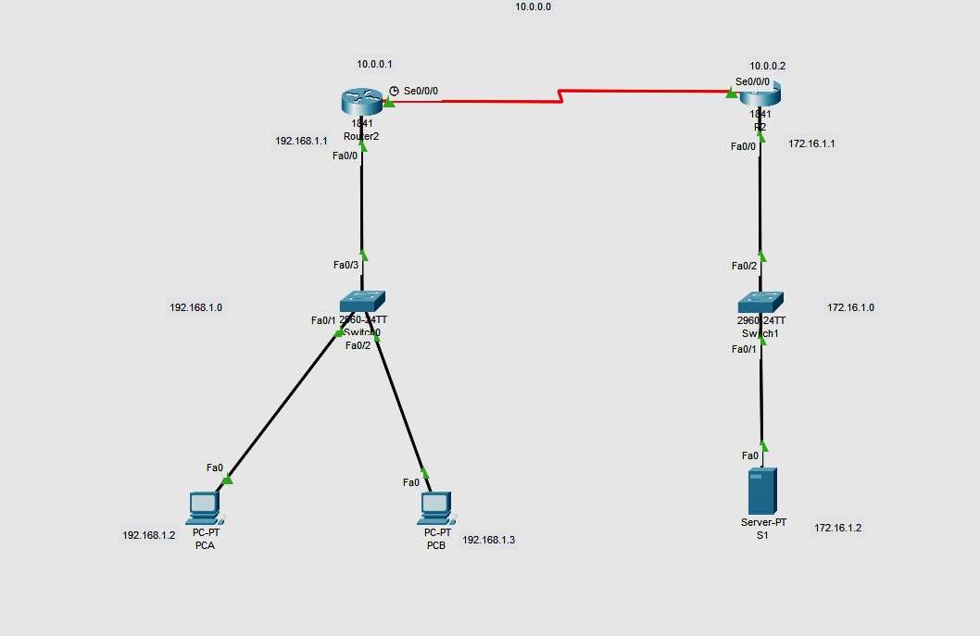

**Part 1 : Configure the Router**

| **Device** | **Interface** | **IP** **Address** | **Subnet** **Mask** | **Default** **Gateway** |
| --- | --- | --- | --- | --- |
| R1 | F0/0 | 192.168.1.1 | 255.255.255.0 | N/A |
| S0/0/0 | 10.0.0.1 | 255.0.0.0 | N/A |
| R2 | F0/0 | 172.168.1.1 | 255.255.0.0 | N/A |
| S0/0/0 | 10.0.0.2 | 255.0.0.0 | N/A |
| PC-A | NIC | 192.168.1.2 | 255.255.255.0 | 192.168.1.1 |
| PC-C | NIC | 192.168.1.3 | 255.255.255.0 | 192.168.1.1 |
| SERVER | Fa0 | 172.16.1.2 | 255.255.0.0 | 172.16.1.1 |

**In router r2**

Router>enable

Router#configure terminal

Router(config)#interface Serial0/0/0

Router(config-if)#ip address 10.0.0.2 255.0.0.0

Router(config-if)#clock rate 64000

Router(config-if)#no shutdown

Router(config-if)#exit

Router(config)#interface FastEthernet0/0

Router(config-if)#ip address 172.16.1.1 255.255.0.0

Router(config-if)#no shutdown

Router(config-if)#exit

Router(config)#router rip

Router(config-router)#network 172.16.0.0

Router(config-router)#network 10.0.0.0

**In router r1**

Router>enable

Router#configure terminal

Router(config)#interface FastEthernet0/0

Router(config-if)#ip address 192.168.1.1 255.255.255.0

Router(config-if)#no shutdown

Router(config-if)#exit

Router(config)#interface Serial0/0/0

Router(config-if)#ip address 10.0.0.1 255.0.0.0

Router(config-if)#clock rate 64000

Router(config-if)#no shutdown

Router(config)#router rip

Router(config-router)#network 192.168.1.0

Router(config-router)#network 10.0.0.0

Router(config-router)#exit

Router(config)#int fa0/0

Router(config-if)#ip nat inside

Router(config-if)#int s0/0/0

Router(config-if)#ip nat outside

Router(config-if)#exit

Router(config)#ip nat inside source static 192.168.1.2 10.0.0.1

Router(config)#ip route 0.0.0.0 0.0.0.0 s0/0/0

Router(config)#ip nat inside source static 192.168.1.3 10.0.0.1

Router(config)#ip route 0.0.0.0 0.0.0.0 s0/0/0

Router(config)#exit

**To check nat statu**s

Router#show ip nat ?

statistics Translation statistics

translations Translation entries

Router#show ip nat statistics

Total translations: 1 (2 static, 4294967295 dynamic, 0 extended)

Outside Interfaces: Serial0/0/0

Inside Interfaces: FastEthernet0/0

Hits: 0 Misses: 16

Expired translations: 0

Dynamic mappings:

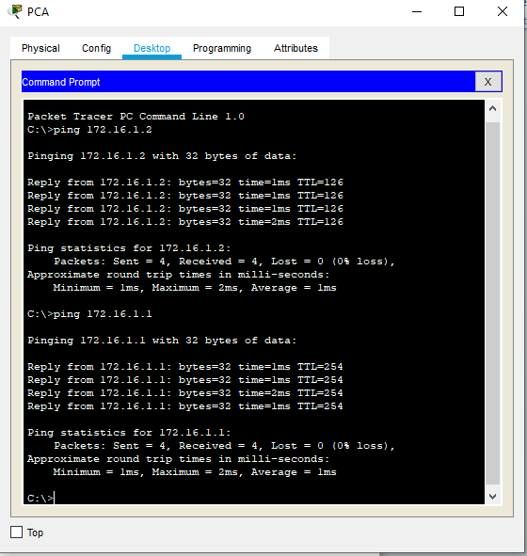

After pinging to server

Router#show ip nat statistics

Total translations: 5 (2 static, 3 dynamic, 4 extended)

Outside Interfaces: Serial0/0/0

Inside Interfaces: FastEthernet0/0

Hits: 4 Misses: 23

Expired translations: 0

Dynamic mappings:

After pinging to router 2 just after sending packet to server

Router#show ip nat statistics

Total translations: 9 (2 static, 7 dynamic, 8 extended)

Outside Interfaces: Serial0/0/0

Inside Interfaces: FastEthernet0/0

Hits: 8 Misses: 30

Expired translations: 0

Dynamic mappings:

Router#

