Aim:- Implement IP SLA (IP Service Level Agreement)

Topology:

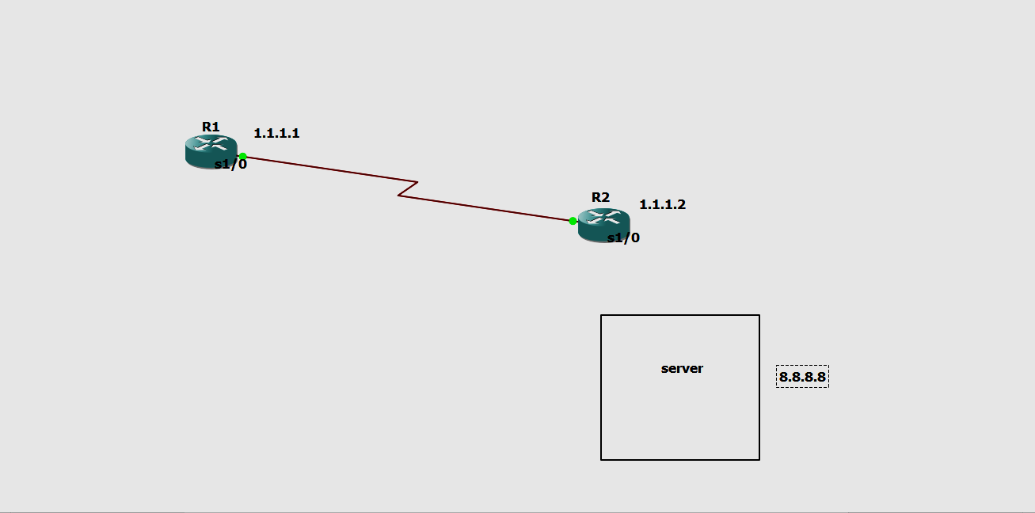

Addressing Table:

| **Device** | **Interface** | **IP Address** | **Subnet Mask** | **Default Gateway** |
| --- | --- | --- | --- | --- |
| R1 | S0/0/0 | 1.1.1.1 | 255.0.0.0 | N/A |
| ISP | S0/0/0 | 1.1.1.2 | 255..0.0.0 | N/A |
| Lo0 | 8.8.8.8 | 255..0.0.0 | N/A |

**Part 1: Build the Network and Verify Connectivity**

**Step 1: Cable the network as shown in the topology**.

**Step 2**: **Configure basic settings for R1**

**Code in R1**

R1>enable

R1#config terminal

Enter configuration commands, one per line. End with CNTL/Z.

R1(config)#int s1/0

R1(config-if)#ip address 1.1.1.1 255.0.0.0

R1(config-if)#no shut

R1(config-if)#ip route 0.0.0.0 0.0.0.0 1.1.1.2

R1(config)#exit

**Step 3: Configure basic settings for R2(ISP ROUTER)**

**Code in R2**

R2>enable

R2#config terminal

Enter configuration commands, one per line. End with CNTL/Z.

R2(config)#int s1/0

R2(config-if)#ip address 1.1.1.2 255.0.0.0

R2(config-if)#clock rate 64000

R2(config-if)#no shut

R2(config)#exit

**Step 4: IN R2 TO CONFIGURE THE ISP ROUTER**

R2(config)#int loopback 1

R2(config)#int s1/0

R2(config-if)#no ip domain-lookup

R2(config-if)#ip address 8.8.8.8 255.0.0.0

R2(config-if)#no shut

R2(config)#exit

**Step 5: Ping 8.8.8.8 and 1.1.1.2 from R1 AND R2 To check whether the connection is proper**

**PING FROM R1**

R1#ping 8.8.8.8

Type escape sequence to abort

Sending 5, 100-bytes ICMP Echo to 8.8.8.8, timeout is 2 seconds:

!!!!

Success rate is 100 percent (5/5), round-trip min/avg/max = 28/30/40 ms

R1#ping 1.1.1.2

Type escape sequence to abort

Sending 5, 100-bytes ICMP Echo to 8.8.8.8, timeout is 2 seconds:

!!!!

Success rate is 100 percent (5/5), round-trip min/avg/max = 28/30/40 ms

**PINGING FROM R2**

R2#ping 8.8.8.8

Type escape sequence to abort

Sending 5, 100-bytes ICMP Echo to 8.8.8.8, timeout is 2 seconds:

!!!!

Success rate is 100 percent (5/5), round-trip min/avg/max = 28/30/40 ms

R2#ping 1.1.1.2

Type escape sequence to abort

Sending 5, 100-bytes ICMP Echo to 8.8.8.8, timeout is 2 seconds:

!!!!

Success rate is 100 percent (5/5), round-trip min/avg/max = 28/30/40 ms

**PART 2: Configure IP SLA ICMP Echo on R1**

**Code in R1**

R1#config terminal

Enter configuration commands, one per line. End with CNTL/Z.

R1(config)#ip sla 1

R1(config-ip-sla)#icmp-echo 8.8.8.8

R1(config-ip-sla-echo)#frequency 10

R1(config-ip-sla-echo)#ip sla schedule 1 start-time now life forever

R1(config)#end

**PART 3: Monitor the IP SLA Operation to check the output**

**Issue the command used to display the IP SLA operation statistics on R1.**

R1# **show ip sla statistics**

IPSLAs Latest Operation Statistics

IPSLA operation id: 22

Latest RTT: 1 milliseconds

Latest operation start time: 18:44:45 UTC Thu Sep 22 2022

Latest operation return code: OK

Number of successes: 103

Number of failures: 10

Operation time to live: Forever

R1# **show ip sla configuration**

IP SLA Infrastructure Engine-III

Entry number: 1

Owner:

Tag:

Operation timeout (milliseconds): 5000

Type of operation to perform: icmp-echo

Target address/Source address :8.8.8.8/0.0.0.0

Type of service parameter : 0x0

Request size (ARR data portion):28

Verify data: No

Vrf Name:

Schedule:

Operation frequency (seconds): 10 (not considered if randomly scheduled)

Next Scheduled start time: Start Time already passed

Group Scheduled: FALSE  
Randomly scheduled: FALSE

Life (seconds): FALSE

Entry Agent (seconds): never

**Output R1:**

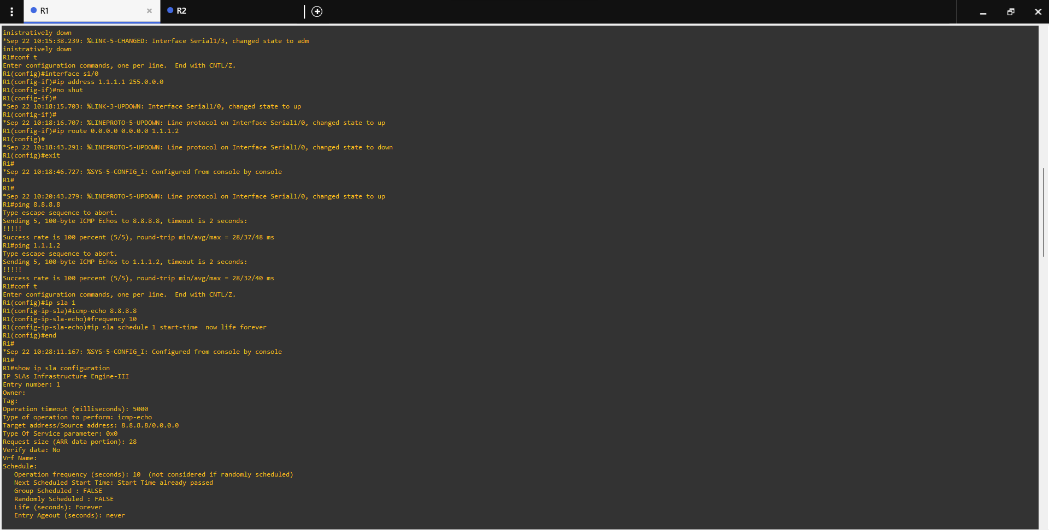

**Output R2:**

