Implement span technologies (switch port analyzer)

3A Implement span technologies (switch port analyzer)

Topology:

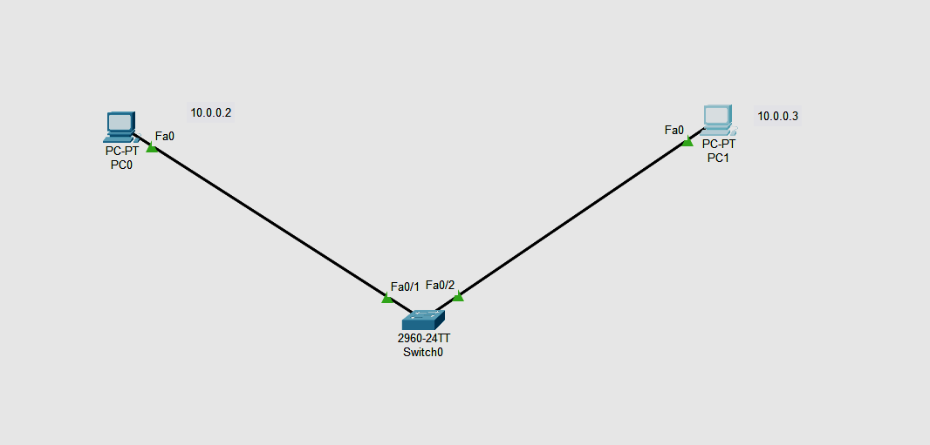

1. **Addressing Table:**

| **Device** | **Interface** | **IP Address** | **Subnet Mask** | **Default Gateway** |
| --- | --- | --- | --- | --- |
| R1 | Fa0 | 10.0.0.3 | 255.0.0.0 | N/A |
| PC0 | Fa0 | 10.0.0.2 | 255.0.0.0 | 10.0.0.1 |
| Switch0 | Fa0/1 | N/A | 255..0.0.0 | N/A |
| Fa0/2 | N/A | 255..0.0.0 | N/A |

**Part 1: Build the Network and verify Connectivity**

In Part 1, you will set up the network topology and configure basic settings, such as the interface IP addresses.

Set ip address of PC0 as 10.0.0.2 and its default gateways as 10.0.0.1 and assign ip address of Router as 10.0.0.3

Part 2: monitoring switch port analyser working in switch 0:

Switch>enable

Switch#config terminal

Switch(config)# moniter session 1 source int fa0/1

Switch(config)# moniter session 1 destination int fa0/2

Switch(config)#end

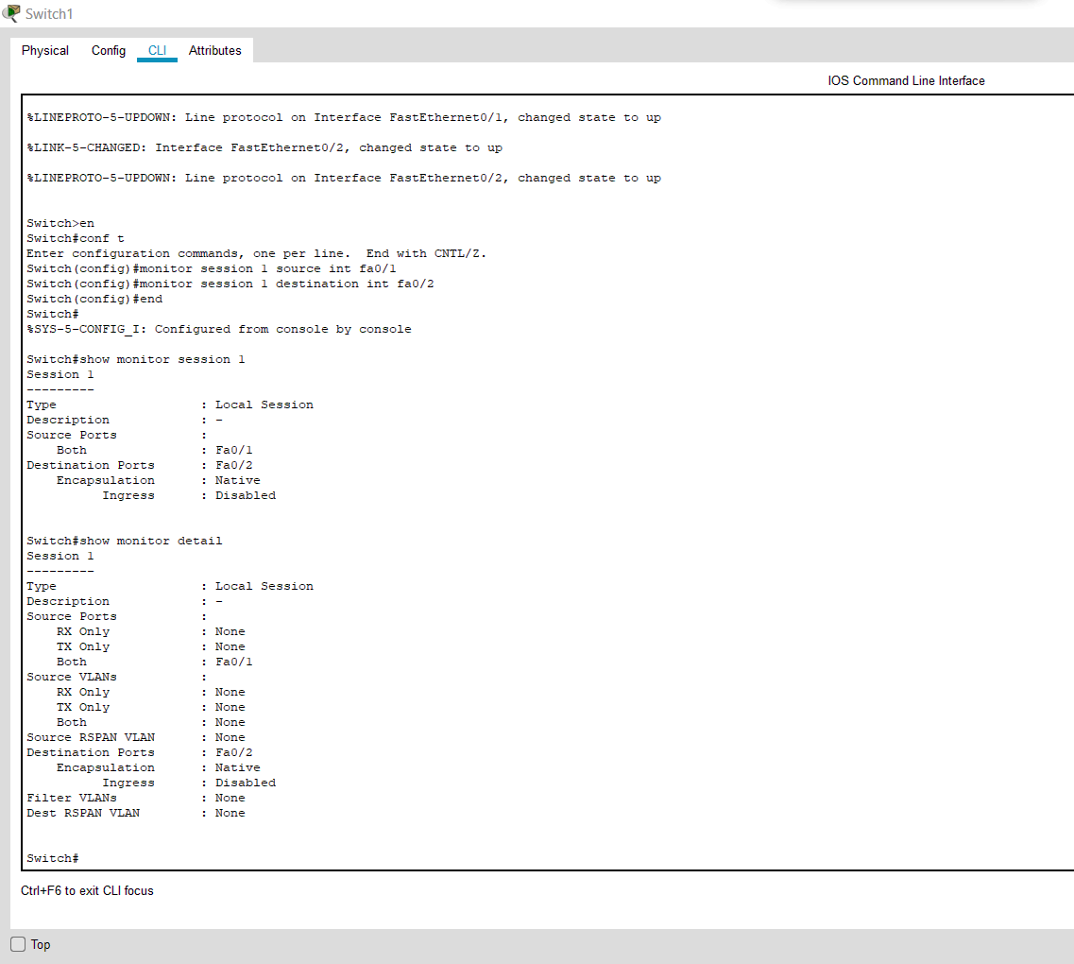

**3B IMPLEMENTATION OF SNMP AND SYSLOG**

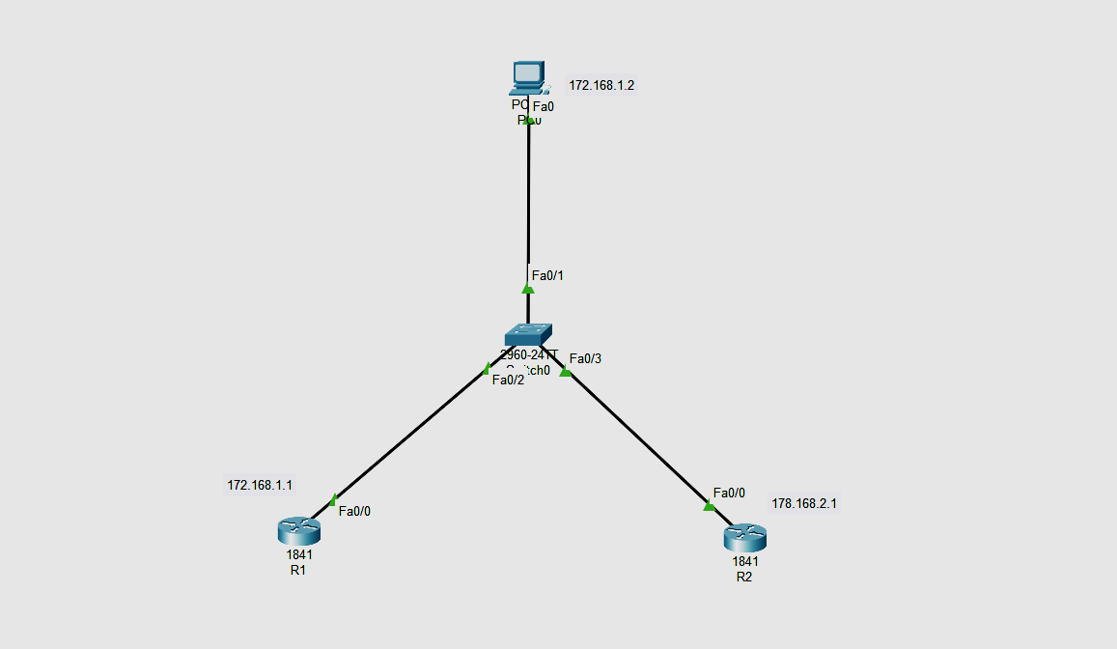

| **Device** | **Interface** | **IP Address** | **Subnet Mask** | **Default Gateway** |
| --- | --- | --- | --- | --- |
| R1 | Fa0 | 172.168.1.1 | 255.255.0.0 | N/A |
| R2 | Fa0 | 172.168.2.1 | 255.255.0.0 | N/A |
| PC0 | Fa0 | 172.168.1.2 | 255.255.0.0 | 172.168.1.1 |
| Switch0 | Fa0/1 | N/A | 255..0.0.0 | N/A |
| Fa0/2 | N/A | 255..0.0.0 | N/A |
| Fa0/3 | N/A | 255..0.0.0 | N/A |

Go to r1 or r2 any can be taken

R1>enable

R1#config terminal

Enter configuration commands, one per line. End with CNTL/Z.

R1(config)#int fa0/1

R1(config-if)#ip address 172.168.1.1 255.255.0.0

R1(config-if)#no shut

R1(config-if)#exit

R1(config)#snmp-server community read ro

R1(config)#snmp-server community write rw

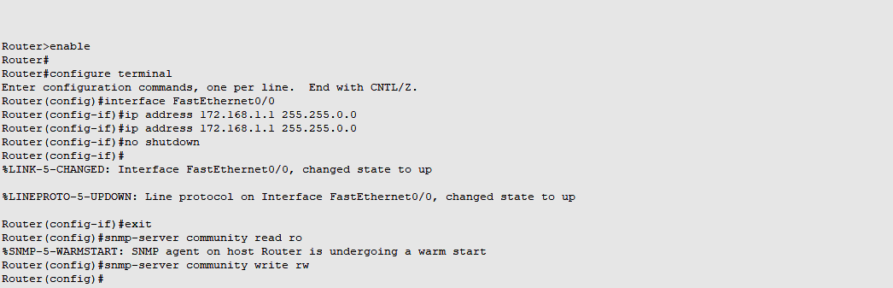

Step 2

Go to pc o then

Mib browser in desktop

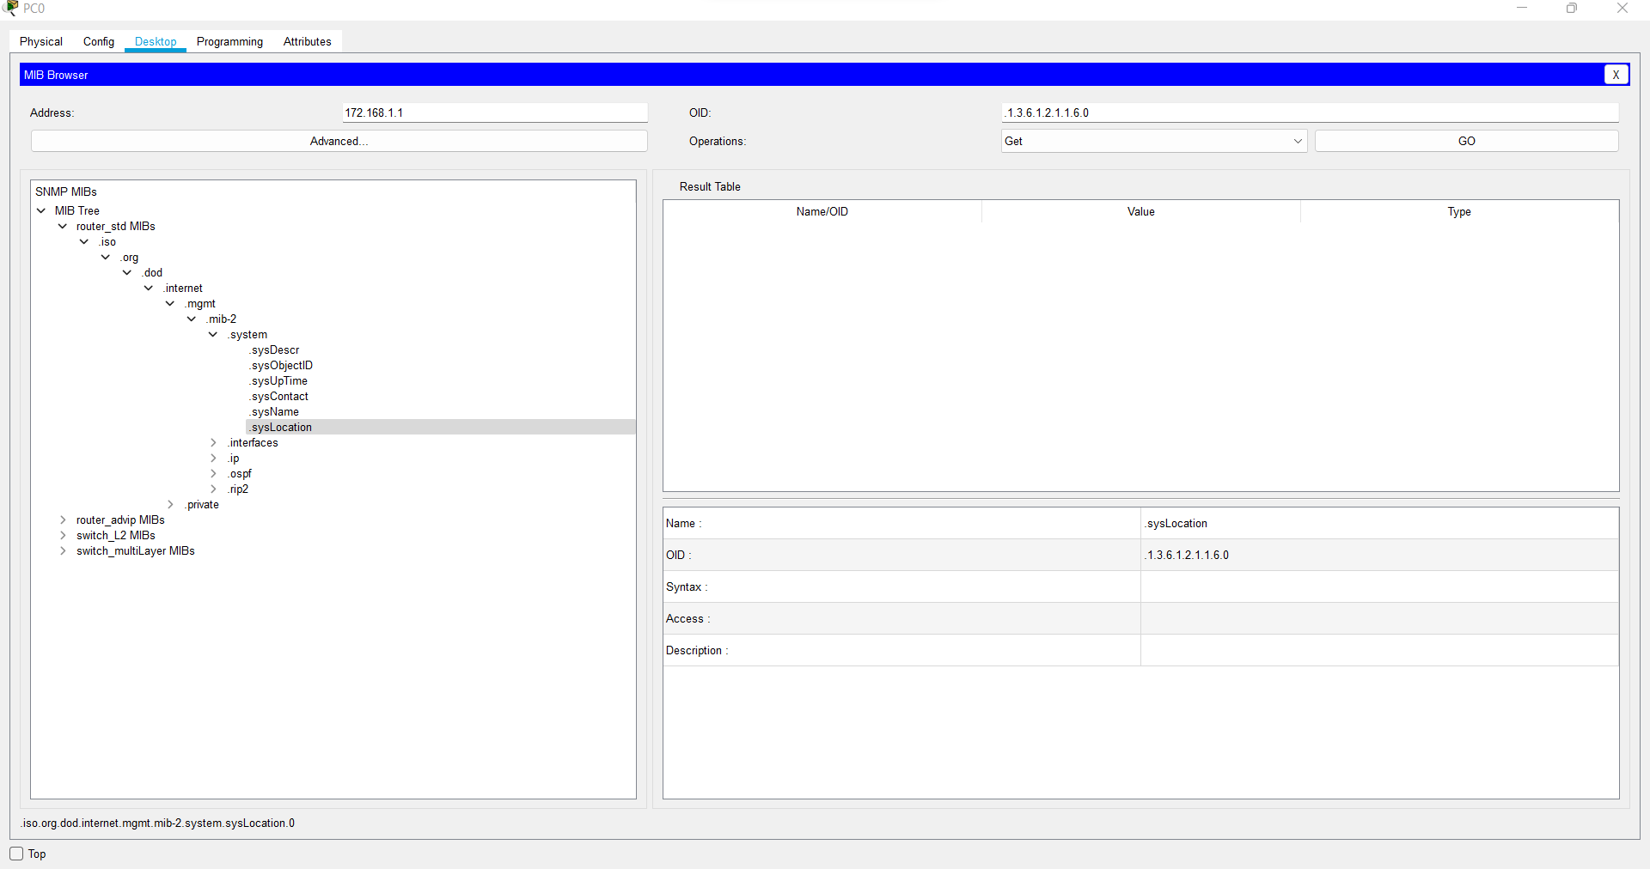

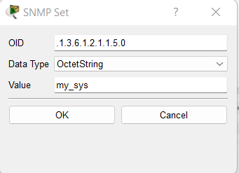

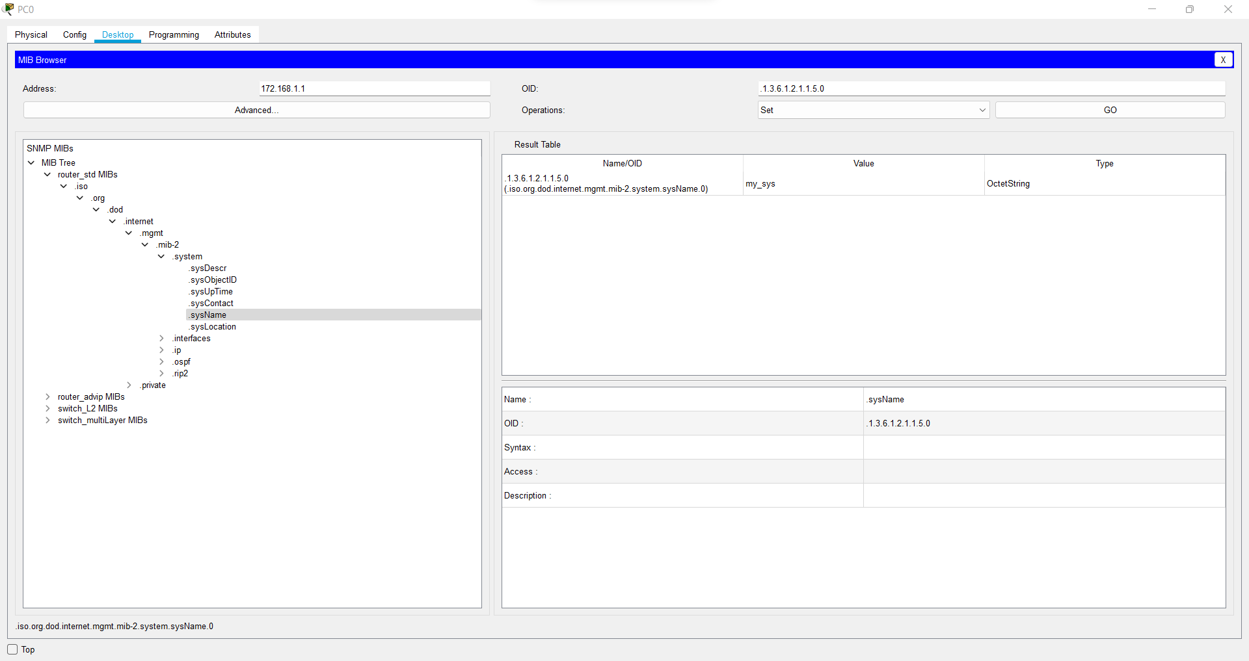

**b)Syslog**

**Topology**

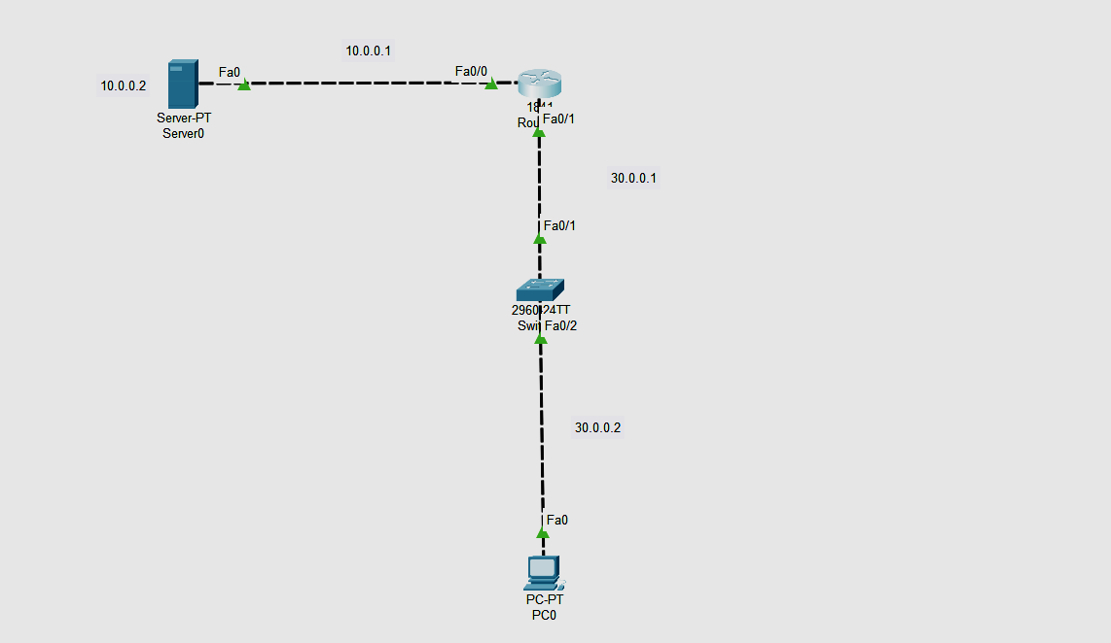

Addressing Table

| **Device** | **Interface** | **IP Address** | **Subnet Mask** | **Default Gateway** |
| --- | --- | --- | --- | --- |
| R1 | Fa0/0 | 10.0.0.1 | 255.0.0.0 | N/A |
| Fa0/1 | 30.0.0.1 | 255.0.0.0 | N/A |
| PC0 | Fa0 | 30.0.0.2 | 255.0.0.0 | 30.0.0.1 |
| Switch0 | Fa0/1 | N/A | 255..0.0.0 | N/A |
| Fa0/2 | N/A | 255..0.0.0 | N/A |

Configure Pc0

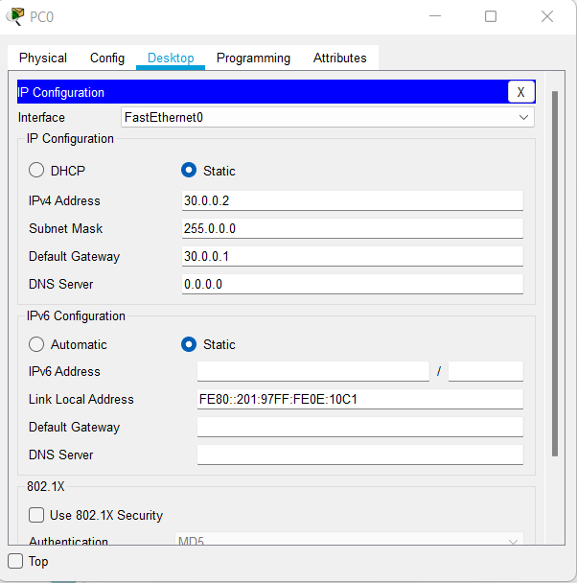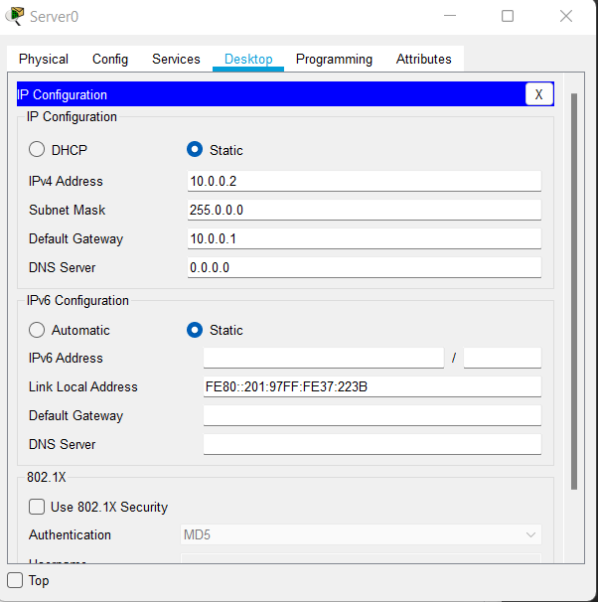

Go to r0 and configure network

Fa0/0

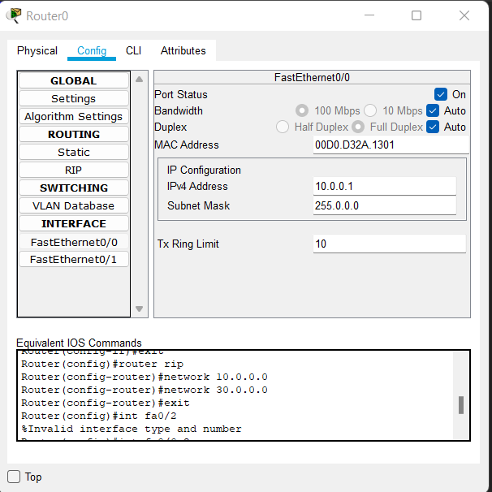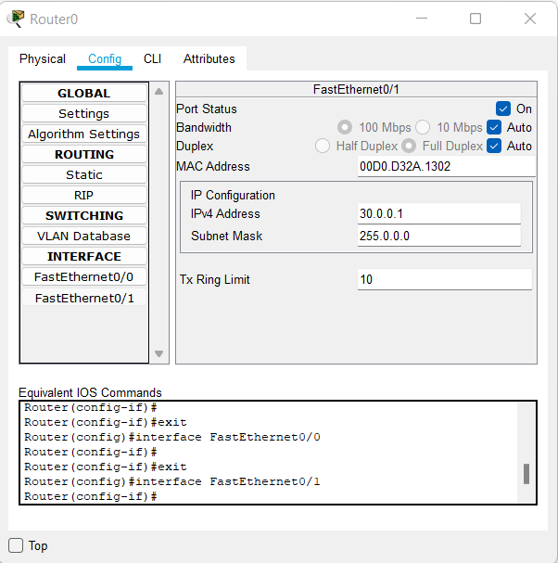

Fa0/1

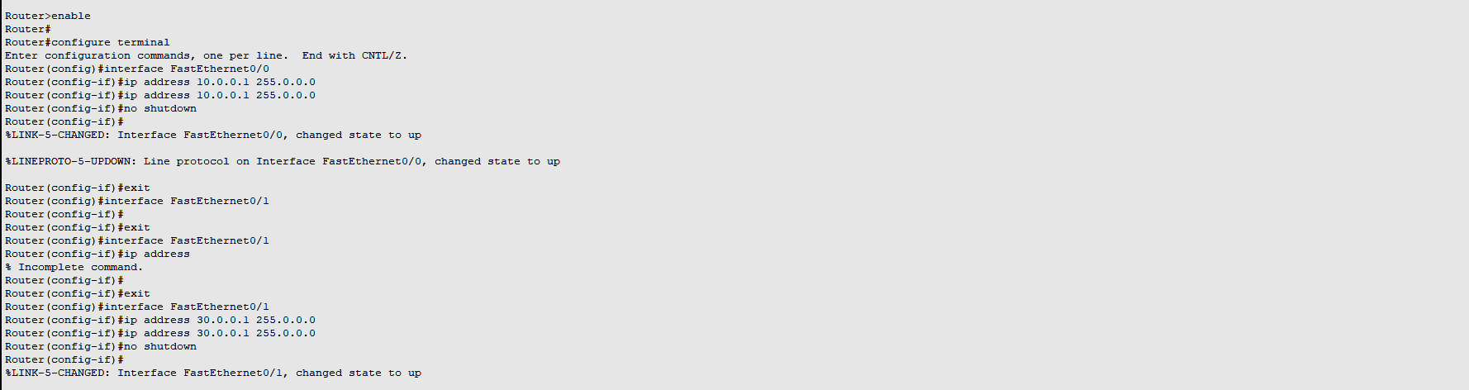

Go to r1 again and at cli put the following command

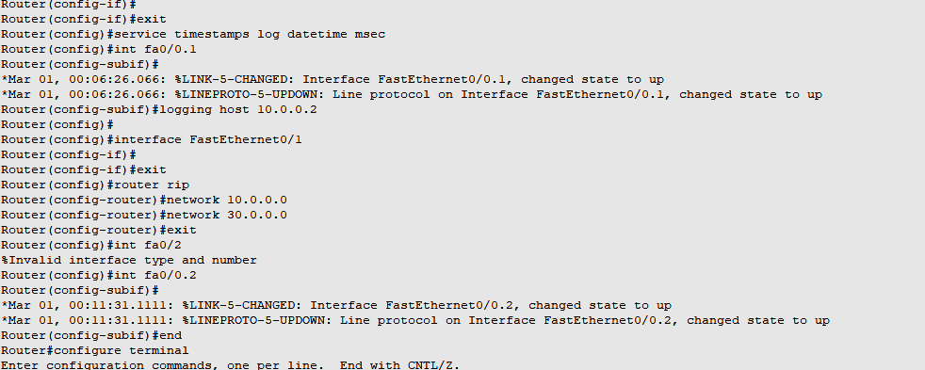

Output at server services and you will find syslog

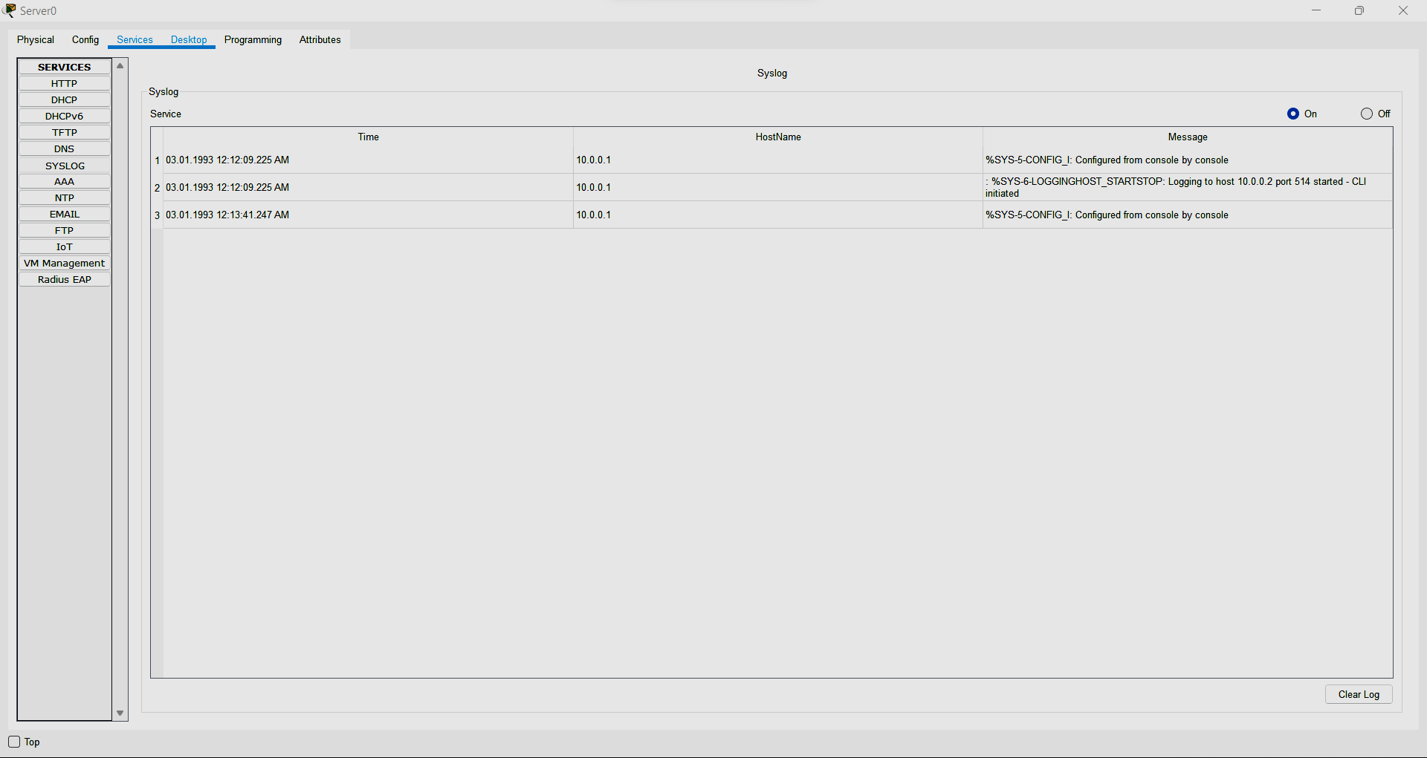

**3.C IMPLEMENT FLEXIBLE NETFLOW**



Do the configuration as above dig

Go to r1

R1>enable

R1#config terminal

Enter configuration commands, one per line. End with CNTL/Z.

R1(config)#int fa0/0

R1(config-if)#ip flow ingress

R1(config-if)#ip flow engress

R1(config-if)#ip flow-export source fa0/0

R1(config-if)#end

R1#show ip cache flow

