Retail Behavior Scorecard Process Wiki
Process explanation, executable pipeline flow, and provisional model validation summary

Executive Summary
- Current development population rows: 72,031
- Reference months and split design: 2022-09 validation_1, 2023-09 development, 2024-09 validation_2_oot
- Modeling method: development-fitted WoE transformation and logistic regression
- Current labeling basis: proxy snapshot label only, not forward 12M borrower-level bad event
- Development discriminatory power: KS 0.3630, ROC 0.7434, AR 0.4869
- Validation stability: PSI validation_1 0.0018, validation_2_oot 0.0010

1. Pipeline Overview
The first figure shows the full scorecard redevelopment pipeline. The second figure shows the currently executable flow, including the proxy label fallback.
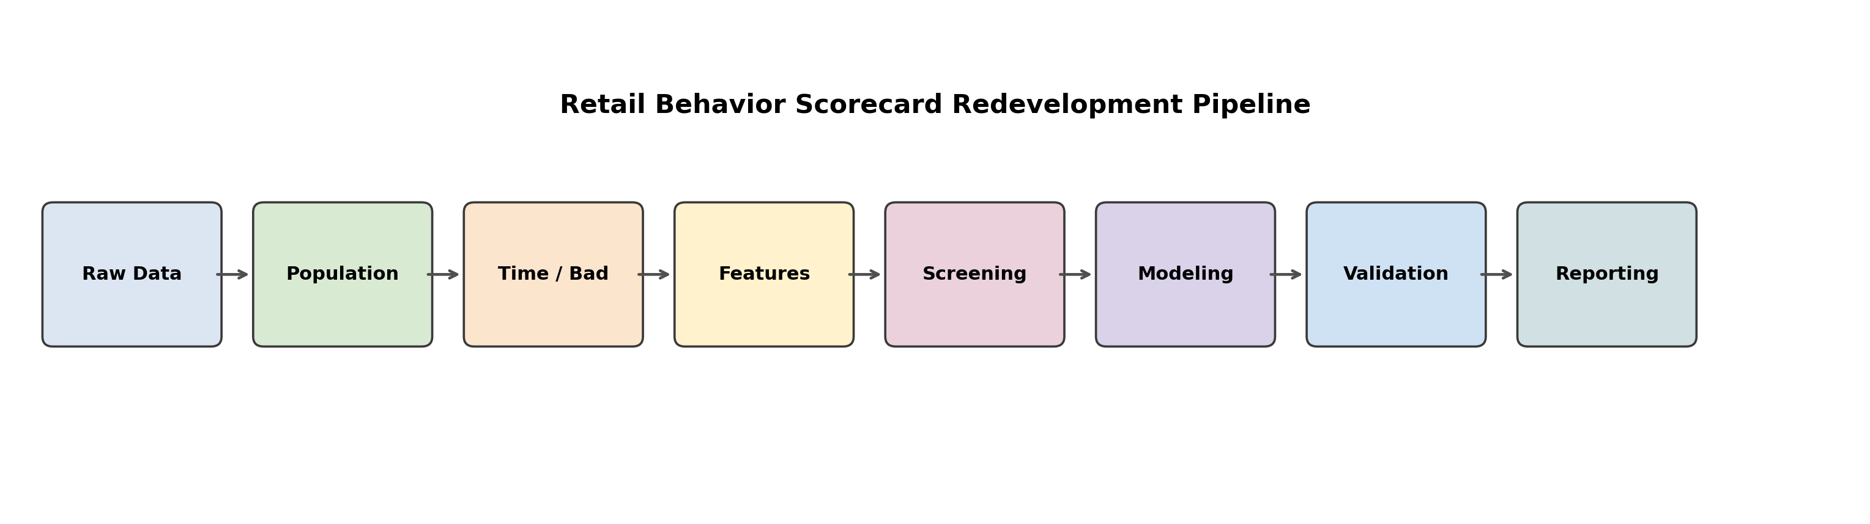
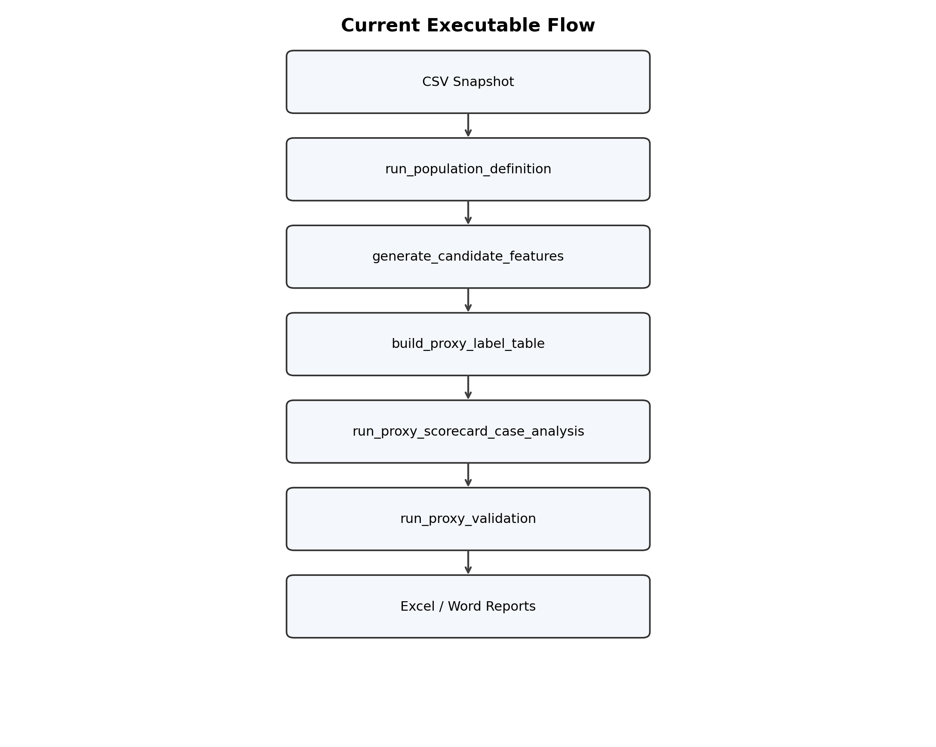

2. Time Structure And Split
The project follows a time-separated behavior scorecard design. Reference months are separated into validation_1, development, and validation_2_oot.
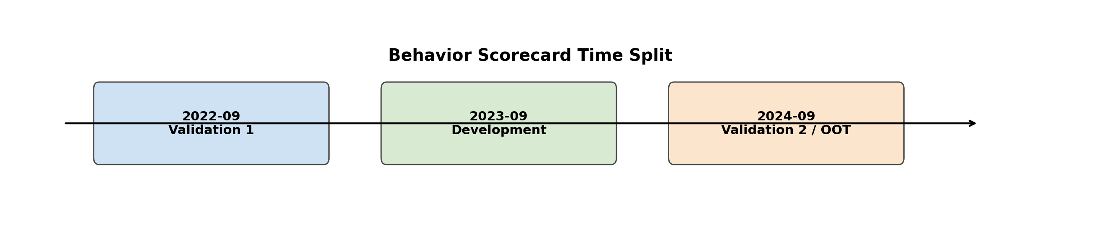

3. Population Definition
The development population is defined at the customer-month level with key `customer_id + reference_month`. The current implementation uses only the three approved reference months and applies a waterfall exclusion structure.
- reference month outside target scope
- non-retail exposure
- inactive account
- no valid credit card
- non-scoring product
- bad-at-observation-point customer
Population waterfall summary:
기준년월 | step_no | step_name | before_cnt | after_cnt | excluded_cnt | exclusion_rate | column_name | rule_description
202209 | 0 | reference_month_filter | 33242 | 33242 | 0 | 0.000000 | 기준년월 | keep in [202209, 202309, 202409]
202209 | 1 | retail_exposure | 33242 | 30044 | 3198 | 0.096204 | 소매카드익스포져여부 | keep (1,)
202209 | 2 | active_account | 30044 | 27774 | 2270 | 0.075556 | 활동계좌여부 | keep (1,)
202209 | 3 | valid_credit_card | 27774 | 27222 | 552 | 0.019875 | 유효신용카드여부 | keep (1,)
202209 | 4 | scoring_product | 27222 | 26169 | 1053 | 0.038682 | 평점비대상상품여부 | keep (0,)
202209 | 5 | good_at_observation | 26169 | 24755 | 1414 | 0.054033 | 현재연체여부 | keep (0,)
202309 | 0 | reference_month_filter | 31422 | 31422 | 0 | 0.000000 | 기준년월 | keep in [202209, 202309, 202409]
202309 | 1 | retail_exposure | 31422 | 28453 | 2969 | 0.094488 | 소매카드익스포져여부 | keep (1,)
202309 | 2 | active_account | 28453 | 26222 | 2231 | 0.078410 | 활동계좌여부 | keep (1,)
202309 | 3 | valid_credit_card | 26222 | 25707 | 515 | 0.019640 | 유효신용카드여부 | keep (1,)
202309 | 4 | scoring_product | 25707 | 24630 | 1077 | 0.041895 | 평점비대상상품여부 | keep (0,)
202309 | 5 | good_at_observation | 24630 | 23330 | 1300 | 0.052781 | 현재연체여부 | keep (0,)
202409 | 0 | reference_month_filter | 32123 | 32123 | 0 | 0.000000 | 기준년월 | keep in [202209, 202309, 202409]
202409 | 1 | retail_exposure | 32123 | 29093 | 3030 | 0.094325 | 소매카드익스포져여부 | keep (1,)
202409 | 2 | active_account | 29093 | 26821 | 2272 | 0.078094 | 활동계좌여부 | keep (1,)
202409 | 3 | valid_credit_card | 26821 | 26304 | 517 | 0.019276 | 유효신용카드여부 | keep (1,)
202409 | 4 | scoring_product | 26304 | 25249 | 1055 | 0.040108 | 평점비대상상품여부 | keep (0,)
202409 | 5 | good_at_observation | 25249 | 23946 | 1303 | 0.051606 | 현재연체여부 | keep (0,)

4. Time Structure And Bad Definition
Observation windows are fixed at 1M, 3M, 6M, and 12M. The policy performance period is 12 months. The executable fallback still uses a proxy snapshot label, but the policy bad definition remains Basel-oriented.
reference_month | split_name | split_role
202209 | validation_1 | stability_and_discrimination_check
202309 | development | model_building
202409 | validation_2_oot | out_of_time_stability_check
Policy bad definition includes:
- internal delinquency >= 60 DPD
- external delinquency >= 60 DPD
- default, charge-off, or CB default registration
- borrower-level recognition across all eligible facilities
- optional indeterminate bucket for 10 to 59 DPD

5. Raw-Data-First Feature Engineering
All model features are designed to be derivable from raw variables only. This preserves lineage and leakage control.
Raw-to-feature mapping examples:
feature_family | raw_columns | example_features | leakage_control
salary_stability | 급여이체금액_M01~M12, 급여이체일자_M01~M12, 급여이체주거래여부_현재 | salary_transfer_months_12m, avg_salary_amt_6m, salary_gap_months_12m | use observation-window months only; exclude any post-reference payment traces
application_profile | 연령, 직업구분코드, 직위코드, 신청소득구분코드, 주거형태코드 | age_band, occupation_risk_group, housing_stability_flag | freeze as-of attributes at reference month; do not refresh from future applications
deposit_behavior | 총수신평잔_M01~M12, 요구불평잔_M01~M12, 유동성수신평잔_M01~M06 | avg_total_deposit_3m, demand_deposit_volatility_6m, liquidity_share_1m | derive only from balances observed on or before reference month
internal_delinquency_trend | 현재연체여부, 연체건수_12M, 연체일수_M01~M12, 내부카드연체건수_12M | max_internal_dpd_12m, delinquent_month_count_6m, recent_internal_delinquency_flag | exclude performance-window arrears and target-construction future states
enterprise_exposure | 기업신용공여기관수_3M/6M/12M, 기업신용공여잔액_현재, 대표자보증여신보유여부 | enterprise_exposure_flag, enterprise_balance_level, guaranteed_enterprise_loan_flag | treat as observation-point exposures only; no future restructuring/default outcomes
external_loan_burden | 타사대출건수_현재, 미상환대출총건수_현재, 미상환대출총잔액_현재, 신규대출발생기관수_12M | external_loan_count, nonbank_loan_balance, new_lender_count_12m | use snapshot or historical counts available at reference month only
card_usage_intensity | 총카드한도_현재, 총카드이용잔액_현재, 일시불이용률_M01~M06, 신판이용률_M01~M06, 카드론이용률_M01~M06 | current_card_utilization, purchase_util_avg_3m, card_loan_util_trend_6m | derive strictly from observation-window usage history
relationship_vintage | 거래개시일, 가입경과개월수, 카드보유개월수, 최초신용개설일, 최근신용개설일 | relationship_months, credit_vintage_months, recent_opening_flag_12m | calculate tenure relative to reference month; never use future openings
external_delinquency_risk | 외부연체건수_12M, 외부최장연체일수_12M, NICE단기연체60일이상발생여부_12M, CB채무불이행등재여부_12M | external_delinquency_count_12m, max_external_dpd_12m, cb_default_flag | use only delinquency history observable at reference month; do not inject future performance events
Candidate feature families:
feature_name | feature_group | pattern_type | raw_columns | formula | description
int_dq_days_max_12m | internal_delinquency | severity | 연체일수_M01~M12 | max(연체일수_M01..M12) | 12개월 내부 연체일수 최대값
int_dq_months_freq_12m | internal_delinquency | frequency | 연체일수_M01~M12 | count(연체일수_Mxx > 0) | 12개월 내부 연체 발생 월수
int_dq_amt_sum_6m | internal_delinquency | severity | 연체금액_M01~M06 | sum(연체금액_M01..M06) | 최근 6개월 내부 연체금액 합계
int_dq_recency_3m_flag | internal_delinquency | recency | 연체일수_M01~M03 | 1 if any(연체일수_M01..M03 > 0) else 0 | 최근 3개월 내부 연체 발생 여부
int_dq_trend_last3_vs_prev3 | internal_delinquency | trend | 연체일수_M01~M06 | avg(연체일수_M01..M03) - avg(연체일수_M04..M06) | 최근 3개월 대비 직전 3개월 내부 연체일수 추세
int_dq_volatility_6m | internal_delinquency | volatility | 연체일수_M01~M06 | std(연체일수_M01..M06) | 최근 6개월 내부 연체일수 변동성
deposit_avg_total_bal_3m | deposit_performance | severity | 총수신평잔_M01~M03 | mean(총수신평잔_M01..M03) | 최근 3개월 총수신 평균잔액
deposit_avg_demand_bal_6m | deposit_performance | severity | 요구불평잔_M01~M06 | mean(요구불평잔_M01..M06) | 최근 6개월 요구불 평균잔액
deposit_trend_total_bal_3m_vs_6m | deposit_performance | trend | 총수신평잔_M01~M06 | mean(M01..M03) / (mean(M04..M06)+1) - 1 | 최근 3개월과 직전 3개월 총수신 평균잔액 변화율
deposit_volatility_total_bal_6m | deposit_performance | volatility | 총수신평잔_M01~M06 | std(총수신평잔_M01..M06) | 최근 6개월 총수신 잔액 변동성
deposit_liquidity_share_3m | deposit_performance | severity | 유동성수신평잔_M01~M03, 경험총수신평잔_M01~M03 | sum(유동성수신평잔_M01..M03) / (sum(경험총수신평잔_M01..M03)+1) | 최근 3개월 유동성수신 비중
salary_transfer_freq_12m | salary_transfer | frequency | 급여이체금액_M01~M12 | count(급여이체금액_Mxx > 0) | 12개월 급여이체 발생 월수
salary_transfer_avg_amt_6m | salary_transfer | severity | 급여이체금액_M01~M06 | mean(nonzero 급여이체금액_M01..M06) | 최근 6개월 급여이체 평균금액
salary_transfer_recency_3m_flag | salary_transfer | recency | 급여이체금액_M01~M03 | 1 if any(급여이체금액_M01..M03 > 0) else 0 | 최근 3개월 급여이체 발생 여부
salary_transfer_volatility_6m | salary_transfer | volatility | 급여이체금액_M01~M06 | std(급여이체금액_M01..M06) | 최근 6개월 급여이체 금액 변동성
salary_transfer_trend_3m_vs_6m | salary_transfer | trend | 급여이체금액_M01~M06 | mean(M01..M03) / (mean(M04..M06)+1) - 1 | 최근 3개월 대비 직전 3개월 급여이체 추세
cb_card_util_curr | cb_card_usage | severity | 총카드이용잔액_현재, 총카드한도_현재 | 총카드이용잔액_현재 / (총카드한도_현재 + 1) | 관측시점 총카드 사용률
cb_purchase_util_avg_3m | cb_card_usage | severity | 신판이용률_M01~M03 | mean(신판이용률_M01..M03) | 최근 3개월 신판 이용률 평균
cb_cash_service_freq_6m | cb_card_usage | frequency | 현금서비스20만원이상이용여부_M01~M06 | sum(현금서비스20만원이상이용여부_M01..M06) | 최근 6개월 고액 현금서비스 이용 횟수
cb_card_loan_util_trend_3m_vs_6m | cb_card_usage | trend | 카드론이용률_M01~M06 | mean(M01..M03) - mean(M04..M06) | 최근 3개월 대비 직전 3개월 카드론 이용률 추세
Displayed 20 rows out of 34.
Variable screening guidance:
step_no | step_name | purpose | output
1 | fine_classing | define initial bins with enough support and interpretable risk direction | fine classing table
2 | iv_screening | remove weak or unstable variables using IV thresholds and business review | IV-ranked shortlist
3 | correlation_filtering | group highly correlated variables and keep one representative per cluster | correlation clusters
4 | coarse_classing | collapse fine bins into stable WoE bins for modeling | final binning map

6. Scorecard Modeling
The modeling sequence uses development-only coarse classing, WoE transformation, case analysis, logistic regression, and governance-oriented diagnostic review.
Case comparison summary:
case_id | variable_count | aic | max_p_value | max_vif | sign_mismatch_count
C1 | 8 | 9763.023074 | 0.054499 | 1.019905 | 0
C2 | 9 | 9764.224032 | 0.370728 | 1.019969 | 0
C3 | 10 | 9752.197938 | 0.375631 | 1.295675 | 1
Selected provisional best-case features:
feature_name
int_dq_days_max_12m
int_dq_recency_3m_flag
deposit_liquidity_share_3m
salary_transfer_freq_12m
salary_transfer_avg_amt_6m
cb_purchase_util_avg_3m
cb_cash_service_freq_6m
ext_cb_default_flag
loan_exposure_nonbank_share
loan_new_lender_freq_12m
Coefficient diagnostics:
feature_name | coefficient | p_value
const | -2.725480 | 0.000000
int_dq_days_max_12m__woe | -0.928334 | 0.000000
deposit_liquidity_share_3m__woe | -1.106678 | 0.054499
salary_transfer_freq_12m__woe | -0.958772 | 0.000000
salary_transfer_avg_amt_6m__woe | -1.754992 | 0.033787
cb_purchase_util_avg_3m__woe | -0.673871 | 0.000000
cb_cash_service_freq_6m__woe | -0.953657 | 0.000000
loan_exposure_nonbank_share__woe | -0.943829 | 0.000000
loan_new_lender_freq_12m__woe | -0.890002 | 0.000000
Sign consistency review:
feature_name | raw_feature_name | coefficient | expected_sign | actual_sign | sign_match_flag
int_dq_days_max_12m__woe | int_dq_days_max_12m | -0.928334 | - | - | Y
deposit_liquidity_share_3m__woe | deposit_liquidity_share_3m | -1.106678 | - | - | Y
salary_transfer_freq_12m__woe | salary_transfer_freq_12m | -0.958772 | - | - | Y
salary_transfer_avg_amt_6m__woe | salary_transfer_avg_amt_6m | -1.754992 | - | - | Y
cb_purchase_util_avg_3m__woe | cb_purchase_util_avg_3m | -0.673871 | - | - | Y
cb_cash_service_freq_6m__woe | cb_cash_service_freq_6m | -0.953657 | - | - | Y
loan_exposure_nonbank_share__woe | loan_exposure_nonbank_share | -0.943829 | - | - | Y
loan_new_lender_freq_12m__woe | loan_new_lender_freq_12m | -0.890002 | - | - | Y

7. Validation Summary
Validation compares development, validation_1, and validation_2_oot using scorecard metrics. The interpretation is provisional because the current label is a snapshot proxy.
Metric summary:
period_name | sample_cnt | bad_cnt | good_cnt | bad_rate | psi | car_proxy | ks | roc | cap_proxy | sdr_proxy | cdr_proxy | ar
development | 23330 | 1467 | 21863 | 0.062880 | 0.000000 | 0.213528 | 0.362974 | 0.743437 | 0.743437 | 0.115710 | 0.213528 | 0.486875
validation1 | 24755 | 1514 | 23241 | 0.061159 | 0.001773 | 0.194531 | 0.339183 | 0.731374 | 0.731374 | 0.114107 | 0.194531 | 0.462748
validation2_oot | 23946 | 1443 | 22503 | 0.060261 | 0.000986 | 0.244938 | 0.354080 | 0.733373 | 0.733373 | 0.115718 | 0.244938 | 0.466746
Regulatory interpretability review:
feature_name | coefficient_x | p_value | raw_feature_name | coefficient_y | expected_sign | actual_sign | sign_match_flag | vif | regulatory_interpretability_flag
const | -2.725480 | 0.000000 |  |  |  |  |  |  | Y
int_dq_days_max_12m__woe | -0.928334 | 0.000000 | int_dq_days_max_12m | -0.928334 | - | - | Y | 1.016558 | Y
deposit_liquidity_share_3m__woe | -1.106678 | 0.054499 | deposit_liquidity_share_3m | -1.106678 | - | - | Y | 1.001614 | N
salary_transfer_freq_12m__woe | -0.958772 | 0.000000 | salary_transfer_freq_12m | -0.958772 | - | - | Y | 1.005948 | Y
salary_transfer_avg_amt_6m__woe | -1.754992 | 0.033787 | salary_transfer_avg_amt_6m | -1.754992 | - | - | Y | 1.003370 | Y
cb_purchase_util_avg_3m__woe | -0.673871 | 0.000000 | cb_purchase_util_avg_3m | -0.673871 | - | - | Y | 1.019905 | Y
cb_cash_service_freq_6m__woe | -0.953657 | 0.000000 | cb_cash_service_freq_6m | -0.953657 | - | - | Y | 1.002649 | Y
loan_exposure_nonbank_share__woe | -0.943829 | 0.000000 | loan_exposure_nonbank_share | -0.943829 | - | - | Y | 1.003985 | Y
loan_new_lender_freq_12m__woe | -0.890002 | 0.000000 | loan_new_lender_freq_12m | -0.890002 | - | - | Y | 1.004050 | Y
Model risk summary:
risk_topic | observation | mitigation
stability | PSI vs development: validation1=0.0018, validation2=0.0010 | monitor drift and replace proxy label with forward 12M real label before final approval
discrimination | AR/KS development=0.4869/0.3630, validation1=0.4627/0.3392, validation2=0.4667/0.3541 | re-run full validation with borrower-level forward performance data
interpretability | flagged coefficient rows=1 | review non-significant or unstable variables and refresh case selection if needed
label_validity | current validation uses proxy snapshot label, not Basel-style forward 12M bad flag | treat all current conclusions as provisional only

8. Provisional Score Table
The current points table is derived from the provisional best-case logistic model with PDO 40 and anchor score 500. It is a process demonstration artifact, not a final production scorecard.
feature_name | bin_cnt | total_cnt | bad_cnt | good_cnt | iv | min_points | max_points
cb_cash_service_freq_6m | 2 | 23330 | 1467 | 21863 | 0.158372 | -88.541343 | 5.486980
cb_purchase_util_avg_3m | 5 | 23330 | 1467 | 21863 | 0.088608 | -18.060145 | 15.530443
deposit_liquidity_share_3m | 5 | 23330 | 1467 | 21863 | 0.002375 | -4.197725 | 4.158019
int_dq_days_max_12m | 2 | 23330 | 1467 | 21863 | 0.240501 | -41.990319 | 16.771387
loan_exposure_nonbank_share | 5 | 23330 | 1467 | 21863 | 0.140474 | -28.043716 | 35.395774
loan_new_lender_freq_12m | 2 | 23330 | 1467 | 21863 | 0.105408 | -28.902446 | 9.705209
salary_transfer_avg_amt_6m | 5 | 23330 | 1467 | 21863 | 0.001165 | -3.483296 | 6.593868
salary_transfer_freq_12m | 4 | 23330 | 1467 | 21863 | 0.215627 | -25.745127 | 41.251752
Bin-level score table sample:
feature_name | bin | total_cnt | bad_cnt | good_cnt | woe | iv_component | coefficient | bin_points
deposit_liquidity_share_3m | (-0.001, 0.213] | 4666 | 312 | 4354 | -0.065729 | 0.000889 | -1.106678 | -4.197725
deposit_liquidity_share_3m | (0.213, 0.293] | 4666 | 281 | 4385 | 0.046014 | 0.000415 | -1.106678 | 2.938638
deposit_liquidity_share_3m | (0.293, 0.366] | 4666 | 276 | 4390 | 0.065107 | 0.000824 | -1.106678 | 4.158019
deposit_liquidity_share_3m | (0.366, 0.451] | 4666 | 295 | 4371 | -0.005804 | 0.000007 | -1.106678 | -0.370697
deposit_liquidity_share_3m | (0.451, 1.227] | 4666 | 303 | 4363 | -0.034394 | 0.000240 | -1.106678 | -2.196528
salary_transfer_freq_12m | (0.999, 7.0] | 8991 | 868 | 8123 | -0.465313 | 0.102435 | -0.958772 | -25.745127
salary_transfer_freq_12m | (7.0, 8.0] | 5382 | 259 | 5123 | 0.283091 | 0.016355 | -0.958772 | 15.663043
salary_transfer_freq_12m | (8.0, 9.0] | 4776 | 211 | 4565 | 0.372739 | 0.024217 | -0.958772 | 20.623155
salary_transfer_freq_12m | (9.0, 12.0] | 4181 | 129 | 4052 | 0.745577 | 0.072620 | -0.958772 | 41.251752
loan_new_lender_freq_12m | (-0.001, 1.0] | 18794 | 989 | 17805 | 0.188964 | 0.026497 | -0.890002 | 9.705209
loan_new_lender_freq_12m | (1.0, 7.0] | 4536 | 478 | 4058 | -0.562741 | 0.078910 | -0.890002 | -28.902446
cb_cash_service_freq_6m | (-0.001, 1.0] | 22653 | 1297 | 21356 | 0.099703 | 0.009242 | -0.953657 | 5.486980
cb_cash_service_freq_6m | (1.0, 4.0] | 677 | 170 | 507 | -1.608864 | 0.149130 | -0.953657 | -88.541343
int_dq_days_max_12m | (-0.001, 33.0] | 18709 | 875 | 17834 | 0.313062 | 0.068642 | -0.928334 | 16.771387
int_dq_days_max_12m | (33.0, 72.0] | 4621 | 592 | 4029 | -0.783809 | 0.171859 | -0.928334 | -41.990319
salary_transfer_avg_amt_6m | (-0.001, 1359283.347] | 4666 | 276 | 4390 | 0.065107 | 0.000824 | -1.754992 | 6.593868
salary_transfer_avg_amt_6m | (1359283.347, 1789512.733] | 4666 | 299 | 4367 | -0.020188 | 0.000082 | -1.754992 | -2.044598
salary_transfer_avg_amt_6m | (1789512.733, 2286686.7] | 4666 | 303 | 4363 | -0.034394 | 0.000240 | -1.754992 | -3.483296
salary_transfer_avg_amt_6m | (2286686.7, 3193824.533] | 4666 | 296 | 4370 | -0.009417 | 0.000018 | -1.754992 | -0.953761
salary_transfer_avg_amt_6m | (3193824.533, 35117721.0] | 4666 | 293 | 4373 | 0.001456 | 0.000000 | -1.754992 | 0.147432
loan_exposure_nonbank_share | (-0.001, 0.167] | 8669 | 364 | 8305 | 0.425883 | 0.056106 | -0.943829 | 23.196267
loan_exposure_nonbank_share | (0.167, 0.333] | 5212 | 359 | 4853 | -0.097546 | 0.002219 | -0.943829 | -5.312983
loan_exposure_nonbank_share | (0.333, 0.5] | 4823 | 390 | 4433 | -0.270891 | 0.017089 | -0.943829 | -14.754436
loan_exposure_nonbank_share | (0.5, 2.0] | 2942 | 297 | 2645 | -0.514882 | 0.041949 | -0.943829 | -28.043716
loan_exposure_nonbank_share | MISSING | 1684 | 57 | 1627 | 0.649866 | 0.023111 | -0.943829 | 35.395774
Displayed 25 rows out of 30.

9. Code Module Map
module | role
src/population_definition.py | development population and waterfall
src/time_structure.py | observation, performance, and split definitions
src/bad_definition.py | policy bad-definition logic
src/label_builder.py | proxy label fallback and label schema
src/base_dataset_schema.py | raw schema, domains, and raw-to-feature mapping
src/candidate_features.py | behavior feature generation from raw variables
src/variable_screening.py | fine classing, IV, correlation, representative selection
src/scorecard_modeling.py | WoE, logistic regression, case analysis, score table
src/scorecard_validation.py | provisional scorecard validation metrics
src/word_report.py | Word report and pipeline figure generation

10. Key Assumptions And Limitations
- The current executable label is a proxy snapshot label, not a forward 12M borrower-level bad flag.
- The current scorecard is therefore suitable for process demonstration, code review, and provisional analytics only.
- All feature engineering is intentionally raw-data-first and reference-month aligned.
- Development / validation / OOT separation is time-based, not random.
- The final regulatory package should be refreshed once real forward performance events become available.

