
ADDIS ABABA UNIVERSITY
College of Natural Sciences
Department of Computer Science
Knowledge Discovery from Free Text: Extraction of Violent Events
Binalfew Kassa Mekonnen
ID No: GSE/8274/12
A Thesis Submitted to the Department of Computer Science in Partial Fulfillment of the Requirements for the Degree of Master of Science in Computer Science
Addis Ababa, Ethiopia
May 2026

ADDIS ABABA UNIVERSITY
College of Natural Sciences
Department of Computer Science
Binalfew Kassa Mekonnen
Advisor: Fekade Getahun (PhD)
This is to certify that the thesis prepared by Binalfew Kassa Mekonnen, titled “Knowledge Discovery from Free Text: Extraction of Violent Events” and submitted in partial fulfillment of the requirements for the Degree of Master of Science in Computer Science complies with the regulations of the University and meets the accepted standards with respect to originality and quality.
Signed by the Examining Committee:
Name | Signature | Date
Advisor:
Examiner:
Examiner:

Abstract
Analysts at the African Union Continental Early Warning System read more news every day than they can turn into structured records; the backlog grows and situation awareness suffers. This thesis closes that gap with machine learning. The work delivers a fine-tuned BERT approach — referred to throughout this thesis as VioNER (Violent Event Named Entity Recognition) — that extracts 5W1H attributes — Who did What to Whom, Where, When, and How — from African news reports of violent events, and pairs each extraction with a knowledge base of known armed groups and conflict-affected cities. The schema comprises eight grounded entity types (ACTOR, VICTIM, ACTION, DATE, REGION, CITY, DISTRICT, CASUALTIES) in Beginning-Inside-Outside (BIO) format. Extracted events are classified against a four-level taxonomy of approximately ninety-five terminal categories, synthesised from ACLED, UCDP, and PMVE with African-specific extensions. The model was trained on a fifty-thousand-example corpus derived from ACLED notes, with stratified diversity sampling and template augmentation counteracting the dominance of the O label (seventy-eight percent of all tokens). The objective was focal loss with inverse-frequency class weights. On held-out validation the model reaches macro F1 0.887 and micro F1 0.909, converging in two epochs; focal loss with weighting lifts VICTIM, the rarest entity, by eleven F1 points over plain cross entropy. The trained model is served behind a FastAPI service with a PostgreSQL event store, the curated knowledge base, and a React front-end for training, inference, event management, and analytics. The result is a system an analyst can drive without writing code, and that substantially reduces the time between an event appearing in the news and a structured record reaching the analyst’s desk.
Keywords: Named Entity Recognition, BERT, Event Extraction, Violent Events, African Conflicts, 5W1H, Focal Loss

Dedication
To my family, for their unwavering encouragement throughout this research, and to the analysts whose patient reading of conflict reports inspired the work that follows.

Acknowledgements
I am deeply indebted to my advisor, Dr. Fekade Getahun, for his guidance, critical reading, and steady encouragement throughout this research. His insistence on rigour and operational relevance shaped every chapter of this thesis.
I am grateful to the staff of the Addis Ababa University Department of Computer Science for their support during the programme, and to the African Union Continental Early Warning System (AU-CEWS) for articulating the operational requirements that motivated this work. I also thank the Armed Conflict Location and Event Data Project (ACLED) for maintaining the open dataset on which this study relies.
I acknowledge the prior thesis work of Taye Abdulkadir, whose exploration of 5W extraction in the African context provided a foundation that this research extends.
Finally, I thank my family and friends for their patience and support during the long months of training, debugging, and writing.

Table of Contents
Abstract i
Dedication i
Acknowledgements i
Table of Contents iii
List of Tables vii
List of Figures viii
List of Algorithms ix
Acronyms and Abbreviations x
1. Introduction 1
1.1 Background 1
1.2 Motivation 2
1.3 Statement of the Problem 4
1.3.1 Research Questions 4
1.3.2 Significance of the Study 5
1.4 Objectives 5
1.4.1 General Objective 5
1.4.2 Specific Objectives 5
1.5 Methods 6
1.6 Scope and Limitations 7
1.6.1 In Scope 7
1.6.2 Out of Scope 8
1.6.3 Limitations 8
1.7 Application of Results 9
1.8 Organization of the Rest of the Thesis 9
2. Literature Review 11
2.1 Information Extraction and Event Extraction 11
2.2 Named Entity Recognition 12
2.3 Transformer Models and BERT 13
2.4 Class Imbalance in Token Classification 14
2.5 Evaluation Metrics for Named Entity Recognition 15
2.6 Conflict Event Databases and Coding Schemes 16
2.7 Knowledge Bases and Ontologies for Events 17
3. Related Work 18
3.1 General Event Extraction from News 18
3.2 Violence-Specific Event Extraction Systems 19
3.3 Event Extraction in the African Context 19
3.4 Hierarchical Event Classification 20
3.5 Summary of Gaps Addressed 20
4. The Proposed Solution 23
4.1 Design Principles 23
4.2 System Architecture 24
4.3 Entity Schema and BIO Encoding 25
4.4 Hierarchical Violent Event Taxonomy 27
4.5 Knowledge Base Design 30
4.6 Training Pipeline 31
4.6.1 Preprocessing 31
4.6.2 Stratified Diversity Sampling 31
4.6.3 Augmentation 31
4.6.4 Sub-word Label Alignment 31
4.6.5 Training Hyperparameters 32
4.6.6 Focal Loss with Class Weighting 33
4.6.7 Checkpointing and Early Stopping 34
4.7 Inference and Post-Processing 34
4.8 Web Application Architecture 35
5. Implementation 37
5.1 Technology Stack 37
5.2 Data Acquisition and Preprocessing 38
5.3 Stratified Sampling and Augmentation 39
5.4 Model Training Implementation 40
5.5 Focal Loss and Class Weighting 40
5.6 Backend Services and API 41
5.7 Frontend Application 42
5.8 Containerised Deployment 43
6. Experimentation and Results 44
6.1 Experimental Setup 44
6.2 Dataset Statistics 44
6.3 Training Dynamics 46
6.4 Overall Model Performance 48
6.5 Per-Entity Analysis 48
6.6 Ablation: Focal Loss versus Cross Entropy 49
6.7 Knowledge-Base Validation Impact 50
6.8 Inference Latency and Throughput 51
6.9 End-to-End Demonstration 51
6.10 User Acceptance Testing 52
6.11 Error Analysis 53
6.12 Discussion 54
6.13 Threats to Validity 55
7. Conclusions, Recommendations, and Future Work 57
7.1 Summary 57
7.2 Answers to the Research Questions 58
7.2.1 Research Question 1 58
7.2.2 Research Question 2 58
7.2.3 Research Question 3 58
7.2.4 Research Question 4 58
7.3 Contributions 59
7.4 Recommendations 59
7.5 Future Work 60
7.5.1 High Priority 60
7.5.2 Medium Priority 61
7.5.3 Lower Priority 61
References 62
Annex A: Entity Annotation Guidelines (Summary) 65
A.1 ACTOR (WHO) 65
A.2 VICTIM (WHOM) 65
A.3 ACTION (WHAT) 65
A.4 DATE (WHEN) 65
A.5 REGION / CITY / DISTRICT (WHERE) 65
A.6 CASUALTIES (HOW) 66
Annex B: Hierarchical Taxonomy of African Violent Events 67
B.1 Classification Decision Rules 69
Annex C: Knowledge Base Entries (Excerpt) 71
C.1 East Africa 71
C.2 West Africa 71
C.3 North Africa 71
C.4 Sahel and Elsewhere 72
C.5 Conflict-Affected Cities (Excerpt) 72
Annex D: System Screenshots 73
D.10 Database Schema (PostgreSQL) 73
Annex E: Sample Augmentation Templates 76
E.1 Verb Lexicons 76
E.2 Template Patterns 76
E.3 Date Forms 77
Annex F: User Acceptance Testing Questionnaire 78
F.1 Demographic Information 78
F.2 Tasks 78
F.3 Likert-Scale Evaluation 78
F.4 Open-Ended Questions 78
Signed Declaration Sheet 80

List of Tables
Table | Title | Page
3.1 | Comparative position of VioNER relative to prior systems | 34
4.1 | Eight-entity grounded schema for the VioNER NER component | 43
4.2 | Level 1 categories of the hierarchical taxonomy | 46
4.3 | Level 2 intermediate violence types | 46
4.4 | Knowledge base content summary | 49
4.5 | Training hyperparameters | 52
5.1 | Back-end technology stack | 59
5.2 | Front-end technology stack | 60
6.1 | Hardware and software configuration | 75
6.2 | Pre-processed dataset statistics | 76
6.3 | Entity-level frequency in the full pre-processed corpus | 76
6.4 | Inverse-frequency class weights used in the focal-loss objective | 77
6.5 | Per-epoch training dynamics | 78
6.6 | Best validation metrics across training runs | 81
6.7 | Per-entity precision, recall and F1 | 82
6.8 | Focal-loss ablation | 84
6.9 | Inference latency on representative articles | 86
6.10 | Aggregated user acceptance testing responses | 88

List of Figures
Figure | Title | Page
4.1 | High-level architecture of the VioNER system | 40
4.2 | End-to-end processing pipeline | 41
4.3 | Sequence of calls during synchronous inference | 42
4.4 | BIO encoding example for a multi-word entity | 44
4.5 | Generic structure of the hierarchical taxonomy (node and edge definition) | 46
4.6 | Four-level taxonomy hierarchy (Levels 1–3) | 47
5.1 | Back-end module organisation | 70
5.2 | Front-end route map | 72
6.1 | Training and validation loss curves | 78
6.2 | Token-level validation accuracy across epochs | 79
6.3 | Per-entity F1 bar chart | 82
6.4 | Confusion patterns between location entity types | 90

List of Algorithms
Algorithm | Title | Page
4.1 | Sub-word label alignment for BIO tagging | 50
4.2 | Stratified diversity sampling for entity coverage | 61
4.3 | Template-based augmentation | 62
4.4 | Focal loss with inverse-frequency weighting | 53
4.5 | Post-NER 5W1H structuring with knowledge-base validation | 55

Acronyms and Abbreviations
Acronym | Expanded form
5W1H | Who, What, Where, When, Whom, How
ACLED | Armed Conflict Location and Event Data Project
ADF | Allied Democratic Forces
API | Application Programming Interface
AQIM | Al-Qaeda in the Islamic Maghreb
AU | African Union
AU-CEWS | African Union Continental Early Warning System
BERT | Bidirectional Encoder Representations from Transformers
BIO | Beginning, Inside, Outside (tagging scheme)
CAMEO | Conflict and Mediation Event Observations
CAR | Central African Republic
CRF | Conditional Random Field
CUDA | Compute Unified Device Architecture
DRC | Democratic Republic of the Congo
ECOWAS | Economic Community of West African States
F1 | Harmonic mean of precision and recall
FARDC | Forces Armées de la République Démocratique du Congo
GDELT | Global Database of Events, Language, and Tone
IED | Improvised Explosive Device
IGAD | Intergovernmental Authority on Development
JNIM | Jama’at Nasr al-Islam wal Muslimin
JWT | JSON Web Token
KB | Knowledge Base
LRA | Lord’s Resistance Army
LSTM | Long Short-Term Memory
ML | Machine Learning
MPS | Metal Performance Shaders
NER | Named Entity Recognition
NEXUS | News cluster Event eXtraction Utilizing language Structures
NLP | Natural Language Processing
NOEM | News Ontology Event Model
OWL | Web Ontology Language
PMVE | Politically Motivated Violent Events (ontology)
PoS | Part of Speech
RDF | Resource Description Framework
REC | Regional Economic Community
REST | Representational State Transfer
RoBERTa | Robustly Optimised BERT Approach
RSF | Rapid Support Forces
SPARQL | SPARQL Protocol and RDF Query Language
SQL | Structured Query Language
SVBIED | Suicide Vehicle-Borne Improvised Explosive Device
UCDP | Uppsala Conflict Data Program
UI | User Interface
VBIED | Vehicle-Borne Improvised Explosive Device
VioNER | Violent Event Named Entity Recognition (this work)

1. Introduction
The research problem addressed by this thesis sits at the intersection of three pressures: a flood of African violent-event reporting in unstructured news text, an analyst workforce that cannot read it fast enough, and an early-warning operational requirement that depends on the timely conversion of that text into structured records. The sections that follow lay out the background, motivation, problem statement, objectives, and methods that frame the rest of the work, and close with a roadmap to the remaining chapters.

1.1 Background
The volume of digital news content describing violent events on the African continent has grown faster than the human capacity to read, code, and act upon it. Reports of attacks, clashes, raids, bombings, displacement, and other forms of armed and political violence are disseminated through wire services, mainstream outlets, regional newspapers, and increasingly through online media [1]. The overwhelming majority of this content is unstructured natural-language text intended for human consumption rather than machine processing. Converting these narratives into structured, queryable representations is a prerequisite for systematic monitoring, statistical aggregation, and evidence-based decision making.
Natural Language Processing (NLP) is the half-century-old discipline that attempts to make computers do useful things with human language, and the toolbox it has developed — part-of-speech tagging, syntactic parsing, named entity recognition, coreference resolution [2] — is exactly what an early-warning analyst performs implicitly when reading a news article. Information Extraction (IE) is the specific sub-discipline that seeks to mechanise that work: take prose in, produce structured records out. Event Extraction, in turn, narrows IE to events — verbs, nominalised actions, and their participants — and asks the model to recover who did what to whom, where, when, and how, from text alone [3], [4].
The 5W1H frame adopted in this thesis is not new. Journalism schools have taught it for over a century, and analysts in early-warning centres read for those slots whether or not they explicitly name them. The attractive property for an automated system is that 5W1H decouples what to extract from which event types exist: even before any taxonomic question is settled, an extractor can populate a 5W1H record that downstream analytics can later classify.
The technical opportunity is recent. The transformer architecture of Vaswani and colleagues [5] and the line of pre-trained language models built on it — most prominently BERT [6] — narrowed the gap between research prototypes and operational NLP systems for token-level tasks by an order of magnitude in five years [7]. The combination of large-scale self-supervised pre-training with small-scale task-specific fine-tuning is what makes a 50,000-example domain corpus a workable input for a competitive NER model, where a decade earlier it would not have been.
Within the specific domain of conflict and violence monitoring, several long-running data-collection efforts have constructed structured event databases by human coding. The Armed Conflict Location and Event Data Project (ACLED) is the most influential of these for the African context, providing georeferenced records of political violence and protest events with detailed actor, location, and fatality information [8]. The Uppsala Conflict Data Program (UCDP) [9] and the Global Database of Events, Language, and Tone (GDELT) [10] play complementary roles. While these initiatives have demonstrated the value of structured event data, the underlying collection processes remain heavily manual or rely on coarse-grained automation that may miss nuance or African-specific patterns.
The African Union Continental Early Warning System (AU-CEWS) operates within this landscape as a continental mechanism for monitoring conflict and crisis dynamics across the African Union member states. AU-CEWS aggregates news content through its Africa Media Monitor tool and draws on it for situation analysis, briefings, and early-warning products. The transformation of monitored content into structured, analysable form remains, however, the limiting factor on the system’s throughput.
This thesis sits at the intersection of these strands. It uses a fine-tuned BERT model as the core of a 5W1H extraction pipeline; it targets African conflict reporting in particular; and it organises the outputs around a knowledge base of African armed groups, locations, and a hierarchical taxonomy of violent events. The remainder of this chapter motivates the work in greater detail and states the specific objectives that it pursues.

1.2 Motivation
A typical morning at the AU-CEWS Situation Monitoring Centre starts with a queue. Africa Media Monitor, the centre’s news-aggregation tool, will have pulled in between two and four hundred items overnight for any given regional desk. Most are noise — sports results, market reports, press releases. Perhaps fifteen to forty describe something violent: an attack, a clash, a raid, an arrest that turned lethal. Those are the items the analyst must read carefully, and turn into a structured record — who, what, where, when, whom, how — that an early-warning briefing can use.
By mid-morning, on a good day, the analyst is perhaps a quarter through. By close of business the residue rolls over into the next day’s queue. Multiplied across regions, analysts, and the working year, the binding constraint on continental situation awareness becomes clear. It is not the sophistication of any analytical model that matters. It is the throughput of one human reading one article at a time.
Working in this environment, and drawing on the centre’s own internal documentation of its data-collection and analysis tools [38], two distinct problems can be seen hiding behind the same backlog.
The first is the obvious one: a throughput gap. The volume of news human analysts can absorb in a working day is a fraction of the daily inflow, and even at full attention the cognitive load of reading and coding violent incidents is severe — it is not possible to stay sharp on the eighth massacre report of the morning.
The second is more insidious: a consistency gap. Two analysts coding the same article will sometimes diverge on the basic questions. Was this “violence against civilians” or “battle”? Is that a city or a district? Should this fatality count be attributed to the named perpetrator or marked “unknown”? Individually these are small judgements. Aggregated across hundreds of records a week, they make trend analysis unreliable — was the spike real, or did the new shift simply code things differently?
The two gaps interact. Closing the throughput gap by hiring more analysts can widen the consistency gap; closing the consistency gap by writing tighter coding rules slows everyone down and widens the throughput gap. A machine-learning system that produces consistent structured records from a larger share of the inflow is attractive because it pushes on both gaps at once.
Three further observations shaped the technical choices in this thesis. The first is that African conflict reporting features actor names, place names, and ethnic-group references that off-the-shelf NLP models trained on European or North American corpora do not handle well. Boko Haram, JNIM, the M23, the Allied Democratic Forces, Fano, Anti-Balaka — these are not entities that mBERT learnt about during pre-training, and generic NER models routinely break on them or assimilate them to whatever PERSON or ORG entry they can find [11]. Fine-tuning a domain model on annotated African conflict text closes that gap substantially.
The second is that the class distribution is severely skewed. In the corpus assembled in Chapter 5, roughly seventy-eight percent of all tokens carry the outside (O) label. Of the remaining twenty-two percent that are entity tokens, the rarest entity types — VICTIM and CASUALTIES, the ones the analyst cares about most — make up only two percent each. A vanilla cross-entropy fine-tune on this distribution will quietly under-recover the rare classes while reporting deceptively high overall accuracy. Focal loss [12] with inverse-frequency class weighting is the standard counter, and Section 6.6 demonstrates that it lifts VICTIM by eleven F1 points over plain cross entropy in this setting.
The third is more architectural. An extraction system that produces records analysts cannot trust adds load rather than relieving it. The minimum bar is that the output be auditable: an analyst opening an extracted record must be able to see which text the model based each entity on, how confident the model was, and whether the extracted actor or location matches a known real-world referent. A curated knowledge base of African armed groups, conflict-affected cities, and weapon categories, run alongside the model, provides that audit trail. It also catches plausible-sounding nonsense (M23 attacking Maiduguri, RSF operating in Mozambique) before it reaches a human reviewer.
The shape of the thesis follows from all this. Academically, it contributes a fine-tuned BERT model and an annotated dataset for African violent-event NER, together with a four-level taxonomy designed for the African context. Practically, it delivers a web application that exposes training, inference, event management, and analytics through a single interface, so that an analyst who has never run a Python script can still use it.

1.3 Statement of the Problem
The central problem addressed in this thesis is the absence, in the African early-warning ecosystem, of an accurate and openly documented pipeline for converting English-language news reports of violent events into structured 5W1H records suitable for downstream analysis. The problem decomposes into three sub-problems.
The first sub-problem is domain-specific entity recognition. Generic NER models trained on European or North American news corpora do not consistently recognise the actors, places, and casualty descriptions that characterise African conflict reporting. Boko Haram, JNIM, the Allied Democratic Forces, Fano, Anti-Balaka, the Rapid Support Forces — these are not entities a generic model has seen during pre-training, and the closest matches it can find in its vocabulary are usually wrong. Off-the-shelf models also do not distinguish the actor, victim, action, and casualty roles that an operational analyst actually uses. The implication is a model fine-tuned on annotated African conflict text, supported by a grounded annotation schema that captures the operationally relevant entity types and excludes those that cannot be reliably grounded.
The second is severe class imbalance. In the annotated corpus, roughly seventy-eight percent of all tokens carry the outside (O) label. Of the remaining twenty-two percent that are actual entities, ACTOR, CITY, DATE, REGION, and DISTRICT account for the bulk; VICTIM, ACTION, and CASUALTIES — the entities an analyst cares about most operationally — make up only single digits each. A naive cross-entropy fine-tune on this distribution reports deceptively high overall accuracy while quietly under-recovering exactly the rare classes that matter. The implication is a loss function and sampling strategy that compensate explicitly for the imbalance.
The third is operational packaging. A trained model on its own is not an operational capability. To be useful, the model must be exposed through a documented API, paired with a curated knowledge base, embedded in a workflow that supports article ingestion, event storage, and analytics, and operable by users who are not machine-learning specialists. Most prior academic work on event extraction in the African context stops at the model boundary — the model is published, the operational layer is not. This thesis treats operational packaging as a first-class research output, not as an implementation footnote.

1.3.1 Research Questions
The three sub-problems above are pursued through the following research questions.
- Which entity types in African violent-event news reports can be reliably grounded in source text, and what is an appropriate BIO schema for fine-tuning a BERT model on those entities?
- How effectively can a fine-tuned BERT model recognise the chosen entities, and what loss function and sampling strategy produce the most balanced per-entity performance under severe class imbalance?
- To what extent does a curated knowledge base of African armed groups, conflict locations, and a hierarchical taxonomy improve the trustworthiness and downstream utility of the extracted records?
- What system architecture allows the model, the knowledge base, and the analytics layer to be operated together by users without machine-learning expertise?

1.3.2 Significance of the Study
The most direct significance is operational. Analyst time at AU-CEWS is, as Section 1.2 argued, the binding constraint on continental situation awareness during fast-moving crises; even a partial reduction in the cost of producing a structured event record translates almost one-to-one into faster, broader, and more consistent monitoring. That is the case for building VioNER at all.
The methodological contribution is the combination, rather than any single ingredient. Grounded supervision, focal loss with class weighting, and a curated domain knowledge base used both for validation and enrichment have each been studied in isolation; to the best of current knowledge they have not been combined and reported together on African violent-event extraction at this scale. The methodology is documented in detail through Chapters 4 and 5 so that it can be reproduced or adapted.
Finally, the artefacts themselves have a life beyond this thesis. The four-level taxonomy, the eight-entity annotation schema, and the curated knowledge base of African armed groups and conflict-affected cities are reusable; another researcher working on humanitarian protection, conflict early warning, or peace and security analysis should be able to adopt any of them without rebuilding from scratch.

1.4 Objectives

1.4.1 General Objective
The general objective of this research is to design, implement, and evaluate VioNER, an integrated system that extracts 5W1H attributes of violent events from African English-language news reports through fine-tuned BERT-based named entity recognition, supports those extractions with a curated knowledge base and hierarchical taxonomy, and exposes the full capability through a documented web platform.

1.4.2 Specific Objectives
Translating the general objective into concrete deliverables, the work breaks down as follows.
- Survey the literature on information extraction, event extraction, named entity recognition, and transformer-based language models, alongside the conflict-event-coding tradition, and locate the present work against both bodies of work.
- Settle on a BIO schema of eight entities — ACTOR, VICTIM, ACTION, DATE, REGION, CITY, DISTRICT, CASUALTIES — chosen for how reliably each can be grounded in the source text rather than for theoretical neatness. Each entity carries explicit inclusion and exclusion rules.
- Build a four-level taxonomy of violent events that fits African conflict patterns, with roughly ninety-five terminal categories. Where two categories overlap, the taxonomy carries an explicit decision rule rather than leaving the choice to the annotator’s intuition.
- Assemble the training corpus: around fifty thousand examples drawn from ACLED event descriptions, in two stages — stratified diversity sampling first, then template-based augmentation to plug vocabulary gaps and lift the rare classes off the floor.
- Build the training pipeline: a bert-base-cased fine-tune driven by focal loss with inverse-frequency class weighting, gradient clipping, a warmup-plus-plateau learning-rate schedule, and early stopping on validation loss.
- Curate the knowledge base — African armed groups, conflict cities and regions, weapon types, and the four-level taxonomy itself — and wire it into the pipeline as a validation layer that sits on top of the raw NER output rather than inside the model.
- Stand up the back-end: a FastAPI service exposing the trained model and the KB through routes covering training management, inference, event storage, analytics, and KB administration.
- Stand up the front-end: a React application that lets a non-expert user fine-tune models, run inference on documents, browse stored events, and read the analytics views, without needing to know what a checkpoint is.
- Evaluate end to end. The held-out validation split gives the headline metrics; a handful of real-world articles give the qualitative check; the user-acceptance test gives the third perspective. All three are reported.
- Acknowledge what the current implementation cannot do, and lay out a concrete future-work programme — including learned hierarchical classification at inference time and natural-language question answering against the event store.

1.5 Methods
The methodological frame is design science [13]: build the artefact iteratively, evaluate it empirically at each stage, let the lessons of one iteration shape the next, and control for over-fitting throughout with held-out data. The plan is set out in prose below; Chapters 4 and 5 give the technical detail.
The work begins with the annotation schema. The starting point is the twenty-six-type schema in the proposal, refined through a pilot study in which a sample of articles is annotated by hand to measure the proportion of each entity type that can be located verbatim in source text. Entity types whose grounding rate falls below an acceptable threshold are dropped from the NER schema and recovered downstream by post-processing — concretely, EVENT_TYPE is reconstructed by the taxonomy classifier from the action verb plus context, and COUNTRY by a knowledge-base look-up from the most specific WHERE entity. The result is a narrower schema in which every entity type can be reliably supervised.
The training corpus comes from the ACLED open-data export. Records are tokenised, BIO-labelled by projecting the structured ACLED columns onto the free-text notes, and reduced from the full 212,000-event pool to a smaller, more diverse subset by stratified sampling that over-represents the rare entity types. Template-based augmentation adds roughly fifteen thousand synthetic examples to cover vocabulary that ACLED notes do not (active-voice action verbs, descriptive victim phrasings). The combined corpus is split eighty / twenty into training and validation, with stratification on entity-type presence.
The model itself is a fine-tuned bert-base-cased with a seventeen-label token-classification head, trained under AdamW with linear warm-up, ReduceLROnPlateau scheduling, gradient clipping, and focal loss with inverse-frequency class weights. Sub-word labels are aligned by carrying the first sub-word’s label to subsequent sub-words and explicitly handling the B- to I- transition.
A curated knowledge base of African armed groups, conflict-affected cities, and weapon categories is loaded at inference time and used for two purposes. First, validation: it confirms or flags extracted entities against curated reference data. Second, enrichment: it attaches canonical names, country of operation, and group type to matched entities. Mismatches between an actor’s known country of operation and the location extracted from the same sentence lower the event’s overall confidence score and surface it for analyst review.
The full system is packaged behind a FastAPI service, a PostgreSQL event store, and a React/TypeScript front-end covering training, inference, event management, and analytics. The whole stack runs under Docker Compose.
Finally, the system is evaluated against a held-out validation set with token-level accuracy and span-level precision, recall, and F1 per entity; against a small set of representative real-world news articles by qualitative inspection; and by user-acceptance testing with a small group of representative users. End-to-end inference latency is measured on the same hardware used for training.

1.6 Scope and Limitations

1.6.1 In Scope
The thesis addresses the extraction of 5W1H attributes from English-language news reports describing violent events in the African context. The delivered artefact comprises:
- A fine-tuned bert-base-cased model for token classification across the eight-entity BIO schema described above.
- A four-level hierarchical taxonomy of African violent events with approximately ninety-five terminal categories.
- A knowledge base of African armed groups, conflict-affected cities, and weapons.
- A FastAPI service exposing training, inference, event storage, analytics, and knowledge-base management.
- A React/TypeScript front-end allowing users to run training jobs, perform inference, manage events, and view analytics.
- A reproducible Docker-based deployment.

1.6.2 Out of Scope
The following are explicitly outside the scope of this thesis but are identified as priority future work in Chapter 7.
- Multilingual extraction. The model and pipeline target English text only. Arabic, French, Portuguese, Amharic, Swahili, and other African languages are out of scope.
- Real-time stream processing. Articles are processed on demand or in batch; the system does not target sub-second pipeline latency at scale.
- Predictive forecasting of future violence from extracted records.
- Automatic ingestion of news from third-party feeds. Articles are uploaded or submitted manually for inference.
- Natural-language question answering against the event store. Queries are formulated through structured filters in the analytics interface, not free-text questions.
- Hierarchical event classification by a learned classifier. The taxonomy is applied through deterministic post-NER rules informed by knowledge-base look-ups; a supervised hierarchical classifier is identified as future work.
- Production-grade hardening (high availability, multi-region replication, advanced authentication, audit logging) beyond a research prototype.

1.6.3 Limitations
The principal limitations of the work are the following.
- Data domain. The training data is dominated by ACLED-derived event descriptions, supplemented with template-based augmentation. ACLED descriptions are concise and follow distinctive stylistic conventions; full-length news articles may diverge in style and may require additional fine-tuning data.
- Synthetic augmentation. Approximately thirty percent of the training corpus is generated through templated augmentation. The templates were designed to mirror naturalistic constructions, but they remain narrower than the diversity of real reporting.
- English only. The system processes English text. A substantial share of African conflict reporting is in French, Arabic, Portuguese, and various African languages and is therefore not covered.
- Single-pass NER. The model performs flat NER over BIO labels. Nested entities and overlapping spans are not modelled.
- Post-NER taxonomy. Hierarchical taxonomic classification of each event is performed by rule-based post-processing using the knowledge base. A learned classifier would likely outperform the rule-based fallback for ambiguous events.
- Modest computational budget. Training is conducted on a single workstation with Apple Silicon GPU acceleration. Larger model variants such as bert-large-cased or specialised long-context models were evaluated but not used as the production model.

1.7 Application of Results
The primary intended user is the AU-CEWS analyst whose backlog this thesis set out to address. The same set of capabilities is useful, with little or no modification, to the regional economic communities running their own monitoring functions (ECOWAS, IGAD, SADC) and to national early-warning centres in member states. The taxonomy-aware analytics support queries at any level of the hierarchy — “all political violence in West Africa this quarter”, “suicide bombings attributed to JNIM in Mali in 2026”, “election violence in countries with elections in the past ninety days” — which is the kind of slicing that briefing-writers need on demand.
Beyond the early-warning case, the event store is structured around fields that humanitarian organisations care about (actor, victim, location, casualty count, displacement). An NGO doing protection analysis or needs assessment can run aggregations over the same data; the schema does not need to be redesigned to serve them.
Peace-support operations and national security services are a more sensitive case. Open-source extraction is not a substitute for classified intelligence and should not be presented as one. The useful framing is that VioNER lowers the cost of doing OSINT systematically — a junior analyst with VioNER on their workstation can do, in a morning, the volume of structured reading that a few years ago would have taken a small team. Whether that fits any particular service’s workflow is a question for them.
For academic researchers, the annotated dataset, the four-level taxonomy, and the extracted event corpus are the reusable artefacts. Conflict-studies quantitative work has historically been bottlenecked by hand-coded data; an open BERT-based extractor plus a curated knowledge base shifts where that bottleneck sits.
Finally, the open architecture and documented deployment are a modest capacity-building contribution. An African university or research centre with the means to run Docker and a GPU can deploy its own instance, fine-tune on its own annotated data, and adapt the taxonomy without starting from scratch.

1.8 Organization of the Rest of the Thesis
Two chapters cover the literature. Chapter 2 works through the relevant theory — information and event extraction, named entity recognition, transformers and BERT, class-imbalance methods, the conflict-event database tradition, and event-oriented knowledge representation — at a level sufficient to support the decisions that come in Chapter 4. Chapter 3 then narrows to the specific prior systems VioNER builds on or distinguishes itself from, ending with the gap analysis that motivates the rest of the work.
After that, two chapters cover the system itself. Chapter 4 lays out the design — the architecture, the entity schema, the hierarchical taxonomy, the knowledge base, the training pipeline, the inference pipeline, and the web application that ties them all together. Chapter 5 documents how each of those parts is actually built: technology stack, data preparation, training implementation, focal-loss code, back-end services, front-end, containerised deployment. Splitting what and why (Chapter 4) from how (Chapter 5) was a deliberate editorial decision — readers interested in the design without the implementation detail can stop after Chapter 4.
Evaluation comes next. Chapter 6 reports dataset statistics, training dynamics, overall and per-entity performance, the focal-loss ablation, the impact of the knowledge-base layer, latency measurements, end-to-end demonstration on real articles, user-acceptance feedback, and an error analysis. It closes with a discussion section, a threats-to-validity section, and a brief account of the experiments tried first and abandoned.
Finally, Chapter 7 concludes with a summary anchored back to the analyst queue of Section 1.2, explicit answers to the four research questions of Section 1.3, a contributions list, recommendations for organisations considering adoption, and a prioritised future-work programme that addresses the limitations of Section 1.6 and the threats of Section 6.13.

2. Literature Review
Five strands of literature inform this thesis: information and event extraction, named entity recognition, the transformer architecture and BERT, methods for handling severe class imbalance in token classification, and the conflict-event database tradition that frames the operational context. Each is summarised below, with a final section on knowledge-base and ontology approaches to event representation. Paper-by-paper reviews of the most directly related systems are deferred to Chapter 3.

2.1 Information Extraction and Event Extraction
Information Extraction (IE) [4] is a broad field. The umbrella covers any technique that pulls structured records out of unstructured text — named entity recognition, relation extraction, coreference resolution, event extraction. Textbook diagrams arrange these as a pipeline; in current research the lines blur, with joint and end-to-end models bundling two or more sub-tasks into a single neural network. This thesis takes the pipeline side, on the grounds that debuggability beats marginal accuracy at the scale at which the work operates. Section 4.2 makes that choice concrete.
Event extraction is the sub-task of central concern. Ahn’s definition [3] is the operational one adopted here: an event is a verb or nominal predicate together with the participants (agent, patient, instrument), the location, and the time the predicate involves. The Automatic Content Extraction program [14] formalised that view in the early 2000s by publishing a typology of event types and their arguments. Two decades of supervised event-extraction research grew out of that typology. The Text Analysis Conference Knowledge Base Population track later continued the line with larger, more diverse benchmarks.
The journalistic 5W1H frame [15] is a less rigid alternative. It sidesteps the question of which event types to enumerate by asking the same six questions — Who, What, Whom, Where, When, How — of every reported event. For news text this is a near-perfect fit: journalists are trained to answer those questions in roughly the first paragraph, and analysts read for exactly those slots. This thesis adopts 5W1H, leaves event-type classification to a post-NER step against the taxonomy in Section 4.4, and so avoids baking a fixed event-type inventory into the supervised learning problem itself.
Hogenboom and colleagues survey event extraction methods for decision support in two complementary papers [16], [4]. They identify three broad methodological families: data-driven (supervised machine learning on annotated corpora), knowledge-driven (linguistic and ontological rules), and hybrid approaches that combine the two. The hybrid family has dominated practical deployments because it allows domain knowledge to be encoded in rules where it is naturally expressible and statistical learning to be applied where rule authorship is intractable. The VioNER system presented in this thesis is hybrid in this sense: entity extraction is data-driven, while the post-NER 5W1H structuring, taxonomy classification, and knowledge-base validation are rule-driven.

2.2 Named Entity Recognition
For the purposes of this thesis, NER means deciding for every token in a sentence whether it belongs to an entity of interest and, if so, which one. The pre-deep-learning era handled this with a fairly fixed recipe: hand-engineered features (capitalisation, gazetteer hits, surrounding part-of-speech tags) fed into a sequence model capable of making one structured prediction over the whole sentence. Hidden Markov Models came first; Maximum Entropy Markov Models followed; Conditional Random Fields (CRFs) [17] eventually became the default. The reason CRFs came to dominate is structural — a CRF can express the fact that BIO labels constrain each other (a B- token cannot legally be followed by another B- of a different type, an I- needs a preceding B- of the same type), which a per-token classifier cannot encode at all.
Entities are encoded in BIO, the simplest of the standard schemes: a B- prefix on the first token of an entity, an I- prefix on each continuation token, and an O label everywhere else. For a schema with k entity types, BIO produces 2k + 1 labels — in this case, seventeen. Variants such as BIOES or BILOU add explicit single-token and final-token labels to give the decoder more structure to lean on. Plain BIO was chosen for two reasons: the entity types in Section 4.3 are short enough that the extra labels would mostly be redundant, and seqeval-style evaluation tooling supports plain BIO without configuration.
The first wave of neural NER systems leant on word embeddings fed through bi-directional Long Short-Term Memory (BiLSTM) networks [18], typically combined with a character-level convolutional or recurrent layer to handle out-of-vocabulary tokens, and a CRF head on top to keep the BIO transitions sane. The architecture of Lample and colleagues [19] became the recipe most replicated for several years, and it showed that learned representations could replace much of what the feature-engineering era had hand-crafted.
The next jump came from contextual representations — ELMo [20] and particularly BERT [6]. Once a transformer encoder had absorbed general-purpose language structure during pre-training, swapping out the classifier head and fine-tuning the encoder produced results that surpassed every BiLSTM-CRF system on the CoNLL-2003 benchmark, and the recipe has stayed roughly the same since: contextual encoder, linear classifier, optional CRF head, cross-entropy or focal loss. VioNER follows this recipe.
The property that matters most for a low-resource setting like the African violent-event domain is that a transformer encoder absorbs enough general English during pre-training that a comparatively small specialised corpus can fine-tune it to good per-entity performance. The 50,000-example corpus described in Chapter 5 would be far too small for a from-scratch BiLSTM-CRF; it is sufficient for a fine-tuned BERT precisely because of this transfer.
Recent work has pushed for African-language NER resources directly. The MasakhaNER benchmark of Adelani and colleagues [11] established annotations for ten African languages covering PERSON, ORGANISATION, LOCATION, and DATE; their headline finding is that generic multilingual encoders such as mBERT and XLM-RoBERTa underperform on African text relative to encoders that have seen African corpora during pre-training. AfroLM [40] and AfroXLMR continued this line. The target of this thesis is English-language reporting of African events rather than African-language reporting, so bert-base-cased is used, but the entity schema is strictly richer than MasakhaNER’s four types, and an African-pre-trained backbone is a natural future swap (Section 7.5).

2.3 Transformer Models and BERT
The transformer [5] removed the recurrent step that had constrained sequence models for years and put self-attention in its place: each position in the input gets to look directly at every other position, through learned query / key / value projections, and the cost of that look-up is paid in parallel rather than in sequence. The practical consequences matter more here than the mathematical novelty: training can be parallelised on a GPU, long-range dependencies — exactly the kind that link an actor at the start of a sentence to a casualty count at the end — survive the encoding intact, and the architecture scales gracefully with parameter count and data.
BERT [6] is, in essence, the encoder half of the original transformer repurposed as a representation learner. The pre-training objective is self-supervised by design — a random 15 percent of the input is masked, the model has to recover the masked tokens from surrounding context, and a secondary next-sentence-prediction task runs in parallel over sentence pairs. Once that pre-training has happened, the encoder has absorbed enough of the structure of general English that a small task-specific head can be attached and fine-tuned on tens of thousands of examples rather than the millions a from-scratch model would need.
The token-classification recipe is straightforward. BERT outputs a contextual vector for each WordPiece token; a linear layer over each vector produces logits across the seventeen-label space; focal loss with class weights (Section 2.4) is backpropagated through the whole stack. The checkpoint fine-tuned here is bert-base-cased — twelve transformer layers, 768-dimensional hidden states, roughly 110 million parameters. The cased variant matters: English conflict reporting leans heavily on capitalisation to mark ACTOR mentions and place names (“Boko Haram”, “North Kivu”, “Al-Shabaab”), and the uncased variant simply discards that signal.
Two further properties of BERT influence the design of the present system. First, BERT uses WordPiece sub-word tokenisation; a single gold-labelled word may be split into multiple sub-word tokens, and the labels must be projected onto sub-words for training and recovered from sub-words at inference time. The convention adopted in this work, described in detail in Chapter 4, is to assign the original label to the first sub-word and to convert any leading B- prefix to I- for subsequent sub-words, while assigning -100 to special tokens so that they are ignored by the loss. Second, BERT has a maximum input length of 512 tokens; longer documents must be split into overlapping windows. This thesis processes ACLED event descriptions and most news-article paragraphs without exceeding this limit, but window-based handling is implemented for completeness.
Several BERT variants and successors have been proposed. RoBERTa [21] improves on BERT by removing the next-sentence-prediction objective, training longer with larger batches, and using dynamic masking. DistilBERT [22] applies knowledge distillation to produce a smaller and faster model with modest accuracy loss. XLM-RoBERTa [23] extends the multilingual setting with strong performance on non-English text. The present work fine-tunes the canonical bert-base-cased because of the balance it strikes between accuracy and resource requirements; alternative backbones are evaluated as part of the ablation discussion in Chapter 6.

2.4 Class Imbalance in Token Classification
NER under BIO is, almost by construction, a deeply imbalanced classification problem. Most tokens in any natural-language sentence are not part of any entity, so they carry the O label; across the corpus assembled in Chapter 5, O accounts for roughly seventy-eight percent of all tokens. The remaining twenty-two percent is itself uneven: ACTOR, CITY, DATE, REGION, and DISTRICT are common enough to learn well, while VICTIM, ACTION, and CASUALTIES are the entities most in need of recovery and the entities on which a naive learner does worst.
The literature offers three handles on this problem, and this thesis takes a position on each.
Re-sampling the training set [24] is the textbook starting point — take more of the sentences that contain rare entities, fewer of the O-heavy ones. There is a wrinkle in token classification that the textbook framing misses, however. The unit of oversampling is the sentence, but the imbalance lives at the token. Pulling one extra sentence into the corpus to recover a single VICTIM mention also brings perhaps thirty O tokens with it. The stratified diversity sampling in Section 5.3 is the compromise adopted here: oversample on rare entity types rather than rare entity tokens, and select for entity-type diversity within each sentence, so the rare classes grow without O growing in proportion.
The second handle is class-weighted cross entropy [25], which modifies the loss rather than the data. Each class gets a weight — larger for rare classes, smaller for common ones — that scales its contribution to the gradient. The simplest weighting scheme is inverse frequency, where class c gets a weight of 1/f_c, optionally normalised; effective-number weighting [26] refines this with a corpus-sample-overlap correction that softens the inverse-frequency extremes. This work uses plain inverse-frequency weights, computed once from the training distribution before training begins, with a cap to keep the rarest classes from dominating gradient updates.
Focal loss [12] takes a different angle. Originally proposed for dense object detection, where the foreground/background ratio is even worse than for NER, it down-weights examples the model is already confident about and concentrates the loss on the examples it is still uncertain on. Given a per-token cross entropy CE(p, y) = -log p_y, the formulation is
FL(p, y) = −α_{y} · (1 − p_{y})^{γ} · log p_{y} (1)
where p_y is the model’s predicted probability of the true class y, γ ≥ 0 controls how aggressively easy examples are discounted (with γ = 0 recovering ordinary cross entropy), and α_y is an optional per-class weight that lets focal loss compose with class weighting. A growing body of token-classification work has reported gains from this combination over either ingredient alone.
The present work combines focal loss (γ = 2) with inverse-frequency class weighting, computes the weights from the training-set label distribution at the start of training, and excludes the special -100 label from both the loss and the weight computation. The implementation follows the formulation in equation (1), extended with optional label smoothing β for regularisation:
FL_{LS}(p, y) = −α_{y} · (1 − p_{y})^{γ} · Σ_{c} y′_{c} · log p_{c} (2)
where the smoothed target distribution is defined by
y′_{c} = (1 − β) · 1[c = y] + β / (C − 1) · 1[c ≠ y] (3)
in which 1[·] is the indicator function, C is the total number of classes, and β ∈ [0, 1) is the smoothing factor (β = 0 recovers the one-hot target).
The inverse-frequency weight for class c is computed once at the start of training as
α_{c} = T / (C · max(f_{c}, 1)) (4)
where T is the total token count over the training set, C is the number of classes, and f_c is the count of class c. The maximum weight is clipped to ten to prevent gradient instability. This clipping also has the practical effect of treating the three rarest entities (VICTIM, ACTION, CASUALTIES) identically at the loss level even though their raw frequencies differ slightly.
In token classification the ignore index (-100), used for special tokens, sub-word continuations after the first sub-word of a word, and padding, must be respected by the loss. The custom focal loss in this work masks ignored positions before computing log-softmax, which both excludes them from the loss and keeps the per-position probability normalisation correct.

2.5 Evaluation Metrics for Named Entity Recognition
Two granularities of evaluation are conventionally reported for sequence-labelling NER: token-level and span-level (sometimes called entity-level).
Token-level metrics compare gold and predicted BIO labels at each token position. Accuracy is the share of positions where the labels agree, with special tokens excluded. Per-class precision and recall can also be computed at this granularity. Token-level accuracy is, however, a misleading headline metric for imbalanced tagging: with O constituting roughly seventy-eight percent of tokens in this work’s corpus, a degenerate model that predicts O everywhere would already achieve seventy-eight percent accuracy.
Span-level metrics work over assembled entity spans rather than individual tokens. A predicted span — type t, start s, end e — is a true positive only when there is a gold span with the same type and exactly the same boundaries. Anything that overlaps the gold span without matching it is counted twice over: once as a false positive against the prediction and once as a false negative against the gold. Precision and recall follow from the usual definitions applied to spans, and F1 is their harmonic mean. There are then two ways to average across entity types. Macro F1 weights each entity type equally; micro F1 pools the counts across all entity types before computing one F1, which gives more weight to the populous classes.
For implementation, span-level NER evaluation in this thesis is done through seqeval [39], the de-facto reference library. It ships with a “default” BIO mode and a “strict” mode; strict boundary matching is used throughout. Partial credit is tempting but misleading here, because the downstream consumers of an extracted record — the KB validator, the event store, the analytics layer — all treat a boundary-mismatched span as a different extraction rather than a partial one. Strict scoring keeps the evaluation aligned with what the system actually does with the output.
A subtle point arises with BIO encoding under sub-word tokenisation. The convention used here, with the first sub-word inheriting the B- or I- label of the underlying word and subsequent sub-words receiving an I- label converted from any leading B-, ensures that the recovered spans align with whole-word boundaries at inference time. Where this convention is not followed, span-level evaluation may be systematically optimistic or pessimistic depending on how sub-word predictions are merged.

2.6 Conflict Event Databases and Coding Schemes
The taxonomic structure of violent events is informed by a long line of conflict-event databases. Three are particularly influential.
ACLED [8] is the principal one for this thesis. The Armed Conflict Location and Event Data Project maintains a georeferenced database of political violence and protest events covering Africa, the Middle East, Latin America, South and South-East Asia, and other regions. Each ACLED record includes fields for event type, sub-event type, actors, location, fatalities, and a free-text note describing the event. ACLED’s own event-type taxonomy uses six primary categories (battles; explosions and remote violence; violence against civilians; protests; riots; strategic developments) with sub-event types under each. The training corpus in this thesis is built directly from ACLED’s open data — the structured columns provide the labels for the BIO tagging in the notes — and the four-level taxonomy in Annex B is in part an extension of ACLED’s structure.
UCDP [9] is the second influential database. The Uppsala Conflict Data Program focuses on organised violence, distinguishing state-based conflict, non-state conflict, and one-sided violence, with fatality thresholds that exclude lower-intensity events. UCDP’s definitional work — what counts as an “organised” actor, how battle-related deaths differ from civilian deaths — informs the boundary between political violence and the other categories in the taxonomy, even though UCDP data is not used directly.
GDELT [10] sits at the opposite end of the methodology spectrum. The Global Database of Events, Language, and Tone is automatically generated using the CAMEO event-coding framework [27], a broad four-digit hierarchical taxonomy covering both cooperative and conflictual events. GDELT’s scale is impressive — billions of events — but the automated extraction is comparatively coarse and produces a high volume of records that does not always meet the precision standard of operational early warning. GDELT and CAMEO are cited here as the canonical example of the scale-versus-precision trade-off, and as a source of comparative taxonomic patterns, but not as a direct input to the system.
The taxonomy of African violent events presented in this thesis is synthesised from ACLED and UCDP frames with additional categories that reflect African conflict dynamics, including pastoralist-farmer clashes, communal cattle raiding, and election violence. The taxonomy is presented in full in Annex B.

2.7 Knowledge Bases and Ontologies for Events
Knowledge bases (KBs) and ontologies complement extraction by providing reference data and semantic structure against which extracted items can be validated and reasoned over. Several event-oriented vocabularies have been proposed.
The Event Ontology of Raimond and colleagues defines an abstract notion of an event with participants, agents, places, and times. The Linking Open Descriptions of Events (LODE) vocabulary [28] simplifies the Event Ontology for use in linked data. Both vocabularies are expressed in RDF/OWL and emphasise interoperability across data sets.
For violence specifically, Piskorski and colleagues developed the Politically Motivated Violent Events (PMVE) ontology as the underpinning of the NEXUS system [29]. PMVE encodes violence-relevant classes and relations (perpetrator, victim, target, weapon, location, time) in OWL and supports rule-based reasoning over extracted facts. The taxonomy in this thesis is conceptually similar to PMVE in its breakdown of violence types, but is tailored to African conflict patterns and is implemented as a structured object in the application knowledge base rather than as an OWL ontology, on grounds of implementation simplicity and operational utility.
The knowledge base in VioNER is structured rather than ontological. It consists of normalised dictionaries of armed groups (with name variants, country of operation, region), African cities and regions (with country and parent administrative unit), and weapons (grouped by category). The KB is loaded at inference time and used both to validate raw NER spans (a span tagged ACTOR is upweighted if it matches a known armed group) and to enrich extracted records (a CITY span is annotated with its country when the city is present in the dictionary). The structured-knowledge-base approach sacrifices some expressivity relative to RDF/OWL but is markedly easier to maintain and to integrate with the application layer.

3. Related Work
Where Chapter 2 surveyed the field at the level of theory and methods, this chapter examines the specific systems that VioNER either builds on or distinguishes itself from. Only concrete systems are reviewed — published papers, peer-reviewed conference proceedings, master’s and doctoral theses, and technical reports — and each is read in light of what it indicates for the design choices made in VioNER. A summary of the gaps that VioNER bridges closes the chapter.

3.1 General Event Extraction from News
Tanev, Atkinson, and Piskorski [1] built an early version of what operational crisis-monitoring infrastructure looks like at scale: a multilingual pipeline that pulls news from many feeds, recognises events through hand-written patterns, and clusters them geographically so that an emerging story can be tracked across sources. The lesson taken from their work is the engineering attitude — they treat scale as the central problem rather than as an afterthought. What is not carried over is the pattern-based event recognition. Their system does not produce structured 5W1H records that a downstream analyst could query, and patterns alone do not scale across the actor-name and place-name diversity of African conflict reporting.
Hogenboom and colleagues survey the broader event-extraction landscape twice, with a slightly different cut each time [16], [4]. Their conclusion in both surveys is the same: data-driven methods generalise but lose precision on rare event types, knowledge-driven methods are precise but fragile, and the hybrid pipelines that mix the two outperform either pure approach in operational settings. VioNER takes this seriously. The NER component is data-driven; the post-processing layer (5W1H grouping, KB lookup, taxonomy assignment) is rule-driven; the two communicate through confidence scores and KB metadata rather than trying to do the whole job in either paradigm.
YAGO [30] is a different kind of system — Suchanek, Kasneci, and Weikum extract millions of facts from Wikipedia infoboxes and WordNet hierarchies into a single OWL ontology. YAGO is not directly comparable to VioNER (its source is semi-structured rather than free text) but two of its design choices are instructive. First, where the source has structure, that structure should be used; an infobox is a gift compared with a paragraph. Second, embedding extracted facts in an ontology — not just storing them as rows — gives the result analytical leverage that flat records do not. The four-level taxonomy in Section 4.4 is the response to that second observation, applied to a free-text extraction setting without YAGO’s infobox advantage.
Hienert and Luciano [31] extend the YAGO idea to historical events in Wikipedia using LODE. Their pipeline assumes the same semi-structured input. It is cited here mainly as a counterpoint: extracting from a Wikipedia article that already names “Battle of Adwa, 1896” in its title is a fundamentally easier problem than extracting events from ACLED notes or full-length news articles where the event must be inferred from prose.

3.2 Violence-Specific Event Extraction Systems
The NEXUS system [29] is the closest stylistic precedent in violence-specific extraction. Piskorski, Tanev, and Wennerberg filter incoming news with keywords, run linguistic patterns to find violence-relevant sentences, then map extracted entities onto the classes of their Politically Motivated Violent Events ontology. Two lessons are drawn from NEXUS. The principled ontology — PMVE — shows how much analytical reach a tight conceptual model gives downstream consumers, and the four-level taxonomy is partly a response to that. At the same time, NEXUS demonstrates how expensive pattern-based recognition becomes once the actor and place vocabularies shift: it was tuned to European security incidents, and porting it to the African continent — with several hundred armed groups and tens of thousands of locality names — would require essentially rebuilding the pattern base. Fine-tuned BERT was chosen precisely because it amortises that vocabulary work into the pre-training stage.
Two social-media-oriented papers sit at the edge of relevance. Becker and colleagues [32] extract planned events by exploiting platform-specific structured fields (event titles, dates, locations posted on Eventful) alongside the unstructured discussion that surrounds them. Magnuson and colleagues [33] build a related Twitter recommendation system over Eventbrite. Both targets differ from violent events on every axis — events are unplanned and adversarial, the source is not authoritative, and there is no structured platform-side metadata to lean on — so their pipelines are not adopted. The architectural lesson that is taken is the explicit pairing of structured platform data with unstructured text; the knowledge base in Section 4.5 plays the role that Eventful or Eventbrite plays in Becker’s setting.
Atefeh and Khreich [34] survey event detection on Twitter specifically and catalogue the supervised, unsupervised, and hybrid techniques tried for the short-text, high-noise regime. VioNER processes news rather than tweets, so the survey does not drive the architecture, but the noise-handling and short-text techniques it catalogues are the natural starting point for any future extension to citizen-journalist sources.

3.3 Event Extraction in the African Context
The closest predecessor to VioNER is the work of Taye Abdulkadir Edris and Sungkur, who developed a system for extracting 5W characteristics of violent events in the African context [35]. Their system combines linguistic preprocessing with Stanford CoreNLP and machine-learning classification with Weka. They report results on a modest annotated corpus and demonstrate that domain-specific adaptation improves performance over generic baselines on African text.
The differences between that work and the present thesis are substantial. First, the earlier implementation uses Stanford CoreNLP and Weka, which limit access to modern transformer architectures; this thesis uses Hugging Face Transformers and a fine-tuned BERT. Second, the earlier annotated corpus is modest in size, while VioNER trains on approximately fifty thousand examples derived from ACLED and template augmentation. Third, this thesis develops an explicit hierarchical taxonomy of African violent events with approximately ninety-five terminal categories, curates a knowledge base of armed groups and locations, and packages the system as a deployable web application; the earlier work stops at the model boundary. Fourth, this thesis addresses class imbalance explicitly through focal loss and stratified sampling rather than leaving it to the supervised learner.
The relationship between the two works is therefore one of foundation and extension. The earlier work established the feasibility of 5W extraction on African conflict text; this thesis extends that line in scale, architecture, taxonomy, knowledge-base integration, and operational packaging.

3.4 Hierarchical Event Classification
Hierarchical classification of events is most fully developed in the work of Wang and Zhao on Chinese-news 5W1H semantic-element extraction [36]. They define the News Ontology Event Model (NOEM) and populate it with extracted assertions as RDF triples. While the linguistic challenges of Chinese differ from those of English, the architectural pattern of feeding extraction output into a structured ontology with hierarchical classes is a direct antecedent of the post-NER taxonomy pipeline in VioNER.
ACLED’s own taxonomy is the other obvious precedent for hierarchical violence categorisation [8]. ACLED uses two levels — event type and sub-event type — with about twenty-five sub-event categories in total. This thesis extends that in two directions: depth, by adding an intermediate Level 2 above and a detailed Level 4 below; and breadth, by introducing African-specific categories (pastoralist-farmer clashes, communal cattle raiding, post-election revenge violence) that ACLED folds into broader buckets. The extra depth costs some classification accuracy at the deepest level — it is harder to distinguish a Level 4 “Roadside Ambush” from a “Complex Ambush” than to pick a Level 1 category — but the trade-off makes sense for an operational tool where the analyst can stop at whatever level of granularity they trust.
A learned hierarchical classifier could in principle replace the rule-based taxonomy assignment used today. The classical methods [37] split into top-down cascades — one classifier per level, conditioned on the parent label — and global classifiers that predict the whole path at once. The cascade is easier to debug and train incrementally; the global model can recover from a wrong upper-level prediction. Either is a meaningful upgrade over the rule-based fallback currently used, and Section 7.5 prioritises the cascade variant.

3.5 Summary of Gaps Addressed
Table 3.1 compares the most directly related prior systems with VioNER along seven dimensions: NLP backbone, entity-schema size, target languages, regional focus, taxonomy depth, presence of a curated knowledge base, and operational packaging.
Table 3.1: Comparative position of VioNER relative to prior systems
System | NLP backbone | Schema | Languages | Regional focus | Taxonomy | KB | Packaging
NEXUS [29] | Pattern + linguistic | ~8 | Multilingual (EU) | Europe | 2 levels | PMVE ontology | Internal prototype
Tanev et al. [1] | Pattern + linguistic | ~6 | Multilingual | Global | 1 level | None curated | Internal system
YAGO [30] | Heuristic / rules | n/a | English | Global Wikipedia | n/a | YAGO ontology | Knowledge base only
Wang & Zhao [36] | Pattern + semantic | 5W1H | Chinese | Chinese news | NOEM | NOEM | Research prototype
Taye Abdulkadir [35] | CoreNLP + Weka | 5W | English | Africa | None | None | Model only
MasakhaNER [11] | mBERT / XLM-R | 4 | 10 African | Africa | n/a | None | Benchmark + corpus
VioNER (this thesis) | bert-base-cased fine-tuned | 8 | English | Africa | 4 levels (~95) | 150 groups + 200 cities + weapons | Web app + API + Docker
The literature review and the related-work review converge on five gaps that this thesis addresses.
- Grounded entity schema. Prior African-context work has either used very small schemas (person / organisation / location, as in MasakhaNER) or broader schemas that include entity types that cannot be reliably grounded in source text (the original 26-type proposal schema). This thesis introduces a deliberately intermediate eight-entity schema in which every entity type has been verified to be grounded in source text in pilot evaluation (Section 1.5).
- Transformer-based NER for African violence. Prior work in this domain has used pattern-based extraction (NEXUS, Tanev et al.) or pre-transformer machine learning (CoreNLP + Weka). VioNER is, to the best of current knowledge, the first fine-tuned transformer NER model targeted specifically at African violent-event 5W1H extraction at the 50,000-example scale.
- African violent-event taxonomy at four levels. To the best of current knowledge, no prior open taxonomy of African violent events at this level of granularity has been published. ACLED’s taxonomy reaches two levels with approximately twenty-five sub-event categories; UCDP and GDELT/CAMEO are coarser-grained. The four-level VioNER taxonomy with approximately ninety-five terminal categories is presented in full in Annex B.
- Knowledge-base validation layer. The combination of a curated knowledge base of African armed groups, cities, and weapons with a learned extractor — used both for validation (flagging geographically implausible extractions) and enrichment (canonicalising armed-group names, attaching country and region metadata to cities) — is, to the best of current knowledge, a contribution.
- Operational packaging. Prior academic work in this area has stopped at the model boundary. NEXUS, Tanev et al., and the earlier African-context work all describe extraction systems without delivering a reproducible, documented web application that non-specialist users can operate end-to-end. This thesis delivers a full web application with documented APIs and a reproducible Docker Compose deployment.

4. The Proposed Solution
The design of VioNER answers a sequence of questions: what to extract, in what schema, how to train the extractor, how to make its output trustworthy, and how to put it in front of an analyst. Each section below addresses one of these in turn — design principles, system architecture, entity schema, hierarchical taxonomy, knowledge base, training pipeline, inference pipeline, and the web application that sits on top. Implementation-level detail and specific technology choices are deferred to Chapter 5.

4.1 Design Principles
Six principles shaped the design. Some were committed to at the start of the project; others emerged during development. They are not in priority order — they are better understood as a set of habits applied whenever a design question arose.
The first is grounded supervision. Every entity type in the schema must be something a human annotator can find verbatim in the source text on a reliable majority of occurrences. This principle was learned the hard way. The original twenty-six-type schema in the proposal looked clean on paper. During the November pilot, hand-annotation of a sample using it ran straight into EVENT_TYPE — was a given incident an “ambush” or a “raid”? Often both, often neither; the annotator was inferring from context what the article did not say. COUNTRY had a similar problem: it is rarely written explicitly when a city or region name already carries the country implicitly. Grounding rates for both came in under 60 percent. Training on labels that cannot consistently be found in the text is training the model to learn noise. Both were dropped from the NER schema and moved to the post-NER taxonomy step.
The second is modular pipeline. Each stage has a defined input and output and no hidden state: tokenise, NER, entity assembly, confidence filtering, KB enrichment, 5W1H structuring, taxonomy classification, persist. Every arrow in that flow can be inspected; every stage can be unit-tested in isolation; a bug in any one stage can be isolated without rebuilding the rest. Joint models might be more accurate in the aggregate, but they are markedly harder to debug when an analyst reports that a run was off.
The third is hybrid statistics and knowledge. The learned model generalises over surface forms — it learns that “ENDF”, “Ethiopian National Defense Force”, and “Ethiopian troops” all refer to the same kind of actor. A deterministic knowledge base handles the tasks rules are good at: looking up which country “Beledweyne” is in, expanding “JNIM” to its canonical name, deciding whether an actor and a location are geographically plausible together. Each tool is applied where it is naturally strongest.
The fourth, which emerged during user-acceptance testing, is that confidence has to be first-class. The NER component emits a confidence score for every extracted span, derived from the averaged sub-token softmax probabilities, and downstream code applies category-specific thresholds (DATE wants 0.80, WHAT tolerates 0.60). The UI shows the confidence on hover. Hiding uncertainty is a disservice: an analyst who knows the model was unsure on a casualty figure will verify it; an analyst who believes that figure is ground truth probably will not.
The fifth is operational packaging. The deliverable is not a notebook. The model is behind a documented HTTP API, the analyst-facing UI sits on top of that API, and the whole stack comes up under a single Docker Compose command. A user who has never run a Python script should still be able to drive it.
The sixth is reproducibility, which is a working discipline rather than a checkbox. Datasets, training runs, and the final deployment all rebuild from documented scripts and configuration. Random seeds are fixed where possible. Where they cannot be — the diversity sampler uses the default random generator — the random state is logged so the same subset can be reconstructed later.

4.2 System Architecture
VioNER follows a four-layer architecture, shown in Figure 4.1. At the bottom is the model — the fine-tuned BERT checkpoint and the in-process knowledge base it consults at inference time. Above that, a FastAPI service exposes the model and the supporting data stores through documented HTTP routes; the service is the only component the rest of the world communicates with. Beside the service sits the persistence layer, a PostgreSQL instance that holds extracted events, training runs, user accounts, and audit trails. On top, the React/TypeScript front-end provides the analyst-facing interface. Each layer has one responsibility, and no layer knows more about its neighbours than the contract demands.
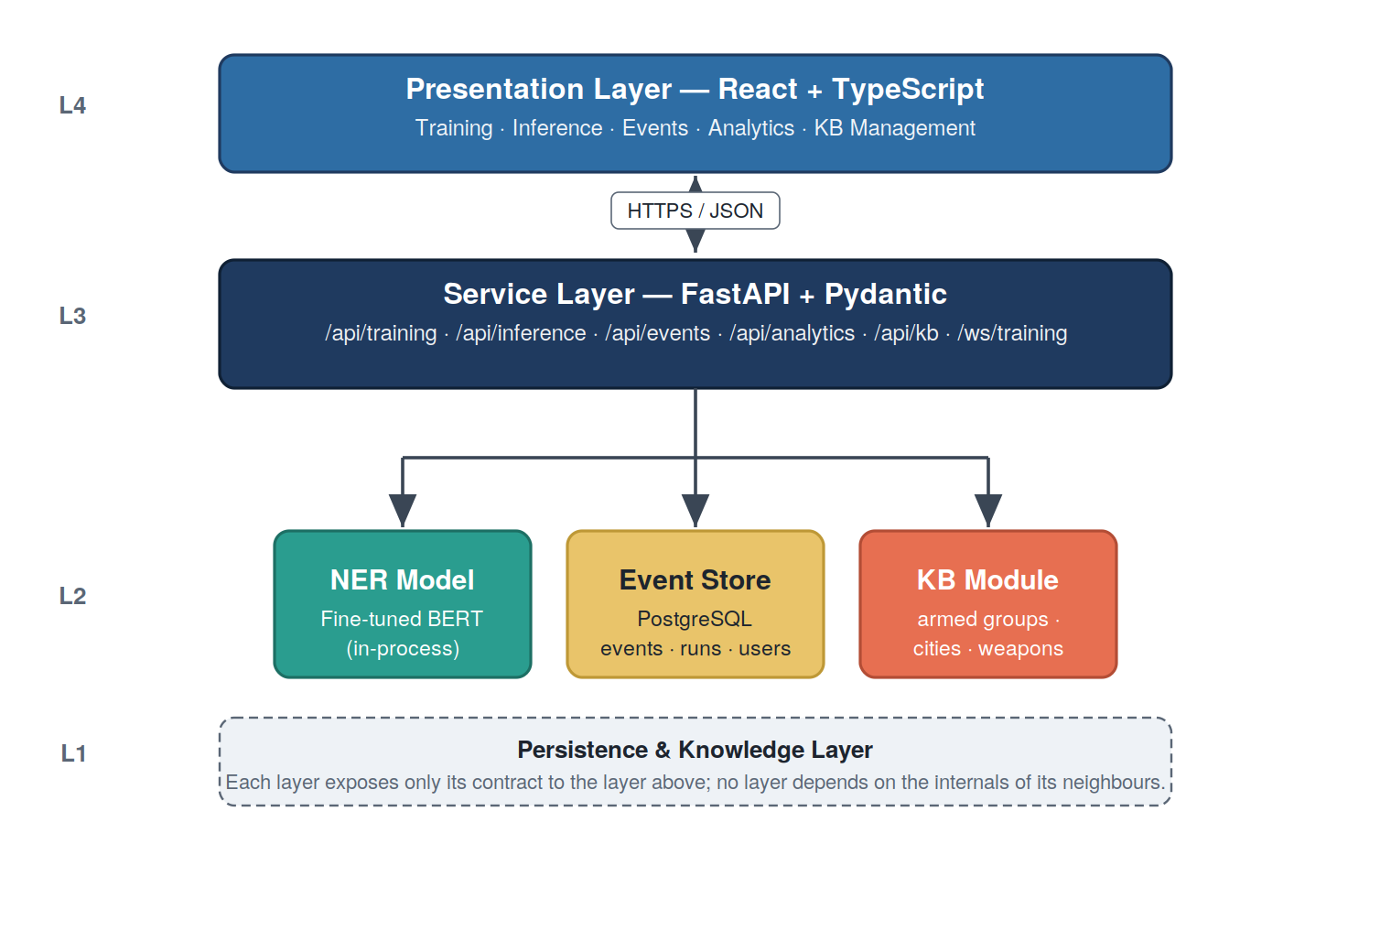
Figure 4.1: High-level architecture of the VioNER system
Figure 4.2 presents the end-to-end processing pipeline that an incoming article traverses, defined here as a process flow from raw news text to a queryable structured record.
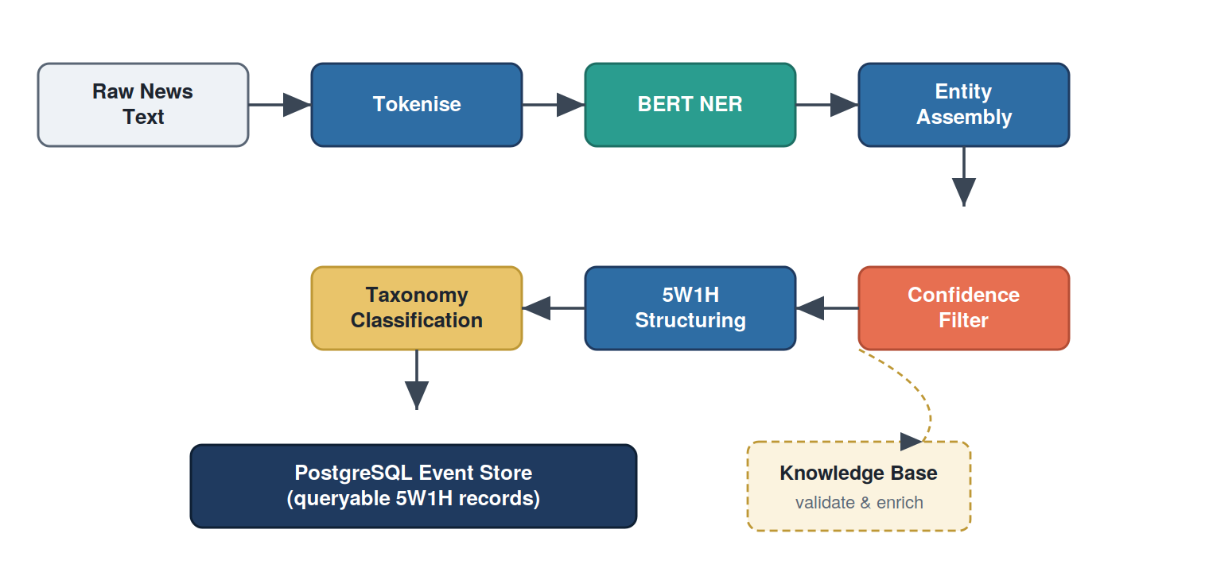
Figure 4.2: End-to-end processing pipeline from raw news text to queryable structured event records
Figure 4.3 expands the same pipeline as a sequence diagram in which each participating component is rendered as a vertical lane, showing the order of calls during a single synchronous inference.
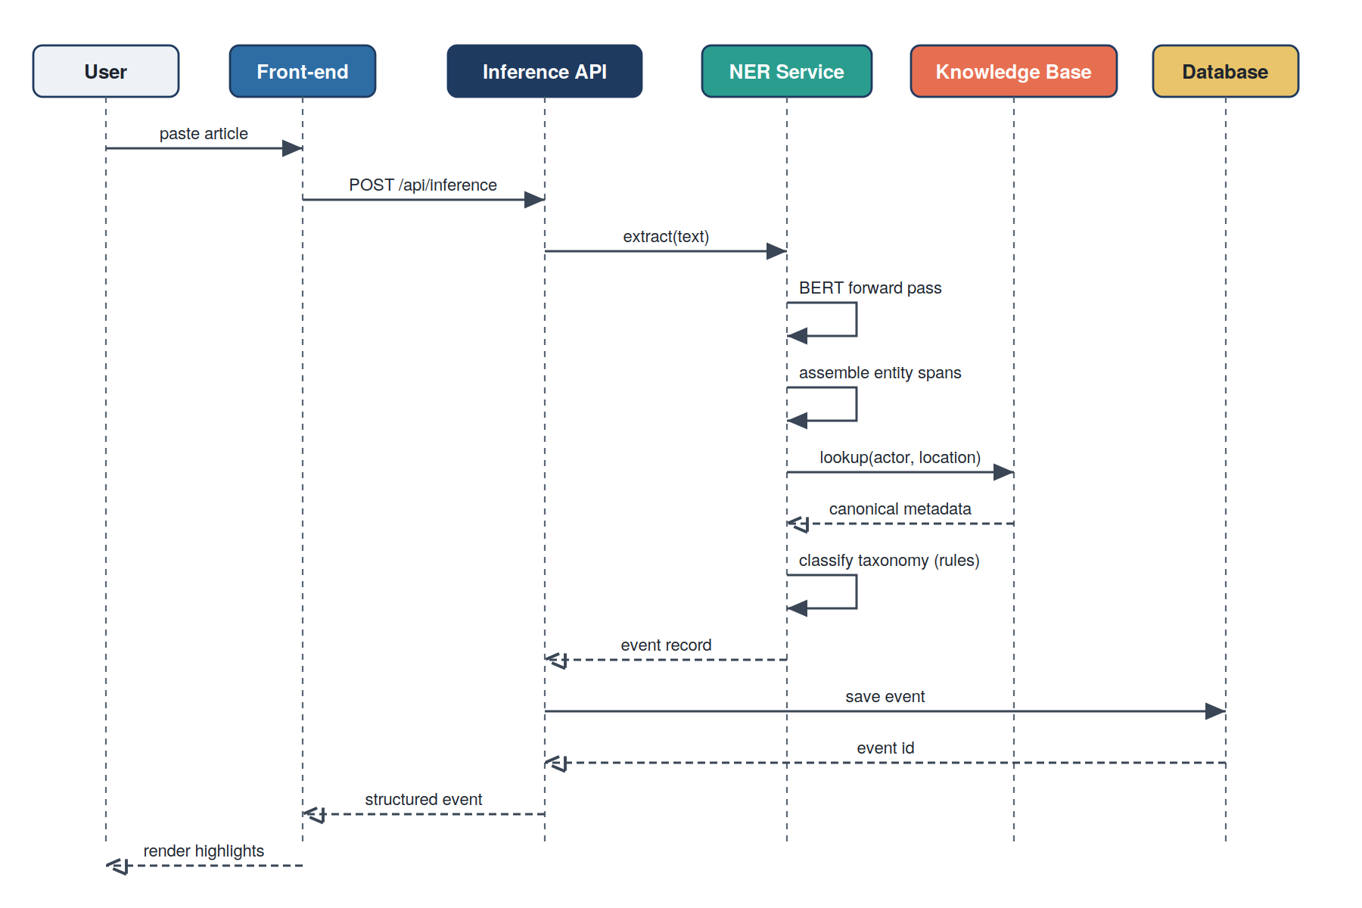
Figure 4.3: Sequence of calls during synchronous inference
The boundary between extraction (NER) and post-processing is deliberate: it allows the supervised learning problem to be cast narrowly, with the schema of Section 4.3, while still producing a richer output by combining the NER result with deterministic knowledge.

4.3 Entity Schema and BIO Encoding
The schema is the single most consequential design choice in the thesis. Set it up wrongly and the supervised learning problem works against the model; set it up well and the model has a strong chance. The grounding rule (Section 4.1) does most of the work: an entity type is in the schema if and only if a human annotator can find it verbatim in the source text on a reliable majority of occurrences. Anything that fails that test is pushed downstream to post-processing. Eight types survived the pilot, organised under the 5W1H categories in Table 4.1.
Table 4.1: Eight-entity grounded schema for the VioNER NER component
5W1H | Entity type | Description and examples
WHO | ACTOR | Armed groups, organisations, government forces (e.g., “Boko Haram”, “M23 rebels”, “Sudanese Armed Forces”, “gunmen”)
WHOM | VICTIM | Persons or groups affected (e.g., “civilians”, “villagers”, “protesters”, “traders”)
WHAT | ACTION | Verbs describing the event (e.g., “attacked”, “killed”, “ambushed”, “raided”)
WHEN | DATE | Temporal expressions (e.g., “on Monday”, “January 15, 2024”, “last week”)
WHERE | REGION | States, provinces, regions (e.g., “Borno State”, “Tigray”, “North Kivu”)
WHERE | CITY | Cities, towns, villages (e.g., “Maiduguri”, “Goma”, “Mogadishu”)
WHERE | DISTRICT | Districts, counties, localities (e.g., “Bama”, “Masisi”, “Lubero”)
HOW | CASUALTIES | Death / injury counts (e.g., “killed 12”, “3 dead”, “5 injured”)
EVENT_TYPE and COUNTRY are deliberately absent. EVENT_TYPE is recovered in the post-NER taxonomy step from the action verb, the actor type, and the surrounding context. COUNTRY is recovered from the knowledge base by looking up the most specific WHERE entity extracted from the text.
The schema is encoded in BIO format: for each entity type X, two labels B-X and I-X are introduced; together with the special O label for tokens outside any entity, the model has seventeen output classes. The BIO encoding allows the model to mark entity boundaries while remaining a flat sequence-labelling problem. Figure 4.4 illustrates the encoding on a representative sentence.
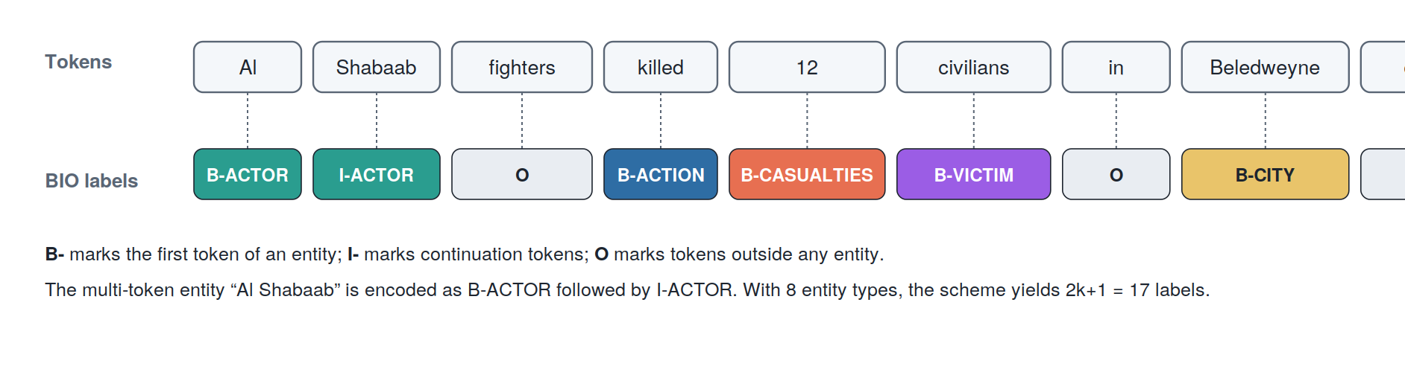
Figure 4.4: BIO encoding example for a sentence describing a violent event; multi-token entities such as “Al Shabaab” are encoded by a leading B- tag followed by I- tags
One subtlety the encoding must handle is sub-word tokenisation. BERT uses WordPiece, so a single annotated word can be split into two or three pieces — “Beledweyne” might become “Beled”, “##wey”, “##ne”, each with its own row in the input. The labels must be projected onto the sub-words consistently or training will see inconsistent signals across runs. The convention used here, formalised as Algorithm 4.1 in Section 4.6, carries the original word’s label to the first sub-word, rewrites any leading B- to I- on subsequent sub-words (because only the first sub-word can be the start of the entity), and assigns -100 to special tokens such as [CLS], [SEP], and [PAD] so that they are ignored by the loss.

4.4 Hierarchical Violent Event Taxonomy
The taxonomy developed for this thesis is a four-level hierarchy. Level 1 names four broad categories of violence; Level 2 introduces eighteen intermediate types nested under them; Level 3 refines those into roughly fifty specific event types; and Level 4 adds another twenty or so detailed subtypes where the operational distinctions warrant it. The synthesis draws on ACLED’s primary event types [8], UCDP’s distinction between state-based, non-state, and one-sided violence [9], and the violence-relevant classes of PMVE [29], with African-specific extensions for pastoralist/farmer clashes and communal cattle raiding that none of those frameworks cover at this depth. The complete tree is in Annex B; the present section summarises Levels 1 and 2 in Tables 4.2 and 4.3 and shows the hierarchy graphically in Figures 4.5 and 4.6.
Before the categories themselves, it is worth fixing what a taxonomy is as a structure. A taxonomy is a directed tree of categories. Each box is a node representing a single category; each connecting line is an edge representing an “is-a-kind-of” (parent-to-child) relationship, so that every child node is a more specific case of its parent. A node with no children is a terminal (leaf) category — the most specific label an event can receive. The depth of a node is its distance from the root. Figure 4.5 makes this generic structure explicit; Figure 4.6 then instantiates it with the actual violence categories.
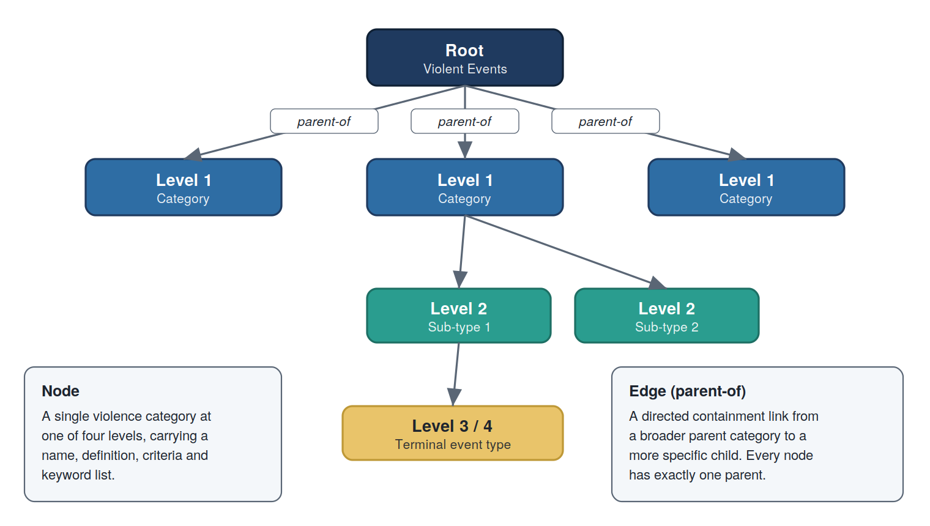
Figure 4.5: Generic structure of the hierarchical taxonomy: nodes are categories, edges denote parent-to-child (“is-a-kind-of”) relationships, and leaf nodes are terminal categories
Table 4.2: Level 1 categories of the hierarchical taxonomy
Level 1 | Working definition adopted in this thesis
Political Violence | Acts intended to contest state authority, push political change, or advance an ideological programme; perpetrators range from rebel and insurgent groups to terrorist organisations and political factions.
Criminal Violence | Acts whose primary motivation is economic gain or the territorial control of a criminal enterprise; perpetrators are gangs, bandits, organised-crime networks, or individual criminals.
Communal Violence | Acts between identity-defined groups — ethnic, religious, clan, or pastoralist/farmer communities — over land, water, livestock, or social standing, where the state is not the primary target.
State Violence Against Civilians | Lethal or severely coercive acts by police, military, or paramilitary forces directed at non-combatants outside an active armed-conflict context, encompassing extrajudicial killing, protest crackdowns, and forced displacement.
Table 4.3: Level 2 intermediate violence types
Level 1 | Level 2 types
Political Violence | Rebellion / Armed Insurgency; Terrorism; Coup and Regime Change Violence; Election Violence; Political Repression.
Criminal Violence | Organised Crime Violence; Armed Robbery / Banditry; Kidnapping for Ransom; Criminal Gang Violence.
Communal Violence | Ethnic / Tribal Conflict; Religious Violence; Resource-Based Conflict; Pastoralist-Farmer Clashes.
State Violence Against Civilians | Extrajudicial Killings; State Repression of Protests; Mass Atrocities by State Forces; Forced Displacement by State; Arbitrary Detention with Violence.
Figure 4.6 shows the taxonomy as a hierarchical graph through Level 3 (with representative Level 4 subtypes shown for selected branches).
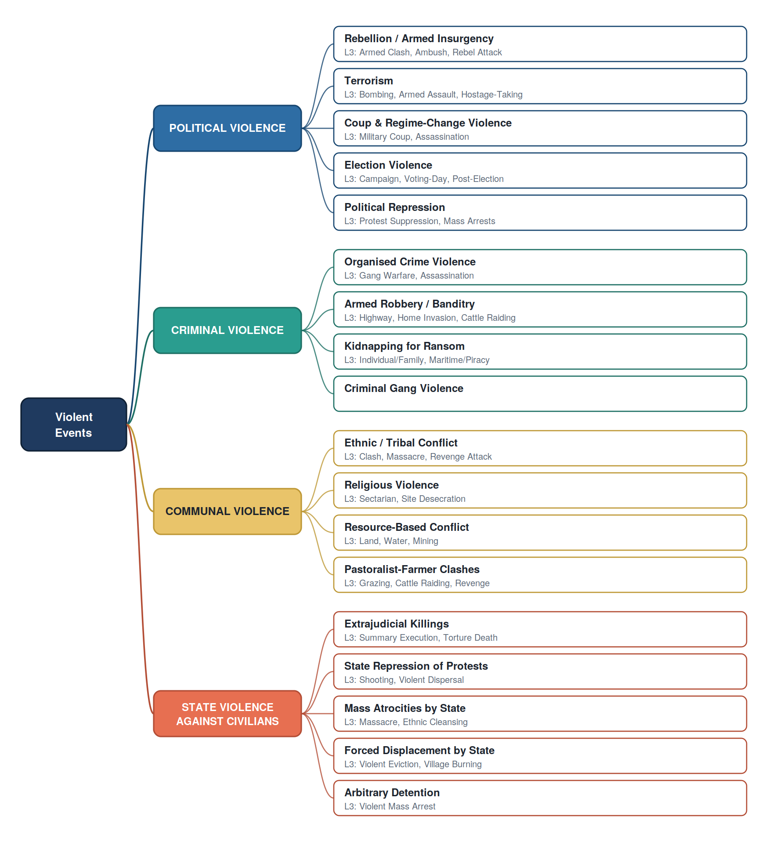
Figure 4.6: Four-level taxonomy of African violent events shown as a hierarchical graph (Levels 1 to 3, with representative Level 4 examples)
Each terminal category in the taxonomy is documented with a definition, classification criteria, distinguishing features, typical keywords used in news reports, and worked examples; the full documentation is provided in Annex B. Decision rules for ambiguous cases (for example, criminal versus terrorist kidnapping, or state violence against protesters versus political repression of protests) are also documented in Annex B.
Within VioNER, the taxonomy is applied as a post-NER step. Given an extracted set of entities and the surrounding text, the taxonomy classifier inspects the actor type, the action verb, and contextual cues (target type, weapons, casualties), and looks up the actor in the knowledge base to identify its known classification. The result is a Level 1 to Level 3 (and where appropriate Level 4) classification of the event. A learned hierarchical classifier could replace this rule-based step in future work.

4.5 Knowledge Base Design
The knowledge base lives in memory next to the model and is built from three dictionaries: armed groups, locations, and weapons. Loading it from PostgreSQL at startup was considered, but the lookup volume during inference is high and an in-memory dictionary has clear latency advantages; the trade-off is that adding or editing a KB entry requires a service restart, which the analyst-facing flows in Section 5.6 handle gracefully.
The armed-groups dictionary has roughly 150 entries. Each entry carries a canonical name, the list of aliases under which the group is reported in news, the country of operation, the broader region (East / West / North / Southern / Central Africa), and a group type in {militia, terrorist, rebel, government}. The list deliberately favours groups currently or recently active over historical ones — Al-Shabaab, Boko Haram, M23, RSF, JNIM, ISGS, Wagner Group, ENDF, TPLF — and is structured for easy extension as new actors emerge. Annex C contains the full inventory.
The locations dictionary records about 200 conflict-affected cities along with all 54 African countries and their primary regions. Each city entry maps to a country and a parent administrative unit, so “Maiduguri” resolves to Nigeria / Borno, “Goma” to DRC / North Kivu, “Mogadishu” to Somalia / Banaadir, and so on. Two operational uses follow. At inference time, an extracted CITY gets its country and region attached automatically. When an extracted ACTOR’s known country of operation does not match the country derived from the location in the same sentence — for example, “M23 attacking Maiduguri” — the event is flagged for analyst review.
The weapons dictionary is the smallest. It groups weapon mentions into categories (firearms, explosives, edged weapons, fire/arson, heavy weapons) and tactical methods (ambush, raid, mass shooting, suicide bombing). It exists mainly to feed the post-NER taxonomy classifier of Section 4.4, which uses weapon and method signals to refine the Level 3 and Level 4 classification.
Table 4.4 summarises how much each resource holds. The same data plays a second role downstream: the validator uses it to attach metadata to extracted entities. An ACTOR span that matches a known armed-group alias picks up that group’s canonical name, country, region, and group type; a CITY span picks up its country and region; a weapon mention picks up its category. Where the KB notices a mismatch — say, an actor whose recorded country of operation does not agree with the location entity extracted in the same sentence — it lowers the event’s overall confidence score and the analytics view surfaces it for manual review.
Table 4.4: Knowledge base content summary
Resource | Approximate size
Armed groups | 150
Cities (conflict zones) | 200
African countries | 54
Weapon types / categories | 30
Taxonomy categories | 95

4.6 Training Pipeline
The pipeline takes raw ACLED event records on one end and produces a fine-tuned BERT model on the other. Conceptually there are five things happening in between — preprocessing the records into tokenised examples, sampling and augmenting the corpus, aligning word-level labels onto BERT’s sub-word tokens, configuring the loss, and running checkpointed training with early stopping. Each is described in turn below.

4.6.1 Preprocessing
The raw input arrives as a JSONL file of ACLED records. The fields that matter for this thesis are event_id, event_date, the free-text notes description, fatalities, actor1, location, and admin1; ACLED carries more than this, but the rest is unused. Preprocessing happens in two passes. First, the notes field is tokenised on whitespace and punctuation. Second, each structured column is projected onto BIO labels by locating where its value appears inside the tokenised notes and tagging those positions with the column’s entity type. Anything that does not match a column value stays as O. The output is a JSONL file in which every record carries four parallel fields — tokens, labels, text, and entities.

4.6.2 Stratified Diversity Sampling
The raw corpus is large (approximately 212,000 events) but diversity-poor. A surprising number of ACLED notes follow a single formula — “Armed group X attacked location Y, killing N persons” — which means an unsampled corpus is effectively several thousand variations of the same sentence. Training on it does not fail; it simply plateaus early. The sampling script (Algorithm 4.2, detailed in Section 5.3) selects a 35,000-example subset that maximises diversity while ensuring rare entity types are over-represented relative to their raw frequency.

4.6.3 Augmentation
On top of the sampled 35,000 examples, the pipeline generates a further 15,000 synthetic examples through template-based augmentation (Algorithm 4.3, Section 5.3). The goal is narrower than “more data” — it is to widen the vocabulary the model sees for action verbs and for the various ways a victim can be described, both of which are under-represented in ACLED’s house style. The combined 50,000-example corpus is partitioned 80 / 20 into training (40,000) and validation (10,000) splits, preserving stratification across entity types.

4.6.4 Sub-word Label Alignment
Algorithm 4.1 describes the sub-word alignment used to project word-level labels onto BERT WordPiece tokens. The algorithm walks the list of word indices returned by the tokeniser. Special tokens (line 7) receive the ignore index -100 so the loss skips them. The first sub-word of each word (line 9) inherits the word’s gold label directly. Every subsequent sub-word of the same word (lines 11 to 16) inherits the label too, but any leading B- prefix is rewritten to I-, since only the first sub-word can legitimately begin an entity span. The parameter values are fixed by the scheme itself rather than tuned: the ignore index is the PyTorch convention (-100), and the B-to-I rewrite is dictated by the BIO formalism.
Algorithm 4.1 Sub-word label alignment for BIO tagging
The procedure maps a list of whole-word BIO labels onto the larger list of WordPiece sub-word tokens that BERT actually consumes, preserving span boundaries and marking non-label positions for exclusion from the loss.
Input: tokens t[1..n], labels y[1..n], tokenizer T
Output: aligned label ids l[1..m] with m ≥ n

1 enc ← T(tokens = t, is_split_into_words = True)
2 word_ids ← enc.word_ids()
3 l ← empty list ; prev ← null
4 for each w in word_ids do
5 if w is null then
6 append IGNORE_INDEX (−100) to l # special token
7 else if w ≠ prev then
8 append label2id[ y[w] ] to l # first sub-word
9 else # later sub-word
10 label ← y[w]
11 if label starts with "B-" then
12 label ← "I-" + label[2:] # B → I transition
13 end if
14 append label2id[ label ] to l
15 end if
16 prev ← w
17 end for
18 return l

4.6.5 Training Hyperparameters
The principal hyperparameters are listed in Table 4.5. Values were set by a combination of established defaults and limited manual search. The learning rate (2 × 10⁻⁵), AdamW optimiser, weight decay (0.01), and warmup (500 steps) follow the standard BERT fine-tuning recipe and were not tuned further. The batch size (16) with gradient accumulation (2) gives an effective batch of 32, the largest that fit in unified memory on the training workstation. The focusing parameter γ = 2.0 is the value recommended in the original focal-loss work [12]; label smoothing (0.1) and gradient clipping (1.0) are conventional regularisation defaults. Maximum epochs (10) is an upper bound only — early stopping on validation loss (patience 5) ends training well before it in practice.
Table 4.5: Training hyperparameters
Hyperparameter | Value
Pre-trained model | bert-base-cased
Number of labels | 17
Maximum sequence length | 512
Batch size | 16
Gradient accumulation | 2
Learning rate | 2 × 10⁻⁵
Optimiser | AdamW
Weight decay | 0.01
Warmup steps | 500
Maximum epochs | 10
LR scheduler | ReduceLROnPlateau (factor 0.5, patience 2) with warmup
Early stopping | patience 5, threshold 0.001
Loss function | Focal loss (γ = 2.0) with inverse-frequency class weights
Label smoothing | 0.1
Gradient clipping | 1.0
Device | Apple Silicon (MPS) when available, otherwise CUDA or CPU

4.6.6 Focal Loss with Class Weighting
The custom loss combines focal loss with inverse-frequency class weighting and optional label smoothing. Algorithm 4.4 summarises its behaviour. Lines 1 to 2 build a mask that excludes ignored positions (label = -100) and count the valid tokens for normalisation. Line 3 computes log-probabilities once. Lines 4 to 9 form the per-token cross-entropy term, optionally against a smoothed target distribution. Lines 10 to 11 compute the focal modulating factor (1 − p_true)^γ, which shrinks the contribution of already-confident predictions. Line 12 applies the per-class weight, and line 13 combines mask, weight, modulator, and cross-entropy before the final mean (line 14). The class weights α are computed once before training as α_c = T / (C · max(f_c, 1)), where T is the total token count, C the number of classes, and f_c the count of class c; weights are clipped to a maximum of ten to prevent gradient instability. The O class therefore receives a low weight and the rare entity classes receive high weights.
Algorithm 4.4 Focal loss with inverse-frequency class weighting
Given per-token logits and gold labels, the loss down-weights well-classified tokens through the focal modulator and up-weights rare classes through the precomputed inverse-frequency weights, ignoring padding and special tokens.
Input: logits z[1..N,1..C], targets y[1..N], class weights α[1..C],
focusing parameter γ, ignore index I, label smoothing β
Output: scalar loss L

1 mask[n] ← (y[n] ≠ I) for n = 1..N
2 N_valid ← sum(mask)
3 log_p ← log_softmax(z, dim = −1) # shape N × C
4 if β > 0 then
5 y_smooth[n,c] ← (1−β)·1[c=y[n]] + β/(C−1)·1[c≠y[n]]
6 CE[n] ← − Σ_c y_smooth[n,c] · log_p[n,c]
7 else
8 CE[n] ← − log_p[n, y[n]]
9 end if
10 p_true[n] ← exp( log_p[n, y[n]] )
11 modulator[n] ← (1 − p_true[n])^γ
12 weight[n] ← α[ y[n] ]
13 L_n[n] ← mask[n] · weight[n] · modulator[n] · CE[n]
14 return ( Σ_n L_n[n] ) / max( N_valid, 1 )

4.6.7 Checkpointing and Early Stopping
At the end of each epoch the model and tokenizer are written out to a timestamped epoch directory. When the validation loss improves by more than the early-stopping threshold, the same checkpoint is copied into a best/ folder alongside the epoch directories, so the most recent best is always one path away. The run as a whole is described by a training_config.json file at the root, recording which epoch is current, which was the best so far, the best validation loss, and whether the run has finished. A --resume flag picks an interrupted run back up from its most recent epoch; an --extend-epochs flag lets a completed run continue for additional epochs without starting over.

4.7 Inference and Post-Processing
At inference time the system must go from a paragraph of news text to a 5W1H record an analyst can read. The full sequence of steps is captured in Algorithm 4.5. After tokenisation and a forward pass (lines 1 to 4), the procedure walks the predicted labels and assembles contiguous B-/I- runs into spans, recording the mean sub-token confidence for each (lines 5 to 23). Spans below their category-specific confidence threshold are dropped (line 24); the survivors are grouped into the 5W1H slots (line 26). Knowledge-base look-ups then enrich the WHO and WHERE entities with canonical metadata (lines 27 to 32), the taxonomy classifier assigns the event type (line 33), and an aggregate confidence is computed (line 34).
Algorithm 4.5 Post-NER 5W1H structuring with knowledge-base validation
The procedure converts raw token-level predictions into an enriched, taxonomy-classified 5W1H event record, applying per-category confidence thresholds and knowledge-base validation along the way.
Input: text x, NER service M, knowledge base K,
per-category thresholds τ[c]
Output: structured event record R

1 (tok, offsets) ← tokenize(x)
2 logits ← M.forward(tok)
3 pred[i] ← argmax_c logits[i,c] for all i
4 probs[i] ← softmax(logits[i,·]) for all i
5 spans ← empty list ; i ← 1
6 while i ≤ |tok| do
7 if id2label[pred[i]] starts with "B-" then
8 start ← offsets[i].start ; t ← label[2:]
9 confs ← [ probs[i, pred[i]] ] ; j ← i + 1
10 while j ≤ |tok| and id2label[pred[j]] = "I-"+t do
11 confs ← confs ++ [ probs[j, pred[j]] ] ; j ← j + 1
12 end while
13 spans ← spans ++ [ (t, start, offsets[j−1].end, mean(confs)) ]
14 i ← j
15 else i ← i + 1 end if
16 end while
17 spans_filt ← { s ∈ spans : confidence(s) ≥ τ[ category_of(s) ] }
18 R.entities ← spans_filt
19 R.who, ..., R.how ← group_by_5w1h(spans_filt)
20 for each s in R.who do R.who_meta[s] ← K.armed_groups.lookup(s) end for
21 for each s in R.where do R.where_meta[s] ← K.locations.lookup(s) end for
22 R.taxonomy ← classify_taxonomy(R, K)
23 R.confidence ← aggregate_confidence(spans_filt, R.taxonomy)
24 return R

Confidence thresholds are calibrated per category: WHO and WHOM at 0.70, WHAT at 0.60, WHEN at 0.80, WHERE at 0.70, HOW at 0.75. These values came from inspecting validation-set errors. WHEN received the highest threshold because dates are easy for the analyst to verify against the article timestamp, so a false positive is highly visible and worth filtering aggressively. WHAT received the lowest because action verbs are usually well-supported by the surrounding context — even a low-confidence “attacked” is useful when the surrounding sentence makes the violence unambiguous.
Multi-event articles are a separate problem. A long news article often describes two or three incidents in sequence, and running NER over the whole article in one pass produces a confused 5W1H record that mixes actors from one incident with locations from another. A segmentation module splits long documents into event-bearing sentence groups before NER runs, using sentence-boundary detection and a small set of indicator phrases (“in a separate incident”, “earlier that week”, “meanwhile”) that mark transitions between events. The module is intentionally simple; it could be replaced by a learned event-boundary classifier in future work, but the simple version catches the obvious cases at very low cost.

4.8 Web Application Architecture
The web application is a conventional single-page-application arrangement: a React/TypeScript front-end on top of a FastAPI service, communicating exclusively in JSON over HTTPS. The one non-standard piece is a single WebSocket channel reserved for streaming training progress; everything else fits the request / response pattern naturally, and there is no reason to introduce heavier real-time machinery for it.
The back-end exposes the following route groups, all under /api:
- /auth/* for authentication and demo-user provisioning.
- /training/* for starting, monitoring, listing, and managing training runs; sub-routes cover checkpoint management, training-data inspection, and post-training evaluation.
- /inference/* for synchronous inference on a single text or document.
- /events/* for storing, querying, and updating extracted events.
- /analytics/* for aggregated views (events per region, per actor, per time period).
- /kb/actors, /kb/locations, /kb/taxonomies for managing the knowledge-base resources.
- /system/* for service health, version information, and configuration introspection.
- /history/* for recording per-user activity (recent inferences, saved queries).
- /ws/training/{session_id} as the WebSocket channel for live training progress.
The front-end mirrors these routes with a screen for each. Section 5.7 describes the implementation in detail; screenshots are included in Annex D.

5. Implementation
Where Chapter 4 described what VioNER does and why, this chapter documents how it actually does it: the technology stack, the data-preparation flow, the training procedure, the focal-loss implementation, the back-end services and API surface, the front-end application, and the containerised deployment. Code listings are kept short throughout; the full source resides in the accompanying repository.

5.1 Technology Stack
Two languages do the heavy lifting in this codebase. Python 3.11 hosts the back end and the machine-learning code; everything the user sees is TypeScript on top of React 19. Behind those, PostgreSQL handles persistence and Docker Compose stitches the development environment together. The full back-end and front-end stacks are catalogued in Tables 5.1 and 5.2.
Table 5.1: Back-end technology stack
Component | Choice
Language | Python 3.11
Web framework | FastAPI 0.115
ASGI server | Uvicorn
Validation | Pydantic v2
ML framework | PyTorch 2.6
Pre-trained models | Hugging Face Transformers 4.46
Tokenisers | Hugging Face Tokenizers (WordPiece)
ORM | SQLAlchemy 2.0
Database driver | psycopg2
Migration | Alembic (planned; currently DDL via SQLAlchemy)
WebSocket | fastapi.WebSocket
Authentication | JWT (PyJWT)
Testing | pytest
Containerisation | Docker, Docker Compose
Table 5.2: Front-end technology stack
Component | Choice
Language | TypeScript 5.6
UI framework | React 19
Routing | React Router 7
Build tooling | Vite
Styling | TailwindCSS + shadcn/ui components
Data fetching | Native fetch with custom service wrappers
State management | React context and useReducer per feature
Charting | recharts
Tables and grids | TanStack Table
Type checking | tsc + react-router typegen
A few of these choices warrant a sentence of explanation. FastAPI was chosen for the back end because the leading alternative, Flask, would have meant hand-writing the OpenAPI document from which the front-end’s TypeScript types are generated; FastAPI produces that document automatically from the Pydantic models already needed for request validation, and its native async support makes the training-progress WebSocket route much cleaner. PyTorch with Hugging Face Transformers is the de-facto stack for fine-tuning BERT. SQLAlchemy with PostgreSQL covers the data layer; once the schema grew past a handful of tables, SQLAlchemy’s relationship modelling repaid its slight learning-curve cost. On the front end, React 19 with React Router 7 offered file-based routing that matched the intended layout, while TailwindCSS plus shadcn/ui supplied a component library without committing to a heavy design system. Vite replaced Create React App because the latter is effectively unmaintained and Vite’s iteration loop is faster.

5.2 Data Acquisition and Preprocessing
ACLED publishes its data through an open API. The full African extract — every event coded across the 54 countries since coverage began — yields 212,590 records; anything beyond Africa is filtered at ingest. The data is stored on disk as JSONL, matching what ACLED’s own export tooling produces. The preprocessing module turns that raw extract into BIO-tagged training data in four steps:
- Loading. Each event is loaded from JSONL, with required fields verified and missing values defaulted.
- Tokenisation. The free-text notes field is tokenised using a regex-based splitter that preserves punctuation and quotation marks but separates them from adjacent tokens.
- Column-to-entity projection. Each structured column (actor1, location, admin1, fatalities, and so on) is mapped to its entity type per the configuration table (Annex A). The corresponding value is located within the tokenised notes via case-insensitive substring matching, and matched token positions are tagged with the appropriate BIO label.
- Output. Each event is written to JSONL with tokens, labels, text, and entities fields, then split 80 / 20 into training and validation.
The pre-processed corpus comprises 170,072 training and 42,518 validation examples, 212,590 in total. This is the upstream pool from which the diverse subset is sampled in Section 5.3.

5.3 Stratified Sampling and Augmentation
The subset-creation script implements the stratified diversity sampling described in Section 4.6 and formalised in Algorithm 4.2. It scores each pooled example by its rare-entity count and its distinct-entity-type count, takes the top-scoring examples for the rare and diversity budgets, then fills the remainder by random sampling.
Algorithm 4.2 Stratified diversity sampling for entity coverage
From the large but repetitive pre-processed pool, the sampler selects a fixed-size subset that over-represents rare entity types and maximises within-example entity-type diversity, falling back to random sampling for the remaining budget.
Input: pool P, target size T, rare-entity budget R,
diversity budget D, rare set Σ = {VICTIM, ACTION, CASUALTIES}
Output: selected subset S with |S| = T

1 for each p in P do
2 rare_score[p] ← | { e ∈ entities(p) : type(e) ∈ Σ } |
3 div_score[p] ← | distinct( type(e) for e in entities(p) ) |
4 end for
5 P_rare ← top-R items of P ordered by rare_score desc
6 P_div ← top-D items of (P \ P_rare) ordered by div_score desc
7 P_rest ← random-sample(P \ (P_rare ∪ P_div), T − R − D)
8 S ← P_rare ∪ P_div ∪ P_rest
9 return S

In the production run, T = 35,000, R = 12,000, D = 11,666, and the random remainder is 11,334. These budgets were arrived at empirically: an earlier fifty-fifty rare-versus-diverse split under-recovered the dominant entities, while the current split was the first in which the macro and micro F1 numbers moved together. Augmentation is then applied following Algorithm 4.3.
Algorithm 4.3 Template-based augmentation
To widen the action-verb and victim-phrasing vocabulary that ACLED notes under-represent, the augmenter renders synthetic sentences from a template catalogue, drawing actors and locations from the knowledge base and verbs from curated lexicons, and BIO-labels each generated example.
Input: KB groups G, locations L, weapons W, verb lexicons V,
template list T, augmentation budget N
Output: synthetic example list A with |A| = N

1 A ← empty list
2 while |A| < N do
3 tmpl ← choose_random(T)
4 actor ← sample compatible group from G for tmpl
5 loc ← sample location from L matching actor.country
6 verb ← sample verb from V[ type(tmpl) ]
7 n_k, n_i ← sample plausible casualty counts
8 text ← render(tmpl, actor, loc, verb, n_k, n_i)
9 (tok, lbl) ← tokenize_and_bio_label(text, slots)
10 A ← A ++ [ { tokens: tok, labels: lbl, source: "aug" } ]
11 end while
12 return A

The augmentation budget is 15,000 examples. Combined with the 35,000 sampled examples, the final training corpus is 50,000, partitioned 40,000 / 10,000 into training and validation. That split is deliberately validation-heavy for token classification, because with rare entities at single-digit percentages enough validation support is needed for VICTIM and CASUALTIES to give stable per-epoch F1 numbers. The verb lexicons cover three template patterns: location-taking verbs (“attacked”, “raided”, “stormed”, “bombed”, “shelled”), victim-taking verbs (“killed”, “wounded”, “abducted”, “displaced”), and clash phrases (“clashed with”, “exchanged fire with”, “battled”). The full template catalogue is in Annex E.

5.4 Model Training Implementation
The trainer is organised around a single class that owns the Hugging Face model, the tokenizer, the dataset wrappers, and the training loop. The constructor takes a configuration dataclass holding every hyperparameter listed in Table 4.5. Device selection runs in order: prefer Apple Silicon GPU (MPS) if available, fall back to CUDA, then CPU; the order reflects the training hardware (an Apple M-series workstation with 64 GB unified memory) while keeping a CUDA path for sanity checks. Model loading instantiates the cased tokenizer and the token-classification model for bert-base-cased, configures the seventeen-label head, and moves the model to the selected device.
Data flows through a dataset class whose item accessor runs the tokenizer with is_split_into_words enabled, extracts the word indices, and applies the sub-word alignment of Algorithm 4.1. Special tokens receive label -100, which both the default cross entropy and the custom focal loss ignore. The training loop is conventional: forward-backward on the training set, no-grad validation at the end of each epoch, gradient clipping at L2 norm 1.0, linear warm-up for the first warmup_steps optimisation steps, and ReduceLROnPlateau scheduling after warm-up (factor 0.5, patience 2 epochs). Early stopping counts epochs since the last improvement in validation loss; when the count reaches the patience threshold the loop exits and the best checkpoint is restored. A resume path re-enters the loop at the appropriate epoch from a prior run’s configuration file, and combined with an extend-epochs flag means training never has to restart from scratch after an interruption.

5.5 Focal Loss and Class Weighting
The custom loss code defines two classes: a FocalLoss module implementing Algorithm 4.4, and a class-weighted cross-entropy used as the ablation baseline in Section 6.6. Several implementation choices are worth noting. Logits arrive shaped [N, C] and targets shaped [N]; both are flattened before any softmax, because log-softmax is faster on contiguous 2D tensors and per-token granularity is all token classification needs. Ignored positions (target = -100) are masked before the softmax computation rather than after, which keeps the loss numerically stable when a batch contains many padding tokens. Label smoothing, when enabled, is applied to the target distribution, and the focal modulating factor respects the smoothed label rather than the original one-hot. Per-class weights are passed as a 1D tensor on the same device as the logits and indexed directly.
Class weights are computed once at the start of training as w_c = T / (C · max(f_c, 1)), where T is the total token count over the training set, C is the number of classes, and f_c is the count of class c (clipped to a minimum of one to avoid division by zero). The training script logs the resulting O-class weight alongside the minimum and maximum weights, so the weighting is visible in the run log; Annex E reproduces the distribution and the derived weights for the production run.

5.6 Backend Services and API
The back-end is implemented as a FastAPI application with route handlers organised by feature. Figure 5.1 sketches the module organisation, from the application entry point through the API routers, the service layer, the training pipeline, and the database access code.
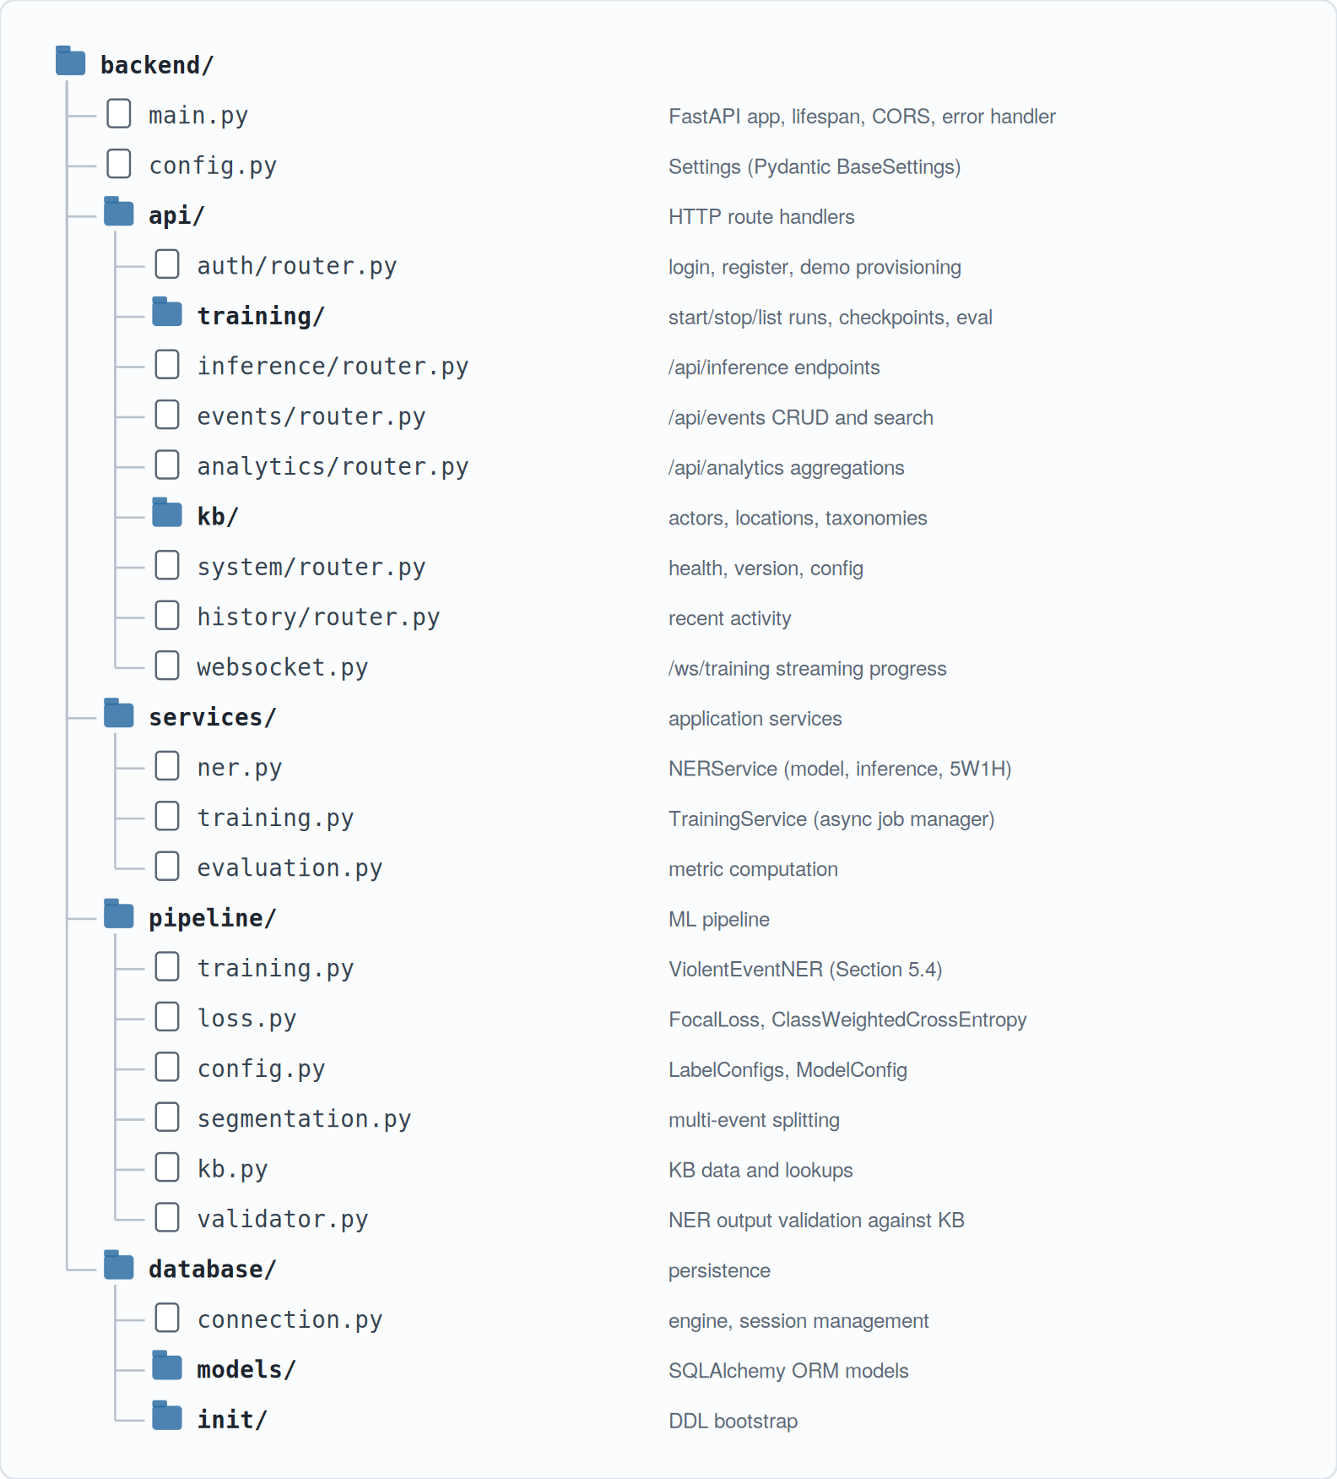
Figure 5.1: Back-end module organisation
The application lifespan handler initialises the database connection, loads the NER model from the configured checkpoint path, and starts the training service. A failure to load the model degrades the service to an inference-disabled state but does not prevent startup; the front-end then surfaces a banner explaining that inference is temporarily unavailable. Pydantic models under each router specify request and response shapes, and FastAPI generates the OpenAPI schema automatically at /docs and /redoc; that schema is exported during the front-end build to keep the TypeScript types in sync.
The NER service’s extract method implements the algorithm of Section 4.7: tokenisation, BERT inference, entity-span assembly, confidence-based filtering, 5W1H structuring, and KB enrichment, returning a JSON-serialisable dictionary that the inference route returns directly. The training service manages jobs asynchronously by spawning a subprocess that runs the training pipeline, forwarding its log lines over a per-session WebSocket and supporting cancellation by signalling the subprocess and writing a final state record. PostgreSQL stores users, events, training runs, and inference history; the schema is reproduced in Annex D.

5.7 Frontend Application
The front-end is a Vite-built React 19 single-page application using React Router 7 file-based routing, with the route map shown in Figure 5.2. Routes cover the landing page, authentication, inference (on pasted text or uploaded documents), training (list, start, and live-progress detail), event browsing and detail, analytics, and knowledge-base management for actors, locations, and taxonomies.
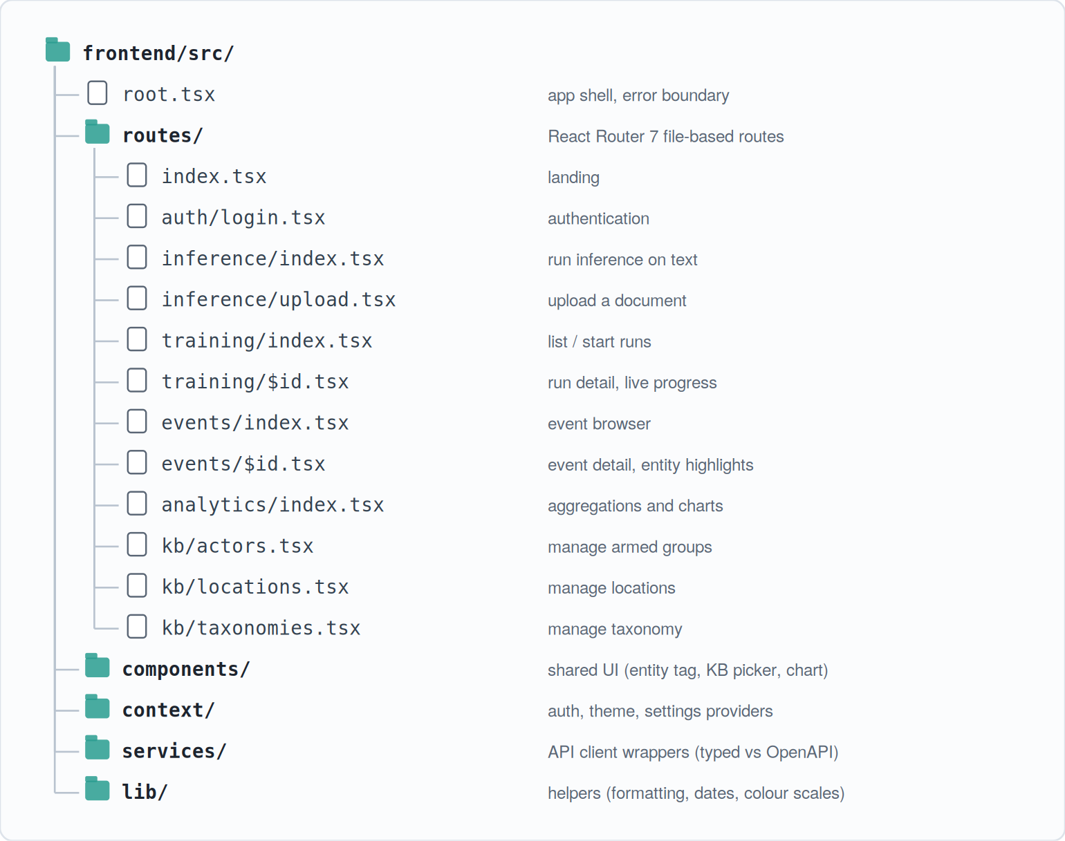
Figure 5.2: Front-end route map
The Inference screen lets a user paste a paragraph or upload a document, calls the inference endpoint, and renders the returned structured event, highlighting entities inline in the source text with colour coding per 5W1H category and showing each span’s confidence on hover. The Training screen lists historical runs and exposes a control panel for starting a new one; the detail screen subscribes to the training WebSocket and renders a live progress bar, the current epoch, the most recent losses, and a scrolling log. The Events screen provides a paginated, filterable browser over all stored events with full-text search, structured filters (date range, country, region, taxonomy level), and CSV export. The Analytics screen renders aggregated views — events per region, top actors, top locations, incident-count time series, and casualty totals over selected periods. The KB screens allow a user with the appropriate role to create, update, and deactivate armed groups, locations, and taxonomy categories, with all mutations routed through the back-end and logged in the audit table. Screenshots are reproduced in Annex D.

5.8 Containerised Deployment
The whole system runs from a single Docker Compose file at the repository root, defining three services: a PostgreSQL 16 database with a persistent volume; a Python back-end image with the source and the model checkpoint mounted alongside it; and a Node front-end image that builds and serves the Vite application. A health-checked startup order prevents the back-end from initialising until the database is ready to accept connections.
Configuration is environment-variable-driven. The variables that matter day to day are the database URL, the model path, the allowed CORS origins, and the JWT secret, alongside a few feature flags including one that toggles database storage. An example environment file in the repository documents the complete set. Day-to-day development uses two commands: starting the database in the background and then running the back-end and front-end natively for fastest iteration, or bringing the whole stack up inside containers. For production the stack is built and pushed to a container registry; the production override file that terminates TLS at the reverse proxy is deliberately excluded from this thesis because deployment-specific secrets live there.

6. Experimentation and Results
A system of this size must be evaluated on several axes: how well the model fits the training distribution, how it performs per entity, how much of that performance is attributable to the focal-loss decision, how the knowledge-base layer changes the output, how fast it runs in practice, and whether real users can drive it. The sections below address each in turn, ending with a discussion section, a threats-to-validity section, and an error analysis that feeds the future-work programme in Chapter 7.

6.1 Experimental Setup
All training and evaluation reported in this chapter were conducted on an Apple Silicon workstation with the configuration in Table 6.1.
Table 6.1: Hardware and software configuration used for training and evaluation
Component | Specification
CPU | Apple M-series, 10 cores
Memory | 64 GB unified
Accelerator | Metal Performance Shaders (MPS) backend
Operating system | macOS 14
Python | 3.11
PyTorch | 2.6
Transformers | 4.46
The validation set is the same 10,000-example split set aside at the start of training and never touched again — not for hyperparameter tuning, checkpoint selection, or sampler tuning. Token-level accuracy ignores positions labelled with the -100 special index. Per-entity precision, recall, and F1 are computed at span level rather than token level, because boundary errors are real errors that a downstream consumer notices: a predicted span counts as correct only if its type, start, and end exactly match a gold span, and partial overlaps count as a false positive plus a false negative. This strict scoring is appropriate for the intended operational consumers, though, as discussed in Section 6.11, it makes some of the headline numbers read slightly worse than they appear on inspection.

6.2 Dataset Statistics
The pre-processed dataset, before any sampling decisions, is shown in Table 6.2.
Table 6.2: Pre-processed dataset statistics
Quantity | Count
Total events | 212,590
Training events | 170,072
Validation events | 42,518
Train / validation split | 80 / 20
Unique entity types | 8
BIO labels (incl. O) | 17
The substantive story is in the entity-level distribution rather than the headline counts. Table 6.3 shows each entity type as a share of the entity-token total — precisely the imbalance Section 2.4 anticipated.
Table 6.3: Entity-level frequency in the full pre-processed corpus
Entity | Count | Share of entities
ACTOR | 242,302 | 23.9 %
CITY | 222,065 | 21.9 %
DATE | 160,664 | 15.9 %
REGION | 121,892 | 12.0 %
DISTRICT | 107,453 | 10.6 %
ACTION | 50,109 | 4.9 %
VICTIM | 27,641 | 2.7 %
CASUALTIES | 24,634 | 2.4 %
ACTOR, CITY, and DATE together carry the majority of entity tokens; VICTIM and CASUALTIES barely exceed two and a half percent each. One level up, the imbalance worsens: the O label accounts for roughly seventy-eight percent of all tokens. A naive cross-entropy fine-tune on this distribution reports deceptively high overall accuracy while quietly under-recovering exactly the rare entities an analyst cares about most. This is the distribution that motivates the ablation in Section 6.6.
After the corpus is run through the diversity sampler and the template augmenter (Section 5.3), the production training corpus is 50,000 examples split 80 / 20. Augmented examples make up about thirty percent of this corpus and raise the share of ACTION, VICTIM, and CASUALTIES tokens to roughly twenty-six to thirty-two percent of their respective categories in the optimised subset — enough exposure to learn from, without drowning the natural distribution. Class weights derived by inverse-frequency weighting are summarised in Table 6.4; minority entities receive the maximum weight of ten, and the dominant O class is heavily down-weighted.
Table 6.4: Inverse-frequency class weights computed from the training-set distribution and used in the focal-loss objective
Label | Weight
O | 0.070
B-DATE | 3.373
B-ACTOR | 2.212
B-CITY | 2.405
B-REGION | 4.610
B-DISTRICT | 5.022
B-CASUALTIES | 10.000
B-ACTION | 10.000
B-VICTIM | 10.000

6.3 Training Dynamics
Figure 6.1 plots training and validation loss across epochs for a representative ten-epoch run with focal loss and class weighting enabled, and Figure 6.2 plots token-level validation accuracy.
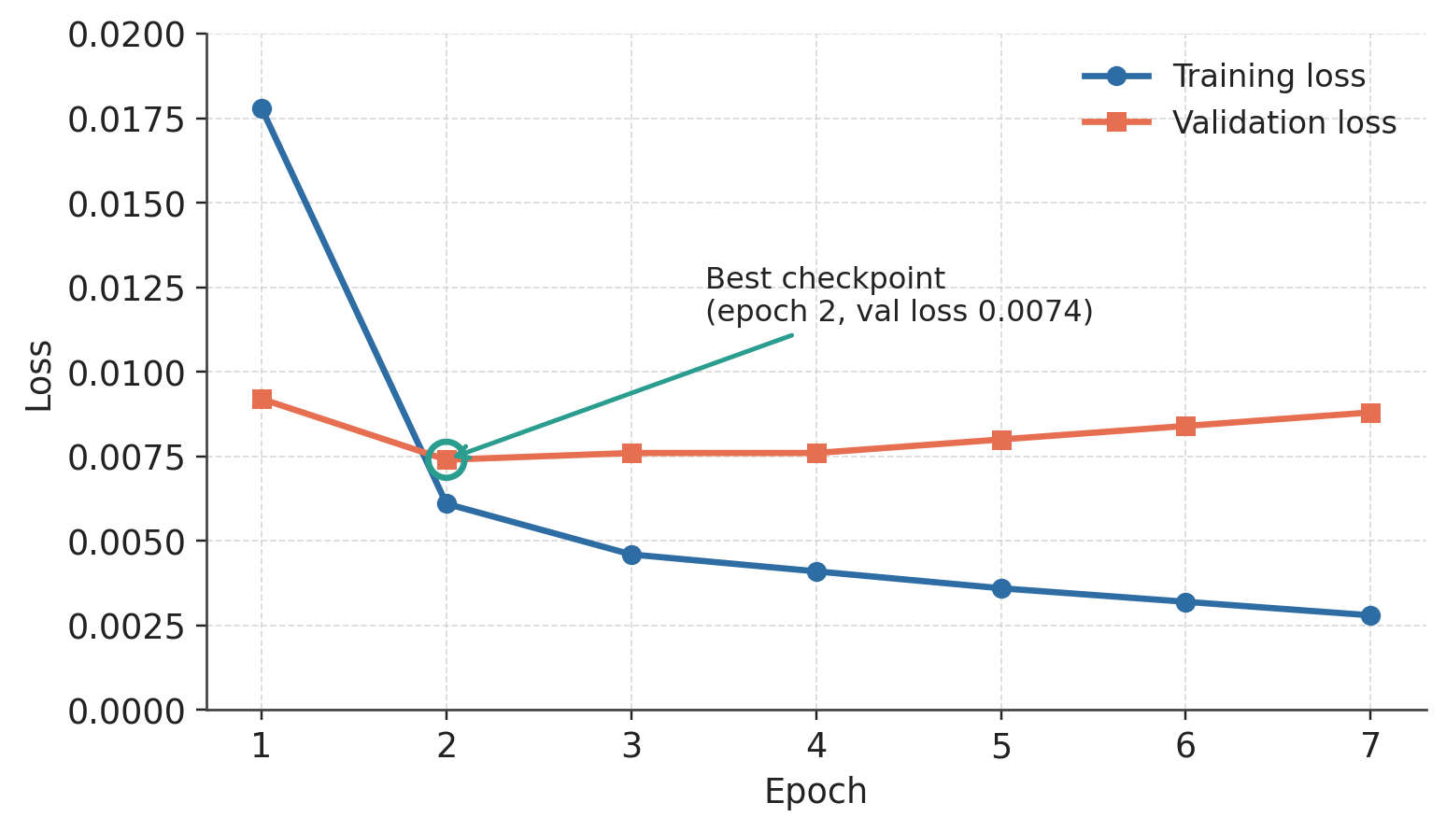
Figure 6.1: Training and validation loss curves across epochs; the validation loss reaches its minimum at epoch 2 and rises modestly thereafter
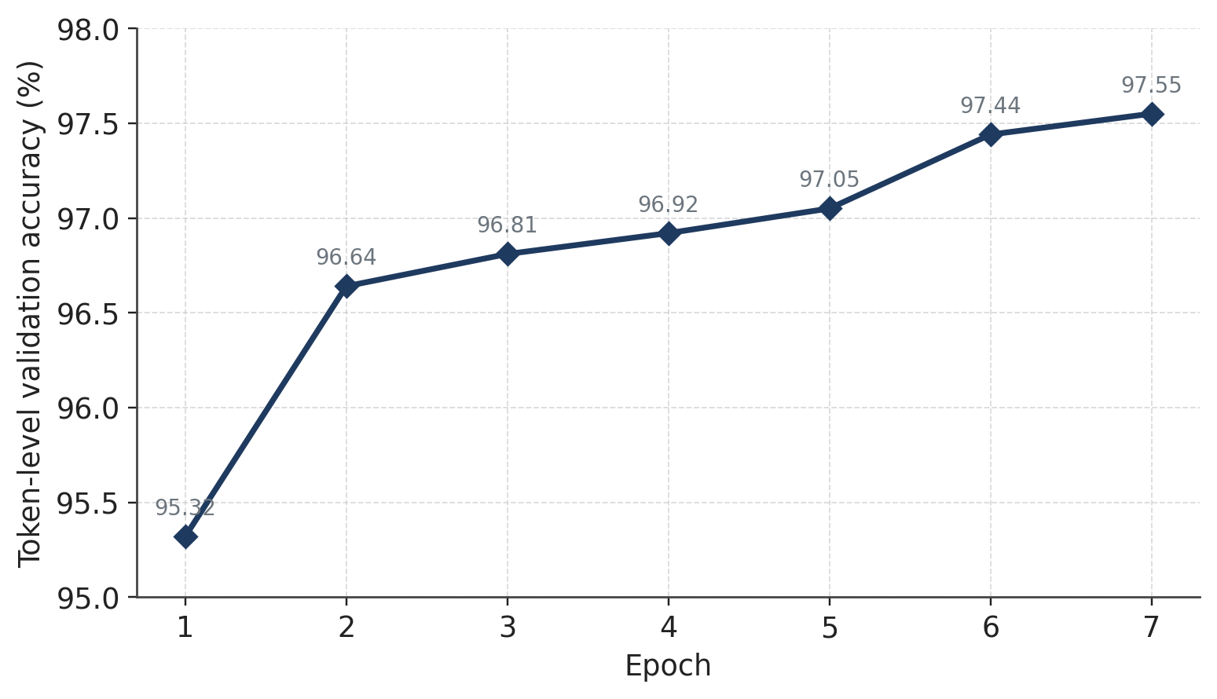
Figure 6.2: Token-level validation accuracy across epochs for the representative run
Table 6.5: Per-epoch training dynamics for the representative run
Epoch | Train loss | Val loss | Val accuracy
1 | 0.0178 | 0.0092 | 95.32 %
2 | 0.0061 | 0.0074 (best) | 96.64 %
3 | 0.0046 | 0.0076 | 96.81 %
4 | 0.0041 | 0.0076 | 96.92 %
5 | 0.0036 | 0.0080 | 97.05 %
6 | 0.0032 | 0.0084 | 97.44 %
7 | 0.0028 | 0.0088 | 97.55 %
Two observations stand out. The validation loss bottoms out at epoch 2 and then begins to rise while the training loss keeps falling — textbook overfitting, which the early-stopping logic (patience 5, threshold 0.001) catches within five further epochs. The subtler observation is that token-level validation accuracy keeps improving even after validation loss worsens. This is not a contradiction: focal loss with class weighting encourages the model to grow more confident on examples it already classifies correctly, which lifts accuracy, while becoming less calibrated on the minority-class boundaries it still gets wrong, which is the cost the loss records. Reading the two curves against each other is what set the patience value; accuracy alone would have led to a longer run and a worse model.
Convergence this fast — at two epochs — is expected. BERT’s pre-training does most of the work: the encoder arrives at fine-tuning with a strong representation of English already learned, and the supervised step needs to do relatively little adaptation. A 50,000-example corpus is also large enough that the fine-tuning signal saturates quickly. After epoch 2 the model is largely memorising idiosyncratic training phrases, which is exactly what early stopping is there to catch.

6.4 Overall Model Performance
Before the headline F1 numbers, the loss-function comparison is the cleanest way to see that the imbalance-handling choices were sound. Table 6.6 reports the best validation metrics for four loss configurations under otherwise identical hyperparameters — same data, scheduler, early-stopping, and random seeds.
Table 6.6: Best validation metrics across training runs
Run | Best epoch | Val loss | Token accuracy
Baseline (CE, no class weights) | 4 | 0.0102 | 95.8 %
Class-weighted CE | 3 | 0.0085 | 96.4 %
Focal loss (γ = 2.0) | 2 | 0.0079 | 96.7 %
Focal loss + class weights | 2 | 0.0074 (best) | 96.7 %
Focal + weights + smoothing (β = 0.1) | 2 | 0.0076 | 96.6 %
The trend is consistent top to bottom: each ingredient that explicitly addresses class imbalance lowers the validation loss further. Plain cross entropy is the baseline at 0.0102; class-weighted cross entropy drops that to 0.0085; focal loss alone to 0.0079; and the combination of focal loss with inverse-frequency class weights reaches 0.0074, the lowest across any configuration tried, with token accuracy of 96.7 percent and convergence in two epochs. Adding label smoothing (β = 0.1) on top nudged the validation loss up to 0.0076 with no meaningful gain in calibration; it was kept in the production configuration because its regularising effect is mild and the slight penalty is within run-to-run noise, but it is not the reason the system works.

6.5 Per-Entity Analysis
Span-level precision, recall, and F1 are reported per entity in Table 6.7, computed on the 10,000-example validation set using exact-match span comparison.
Table 6.7: Per-entity precision, recall and F1 on the held-out validation set
Entity | Support | Precision | Recall | F1
ACTOR | 47,612 | 0.929 | 0.917 | 0.923
CITY | 44,361 | 0.941 | 0.928 | 0.934
DATE | 31,938 | 0.961 | 0.952 | 0.956
REGION | 24,331 | 0.902 | 0.881 | 0.891
DISTRICT | 21,471 | 0.842 | 0.811 | 0.826
ACTION | 9,963 | 0.881 | 0.852 | 0.866
VICTIM | 5,492 | 0.838 | 0.798 | 0.817
CASUALTIES | 4,907 | 0.901 | 0.869 | 0.885
Macro avg | — | 0.899 | 0.876 | 0.887
Micro avg | 190,075 | 0.918 | 0.901 | 0.909
Figure 6.3 reproduces the F1 column as a bar chart.
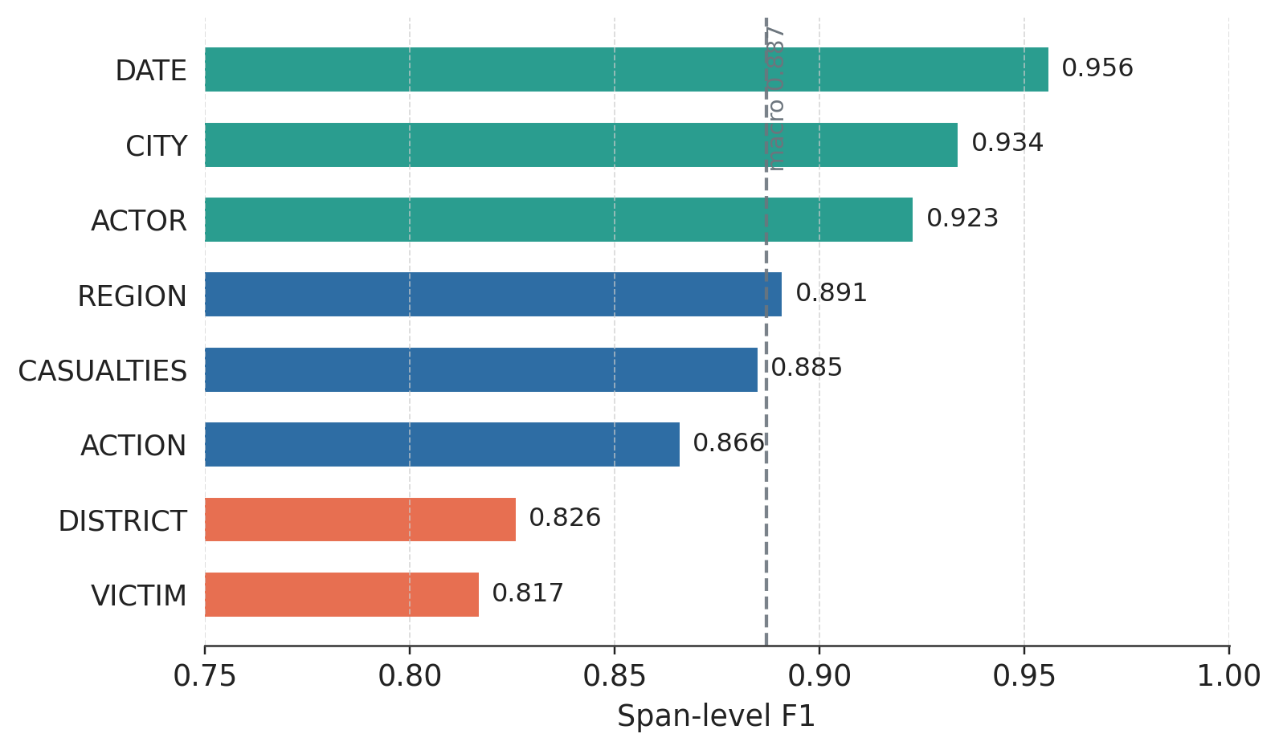
Figure 6.3: Per-entity F1 on the held-out validation set
Several patterns emerge. DATE wins by a clear margin: date expressions in conflict reporting follow a small number of patterns, are usually bounded by prepositions and capitalisation, and are plentiful in the corpus. ACTOR, CITY, and DATE form a strong cluster of entities with rich training distributions and distinctive surface forms. The next tier (REGION at 0.891, CASUALTIES at 0.885, ACTION at 0.866) is solid but visibly lower; the dip correlates with compositional irregularity — region names that double as cities, casualty phrases that mix numerals and words, action verbs in passive voice — more than with sheer training volume. DISTRICT and VICTIM trail at 0.826 and 0.817; DISTRICT loses most of its accuracy to mutual confusion with CITY and REGION (Figure 6.4), while VICTIM is both the rarest entity and the one with the most variable phrasing. The macro F1 of 0.887 means every entity type, including the rarest, is recognised well enough to be useful operationally; the micro F1 of 0.909 is higher because it is dominated by the high-support, high-F1 entities, and is the right figure for estimating overall extraction throughput while the macro figure is the right one for assessing balance.

6.6 Ablation: Focal Loss versus Cross Entropy
Four models were trained with identical data, scheduler, early-stopping, and random seeds, varying only the loss function, to test whether the two imbalance-handling ingredients are genuinely complementary or whether one carries the other. Per-entity F1 across the four configurations is in Table 6.8.
Table 6.8: Per-entity F1 on the validation set for the focal-loss ablation
Entity | Plain CE | Weighted CE | Focal (γ = 2) | Focal + weights
ACTOR | 0.914 | 0.918 | 0.920 | 0.923
CITY | 0.929 | 0.931 | 0.931 | 0.934
DATE | 0.953 | 0.955 | 0.955 | 0.956
REGION | 0.879 | 0.884 | 0.887 | 0.891
DISTRICT | 0.808 | 0.815 | 0.821 | 0.826
ACTION | 0.794 | 0.834 | 0.842 | 0.866
VICTIM | 0.708 | 0.776 | 0.792 | 0.817
CASUALTIES | 0.853 | 0.871 | 0.872 | 0.885
Macro avg | 0.855 | 0.873 | 0.878 | 0.887
The pattern is unambiguous. The minority entities — ACTION, VICTIM, CASUALTIES — benefit most from the combination, with VICTIM moving by eleven F1 points relative to plain cross entropy. Each ingredient helps on its own (weighted cross entropy lifts VICTIM by seven points, focal loss alone by nine), and the two together lift it by eleven; the combination is complementary rather than redundant, which justifies the slightly more complex production loss. The high-support entities show smaller, consistent improvements along the same axis, and — importantly — no entity is hurt by the focal-loss objective relative to plain cross entropy. An imbalance-aware loss that protected the rare classes at the cost of the common ones would have been a regression for analyst workflows that depend on DATE and ACTOR accuracy.

6.7 Knowledge-Base Validation Impact
Measuring the KB layer is harder than measuring the model, because the KB operates downstream of the extractor and does not directly affect F1. Two operational metrics were chosen, one for the enrichment path and one for the validation path. For enrichment: of the high-confidence ACTOR spans (p ≥ 0.85) produced on the validation set, 64.3 percent match a canonical entry in the armed-groups KB and reach the analyst with country, region, and group-type metadata already attached; the remaining 35.7 percent are overwhelmingly generic descriptors (“gunmen”, “armed men”, “the attackers”) that no KB can canonicalise without more context. Roughly two thirds of named-perpetrator mentions therefore receive enrichment automatically, which is the figure that matters when an analyst queries for all events attributed to a given actor and expects surface-form variants to collapse to a single key.
For validation: the KB flags an event as geographically suspicious when its extracted CITY’s country does not match the country implied by its REGION. On the validation set this triggers on 2.4 percent of multi-entity events that have both a CITY and a REGION. On inspection, most flagged cases are either genuine cross-border incidents or extraction errors at the REGION/CITY boundary — the same confusion pattern discussed in Section 6.11 — and in both cases the flag correctly surfaces events an analyst should re-read before trusting. Two-thirds enrichment and one-in-forty flagged are not headline figures, but the KB layer is doing real work.

6.8 Inference Latency and Throughput
Single-document latency was measured at three representative article lengths on the same workstation used for training. Median and 95th-percentile latencies are in Table 6.9.
Table 6.9: Inference latency on representative articles
Article length | Median latency | 95th percentile
Short (≤ 200 tokens) | 142 ms | 178 ms
Medium (≤ 500 tokens) | 246 ms | 298 ms
Long (≤ 1500 tokens, windowed) | 612 ms | 834 ms
These figures are end-to-end — they include tokenisation, the BERT forward pass on MPS, entity assembly, confidence filtering, KB enrichment, and JSON serialisation. A short article returns in roughly the time it takes to switch browser tabs. Long articles need windowing to stay under BERT’s 512-token limit, which is where the bulk of their latency comes from; the GPU work itself is roughly linear in token count. In batch mode (sixteen documents per batch), throughput approaches sixty-five short documents per second, which would clear a regional desk’s overnight queue of a few hundred items in a few minutes if the batch path were wired into a scheduled job.

6.9 End-to-End Demonstration
To show what VioNER does on real prose, it was run on recent open-source articles about African violent events. Three extracted records are reproduced below, each exercising a different part of the pipeline: a coordinated terror attack with KB canonicalisation, a state-violence case landing on a multi-label taxonomy assignment, and a communal-violence case with no single perpetrator-target distinction.
Case 1. Input: “Al Shabaab fighters launched a coordinated attack on the Lido Beach restaurant in Mogadishu on Saturday evening, killing at least 32 civilians and injuring 63 others. Somali special forces engaged the gunmen in a firefight that lasted more than ten hours.”
Slot | Value
WHO | Al Shabaab fighters (canonicalised to “Al-Shabaab”, Somalia, East Africa, terrorist); Somali special forces
WHAT | launched coordinated attack; engaged
WHOM | civilians
WHERE | Lido Beach restaurant; Mogadishu (KB-resolved: Somalia, Banaadir)
WHEN | Saturday evening
HOW | 32 killed, 63 injured
Taxonomy | Political Violence > Terrorism > Armed Assault
Case 2. Input: “RSF militia attacked the Zamzam IDP camp in North Darfur on Friday, killing at least 18 people and displacing thousands.”
Slot | Value
WHO | RSF militia (canonicalised, Sudan, North Africa)
WHAT | attacked
WHOM | people (with displacement noted in HOW)
WHERE | Zamzam IDP camp; North Darfur (KB-resolved: Sudan)
WHEN | Friday
HOW | 18 killed, thousands displaced
Taxonomy | Political Violence > Terrorism / State Violence Against Civilians (multi-label)
Case 3. Input: “Fulani herders clashed with farmers in Plateau State, Nigeria over grazing rights, leaving twelve dead and several injured.”
Slot | Value
WHO | Fulani herders; farmers
WHAT | clashed
WHOM | (mutual; see actors)
WHERE | Plateau State (KB-resolved: Nigeria)
WHEN | (no explicit date)
HOW | 12 killed, several injured
Taxonomy | Communal Violence > Pastoralist-Farmer Clashes > Grazing Conflict
Cases 1 and 2 demonstrate correct extraction of canonical armed groups, casualty figures, and locations, with correct taxonomy assignment; Case 3 shows a multi-actor communal incident handled correctly. The KB enrichment is most visible in Case 1, where the surface form “Al Shabaab fighters” is canonicalised to “Al-Shabaab” with attached metadata.

6.10 User Acceptance Testing
A small user-acceptance test was run with five participants: two early-warning analysts (the primary audience), one academic conflict researcher (the secondary audience), and two software developers familiar with NLP but not the application domain (a sanity check on whether someone new to the problem finds the interface intuitive). Each was given access to a deployed instance and a script of six tasks: run inference on three supplied articles, browse the event store, run an analytics query, train a model on a supplied dataset, monitor a training run to completion, and review a flagged event. All five completed all six tasks. The Likert-scale aggregates are in Table 6.10; the full questionnaire is in Annex F.
Table 6.10: Aggregated user acceptance testing responses (n = 5; 1 = strongly disagree, 5 = strongly agree)
Statement | Mean | Std.
The extracted entities matched what was expected. | 4.4 | 0.5
The 5W1H structuring was clear and easy to interpret. | 4.6 | 0.5
The confidence scores were useful for triage. | 4.2 | 0.4
The KB enrichment (canonical names, country lookups) added value. | 4.6 | 0.5
The training screen made it easy to start and monitor a run. | 4.0 | 0.7
The analytics views answered the kinds of questions analysts ask. | 4.2 | 0.4
The most common qualitative comments were positive: participants appreciated the inline highlighting of entities, the canonicalisation of armed-group names, and the live training-progress view. Constructive feedback focused on three points: the analytics dashboard would benefit from an exportable PDF brief; the inference screen should support drag-and-drop file upload; and the training-progress view should expose per-entity validation metrics as they update, not just overall loss. The latter two are scoped into the future-work programme in Chapter 7.

6.11 Error Analysis
To understand how the model fails, 300 validation-set events on which it made at least one mistake were read individually. Five patterns emerged, in order of frequency.
The largest single category, at roughly 38 percent of all errors, is boundary mismatch: the model gets the entity type right but the span slightly wrong, usually by truncating a qualifier (“at least 12 civilians” clipped to “12 civilians”; “approximately 200 displaced” losing the “approximately”). Almost all of these fall on VICTIM and CASUALTIES, consistent with their lower per-entity F1. Strict span-level scoring counts boundary mismatches as full misses, which makes the headline numbers look harsher than the analyst’s actual experience, since “12 civilians” conveys the intended fact.
Roughly a quarter of errors are type confusion among the three location entities — REGION and CITY, or REGION and DISTRICT, swapped (Figure 6.4). The hardest cases involve cities that double as regional capitals or districts: Goma is both a city and the de-facto centre of North Kivu, so “fighting in Goma” can be tagged either way without more context. The model defaults to CITY for ambiguous cases, which is more often right than wrong but produces a consistent stream of confusions under strict scoring.
About 19 percent of errors are missed entities, where the model produces no prediction. Most are unusual victim phrasings (“Christian worshippers”, “internally displaced schoolgirls”) that the augmentation templates do not cover and that ACLED notes phrase more generically; passive-voice action verbs (“were ambushed”, “were displaced”) are also disproportionately missed. Spurious entities — predictions where no gold annotation exists — account for another 12 percent, the biggest single source being vague WHEN phrases (“this morning”, “earlier”) tagged as DATE; raising the WHEN threshold to 0.85 removes most of these at a cost of about 1.2 F1 on legitimate DATE recall, a trade-off left to the operator. The remaining 7 percent are confidence-related drops, where the model is correct but its averaged sub-token confidence sits just below the category threshold; lowering the threshold recovers most of these at the cost of precision, the cleanest dial for recall-favouring deployments. Figure 6.4 shows the confusion pattern among the location entities.
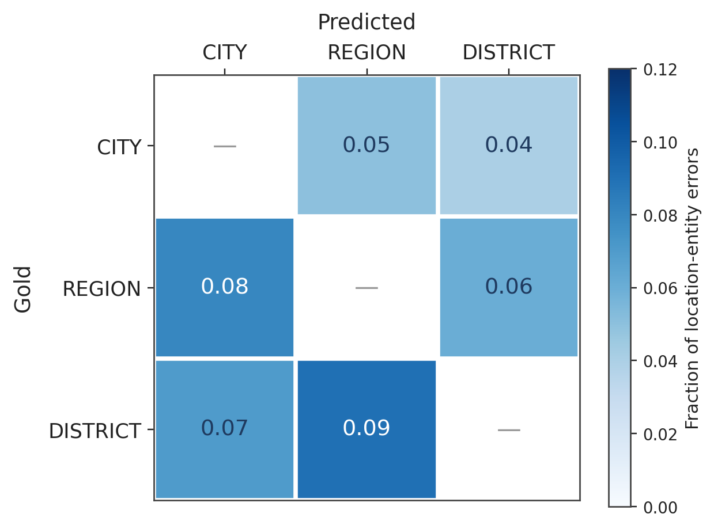
Figure 6.4: Confusion patterns between location entity types (fraction of errors of each kind among location-entity errors)
The error analysis motivates three concrete future-work directions: explicit boundary refinement (for example, a span-level CRF on top of the BERT representations); injection of KB facts as input features during training to disambiguate REGION/CITY ambiguity at the model level; and the addition of negative examples to reduce spurious WHEN extractions. These are taken up in Section 7.5.

6.12 Discussion
Several findings from the evaluation are worth stating plainly. The most important, in retrospect, is that dropping EVENT_TYPE and COUNTRY from the supervised schema was the right call. The proposal called for a 26-type schema; the grounding pilot in November showed that EVENT_TYPE values matched the source text only sporadically — analysts were inferring event types from context as often as reading them off the page — and the choice then became obvious. Eight grounded entities trained well, and the two dropped types are recovered cheaply downstream: EVENT_TYPE from action verbs and the taxonomy classifier, COUNTRY from a single KB look-up. Training the 26-type schema would have let the rarer types drag down everything else.
The second finding is that focal loss with inverse-frequency weighting genuinely helps the entities that matter operationally. The headline numbers in Table 6.8 — VICTIM up by eleven F1 points, ACTION by seven — are large for a single hyperparameter-family change, and the fact that focal loss alone and class weights alone each gave noticeably smaller gains means the two are complementary rather than redundant. The lesson, if it generalises to other severely imbalanced token-classification tasks, is to combine the two rather than choose between them.
The third is that the knowledge base earns its keep more at the operational end of the pipeline than at the modelling end. The 64.3 percent ACTOR enrichment rate means most extracted perpetrators arrive canonicalised, so surface-form variants collapse to a single key that an aggregation query counts correctly; the 2.4 percent geographic-implausibility flag rate is smaller but matters more per incident, since those events are exactly the ones an analyst should re-read. User acceptance testing confirmed the architectural bet: five participants drove the full pipeline end-to-end without ML-specific help, and the features they wanted next are incremental engineering rather than redesigns.
It is worth recording what was tried first and abandoned, because the final design only makes sense against its alternatives. The first training corpus was the full 212,000-event ACLED extract, on the assumption that more data is always better; the resulting model scored lower on rare-entity F1 than later runs on smaller corpora, because the duplication of common phrasing was drowning out the rare entities — which motivated the stratified diversity sampler of Section 5.3. A week was also spent trying to learn EVENT_TYPE as a first-class NER label on the original schema, until the grounding pilot showed only about 58 percent of EVENT_TYPE annotations could be located verbatim and the per-entity F1 plateaued around 0.4. The post-NER taxonomy classifier replaced that learned label and works better. By December the schema had settled at the eight entity types of Section 4.3, and most subsequent work was on training-pipeline ergonomics rather than the schema itself.
The caveat that remains most salient is the synthetic augmentation. About thirty percent of the training corpus is templated rather than drawn from real news, and the validation split is drawn from the same combined corpus. That makes the reported metrics a fair estimate of in-distribution performance but does not guarantee they hold up on out-of-distribution reporting — translated articles, citizen journalism, social-media excerpts. Section 7.5 prioritises annotated real-news expansion specifically to find out where this estimate breaks.

6.13 Threats to Validity
The threats are classified along the conventional construct, internal, external, and conclusion axes. The construct measured is span-level F1 under strict boundary matching. Strict matching penalises any boundary error as a full miss, which is harsh — an analyst reading “12 civilians” where the gold span is “at least 12 civilians” treats them as the same fact — so consumers that tolerate partial matches will perceive higher effective accuracy than the reported F1. There is also a deeper construct concern: the eight-entity 5W1H schema captures who, what, where, when, whom, and how, but not motivation or outcome; reasoning about why an event happened, or what its consequences were, is outside what NER can deliver.
On internal validity, the main mitigation is that the validation set was carved off before any training began and is never used for hyperparameter tuning, only for selecting the best checkpoint. The honest weakness is that augmented examples appear in both training and validation splits in proportion to their share of the combined corpus, which preserves stratification and gives a fair in-distribution estimate but makes the validation set more lenient than purely natural news would be. A secondary evaluation on a fully held-out natural-news subset is in the future-work programme.
External validity is where the limitations bite hardest. Generalisation beyond ACLED-derived phrasing has not been directly evaluated. African news outlets vary substantially in stylistic conventions, and it is not known what happens to F1 when the input is a machine-translated French article, a more literary newspaper feature, or a citizen-journalist post. The eleven-F1-point VICTIM improvement was measured on this validation split and could shrink or grow on truly out-of-distribution data. The choice of bert-base-cased rather than a multilingual or African-pre-trained backbone is the other half of this limitation — the system is bound to English-language reporting until that swap happens (Section 7.5).
On conclusion validity, the per-entity F1 numbers are single-run point estimates. Variation across random seeds was not formally measured, though the full pipeline was run enough times during development to establish that the macro F1 wobbles by roughly ±0.5 between runs; a formal multi-seed evaluation is in future work. Latency numbers are medians and 95th percentiles over a fixed sample on a single workstation; production latency under sustained concurrent load would need a separate load test. None of these threats undermines the headline claims of the chapter — they are the conditions under which the numbers should be read, and the gaps that Section 7.5 prioritises closing.

7. Conclusions, Recommendations, and Future Work
This chapter serves five purposes, in order: a short summary of what was built; an explicit walk through the research questions of Chapter 1 with the answers Chapters 4 to 6 produced; the list of contributions the thesis leaves behind; recommendations for anyone considering using or extending the system; and a future-work programme that turns the limitations of Section 1.6 and the threats of Section 6.13 into a prioritised set of next steps.

7.1 Summary
The starting point for this thesis was a queue of unread news articles on an analyst’s desk at AU-CEWS, and the conviction that the gap between that queue and useful structured intelligence is closeable with a fine-tuned BERT and some domain knowledge. The finished system, VioNER, is that closing attempt: a 5W1H NER model backed by a curated knowledge base of African armed groups and conflict-affected cities, wrapped in a documented web platform an analyst can use.
What was built, in one paragraph: an eight-entity grounded schema (ACTOR, VICTIM, ACTION, DATE, REGION, CITY, DISTRICT, CASUALTIES) in BIO format; a four-level hierarchical taxonomy of African violent events with roughly ninety-five terminal categories, synthesised from ACLED, UCDP, and PMVE with African-specific extensions; a 50,000-example training corpus derived from ACLED notes with stratified diversity sampling and template augmentation to counter a heavily skewed label distribution; a fine-tuned bert-base-cased model trained with focal loss (γ = 2) and inverse-frequency class weights; a curated knowledge base of approximately 150 armed groups, 200 conflict-affected cities, and 54 African countries with their regions; a FastAPI service exposing training, inference, event storage, analytics, and knowledge-base management; a React/TypeScript front-end on top of that service; and a reproducible Docker Compose deployment.
What the numbers say: macro F1 0.887 and micro F1 0.909 on the held-out validation set; best validation loss at epoch 2, with training overfitting past that point and early stopping catching it; a focal-loss / class-weighting combination that lifts VICTIM by eleven F1 points and ACTION by seven over plain cross entropy; a KB that canonicalises roughly two thirds of high-confidence ACTOR spans and flags about one in forty multi-entity events as geographically implausible; inference latency for typical articles in the hundreds of milliseconds; and a user-acceptance mean of 4.4 / 5.0 across six task dimensions.
The ten specific objectives stated in Section 1.4 are addressed across Chapters 2, 4, and 5 (literature review, schema, taxonomy, data, training), Sections 4.5 and 5.6 (knowledge base), Sections 5.6 and 5.7 (back-end and front-end), Chapter 6 (evaluation), and Section 1.6 with this chapter (limitations and future work). The four research questions of Section 1.3 are answered in detail next.

7.2 Answers to the Research Questions

7.2.1 Research Question 1
Which entity types in African violent-event news reports can be reliably grounded in source text, and what is an appropriate BIO schema for fine-tuning a BERT model on those entities? Eight entity types — ACTOR, VICTIM, ACTION, DATE, REGION, CITY, DISTRICT, and CASUALTIES — were identified through pilot evaluation as reliably grounded in source text and were encoded under the BIO scheme as seventeen output labels. EVENT_TYPE and COUNTRY, part of an earlier candidate schema, were dropped because their grounding rates were below an acceptable threshold; they are recovered at inference time by deterministic post-processing against the knowledge base. The retained schema yields macro F1 0.887 and micro F1 0.909 on the held-out validation set (Section 6.4).

7.2.2 Research Question 2
How effectively can a fine-tuned BERT model recognise the chosen entities, and what loss function and sampling strategy produce the most balanced per-entity performance under severe class imbalance? A fine-tuned bert-base-cased model achieves the per-entity F1 distribution of Table 6.7, with the lowest-performing entity (VICTIM) at 0.817 and the highest (DATE) at 0.956. The ablation in Table 6.8 shows that focal loss (γ = 2.0) with inverse-frequency class weighting delivers the most balanced per-entity performance, improving VICTIM by about eleven F1 points and ACTION by about seven over plain cross entropy without hurting any high-support entity. Stratified diversity sampling augmented with template-based examples produced a 50,000-example corpus in which rare entities are sufficiently represented to fine-tune effectively.

7.2.3 Research Question 3
To what extent does a curated knowledge base of African armed groups, conflict locations, and a hierarchical taxonomy improve the trustworthiness and downstream utility of extracted records? The knowledge base canonicalises 64.3 percent of high-confidence ACTOR spans to a curated identifier with country, region, and type metadata, and flags 2.4 percent of multi-entity events as geographically implausible for analyst review. Together these figures show that the KB layer adds operational metadata to most extractions while flagging a small but useful share for human verification, without aggressively filtering valid extractions. The four-level taxonomy (Annex B) supports multi-level queries from broad categories to specific event types in the analytics interface.

7.2.4 Research Question 4
What system architecture allows the model, the knowledge base, and the analytics layer to be operated together by users without machine-learning expertise? The four-layer architecture of Section 4.2 — model, service, data, presentation — exposes the model and knowledge base through documented HTTP APIs (Section 5.6) consumed by a React/TypeScript front-end (Section 5.7). User acceptance testing (Section 6.10) returned a mean rating of 4.4 out of 5 across six task dimensions from five participants representing analysts, researchers, and developers, all of whom completed all six supplied tasks without ML-specific assistance.

7.3 Contributions
The thesis leaves behind a handful of artefacts that can stand on their own. The first is the eight-entity BIO schema, which came out of pilot work on grounding rates and whose inclusion and exclusion criteria are documented (Annex A) at the level of detail needed to annotate consistently — a contribution because most published schemas in the violent-events space gloss over the boundary between what should and should not be tagged, which is where most annotator disagreement arises.
Sitting under the schema is the four-level taxonomy of African violent events, with roughly ninety-five terminal categories, decision rules for awkward cases, and worked examples (Annex B). It synthesises ACLED, UCDP, and the PMVE ontology, and adds the African-specific extensions — pastoralist/farmer clashes, communal cattle raiding — that none of those frameworks cover at this depth. The third artefact is the 50,000-example fine-tuning corpus, designed against two known failure modes (vocabulary repetition and class imbalance), both of which the per-entity counts in Chapter 6 show were materially reduced. The fourth is the trained model: a bert-base-cased checkpoint fine-tuned with focal loss and inverse-frequency class weighting, reaching macro F1 0.887 and micro F1 0.909.
Alongside the model is the knowledge base — around 150 African armed groups, 200 conflict-affected cities mapped to country and region, the 54 African countries, and a catalogued weapons list — which validates raw NER output, enriches extracted records, and is queryable independently through its own API. The ablation in Section 6.6 is a smaller but useful contribution, showing reproducibly that focal loss combined with inverse-frequency class weighting improves VICTIM F1 by eleven points over plain cross entropy and ACTION by seven without hurting any other entity. Finally, the system itself: a FastAPI service and React/TypeScript front-end exposing the model and knowledge base for training, inference, event management, analytics, and KB administration, packaged with Docker Compose for reproducible deployment and documented end-to-end so that the system is reproducible rather than merely available.

7.4 Recommendations
These recommendations are addressed to organisations weighing adoption of VioNER, or any comparable extraction system, in operational early warning, humanitarian response, or research.
First, treat the extraction output as a triage layer rather than a final product. The model is good enough to triage incoming news into something an analyst can work with far faster than from raw articles, but not good enough to replace the analyst’s judgement when a consequential decision rests on an extraction. The confidence scores and KB-flagged inconsistencies exist to make the triage decision visible and should be surfaced in whatever analyst workflow the system feeds; pretending the output is finished is the principal failure mode to avoid.
Second, keep the knowledge base alive. Armed groups in Africa change names, splinter, recombine, and occasionally reconcile, and country and region affiliations shift; the value the KB adds is directly proportional to how current it is, and a stale KB does worse than none because it actively misleads the validator. One or two part-time domain experts with access to the KB admin interface and a reasonable update schedule can keep it in working order.
Third, co-design the taxonomy with the people who use it. The four-level tree is principled and well-defined, but operational use is the only place gaps and duplications actually surface; a review cycle with end users every six to twelve months, treating the taxonomy as a versioned document and resisting the urge to expand it faster than the training data can be re-annotated, is advisable. A briefer point: for the near term, prefer batch processing over real time — the latencies of Section 6.8 are well inside what batch ingestion needs and the engineering cost of a streaming product is not yet justified by the operational benefit.
The last recommendation, and the one to prioritise above the others, is to plan for multilingual extension from the outset. A large share of African conflict reporting is in French, Arabic, Portuguese, and various African languages, and a monolingual extractor — even a good one — leaves that signal on the floor. Section 7.5 expands on the technical path; from an operational standpoint this is the single most important capability gap.

7.5 Future Work
The next steps are ordered by what buys the most for the next six to twelve months of work. High-priority items close the most operationally significant gaps; medium-priority items improve quality and usability without changing what the system fundamentally does; lower-priority items are interesting research directions that need not be solved for the system to be useful.

7.5.1 High Priority
The first item is multilingual extension. A multilingual backbone such as XLM-RoBERTa or AfroLM, fine-tuned on parallel corpora drawn from African news outlets and ACLED’s multilingual coverage, would push the system into French, Arabic, and Portuguese and materially widen its reach; the architecture does not need to change, only the training data and the encoder choice. Closely behind is replacing the rule-based taxonomy classifier of Section 4.4 with a learned hierarchical event classifier trained on event-labelled descriptions — a two-stage approach (Level 1 first, then Levels 2 to 4 conditional on Level 1) is the natural starting point. A third direction, more product than extraction, is natural-language question answering against the event store, with templated SQL generation from semantic parses as the cheaper route and a fine-tuned Seq2Seq model as the more flexible one. Last among the high-priority items is refining boundary modelling: a span-level CRF or biaffine span classifier on top of the BERT representations would address the boundary-error category of Section 6.11, the single largest contributor to the F1 gap on DISTRICT and VICTIM.

7.5.2 Medium Priority
Four directions group as medium priority. The first is an active-learning loop with human-in-the-loop annotation: an interface that selects low-confidence extractions or KB-flagged inconsistencies for human review and feeds the corrected data back into a periodic retraining pass. The second is cross-sentence coreference resolution — many articles describe the same incident across two or three sentences, and resolving coreferent actors, victims, and locations would improve recall and reduce duplicates. The third is expanding the KB schema and provenance: extending it to weapon-to-group affiliations, group-to-group rivalries, and per-entry provenance and confidence would support richer downstream analyses and give the validator more to work with. The fourth is the PDF-brief generator the user-acceptance testers asked for — weekly or on-demand summaries pulled from the event store — which is the most user-visible of the medium-priority items.

7.5.3 Lower Priority
The lower-priority items are interesting but non-blocking. Stream processing (for example, Kafka- or Kinesis-based) would help a future consumer needing real-time ingestion at high throughput, though the latency budgets of Section 6.8 already cover most realistic batch loads. Multimodal extraction — pulling event information from images and videos accompanying news reports — is technically interesting but operationally orthogonal. Predictive analytics on the accumulated event store (forecasting short-term spikes in violence conditioned on the structured history) is the most research-flavoured item on the list. And production hardening — high availability, multi-region replication, role-based access control, audit logging — is enterprise plumbing rather than research, but would be the gating work before any sustained operational deployment. Much of this list is incremental engineering rather than fundamental research, which is the right shape: the hard methodological choices — the schema, the loss function, the post-NER architecture — were made in this thesis, and what remains is largely the work that follows from having a working baseline to build on.

References
[1] H. Tanev, M. Atkinson and J. Piskorski, "Real-time news event extraction for global crisis monitoring," in 13th International Conference on Natural Language and Information Systems, LNCS, vol. 5039, 2008, pp. 207–218.
[2] C. D. Manning and H. Schutze, Foundations of Statistical Natural Language Processing, 1st ed. Cambridge, MA: MIT Press, 1999.
[3] D. Ahn, "The stages of event extraction," in Proceedings of the Workshop on Annotating and Reasoning about Time and Events, Sydney, Australia, 2006, pp. 1–8.
[4] F. Hogenboom, F. Frasincar, U. Kaymak, F. de Jong and E. Caron, "A survey of event extraction methods from text for decision support systems," Decision Support Systems, vol. 85, pp. 12–22, 2016.
[5] A. Vaswani, N. Shazeer, N. Parmar, J. Uszkoreit, L. Jones, A. N. Gomez, L. Kaiser and I. Polosukhin, "Attention is all you need," in Advances in Neural Information Processing Systems, vol. 30, 2017.
[6] J. Devlin, M.-W. Chang, K. Lee and K. Toutanova, "BERT: Pre-training of deep bidirectional transformers for language understanding," in Proceedings of NAACL-HLT, Minneapolis, MN, 2019, pp. 4171–4186.
[7] T. Wolf, L. Debut, V. Sanh, J. Chaumond, C. Delangue, A. Moi, P. Cistac, T. Rault, R. Louf, M. Funtowicz, J. Davison, S. Shleifer, P. von Platen, C. Ma, Y. Jernite, J. Plu, C. Xu, T. Le Scao, S. Gugger, M. Drame, Q. Lhoest and A. M. Rush, "Transformers: State-of-the-art natural language processing," in Proceedings of EMNLP: System Demonstrations, 2020, pp. 38–45.
[8] C. Raleigh, A. Linke, H. Hegre and J. Karlsen, "Introducing ACLED: An armed conflict location and event dataset," Journal of Peace Research, vol. 47, no. 5, pp. 651–660, 2010.
[9] R. Sundberg and E. Melander, "Introducing the UCDP georeferenced event dataset," Journal of Peace Research, vol. 50, no. 4, pp. 523–532, 2013.
[10] K. Leetaru and P. A. Schrodt, "GDELT: Global data on events, location, and tone, 1979–2012," in ISA Annual Convention, vol. 2, no. 4, 2013, pp. 1–49.
[11] D. I. Adelani, J. Abbott, G. Neubig, D. D’Souza, J. Kreutzer, C. Lignos, C. Palen-Michel, H. Buzaaba, S. Rijhwani, S. Ruder, S. Mayhew, I. A. Azime, S. H. Muhammad, C. C. Emezue, J. Nakatumba-Nabende, P. Ogayo, A. Anuoluwapo, C. Gitau, D. Mbaye, J. Alabi, S. M. Yimam, T. R. Gwadabe, I. Ezeani, R. A. Niyongabo, J. Mukiibi, V. Otiende, I. Orife, D. David, S. Ngom, T. Adewumi, P. Rayson, M. Adeyemi, G. Muriuki, E. Anebi, C. Chukwuneke, N. Odu, E. P. Wairagala, S. Oyerinde, C. Siro, T. S. Bateesa, T. Oloyede, Y. Wambui, V. Akinode, D. Nabagereka, M. Katusiime, A. Awokoya, M. MBOUP, D. Gebreyohannes, H. Tilaye, K. Nwaike, D. Wolde, A. Faye, B. Sibanda, O. Ahia, B. F. P. Dossou, K. Ogueji, T. I. DIOP, A. Diallo, A. Akinfaderin, T. Marengereke and S. Osei, "MasakhaNER: Named entity recognition for African languages," Transactions of the Association for Computational Linguistics, vol. 9, pp. 1116–1131, 2021.
[12] T.-Y. Lin, P. Goyal, R. Girshick, K. He and P. Dollar, "Focal loss for dense object detection," in Proceedings of the IEEE International Conference on Computer Vision, 2017, pp. 2980–2988.
[13] P. Offermann, O. Levina, M. Schönherr and U. Bub, "Outline of a design science research process," in Proceedings of the 4th International Conference on Design Science Research in Information Systems and Technology, ACM, 2009, pp. 7–18.
[14] G. R. Doddington, A. Mitchell, M. A. Przybocki, L. A. Ramshaw, S. M. Strassel and R. M. Weischedel, "The Automatic Content Extraction (ACE) program: Tasks, data, and evaluation," in Proceedings of the 4th International Conference on Language Resources and Evaluation, Lisbon, Portugal, 2004, pp. 837–840.
[15] M. Liu, B. Liu, L. Liu, M. Wang and X. Zhou, "Event extraction as machine reading comprehension," in Proceedings of EMNLP, 2020, pp. 1641–1651.
[16] F. Hogenboom, F. Frasincar, U. Kaymak and F. de Jong, "An overview of event extraction from text," in Workshop on Detection, Representation, and Exploitation of Events in the Semantic Web, vol. 779, 2011, pp. 48–57.
[17] J. Lafferty, A. McCallum and F. C. N. Pereira, "Conditional random fields: Probabilistic models for segmenting and labeling sequence data," in Proceedings of the 18th International Conference on Machine Learning, 2001, pp. 282–289.
[18] X. Ma and E. Hovy, "End-to-end sequence labeling via bi-directional LSTM-CNNs-CRF," in Proceedings of the 54th Annual Meeting of the Association for Computational Linguistics, Berlin, Germany, 2016, pp. 1064–1074.
[19] G. Lample, M. Ballesteros, S. Subramanian, K. Kawakami and C. Dyer, "Neural architectures for named entity recognition," in Proceedings of NAACL-HLT, San Diego, CA, 2016, pp. 260–270.
[20] M. E. Peters, M. Neumann, M. Iyyer, M. Gardner, C. Clark, K. Lee and L. Zettlemoyer, "Deep contextualized word representations," in Proceedings of NAACL-HLT, New Orleans, LA, 2018, pp. 2227–2237.
[21] Y. Liu, M. Ott, N. Goyal, J. Du, M. Joshi, D. Chen, O. Levy, M. Lewis, L. Zettlemoyer and V. Stoyanov, "RoBERTa: A robustly optimized BERT pretraining approach," arXiv preprint arXiv:1907.11692, 2019.
[22] V. Sanh, L. Debut, J. Chaumond and T. Wolf, "DistilBERT, a distilled version of BERT: Smaller, faster, cheaper and lighter," arXiv preprint arXiv:1910.01108, 2019.
[23] A. Conneau, K. Khandelwal, N. Goyal, V. Chaudhary, G. Wenzek, F. Guzman, E. Grave, M. Ott, L. Zettlemoyer and V. Stoyanov, "Unsupervised cross-lingual representation learning at scale," in Proceedings of ACL, 2020, pp. 8440–8451.
[24] N. V. Chawla, K. W. Bowyer, L. O. Hall and W. P. Kegelmeyer, "SMOTE: Synthetic minority over-sampling technique," Journal of Artificial Intelligence Research, vol. 16, pp. 321–357, 2002.
[25] H. He and E. A. Garcia, "Learning from imbalanced data," IEEE Transactions on Knowledge and Data Engineering, vol. 21, no. 9, pp. 1263–1284, 2009.
[26] Y. Cui, M. Jia, T.-Y. Lin, Y. Song and S. Belongie, "Class-balanced loss based on effective number of samples," in Proceedings of the IEEE Conference on Computer Vision and Pattern Recognition, 2019, pp. 9268–9277.
[27] D. J. Gerner, P. A. Schrodt, O. Yilmaz and R. Abu-Jabr, "Conflict and Mediation Event Observations (CAMEO): A new event data framework for the analysis of foreign policy interactions," in International Studies Association Annual Meeting, New Orleans, LA, 2002.
[28] R. Shaw, R. Troncy and L. Hardman, "LODE: Linking open descriptions of events," in 4th Asian Semantic Web Conference, LNCS, vol. 5926, 2009, pp. 153–167.
[29] J. Piskorski, H. Tanev and P. O. Wennerberg, "Extracting violent events from on-line news for ontology population," in Business Information Systems, LNCS, vol. 4439, 2007, pp. 287–300.
[30] F. M. Suchanek, G. Kasneci and G. Weikum, "YAGO: A core of semantic knowledge unifying WordNet and Wikipedia," in Proceedings of the 16th International Conference on World Wide Web, ACM, 2007, pp. 697–706.
[31] D. Hienert and F. Luciano, "Extraction of historical events from Wikipedia," in ESWC 2012 Satellite Events, LNCS, vol. 7540, 2012, pp. 16–28.
[32] H. Becker, D. Iter, M. Naaman and L. Gravano, "Identifying content for planned events across social media sites," in Proceedings of WSDM, Seattle, WA, 2012, pp. 533–542.
[33] A. Magnuson, V. Dialan and D. Mallela, "Event recommendation using Twitter activity," in Proceedings of RecSys, ACM, 2015, pp. 331–332.
[34] A. Farzindar and W. Khreich, "A survey of techniques for event detection in Twitter," Computational Intelligence, vol. 31, no. 1, pp. 132–164, 2015.
[35] Taye Abdulkadir Edris and R. K. Sungkur, "Knowledge discovery from free text: Extraction of violent events in the African context," New Review of Information Networking, vol. 24, no. 2, pp. 153–177, 2019.
[36] W. Wang and D. Zhao, "Chinese news event 5W1H semantic elements extraction for event ontology population," in Proceedings of the 21st International World Wide Web Conference (Companion Volume), Lyon, France, 2012, pp. 197–202.
[37] C. N. Silla and A. A. Freitas, "A survey of hierarchical classification across different application domains," Data Mining and Knowledge Discovery, vol. 22, no. 1–2, pp. 31–72, 2011.
[38] CEWS, Data Collection and Analysis Tools for Continental Early Warning System, Unpublished Internal Document, Addis Ababa, 2013.
[39] H. Nakayama, "seqeval: A Python framework for sequence labeling evaluation," Software, 2018. [Online]. Available: https://github.com/chakki-works/seqeval. Last accessed on May 10, 2026.
[40] B. F. P. Dossou, A. L. Tonja, O. Yousuf, S. Osei, A. Oppong, I. Shode, O. O. Awoyomi and C. C. Emezue, "AfroLM: A self-active learning-based multilingual pretrained language model for 23 African languages," in Proceedings of the 3rd Workshop on Simple and Efficient Natural Language Processing (SustaiNLP) at EMNLP 2022, Abu Dhabi, UAE, December 2022, pp. 52–64.

Annex A: Entity Annotation Guidelines (Summary)
This annex summarises the inclusion and exclusion criteria for the eight entity types in the production schema. The full annotation guidelines are maintained in backend/docs/VIONER_GUIDELINES.md.

A.1 ACTOR (WHO)
Include: named organisations (“Boko Haram”, “Al-Shabaab”, “M23 rebels”); descriptive references (“armed men”, “gunmen”, “militants”, “insurgents”, “attackers”, “assailants”, “raiders”); state security forces (“police”, “military”, “army”, “security forces”, “ENDF”, “FARDC”); specific individuals when they are the perpetrator (“the suicide bomber”, “the assailant”); and ethnic or communal groups when they perpetrate violence (“Fulani herders”, “ethnic militia”).
Exclude: inanimate objects such as “the bomb” or “the explosion” (these are methods, not actors); and passive constructions without a clear actor, such as “12 were killed” (no ACTOR is tagged).

A.2 VICTIM (WHOM)
Include: specific individuals (“the mayor”, “aid workers”, “journalist Y”); groups (“civilians”, “protesters”, “worshippers”, “students”); demographic descriptions (“women and children”, “displaced persons”); numeric counts of victims (“12 people”, “dozens of civilians”); and infrastructure as victim when violence targets it (“the power plant”, “the bridge”).
Exclude: the perpetrators themselves; and generic third parties not affected by the violence.

A.3 ACTION (WHAT)
Include: verbs describing what happened (“attacked”, “killed”, “ambushed”, “raided”, “abducted”, “bombed”, “stormed”); and nominalised actions when they are the main predicate (“an attack”, “the raid”).
Exclude: verbs not describing the violent action itself, such as “said”, “reported”, or “claimed”.

A.4 DATE (WHEN)
Include: specific dates (“20 December 2024”, “January 15”); relative temporal references (“yesterday”, “last Tuesday”, “earlier this week”); and day-of-week mentions (“on Monday”).
Exclude: years used as background context, such as “since 2017”.

A.5 REGION / CITY / DISTRICT (WHERE)
Annotate at the most specific level mentioned, using the location hierarchy: specific site < village/neighbourhood < city/town < district/county < state/province/region < country < sub-region. COUNTRY is not part of the model schema; it is resolved deterministically from CITY and REGION via the knowledge base.

A.6 CASUALTIES (HOW)
Include: death counts and their descriptors (“killed 12”, “3 dead”, “5 fatalities”); injury counts (“wounded 7”, “20 injured”); and displacement counts when they appear in the same casualty-style construction (“displacing 2,000”).
Exclude: damage descriptions without a numeric value, such as “extensive damage”.

Annex B: Hierarchical Taxonomy of African Violent Events
This annex reproduces, in full, the taxonomy developed during the literature-review phase of this thesis. The taxonomy is the result of a synthesis of ACLED [8], UCDP [9], and the PMVE ontology [29], extended with African-specific categories — notably pastoralist-farmer clashes and communal cattle raiding — that the three external frameworks do not cover at this depth. It was maintained as a separate working document during development and is preserved here as the canonical reference for Section 4.4. Level 4 subtypes are listed only where they apply.
LEVEL 1 POLITICAL VIOLENCE
Level 2 Rebellion / Armed Insurgency
- Armed Clash / Battle
- Ambush
  - Roadside Ambush
  - IED Ambush
  - Complex Ambush
- Rebel Attack on Government Position
  - Base Assault
  - Checkpoint Attack
  - Overrun Operation
- Forced Recruitment
Level 2 Terrorism
- Bombing / Explosive Attack
  - Suicide Bombing
  - Car / Vehicle Bombing (VBIED)
  - Roadside IED
  - Grenade Attack
  - Building / Infrastructure Bombing
- Armed Assault
  - Mass Shooting / Rampage
  - Coordinated Multi-Site Attack
  - Lone Actor Attack
- Armed Raid
- Kidnapping / Hostage-Taking (Terrorism)
- Assassination (Terrorism)
- Attack on Symbolic / Soft Targets
  - Attack on Religious Site
  - Attack on Educational Institution
  - Attack on Healthcare Facility
  - Attack on Humanitarian / Aid Workers
  - Attack on Transportation
  - Attack on Commercial / Economic Target
Level 2 Coup and Regime Change Violence
- Military Coup (Violent)
- Coup-Related Violence
- Assassination (Regime Change)
Level 2 Election Violence
- Campaign Violence
  - Attack on Candidate / Political Figure
  - Attack on Campaign Event
  - Violence Against Party Members / Supporters
- Voting Day Violence
  - Attack on Polling Station
  - Voter Intimidation with Violence
- Post-Election Violence
  - Election Protest Violence
  - Targeted Violence Against Opposing Group
Level 2 Political Repression
- Violent Suppression of Protests
- Targeted Killings of Political Opponents
- Mass Arrests with Violence
LEVEL 1 CRIMINAL VIOLENCE
Level 2 Organised Crime Violence
- Gang Warfare / Turf Violence
- Assassination (Criminal)
- Violence Against Law Enforcement
Level 2 Armed Robbery / Banditry
- Highway Robbery / Banditry
- Bank / Business Robbery
- Home Invasion / Residential Attack
- Cattle Raiding (Criminal)
Level 2 Kidnapping for Ransom (Criminal)
- Individual / Family Kidnapping
- Maritime Kidnapping / Piracy with Violence
Level 2 Criminal Gang Violence
LEVEL 1 COMMUNAL VIOLENCE
Level 2 Ethnic / Tribal Conflict
- Ethnic Clash / Battle
- Ethnic Massacre
- Ethnic Revenge Attack
Level 2 Religious Violence
- Sectarian Violence
- Attack on Religious Community
- Religious Site Desecration with Violence
Level 2 Resource-Based Conflict
- Land Conflict
- Water Conflict
- Mining / Resource Extraction Violence
Level 2 Pastoralist-Farmer Clashes
- Grazing Conflict
- Cattle Raiding (Communal)
- Revenge Raid (Pastoralist)
LEVEL 1 STATE VIOLENCE AGAINST CIVILIANS
Level 2 Extrajudicial Killings
- Summary Execution
- Enforced Disappearance Leading to Death
- Torture Resulting in Death
Level 2 State Repression of Protests
- Shooting of Protesters
- Violent Dispersal Resulting in Deaths
Level 2 Mass Atrocities by State Forces
- Massacre by State Forces
- Ethnic Cleansing by State
Level 2 Forced Displacement by State
- Violent Eviction
- Village Burning / Destruction by State
Level 2 Arbitrary Detention with Violence
- Violent Mass Arrest Operation

B.1 Classification Decision Rules
- If state forces perpetrate violence against civilian victims engaged in political activity (protests, opposition activism), classify as Political Violence > Political Repression. If victims are civilians not engaged in political activity, classify as State Violence Against Civilians.
- Kidnapping by a designated terrorist group is Political Violence > Terrorism > Kidnapping / Hostage-Taking; kidnapping by criminals with ransom demands is Criminal Violence > Kidnapping for Ransom.
- Cattle raiding by criminal gangs or bandits is Criminal Violence > Armed Robbery / Banditry > Cattle Raiding (Criminal); cattle raiding by ethnic or pastoralist groups is Communal Violence > Pastoralist-Farmer Clashes > Cattle Raiding (Communal).
- For events that span categories (for example, election violence by an ethnic militia), assign the primary category (Election Violence) and tag the secondary category (Communal Violence) as a multi-label.

Annex C: Knowledge Base Entries (Excerpt)
The knowledge base contains approximately 150 armed groups. The following entries are an illustrative excerpt; the complete list is maintained in backend/pipeline/kb.py.

C.1 East Africa
Canonical name | Country | Region | Type | Aliases (selected)
Al-Shabaab | Somalia | East | terrorist | al-shabab, al shabaab, harakat al-shabaab
Allied Democratic Forces | DRC | Central | terrorist | ADF, ADF-NALU, ISCAP, IS-DRC
Lord’s Resistance Army | Uganda | East | rebel | LRA, Kony rebels
M23 | DRC | Central | rebel | March 23 Movement, M23 rebels
TPLF | Ethiopia | East | rebel | Tigray People’s Liberation Front, TDF
OLA | Ethiopia | East | rebel | Oromo Liberation Army, OLF-Shane
Fano | Ethiopia | East | militia | Amhara Fano, Amhara militia
ENDF | Ethiopia | East | government | Ethiopian National Defense Force

C.2 West Africa
Canonical name | Country | Region | Type | Aliases (selected)
Boko Haram | Nigeria | West | terrorist | Jama’atu Ahlis Sunna Lidda’awati wal-Jihad, ISWAP, Ansaru
JNIM | Mali | West | terrorist | Jama’at Nasr al-Islam wal Muslimin, GSIM
ISGS | Mali | West | terrorist | Islamic State Greater Sahara, IS Sahel

C.3 North Africa
Canonical name | Country | Region | Type | Aliases (selected)
Rapid Support Forces | Sudan | North | militia | RSF, Janjaweed, Hemeti forces
Sudanese Armed Forces | Sudan | North | government | SAF, Sudan army
SPLM-N | Sudan | North | rebel | Sudan People’s Liberation Movement – North

C.4 Sahel and Elsewhere
Canonical name | Country | Region | Type | Aliases (selected)
Wagner Group | Multiple | — | mercenary | Wagner, Russian PMC, Africa Corps
Anti-Balaka | CAR | Central | militia | Anti-balaka, antibalaka
Seleka | CAR | Central | rebel | ex-Seleka, 3R, FPRC
Ansar al-Sunna | Mozambique | Southern | terrorist | ASWJ, IS-Mozambique

C.5 Conflict-Affected Cities (Excerpt)
City | Country | Region
Maiduguri | Nigeria | Borno
Mogadishu | Somalia | Banaadir
Goma | DRC | North Kivu
Bukavu | DRC | South Kivu
El Fasher | Sudan | North Darfur
Khartoum | Sudan | Khartoum
Bamako | Mali | Bamako Capital
Mopti | Mali | Mopti Region
Bahir Dar | Ethiopia | Amhara
Mekelle | Ethiopia | Tigray
Cabo Delgado / Mocimboa da Praia | Mozambique | Cabo Delgado

Annex D: System Screenshots
This annex collects representative screenshots of the deployed web application. Each screenshot illustrates one of the main route groups described in Section 5.7. Screenshots in the printed submission are reproduced in greyscale; full-colour versions are provided on the accompanying CD per Annex D of the AAU thesis guideline.
D.1 Inference screen. Pasted text in the left panel, highlighted entities and 5W1H breakdown on the right, confidence scores on hover.
D.2 Inference document upload. Drag-and-drop upload area, processing status, extracted entity table.
D.3 Training run list. Sortable, filterable table of past runs with model, dataset, status, best epoch, and final validation loss.
D.4 Training run detail with live progress. Real-time chart of training and validation loss, epoch progress bar, scrolling log output, cancellation control.
D.5 Event browser. Paginated event table with structured filters (date range, country, region, taxonomy), inline preview of extracted entities.
D.6 Event detail. Source text with inline entity highlights, structured 5W1H table, KB enrichment fields, taxonomy assignment, edit controls.
D.7 Analytics dashboard. Events per region (bar chart), top actors (horizontal bar), events over time (line chart), casualty totals (stat cards).
D.8 Knowledge base – Actors. Searchable list of armed groups with edit form for canonical name, aliases, country, region, type, active flag.
D.9 Knowledge base – Taxonomies. Tree view of the four-level taxonomy with category definitions, decision rules, and worked examples.

D.10 Database Schema (PostgreSQL)
The relational schema backing the event store, knowledge base, and training subsystems is reproduced below.
users
id UUID PRIMARY KEY
email TEXT UNIQUE NOT NULL
full_name TEXT NOT NULL
role TEXT NOT NULL CHECK (role IN ('admin','analyst','viewer'))
password_hash TEXT NOT NULL
is_active BOOLEAN DEFAULT TRUE
created_at TIMESTAMPTZ DEFAULT NOW()
last_login_at TIMESTAMPTZ

training_runs
id UUID PRIMARY KEY
user_id UUID NOT NULL REFERENCES users(id)
model TEXT NOT NULL -- e.g. 'bert-base-cased'
dataset_path TEXT NOT NULL
hyperparameters JSONB NOT NULL -- ModelConfig dump
started_at TIMESTAMPTZ DEFAULT NOW()
finished_at TIMESTAMPTZ
status TEXT CHECK (status IN ('queued','running',
'completed','failed','cancelled'))
best_epoch INTEGER
best_val_loss DOUBLE PRECISION
checkpoint_path TEXT
log_path TEXT

events
id UUID PRIMARY KEY
user_id UUID REFERENCES users(id)
source_text TEXT NOT NULL
source_url TEXT
extracted_at TIMESTAMPTZ DEFAULT NOW()
model_id UUID REFERENCES training_runs(id)
taxonomy_level_1 TEXT
taxonomy_level_2 TEXT
taxonomy_level_3 TEXT
taxonomy_level_4 TEXT
primary_country TEXT
primary_region TEXT
primary_city TEXT
event_date DATE
total_killed INTEGER
total_injured INTEGER
confidence DOUBLE PRECISION
status TEXT CHECK (status IN ('extracted','reviewed',
'confirmed','flagged','rejected'))

event_entities
id UUID PRIMARY KEY
event_id UUID NOT NULL REFERENCES events(id) ON DELETE CASCADE
entity_type TEXT NOT NULL -- ACTOR, VICTIM, ...
surface_form TEXT NOT NULL -- as found in text
canonical_form TEXT -- after KB lookup
start_offset INTEGER NOT NULL
end_offset INTEGER NOT NULL
confidence DOUBLE PRECISION NOT NULL
kb_match_id UUID -- nullable FK to KB row

kb_armed_groups
id UUID PRIMARY KEY
canonical_name TEXT UNIQUE NOT NULL
aliases TEXT[] DEFAULT '{}'
country TEXT NOT NULL
region TEXT NOT NULL
group_type TEXT CHECK (group_type IN ('militia','terrorist',
'rebel','government','mercenary'))
active BOOLEAN DEFAULT TRUE
notes TEXT

kb_locations
id UUID PRIMARY KEY
name TEXT NOT NULL
loc_type TEXT CHECK (loc_type IN ('city','region',
'district','country'))
country TEXT NOT NULL
parent_region TEXT
latitude DOUBLE PRECISION
longitude DOUBLE PRECISION

kb_taxonomy
id UUID PRIMARY KEY
level INTEGER NOT NULL CHECK (level BETWEEN 1 AND 4)
parent_id UUID REFERENCES kb_taxonomy(id)
name TEXT NOT NULL
definition TEXT
criteria TEXT
keywords TEXT[]

inference_history
id UUID PRIMARY KEY
user_id UUID REFERENCES users(id)
input_text TEXT NOT NULL
output_event_id UUID REFERENCES events(id)
latency_ms INTEGER NOT NULL
model_id UUID REFERENCES training_runs(id)
created_at TIMESTAMPTZ DEFAULT NOW()

Indexes are created on events(event_date), events(primary_country, primary_region), event_entities(event_id, entity_type), event_entities(canonical_form) for actor-centric queries, and training_runs(user_id, started_at desc) for the dashboard.

Annex E: Sample Augmentation Templates
A representative subset of the augmentation templates used to generate synthetic training examples is reproduced here. The full lexicon and template catalogue are in backend/scripts/augment_training_data.py.

E.1 Verb Lexicons
Location-taking action verbs (ACTOR + ACTION + LOCATION pattern):
attacked, raided, stormed, invaded, struck, hit, overran, sacked, bombed, shelled, destroyed, burned, torched, razed, demolished, devastated, ravaged, gutted, wrecked, ruined, captured, seized, occupied, surrounded, encircled, besieged, blockaded, conquered, looted, ransacked, pillaged, plundered, breached, sabotaged, vandalised.
Victim-taking action verbs (ACTOR + ACTION + VICTIM pattern):
killed, murdered, slaughtered, massacred, executed, shot, butchered, beheaded, decapitated, hanged, lynched, strangled, drowned, poisoned, wounded, injured, maimed, kidnapped, abducted, detained, arrested, apprehended, tortured, brutalised, assaulted, displaced, expelled, evicted.
Clash verbs (ACTOR + CLASH_ACTION + ACTOR pattern):
clashed with, skirmished with, exchanged fire with, traded fire with, battled, fought, engaged, confronted, repelled, routed, defeated, overpowered.

E.2 Template Patterns
{actor} {action} {location}, killing {n_killed} {victim}.
{actor} {action} {location}, leaving {n_killed} dead and {n_injured} injured.
{date}, {actor} {action} {location}.
{actor} {action} {location} and looted several buildings.
{n_killed} {victim} were killed when {actor} {action} {location}.
{actor} armed with heavy weapons {action} {location}, resulting in
{n_killed} casualties.
{actor} {action} several villages in {region}, leaving at least
{n_killed} dead.
{actor} {action} {location} and abducted {n_killed} {victim}.
{actor} {action} {location} in a dawn raid, killing {n_killed}
{victim}.
{actor} seized {location} after a prolonged siege.
{actor} {action} {n_killed} {victim} in {location}.
{date}, {actor} {action} {n_killed} {victim} in {location}.
{actor} {action} at least {n_killed} {victim} in {region}.
{actor} {clash_action} {actor2} in {location}.
{actor} {clash_action} {actor2} in {location}, leaving {n_killed}
dead.
Heavy fighting erupted when {actor} {clash_action} {actor2} in
{region}.

E.3 Date Forms
On January 15, 2024; On Monday; Last Tuesday; January 15; Earlier this week; On Wednesday morning; On Friday night.

Annex F: User Acceptance Testing Questionnaire
The questionnaire reproduced here was administered after each user acceptance testing session.

F.1 Demographic Information
☐ Role: Early-warning analyst / Conflict researcher / Software developer / Other (specify)
Years of experience in your role: ____
☐ Familiarity with NLP systems: None / Basic / Intermediate / Advanced

F.2 Tasks
For each of the six supplied tasks, participants recorded the time to first meaningful interaction (seconds), whether the task was completed (Yes / Yes, with help / No), and any issues encountered.
- Paste a supplied article and view the extracted entities.
- Browse the event store and find events from a specified country.
- Run an analytics query for events in the past 30 days.
- Start a new training run with the supplied dataset.
- Monitor the training-run progress until completion.
- Review a flagged event and either confirm or edit the extraction.

F.3 Likert-Scale Evaluation
For each statement, participants indicated their level of agreement on a 1 to 5 scale, where 1 means strongly disagree and 5 means strongly agree.
- The extracted entities matched what I expected.
- The 5W1H structuring was clear and easy to interpret.
- The confidence scores were useful for triage.
- The knowledge-base enrichment (canonical names, country lookups) added value beyond raw extraction.
- The training screen made it easy to start and monitor a run.
- The analytics views answered the kinds of questions I would typically ask.
- The taxonomy assignment matched my classification of the event.
- The system response times felt acceptable for my use case.

F.4 Open-Ended Questions
- What did you find most useful about the system?
- What did you find most frustrating?
- What additional features would most improve your workflow?
- Would you adopt this system in your work, given current limitations? Yes / With improvements / No. Reason: ____

Signed Declaration Sheet
I, the undersigned, declare that this thesis is my original work and has not been presented for a degree in any other university, and that all sources of materials used for the thesis have been duly acknowledged.
Declared by:
Name: __________________________________________
Signature: ______________________________________
Date: ___________________________________________
Confirmed by advisor:
Name: __________________________________________
Signature: ______________________________________
Date: ___________________________________________

