Assignment 5
Technical Analysis using R, Development Phase
Repository link:

1. Introduction
In this assignment I wrote nine technical analysis functions in R: sma, ema, macd, stdev, linreg, rsi, stoch_rsi, crossover and crossunder. I did not use any packages or library functions for the calculations. I only used basic R things like sum(), length(), sqrt(), abs(), max(), min() and for loops. Every function uses the same name and arguments as the template, and each one is saved in its own .R file.
I followed the pseudocode that was given for each function. In a few places the pseudocode and the written description are different from each other, so I wrote those down in Section 4.

2. How to Run the Code
- Download or clone my repository and keep all the .R files in the same folder.
- Open R or RStudio and set the working directory to that folder, for example setwd("C:/path/to/folder").
- To use one function, load its file with source(). Example: source("sma.R") and then sma(c(10, 12, 15, 20, 18, 22, 25, 24, 21), period = 3).
- macd.R loads ema.R by itself, and stoch_rsi.R loads rsi.R and sma.R by itself, as long as those files are in the same folder.
- To run everything at once, run Rscript test_indicators.R in the terminal, or open test_indicators.R in RStudio and click Source. It loads all nine files, prints the results of the example data, and prints PASS or FAIL for 11 checks.
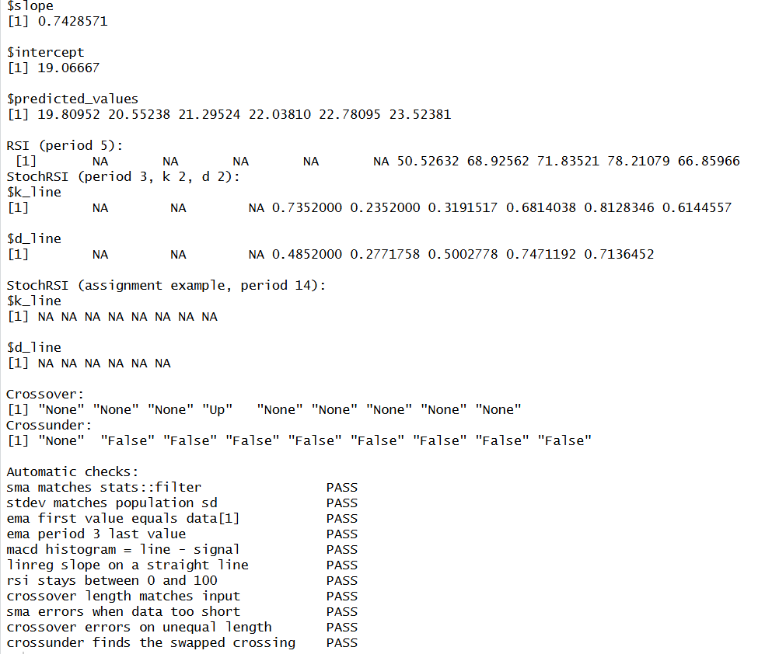
Figure: RStudio console after running source("test_indicators.R"), ending with the PASS checks
Files in the repository:
- sma.R
- ema.R
- macd.R
- stdev.R
- linreg.R
- rsi.R
- stoch_rsi.R
- crossover.R
- crossunder.R
- test_indicators.R

3. Explanation of Each Implementation

3.1 Simple Moving Average (sma.R)
The SMA is the average of the last "period" values. It gives every value in the window the same weight, so it smooths out small ups and downs in the price.
How my code works:
- First it checks that the data is at least as long as the period. If not, it stops with the error message from the pseudocode.
- It makes an empty vector with length(data) - period + 1 spots, which is the number of windows.
- A for loop takes each window of "period" values, adds them up and divides by the period.
Code (sma.R):
# sma.R - Simple Moving Average (SMA)
# data : numeric vector
# period : number of data points in each window
sma <- function(data, period) {
# Check if the length of data is less than the specified period
if (length(data) < period) {
stop("Data length should be greater than or equal to the period")
}

# Initialize a vector to store the SMA values
n_windows <- length(data) - period + 1
sma_values <- numeric(n_windows)

# Calculate SMA for each window of 'period' data points
for (i in 1:n_windows) {
current_window <- data[i:(i + period - 1)]
mean_value <- sum(current_window) / period
sma_values[i] <- mean_value
}

return(sma_values)
}
Output from the assignment example data (screenshot from RStudio):
Figure: sma() output in the R console
Check by hand: (10 + 12 + 15) / 3 = 12.33333

3.2 Exponential Moving Average (ema.R)
The EMA is like the SMA but it puts more weight on the newest prices, so it reacts faster to price changes.
How my code works:
- The multiplier is 2 / (period + 1).
- The first EMA value is just the first data point.
- Every next value uses EMA(i) = (Price(i) - EMA(i-1)) * multiplier + EMA(i-1).
- The output has the same length as the input data.
Code (ema.R):
# ema.R - Exponential Moving Average (EMA)
# data : numeric vector
# period : number of data points used for the EMA
ema <- function(data, period) {
# Calculate the multiplier for EMA
multiplier <- 2 / (period + 1)

# Initialize an empty array to store EMA values
ema_values <- numeric(length(data))

# Loop through the data array
for (i in seq_along(data)) {
if (i == 1) {
# Calculate EMA for the first data point
ema_values[i] <- data[i]
} else {
# Calculate EMA for subsequent data points
ema_values[i] <- (data[i] - ema_values[i - 1]) * multiplier + ema_values[i - 1]
}
}

return(ema_values)
}
Output from the assignment example data (screenshot from RStudio):
Figure: ema() output in the R console
Check by hand: multiplier = 0.5, second value = (12 - 10) * 0.5 + 10 = 11

3.3 MACD (macd.R)
The MACD shows the momentum of a trend. It is the short EMA minus the long EMA. A signal line (an EMA of the MACD line) is added, and the histogram is the MACD line minus the signal line.
How my code works:
- It calls my own ema() function for the short period and the long period.
- macd_line = short_ema - long_ema.
- signal_line = ema(macd_line, signal_period).
- histogram = macd_line - signal_line.
- It returns a list with macd_line, signal_line and histogram.
Code (macd.R):
# macd.R - Moving Average Convergence Divergence (MACD)
# This function uses ema(), so ema.R must be loaded first.
if (!exists("ema", mode = "function")) source("ema.R")

macd <- function(data, short_period, long_period, signal_period) {
# Calculate the short-term and long-term exponential moving averages (EMA)
short_ema <- ema(data, short_period)
long_ema <- ema(data, long_period)

# Calculate the MACD line
macd_line <- short_ema - long_ema

# Calculate the signal line (EMA of the MACD line)
signal_line <- ema(macd_line, signal_period)

# Calculate the histogram (the difference between the MACD line and the signal line)
histogram <- macd_line - signal_line

# Return the MACD line, signal line, and histogram as a list
result <- list(
macd_line = macd_line,
signal_line = signal_line,
histogram = histogram
)
return(result)
}
Output from the assignment example data (screenshot from RStudio):
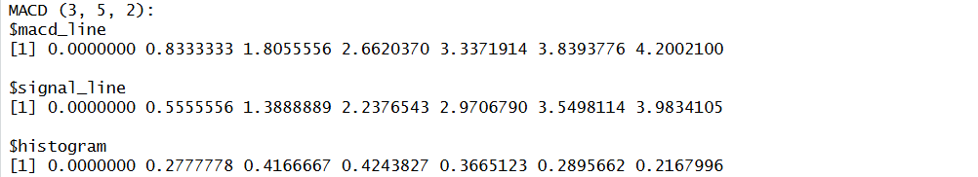
Figure: macd() output in the R console
The numbers are positive because the prices keep going up (bullish momentum).

3.4 Standard Deviation (stdev.R)
Standard deviation shows how spread out the data is around the mean. A bigger number means the values are more spread out.
How my code works:
- Find the mean (sum / number of values).
- Subtract the mean from every value.
- Square each difference.
- Divide the sum of the squared differences by n to get the variance.
- Take the square root. I divide by n (not n - 1), because that is what the formula in the assignment says. This means it will not match R's built-in sd(), which divides by n - 1.
Code (stdev.R):
# stdev.R - Standard Deviation (population: divides by n)
stdev <- function(data) {
# Calculate the mean of the data
mean_value <- sum(data) / length(data)

# Calculate the differences between the data points and the mean
diff_values <- numeric(length(data))
for (i in seq_along(data)) {
diff_values[i] <- data[i] - mean_value
}

# Calculate the squared differences
squared_diff <- numeric(length(diff_values))
for (i in seq_along(diff_values)) {
squared_diff[i] <- diff_values[i] * diff_values[i]
}

# Calculate the variance (mean of squared differences)
variance <- sum(squared_diff) / length(squared_diff)

# Calculate the standard deviation (square root of the variance)
standard_deviation <- sqrt(variance)

return(standard_deviation)
}
Output from the assignment example data (screenshot from RStudio):
Figure: stdev() output in the R console
Check: mean = 167 / 9 = 18.5556, variance = 24.4691, square root = 4.946629

3.5 Linear Regression (linreg.R)
Linear regression finds the straight line y = intercept + slope * x that best fits the data. In technical analysis the slope tells you if the price is trending up or down.
How my code works:
- It checks that regressionLength is not bigger than the data, and that regressionOffset is smaller than regressionLength.
- It works out start_index and end_index with the formulas from the pseudocode and takes that part of the data.
- The x values are 1, 2, 3, ... for each point in the subset.
- slope = sum((x - mean_x) * (y - mean_y)) / sum((x - mean_x)^2), and intercept = mean_y - slope * mean_x.
- It returns a list with slope, intercept and predicted_values.
Code (linreg.R):
# linreg.R - Simple Linear Regression
# regressionSource : numeric vector
# regressionLength : how many points the regression window covers
# regressionOffset : how many points to skip from the end of the data
linreg <- function(regressionSource, regressionLength, regressionOffset) {
# Calculate the total number of elements in the regressionSource
n <- length(regressionSource)

# Check if regressionLength is greater than the number of elements in regressionSource
if (regressionLength > n) {
stop("regressionLength cannot be greater than the number of elements in regressionSource")
}

# Check if regressionOffset is greater than or equal to regressionLength
if (regressionOffset >= regressionLength) {
stop("regressionOffset must be less than regressionLength")
}

# Calculate the starting index for the regressionSource
start_index <- max(1, n - regressionLength + regressionOffset)

# Calculate the ending index for the regressionSource
end_index <- min(n, n - regressionOffset)

# Extract the relevant portion of regressionSource
source_subset <- regressionSource[start_index:end_index]

# Calculate the index values for the regression points
index_values <- 1:length(source_subset)

# Calculate the sum of index values and the sum of source_subset
sum_index <- sum(index_values)
sum_source <- sum(source_subset)

# Calculate the mean of index values and the mean of source_subset
mean_index <- sum_index / length(index_values)
mean_source <- sum_source / length(source_subset)

# Calculate the numerator and denominator for the linear regression formula
numerator <- sum((index_values - mean_index) * (source_subset - mean_source))
denominator <- sum((index_values - mean_index)^2)

# Calculate the slope and intercept of the linear regression line
slope <- numerator / denominator
intercept <- mean_source - slope * mean_index

# Calculate the predicted values for the regressionSource
predicted_values <- slope * index_values + intercept

# Return the slope, intercept, and predicted values as a list
result <- list(
slope = slope,
intercept = intercept,
predicted_values = predicted_values
)
return(result)
}
Output from the assignment example data (screenshot from RStudio):
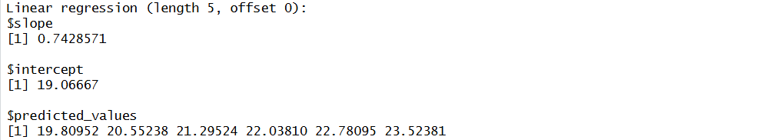
Figure: linreg() output in the R console

3.6 Relative Strength Index (rsi.R)
The RSI is a momentum indicator between 0 and 100. Above 70 usually means overbought, and below 30 usually means oversold.
How my code works:
- It finds the difference between each price and the one before it.
- Positive differences are gains and the absolute value of negative ones are losses. The other spots are set to 0.
- The first average gain and average loss are the mean of the first "period" values.
- For each point after that it uses Wilder's smoothing: avg = (avg * (period - 1) + new value) / period.
- RS = avg_gain / avg_loss and RSI = 100 - 100 / (1 + RS). The first values stay NA because there is not enough data yet.
- If the data is not longer than the period it returns all NA instead of crashing.
Code (rsi.R):
# rsi.R - Relative Strength Index (RSI) using Wilder's smoothing
rsi <- function(data, period) {
n <- length(data)

# Initialize the RSI vector with NA values
rsi_values <- rep(NA_real_, n)

# Not enough data to calculate even one RSI value, so return all NA
if (n <= period) {
return(rsi_values)
}

# Calculate the differences between consecutive data points
diff_values <- data[2:n] - data[1:(n - 1)]

# Initialize two vectors to store the gains and losses
gains <- numeric(length(diff_values))
losses <- numeric(length(diff_values))

# Calculate gains and losses
for (i in seq_along(diff_values)) {
if (diff_values[i] > 0) {
gains[i] <- diff_values[i]
} else {
losses[i] <- abs(diff_values[i])
}
}

# Calculate the average gains and average losses for the first 'period' elements
avg_gain <- sum(gains[1:period]) / period
avg_loss <- sum(losses[1:period]) / period

# Calculate RSI values using the Wilder's smoothing method
for (i in (period + 1):n) {
avg_gain <- (avg_gain * (period - 1) + gains[i - 1]) / period
avg_loss <- (avg_loss * (period - 1) + losses[i - 1]) / period

if (avg_loss == 0) {
# no losses at all: RS is infinite, so RSI is 100 (or 50 if nothing moved)
rsi_values[i] <- if (avg_gain == 0) 50 else 100
} else {
rs <- avg_gain / avg_loss
rsi_values[i] <- 100 - (100 / (1 + rs))
}
}

return(rsi_values)
}
Output from the assignment example data (screenshot from RStudio):
Figure: rsi() output in the R console

3.7 Stochastic RSI (stoch_rsi.R)
The StochRSI takes the RSI and rescales it between 0 and 1 using the lowest and highest RSI. It shows overbought and oversold conditions faster than the normal RSI.
How my code works:
- It calls my rsi() function.
- It finds the min and max of the RSI values (ignoring the NA values) and does (rsi - min) / (max - min).
- %K line = sma(k_values, k_period).
- %D line = sma(k_line, d_period).
- It returns a list with k_line and d_line.
Code (stoch_rsi.R):
# stoch_rsi.R - Stochastic RSI (StochRSI)
# This function uses rsi() and sma(), so rsi.R and sma.R must be loaded first.
if (!exists("rsi", mode = "function")) source("rsi.R")
if (!exists("sma", mode = "function")) source("sma.R")

stoch_rsi <- function(data, period, k_period, d_period) {
# Calculate the RSI
rsi_values <- rsi(data, period)

# Calculate the StochRSI (ignore the NA values at the start of the RSI)
valid <- rsi_values[!is.na(rsi_values)]
if (length(valid) == 0) {
k_values <- rep(NA_real_, length(rsi_values))
} else {
min_rsi <- min(valid)
max_rsi <- max(valid)
if (max_rsi == min_rsi) {
k_values <- ifelse(is.na(rsi_values), NA_real_, 0)
} else {
k_values <- (rsi_values - min_rsi) / (max_rsi - min_rsi)
}
}

# Calculate the %K line (StochRSI)
k_line <- sma(k_values, k_period)

# Calculate the %D line (simple moving average of %K)
d_line <- sma(k_line, d_period)

# Return the %K and %D lines as a list
result <- list(
k_line = k_line,
d_line = d_line
)
return(result)
}
Output from the assignment example data (screenshot from RStudio):
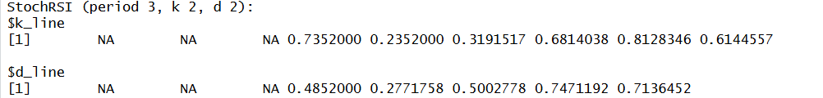
Figure: stoch_rsi() output with RSI period 3
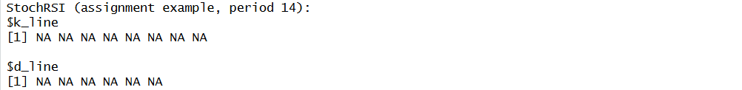
Figure: stoch_rsi() output for the assignment example (RSI period 14)
The assignment example uses RSI period 14 on only 10 values. There is not enough data for that, so all the results are NA and the function does not crash.

3.8 Crossover (crossover.R)
The crossover function finds the points where one line (arr1) goes from below to above another line (arr2). This is often used as a buy signal.
How my code works:
- It stops with an error if the two arrays are not the same length.
- The first position is always "None" because there is no previous value to compare with.
- From the second position on, if arr1[i] > arr2[i] and arr1[i-1] <= arr2[i-1] it saves "Up". If arr1[i] < arr2[i] and arr1[i-1] >= arr2[i-1] it saves "Down". Otherwise it saves "None". This follows the pseudocode.
Code (crossover.R):
# crossover.R - Crossover function
# Returns "Up" when arr1 crosses above arr2, "Down" when it crosses below, "None" otherwise.
crossover <- function(arr1, arr2) {
# Check if the length of both arrays is the same
if (length(arr1) != length(arr2)) {
stop("Both arrays should have the same length")
}

# Initialize a vector to store the crossover signals
crossover_signals <- character(length(arr1))
crossover_signals[1] <- "None"

# Check for crossovers at each data point
if (length(arr1) >= 2) {
for (i in 2:length(arr1)) {
if (arr1[i] > arr2[i] && arr1[i - 1] <= arr2[i - 1]) {
crossover_signals[i] <- "Up"
} else if (arr1[i] < arr2[i] && arr1[i - 1] >= arr2[i - 1]) {
crossover_signals[i] <- "Down"
} else {
crossover_signals[i] <- "None"
}
}
}

return(crossover_signals)
}
Output from the assignment example data (screenshot from RStudio):
Figure: crossover() output in the R console
arr1 goes above arr2 at position 4 (20 > 18, and before that 15 <= 22).

3.9 Crossunder (crossunder.R)
The crossunder function is the opposite of crossover. It finds where arr1 goes from above (or equal) to below arr2. This is often used as a sell signal.
How my code works:
- It stops with an error if the arrays have different lengths.
- The first position is "None".
- From the second position on, it saves "True" if arr1[i] < arr2[i] and arr1[i-1] >= arr2[i-1], and "False" otherwise. This follows the pseudocode.
Code (crossunder.R):
# crossunder.R - Crossunder function
# Returns "True" when arr1 crosses under arr2, "False" otherwise (first value is "None").
crossunder <- function(arr1, arr2) {
# Check if the length of both arrays is the same
if (length(arr1) != length(arr2)) {
stop("Both arrays should have the same length")
}

# Initialize a vector to store the crossunder signals
crossunder_signals <- character(length(arr1))
crossunder_signals[1] <- "None"

# Check for crossunder signals at each data point
if (length(arr1) >= 2) {
for (i in 2:length(arr1)) {
if (arr1[i] < arr2[i] && arr1[i - 1] >= arr2[i - 1]) {
crossunder_signals[i] <- "True"
} else {
crossunder_signals[i] <- "False"
}
}
}

return(crossunder_signals)
}
Output from the assignment example data (screenshot from RStudio):
Figure: crossunder() output in the R console
There is no crossunder in this example because arr1 starts below arr2 and only crosses up once.
Test: crossunder(arr2, arr1) gives "True" at position 4, so the function does detect crossings.

4. Notes About the Pseudocode
- Crossover and crossunder: the written description says the result should be TRUE/FALSE values, but the pseudocode returns text ("Up", "Down", "None", "True", "False"). I followed the pseudocode.
- linreg: the pseudocode uses start_index = n - regressionLength + regressionOffset and end_index = n - regressionOffset. With an offset of 0 this takes regressionLength + 1 points (6 points in my example with length 5). I kept it the way the pseudocode is written.
- rsi: in the pseudocode, the first smoothing step uses the gain at position "period" again, because it was already in the first average. I kept the pseudocode so the results match what the instructor expects.
- stdev: it divides by n (population standard deviation), as in the given formula.

5. Testing
I tested every function with the example data from the assignment. test_indicators.R also has automatic checks. For example, my sma() matches a moving average made with stats::filter, my stdev() matches the population standard deviation worked out another way, and the error messages show up when the data is too short or the arrays have different lengths. All 11 checks passed. The built-in functions are only used inside the test file, never inside the indicator functions.
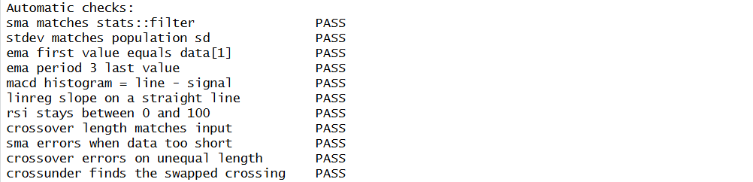
Figure: automatic checks, all 11 show PASS

