Diseño conceptual BD Hospital.

Designed by Jorge Flores, Accenture

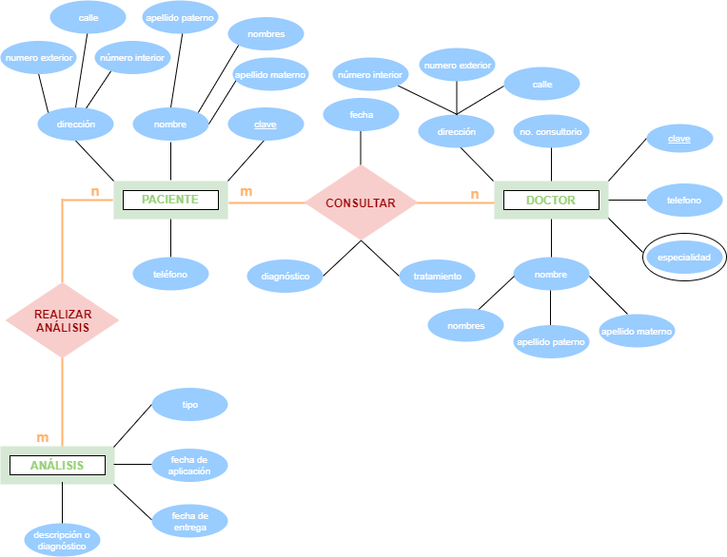

**1**