README.MD

Group ExoCyber

‘XPace’

Prepared by Syafiq Asyraf (2116239), Aiman Akim (2113823), Hafiz Adlan (2114989), Hafiz Zulkarnain (2111359), Khairul Fahmi(2115889)

‘XPace’ is a website for people to share their artwork, ideas and give inspiration for the community.

1. **Project Description**

We have decided to choose project gallery as our theme. For this task, we have come up with an idea to make a platform form the public to share their personal projects/arts and promote them in our website. So we have named our website as “XPace”. It derives from two English words which are expose and space. The term expose here to enable the public to share their projects/arts publicly as well as the creator will have their own gallery to publish them. Space means that the website is not limited in numbers of arts, users can explore our website to find some ideas that can give some inspirations for them to innovate new products. This can be relate to Sustainable Development Goals, Goal 9, which is industry, innovation and infrastructure. Our tagline for Xpace is “The Shack For Creative Communities”.

Our website consist of six different main web pages which are home, about us, team, explore, sign in and sign up page as well as the user dashboard page. We only use one type of font which is Inter. The reason is that, we want to have a minimalist design which is used and practiced also in other modern websites. By having a minimalist design, we believe that we can attract more users to visit and use our website more often. We use white colour as our background and colorized elements such as light pink, light purple and dark purple and some gradients to make our webpage outstanding.

For the website flow, it will begin with homepage where the user can explore briefly about our website. If they want to use our website and upload their project, they need to be registered first into our system and logged in with their credentials. In explore page, the user can find some ideas by searching a keyword for example like drawing, code snippets, web designs and creative videos.

1. **Project Sitemap**

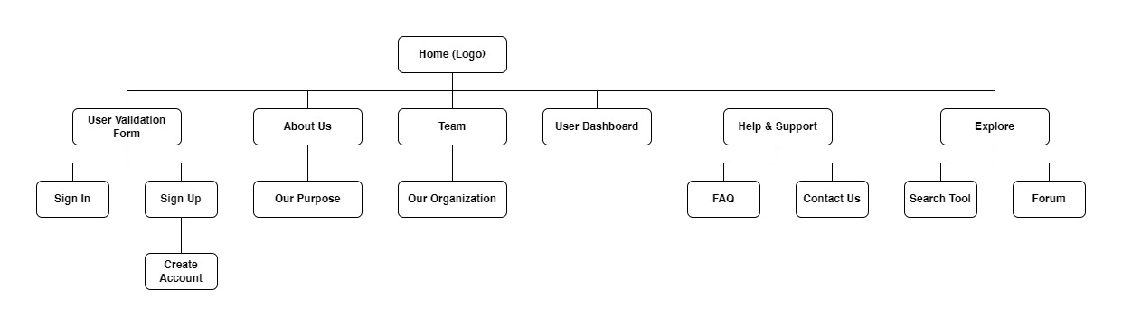

1. **Group Contributions**

Each of the team members prepared 2 web pages for the project as shown in the following table.

|  |  |
| --- | --- |
| **Name** | **Contributions** |
| Syafiq Asyraf  (2116239) | * Pages: Main page, Dashboard Page * Web elements: Navigation bar, Footer, Logo, Color Scheme (black, yellow, orange, red, purple) * Provide a consistent design for the whole project * Using accordion property from Bootstrap * Use ‘keyframes’ and ‘animation’ (CSS properties) animate objects * Compile all web pages * Do the quality checking (design consitency) |
| Mohamad Aiman Akim Bin Adanan(2113823) | * Pages: Why Xpace? page, FAQ page * Web elements: drop down menu, animated object * Using accordion property from Bootstrap * Using CSS properties to align text, object and logo |
| Muhammad Hafiz Bin Mohd Zulkarnain | * Pages: Team, Help & Support * Web element: Box of each member, Box of contact information, transition animation for contact details * Styling boxes for each member * Using CSS to animate the transition of the symbols, align the items into centre, create a rounded image. |
| Khairul Fahmi bin Mazlan (2115889) | * Pages: Sign In page, Sign Up page * Web element: Navigation button to another page, animated object * Using CSS to animate the object using keyframe, align the description at left while all the boxes and button at the right for each page, put colour on button and boxes with on hover responses. |
| Muhammad Hafiz Bin Adlan (2114989) | * Pages: Explore page, Forum page * Use searching method to find content |

1. **Use of third party resources**

|  |  |  |  |
| --- | --- | --- | --- |
| **Web elements** | **Name** | **Use of third party resources and modifications (if any)** | **Modifications (if any)** |
| Symbol for  contact | - | Symbol of mail, phone, map | Color of the symbol and animate the symbol with simple transition |
| Carousel | Carousel | Banner slideshow | Width and height of the carousel |
| Accordion | Accordion | Drop Down Menu | Width, height and margin of the accordion |
| Font | Inter | Taken from Google Fonts | - |
| Images | art1.svg  art2.svg  art3.svg  art4.svg  app.jpg  bitcoin.jpg  doodle.jpg  dish.jpg | Taken from Unsplash and Pexels | - |
| Videos | vid1.mp4  vid2.mp4 | Taken from Pexels | - |

1. **References**

Font Awesome. The iconic SVG, font, and CSS toolkit Retrieved 17 January 2023 from <https://cdnjs.com/libraries/font-awesome>

Plate. Pexels. Retrieved 2 December 2022 from

<https://www.pexels.com/photo/assorted-commemorative-plates-716107/>

Molding Claypot. Pexels. Retrieved 4 January 2023 from

<https://www.pexels.com/video/video-of-person-molding-a-clay-pot-4683406/>

Women Painting on Canvas. Pexels. Retrieved 4 January 2023 from

<https://www.pexels.com/video/a-woman-painting-on-a-canvass-6730925/>

Horse. Unsplash. Retrieved 1 January 2023 from

<https://unsplash.com/photos/0nwpV5A2TVo>

Smoking Painting. Unsplash. Retrived 1 January 2023 from

<https://unsplash.com/photos/R67u24pNSBY>

2 boys playing basketball during daytime. Unsplash. Retrieved 1 January 2023 from

<https://unsplash.com/photos/Lg0Zfs8MHi4>

Bicycle. Unsplash. Retrieved 1 January 2023 from

<https://unsplash.com/photos/oDKyhEjOBfc>

Carousel. Bootstrap. Retrieved 4 January 2022 from

<https://getbootstrap.com/docs/5.2/components/carousel/>

Accordion. Bootstrap. Retrieved 10 January 2022 from

<https://getbootstrap.com/docs/5.0/components/accordion/#sass/>